NETFLIX BUSINESS INSIGHTS REPORT
Task 6 – Advanced Business Intelligence & Exploratory Data Analysis
Source: Dataset(1).csv | Dataset size: 8,790 rows × 10 columns | Duplicate rows: 0 | Missing cells: 0

1. Executive summary
The supplied dataset contains 8,790 Netflix titles across 10 fields. It includes 6,126 Movies (69.7%) and 2,664 TV Shows (30.3%). The most common rating is TV-MA; the leading genre label is International Movies; and the most frequently listed country is United States. The analysis identifies catalog mix, release patterns, content additions, ratings, genres, countries and duration characteristics. These are catalog-level signals and should not be interpreted as audience engagement or revenue performance.

2. Business questions
- What is the composition of the catalog by content type?
- Which content ratings, genres and countries are most represented?
- How has the catalog's release-year profile evolved?
- How has the volume of titles added to Netflix changed over time?
- How do ratings and duration patterns differ between Movies and TV Shows?
- What decisions can be informed by catalog metadata, and what additional data is needed?

3. Exploratory data analysis and data quality
The dataset has 8,790 rows and 10 columns. Exact duplicate rows: 0. Duplicate show_id values: 0. Missing cells: 0.
Missing-value profile (largest first):
Column | Missing values | Missing %
show_id | 0 | 0.0%
type | 0 | 0.0%
title | 0 | 0.0%
director | 0 | 0.0%
country | 0 | 0.0%
date_added | 0 | 0.0%
release_year | 0 | 0.0%
rating | 0 | 0.0%
duration | 0 | 0.0%
listed_in | 0 | 0.0%
Data preparation: date_added was parsed as a date; release_year and duration were treated as numeric fields for summaries; country and listed_in were split into multi-value labels. No source records were intentionally removed.

4. Catalog composition
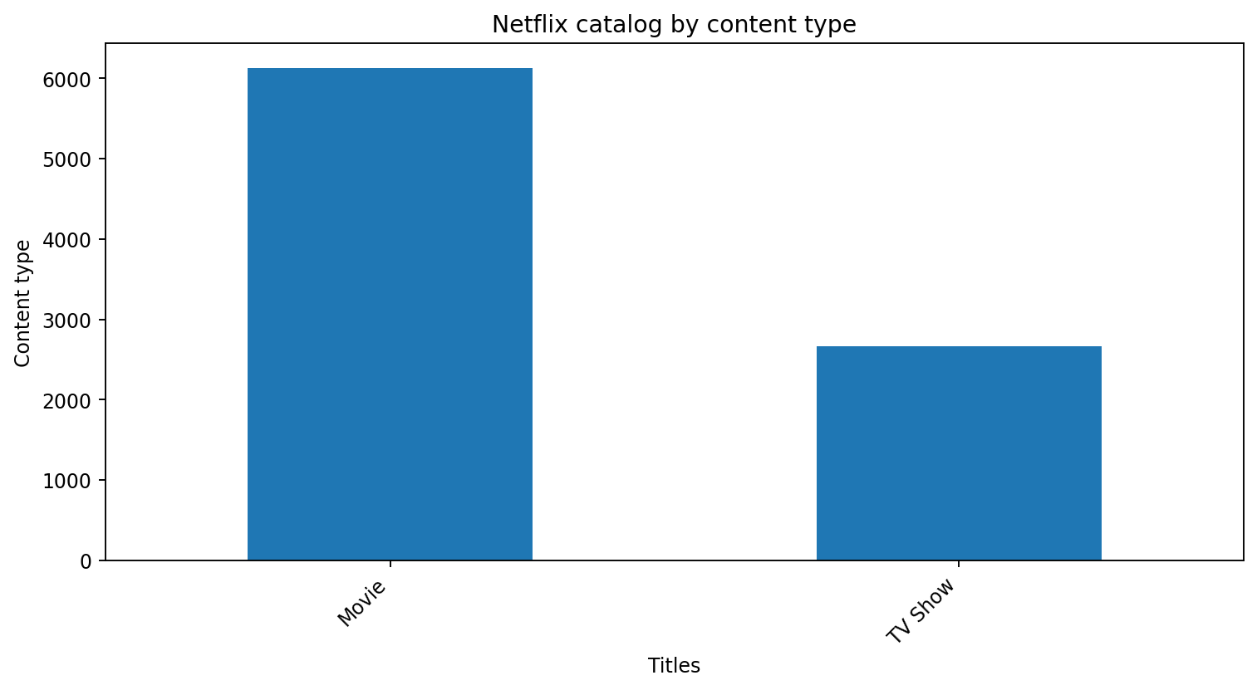
Movies make up 69.7% of the catalog and TV Shows make up 30.3%. This is a catalog availability mix, not evidence that users watch or prefer Movies at the same rate.

5. Content ratings and audience positioning
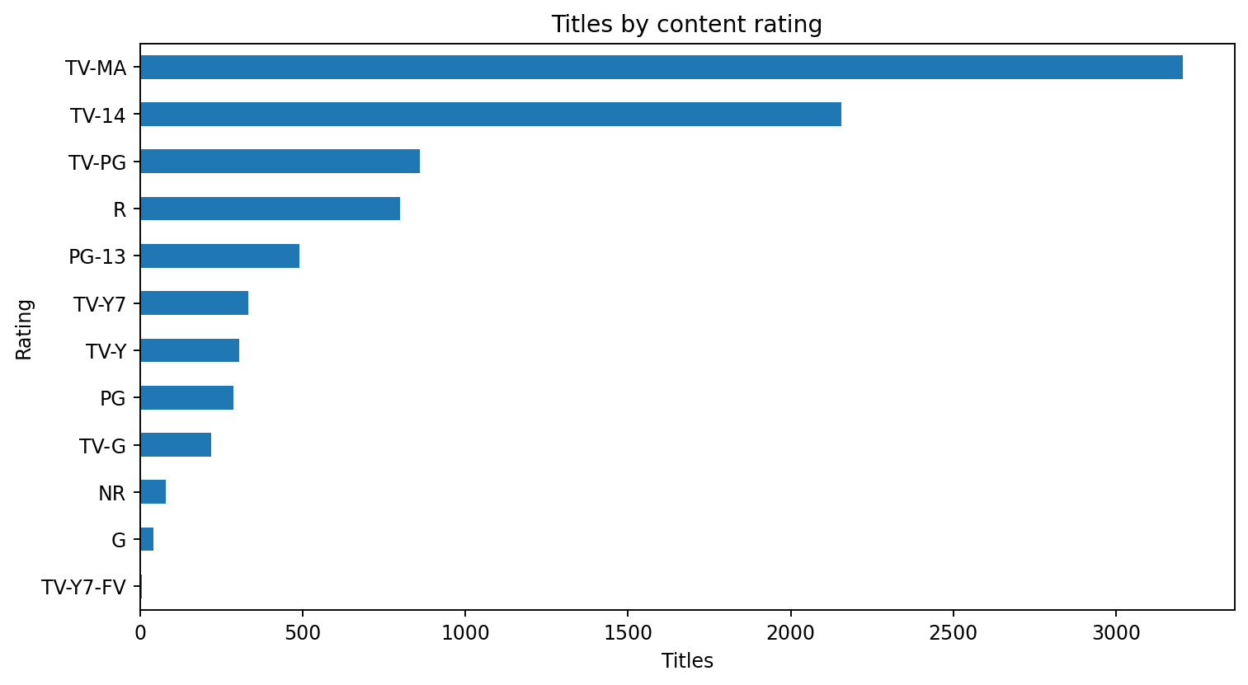
The most common rating is TV-MA (3,205 titles). Ratings can help classify the catalog's intended suitability, but they do not reveal the actual age profile of viewers.

6. Genre portfolio
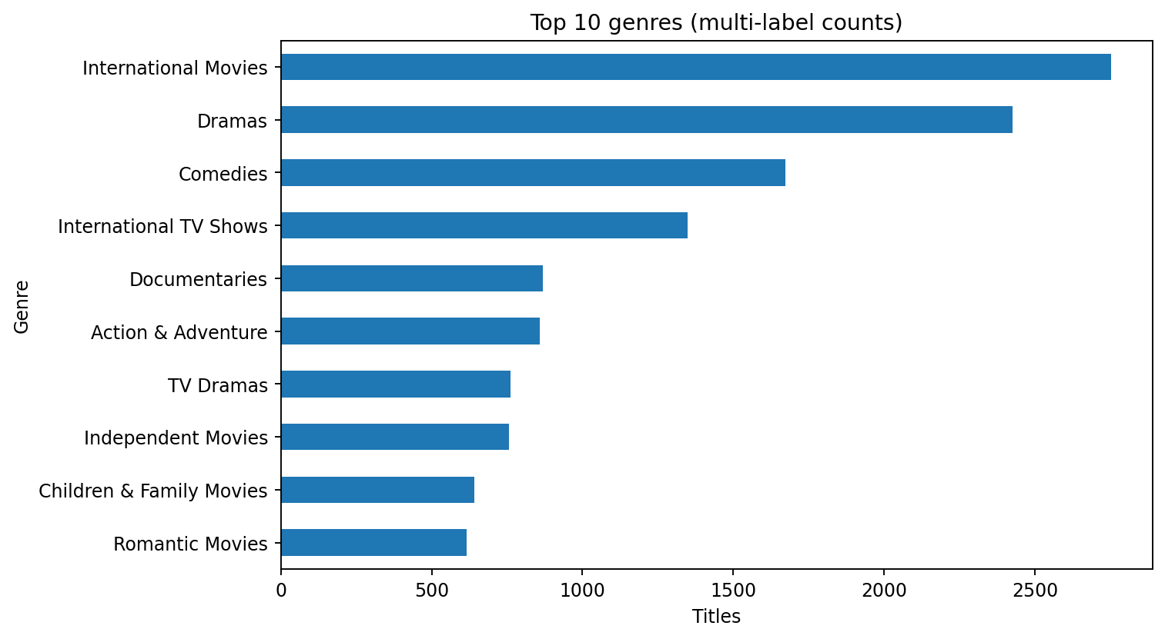
Genre values are multi-label: one title can appear in multiple genres. The top categories identify large catalog pillars, not exclusive genre shares.

7. Geographic footprint
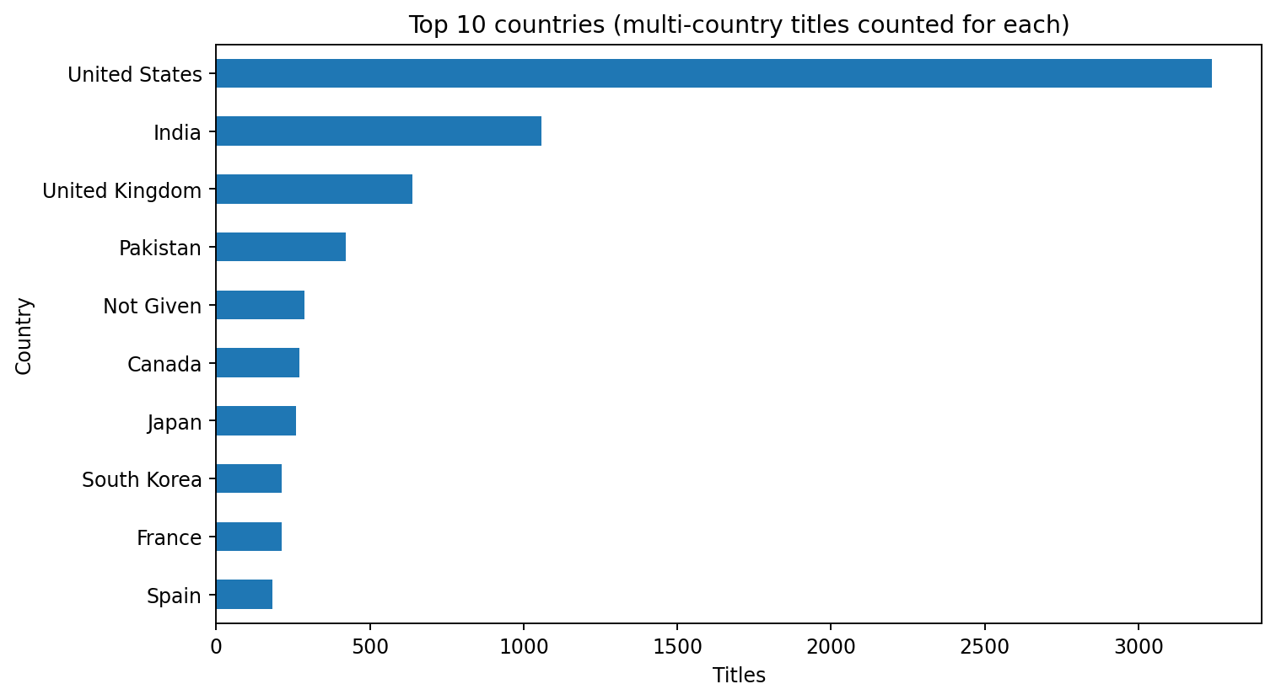
Country values are also multi-label. Co-productions and titles with multiple country entries contribute to more than one country count.

8. Release and acquisition timing
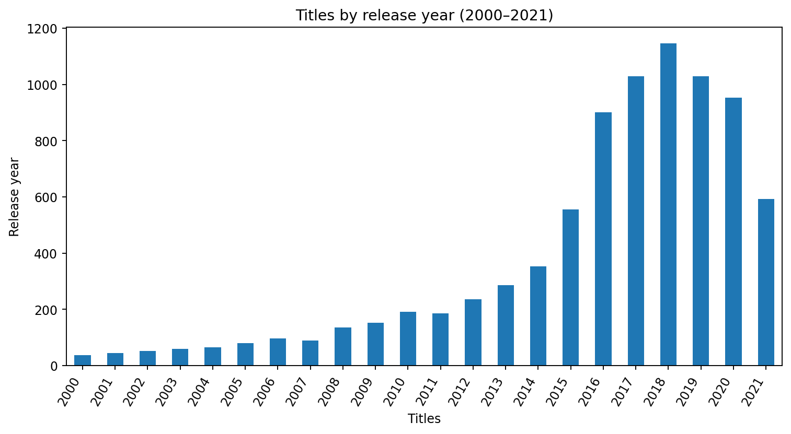
Release year indicates when a title was originally released, not when Netflix acquired it.
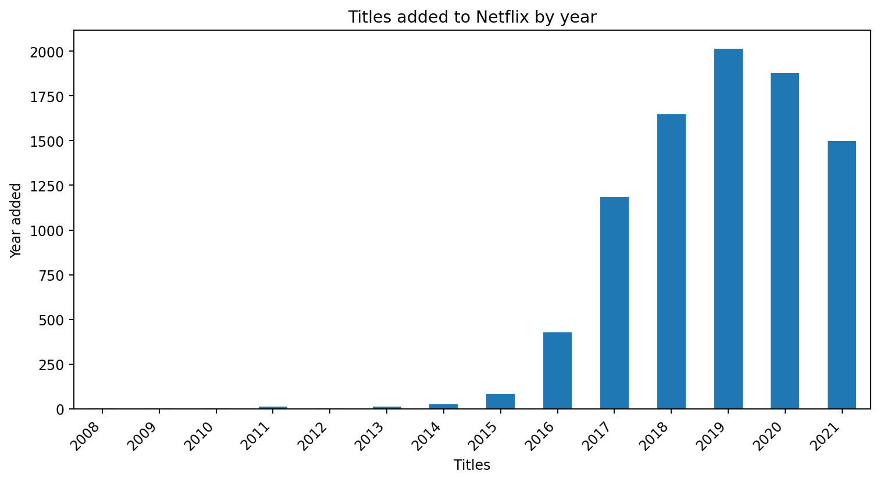
Date added indicates when the title entered the catalog. This is a measure of catalog additions, not a direct measure of new productions or licensing spend.

9. Duration profile
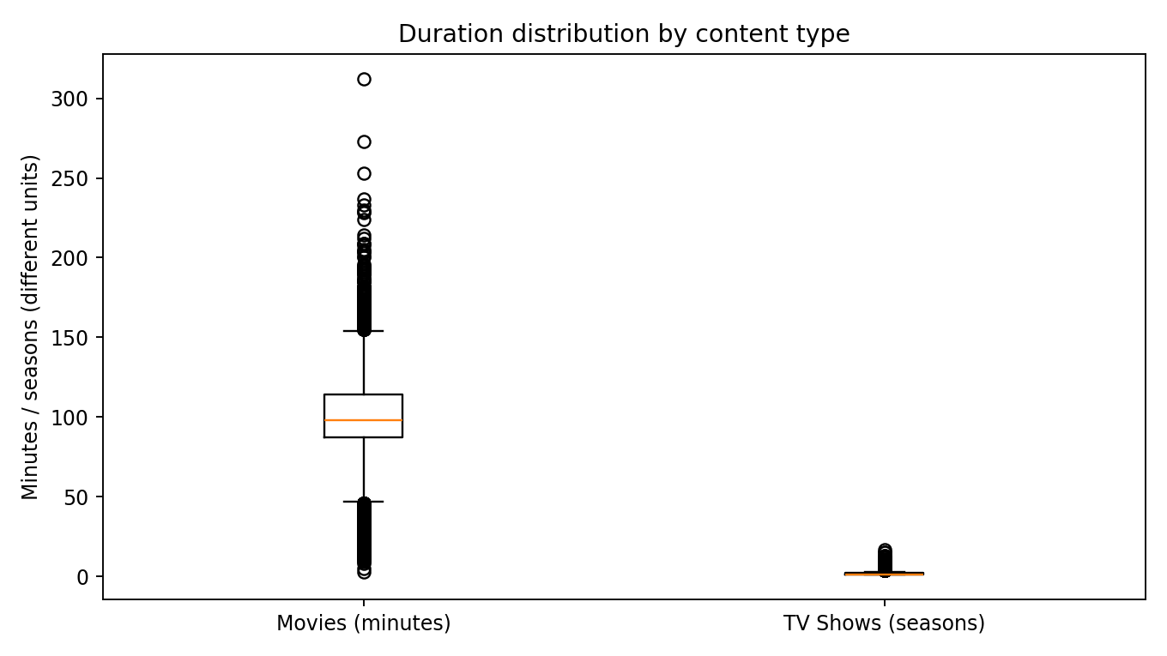
Movie duration median: 98 minutes; mean: 99.6 minutes.
TV Show seasons median: 1; mean: 1.8 seasons.
Movie duration is measured in minutes, while TV Show duration is measured in seasons. These units should not be directly compared on a common scale.

10. Actionable business insights
- Portfolio balance: Movies account for 69.7% of titles. Review this mix alongside viewing hours and completion rates before changing investment allocation.
- Genre strategy: International Movies is the most common genre label. Use genre-level watch time, search demand and completion data to distinguish catalog abundance from actual demand.
- Localization: United States is the most frequently listed country. Evaluate country-level performance together with language, subtitles, dubbing and regional viewing data.
- Content suitability: the rating distribution can guide catalog navigation and parental controls, but should be paired with user-level preferences and compliance requirements.
- Release freshness: compare older release-year titles with recently added titles to understand whether catalog additions are focused on new releases or library depth.
- TV Show development: evaluate seasons, completion and renewal outcomes using engagement and title-level performance data, which are not included in this file.

11. Recommended dashboard views
- Executive overview: total titles, Movies vs TV Shows, top rating, top genre and data quality indicators.
- Content portfolio: genre mix, rating mix, content type and duration distributions.
- Geographic and time trends: top countries, release-year profile and titles added by year.
- Comparative analysis: rating and duration distributions split by content type.

12. Limitations and next steps
The file contains catalog metadata only. It does not include viewing hours, unique viewers, completion rates, churn, subscription revenue, licensing costs, production budgets, customer demographics or recommendation impressions. Therefore, the report can describe what is in the catalog and how the catalog is structured, but cannot prove profitability, popularity, retention impact or audience size. For stronger business decisions, join this dataset to title-level engagement, customer cohort, regional, financial and marketing data.
Conclusion: The Netflix catalog is characterized by a mix of Movies and TV Shows, varied rating categories, multi-genre classification and a broad country footprint. A layered dashboard helps stakeholders monitor portfolio composition and catalog changes; engagement and financial data are required to connect these patterns to business outcomes.

