3/20/2026
Akshay Jadhav
Infosys LIMITED
JAVA
Basic Syntax

Table of Contents
What is Java? 3
Buzz words/features of Java: 3
JDK: 4
JRE: 4
JVM: 4
What is variable in Java? 4
What is Data type? 5
Main Method: 5
What is keyword? 6
What is identifier? 6
Scanner class in Java: 7
What does a private constructor mean in Java? 7
Printing Statement: System.out.println(“Hello world.”); 8
Conditional statements: 9
Transfer statement: 11
Looping Statement in java: 12
What is operator in Java? 13
Class 13
Object: 14
What is method? 14
Arrays: 15
Strings: 16
Constructor: 18
This: 18
Super: 18
Instance vs static block/method: 19
Encapsulation: 19
Abstraction: 22
Interface: 23
Inheritance: 24
Access Specifiers 25
Final Keyword 25
Generalization & Specialization 26
Polymorphism 27
Multi-Threading 29
Exception & Exception Handling 29
Packages 32
Type Casting 32
Java Collections 32

What is Java?
Java is a class based high level object-oriented programming language developed by James’ gosling in 1991.
- Class based means without a class we cannot write a single line of code in java.
- High level means related to English and easy for humans to understand.
- Object oriented programming language means each real-world entity in java is an object which has state & behaviour. Object is tangible and intangible in nature EX. Car & banking system respectively.

Buzz words/features of Java:
- Simple and easy to learn.
- Open-source means anyone anywhere anytime can learn & contribute to Java.
- Platform independent – java is platform-independent due to bytecode which is executed by JVM on any machine with different OS (Operating System: Windows, Mac, Linux, etc.).
- Secure language because of byte code.
- Object oriented: each real-world entity in java is an object which has state & behaviour. State - What the object is & Behaviour - What the object does.
- Distributed: Java is designed to create distributed applications over the network. Java can access remote objects on Internet as easy as they can do in local machines. Java enables multiple users or programmers from multiple remote locations to collaborate and work together on a single project.
- Portable: Java is portable because of the bytecode as it runs on all platforms with a JVM, ensuring write once, run anywhere.
- High performance: JIT (Just-In-Time) Compiler is a part of the JVM that improves Java performance by converting bytecode into native machine code at runtime.
- Multi-threaded: multi-threaded program handles multiple tasks simultaneously.
- Robust programming language: Java has garbage collector and exception handling mechanism which makes Java robust.
- Compiled and interpreted.

JDK:
- JDK stands for Java development kit. It contains JRE and JVM.
- JDK provides all the tools to work with Java language.

JRE:
- JRE stands for Java runtime environment it provides an environment to run Java programs.

JVM:
- JVM stand for Java virtual machine it is a software in the form of interpreter which execute our java program.
- JVM interpret .class file and gives us output.
Source Code
.java file
Compiler
javac
Interpreter
JVM
Output
Byte Code
.class
(1 byte = 8bits)

What is variable in Java?
- Variable is nothing but a piece of memory which is used to store information.
- One variable can store one information at a time.
- Variable fulfils the purpose of code reusability.
- To utilize variables in Java programming we need to follow below steps:
- variable declaration: means allocating/reserving memory i.e. int a
- variable Initialization: means assigning/inserting value i.e. a=10;
- Usage of variable.
- Types of variables:
- local variable: a variable which is defined inside any method/block of code.
- static variable: a variable with a static keyword before it. (We cannot define variable with static keyword inside any method body including main method. It must be globally declared)
- non static/global /instance variable: a variable defined outside of all method body but inside the class body.
- final variable: once we allot any value to the variable, we cannot change that value. Can not inherit such variables.

What is Data type?
- Data type represents the type of data or information stored in a variable.
- In Java programming it is mandatory to declare data type before declaring variable.
- There are two types of data types:
Primitive | Non-primitive
8 data types.  byte(1byte), short(2 byte), int(4 byte), Float(4 byte), double(8 byte),  long(8 byte), char(2byte),  boolean(1bit) | Class, String, Arrays etc.
All data types are keyword. | All data types are identifiers.
Memory size is fixed. | Memory size is not fixed.
Start with lowercase. | Start with uppercase.

Main Method:
In java main method is the starting point of execution of any code for JVM. Without main method we cannot run java programs
Class <className>
{
public static void main (String args[])
{
System.out.println(“Hello World”);
}
}
public: public is a keyword of a Java which is used before main method because whenever JVM tries to execute main method that method should be available for JVM.
Static: main method should be static so we can access that method without creating an object.
Void: main method doesn't return anything, so we use void before the main method.
String: string is a predefined class of Java, and it is a data type as well.

Main method overloading and overriding:
Yes, the main method can be overloaded like any other method in Java, but only public static void main(String[] args) is recognized by the JVM as the entry point. Overloaded versions must be called explicitly. Also, main method cannot be overridden because main is static — static methods are hidden, not overridden — so the JVM decides which main to run based on the class we execute by using the classname.methodName().
The JVM only recognizes public static void main(String[] args) because it’s the standardized entry point defined by the Java language specification. The modifiers ensure accessibility (public), no object creation (static), no return value (void), and a way to pass command-line arguments (String[] args).

What is keyword?
- Keywords are the reserved words whose meaning is already defined in the Java compiler.
- We cannot use keywords for our personal use.
- Keywords are case sensitive.
- There are 50 keywords and 3 literals which are null, true & false.

What is identifier?
  - Identifier is the name given to the variable, method, class, interface etc., to uniquely identify them.
- Int a; // variable identifier
- void m1(); //method identifier
- class A //class identifier
- interface B //interface identifier
  - Identifiers cannot be a keyword.
  - Identifiers are case sensitive.
  - All variables, methods, classes are identifiers, but not all identifiers are variables, methods, classes, interfaces.
  - There are certain rules which need to be followed while naming identifiers.
- starting with a letter, underscore, or dollar sign.
- Can not start with the numbers.

Scanner class in Java:
In Java to get run time input from users we take help of scanner class which is an inbuilt class of Java.
Syntax:
Scanner <refVariableName> = new Scanner(System.in);
- nextInt() → for integers
- nextLine() → for String value
- nextDouble() → for double type of value
System.in → System is a pre-defined class of java and “in” is to take input.
System class in Java:
- Predefined final class
- Present in java.lang package
- Represents system-level resources like console, keyboards etc.,
- Constructor is private → object cannot be created.

What does a private constructor mean in Java?
A private constructor is used to restrict object creation. It’s commonly applied in Singleton classes, utility classes. It prevents instantiation from outside the class and also stops inheritance, ensuring controlled object creation. It’s a design choice to enforce controlled object creation.
Syntax Example -
What does it actually do?
- Restricts object creation
- Constructor can be called only inside the same class
- Prevents external classes from creating objects

class Demo
{
private Demo() {
// private constructor}
}
→ Here, Demo d = new Demo(); ❌ is not allowed outside the class.
✅ Common Uses
- Singleton Pattern
- Ensures only one instance of a class exists.
- Object creation controlled via a static method (getInstance ()).
- Utility / Helper Classes
- Classes with only static methods (e.g., Math, Collections).
- Prevents unnecessary object creation.
⚡ Key Points
- Prevents instantiation from outside the class.
- Stops inheritance (child classes can’t call a private constructor).
- Can still be used inside the same class.

Printing Statement: System.out.println(“Hello world.”);
  - To print output in any programming language, we use printing methods provided by the language.
  - In Java, the print() and println() methods are present in the PrintStream class.
  - The PrintStream class is responsible for sending output to an output destination such as the console or a file.
  - But, Instead of creating an object of the PrintStream class directly, Java provides a predefined final class called System, which is present in the java.lang package.
  - The System class deals with system-level resources, such as the console, keyboard, and error output.
  - The System class contains a static object of the PrintStream class named out. EX: public static final PrintStream out;
  - This out object is created and initialized by the JVM and is already connected to the console.
  - So, using System.out, we can directly call the methods of the PrintStream class, such as print() and println(), without defining the output path every time
  - Java follows: “Don’t make the developer handle system setup.” JVM manages system resources, and the developer just uses them.
Program to add two numbers:
public class addTwoNumber
{
public static void main (String args[])
{
int a, b;
System.out.println(“Enter any two numbers”);
Scanner scan = new Scanner(System.in);
a = scan.nextInt();
b = scan.nextInt();
int c = a + b;
System.out.println(“Sum of two numbers: “+c);
}
}

Conditional statements:
- If statement:
it is used when we want to test single condition and single statement.
Syntax:
if(condition)
{
//Statement;
}

public class ifCondition
{
public static void main (String args[])
{
int psw;
System.out.println(“Enter password”);
Scanner scan = new Scanner(System.in);
psw = scan.nextInt();

if(psw==7464)
{
System.out.println(“Login successful.”);
}
}
}

2. if-else statement:
it is used when we want to execute two statements for a single condition.
Syntax:
if(condition)
{
Statement;
}
else
{
Statement;
}

public class ifCondition
{
public static void main (String args[])
{
int psw;
System.out.println(“Enter password”);
Scanner scan = new Scanner(System.in);
psw = scan.nextInt();
if(psw==7464)
{
System.out.println(“Login successful.”);
}
else
{
System.out.println(“Login unsuccessful.”);
}
}
}

3. else-if statement:
It is used when we have multiple conditions & statements to check.
Else if have only one if block and multiple else-if blocks and at last else block.

4. Nested if-else statement:
Whenever we define if else block inside another if else block then it is called nested if else block.

5. Switch statement:
Switch statement is a multiple-choice decision-making statement.
Syntax-
int day = 2;  switch(day)  {  case 1: System.out.println("Monday");  break;  case 2: System.out.println("Tuesday");  break;  default:  System.out.println(“Invalid”);  } | String choice = "tea";  switch (choice) {  case "coffee":  System.out.println("You selected Coffee");  break;  case "tea":  System.out.println("You selected Tea");  break;  default:  System.out.println("Invalid choice");  }

Transfer statement:
- break: break transfer statement, stops the flow of execution and come out of the iteration.
- continue: this transfer statement which skips that iteration and directly jump to next iteration.
- return: this transfer statement returns the values.

Looping Statement in java:
- while loop:
when number of iterations are not fixed in that case we use while loop.
Syntax:
Starting condition;
while(end condition)
{
Statement;
incre/decre;
}

- for loop:
Whenever we want to execute block of code multiple times in that case, we use for loop. In for loop, we know the number of iterations/repetitions.
Syntax:
1 2/5/8 4/7
for(initialization; condition; incre/decre)
{
3/6
//statement;
}

- do- while loop:
When the number of iterations is not fixed but we want to execute statement at least once in that case we use do while loop.
Syntax:
Starting condition;
do
{
Statement;
Incre/decre;
}
While(end condition);

- Advance for loop:
The advanced for loop (also called the enhanced for loop) is used to iterate directly over arrays or collections without using an index, making code simpler and more readable.
Syntax:
for (datatype variable: collection_or_array) {
// statements using variable
}
Example:
int[] numbers = {1, 2, 3, 4};
for (int num : numbers) {
System.out.println(num); }

What is operator in Java?
- Operator is a symbol that is used to perform mathematical operations according to user requirement.
- Types of operators:
No. | Operator | Symbol
1 | arithmetic operators | +, -, *, %, /
2 | relational operators | ==, !=, >, <, >=, <=
3 | logical operators | &&, ||, !
4 | Increment/decrement | ++, --
5 | assignment operator | a=10; a+=10 o/p=20
6 | conditional operator | ( if) ? ( true) :( false);

Class:
  - Class is a group of elements having common behaviour & properties.
  - Class is virtual entity.

Object:
- Object is a real-world entity which has state & behaviour.
- Object can be physical & imaginary also EX. Car & Banking System, respectively.

What is method?
  - Method is a block of code which take input from user process and generates the output.
  - Method is used to perform action.
  - Method runs only when it is called.
  - Method fulfils the purpose of code reusability.
  - There are some predefined and user defined methods.
- Predefined methods whose meaning is already defined into Java compiler these predefined methods do not have any body.
- User defined methods are those methods which we write for our convenience while writing java program. User defined methods have body in which we write our code/logic.
  - Types of methos:

Arrays:
  - Array is a data structure used to store collection of data or information.
  - Arrays are homogeneous in nature.
  - Arrays declaration need to be done with the capacity.
  - Arrays are not growable in nature.
  - Array is nothing but an object in java.
  - Inside array object indexing is present which start from zero.
  - Types of arrays:
- single dimensional array
- multi-dimensional array.
  - Without initializing array if we print that array then for integer default value of array is zero for string it is null and for char it is blank.
int[] arr = {10,20,30,40,50,60}; //array declaration & initialization
System.out.println(arr[2]); //o/p 30
  - Useful methods of Arrays:

Strings:
- String is used to store the collection of characters.
- String is non primitive data type whose memory size is not fixed.
- String is a class present inside Java’s Lang package.
- At the time of string declaration and initialization object creation takes place.
- String objects are immutable in nature which means its value cannot be changed.
- String class is a final class that's why it cannot be inherited to another class.
- In string object creation can be done in two ways:
- without using new keyword à EX. String str1 = “AKSHAY”;
- with using new keyword à EX. String str2 = new String(“AKSHAY”);
- String objects are going to get stored inside string pool area which is present in heap memory.
- String pool area is used to store string objects.
class GFG {
public static void main(String[] args)
{
// String created using String literal
String s1 = "TAT";
String s2 = "TAT";

// String created using 'new' keyword
String s3 = new String("TAT");
String s4 = new String("TAT");

System.out.println(s1);
System.out.println(s2);
System.out.println(s3);
System.out.println(s4);
}
}

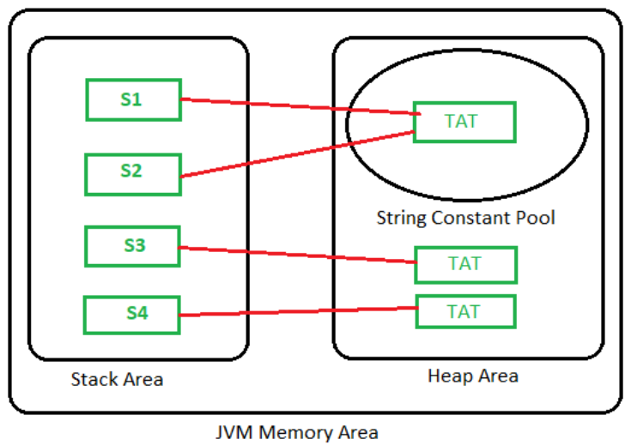

- String pool area is classified into two areas:
  - String constant pool area inside heap memory:
    - During object creation time if we don't use new keyword then object creation takes place inside string constant pool area.
    - Constant pool area doesn't allow duplicate objects.
  - Non constant pool area inside heap memory:
- during object creation if we use new keyword then object creation takes place inside non constant pool area.
- Non constant pool area allows duplicate values.
- Useful Methods of String class:

Constructor:
- Constructor is a special type of method whose name is same as class name.
- Constructor is used to initialize instance variable & also used to initialize objects of classes.
- Constructor cannot be overridden because to override it we need to have same method name in sub and super class, but as constructors name is as per the class name so, we cannot have two classes with the same name.
- We can overload the constructor.
- A constructor does not have any return type including void.
- A constructor is automatically called at the time of object creation.
- Types of constructors:
  - Default constructor:
    - A constructor through which we cannot pass any parameter is called default constructor.
  - Parameterized constructor:
    - A constructor through which we can pass parameter is called parameterized constructor.
    - EX Constructor Overloading

This:
- This ‘this’ keyword is used to differentiate between the local variable and the non-static global variables.
- ‘this’ keyword is also used to call the default constructure of the same class.

Super:
- Super keyword refers to the objects of super class, it is used when we want to call super class variable, method, and constructor through sub class object.
- Whenever the super class and sub class’s variable & method name both are same then in that case to avoid confusion, we should use super keyword.
- We can call variables, methods & constructor by using this keyword.

Instance vs static block/method:
Instance method | Static method
Deals with object | Deals with class
Executed at the time of object creation | Executed at the time of loading .class file to JVM
No keyword is used | ‘static’ keyword is used
Static & non-static variable can be accessed inside of non-static/instance block | Only static variables accessed inside the static block

Encapsulation:
Encapsulation is the process of wrapping data (variables) and methods (functions) into a single unit (class), while restricting direct access to the data using access modifiers.
- It hides the internal details of how data is stored/managed.
- Provides controlled access via getters and setters.
- Often described as “data hiding”.

✅ Key Points
- Achieved using private variables and public methods.
- Improves security and maintainability.
- Prevents unauthorized or accidental modification of data.
- Promotes modularity and reusability

📌 Example
class Employee {
private String name; // hidden data

// public getter
- Name is hidden from outside.
- Access is only through getName() and setName().

public String getName() {
return name;
}
// public setter
public void setName(String name) {
this.name = name;
}
}

⚡Interview-ready takeaway
Encapsulation in Java means binding data and methods together in a class and restricting direct access to the data. It’s achieved using private variables and public getters/setters. In Selenium frameworks, encapsulation is applied in Page Object Model (locators + actions), driver management, and test data handling to ensure security, maintainability, and clean code structure.

🔹 Encapsulation Usage in Selenium Automation Frameworks
- Page Object Model (POM)
  - Each page class encapsulates its locators (private WebElements) and actions (public methods).
  - Example: LoginPage has private locators for username/password fields, and public methods like login(String user, String pass).
📌 Example
public class LoginPage {
// private locators (data hidden)
private By usernameField = By.id("username");
private By passwordField = By.id("password");
private By loginButton = By.id("submit");

private WebDriver driver;
// constructor
public LoginPage(WebDriver driver) {
this.driver = driver;
}

// public action methods (controlled access)
public void login(String user, String pass) {
driver.findElement(usernameField).sendKeys(user);
driver.findElement(passwordField).sendKeys(pass);
driver.findElement(loginButton).click();
}
}
👉 Locators are private, actions are public → encapsulation.
- Test Data Handling
  - Encapsulation is used to hide test data variables and expose them through controlled methods.
📌 Example
public class TestData {
private String username = "student"; // hidden
private String password = "Password123";

// controlled access
public String getUsername() { return username; }
public String getPassword() { return password; }
}
- Driver Management
  - WebDriver instance is often kept private inside a DriverManager class, with public methods to initialize or fetch it.
  - Prevents uncontrolled access to the driver object.
📌 Example
public class DriverManager {
private static WebDriver driver; // hidden

// controlled access
public static WebDriver getDriver() {
if (driver == null) {
driver = new ChromeDriver();
}
return driver;
}

public static void quitDriver() {
if (driver != null) {
driver.quit();
driver = null;
}
}
}

Abstraction:
- Abstraction is nothing but hiding essential information & highlighting only sets of services.
- A class declared with ‘abstract’ keyword is called abstract class.
- An abstract class is nothing but incomplete class where programmer declares complete as well as incomplete methods.
- Abstract method does not have body.
- We cannot create object of abstract class to create object of abstract class we need to make use of concrete class.
Concrete class: A class which provides definition for all incomplete methods which are present inside abstract class with the help of ‘extends’ keyword is called concrete class.
// Abstract class
abstract class Shape {
abstract void draw(); // abstract method
void commonMethod() {
System.out.println("Common functionality");
}
}
🔹Abstraction Usage in Selenium Automation Frameworks
Driver Abstraction
Selenium itself uses abstraction: WebDriver is an interface.
Different browsers (ChromeDriver, FirefoxDriver, EdgeDriver) implement it.
Code interacts with WebDriver without worrying about the specific driver implementation.
Framework Design
Abstract classes like BaseTest or BasePage define common setup/teardown methods.
Specialized test/page classes extend them and provide specific implementations.
Reusable Contracts
Interfaces can define contracts for logging, reporting, or utilities.
Example: ScreenshotCapable interface with captureScreenshot() method, implemented differently across classes.

⚡ Interview-ready takeaway
Abstraction in Java hides implementation details and exposes only essential features, achieved via abstract classes and interfaces. In Selenium frameworks, abstraction is used in the WebDriver interface, base classes for tests/pages, and utility contracts — ensuring flexibility, reusability, and clean design.

Interface:
- It is pure 100% abstract in nature.
- interface is used to declare only incomplete methods in it.
- method declared inside interface are by default public and abstract.
- data members or variables declared inside interface are by default static and final.
- constructor concept is not present inside interface.
- object of constructor cannot be created. To create object of interface programmer, need to make use of implementation class.
Implementation class: A class which provides the definitions for all the incomplete methods which are present in interface with the help of ‘implements’ keyword is called implementation class.
- Interface supports multiple inheritance
// Interface
interface WebDriver {
void get(String url);
void quit();
}

Inheritance:
- One class acquiring properties of another class is called inheritance.
- Inheritance required at least two classes.
- There are 4 types of Inheritance:

Single level inheritance:
When a single class is derived from a single parent class, it is called Single inheritance
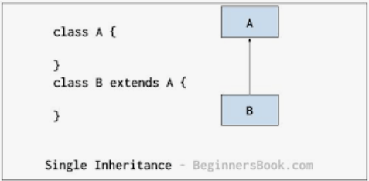
Multi-level inheritance: required at least three classes
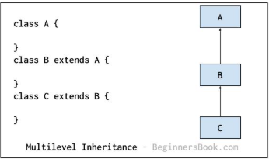
Hierarchical Inheritance: one super class and multiple sub classes

Multiple Inheritance:
One subclass acquiring properties of two super classes at the same time is known as multiple inheritance. We cannot achieve this by using class for it we have to take help of interface.
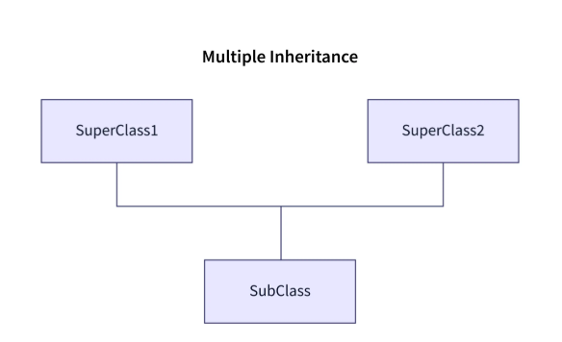

Access Specifiers
Access specifiers define the scope/visibility of class members in Java:
- public → Accessible everywhere in the project.
- private → Accessible only within the same class.
- default (package-private) → Accessible only within the same package. (No keyword, just omit specifier).
- protected → Accessible within the package and outside the package through inheritance.

Final Keyword
- final int a = 10; → Value cannot be changed.
- final void sum(); → Method cannot be overridden.
- final class A {} → Class cannot be inherited.

Generalization & Specialization
Generalization is the process of extracting common features (fields, methods, behaviour) from multiple classes and combining them into a parent type (class, abstract class, or interface). It represents the “is-a” relationship.
Usage in Selenium Frameworks:
- Defining interfaces or abstract classes for common behaviors.
- Example: A DriverManager interface with methods like getDriver(), implemented by ChromeDriverManager, FirefoxDriverManager, etc.
- Helps achieve code reusability and loose coupling.

Specialization is the opposite of generalization. It means creating subclasses from a generalized parent type, adding specific features or behaviors. It represents the “is-a” relationship in the downward direction.
Usage in Selenium Frameworks:
- Creating specific Page Classes in Page Object Model (POM).
- Example: Generalized BasePage with methods like click(), enterText(). Specialized classes like LoginPage, HomePage, CartPage extend BasePage and add page-specific actions.
- Ensures scalability and maintainability of the framework.

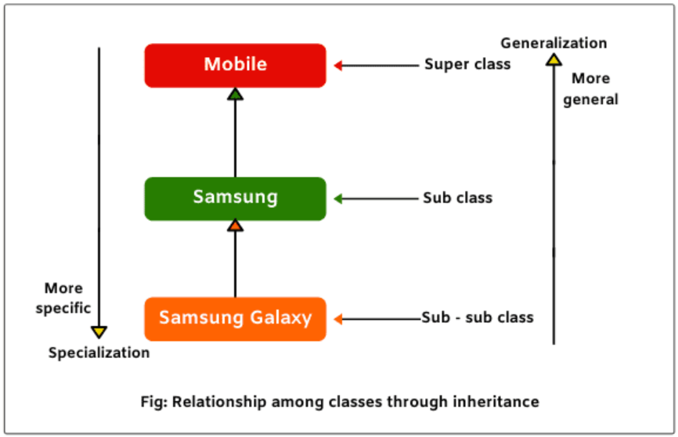

Polymorphism
Polymorphism means “one object showing different behaviors at different times.”
Types:
- Compile-time polymorphism (Static/Early binding)
  - In compile time polymorphism method declaration gets binded to its definition at compile time based on argument is known as compile time polymorphism.
  - As binding takes place during compilation time so it is known as early binding.
  - Once binding is done again rebinding cannot be done so it is called as static binding.
  - Method overloading is an example of compile time polymorphism.

- Runtime polymorphism (Dynamic/Late binding)
  - Achieved by method overriding.
  - Binding happens at runtime based on the object created.
🔹 JVM Memory Areas
- Stack → Stores method calls and local variables (execution flow of main).
- Heap → Stores objects and instance variables (non-static).
- Method Area → Stores class structures, static and non-static method definitions.
- String Constant Pool → Stores unique string literals and static constants.
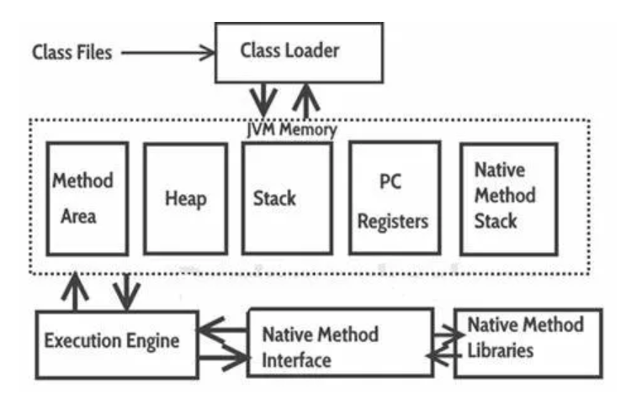

Overloading vs Overriding
Feature | Overloading (Compile-time) | Overriding (Runtime)
Definition | Same method name, different parameters | Subclass redefines superclass method
Binding | Compile-time (early/static) | Runtime (late/dynamic)
Parameters | Must differ | Must be same as superclass
Static/Private/Final | Allowed | Not allowed
Example | Method overloading | Method overriding

Multi-Threading
- Definition: Running multiple threads simultaneously.
- Thread: Smallest unit of CPU execution (java.lang.Thread).
- Advantages:
  - Independent execution (non-blocking).
  - Faster task completion.
  - Better CPU utilization.

Exception & Exception Handling
- Exception: Exception is an abnormal condition occurred during the runtime that disrupts the program flow.
- Exception Handling in Java is one of the powerful mechanisms to handle the runtime errors so that the normal flow of the execution can be maintained.
- It is an object which is thrown at runtime.
- Types:
  - Checked → Verified at compile time.
  - Unchecked → Verified at runtime.
- Keywords:
  - try → Defines block with risky code. The try block must be followed by either catch or finally.
  - catch → Handles exception.
  - finally → Always executes whether an exception is handled or not. It is used to write cleanup code such as closing database connections, quitting WebDriver, releasing resources, or closing files. Even if an exception occurs or not, the finally block will run (except in rare cases like System.exit() being called).
  - throw → Used to explicitly throw an exception.
  - throws → Declares exceptions in method signature.
Keyword | Definition | Usage | Example
final | A keyword used to mark variables, methods, or classes as unchangeable. | Variable → value cannot be changed.  Method → cannot be overridden.  Class → cannot be inherited. | final int x = 10;  final void display();  final class Test {}
finally | A block used in exception handling that always executes, whether an exception occurs or not. | Used to write cleanup code (close DB connections, quit WebDriver, release resources). | try { ... } catch(Exception e) { ... } finally { con.close(); }
finalize | A method of Object class called by Garbage Collector before destroying an object. | Used to perform cleanup operations before object is removed from memory. | protected void finalize() { System.out.println("cleanup"); }

⚡ Interview-ready takeaway
- final → Restricts modification (variable, method, class).
- finally → Ensures cleanup code always runs in exception handling.
- finalize → Called by Garbage Collector before object destruction (not reliable, mostly replaced by try-with-resources).

Keyword | Definition | Purpose / Usage | Example
throw | A keyword used to actually throw an exception object inside a method/block. | Transfers control to the exception handler at runtime. Only one exception object can be thrown at a time. | throw new ArithmeticException("Not eligible");
throws | A keyword used in a method signature to declare possible exceptions. | Informs the compiler and caller that the method may throw exceptions. Multiple exceptions can be declared, separated by commas. | public void readFile() throws IOException, SQLException { ... }
Throwable | A class in Java (superclass of all errors and exceptions). | Parent class of Exception and Error. Any object that can be thrown must be a subclass of Throwable. | catch (Throwable t) { System.out.println(t); }

⚡ Interview-ready takeaway
- throw → Used to explicitly throw an exception object inside a method.
- throws → Declares exceptions in a method signature so the caller knows to handle them.
- Throwable → The superclass of all exceptions and errors; only objects of type Throwable (or its subclasses) can be thrown.

Packages
- Definition: A package is a folder that groups related classes, interfaces, and sub-packages.
- Types:
  - Predefined (e.g., java.lang, java.util, java.io, java.sql, java.net, java.awt, java.applet).
  - User-defined (created as per project needs).
- Advantages: Reusability, security, fast searching, avoids name conflicts, hides implementation.
- Limitation: Cannot pass parameters to packages.

Type Casting
- Definition: Converting one data type into another.
- Types:
  - Widening (Implicit/Upcasting) → Smaller to larger type. Safe, no data loss. Example: int → long → float → double
  - Narrowing (Explicit/Downcasting) → Larger to smaller type. Manual, may lose data. Example:
double d = 166.66;
long l = (long)d; // 166
int i = (int)l; // 166

Java Collections
1. Cursors: Used to fetch data from collection implementation classes.
- Iterator
  - Universal cursor (works with all collection classes).
  - Syntax:
Iterator itr = al.iterator();
while(itr.hasNext()) {
System.out.println(itr.next());
}
- ListIterator
  - Works only with List interface implementations.
  - Syntax:
ListIterator ltr = al.listIterator();
while(ltr.hasNext()) {
System.out.println(ltr.next());
}
- Enumeration
  - Works only with legacy classes (Vector).
  - Syntax:
Enumeration enu = v.elements();
while(enu.hasMoreElements()) {
System.out.println(enu.nextElement());
}

2. ArrayList
✅Properties
- Duplicates allowed
- Multiple null values allowed
- Maintains insertion order
- Default capacity = 10
- Data structure: Resizable
- Incremental capacity = (currentCapacity * 3/2) + 1
✅Common Methods
- isEmpty() → check empty (RT: boolean)
- size() → returns size (RT: int)
- contains(value) → check if value exists
- add(index, element) → inserts at index (right shift)
- remove(index) → deletes at index (left shift)
- set(index, element) → update value
- indexOf(value) → returns index of element
- get(index) → fetch value at index

✅For-Each Loop
for(Object obj : al) {
System.out.println(obj);
}
3. Vector
✅Properties
- Legacy class
- Duplicates allowed
- Multiple null values allowed
- Maintains insertion order
- Default capacity = 10
- Data structure: Doubly
- Incremental capacity = (currentCapacity * 2)
- Synchronized → thread-safe (low performance)

✅Ways to Print
- Iterator
- ListIterator
- Enumeration
- For-Each loop
✅Comparison: ArrayList vs Vector
Feature | ArrayList | Vector
Legacy | No | Yes
Data Structure | Resizable | Doubly
Incremental Capacity | (3/2)+1 | *2
Thread Safety | Not sync | Sync
Performance | High | Low

4. LinkedList
✅Properties
- Duplicates allowed
- Multiple null values allowed
- Maintains insertion order
- No default capacity
- Data structure: Linear
- Best for manipulation (no shift ops)

✅Methods
- isEmpty(), size(), contains(value)
- add(index, element), remove(index)
- set(index, element), indexOf(value), get(index)
✅Printing
- Iterator
- ListIterator
- For-Each loop
✅Comparison: ArrayList vs LinkedList
Feature | ArrayList | LinkedList
Default Capacity | 10 | None
Data Structure | Resizable | Linear
Best For | Retrieval | Manipulation
Worst For | Manipulation | Retrieval

5. HashSet
✅Properties
- No duplicates
- Only one null allowed
- Random insertion order
- Data structure: Hash table
- Best for random data removal
✅Methods
- isEmpty(), size(), contains(value)
- add(value) (no index)
- remove(value) (no index)
✅Printing
- Iterator
- For-Each loop

6. LinkedHashSet
✅Properties
- No duplicates
- Only one null allowed
- Maintains insertion order
- Data structure: Hybrid (linear + hash table)
- Best for removing duplicates while keeping order
✅Methods
- isEmpty(), size(), contains(value)
✅Printing
- Iterator
- For-Each loop

7. TreeSet
✅Properties
- Stores only homogeneous data
- No duplicates
- No null values allowed
- Maintains sorted order

