Reports.

This lab has two parts:
- Fully Connected Feed Forward Neural Network
- Convolutional Neural Net

For Fully Connected Feed Forward Neural Network:

- Neural Network: Fully Connected Feed Forward Neural Network
- output layer: Soft-max Function.
- Output Encoding: 1 to c.
- Early Stopping Technique is used using validation set.
- Training datasets is divided into two parts into 80:20 ratios
- train (80%)
- Validation (20%)

Now, In the first Scenarios,

- Tanh Activation Function (Sum of Squared vs Cross Entropy Error Function)

Now, there are parameters to build the model which is described below.

Parameters:

loss = "Quadratic",
distribution = "multinomial",
activation = "Tanh",
hidden = c(300,300,300),
adaptive_rate = FALSE,
rate = 0.01,
momentum_start = 0.2,
input_dropout_ratio = 0.2,
sparse = TRUE,
epochs = 100

Best Model is described here:

Best Model | Sum of Squared Error
number of hidden layers | 3
number of hidden units in each layer | 310,310,310
learning rates | 0.01
momentum rate | 0.2
Overall Classification Accuracy | 0.9632721

Cross Entropy Function converges faster for the given datasets for same parameters.

Following points need to note:

For hidden layers - 2:
Increased Accuracy on increasing no of hidden units.

For hidden layers - 3:
Decreased Accuracy on increasing no of hidden units.

For Learning Rate:
Decreased Accuracy with increasing Learning Rate.

For Momentum Rate:
Decreased Accuracy with increasing Momentum Rate.

“Confusion Matrix for Training data”

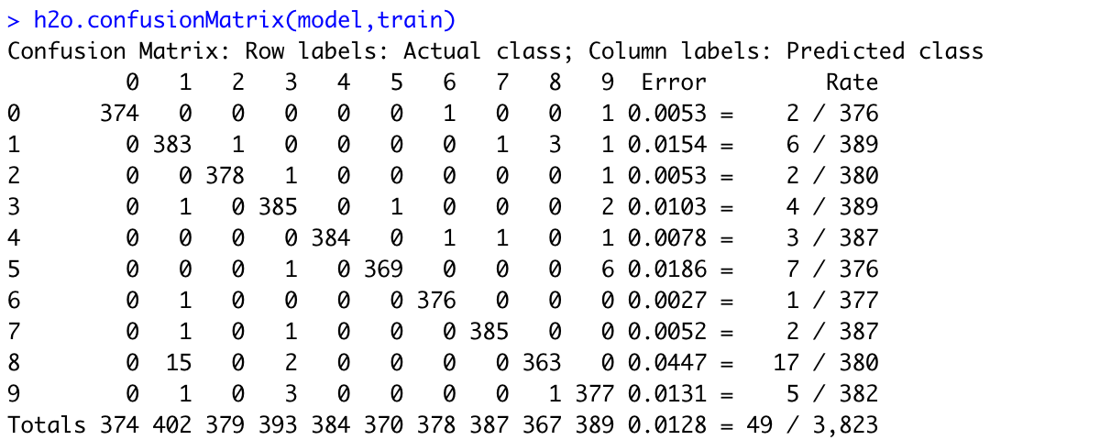

“Class Accuracy for Training data”

Test Data Confusion Matrix:

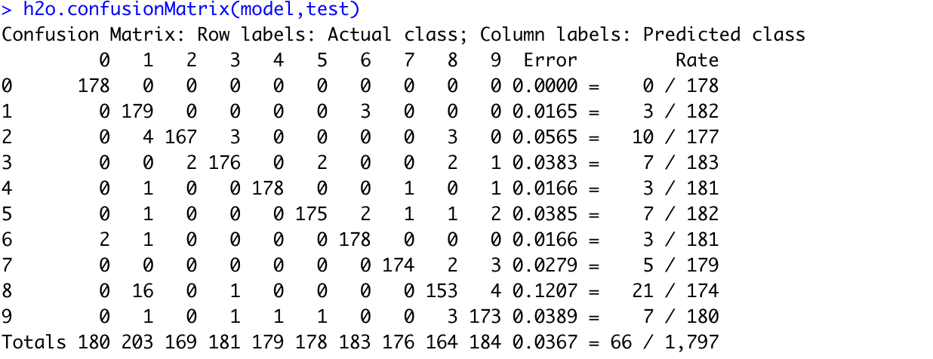

Class Accuracy for Test:

Now, In the Second Scenarios,

Cross Entropy Error Function (Tanh Activation Function vs ReLU Activation Function)

- Early Stopping Technique is used using validation set.
- Training datasets is divided into two parts into 80:20 ratios
- train (80%)
- Validation (20%)

Parameters:

loss = "CrossEntropy",
distribution = "multinomial",
activation = "Tanh",
hidden = c( 100,100,100),
adaptive_rate = FALSE,
rate = 0.01,
momentum_start = 0.2,
input_dropout_ratio = 0.2,
sparse = TRUE,
epochs = 100

Best Model | Tanh Activation
No of hidden layers | 3
No of hidden units in each layer | 100,100,100
learning rates | 0.01
momentum rate | 0.2
Overall Classification Accuracy | 0.9449082

ReLU Function Convergences faster than Tanh Function for the same value of parameters on the datasets.

Following points need to note:

For hidden layers - 2:
Increased Accuracy on increasing no of hidden units.

For hidden layers - 3:
Decreased Accuracy on increasing no of hidden units.

For Learning Rate:
Decreased Accuracy with increasing Learning Rate.

For Momentum Rate:
Decreased Accuracy firstly then increase with increasing Momentum Rate.

“Training data Confusion Matrix”

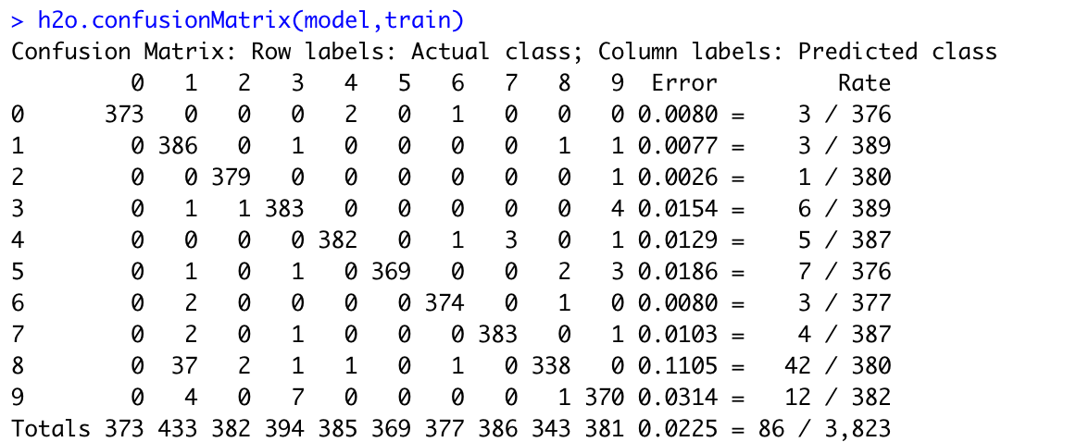

Class Accuracy for Train:

Test Data Confusion Matrix:

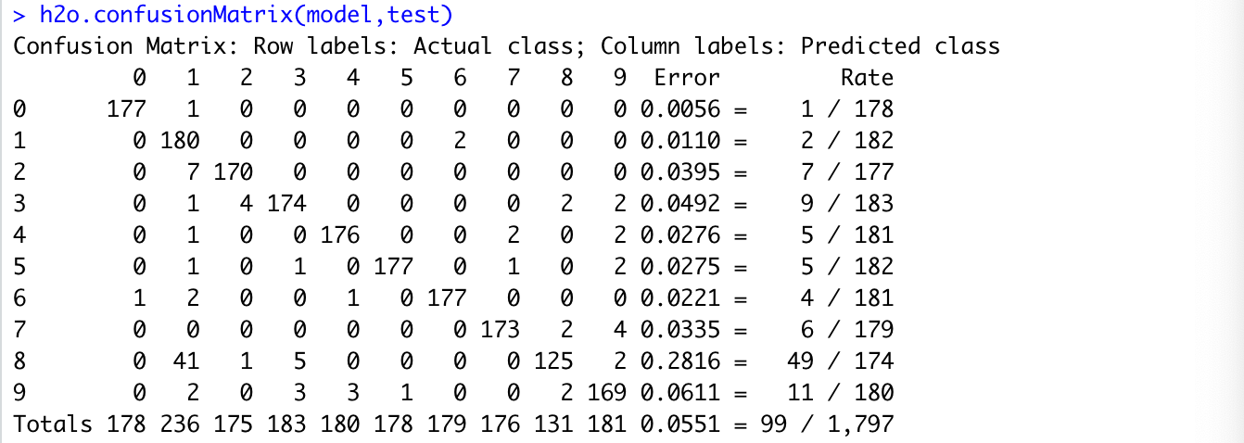

Class Accuracy for Test:

For Convolutional Neural Network:

Model Details:

layer_conv_2d(filters = 32,
kernel_size = c(3,3),
activation = 'relu',
input_shape = c(100, 100, 3)) %>%
layer_conv_2d(filters = 32,
kernel_size = c(3,3),
activation = 'relu') %>%

# Pooling layer
layer_max_pooling_2d(pool_size = c(2,2)) %>%

# Dropout layer
layer_dropout(rate = 0.25) %>%

# Adding one more layer
layer_conv_2d(filters = 64,
kernel_size = c(3,3),
activation = 'relu') %>%

layer_conv_2d(filters = 64,
kernel_size = c(3,3),
activation = 'relu') %>%

layer_max_pooling_2d(pool_size = c(2,2)) %>%
layer_dropout(rate = 0.25) %>%

layer_flatten() %>%

layer_dense(units = 256, activation = 'relu') %>%
layer_dropout(rate=0.25) %>%
layer_dense(units = 3, activation = 'softmax') %>%

Model Accuracy: 0.98

