**Translation**

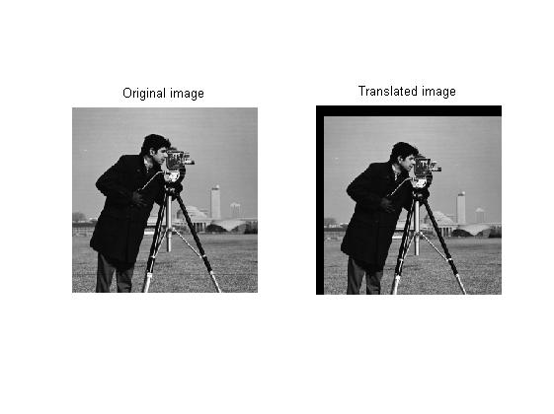

* Image is translate by 16 rows and 11 columns