**Thresholding**

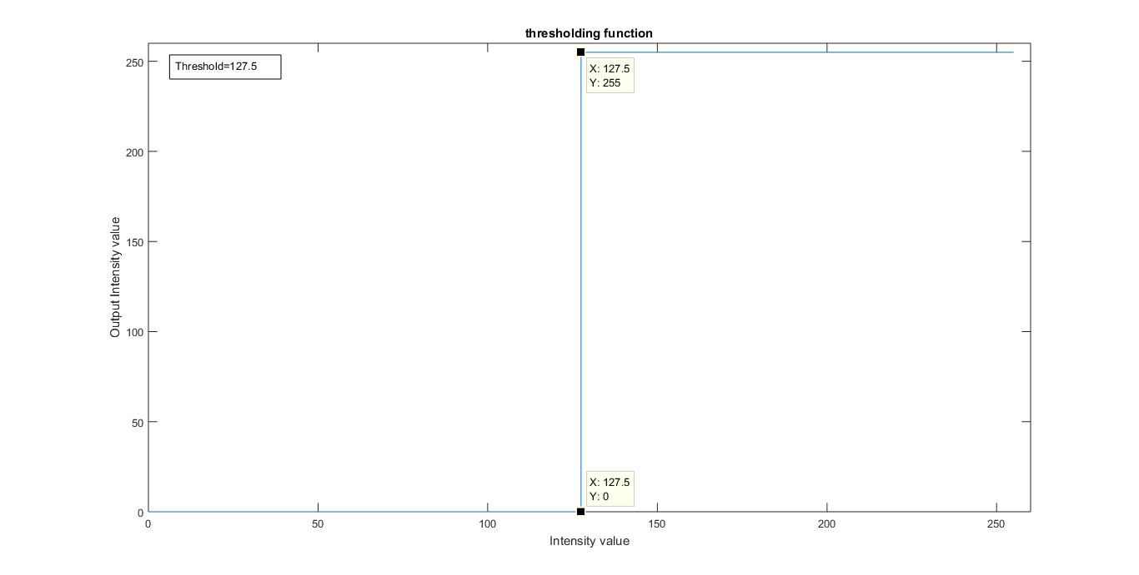

* Image is transformed by transformation function as shown in the graph above:

b=0 if a<127.5

b=127.5 if a>=127.5

where

a is every pixel of original image

b is pixel of output image

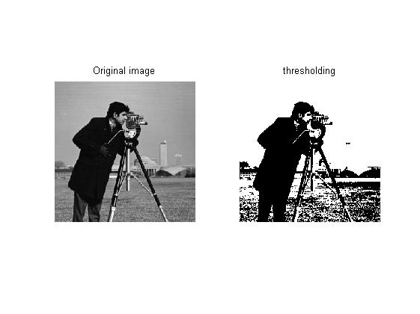

By using such a transformation, we get pixel values either black or white and no other shades of grey are found in transformed image.