<https://www.dotnetmastery.com/Home/Details?courseId=19>

<https://github.com/bhrugen/Mango/>

<https://github.com/bhrugen/Mango/commits/master>

add-migration AddProductModelToDb

update-database

Mango.Services.ProductAPI/Repository/IProductRepository.cs

Go to Azure Portal 🡪 create a storage account 🡪 Create a container 🡪 with public read access level.

Go to Storage Account🡪 Storage Browser -🡪 Upload all images.

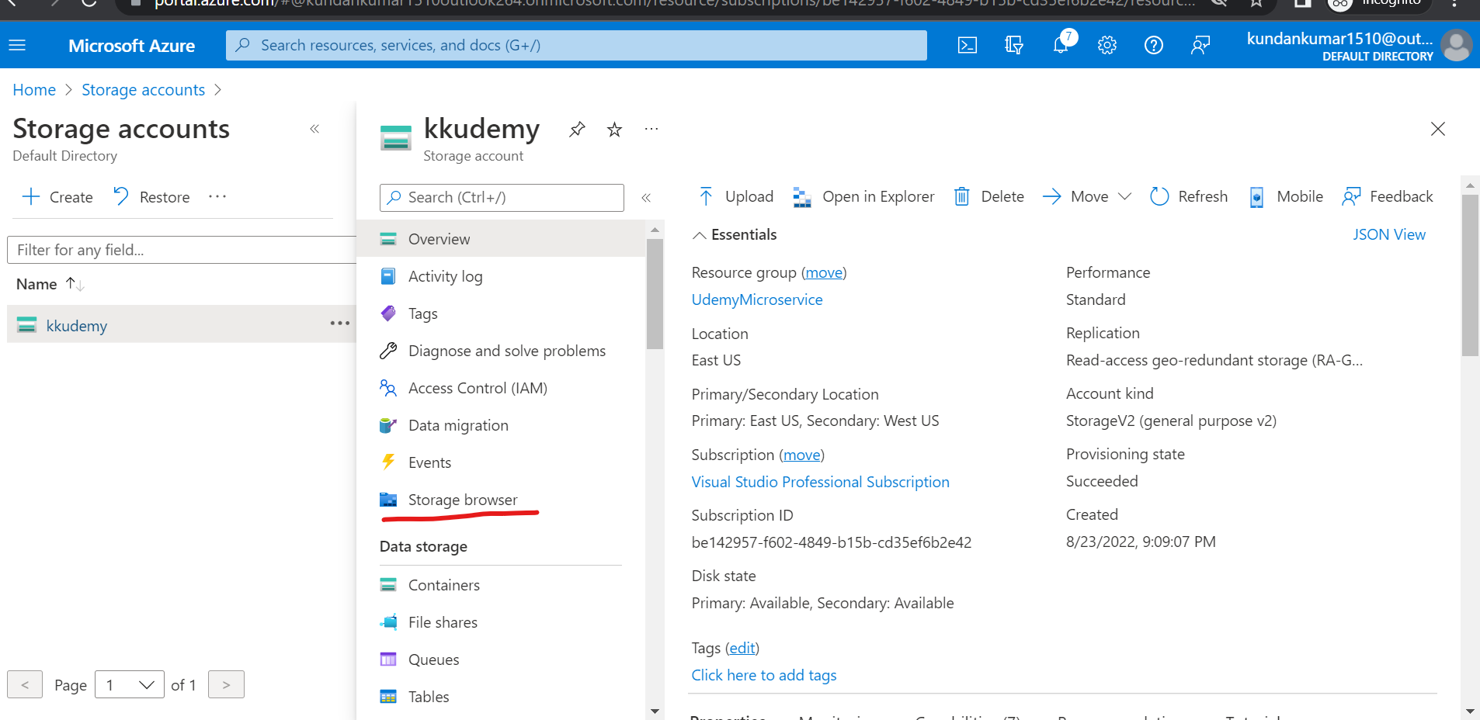

add-migration seedproduct

update-database

Make starup project to both project to test it.

Best place to debug is BaseService.cs.

add-migration ConfigureDefaultIdentityTables

update-database -context ApplicationDbContext

add-migration ConfigureDefaultIdentityTables -verbose -context ApplicationDbContext

add-migration FirstNameAndLastNameColumn -verbose -context ApplicationDbContext