**Question 1**

* Firstly, I have made a data struct called **Trip** which contains the different data types as mentioned below.

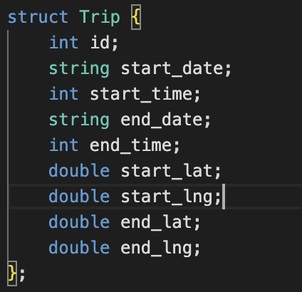

* Then I have created array of the above data structure type
* Then I stored the data in that array.
* Now according to question, I have created the below function to remove the data which have zero trip duration (here I am using array of name **deletedTripsZero** which store the details of the data which have zero trip duration).

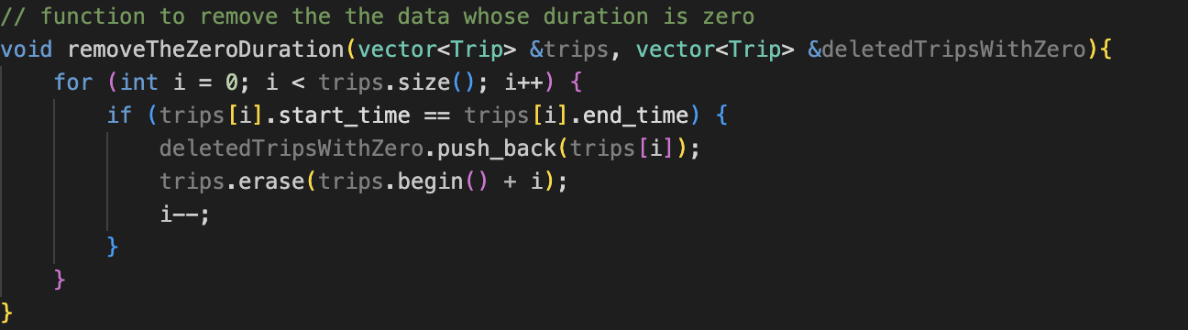

**Here are the report of the result for the 1st part of question 1.**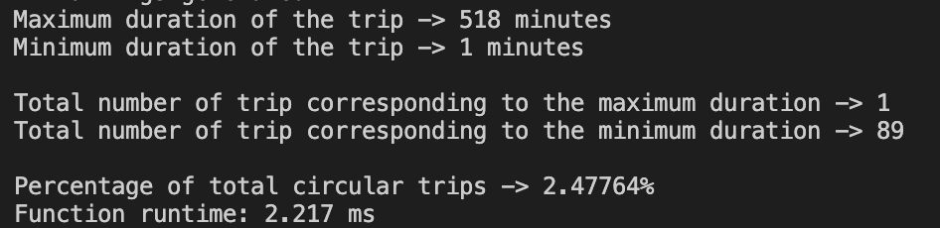

* After coming to the next part of the question, here I have created the function **FindingMaxMin** which finds the maximum and minimum of the trip duration.

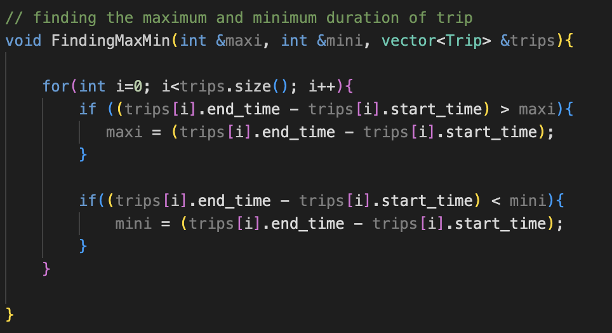

* For the next part of the question, I have created a function **FindingTheCount** which counts the number of maximum trip duration count and minimum trip duration count.

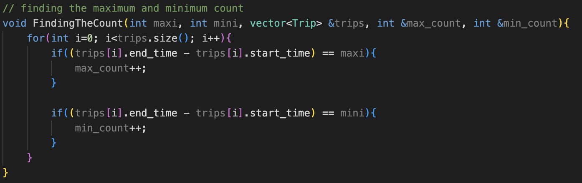

* For the next part of the question, I have created a function **FIndCircular** which finds the number of circular trips is there in the dataset.
* After that I found the percentage.

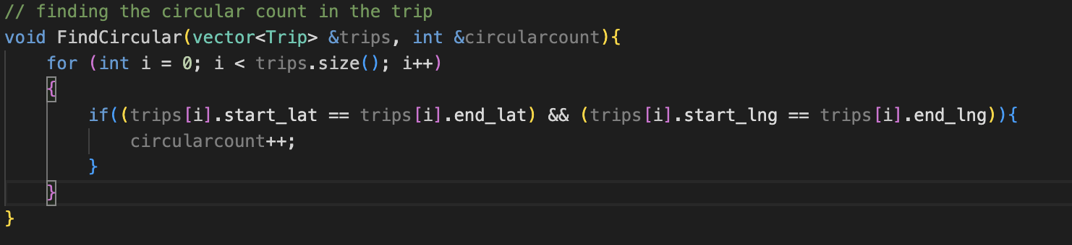

**Coming to the final part of the question 1 part 1**

* Here I have used **chrono library** to find the total runtime for the function.

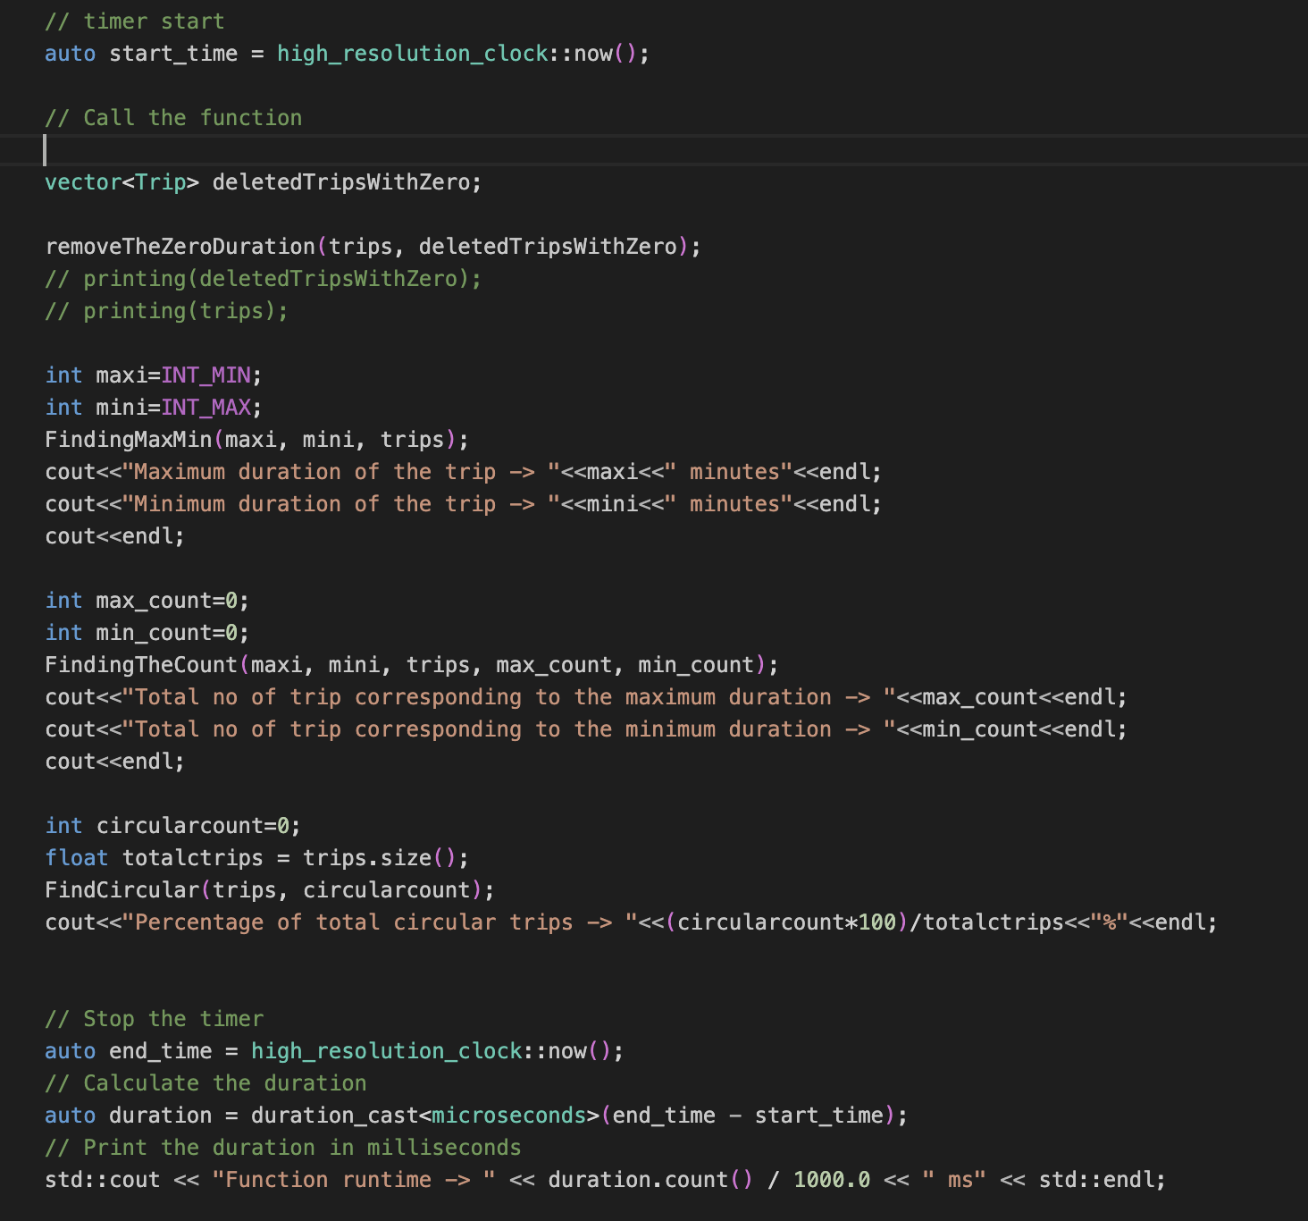

**Coming to the 2nd part of question 1.**

* For this part I have created the array of Trip type data structures of name **filterdata** which I used to store of the filter data according to the question.
* Then I created a function **filterningdata** which filters the data according to the question condition.

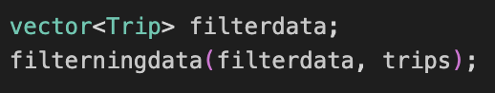

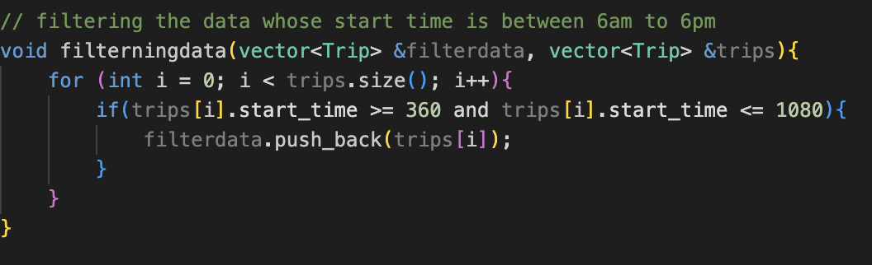

* Now going forward according to the question I have created the function name feasible which counts the number of feasible pair is formed.

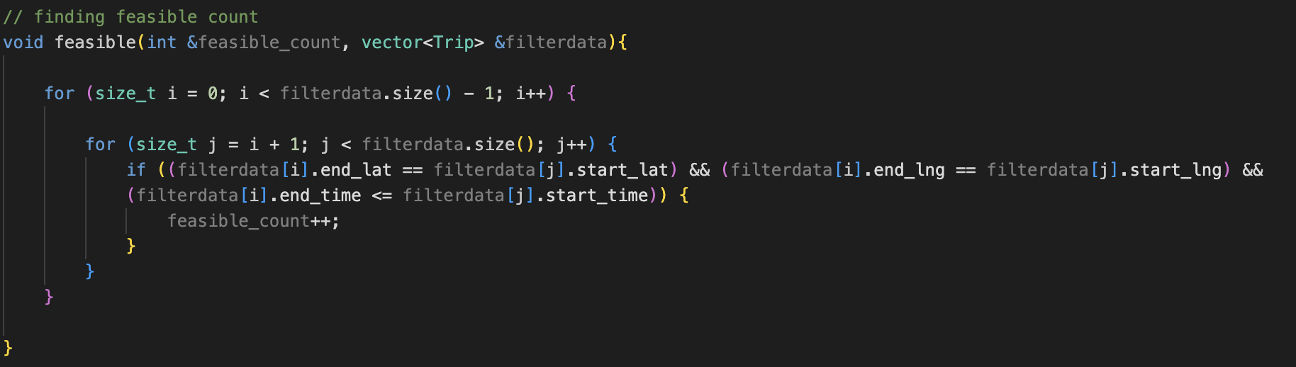

**Here are the report of the result for the 2nd part of question 1.Screenshot 2023-04-09 at 11.47.00 PM.png**

* But the above code has time complexity of **O(n2)** then I optimize the code which is the below one has time complexity of **O(n)**.

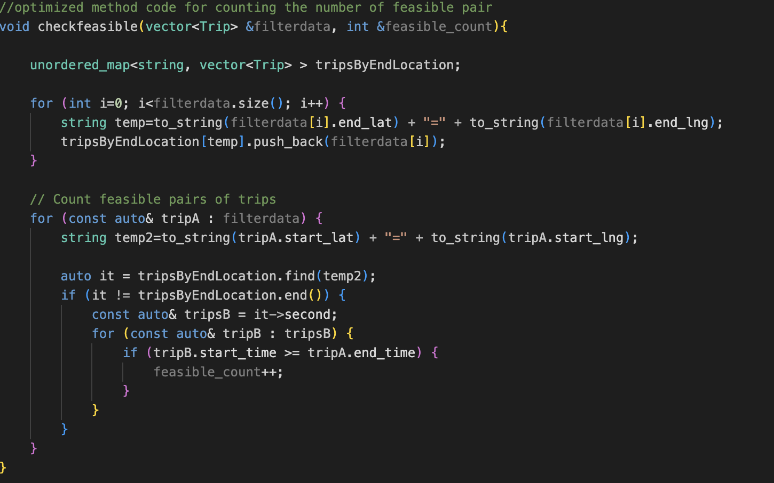

**Coming to last part of the question 1**

* Here question is asking to include only the first 100 trips so for that I have created the function name **lastpart** in which I am storing the first 100 data in **lastpartdata** array.

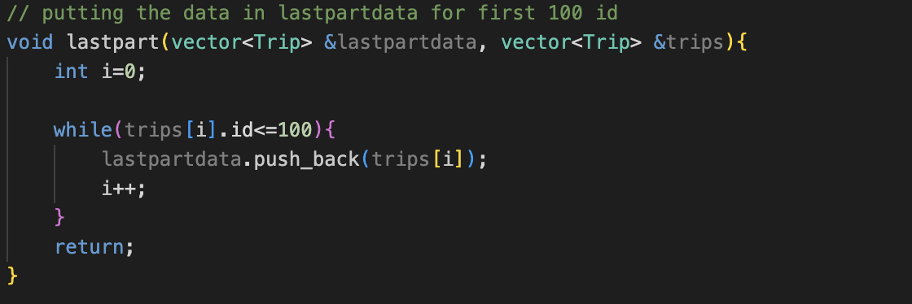

* Now for the next part I have created the function **countUniqueDepots** where I count the number of unique depots in the dataset for the first 100 trip data.

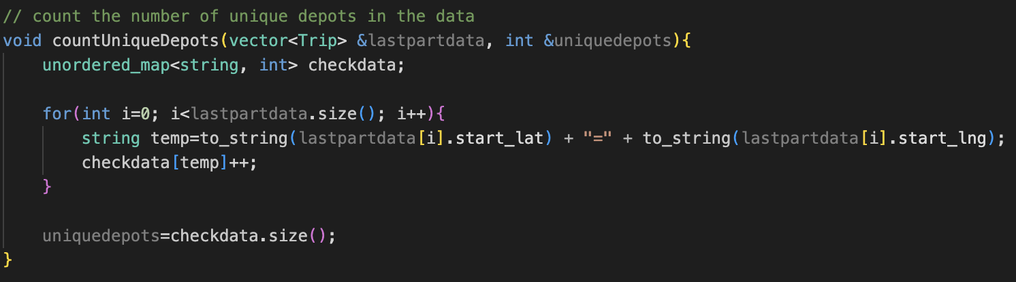

* Now coming to the next part, I have created new data structures of the name **Eucli** to store the distance, latitude, and longitude of the depots.

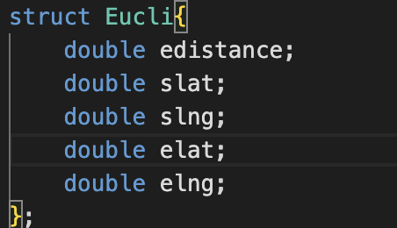

* Then I have created a function name **findingTheDistance** which find the distance between depots and then store it in the array name of **euclideandistance**.

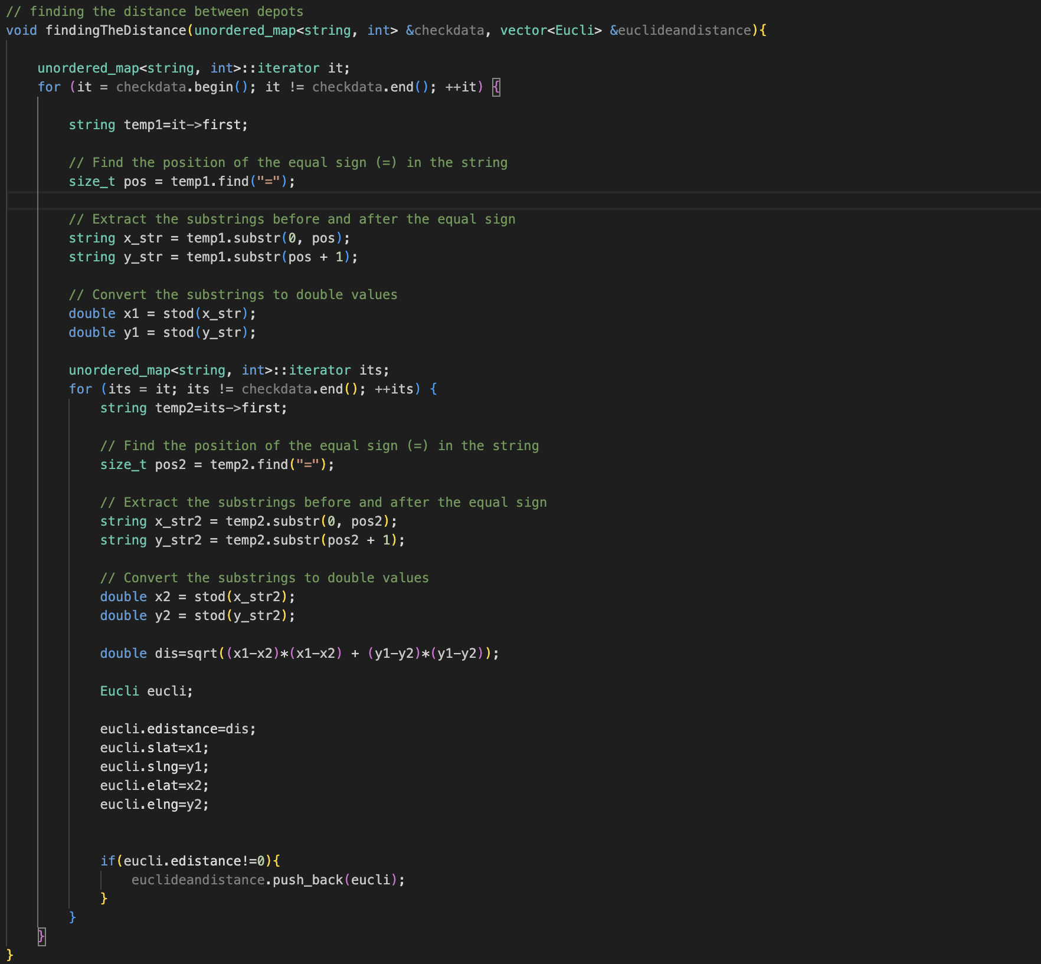

* After that I have created a function for printing the data of **euclideandistance** whose name is **printthevector.**

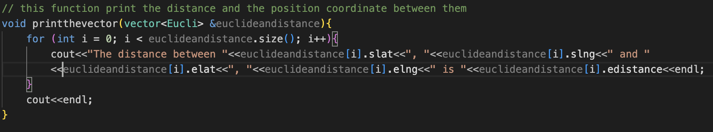

* After that I created a function named **findTheMaxMindistance** which finds the maximum and minimum distance between depots.

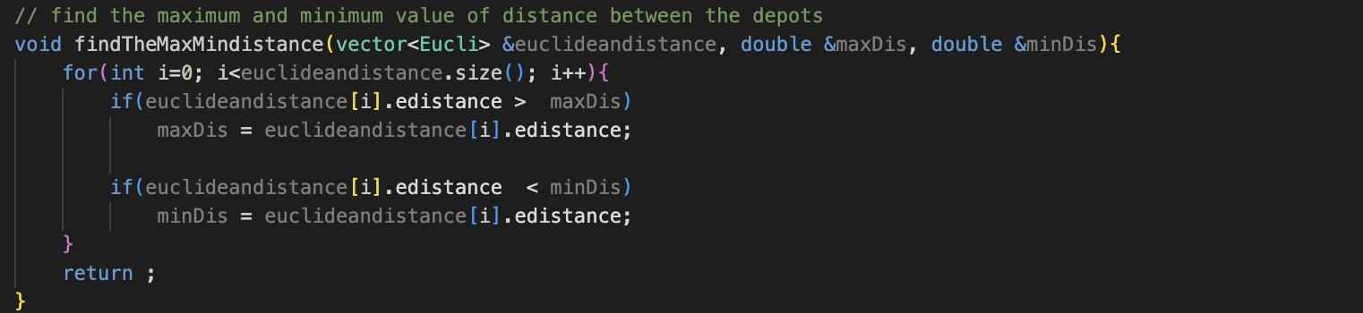

**Here are the report of the result for the 3rd part of question 1**