Q1>

**Creating git repository**

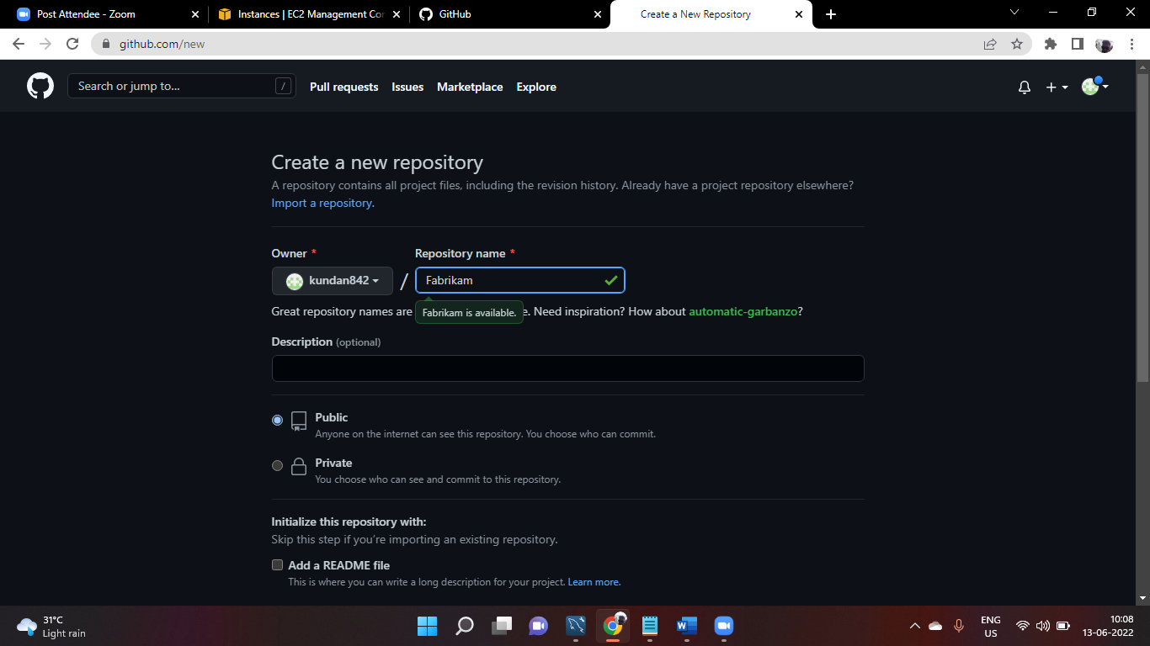

**Commnads to run docker container conataing dokcer images named fabrikam on aws amzon linux command line interface**

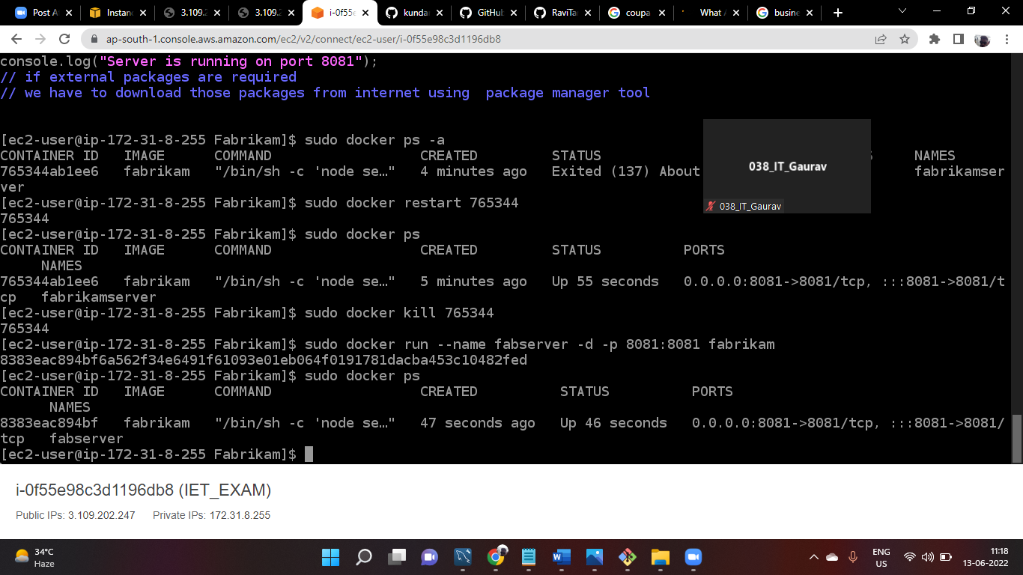

**Setting firewall**

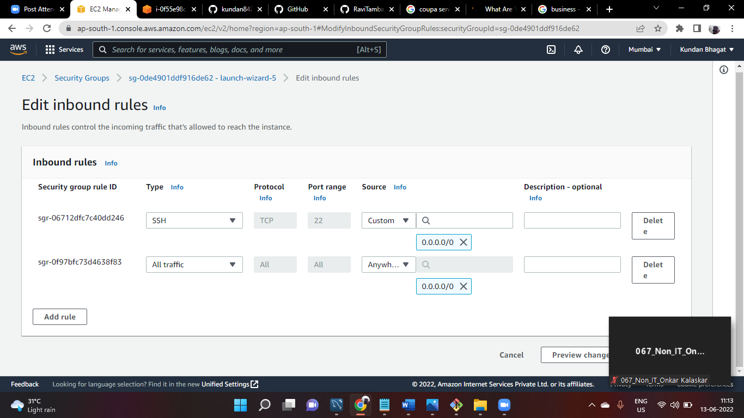

**Public hosted webite**

