FULL STACK DEVELOPMENT WITH MERN
Project Documentation
StockTrade
A Full-Stack MERN Stock Trading Simulation Platform
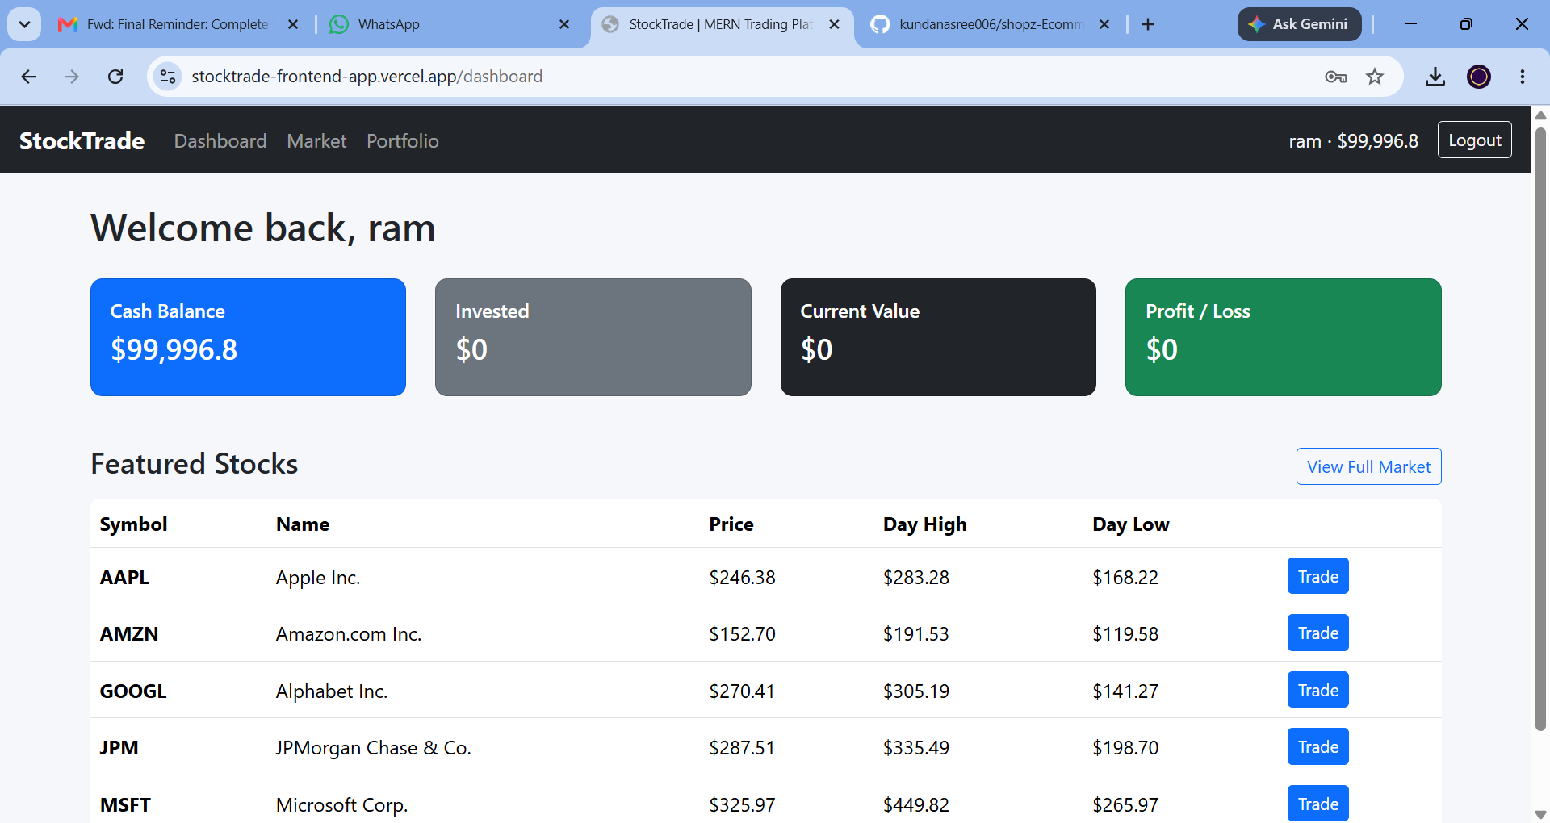
GitHub Repository | github.com/kundanasree006/shopz-Ecommerce
Live Demo | stocktrade-frontend-app.vercel.app

Team
Kammannagari Kundanasree — Team Lead
Chiranjeevi Chiru
Roshinipriya Elecombadu
Kamakshi Gangarapu
Kavitha Paligala

1. Introduction

Project Title
StockTrade — Full-Stack MERN Stock Trading Platform

Team Members
Name | Role
Kammannagari Kundanasree | Team Lead / Full-Stack Developer
Chiranjeevi Chiru | Full-Stack Developer
Roshinipriya Elecombadu | Full-Stack Developer
Kamakshi Gangarapu | Full-Stack Developer
Kavitha Paligala | Full-Stack Developer

2. Project Overview

Purpose
StockTrade is a complete MERN (MongoDB, Express.js, React.js, Node.js) web application that lets users explore listed stocks, follow a live-updating market dashboard, simulate buy/sell trades using a virtual cash balance, and track their portfolio's profit and loss in real time. It also gives administrators a dedicated panel to manage stock listings, moderate users, and monitor all trading activity across the platform.

Features
- JWT-based authentication — registration and login with passwords hashed using bcrypt.js
- Role-based access control — separate USER and ADMIN roles with route-level protection on both the frontend and backend
- Live market dashboard — a backend interval simulates real-time price ticks every 5 seconds (±1% moves); the frontend polls every 5 seconds so prices feel live
- Buy / Sell trade simulation — trades atomically update a user's virtual cash balance and portfolio holdings
- Portfolio tracking — current holdings, average buy price, current value, and profit/loss shown in both absolute and percentage terms
- Admin panel — add or deactivate stock listings, enable/disable user accounts, and view all transactions with live volume statistics
- Stock detail page — a live price chart (Chart.js / react-chartjs-2) alongside a buy/sell form
- Responsive UI — built with React and Bootstrap 5

3. Architecture

Frontend — React
The client is a single-page application built with Create React App and React Router (v6). Routing is centralized in App.js, which wraps the app in an AuthProvider (React Context) for global authentication state and gates protected routes with a PrivateRoute component that checks for a valid session and, where required, an ADMIN role.
- Pages: Login, Register, Dashboard, Market, StockDetail, Portfolio, AdminDashboard
- Shared components: Navbar (top navigation with live balance display) and PrivateRoute (route guard)
- context/AuthContext.js: stores the logged-in user and JWT, exposes login/logout helpers
- api/axios.js: a pre-configured Axios instance that automatically attaches the JWT to the Authorization header of every request
- Charts rendered with Chart.js via react-chartjs-2 on the Stock Detail page
- Styling with Bootstrap 5 for a responsive, mobile-friendly layout

Backend — Node.js & Express.js
The server is an Express.js REST API. server.js wires up middleware (CORS, JSON body parsing), mounts the route modules, and starts a setInterval-based price simulation engine that nudges every active stock's price by up to ±1% every 5 seconds, updates its day-high/day-low/volume, and appends the new value to its price history — this is what powers the platform's "live" market data without requiring a paid market-data API key.
- routes/auth.js — registration, login, current-user profile
- routes/stocks.js — public stock listing/search and admin stock management (create, update, deactivate)
- routes/trade.js — buy/sell execution and trade history
- routes/portfolio.js — computes live holdings, invested amount, current value, and profit/loss
- routes/admin.js — user management, platform-wide transactions, and dashboard summary stats
- middleware/auth.js — protect (JWT verification) and requireRole (role-based route guard)
- utils/seed.js — seeds an admin account, a demo account, and sample stocks

Database — MongoDB (Mongoose)
Data is modeled with four Mongoose schemas:
Model | Purpose | Key Fields
User | Registered accounts and virtual balance | name, email, password (hashed), role (USER/ADMIN), balance, isActive
Stock | Tradable securities and live price history | symbol, name, price, previousClose, dayHigh, dayLow, volume, sector, isActive, history[]
Portfolio | A user's current holdings | user (ref), holdings[{ stock, symbol, quantity, avgBuyPrice }]
Transaction | Immutable record of every trade | user (ref), stock (ref), symbol, type (BUY/SELL), quantity, price, total, status

Each user has exactly one Portfolio document; each trade creates one Transaction document, and Stock documents keep a bounded price history array (capped at 100 points) used to drive the live chart.

4. Setup Instructions

Prerequisites
- Node.js v18 or later, and npm v8 or later
- MongoDB — a local instance, or a MongoDB Atlas connection string
- Git (to clone the repository)

Installation

1. Clone the repository
git clone https://github.com/kundanasree006/shopz-Ecommerce.git
cd shopz-Ecommerce/stock-trading-app

2. Backend setup
cd backend
npm install
cp .env.example .env
# edit .env — set MONGO_URI and a long random JWT_SECRET
npm run seed # creates admin + demo user + sample stocks
npm run dev # starts the API on http://localhost:5000 (nodemon)

3. Frontend setup
cd ../frontend
npm install
cp .env.example .env
# edit .env if the backend runs somewhere other than localhost:5000
npm start # starts the React dev server on http://localhost:3000
Once both servers are running, open http://localhost:3000 and log in with a seeded or newly registered account.

Seeded demo accounts
Role | Email | Password
Admin | admin@stocktrade.com | Admin@123
Demo user | demo@stocktrade.com | Demo@123

5. Folder Structure

Client (frontend/)
frontend/
├── public/index.html
└── src/
├── api/axios.js # Axios instance with JWT interceptor
├── context/AuthContext.js # global auth state (Context API)
├── components/
│ ├── Navbar.js
│ └── PrivateRoute.js
├── pages/
│ ├── Login.js
│ ├── Register.js
│ ├── Dashboard.js
│ ├── Market.js
│ ├── StockDetail.js
│ ├── Portfolio.js
│ └── AdminDashboard.js
├── App.js # route definitions
└── index.js

Server (backend/)
backend/
├── config/db.js # MongoDB connection
├── models/
│ ├── User.js
│ ├── Stock.js
│ ├── Portfolio.js
│ └── Transaction.js
├── middleware/auth.js # JWT verification + role guard
├── routes/
│ ├── auth.js
│ ├── stocks.js
│ ├── trade.js
│ ├── portfolio.js
│ └── admin.js
├── utils/seed.js # seeds admin/demo users + sample stocks
├── server.js # app entry point + simulated price engine
├── package.json
└── .env.example

6. Running the Application
With MongoDB running and both .env files configured, start each service in its own terminal:

Backend
cd backend
npm start # or: npm run dev for auto-restart via nodemon
# API available at http://localhost:5000

Frontend
cd frontend
npm start
# App available at http://localhost:3000
A hosted build is also available for reference — see Section 11 (Screenshots / Demo) for the live deployment link.

7. API Documentation
All endpoints are prefixed with /api. Authenticated routes expect a Bearer JWT in the Authorization header (Authorization: Bearer <token>).

Auth — /api/auth
Method | Endpoint | Access | Description
POST | /auth/register | Public | Create an account (name, email, password); returns a JWT + user profile
POST | /auth/login | Public | Log in with email + password; returns a JWT + user profile
GET | /auth/me | Authenticated | Return the current user's profile

Stocks — /api/stocks
Method | Endpoint | Access | Description
GET | /stocks | Public | List / search stocks (query params: search, sector)
GET | /stocks/:symbol | Public | Stock detail, including recent price history for the chart
POST | /stocks | Admin | Create a new stock listing
PUT | /stocks/:id | Admin | Update a stock's fields
DELETE | /stocks/:id | Admin | Soft-delete (deactivate) a stock

Trade — /api/trade
Method | Endpoint | Access | Description
POST | /trade/buy | Authenticated | Buy shares — body: { symbol, quantity }; deducts balance, updates holdings
POST | /trade/sell | Authenticated | Sell shares — body: { symbol, quantity }; credits balance, updates holdings
GET | /trade/history | Authenticated | The current user's full trade history, newest first

Portfolio — /api/portfolio
Method | Endpoint | Access | Description
GET | /portfolio | Authenticated | Current holdings enriched with live price, invested amount, current value, and P/L

Admin — /api/admin
Method | Endpoint | Access | Description
GET | /admin/users | Admin | List all registered users
PUT | /admin/users/:id/status | Admin | Enable or disable a user account
GET | /admin/transactions | Admin | All trades across the platform (most recent 200)
GET | /admin/stats | Admin | Summary counts: users, active stocks, transactions, total traded volume

Example — Buy order
POST /api/trade/buy
Authorization: Bearer <token>
Body: { "symbol": "AMZN", "quantity": 4 }
Response 201:
{
"message": "Buy order executed",
"transaction": { "symbol": "AMZN", "type": "BUY", "quantity": 4, "price": 150.86, "total": 603.44, ... },
"balance": 99393.36
}

8. Authentication
StockTrade uses stateless JSON Web Tokens (JWT) rather than server-side sessions. On registration or login, the backend signs a token containing the user's id, role, name, and email, and returns it to the client alongside the user profile. The frontend stores this token (via AuthContext) and the api/axios.js instance automatically attaches it to every outgoing request as an Authorization: Bearer <token> header.
- Password security: passwords are hashed with bcrypt.js (salted, 10 rounds) before being stored — plaintext passwords are never persisted.
- Token verification: the protect middleware (middleware/auth.js) validates the JWT signature and expiry on every protected request and attaches the decoded payload to req.user.
- Authorization: the requireRole(...roles) middleware restricts specific routes (e.g. all /api/admin/* routes, and stock create/update/delete) to users whose role is ADMIN, returning 403 Forbidden otherwise.
- Session expiry: tokens are issued with a 7-day expiration (expiresIn: "7d"); an expired or invalid token results in a 401 Unauthorized response and the frontend redirects the user back to the Login page via PrivateRoute.
- Account status: inactive accounts (isActive: false) cannot log in, and an admin can toggle this via the Admin Panel.

9. User Interface
A brief tour of the main screens, in the order a user would typically encounter them.

Login
Existing users sign in with their email and password. Demo and admin credentials are shown on-screen for convenience, and a link is provided to the registration page.
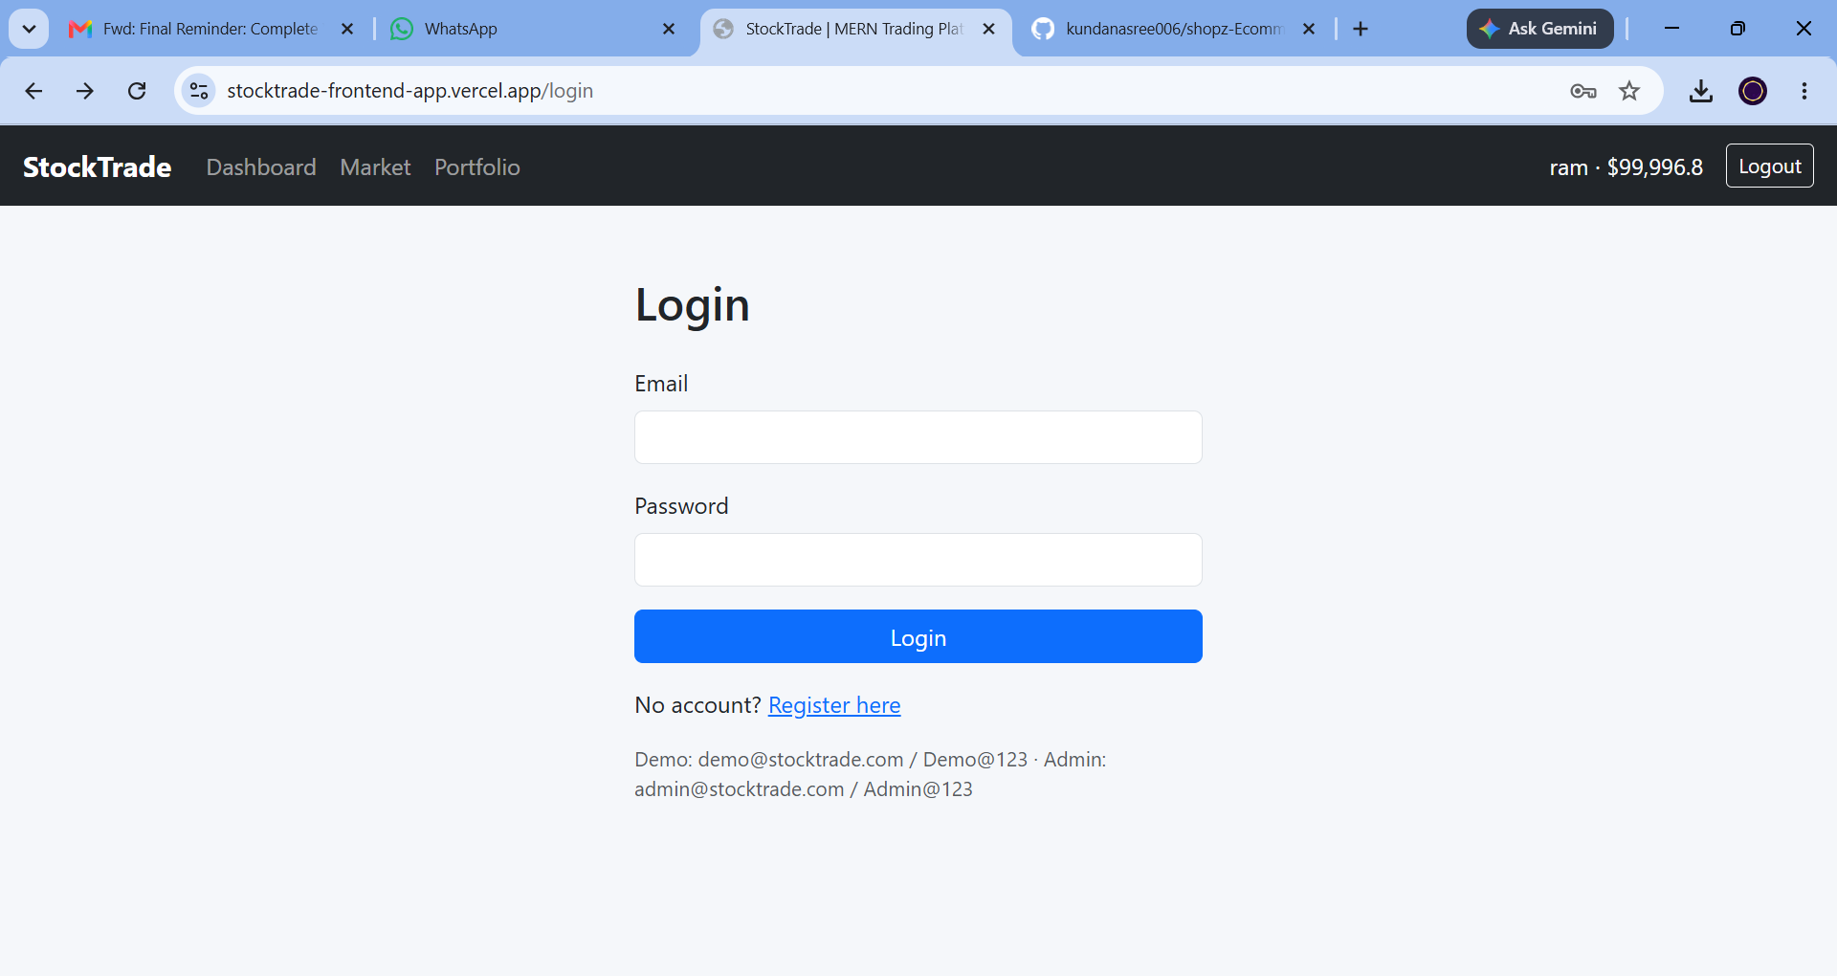
Figure 1 — Login screen

Register
New users create an account with their name, email, and password. Every new account starts with a virtual cash balance for trading.
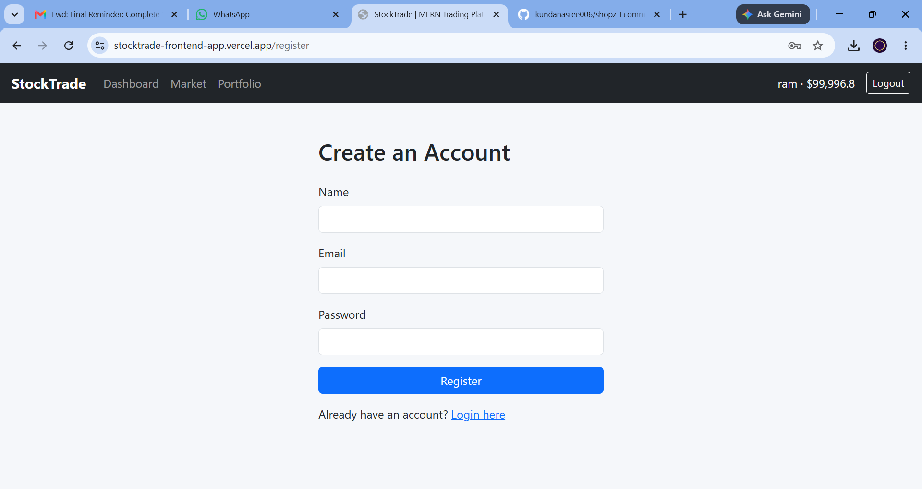
Figure 2 — Registration screen

Dashboard
After logging in, users land on a summary dashboard showing their cash balance, invested amount, current portfolio value, and overall profit/loss, along with a table of featured stocks with a quick Trade action.

Figure 3 — Dashboard

Market
The Market page lists every active stock with its sector, live price, day high/low, and volume, and supports searching by symbol or company name. Prices refresh automatically as the backend's simulated price feed ticks.
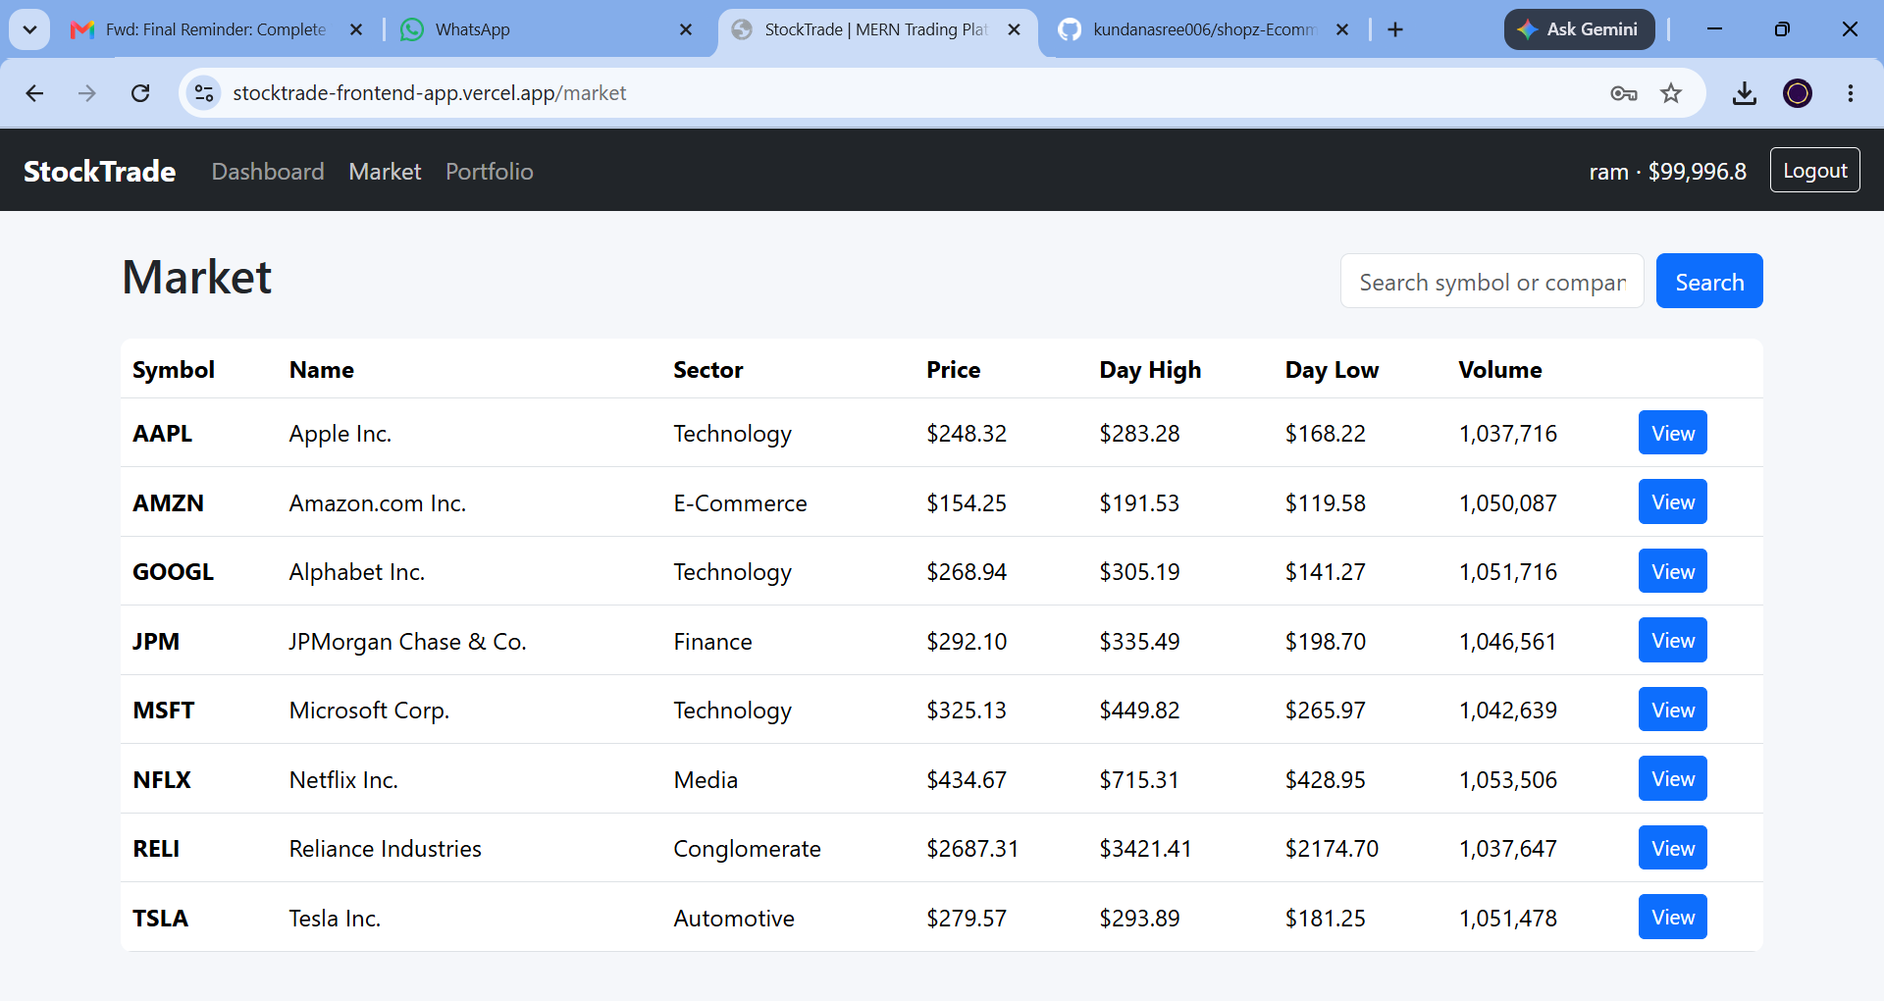
Figure 4 — Market listing

Portfolio
The Portfolio page shows a user's live holdings with quantity, average buy price, current price, invested amount, current value, and profit/loss in both dollars and percent. Before any trade, it prompts the user to visit the Market to get started.
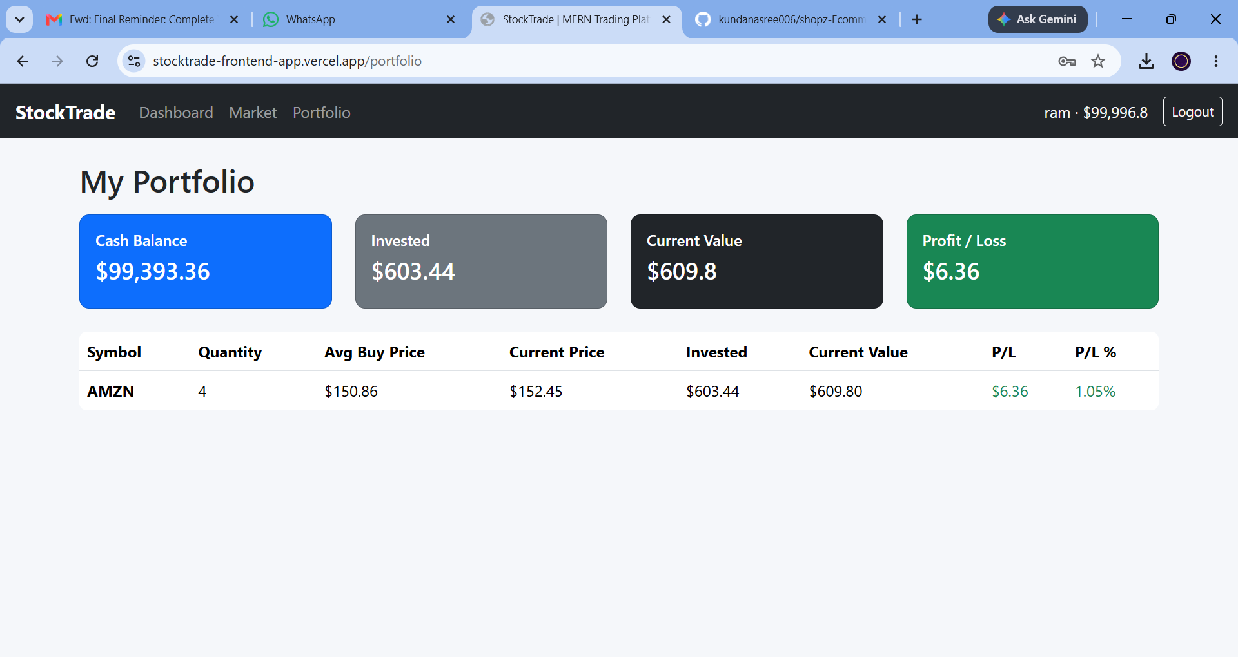
Figure 5 — Portfolio after a trade (holding AMZN)

10. Testing
Testing was carried out primarily through structured manual verification of each user flow and API endpoint, supported by the project's built-in validation checklist. React's testing utilities (via react-scripts test / Jest) are available in the frontend scaffold for future automated unit and component tests.

Manual Testing Checklist
- CRUD operations verified on all entities — users, stocks, transactions, and portfolio holdings
- Form validation exercised on registration, login, and the buy/sell trade forms (required fields, positive quantities, duplicate email/symbol checks)
- Balance updates and transaction history confirmed accurate after repeated buy/sell cycles
- Admin moderation workflows tested — enabling/disabling users, adding/deactivating stocks, and access-control checks (non-admins receive 403 on admin routes)
- Responsive layout checked across common breakpoints (desktop, tablet, mobile) using the Bootstrap 5 grid

Tools
- Postman / browser fetch for manual API endpoint verification
- Browser DevTools for responsive layout and network inspection
- MongoDB Compass for verifying database state after trades

11. Screenshots / Demo
A live, hosted build of the frontend is available at:
https://stocktrade-frontend-app.vercel.app
Source code repository:
https://github.com/kundanasree006/shopz-Ecommerce.git

Additional Screens
Market listing showing live-ticking prices on a subsequent refresh, and the Portfolio page prior to any trade being placed.
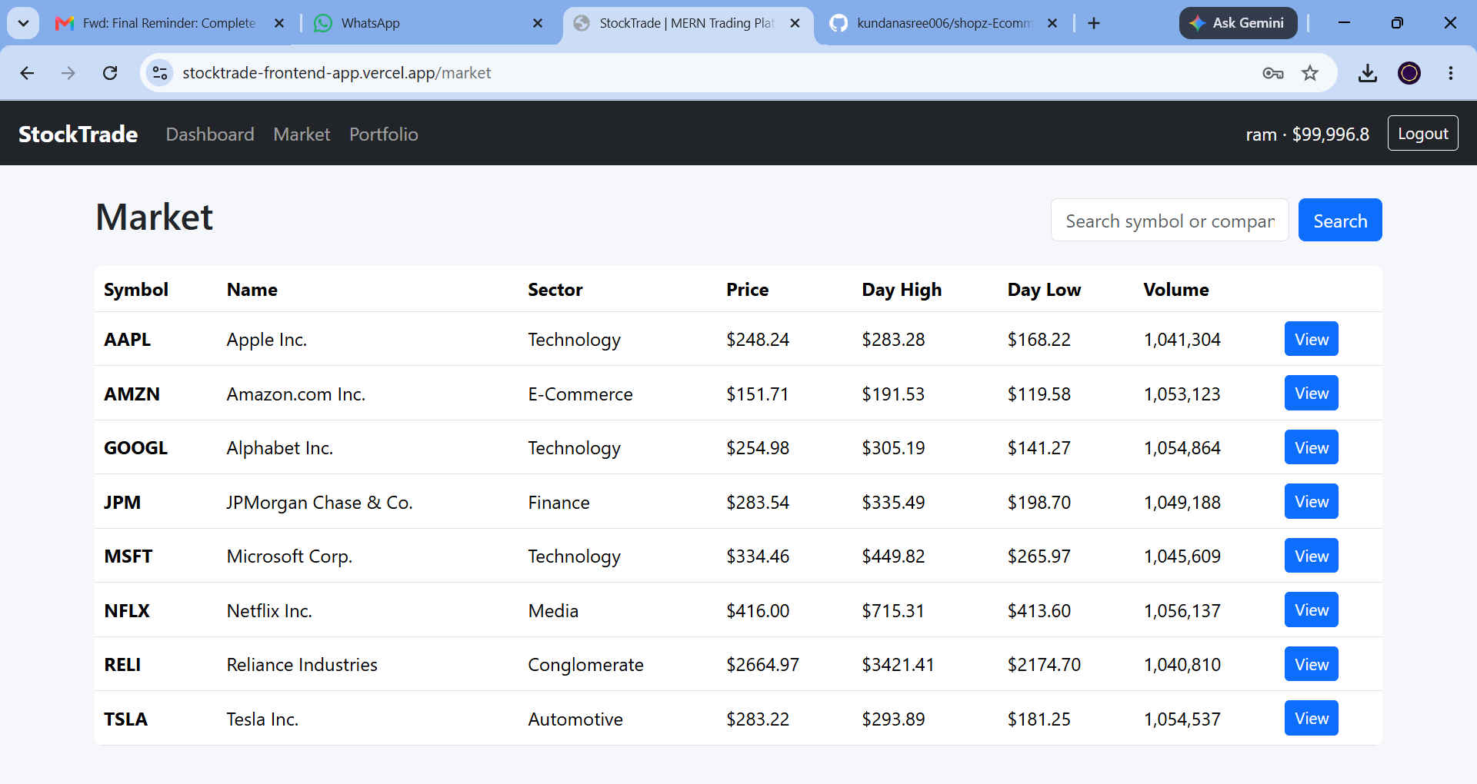
Figure 6 — Market listing (a later live price tick)
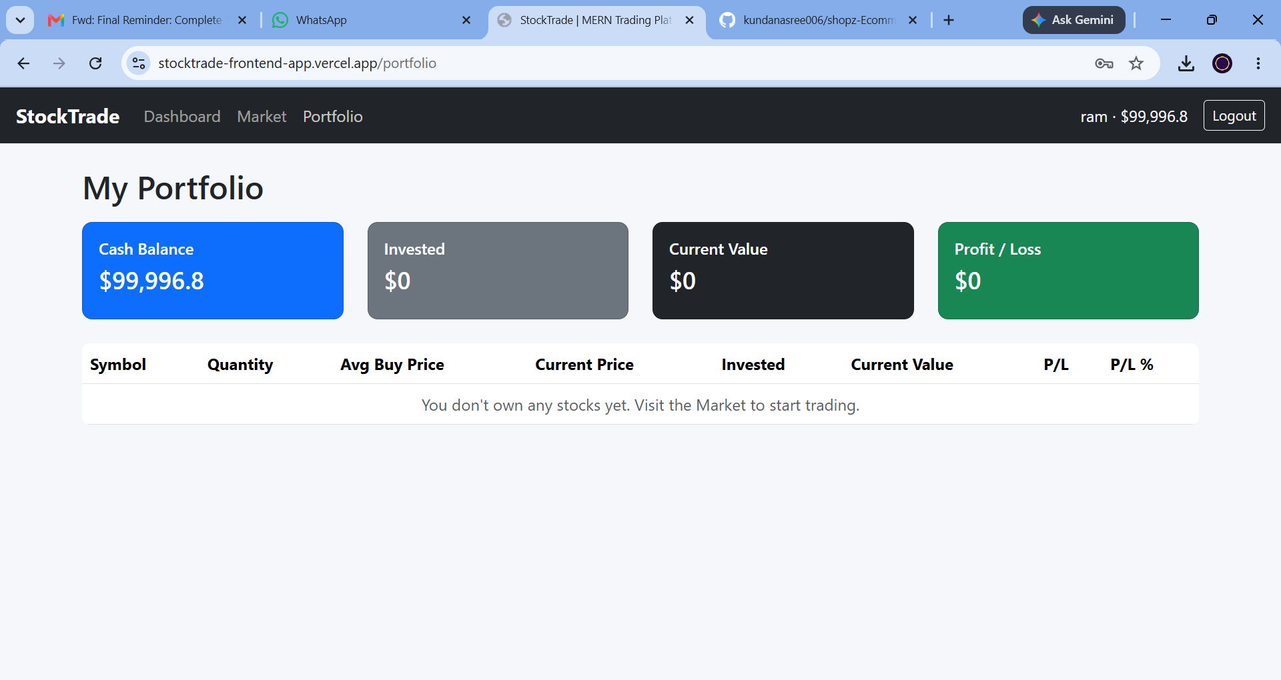
Figure 7 — Portfolio before any trades have been placed

12. Known Issues
- Simulated market data: prices are generated by a random ±1% walk on the server rather than sourced from a real market-data provider, so movements are not reflective of actual markets.
- No password reset flow: there is currently no "forgot password" / email-based reset mechanism.
- No pagination: the Market and Admin transaction lists are not paginated, which may affect performance as data grows (admin transactions are currently capped at the most recent 200).
- No automated test suite: the current test coverage relies on manual verification rather than a CI-integrated unit/integration test suite.
- Single currency / no fees: trades do not account for brokerage fees, taxes, or multi-currency support.

13. Future Enhancements
- Integrate a real market-data API (e.g. Alpha Vantage, Finnhub, or Polygon.io) in place of the simulated price engine in server.js.
- Add automated testing (Jest/React Testing Library on the frontend, Supertest on the backend) and wire it into a CI pipeline.
- Add password reset and email verification flows.
- Introduce watchlists, price alerts, and order types beyond immediate market buy/sell (e.g. limit orders).
- Add pagination and server-side filtering for large stock and transaction lists.
- Support multiple currencies and configurable brokerage fees for a more realistic simulation.
- Add dark mode and richer data visualizations (e.g. portfolio allocation pie chart, historical performance graph).

