Text Analysis of GRI Sustainability Reports:
Dominant Themes and Temporal Trends

Abstract
Sustainability reporting has become a critical element of modern corporate communication. This shift in corporate behaviour is primarily driven by growing stakeholder expectations, as investors, regulators, and the public increasingly demand transparency beyond traditional financial metrics. Thus, companies spend considerable resources to communicate their environmental, social, and governance (ESG) performance through structured frameworks such as the Global Reporting Initiative (GRI). This paper attempts to identify the dominant sustainability themes in GRI reports and examine how these themes have evolved over time through computational text analysis of 972 English-language corporate reports spanning 2002 to 2018.

Keywords: Corporate Social Responsibility, GRI, Sustainability, Environment, Governance, Text Analysis, Temporal Trends.
I. INTRODUCTION
Corporate sustainability reporting has grown significantly over the past two decades. The Global Reporting Initiative (GRI), established in 1997, is the most widely adopted standard for corporate sustainability disclosure, enabling companies to communicate environmental, social, and governance (ESG) performance to stakeholders (GRI, 2022). The large volume of GRI reports provides a valuable text corpus for computational analysis of sustainability themes. This report analyses 972 English-language GRI reports to identify dominant themes and their temporal evolution.

II. LITERATURE REVIEW
Luhmann and Theuvsen (2017) argue that CSR reporting must address social, environmental, and economic dimensions simultaneously. Moravcikova et al. (2015) found that environmental disclosure dominates corporate sustainability communication. Governance and supply chain transparency have grown following the EU CSR Directive (2014/95/EU), which mandated nonfinancial reporting for large listed companies from 2017 (Firtcher et al., 2022). Pomering and Dolnicar (2009) note that companies have responded to stakeholder awareness by increasing the depth of sustainability disclosures, while Berad (2011) highlights that human rights and labour practices have gained increasing attention from the mid-2000s onwards.

III. RESEARCH QUESTION
This study addresses two research questions:
RQ1: What are the dominant sustainability themes in GRI reports?
RQ2: How have these themes changed over time (2002–2018)?

IV. METHODOLOGY

- Data Collection
The dataset consists of 5,898 GRI report text files (2000–2018) with metadata including company name, year, sector, country, region, and size. From 1,653 matched English files, a random sample of 1,000 reports (seed = 42) was drawn. After quality filtering - removing documents with fewer than 50 cleaned words and duplicates - the final corpus comprised 972 reports across 60 countries and 37 sectors.
- Text Processing
Reports were preprocessed using a Python pipeline: (1) text and metadata files were loaded and merged on filename keys; (2) text was lowercased and cleaned by removing newlines, URLs, numbers, and punctuation; (3) NLTK tokenisation was applied followed by stopword removal using a standard English list supplemented by 16 domain-specific terms (e.g., "gri", "sustainability", "reporting"); and (4) WordNet lemmatisation was applied. Mean word count reduced from 26,703 to 14,188 words per document (46.9% reduction).
- Theme Detection
Eight sustainability themes were defined using domain-specific keyword dictionaries: Environment, Governance, Supply Chain, Labour & Workers, Community, Economic, Human Rights, and Innovation. A report was classified as containing a theme if at least two theme-specific keywords appeared in its cleaned text. Theme prevalence was calculated as the percentage of reports containing each theme, both overall and by year.
- Visualisation
Visualisations were designed following Tufte's (2001) principles: maximising the data-ink ratio, removing chartjunk, using direct labelling, and applying a greyscale palette. Three figures are presented in the findings: a horizontal bar chart of theme prevalence (Figure 1), a line chart of temporal trend (Figure 2), and a greyscale heatmap summarising all themes across all years (Figure 3).
V. FINDINGS
Figure 1 presents theme prevalence across all 972 reports. Environment is the most dominant theme (94.8%), followed by Governance (90.7%), Supply Chain (86.0%), and Labour & Workers (81.3%). Innovation is the least prevalent at 43.4%, appearing in fewer than half of all reports. The 51-percentage-point gap between Environment and Innovation indicates a clear hierarchy in corporate sustainability disclosure, with environmental and governance concerns firmly dominating.

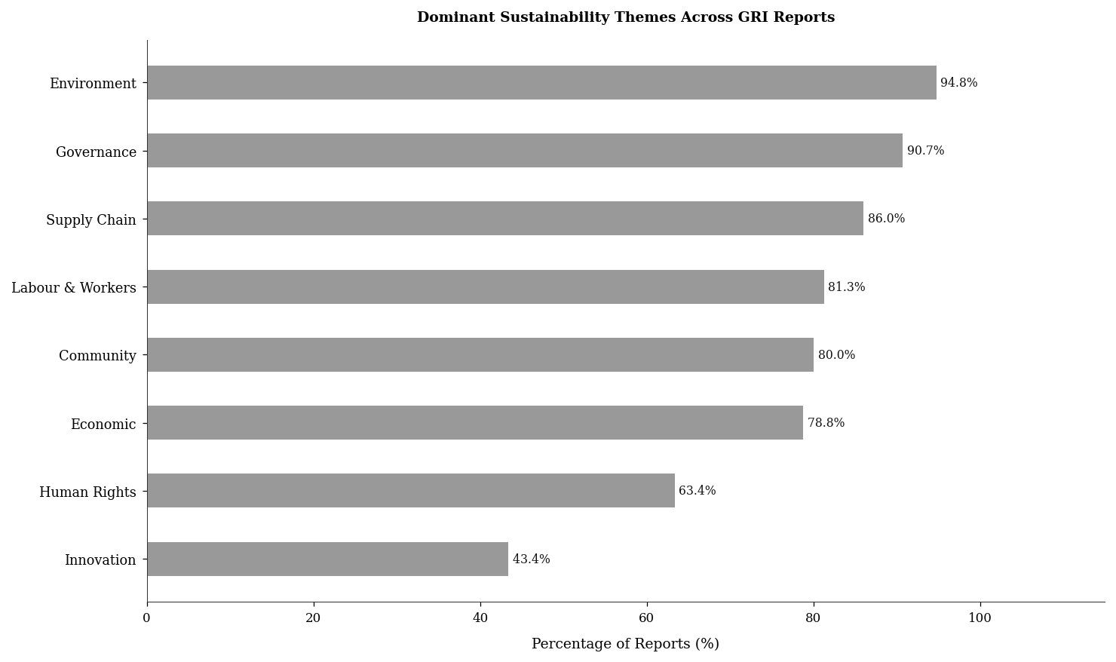
Figure 1: Prevalence of Dominant Sustainability Themes Across GRI Reports (n = 972).

Figure 2 examines how the Environment theme — the most dominant — changed over time. The trend line shows a slope of -0.16% per year, a marginal decline. Despite this, the Environment theme remains present in 83%–100% of reports in every year. The volatility in early years (2002–2006) reflects very small sample sizes (1–6 reports per year) rather than a genuine decline in environmental reporting. From 2008 onwards the trend stabilises, confirming that environmental sustainability is a persistent and consistent theme in GRI reporting.

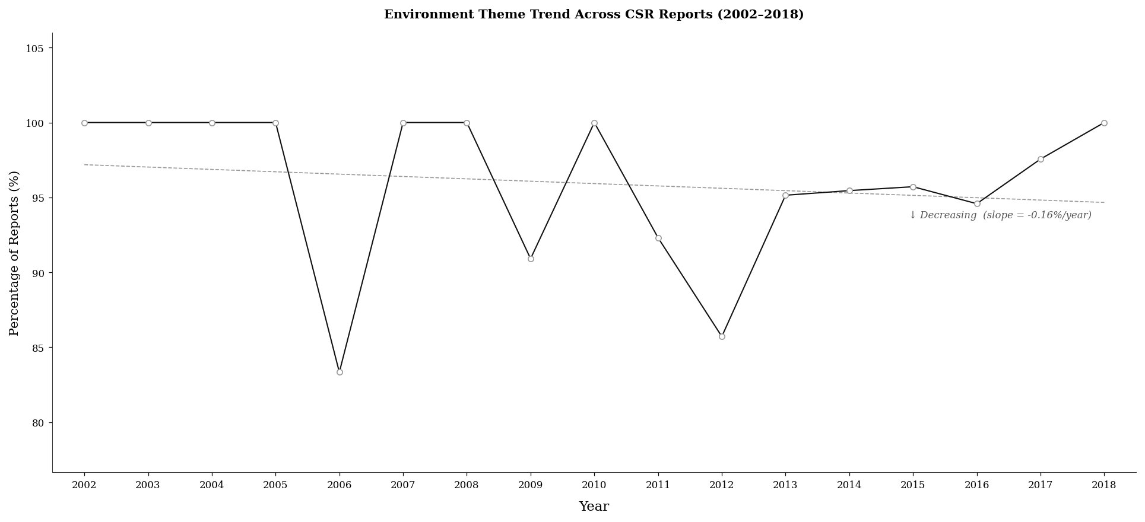
Figure 2: Environment Theme Prevalence Over Time (2002–2018). Dashed line = linear trend (slope = −0.16%/year).

Figure 3 provides a comprehensive summary of all eight themes across all years. Darker cells indicate higher prevalence. Environment and Governance consistently occupy the darkest cells, confirming RQ1. Innovation and Human Rights show consistently lighter cells throughout. From 2013 onwards, most themes converge above 75%, suggesting that GRI reporting matured and broadened thematically in the later period.

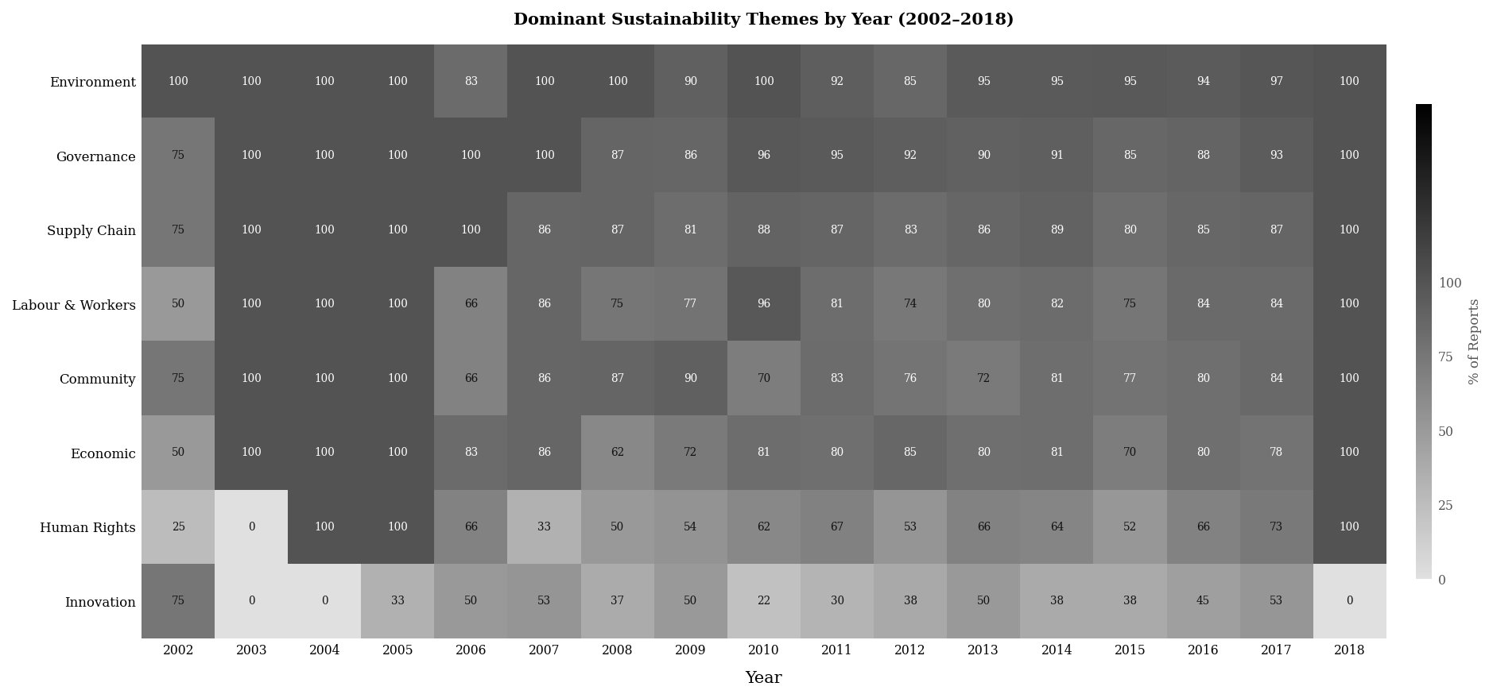
Figure 3: Dominant Sustainability Themes by Year — Greyscale Heatmap (2002–2018). Values = % of reports containing each theme. Darker = higher prevalence.

VI. CONCLUSION
This report analysed 972 GRI sustainability reports to identify dominant themes and their temporal evolution. Environment (94.8%) and Governance (90.7%) are the most prevalent themes, while Innovation (43.4%) is the least common. These findings confirm that corporate sustainability disclosure is primarily oriented towards environmental and governance compliance. Temporal analysis shows the Environment theme has remained near-universally present across 2002–2018, with a negligible decline of -0.16% per year. Report volume grew from 4 in 2002 to 203 in 2016, indicating broad GRI adoption rather than significant thematic diversification.

VII. LIMITATIONS
Several limitations apply. First, keyword-based theme detection may miss relevant reports using synonyms not captured in the dictionaries; more advanced methods such as topic modelling (LDA) would provide richer results. Second, early years (2002–2006) are underrepresented with fewer than 10 reports per year, limiting temporal reliability for that period. Third, non-English reports were excluded, potentially biasing findings towards Western reporting norms. Finally, the dataset covers only up to 2018, limiting conclusions about recent developments in sustainability reporting.

REFERENCES
Berad, N. (2011). Corporate social responsibility: Issues and challenges in India. Journal of Modern Accounting and Auditing.
Fiechter, P., Hitz, J.-M., & Lehmann, N. (2022). Real effects of a widespread CSR reporting mandate: Evidence from the European Union's CSR directive. Journal of Accounting Research, 60(4), 1499–1549.
Global Reporting Initiative. (2022). GRI standards. https://www.globalreporting.org/standards/
Luhmann, H., & Theuvsen, L. (2017). Corporate social responsibility: Exploring a framework for the agribusiness sector. Journal of Agricultural and Environmental Ethics, 30(2), 241–253.
Moravcikova, K., Stefanikova, L., & Rypakova, M. (2015). CSR reporting as an important tool of CSR communication. Procedia Economics and Finance, 26, 332–338.
Pomering, A., & Dolnicar, S. (2009). Assessing the prerequisite of successful CSR implementation: Are consumers aware of CSR initiatives? Journal of Business Ethics, 85(S2), 285–301.
Tufte, E. R. (2001). The visual display of quantitative information (2nd ed.). Graphics Press.

