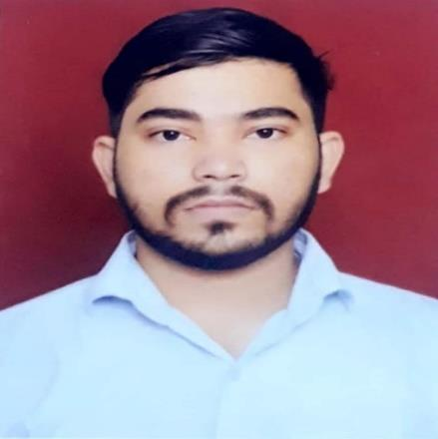  CONTACT  Phone  +91 9082798193  Email  Kundanjaiswal444@gmail.com  Address  Bhayandar East, Mumbai  TECHNICAL SKILLS  - Production Support & Incident Management (L2)  - Root Cause Analysis & Debugging  - Python & Pandas for Data Analysis  - PL-SQL Query Writing & Optimization  - Database Troubleshooting & Reporting  - .NET & C#  - ITIL Processes  - Technical Documentation & Reporting  - HTML, CSS | KUNDAN JAISWAL  SOFTWARE ENGINEER | PRODUCTION SUPPORT ENGINEER (L2)  Results-driven IT professional with 4+ years of experience in production support, incident management, and application monitoring, currently working as an L2 Production Support Engineer. Skilled in root cause analysis, SQL/PL-SQL query development, and building Python (Pandas) based scripts for data analysis and reporting. Strong background in .NET, C#, and ITIL processes, with a track record of resolving complex, business-critical issues and improving system reliability. Seeking to leverage strong debugging, database, and analytical skills in a Production Support L2 or PL/SQL Developer role.  WORK EXPERIENCE  SOFTWARE ENGINEER (L2 PRODUCTION SUPPORT)  Cognizant, Navi Mumbai | Apr 2024 - Present  Working as an L2 Production Support Engineer, performing in-depth root cause analysis and resolving escalated incidents for enterprise applications. Writing and optimizing advanced PL-SQL queries to extract data, build reports, and investigate production issues. Using Python and Pandas to automate data analysis, build reporting scripts, and speed up recurring troubleshooting tasks. Debugging application and database issues, coordinating fixes with development teams, and validating resolutions before closure. Monitoring and managing incident tickets through ITSM tools, ensuring timely resolution within SLA. Collaborating with L1 and L3 teams to triage, escalate, and resolve complex incidents. Assisting with application deployment, deployment verification, and post-deployment troubleshooting. Creating technical documentation and knowledge base articles covering RCA findings, fixes, and reusable queries.  JUNIOR SOFTWARE ENGINEER  Cognizant, Mumbai | Dec 2021 - Mar 2024  Provided L1 technical support for business-critical applications, keeping systems available and users unblocked day to day. Managed and resolved incident tickets within SLA, escalating complex issues to senior teams when needed. Wrote SQL queries to investigate and fix database-related issues and monitored application performance to catch and address bottlenecks early.  INTERN - DATA CURATOR & REVIEWER  Enfuse Analytics Solutions, Mumbai | Apr 2021 - Nov 2021  Processed, cleaned, and validated large datasets to ensure data accuracy, consistency, and integrity across sources. Performed data classification, quality assurance, and error analysis to improve dataset reliability and support data-driven business insights.  INTERN - TAGGER  Quantiphi Analytics Solution Private Limited, Mumbai | Nov 2019 - Mar 2021  Annotated, labelled, and categorized large-scale datasets to build high-quality training data for machine learning and AI models, ensuring labelling accuracy, consistency, and adherence to project quality guidelines.  EDUCATION  BACHELOR OF ENGINEERING (B.E), INFORMATION TECHNOLOGY  Shree L R Tiwari College of Engineering, Mumbai | 2017 - 2021  CGPA: 7.04 / 10  SENIOR SECONDARY (XII), MAHARASHTRA  Thakur College of Science and Commerce | 2017  Percentage: 63.38%  SECONDARY (X), MAHARASHTRA  Guru Nanak Mission High School | 2015  Percentage: 80.60%  PROJECTS  E-COMMERCE BOOK STALL: A DIGITAL MARKETPLACE FOR BOOK LOVERS  Aug 2023 - Sep 2023  Built an online bookstore website where users can sign up, browse books by genre, see clear prices with bulk discounts, add books to a cart, and check out. An admin panel lets the owner manage book listings, orders, and pricing.  ADVANCED PARKING SYSTEM  Apr 2022 - Jun 2022  Built a web application for managing parking, using .NET Core and Entity Framework. Users can register and log in securely, book a parking slot for a chosen date and time, and see in real time which slots are free for their type of vehicle.  LIVE FACIAL RECOGNITION SYSTEM USING MATLAB  Jul 2020 - May 2021  Built a MATLAB application that recognizes people's faces in real time using a webcam. The system captures a live video feed, compares each face against a stored database of registered users, and identifies who the person is. A simple graphical interface displays whether the face was recognized along with the match accuracy.  IOT MINI PROJECT - SECRET KNOCK DOOR LOCKING SYSTEM  Aug 2019 - Oct 2019  Built an Arduino-based smart lock that opens the door when it detects a specific secret knock pattern. A sensor picks up the knocks, the program checks whether they match the saved pattern, and the lock opens — with light and sound signals to confirm the result.  MINI PROJECT - BASIC USER INTERFACE FOR AN EXAMINATION SYSTEM  Mar 2019 - Apr 2019  Designed the user interface for a web-based online exam system. It includes a login and registration screen and a dashboard where students can see upcoming exams, check past results, and update their profile settings.

