VIT-AP University, Amaravati
School of Computer Science and Engineering (SCOPE)
PROJECT REPORT
Community Detection in Social Networks
A Comparative, Robustness and Role-Aware Study of Five Algorithms
Project 4: Community Detection
Submitted by
Kundan Karthikey Naidu
Registration No.: 23BCB7098
B.Tech Computer Science and Business Systems
October 2026

Abstract
Online social networks are rarely homogeneous: people cluster into friend groups, teams and interest circles, and finding those clusters (community detection) underpins recommendation, marketing, epidemic modelling and the study of information flow. This project implements and compares five widely used community detection algorithms, namely Louvain, Greedy Modularity (Clauset-Newman-Moore), Label Propagation, Normalised Spectral Clustering and Girvan-Newman, on real and synthetic social networks.
Beyond a straightforward comparison on Zachary's karate club and the Les Miserables co-appearance network, the study adds four analyses: (i) a robustness study on LFR benchmark graphs in which the community structure is progressively blurred; (ii) a stability test under random edge removal; (iii) a scalability test up to 8,000 nodes; and (iv) a community-aware node-role analysis that combines classical centralities with the within-module degree z-score and participation coefficient. A degree-preserving null model is used to test whether the discovered structure is statistically significant.
Louvain and Spectral Clustering reached the optimal modularity of 0.4198 on the karate club; both were the most accurate methods on LFR graphs for mixing parameters up to 0.4, Label Propagation collapsed into a single community from mu = 0.4 onward, and Greedy Modularity systematically merged small communities. The role analysis showed that within-community prominence and cross-community brokerage are almost independent properties (Spearman rho = 0.17), so ordinary centralities alone do not identify bridge nodes.
Keywords: community detection, social network analysis, modularity, Louvain, label propagation, spectral clustering, LFR benchmark, node roles

1. Introduction

1.1 Problem statement
A social network can be modelled as a graph G = (V, E) whose nodes are people (or accounts) and whose edges are relationships such as friendship, follows or co-appearance. Real networks have a mesoscopic structure: groups of nodes that are densely connected internally and only sparsely connected to the rest of the network. These groups are called communities. Identifying them is an unsupervised problem because, in most practical cases, no labelled ground truth exists, and many algorithms with different assumptions have been proposed. A practitioner therefore needs to know which algorithm to trust, how reliable it is when the structure is weak or the data are incomplete, and how to interpret the result.

1.2 Objectives
- Implement five representative community detection algorithms behind one common interface.
- Evaluate them with internal quality measures (modularity, coverage, performance, conductance) and external measures against known structure (NMI and ARI).
- Quantify how accuracy, stability and running time change as the network becomes harder, noisier and larger.
- Interpret the detected communities and identify the structurally important members using centrality and community-aware role measures.
- Test whether the detected community structure is significantly stronger than chance.

1.3 What is different in this project
Most introductory projects run one or two algorithms on the karate club and report a picture. This project goes further in five ways:
- Controlled difficulty. Instead of a single easy graph, 40 LFR benchmark graphs with a tunable mixing parameter show exactly where each algorithm stops working.
- Robustness to missing data. Communities are recomputed after removing up to 50% of the edges to measure stability.
- Role-aware node analysis. Nodes are classified as hubs, bridges or peripheral members using Guimera-Amaral measures and compared against five classical centralities.
- Statistical significance. A degree-preserving rewiring null model gives a z-score for the detected structure.
- Reproducible and extensible code. Every number and figure in this report is generated by one script with fixed seeds, and the same pipeline accepts any Stanford SNAP edge list.

2. Background and Methods

2.1 Modularity
Modularity, introduced by Newman and Girvan, measures how much denser the connections inside the proposed communities are than expected in a random graph with the same degree sequence:
Q = (1 / 2m) * sum over node pairs (i, j) of [ A_ij - (k_i * k_j) / 2m ] * delta(c_i, c_j)
where A is the adjacency matrix, k_i the degree of node i, m the number of edges and delta(c_i, c_j) equals 1 when i and j are placed in the same community. Q lies between -0.5 and 1; values above about 0.3 are usually taken to indicate meaningful structure. Modularity has a known resolution limit: optimising it can merge communities that are smaller than a scale that depends on the network size (Fortunato and Barthelemy, 2007).

2.2 Algorithms compared
Girvan-Newman (GN). A divisive method that repeatedly removes the edge with the highest betweenness centrality; the connected components that remain form a dendrogram. The level with the highest modularity is retained (up to 15 communities). Its cost of roughly O(m^2 n) restricts it to small graphs, so it is used only on the karate club.
Greedy Modularity (Clauset-Newman-Moore). An agglomerative method that starts with every node alone and repeatedly merges the pair of communities giving the largest increase in Q, stopping when no merge helps.
Louvain. A two-phase heuristic. Nodes are first moved between neighbouring communities while Q increases; each community is then collapsed into a super-node and the process repeats. It is fast but stochastic. Where stated, the best of 30 restarts with different seeds is kept.
Label Propagation (LPA). Every node starts with its own label and repeatedly adopts the label held by most of its neighbours. It needs no objective function and runs in near-linear time, but it is non-deterministic and can converge to a trivial single community.
Normalised Spectral Clustering. The leading eigenvectors of the normalised adjacency matrix D^(-1/2) A D^(-1/2) embed the nodes in a low-dimensional space, which is then clustered with k-means. The number of clusters k (2 to 10) is chosen by maximising modularity.

2.3 Evaluation measures
Internal measures need no ground truth: modularity Q; coverage (fraction of edges that lie inside communities); performance (fraction of correctly classified node pairs); and average conductance (fraction of a community's edge endpoints that leave it; lower is better).
External measures compare a partition with a known one: Normalised Mutual Information (NMI) and the Adjusted Rand Index (ARI), both equal to 1 for identical partitions and close to 0 for unrelated ones.
Node-role measures. For a node i in community s, the within-module degree z-score z_i = (k_is - mean_s) / sd_s states how well connected i is inside its own community relative to its peers, and the participation coefficient P_i = 1 - sum over communities t of (k_it / k_i)^2 states how evenly its links are spread across communities (0 = all links inside one community, values near 1 = links spread widely). A node with a large z is a hub of its community; a node with a large P is a connector between communities (Guimera and Amaral, 2005).

3. Datasets
Table 1: Datasets used
Dataset | Nodes | Edges | Role in this study
Zachary karate club | 34 | 78 | Real network with a known two-way split (ground truth)
Les Miserables | 77 | 254 | Real weighted network, used for qualitative interpretation
LFR benchmark (40 graphs) | 250 | approx. 1,000 | Planted communities, mixing parameter mu = 0.1 to 0.8
Planted-partition graphs | 200 to 8,000 | up to 46,000 | Runtime and scalability tests
Any SNAP edge list | any | any | Optional (--edgelist), e.g. ego-Facebook, 4,039 nodes

Zachary's karate club (Zachary, 1977) records friendships among 34 members of a university karate club that later split into two factions after a dispute between the instructor (node 0) and the administrator (node 33). The graph has 78 edges, density 0.139, average clustering coefficient 0.5706 and diameter 5. The faction each member joined is used as ground truth. Les Miserables (Knuth, 1993) links the 77 characters of Victor Hugo's novel that appear in the same chapter, with edge weights equal to the number of shared chapters.
The LFR benchmark (Lancichinetti, Fortunato and Radicchi, 2008) generates graphs with power-law degree and community-size distributions, which resemble real networks more closely than simple random models. Here n = 250, average degree 8, maximum degree 40, minimum community size 20 and degree and size exponents 3 and 1.5. The mixing parameter mu is the average fraction of a node's links that leave its community, so larger mu means weaker structure. For each of the eight values of mu, five graphs were generated, giving 40 graphs with about 10 planted communities each. The planted-partition graphs (stochastic block model) contain blocks of 50 nodes with an expected internal degree of 10 and about 1.5 links to other blocks per node.

4. Implementation and Experimental Design
The study is implemented in Python 3 with NetworkX (graph algorithms and generators), SciPy and scikit-learn (spectral embedding, k-means, NMI and ARI), pandas and Matplotlib. The code consists of a library module (cd_lib.py: data loaders, the five algorithms behind a common interface, metrics, role analysis and null model) and a driver (main.py) that runs all experiments, writes CSV tables and generates every figure. All random number generators use fixed seeds so that results can be reproduced exactly.
Table 2: Experiments
ID | Experiment | Setup | Measures
E1 | Karate club comparison | 5 algorithms, Louvain best of 30 runs | Q, NMI, ARI, conductance, time
E2 | Les Miserables | Weighted Louvain, best of 30 runs | Q, community composition
E3 | LFR robustness | mu = 0.1 to 0.8, 5 seeds each, 4 algorithms | NMI, communities found
E4 | Stability | 0 to 50% random edge removal, 5 trials | NMI with intact-graph partition
E5 | Scalability | 200 to 8,000 nodes | Runtime
E6 | Node roles | Louvain partition of karate club | 5 centralities, z, P, Spearman rho
E7 | Null model | 30 degree-preserving rewirings | z-score of Q

Two methodological choices deserve mention. First, Louvain and Label Propagation are stochastic, so in the flagship experiments E1 and E2 Louvain keeps the best of 30 runs, whereas in E3 to E5 a single run per seed is used so that run-to-run variability is included in the results. Second, the hub threshold (z >= 2.0) and connector threshold (P > 0.40) used in E6 are lowered from the values of 2.5 and 0.62 proposed for large networks, because a 34-node graph has too few nodes for the original cut-offs to be meaningful.

5. Results and Discussion

5.1 Karate club (E1)
Table 3: Algorithm comparison on the karate club (the real two-faction split has Q = 0.358)
Algorithm | Communities | Modularity Q | NMI | ARI | Conductance | Time (ms)
Louvain | 4 | 0.420 | 0.588 | 0.465 | 0.287 | 37.9
Greedy Modularity | 3 | 0.381 | 0.565 | 0.568 | 0.281 | 3.0
Label Propagation | 4 | 0.403 | 0.506 | 0.459 | 0.297 | 0.8
Spectral | 4 | 0.420 | 0.588 | 0.465 | 0.287 | 85.8
Girvan-Newman | 5 | 0.401 | 0.485 | 0.392 | 0.454 | 71.1

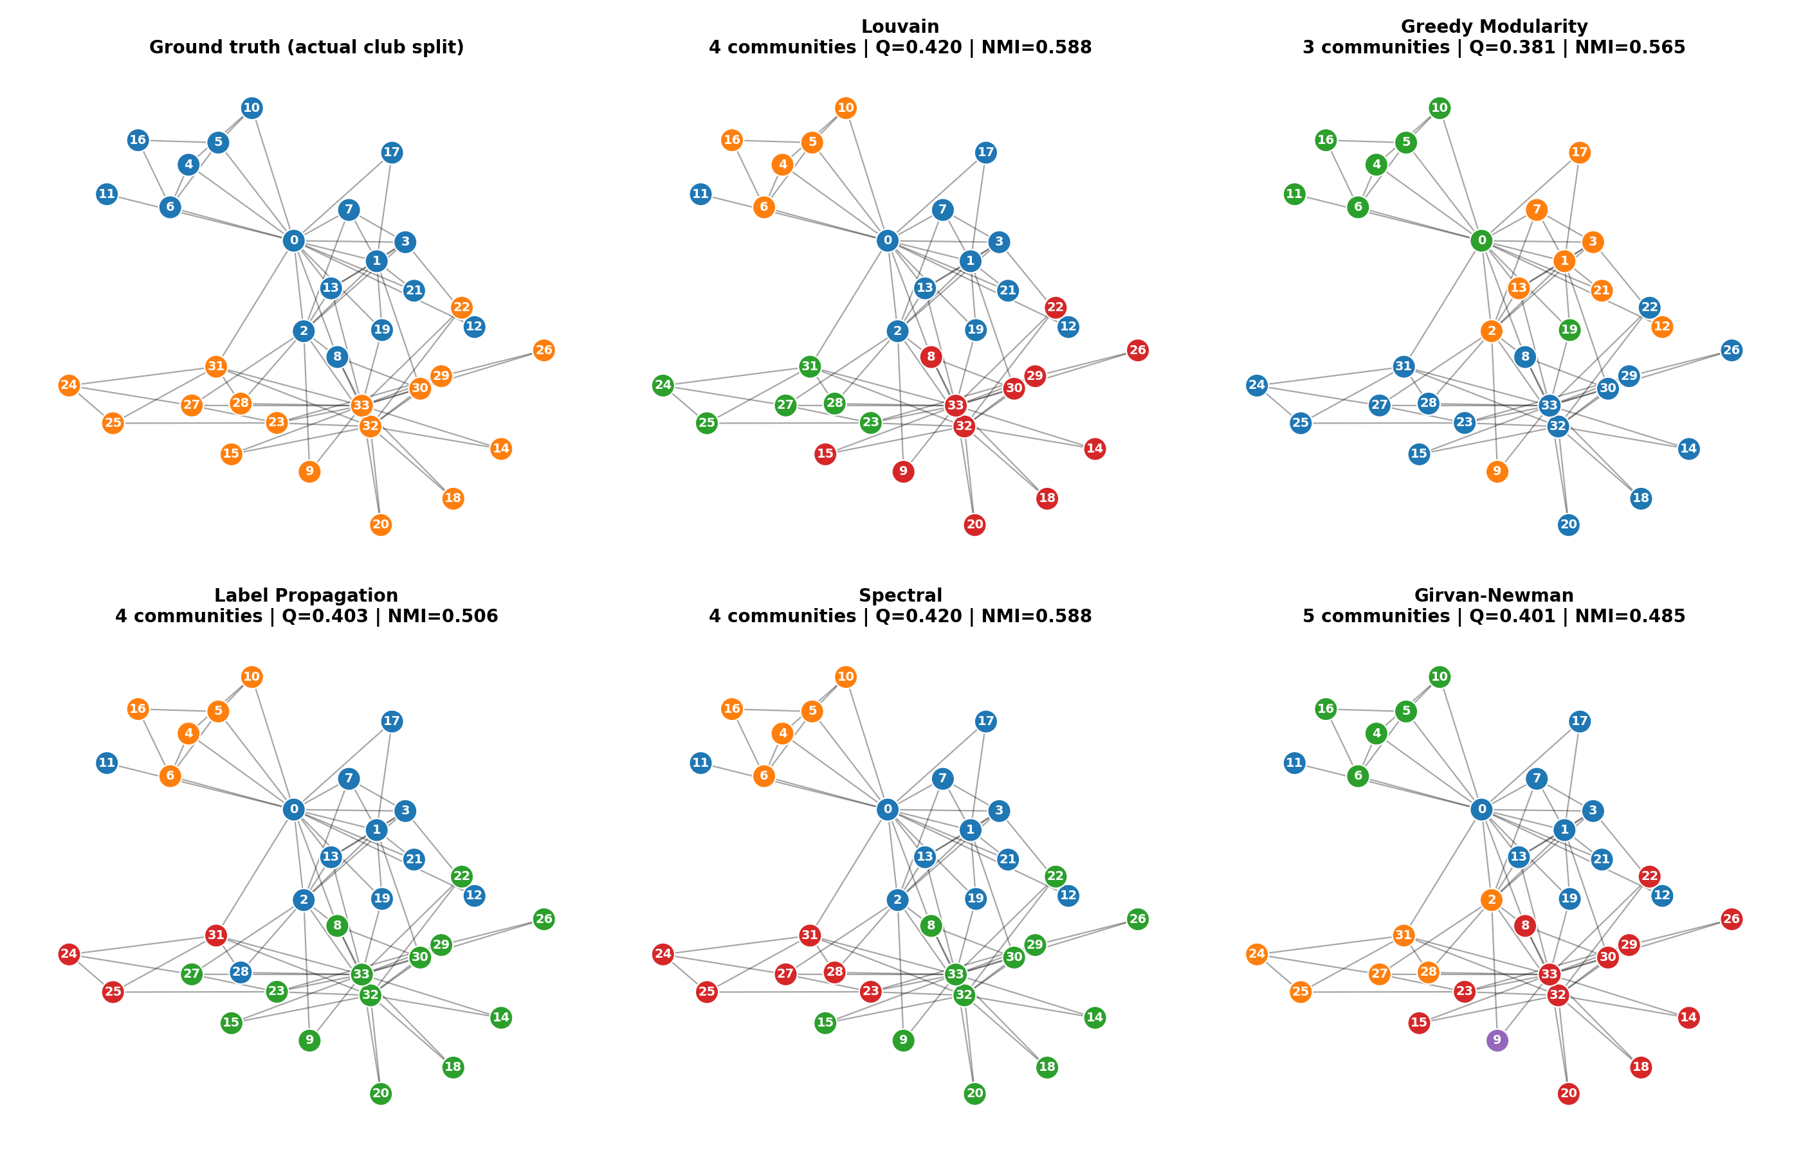
Figure 1: Partitions found by each algorithm; colours are arbitrary labels, node numbers are member IDs.
Louvain and Spectral Clustering returned the same four-community partition with Q = 0.4198, which equals the best modularity known for this network. Label Propagation (Q = 0.403) and Girvan-Newman (Q = 0.401) came close, while Greedy Modularity (Q = 0.381) merged communities too eagerly and stopped at three. Girvan-Newman had the worst average conductance (0.454), meaning its communities are the leakiest, and it is also the only method here whose cost makes it unusable on larger graphs.
An interesting observation is that every algorithm achieved a higher modularity than the actual two-faction split (Q = 0.358). The members' real decision to join one of two factions is therefore not the most modular description of the friendship graph; the algorithms detect finer subgroups inside each faction. This is why NMI against the two factions peaks at only 0.588, and why the highest ARI (0.568) belongs to Greedy Modularity, whose coarser three-community result happens to be closest in granularity to the real split. External scores on a single small graph should therefore be read with care.

5.2 Les Miserables (E2)
Table 4: Weighted Louvain on Les Miserables (6 communities, Q = 0.567)
Community | Size | Most connected characters
1 | 22 | Valjean, Marius, Cosette, Javert, Gillenormand
2 | 17 | Enjolras, Courfeyrac, Combeferre, Bossuet, Gavroche
3 | 11 | Fantine, Tholomyes, Favourite, Dahlia, Blacheville
4 | 11 | Thenardier, MmeThenardier, Babet, Gueulemer, Claquesous
5 | 10 | Myriel, MmeMagloire, MlleBaptistine, Count, Champtercier
6 | 6 | Champmathieu, Judge, Bamatabois, Brevet, Cochepaille

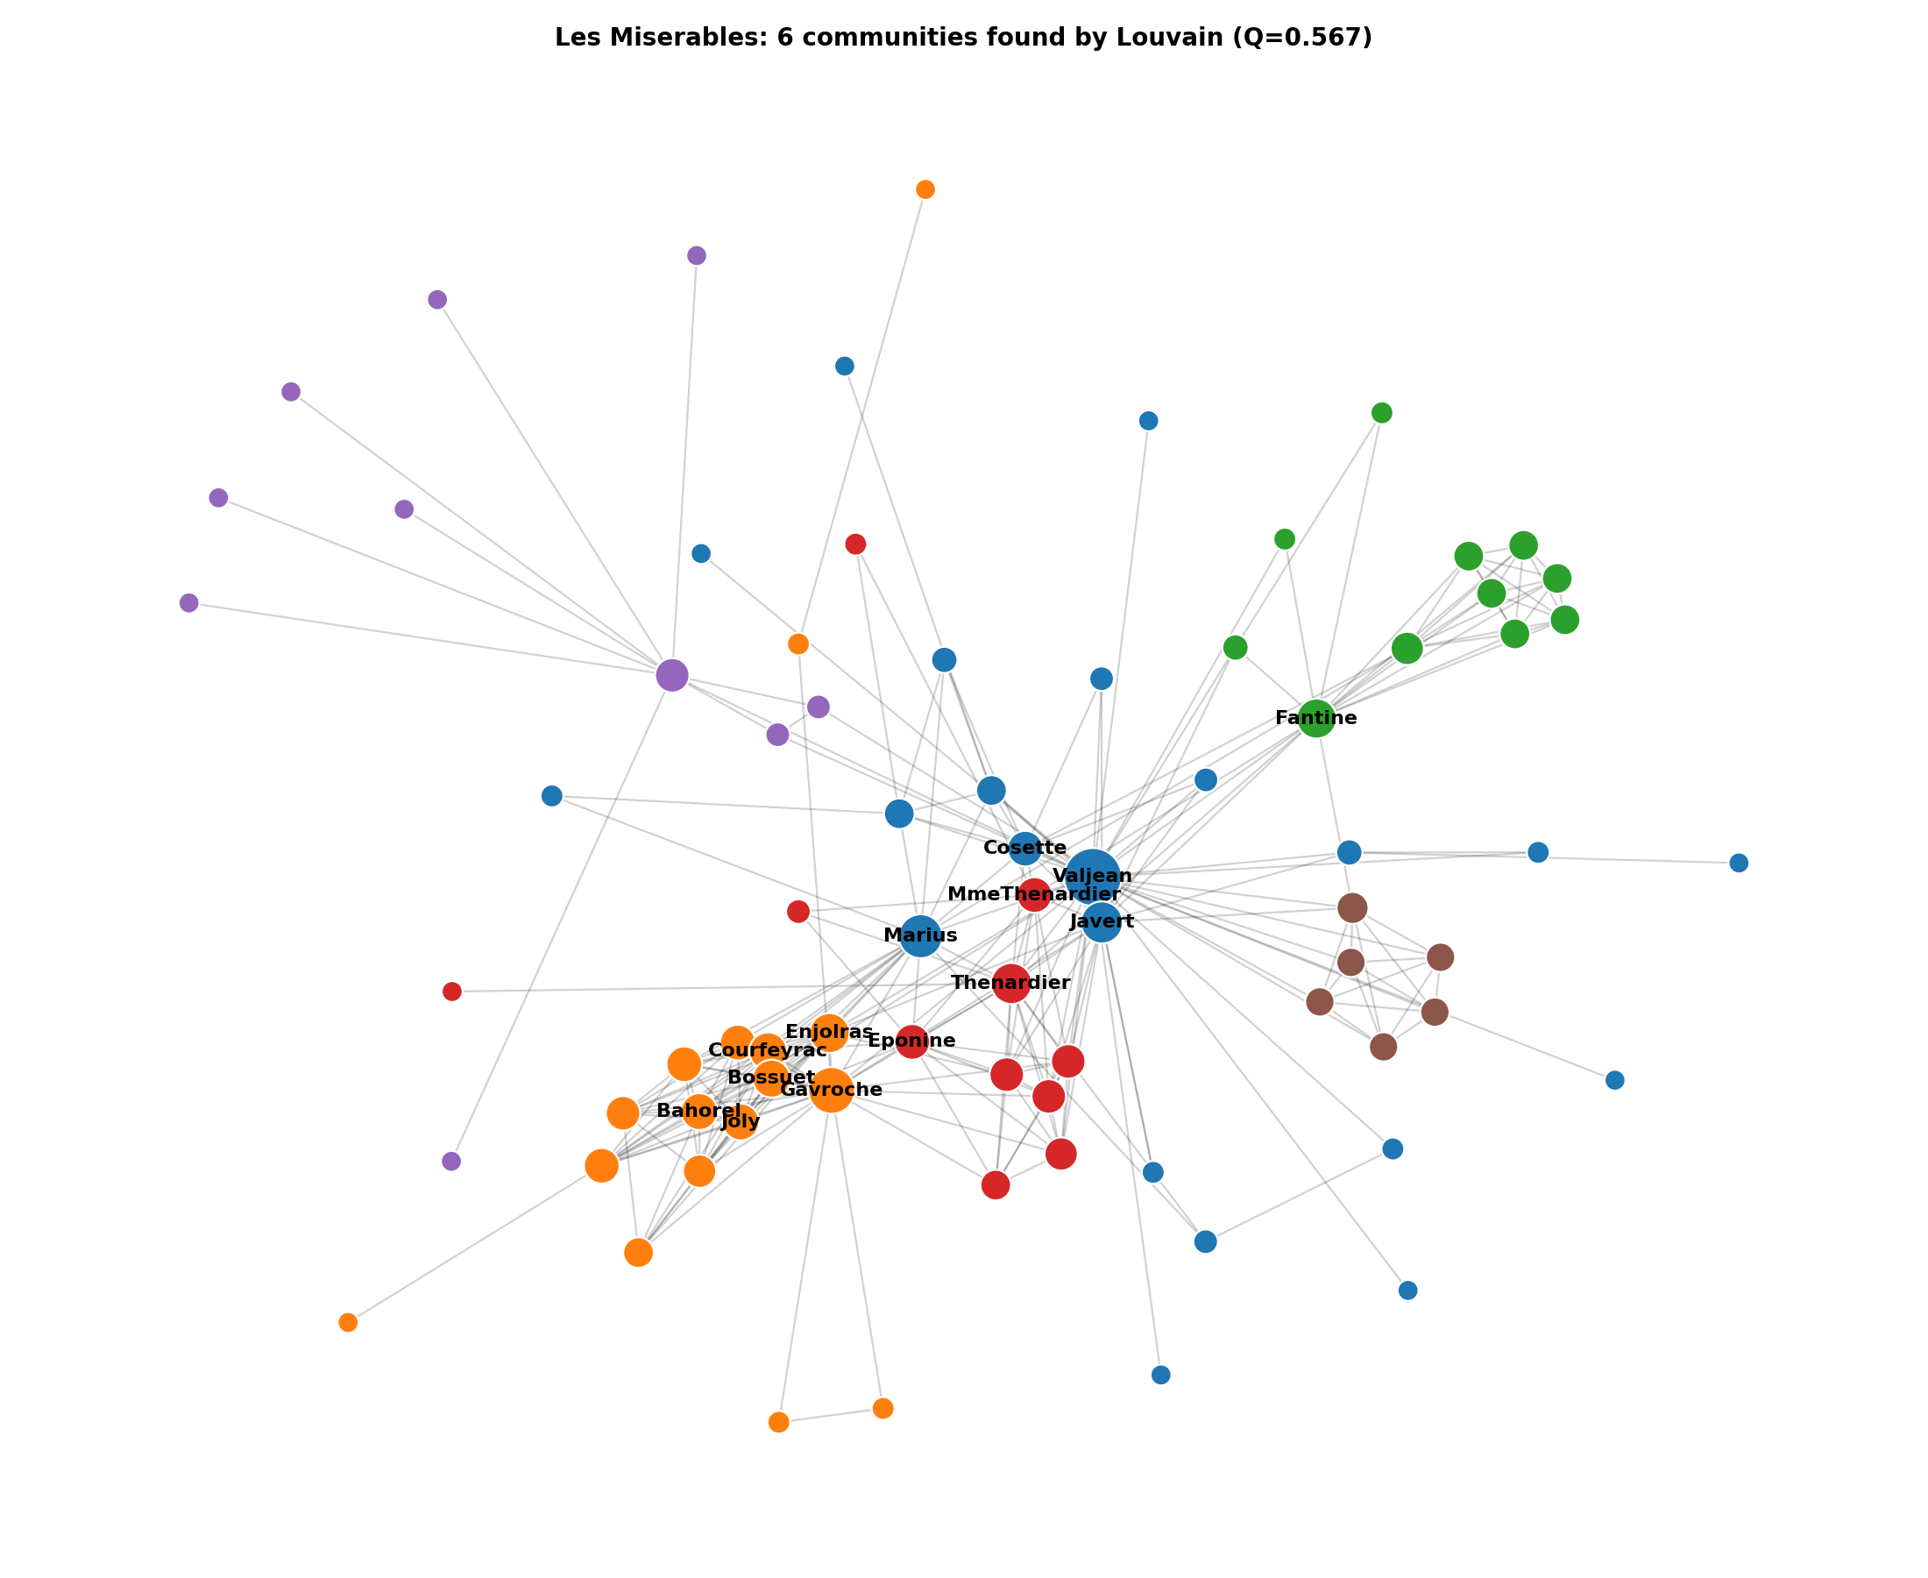
Figure 2: Communities of Les Miserables; node size is proportional to degree.
With no ground truth supplied, the communities can be judged by whether they make narrative sense, and they do. Community 1 is the protagonists' circle around Valjean, Marius, Cosette and Javert; community 2 is the student revolutionaries led by Enjolras together with Gavroche; community 3 is the Paris episode around Fantine and Tholomyes; community 4 is the Thenardier family and its criminal associates; community 5 is the household of Bishop Myriel; and community 6 is the Champmathieu trial. Valjean, whose story overlaps with nearly every other thread, sits at the centre and links the groups.

5.3 Robustness to weakening community structure (E3)
Table 5: Mean NMI with planted communities (5 graphs per mu; n = 250)
mu | Louvain | Greedy Mod. | Label Prop. | Spectral
0.1 | 0.997 | 0.977 | 0.962 | 0.980
0.2 | 0.947 | 0.737 | 0.841 | 0.940
0.3 | 0.820 | 0.628 | 0.469 | 0.853
0.4 | 0.396 | 0.318 | 0.000 | 0.427
0.5 | 0.171 | 0.146 | 0.000 | 0.143
0.6 | 0.134 | 0.088 | 0.000 | 0.091
0.7 | 0.095 | 0.070 | 0.000 | 0.067
0.8 | 0.070 | 0.058 | 0.000 | 0.060

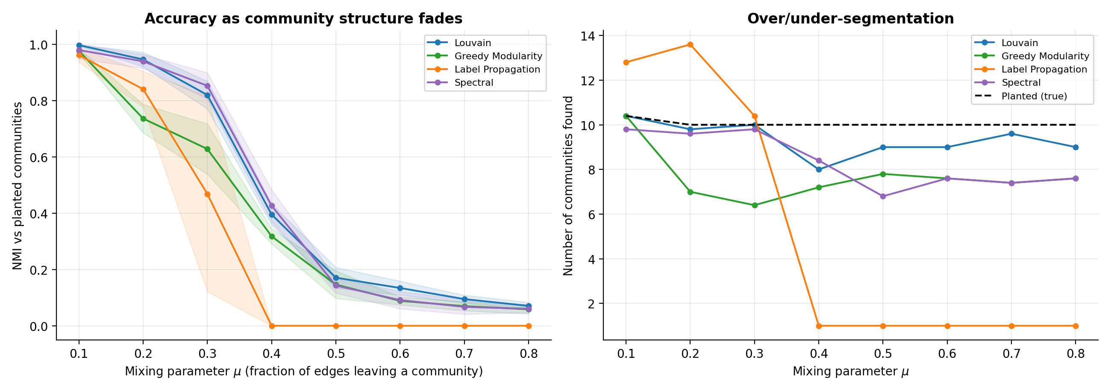
Figure 3: Accuracy (left) and number of communities found (right) as the mixing parameter increases; shaded bands show one standard deviation.
All methods are near-perfect when communities are clear (mu = 0.1) and all fail when most of a node's links leave its community (mu of 0.5 and above, where the planted structure is essentially undetectable). The informative region lies in between. Louvain and Spectral Clustering degrade most gracefully, keeping NMI above 0.8 up to mu = 0.3. Greedy Modularity loses accuracy early: at mu = 0.2 it finds only about 7 of the 10 planted communities (NMI 0.74 against 0.95 for Louvain), which is the resolution limit in action. Label Propagation is accurate for mu up to 0.2 but then collapses: from mu = 0.4 it returns a single giant community (NMI = 0 in every run), a well-known failure mode of consensus-style propagation on noisy graphs.
Table 6: Mean number of communities found
mu | Louvain | Greedy Mod. | Label Prop. | Spectral | Planted
0.1 | 10.4 | 10.4 | 12.8 | 9.8 | 10.4
0.2 | 9.8 | 7.0 | 13.6 | 9.6 | 10.0
0.3 | 10.0 | 6.4 | 10.4 | 9.8 | 10.0
0.4 | 8.0 | 7.2 | 1.0 | 8.4 | 10.0
0.5 | 9.0 | 7.8 | 1.0 | 6.8 | 10.0
0.6 | 9.0 | 7.6 | 1.0 | 7.6 | 10.0
0.7 | 9.6 | 7.4 | 1.0 | 7.4 | 10.0
0.8 | 9.0 | 7.6 | 1.0 | 7.6 | 10.0

5.4 Stability under missing edges (E4)
Table 7: NMI between the partition of the damaged graph and that of the intact graph (LFR, n = 250, mu = 0.2)
Edges removed | Louvain | Greedy Mod. | Label Prop. | Spectral
0% | 0.928 | 1.000 | 0.769 | 0.985
10% | 0.862 | 0.616 | 0.721 | 0.933
20% | 0.805 | 0.556 | 0.721 | 0.872
30% | 0.751 | 0.551 | 0.682 | 0.795
40% | 0.627 | 0.498 | 0.632 | 0.679
50% | 0.524 | 0.435 | 0.636 | 0.551

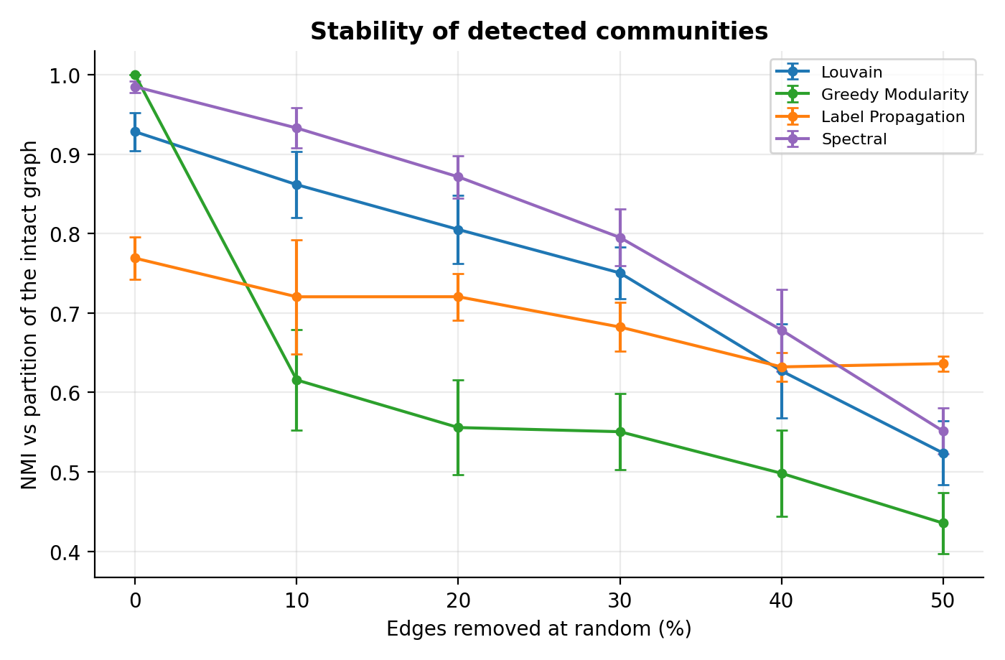
Figure 4: Stability of detected communities under random edge removal.
The value at 0% is not 1 for the stochastic methods because the baseline and test runs use different seeds; it measures the algorithm's own run-to-run variability (0.93 for Louvain, 0.77 for Label Propagation), whereas deterministic Greedy Modularity scores exactly 1. Removing only 10% of the edges lowers the agreement of Greedy Modularity to 0.62, showing that its greedy merge order is sensitive to small changes, while Spectral Clustering (0.93) and Louvain (0.86) retain most of their structure. At 50% removal all methods drop to between 0.44 and 0.64, as the graph itself has fallen apart. In a practical setting where the edge list is incomplete, Spectral and Louvain are the safer choices.

5.5 Scalability (E5)
Table 8: Runtime in seconds (single run, one laptop-class machine)
Nodes | Edges | Louvain (s) | Greedy Mod. (s) | Label Prop. (s) | Spectral (s)
200 | 1133 | 0.017 | 0.060 | 0.004 | 0.089
500 | 2884 | 0.032 | 0.200 | 0.013 | 0.100
1000 | 5857 | 0.060 | 0.577 | 0.020 | 0.126
2000 | 11415 | 0.134 | 1.212 | 0.040 | 0.277
4000 | 23245 | 0.341 | 2.398 | 0.119 | 0.460
8000 | 46052 | 0.603 | 4.808 | 0.237 | n/a

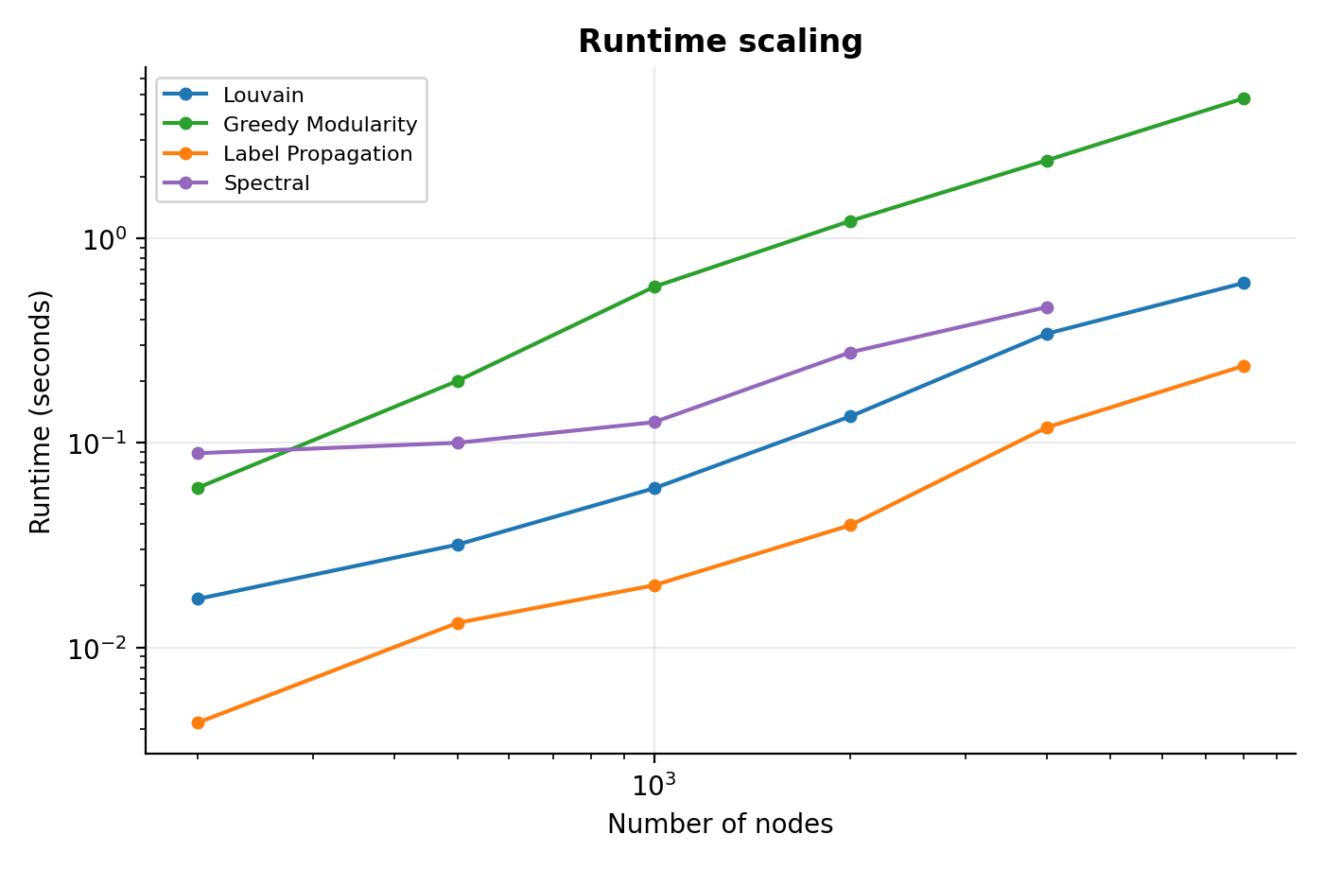
Figure 5: Runtime against graph size on log-log axes.
Label Propagation is the fastest method at every size (0.25 s for 8,000 nodes). Louvain grows almost linearly, taking 0.6 s for 8,000 nodes, a 47-fold increase for a 40-fold increase in size. Greedy Modularity grows faster than linearly and was about eight times slower than Louvain at 8,000 nodes (5.1 s). Spectral Clustering was run up to 4,000 nodes, where it needed 0.6 s. Girvan-Newman was excluded because its cost grows with the square of the number of edges. Absolute timings depend on the hardware used, but the ordering and growth rates are the meaningful result.

5.6 Who are the hubs and the bridges? (E6)
Table 9: Role analysis of selected karate-club members (Louvain partition)
Node | Degree centr. | Betweenness | z (within) | Participation P | Role
0 | 0.485 | 0.438 | 2.14 | 0.539 | Connector hub
33 | 0.515 | 0.304 | 2.51 | 0.512 | Connector hub
32 | 0.364 | 0.145 | 1.84 | 0.403 | Connector (bridge)
2 | 0.303 | 0.144 | 0.30 | 0.620 | Connector (bridge)
31 | 0.182 | 0.138 | 0.89 | 0.611 | Connector (bridge)
8 | 0.151 | 0.056 | -0.17 | 0.480 | Connector (bridge)
28 | 0.091 | 0.002 | -1.79 | 0.667 | Connector (bridge)
27 | 0.121 | 0.022 | -0.45 | 0.625 | Connector (bridge)

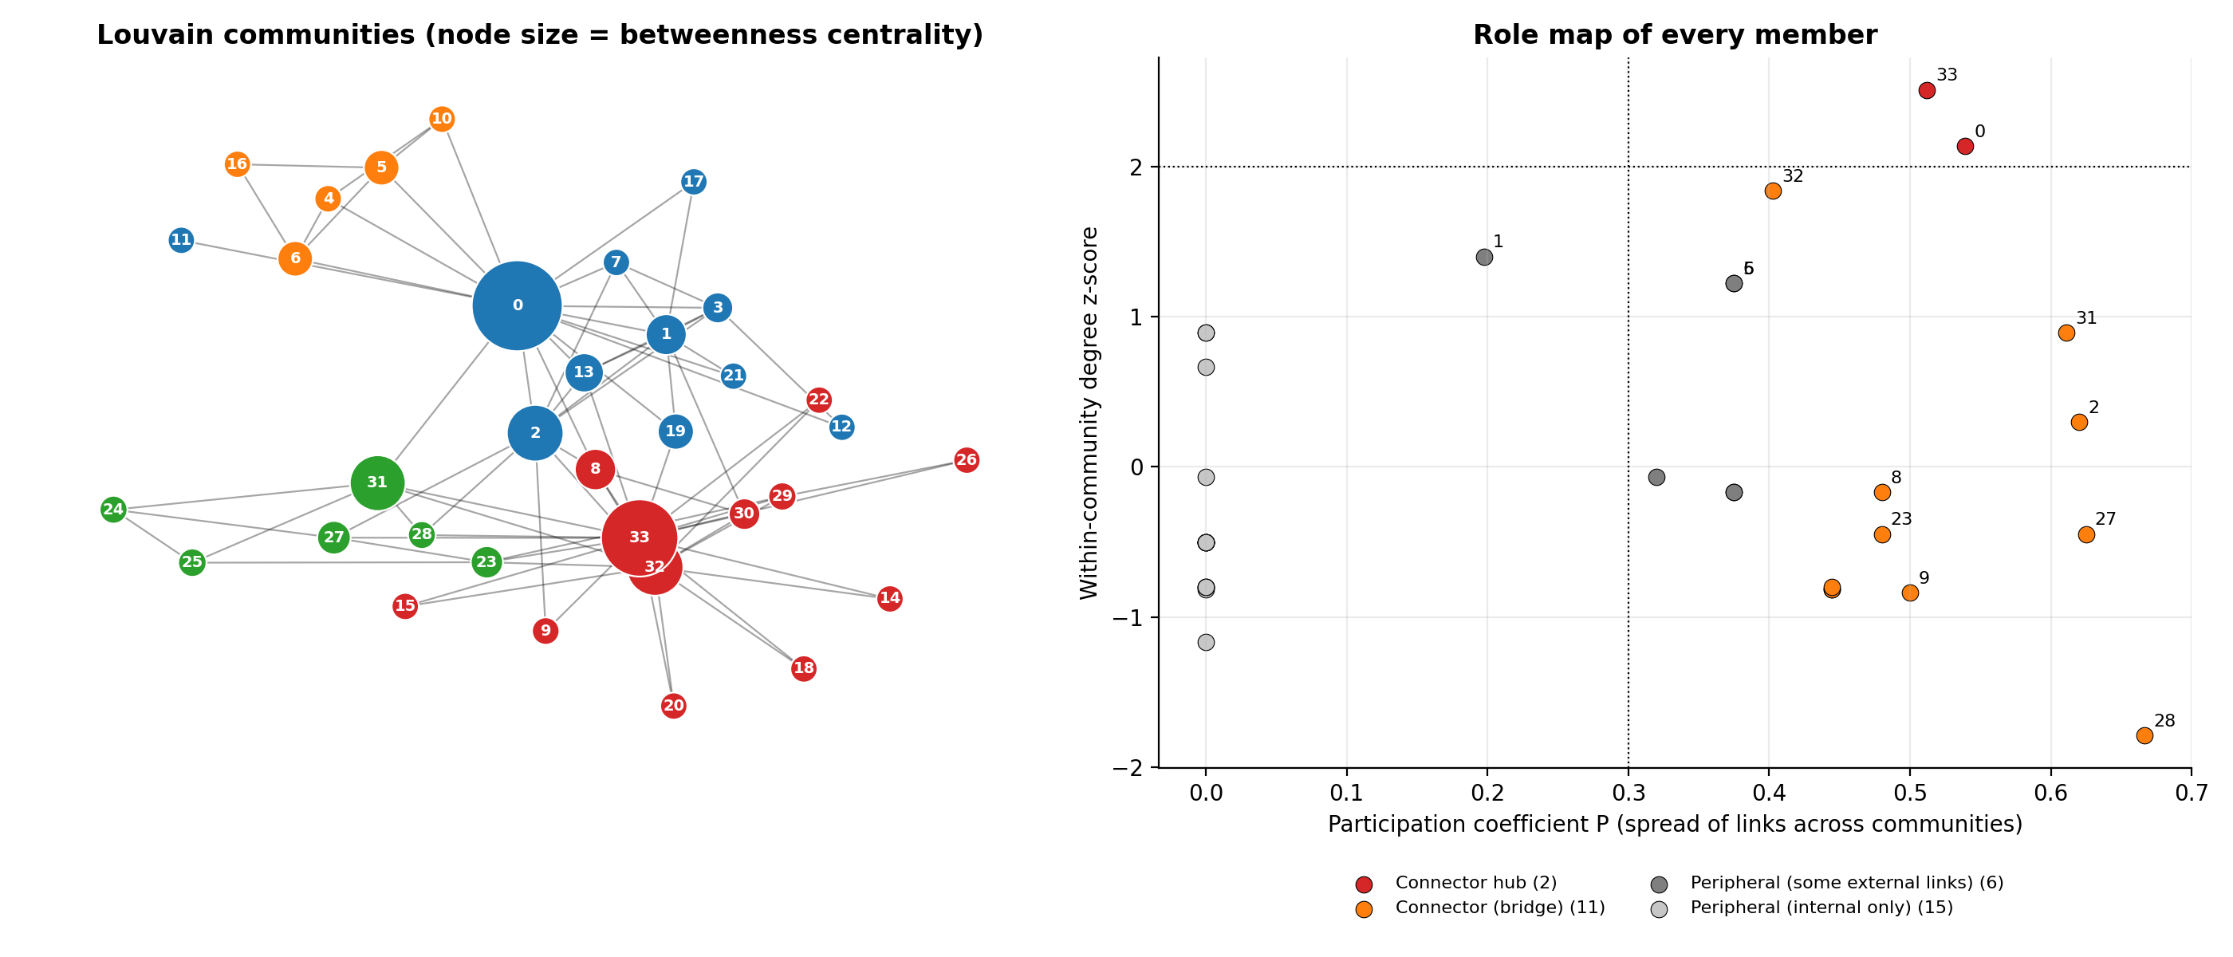
Figure 6: Left, network coloured by community with node size proportional to betweenness; right, role map of all 34 members.
Node 0 (the instructor) and node 33 (the administrator) are the only two hubs (z = 2.14 and 2.51), and both are also connectors because a large share of their ties reach other communities. The more revealing nodes are the brokers. Node 31 has only six friends (degree centrality 0.182) yet ranks fifth in betweenness, and node 2 combines a participation coefficient of 0.620 with an unremarkable within-community z-score. Node 28 has the highest participation coefficient (0.667) with just three friends, each in a different community. Of the 34 members, 11 are classed as bridges, 2 as connector hubs, and 15 have all their links inside their own community.
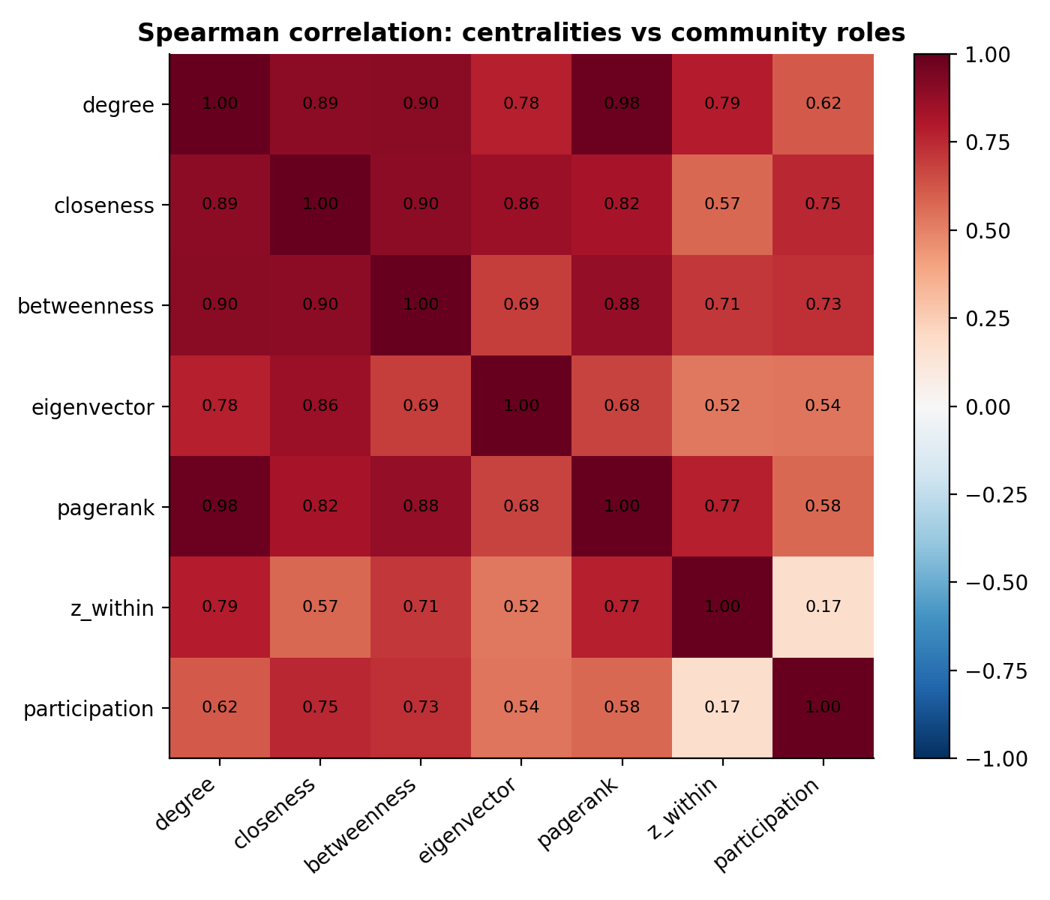
Figure 7: Spearman rank correlation between centralities and the two community-role measures.
The correlation matrix explains why role-aware measures are worth computing. Degree, PageRank and betweenness are strongly related (rho = 0.98 for degree against PageRank and 0.90 for degree against betweenness), so they largely rank the same popular nodes. In contrast the within-community z-score and the participation coefficient are almost uncorrelated (rho = 0.17): being prominent inside a group and being a bridge between groups are different properties, and a method that only ranks nodes by popularity will miss the low-degree brokers.

5.7 Is the community structure real? (E7)
Table 10: Louvain modularity of the real graphs against 30 degree-preserving random rewirings
Network | Q (real) | Q (rewired, mean) | Std. dev. | z-score
Karate club | 0.420 | 0.303 | 0.017 | 7.0
Les Miserables | 0.531 | 0.287 | 0.008 | 30.3

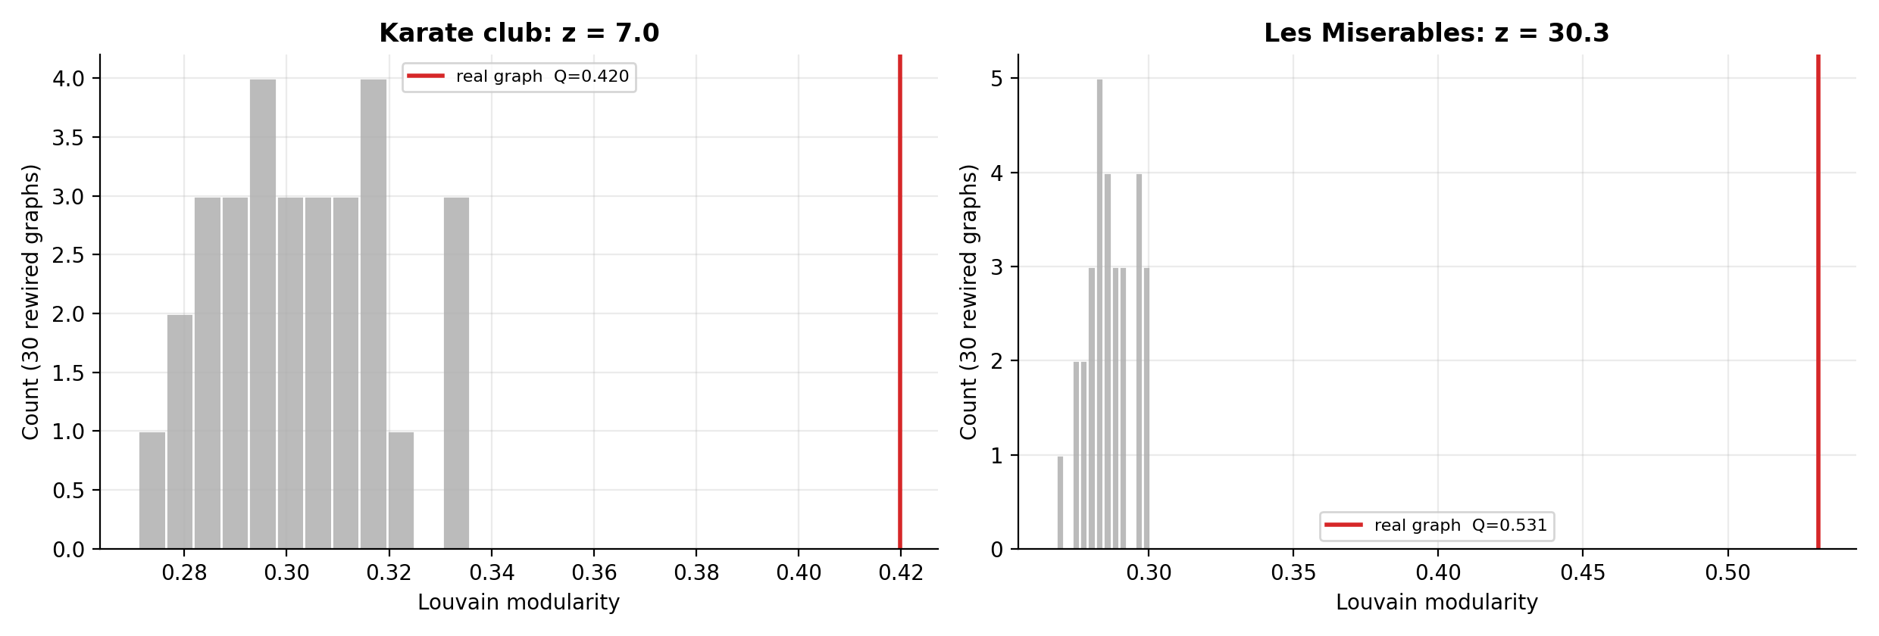
Figure 8: Distribution of Louvain modularity on rewired graphs (grey) against the real value (red line).
Random graphs with the same degree sequence still yield a modularity of about 0.30 for the karate club, because any optimiser can find some partition with positive Q even in a random graph. The fact that a high Q is not by itself evidence of communities is the reason for the test. Both real networks lie far outside the null distribution (z = 7.0 and 30.3), so their community structure cannot be attributed to the degree sequence alone. The much larger z-score for Les Miserables reflects its more pronounced clustering; the karate club, while significant, is a much smaller and less decisive example.

6. Conclusions
- Louvain and Spectral Clustering are the most reliable choices. They matched the optimal modularity on the karate club, were the most accurate on LFR graphs, and were the most stable when edges were removed. Louvain is additionally fast and nearly linear in graph size, making it the best general-purpose default.
- Label Propagation is the fastest but the least dependable. It is excellent when structure is clear but collapses to a single community once mu reaches 0.4, so it should be used for quick exploration, not final conclusions.
- Greedy Modularity and Girvan-Newman have clear drawbacks. The first under-segments (resolution limit) and is unstable, the second is too slow for anything beyond a few hundred edges and gives leaky communities.
- A high modularity or NMI alone is not enough. The real karate-club split is less modular than the algorithms' partitions, and random graphs reach Q near 0.30, so results should be checked against a null model and interpreted qualitatively.
- Bridge nodes need role-aware measures. Classical centralities are strongly correlated with each other but not with the community-role measures, so identifying brokers requires the participation coefficient.

6.1 Limitations
- Only one real network (the karate club) comes with ground truth; the LFR benchmark was used to compensate for this, but synthetic graphs cannot reproduce all properties of real data.
- All algorithms come from the NetworkX and scikit-learn implementations. The Leiden and Infomap methods and overlapping-community methods were not evaluated.
- Timings come from a single machine and a single run per size, and the LFR experiments use 5 graphs per setting, so small differences between methods should not be over-interpreted.
- The role thresholds were adapted heuristically for a small network, and edge removal was uniformly random.

6.2 Future work
- Run the same pipeline on large SNAP graphs (for example ego-Facebook or com-DBLP) and evaluate against their published ground-truth communities.
- Add Leiden, Infomap and overlapping methods such as clique percolation, and compare resolution-parameter sweeps.
- Study temporal networks, in which communities merge and split over time.

References
Blondel, V. D., Guillaume, J.-L., Lambiotte, R. and Lefebvre, E. (2008). Fast unfolding of communities in large networks. Journal of Statistical Mechanics: Theory and Experiment, 2008(10), P10008.
Clauset, A., Newman, M. E. J. and Moore, C. (2004). Finding community structure in very large networks. Physical Review E, 70(6), 066111.
Fortunato, S. (2010). Community detection in graphs. Physics Reports, 486(3-5), 75-174.
Fortunato, S. and Barthelemy, M. (2007). Resolution limit in community detection. Proceedings of the National Academy of Sciences, 104(1), 36-41.
Girvan, M. and Newman, M. E. J. (2002). Community structure in social and biological networks. Proceedings of the National Academy of Sciences, 99(12), 7821-7826.
Guimera, R. and Amaral, L. A. N. (2005). Functional cartography of complex metabolic networks. Nature, 433, 895-900.
Hagberg, A. A., Schult, D. A. and Swart, P. J. (2008). Exploring network structure, dynamics, and function using NetworkX. Proceedings of the 7th Python in Science Conference, 11-15.
Knuth, D. E. (1993). The Stanford GraphBase: A Platform for Combinatorial Computing. Addison-Wesley.
Lancichinetti, A., Fortunato, S. and Radicchi, F. (2008). Benchmark graphs for testing community detection algorithms. Physical Review E, 78(4), 046110.
Leskovec, J. and Krevl, A. (2014). SNAP Datasets: Stanford Large Network Dataset Collection. http://snap.stanford.edu/data
Newman, M. E. J. and Girvan, M. (2004). Finding and evaluating community structure in networks. Physical Review E, 69(2), 026113.
Ng, A. Y., Jordan, M. I. and Weiss, Y. (2002). On spectral clustering: analysis and an algorithm. Advances in Neural Information Processing Systems 14.
Raghavan, U. N., Albert, R. and Kumara, S. (2007). Near linear time algorithm to detect community structures in large-scale networks. Physical Review E, 76(3), 036106.
Zachary, W. W. (1977). An information flow model for conflict and fission in small groups. Journal of Anthropological Research, 33(4), 452-473.

Appendix A: Project Files and How to Run
File | Purpose
cd_lib.py | Algorithms, metrics, benchmark generators, role analysis, null model
main.py | Runs experiments E1 to E7 (and E8 for a SNAP file) and writes results/
results/ | CSV tables, figures fig1 to fig8 and summary.json
requirements.txt, README.md | Dependencies and instructions

Setup and execution on macOS:
python3 -m venv venv
source venv/bin/activate
pip install -r requirements.txt
python3 main.py
python3 main.py --edgelist facebook_combined.txt # optional SNAP dataset

