Ansible

What Is Infrastructure As Code?
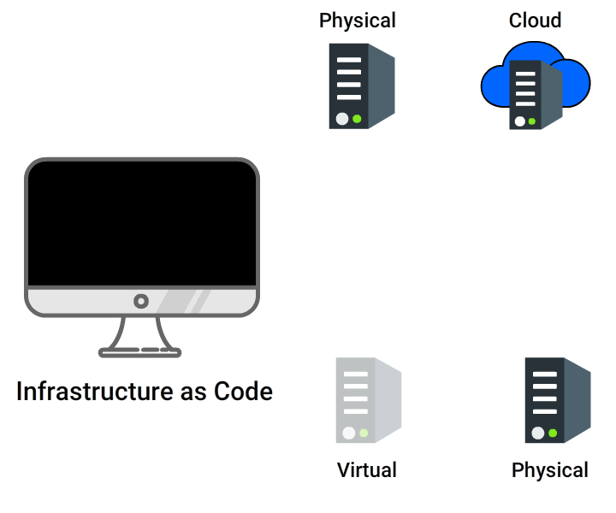
IaC means writing code for infrastructure i.e. your systems and devices, which are used to run Software, are to be treated as software and defined using code(which can be done using a high level or descriptive language).
For example: version control, testing, small deployments, use of design patterns etc.
Configuration Management tools are used to accomplish IaC.

Infrastructure as Code can be achieved using Ansible, which is one of the popular Configuration Management tools. In this course, we will have you explore various capabilities of Ansible.test

What is Configuration Management?
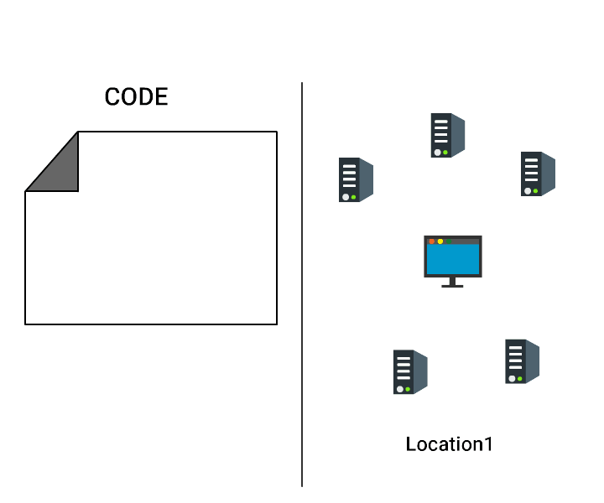
Configuration Management is a process of establishing, tracking and controlling the current design and build state of the system (software versions).
It also ensures that past records of system state is easily and accurately accessible which helps in project management, audit purposes, debugging etc.

Configuration Management Tools
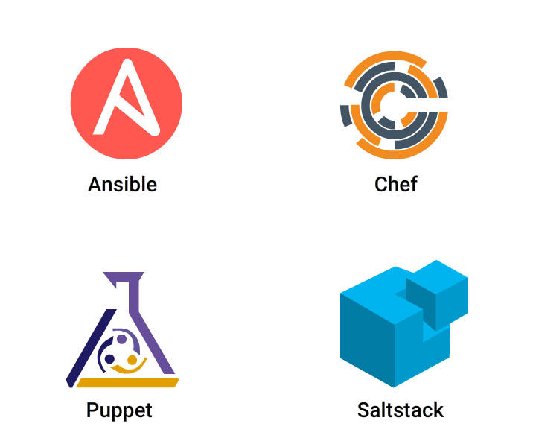
You need some kind of Configuration Management tool that can automate these tasks:
• Roll back to stable version with zero downtime
• Provide you with constant computing environment throughout SDLC
• Automatically scale up or down depending upon traffic
Some of the popular Configuration Management tools are: Ansible, Puppet, Chef and Saltstack.

Ansible is an open source software, first released by Michael DeHaan in 2012 and owned by Red Hat.
- It is used to automate
- configuration management
- application deployment
- software provisioning and other IT needs

Benefits of Ansible
- Simple: Very easy to install, setup and learn. Written in YAML file which is pretty much like reading English.
- Agentless: Do not need to install any agents on target nodes.
- Powerful: It can model any complex IT workflow as it has 1100+ modules
- Efficient: You can customize modules, using any programming language
- Secure: Uses SSH for connection

What is YAML?
- YAML stands for Yet Another Markup Language. It is a data serialization language just like JSON.
Why YAML, when we already have JSON or XML?
- YAML files are easy to read and write for humans, similar to English.

Foundation of YAML
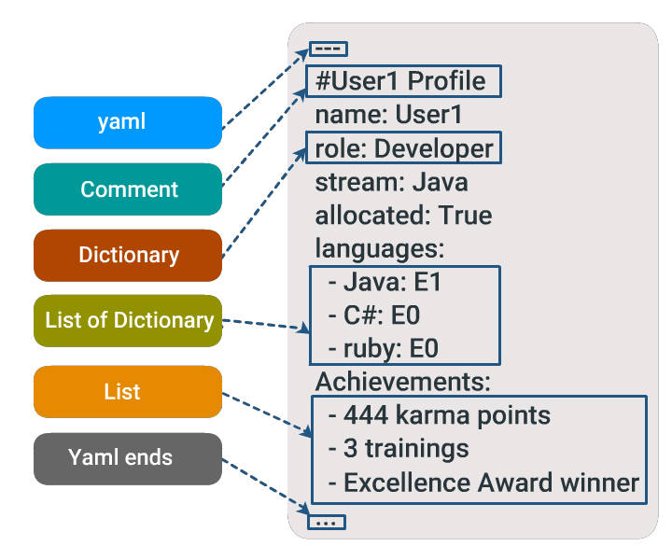
• YAML files should end as .yaml or .yml
• Begins with --- and ends with …
• # defines comment
YAML is Case and Indentation Sensitive
- Members of a list should be at the same indentation level starting with a dash(-) and space.
- Each item in the list is a key: value pair (colon must be followed by a space), called as dictionary.
- At each level, exactly two spaces are used for indentation. Using tabs is not recommended here.
Variables
Defined:
- stream: Java
- allocated: true

Boolean:
- allocated: yes
- allocated: no
- allocated: True
- allocated: TRUE
- allocated: false
In the following example,
- name and job are dictionaries. Skill is a dictionary with a list.
- David and Amy are lists having dictionaries
# Employee records
- David:
name: David Moore
job: Developer
skills:
- python
- sql
- java

- Amy:
name: Amy Brown
job: Developer
skills:
- angular
- redux
- react

How Ansible Works?

It is a configuration management tool, based on push-based architecture to automate configuration of your hosts to achieve a desired state.
Following are the components of Ansible architecture
• Inventory- Defines the list of target hosts
• Playbook (YAML file)- Defines list of tasks
• Module- A python code invoked from tasks and executed on hosts
• Control Machine- Takes playbook and executes each task on particular group of hosts

A Playbook is a file that defines the desired state of your system.
- It contains plays, which has a list of tasks to run in sequence against a list of hosts.
- A play is set of tasks, grouped together to achieve an objective
- A task is an instruction you give to Ansible.
- They are written in YAML format, a data serialization language.

The Inventory file in Ansible contains the list of all hosts (target systems/servers) that need to be configured. You can also group hosts under different names as shown:
- [group A]
- Host 1
- [group B]
- Host 2
- Host N
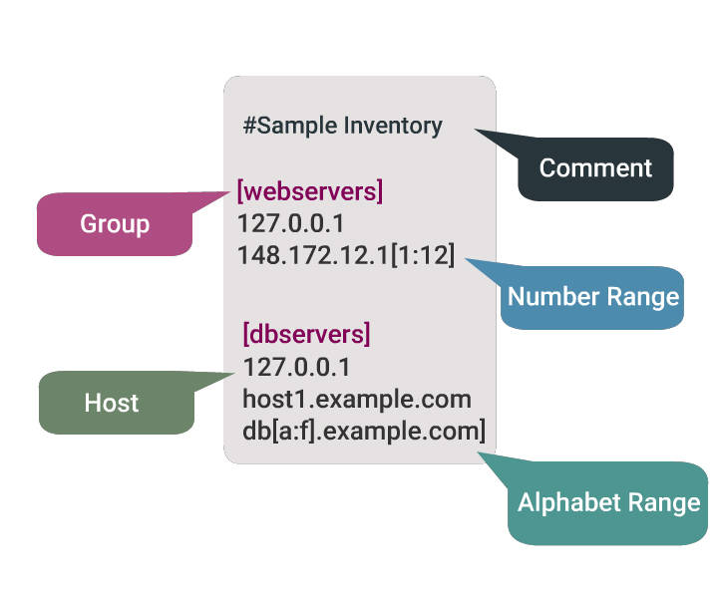
Default location of Inventory File: /etc/ansible/hosts
You can define an Inventory file statically (.ini file) or dynamically (.json file) to Ansible.

Modules Perform the Action
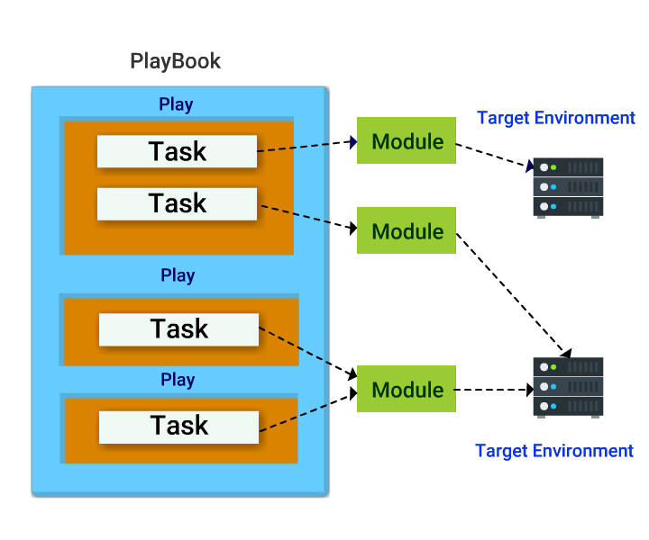
- Modules are a piece of code that gets executed when you run playbook. You use them to describe the state you want the host to be in.
- Each task in play is made of module and arguments.

Ad-Hoc Keywords

ansible: This is a tool that allows you to run a single task at a time.
- $ ansible <host-pattern> [-m module_name] [-a args] [options]

ansible-playbook: This is the tool used to run ansible playbook
- $ ansible-playbook <filename.yml> ... [options]

ansible-console: This is a REPL using which you can run ad-hoc commands on chosen inventories.
- $ ansible-console <host-pattern> [-m module_name] [-a args] [options]

ansible-pull: This inverts the default push architecture of Ansible into a pull architecture, which has near-limitless scaling potential.
- $ ansible-pull -U URL [options] [ <filename.yml> ]

ansible-doc: Displays data on modules installed in Ansible libraries.
- $ ansible-doc [-M module_path] [-l] [-s] [module…]

ansible-vault: Using this you can encrypt any structured data file used by Ansible.
- $ ansible-vault [create|decrypt|edit|encrypt|rekey] [--help] [options] file_name

ansible-galaxy: This is a shared repository for Ansible roles. This ansible-galaxy command can be utilized to manage these roles, or to create a skeleton framework for the roles to be uploaded to Galaxy.
- $ ansible-galaxy [delete|import|info|init|install|list|login|remove|search|setup] [--help] [options]

Short Hands in Ansible
-a: This tells the arguments to pass to the module
-m: Execute the module
-b: Use privilege escalation (become)
-i: The path to the inventory, which defaults to /etc/ansible/hosts
--version: Show program version number
--help: Shows help message

COMMAND
ansible group1 -i myhosts -m ping
The above statement is a single task to ping target host and return pong if the connection is successful.
- ansible is a keyword you need to write before running any ad-hoc command
- group1 is the group name of the list of hosts
- -m means module, this is followed by the module name ping, which will be executed to achieve the task

Copy a File to the Servers
You can use copy module to copy a file from your control machine to host as shown:
$ ansible host01 -i myhosts -m copy -a "src=test.txt dest=/tmp/"
- copy the file test.txt from your control machine (where ansible is installed) to all the hosts defined in myhosts inventory group
- -a means arguments of that module (here copy module)
- src is attribute of copy module that defines the source path of file or directory on control machine
Similarly, to fetch a file from Host to your Control Machine, you can use fetch module.

Encrypting Your File
As you just created a test.txt file, let us now encrypt the same using ansible-vault keyword.
- $ ansible-vault encrypt test.txt: encrypts the file.
This asks for a password to be set. Give a password and confirm it.
- ansible-vault edit test.txt: to edit the file and add some content.
This opens vi editor. Type some text, then save it(:wq)
- cat test.txt: to view the content inside.
Observe the output carefully
- ansible-vault decrypt test.txt: to decrypt the file, use the password set during encryption

- cat test.txt: now observe the output

Create Directories and Files
You can use file module to create files and directories, manage their permissions and ownership as shown:
$ ansible host01 -i myhosts -m file -a "dest=/tmp/test mode=644 state=directory"
- This will create directory /tmp/test on all the host01 of myhosts group
- mode defines permission of file/directory
- state can take value: file, directory, link, absent, etc

You can set the state to absent to delete a file or directory to delete it:
- $ ansible host01 -i myhosts -m file -a "dest=/tmp/test state=absent"

Modules

Modules are blocks of Python code that gets executed on remote hosts when you run each task in Playbook.
Each module is built for a particular task and you can use arguments to change the behavior of module.

About Modules
- Also referred as task plugins or library plugins
- Default location for Ansible modules is /usr/share/ansible
- Take arguments in key=value format (state=stopped)
- Returns data in JSON format
- Modules should be idempotent, meaning they should not do any changes if current state of system matches with the desired final state
- To access list of all installed modules using command line: ansible-doc -l
- To see the documentation of particular module using command line: ansible-doc yum where yum is the module name
- You can run modules from the command line or include them in Playbook.
- Ansible allows you to write your own module (this you will learn later in advanced courses of Ansible).

APT Module
APT (Advanced Package Tool) is a command-line tool used to easily manage (install, remove, search, etc.) packages on Ubuntu/Debian based Linux systems.

Debian Based OS: Ubuntu, Kali Linux, SteamOS and much more.
$ ansible host01 -i myhosts -m apt -a "name=sudo state=latest"
#This is how you write in Playbook
- name: Upgrade sudo to the latest version
apt:`
name: sudo
state: latest

YUM Module
YUM (Yellowdog Updater Modified) is a command-line tool used to easily manage (install, remove, search, etc.) packages on RPM (Red Hat Package Manager) based Linux systems.
Red Hat Based OS: Fedora, Qubes OS, CentOS and much more.

#This is how you write in Playbook
- name: upgrade all packages
yum:
name: sudo
state: latest

Shell Module
In shell module, the command name is followed by arguments, which runs on remote hosts through a shell(/bin/sh).

You can use various operations(|,<,> etc) and environment variable(#HOME).
ansible host01 -i myhosts -m shell -a "echo $TERM": This displays the terminal name of host machine

#This is how you write in Playbook
- name: Execute the command in remote shell
shell: echo $TERM

command Module
In command module, the command name is followed by arguments, which does not run on remote hosts through a shell(/bin/sh).

You cannot use various operations(|,<,> etc) and environment variable(#HOME).
- To check the list of files or folder in remote host: ansible host01 -i myhosts -m command -a "ls"
- Make a directory in remote host: ansible host01 -i myhosts -m command -a "mkdir folder1"
- Check files or folders in remote host: ansible host01 -i myhosts -m command -a "ls"

Now to check files or folders in your terminal use ls and observe the output. As you can see, using command, you can execute tasks on remote host.

Command Everytime
Most of the Ansible modules are idempotent.
But command module does not exhibit this property as this runs every time you run playbook. Hence you will always find the changed status on running the same Playbook again and again.

Consider you wrote a task to copy a file to remote hosts using command module.
Ansible command module will copy the same file the number of times you run the Playbook.

Had this been idempotent; Ansible will not copy from the second time, as the file is already present (current state = desired state).

Command can be Idempotent
To overcome this, you can use creates or remove parameter, where you define the filename/pattern.
- creates: if filename exists, task will not run
- remove: if filename does not exist, task will not run

#This is how you write in Playbook
- name: copy a file, but do not copy if the file already exists
command: cp /home/dist/file1.txt /usr/someFolder/ creates=file1.txt

Template Module
Ansible template is a file having a defined structure with some variables and expressions, which can be replaced with the corresponding values to generate new configuration file.
- Template files are written in Jinja2 language (.j2)
- Generally, in Ansible, these files are copied to remote hosts in JSON or YAML format

There are basically two files involved to define templates in Ansible:
- playbook(YAML file): here you substitute variables in template file with values
- template(Jinja2 file): here you define the template file in Jinja2 format

file: sample-playbook.yml
This is where your template and variables are merged.

Let us consider another example of Payslip as a template, where a structure of payslip is pre-defined. Depending on the values being passed new payslip is generated for each name.

#This is how you write in Playbook
- hosts: all
vars:
quarter: false,
salary : 30000,
extra : 10000,
names: ["John","David"]
tasks:
- name: Ansible Template
template:
src: ../templates/sample-template.j2
dest: /home/sample-template
- src: defines path where your template file is kept.
- dest: path where you want to copy your file (mostly JSON or YAML formatted file).

file: sample-template.j2
This is where you define your template.
{% for name in names %}
Hi {{name}}!
{% if quarter -%}
Your pay cheque for this month is {{ salary + extra }}.
{% else -%}
Your pay cheque for this month is {{ salary }}.
{%- endif %}
{% endfor %}
- variable names are given within double curly braces {{ }}

Environment at a Glance
Control Machine Requirements
- Linux/Mac OS (Windows not supported)
- Python (2.6 or later version) should be installed.
- Install Ansible.

Host Requirements
- Only Python needs to be installed.
- Uses SSH to connect to control machine.
- SFTP is used else scp can be configured.

