Jenkins
Continuous Integration is a software development practice where members of a team integrate their work frequently.
The term Continuous Integration was first coined by Grady Booch.
You need a tool to create a CI enabled environment. Jenkins, Travis CI, Bamboo, Buildbot are different tools available to enable CI.
Jenkins was earlier referred to as Hudson.

What does Jenkins do?
- Compiles and builds the code
- Runs an internal shell or command line script
- Starts execution of the integration tests
- Monitor execution of tasks
- Stops build in case of failure
- Notify user on the build status
- Deploy in test or production environments

Features of Jenkins
- Easy to install
- Easy to configure various tasks
- Rich plugin ecosystem - Integrates with a variety of build, test, deploy, reporting tools
- Permanent links - Jenkins provides direct links to the latest or failed build, which can be used for easy communication
Pre Jenkins:
- Source code was completely built and then tested
- Bugs identified during testing in the source code, should be fixed and then re-tested
- Slows the software delivery, as the entire process is manual
Post Jenkins:
- Once code change is committed, Jenkins automatically takes care of the build , test and reporting of results

Configuring Jenkins
- Add custom environment variables.
- Mention SMTP server, user email suffix in the email notification section.
- Configure the location of JDK installation.
- To build Maven applications configure the location of Maven Home.
- You can perform these tasks by selecting Configure System under Manage Jenkins.
Jenkins Plugins
- Source Control: Git, SVN, Mercurial
- Testing : Selenium, Windmill
- Triggers: Jabber, Directory watchers
- Artifact: To copy components between projects like Amazon S3, SCP
- Code Analysis: To parse the code with tools like CheckStyle,Findbugs,PMD
- Build Tools: In large projects use a build manager such as Maven or Ant.
- Reporting: Jenkins provides its own reports. It can be extended using tools like Static Analysis Collector that collects the different analysis results and shows it in a combined trend graph.
Plugins can be configured via the Manage Plugins under Manage Jenkins.

For setting up a new project in Jenkins, following sections are to be planned and configured as required:
- SCM - Associate with a version control server
- Triggering Build - Control when Jenkins will perform builds by Polling, Periodic or Build based on other projects
- Execution of scripts, Ant and Maven targets
- Archiving the artifacts
- Recording and publishing build and test results
- Email notifications
Create a simple build project.
- Select New Item from Jenkins dashboard
- Type the project name
- Select Freestyle project (freestyle is the most configurable and flexible option, easy to setup!)
Source code management section-
- Select location of files to be built
- If you select git, then under repository URL mention the git location
- If location is github, then under ADD button, mention the user id and password for the github repository.
Build Triggers
After source code location is defined, you need to configure Jenkins to check for code changes, so that, build is triggered automatically.
Various options to trigger the builds are:
- Build whenever a SNAPSHOT dependency is built
- Trigger builds remotely (e.g., from scripts)
- Build after other projects are built
- Build periodically (Runs on CRON job)
- Poll SCM (Runs on CRON job)

How to define CRON expression?
Jenkins schedules are configured using the CRON syntax.
- It consists of five fields separated by white space, indicating respectively the minute (0–59), hour (0–23), day of the month (1–31), month (1–12) and the day of the week (0–7, with 0 and 7 being Sunday).
- Star is a wildcard character which accepts any valid value for that field.
- “* * * * *” means every minute of every hour of every day.
- “* 9-17 * * *” means every minute of every day, between 9am and 5pm.
- There are other convenient short-hands, such as “@daily” and “@hourly”.

In the build section,
Select Add Build step and opt for the required build option.
- For simple Java build - Select Execute Windows Batch command and enter the script in the command window.
- For Maven build - Select Invoke top-level Maven targets. Enter clean package, clean install or clean test as appropriate in the Goals field.
- Hope you know - clean package will delete any previous build artifacts, compile code, run unit tests and generates a JAR file.
Once your code is built, the results should be displayed for you to check and act. Jenkins does a great job of displaying test results and trends. Some of those are:

Post-build
- Aggregate downstream test results
- Archive the artifacts
- Build other projects
- Deploy artifacts to maven repository
- Record fingerprints of files to track usage
- Email Notification
Install post-build script plugin to help you execute scripts after build completion.

Executing the build job
Once a project is created successfully in Jenkins:
- Build job is displayed on the Jenkins dashboard
- Build starts automatically based on the build trigger settings
- To run the job manually select Build Now
- Progress of the build is displayed in the Build History section
- Once build completes, click on the build number
- Select the console output to see the details of the build.
Build Status is indicated in two ways :
- A weather icon (on the home page dashboard) - shows you a record of multiple builds
- A colored ball (on the individual project page) - shows you status of a single build
- Status has corresponding tooltips with explanations , when you hover over it.
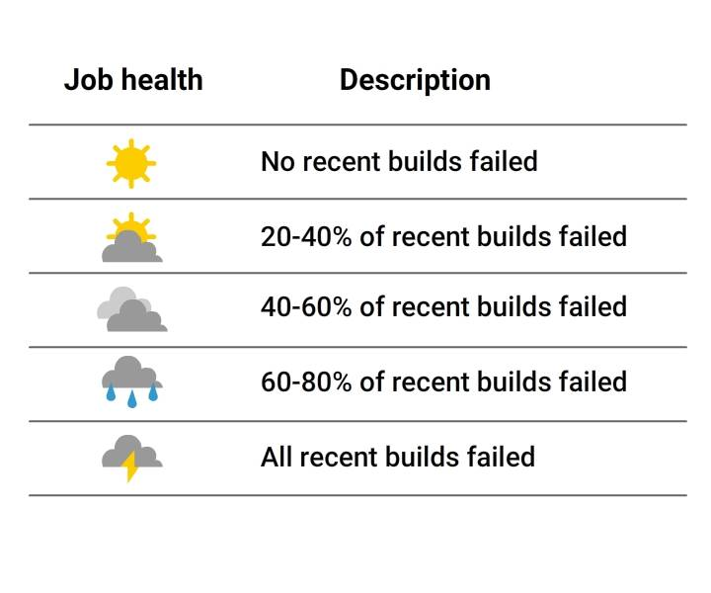
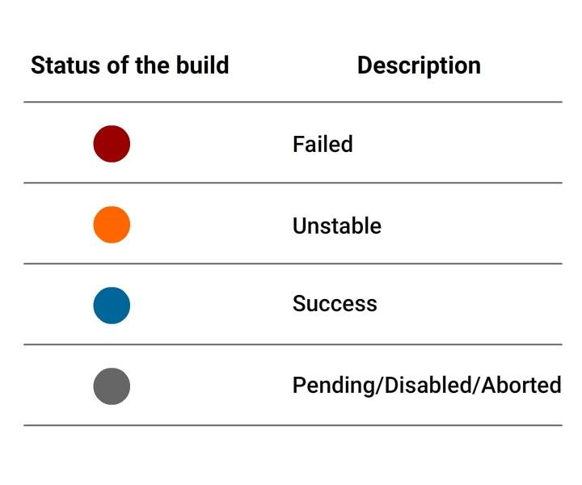

Setting up Jenkins CI Pipeline
- In the Katacoda exercise, you would have learnt how to use Jenkins and Docker in the CI pipeline.

Below are steps to setup Jenkins CI pipeline from Git to Tomcat.

Pre-Requisites
- Jenkins, Maven, Tomcat should be up and running in your machine
- Souce code should be made available in Git

Plugins to install
- Deploy to Container , Git
Jenkins Jobs to be created-
- Create a Pull job that detects code changes in Git
- Create a Build job that is triggered after the Pull job
- Create a Deploy job to push results to tomcat.

Setting up Deploy Job
You should be able to create the first two jobs easily. Below steps will help you to create the deploy job.
In the Post-build Actions section:
- Select deploy war/ear to a container
- Mention the *.war file
- Mention Context path- where your application will be published in Tomcat
- Select Tomcat version in the Container dropdown
- Enter credentials of user who can access Tomcat
- Mention Tomcat URL to reach your tomcat instance
On changing your code in Git, you will see these jobs will trigger automatically on Jenkins.

Jenkins provides a host of plugins for unit testing such as Junit and Mstest for .Net unit tests.
If you choose to use the Junit test
- Select project and choose the configure option
- In Add Build step, choose action to invoke Ant.
- Select Advanced and enter the location of build.xml file
- In Add post-build, select Publish Junit test results.
- In Test Report XMLs field, enter location of result xml files produced by executing Junit test cases
- Save and then build.
Use Automated tests
- For this, install Hudson Selenium Plugin from Manage Plugins section.
- Once plugin is installed successfully, select your project, click on the configure option.
- In the Add Build Step section, select the Selenium SuiteRun option.
- Add the necessary details for tests like browser, suitefile, resultfile and Save.
Now you are ready to build and get it going...

How to distribute work load?
- What if, as part of a large project, you need to build codes and report results regularly?
- Running all the builds on a centralized machine would not be the best option.
- What if, you need to automatically test the code in various environments?
- Different environments are to be set up in separate machines.
Jenkins uses Master - Slave architecture for managing distributed builds. In master node, you need to install Jenkins. While it can also execute build jobs, it handles all related tasks for build system -
- Schedule build job
- Dispatch build job to slaves
- Monitor the slave
- Report the build results
Master-Slave Communication
Slave node offloads work from the master.
- It can run on various operating systems.
- Executes build jobs dispatched by master.
- Jenkins need not be fully installed on slave.
- To operate, master and slave will establish bi-directional communication link like TCP/IP

How to Setup Slave node ?
To setup slave node:
- Select Manage Node under Mange Jenkinsand Click New Node
- Select the dumb slave or permanent agent option and Click Ok
- In the next window, enter details like the IP address and the user credentials
- Select the launch method and then Save.
On completion of the steps mentioned in the previous card, the new node machine will be online and ready .
- To execute the project in the slave node:
- Select 'Restrict where this job can be run' option under your 'project configuration`
- Mention the slave name in Label expression field.

How to Backup Jenkins ?
Taking project backups are crucial in software delivery process.
In Jenkins, all build logs, archives, configuration settings are stored under the Jenkins home directory.
To backup the home directory :
- You can manually copy it to another location OR Install backup plugin
- If you choose to use the backup plugin, you need to trigger backup manually
- If full backup of home directory is not needed, use ThinBackup plugin to backup specific details, like jobs, configuration, build history.

