SonarQube
SonarQube (formerly known as Sonar) is an open source platform that allows you to track and improve the quality of source code.
- It's a code analysis tool for continuous inspection of the code quality.
- One of the most important aspects in analyzing code is how much of your source code is being tested? (code coverage)
- For this, Sonar unites with the most popular open source code coverage tool ( JaCoCo, Cobertura, Emma)
- By default, it uses the JaCoCo engine.

Why JaCoCo ?
- JaCoCo is continuously developing and improving.
- It's fast.
- It's the only tool that analyses bytecode in a flash.
- It has its own Java agent for code analysis.

Installation of SonarQube
SonarQube incorporates with Eclipse, Visual Studio, and IntelliJ ID development environment through SonarLint plugins or else you can install in your local machine.
Steps:
- Install SonarQube.
- Unzip the file.
- Move it to the desired directory (e.g., opt).
- Go to the directory, open the terminal, then run
- /opt/sonarqube/bin/[OS]/sonar.sh console

Architecture
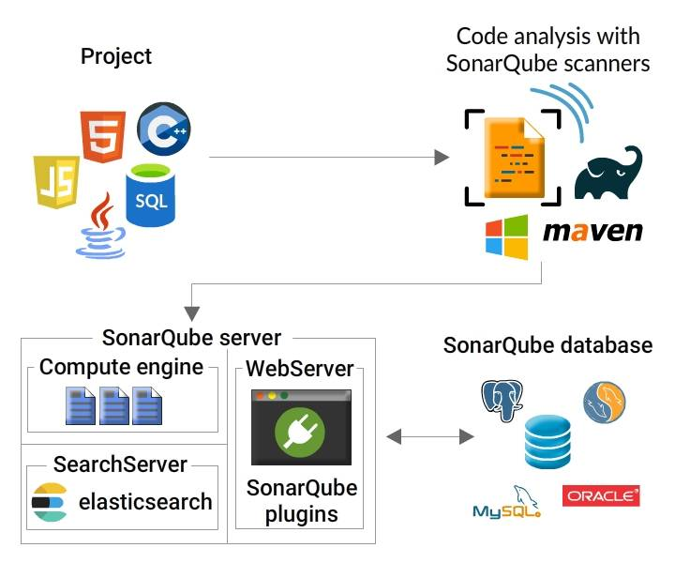

The SonarQube platform constitutes four processes:
1. SonarQube Server
It is comprised of 3 main processes viz.,
- Web Server- to look for quality snapshots and configures the SonarQube instances.
- Search Server- to get results from UI.
- Compute Engine Server- to save the analysis report in the SonarQube Database.
2. SonarQube DataBase
- The configuration of the SonarQube instance (security, plugins settings, etc.)
- The quality snapshots of projects, views, etc.
3. SonarQube Plugins
- Installed on the server.
4. SonarQube Scanners
- Running on your Build / Continuous Integration Servers to analyze projects.

Integration
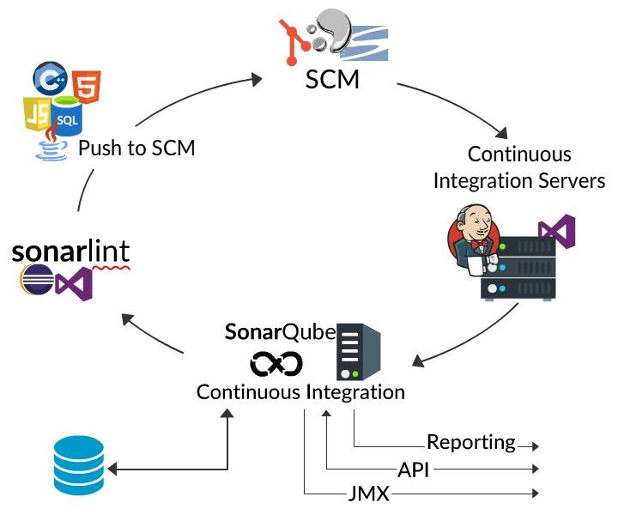
- SonarQube integrates with other Application Lifecycle Management (ALM) tools.
- Developers use SonarLint plugin in their IDEs and to do the local analysis.
- Developers push their code into their favorite SCM: git, etc.
- The Continuous Integration Server triggers an automatic build and the execution of the SonarQube Scanner required to run the SonarQube analysis.
- The analysis report is sent to the SonarQube Server for processing.
- The results are stored in the SonarQube Database.
- Developers review, comment, and challenge their issues to manage and reduce their Technical Debt through the SonarQube UI.
- Managers receive Reports from the analysis.
- Ops use APIs to automate configuration and extract data from SonarQube.
- JMX is being used by Ops to monitor SonarQube Server.

