**HCI [20CS101] COURSE PROJECT REPORT**

**On**

**“RAILWAY TICKET RESERVATION SYSTEM”**

**Developed By:**

**K. GREESHMA 2203A51052**

**D. HASINI 2203A51044**

**V. VARSHA 2203A51132**

**S. HIMA BINDU 2203A51391**

**B. SAI MANIDEEP 2203A51368**

**Under the Guidance of**

**Mr. Dr. N Venkatesh**

Assistant Professor

**Submitted to**

Department of Computer Science and Artificial Intelligence

SR University

Ananthasagar(V), Hasanparthy(M), Hanamkonda(Dist.) – 506371

www.sru.edu.in

**November 2023**

**Department of Computer Science and Artificial Intelligence**

**CERTIFICATE**

This is to certify that the HCI course project report entitled **“Railway Ticket Reservation System”** is a record of bonafide work carried out by the student(s) K. Greeshma, D. Hasini, V. Varsha, S. Hima Bindu, B.Sai Manideep bearing rollnumber(s) 2203A51052, 2203A51044, 2203A51132, 2203A51391, 2203A51368 of Computer Science and Artificial Intelligence department during the academic year 2022-23.

**Supervisor**

(N Venkatesh)

**INDEX**

Sl. No Title Page No.

1. Abstract 4

2. Objective 5

3. Elements used in the project 6

4. Code 7-29

5. Result display 29-34

6. Conclusion 35

**ABSTRACT**

Railway Reservation System" is an HTML, CSS, and JavaScript-powered webpage offering a safe and thrilling journey. With interactive features and all arrangements this platform allows people to explore different places with all facilities. Emphasizing convenience and accessibility, the system streamlines the booking experience while ensuring accurate record-keeping and secure transactions. This system optimizes resource allocation, reduces manual errors, and promotes a seamless travel planning experience for passengers.

**OBJECTIVE:**

The objective of a railway booking system is to streamline and automate the process of ticket reservations, ensuring efficiency, accuracy, and convenience for passengers. It aims to provide a user-friendly platform for booking, modifying, and canceling tickets, along with managing train schedules and seat availability. Additionally, the system should facilitate secure online transactions and generate reliable reports for efficient management.

**ELEMENTS USED IN THE PROJECT:**

* HTML (Hypertext Markup Language):
* Responsible for structuring the content and layout of the webpage.
* Creates the foundation for organizing text, images, links, and other elements on the site.
* CSS (Cascading Style Sheets):
* Controls the visual presentation and design of the webpage.
* Styles elements such as colors, fonts, layouts, and overall aesthetics to enhance user experience and maintain consistency across the site.
* JavaScript:
* Enhances interactivity and functionality of the webpage.
* Enables dynamic features like filtering reviews, user interactions, and real-time updates, creating a more engaging user experience.
* User Interface Elements:
* Text Input Fields: For entering details such as the train name, passenger name, departure date, etc.
* Date Picker: For selecting the departure date.
* Buttons: To submit the form, initiate the booking process, and perform other actions.
* Labels: Descriptive labels for each input field to guide the user.
* Display Elements:
* Confirmation Messages: Display messages to confirm successful booking or inform about any errors.
* Booking Details: Display the details of the booked ticket, including train name, departure date, passenger name, etc

**IMPLEMENTATION:**

HTML CODE:(index.html)

<!DOCTYPE html>

<html>

<head>

<title>Railway Ticket Booking</title>

<link rel="stylesheet" href="index.css"/>

</head>

<body>

<div class="main">

<h1 class="head">Railway Ticket reservation system</h1>

<div class="navigation">

<ul>

<li><a href="index.html" id="onlink">HOME</a></li>

<li><a href="meal.html">MEALS</a></li>

<li><a href="holiday.html">H PACKAGES</a></li>

<li><a href="service.html">SERVICE</a></li>

<li><a href="contact.html">CONTACT US</a></li>

</ul>

</div>

<div class="booking">

<section>

<h2 class="head1">Book</h2>

<h2 class="head2">Your</h2>

<h2 class="head3">Tickets</h2>

<h2 class="head4">Here</h2>

<form>

<ul>

<b class="fsize"> From &emsp;<input type="text" placeholder="From [STN Code]"> </b> <br> <br>

<b class="fsize"> To &emsp;<input type="text" placeholder="To [STN Code]"> </b> <br> <br>

<b class="fsize"> Date&emsp;<input type="Date" placeholder="dd-mm-yy"> </b> <br> <br>

<label class="fsize"><strong> Class </strong> </label>

<select id="class" name="class">

<option value="select">SELECT</option>

<option value="1AC">1AC</option>

<option value="2AC">2AC</option>

<option value="3AC">3AC</option>

<option value="Sleeper">Sleeper</option>

<option value="Chair">Chair</option> <br>

</select>

</ul>

</form>

<button class="submit" type="button" onclick="trainB()">Find Trains </button>

<div class="form-popup" id="bookTrain">

<div class="popup">

<h1>Due to Covid19 all trains are currently cancelled</h1> <br>

<h2>#stayhome</h2>

<h2>#staysafe</h2>

<button type="button" class="hide" onclick="trainC()">Close</button>

</div> </div>

</section>

</div>

<img class="img" src="home.jpg" alt="train" width="500" height="350" align="center" />

<h1 class="holiday">HOLIDAYS</h1>

<img class="imgs" src="taj.jpg" alt="Taj Mahal"/>

<img class="imgs" src="temple.jpg" alt="Golden Temple"/>

<img class="imgs" src="tower.jpg" alt="Eiffel Tower"/>

</div>

<script src="main.js"></script>

</body>

</html>

**(Meal.html):**

<!DOCTYPE html>

<html>

<head>

<title>Railway Ticket Booking</title>

<link rel="stylesheet" href="index.css"/>

</head>

<body>

<div class="main">

<h1 class="head">Railway Ticket reservation system</h1>

<div class="navigation">

<ul>

<li><a href="index.html" >HOME</a></li>

<li><a href="meal.html"id="onlink">MEALS</a></li>

<li><a href="holiday.html">H PACKAGES</a></li>

<li><a href="service.html">SERVICE</a></li>

<li><a href="contact.html">CONTACT US</a></li>

</ul>

</div>

<img src="meal.JPG" alt="meals" width="850px" />

<div>

<table>

<tr>

<th colspan="9"><h1>Meals</h1></th>

</tr>

<tr>

<td class="meald"> HONEY CHILLI POTATO at ₹100 </td>

<td><buttonclass="order" onclick="orderOpen()">Order Now</button></td>

<div class="form-popup" id="avi">

<div class="popup">

Enter PNR <input type="input" name="PNR">

<button type="button" class="hide" onclick="orderO()">Book</button>

<button class="hide" onclick="orderClose()">Close</button>

<div class="form-popup" id="openO">

<div class="popup">

<h1>Your Meal is Booked</h1>

<button type="button" class="hide" onclick="orderC()">Close</button>

</div> </div>

</div> </div>

</tr>

<tr>

<td>VEG DELUXE THALI at ₹150</td>

<td ><button class="order" type="button" onclick="orderOpen()">Order Now</button></td>

<div class="form-popup" id="avi">

<div class="popup">

Enter PNR <input type="input" name="PNR">

<button type="button" class="hide" onclick="orderO()">Book</button>

<button class="hide" onclick="orderClose()">Close</button>

<div class="form-popup" id="openO">

<div class="popup">

<h1>Your Meal is Booked</h1>

<button type="button" class="hide" onclick="orderC()">Close</button>

</div> </div>

</div> </div>

</tr>

<tr>

<td >NON VEG THALI at ₹150 </td>

<td><button class="order" type="button" onclick="orderOpen()">Order Now</button></td>

<div class="form-popup" id="avi">

<div class="popup">

Enter PNR <input type="input" name="PNR">

<button type="button" class="hide" onclick="orderO()">Book</button>

<button class="hide" onclick="orderClose()">Close</button>

<div class="form-popup" id="openO">

<div class="popup">

<h1>Your Meal is Booked</h1>

<button type="button" class="hide" onclick="orderC()">Close</button>

</div> </div>

</div> </div>

</tr>

<tr>

<td >MAHARAJA THALI at ₹250 </td>

<td><button class="order" type="button" onclick="orderOpen()">Order Now</button></td>

<div class="form-popup" id="avi">

<div class="popup">

Enter PNR <input type="input" name="PNR">

<button type="button" class="hide" onclick="orderO()">Book</button>

<button class="hide" onclick="orderClose()">Close</button>

<div class="form-popup" id="openO">

<div class="popup">

<h1>Your Meal is Booked</h1>

<button type="button" class="hide" onclick="orderC()">Close</button>

</div> </div>

</div> </div>

</tr>

<tr>

<td >VEG MEDIUM THALI at ₹150</td>

<td><button class="order" type="button" onclick="orderOpen()">Order Now</button></td>

<div class="form-popup" id="avi">

<div class="popup">

Enter PNR <input type="input" name="PNR">

<button type="button" class="hide" onclick="orderO()">Book</button>

<button class="hide" onclick="orderClose()">Close</button>

<div class="form-popup" id="openO">

<div class="popup">

<h1>Your Meal is Booked</h1>

<button type="button" class="hide" onclick="orderC()">Close</button>

</div> </div>

</div> </div>

</tr>

<tr>

<td >NON VEG DELUXE THALI at ₹200 </td>

<td><button class="order" type="button" onclick="orderOpen()">Order Now</button></td>

<div class="form-popup" id="avi">

<div class="popup">

Enter PNR <input type="input" name="PNR">

<button type="button" class="hide" onclick="orderO()">Book</button>

<button class="hide" onclick="orderClose()">Close</button>

<div class="form-popup" id="openO">

<div class="popup">

<h1>Your Meal is Booked</h1>

<button type="button" class="hide" onclick="orderC()">Close</button>

</div> </div>

</div> </div>

</tr>

</table>

</div>

</div>

<script src="main.js"></script>

</body>

</html>

**(Holidays.html):**

<!DOCTYPE html>

<html>

<head>

<title>Railway Ticket Booking</title>

<link rel="stylesheet" href="index.css"/>

</head>

<body>

<div class="main">

<h1 class="head">Railway Ticket reservation system</h1>

<div class="navigation">

<ul>

<li><a href="index.html" >HOME</a></li>

<li><a href="meal.html">MEALS</a></li>

<li><a href="holiday.html"id="onlink">H PACKAGES</a></li>

<li><a href="service.html">SERVICE</a></li>

<li><a href="contact.html">CONTACT US</a></li>

</ul>

</div>

<h1 class="hpack">Holiday Packages</h1>

<div>

<img class="hpimg" src="hpack1.JPG" alt="hpackages"/>

<button class="bookd" type="button" onclick="h1DB()">Details</button>

<div class="form-popup" id="hBook1">

<div class="popup">

<h1>Travel to GOVINDAM</h1> <br>

<h2>3 Days Trip at TIRUPATI</h2> <br>

<h1> Price - ₹3910</h1>

<button type="button" class="hide" onclick="h1DC()">Close</button>

</div> </div>

<button class="bookh" type="button" onclick="h1BB()">Book Here</button>

<div class="form-popup" id="hBook2">

<div class="popup"><br>

Name <input type="input" name="name"><br> <br>

Age &nbsp;<input type="input" name="Age"><br><br>

Email <input type="input" name="Email"><br><br>

Contact<input type="input" name="Contact"><br>

<button type="button" class="hide" onclick="orderO()">Book</button>

<button type="button" class="hide" onclick="h1BC()">Close</button>

<div class="form-popup" id="openO">

<div class="popup"><br>

<h1>Thanks for Booking</h1><br>

<h2>We will Contact you Shortly</h2>

<button type="button" class="hide" onclick="orderC()">Close</button>

</div> </div>

</div> </div>

</div>

<div>

<img class="hpimg" src="hpack2.JPG" alt="hpackages"/>

<button class="bookd" type="button" onclick="h2DB()">Details</button>

<div class="form-popup" id="hBook3">

<div class="popup">

<h1>Travel New Delhi to Amritsar</h1> <br>

<h2>2 Days Trip</h2> <br>

<h1> Price - ₹5780</h1>

<button type="button" class="hide" onclick="h2DC()">Close</button>

</div> </div>

<button class="bookh" type="button" onclick="h2BB()">Book Here</button>

<div class="form-popup" id="hBook4">

<div class="popup"> <br>

Name <input type="input" name="name"><br> <br>

Age &nbsp;<input type="input" name="Age"><br><br>

Email <input type="input" name="Email"><br><br>

Contact<input type="input" name="Contact"><br>

<button type="button" class="hide" onclick="oO1()">Book</button>

<button type="button" class="hide" onclick="h2BC()">Close</button>

<div class="form-popup" id="o1">

<div class="popup"><br>

<h1>Thanks for Booking</h1><br>

<h2>We will Contact you Shortly</h2>

<button type="button" class="hide" onclick="oC1()">Close</button>

</div> </div>

</div> </div>

</div>

<div>

<img class="hpimg" src="hpack3.JPG" alt="hpackages"/>

<button class="bookd" type="button" onclick="h3DB()">Details</button>

<div class="form-popup" id="hBook5">

<div class="popup">

<h1>Travel Chennai to Shirdi</h1> <br>

<h2>4 Days Trip at Shirdi</h2> <br>

<h1> Price - ₹3570</h1>

<button type="button" class="hide" onclick="h3DC()">Close</button>

</div> </div>

<button class="bookh" type="button"onclick="h3BB()">Book Here</button>

<div class="form-popup" id="hBook6">

<div class="popup"> <br>

Name <input type="input" name="name"><br> <br>

Age &nbsp;<input type="input" name="Age"><br><br>

Email <input type="input" name="Email"><br><br>

Contact<input type="input" name="Contact"><br>

<button type="button" class="hide" onclick="oO2()">Book</button>

<button type="button" class="hide" onclick="h3BC()">Close</button>

<div class="form-popup" id="o2">

<div class="popup"><br>

<h1>Thanks for Booking</h1><br>

<h2>We will Contact you Shortly</h2>

<button type="button" class="hide" onclick="oC2()">Close</button>

</div> </div>

</div> </div>

</div>

<div>

<img class="hpimg" src="hpack4.JPG" alt="hpackages"/>

<button class="bookd" type="button" onclick="h4DB()">Details</button>

<div class="form-popup" id="hBook7">

<div class="popup">

<h1>Travel to Land of Kings</h1> <br>

<h2>9 Days Trip at Rajasthan</h2> <br>

<h1> Price - ₹20180</h1>

<button type="button" class="hide" onclick="h4DC()">Close</button>

</div> </div>

<button class="bookh" type="button" onclick="h4BB()">Book Here</button>

<div class="form-popup" id="hBook8">

<div class="popup"><br>

Name <input type="input" name="name"><br> <br>

Age &nbsp;<input type="input" name="Age"><br><br>

Email <input type="input" name="Email"><br><br>

Contact<input type="input" name="Contact"><br>

<button type="button" class="hide" onclick="oO3()">Book</button>

<button type="button" class="hide" onclick="h4BC()">Close</button>

<div class="form-popup" id="o3">

<div class="popup"><br>

<h1>Thanks for Booking</h1><br>

<h2>We will Contact you Shortly</h2>

<button type="button" class="hide" onclick="oC3()">Close</button>

</div> </div>

</div> </div>

</div>

<div>

<img class="hpimg" src="hpack5.JPG" alt="hpackages"/>

<button class="bookd" type="button" onclick="h5DB()">Details</button>

<div class="form-popup" id="hBook9">

<div class="popup">

<h1>Travel in Steam Express</h1> <br>

<h2>1 Days Trip at Rewari </h2> <br>

<h1> Price - ₹3402</h1>

<button type="button" class="hide" onclick="h5DC()">Close</button>

</div> </div>

<button class="bookh" type="button" onclick="h5BB()">Book Here</button>

<div class="form-popup" id="hBook10">

<div class="popup"><br>

Name <input type="input" name="name"><br> <br>

Age &nbsp;<input type="input" name="Age"><br><br>

Email <input type="input" name="Email"><br><br>

Contact<input type="input" name="Contact"><br>

<button type="button" class="hide" onclick="oO4()">Book</button>

<button type="button" class="hide" onclick="h5BC()">Close</button>

<div class="form-popup" id="o4">

<div class="popup"><br>

<h1>Thanks for Booking</h1><br>

<h2>We will Contact you Shortly</h2>

<button type="button" class="hide" onclick="oC4()">Close</button>

</div> </div>

</div> </div>

</div>

</div>

<script src="main.js"></script>

</body>

</html>

**(Service.html):**

<!DOCTYPE html>

<html>

<head>

<title>Railway Ticket Booking</title>

<link rel="stylesheet" href="index.css"/>

</head>

<body>

<div class="main">

<h1 class="head">Railway Ticket reservation system</h1>

<div class="navigation">

<ul>

<li><a href="index.html">HOME</a></li>

<li><a href="meal.html">MEALS</a></li>

<li><a href="holiday.html">H PACKAGES</a></li>

<li><a href="service.html" id="onlink">SERVICE</a></li>

<li><a href="contact.html">CONTACT US</a></li>

</ul>

</div>

<div>

<h1 class="service">Service at station</h1>

<div class="service2">

<h2 class="service1">Book Wheel chair </h2>

<form>

<ul>

<b>Enter Station&emsp;<input type="text" placeholder=" [STN Code]"> </b> <br> <br>

<b>PNR No.&emsp;&emsp;&emsp;<input type="text" placeholder=" [PNR]"> </b> <br> <br>

<b>Contact No.&emsp;<input type="text" placeholder=" [Contact]"> </b> <br> <br>

<b>Price - ₹500</b>

<button class="submit" type="button" onclick="openForm()">Book Now</button>

<div class="form-popup" id="myForm">

<div class="popup">

<h1>Your Service is Booked</h1>

<h2>You will get SMS</h2>

<button type="button" class="hide" onclick="closeForm()">Close</button>

</div> </div>

</ul>

</form>

</div>

<div class="service2">

<h2 class="service1">Book Rest Rooms</h2>

<form>

<ul>

<b>Enter Station&emsp;<input type="text" placeholder=" [STN Code]"> </b> <br> <br>

<b>PNR No.&emsp;&emsp;&emsp;<input type="text" placeholder=" [PNR]"> </b> <br> <br>

<b>Contact No.&emsp;<input type="text" placeholder=" [Contact]"> </b> <br> <br>

<b>Price - ₹1000 for 24hrs</b>

<button class="submit" type="button" onclick="openForm()">Book Now</button>

<div class="form-popup" id="myForm">

<div class="popup">

<h1>Your Service is Booked</h1>

<h2>You will get SMS</h2>

<button type="button" class="hide" onclick="closeForm()">Close</button>

</div> </div>

</ul>

</form>

</div>

</div>

</div>

<script src="main.js"></script>

</body>

</html>

**(Contact.html):**

<!DOCTYPE html>

<html>

<head>

<title>Railway Ticket Booking</title>

<link rel="stylesheet" href="index.css"/>

</head>

<body>

<div class="main">

<h1 class="head">Railway Ticket reservation system</h1>

<div class="navigation">

<ul>

<li><a href="index.html" >HOME</a></li>

<li><a href="meal.html">MEALS</a></li>

<li><a href="holiday.html">H PACKAGES</a></li>

<li><a href="service.html">SERVICE</a></li>

<li><a href="contact.html"id="onlink">CONTACT US</a></li>

</ul>

</div>

<div class="head">

<h1><center><mark>Contact US</main></h1> </center>

<form>

FirstName&emsp;<inputtype="text" name="First_Name" > &nbsp;&nbsp;&nbsp;Last Name&emsp;<input type="name" name="Last_Name"> <br> <pre></pre>

Email &emsp;&emsp;&nbsp;&nbsp;&nbsp;&nbsp; <input type="Email"> <br> <pre></pre>

Contact No. <input type="text" name="Contact"> <br> <pre></pre>

Query &emsp;&emsp;&nbsp;&nbsp;&nbsp;<input type="text" name="Query"> <br> <pre></pre>

<i>Gender:-</i>

<input type="radio" name="gender" value="male"> Male

<input type="radio" name="gender" value="female"> Female

<input type="radio" name="gender" value="other"> Other <br> <pre></pre>

</form> <pre></pre>&emsp;&emsp;&emsp;&emsp;&emsp;&emsp;&emsp;&emsp;&emsp;&emsp;&emsp;&emsp;&emsp;&emsp;

<button class="open-button" onclick="openForm()">Submit</button>

<div class="form-popup" id="myForm">

<div class="popup">

<h1>Thanks for Contacting US</h1> <br>

<h2>We will Contact You Shortly</h2>

<button type="button" class="hide" onclick="closeForm()">Close</button>

</div> </div>

<h1 style="font-family: calibiri">Email Us&nbsp;-&nbsp;helpdesk@erail.gov.in</h1>

</div><!-- abhinandan-->

<script src="main.js"></script>

</body>

</html>

**(Main.js):**

function openForm() {

document.getElementById("myForm").style.display = "flex";

}

function closeForm() {

document.getElementById("myForm").style.display = "none";

}

function orderOpen(){

document.getElementById("avi").style.display = "flex";

}

function orderClose(){

document.getElementById("avi").style.display = "none";

}

function orderO(){

document.getElementById("openO").style.display = "flex";

}

function orderC(){

document.getElementById("openO").style.display = "none";

}

function oO1(){

document.getElementById("o1").style.display = "flex";

}

function oC1(){

document.getElementById("o1").style.display = "none";

}

function oO2(){

document.getElementById("o2").style.display = "flex";

}

function oC2(){

document.getElementById("o2").style.display = "none";

}

function oO3(){

document.getElementById("o3").style.display = "flex";

}

function oC3(){

document.getElementById("o3").style.display = "none";

}

function oO4(){

document.getElementById("o4").style.display = "flex";

}

function oC4(){

document.getElementById("o4").style.display = "none";

}

function trainB(){

document.getElementById("bookTrain").style.display = "flex";

}

function trainC(){

document.getElementById("bookTrain").style.display = "none";

}

function h1DB(){

document.getElementById("hBook1").style.display = "flex";

}

function h1DC(){

document.getElementById("hBook1").style.display = "none";

}

function h1BB(){

document.getElementById("hBook2").style.display = "flex";

}

function h1BC(){

document.getElementById("hBook2").style.display = "none";

}

function h2DB(){

document.getElementById("hBook3").style.display = "flex";

}

function h2DC(){

document.getElementById("hBook3").style.display = "none";

}

function h2BB(){

document.getElementById("hBook4").style.display = "flex";

}

function h2BC(){

document.getElementById("hBook4").style.display = "none";

}

function h3DB(){

document.getElementById("hBook5").style.display = "flex";

}

function h3DC(){

document.getElementById("hBook5").style.display = "none";

}

function h3BB(){

document.getElementById("hBook6").style.display = "flex";

}

function h3BC(){

document.getElementById("hBook6").style.display = "none";

}

function h4DB(){

document.getElementById("hBook7").style.display = "flex";

}

function h4DC(){

document.getElementById("hBook7").style.display = "none";

}

function h4BB(){

document.getElementById("hBook8").style.display = "flex";

}

function h4BC(){

document.getElementById("hBook8").style.display = "none";

}

function h5DB(){

document.getElementById("hBook9").style.display = "flex";

}

function h5DC(){

document.getElementById("hBook9").style.display = "none";

}

function h5BB(){

document.getElementById("hBook10").style.display = "flex";

}

function h5BC(){

document.getElementById("hBook10").style.display = "none";

}

**(index.css):**

body{

margin: auto;

background-color:lightgrey;

font-family: arial;

}

.navigation{

margin:auto;

width: 860px;

padding: 0px 0px 0px 130px;

height: 50px;

margin-top: 20px;

}

.navigation ul{

padding: 0;

list-style: none;;

}

.navigation ul li{

float: left;

font-size: 20px;

font-weight: bold;

margin-right: 10px;

}

.navigation ul li a{

text-decoration: none;

color: darkblue;

background:lightpink;

border-top: 1px dotted black;

border-left:1px dotted black;

border-right: 1px dotted black;

border-bottom: 1px dotted black;

padding: 10px 20px 10px 20px;

border-top-right-radius:10px;

border-top-left-radius:10px;

border-bottom-right-radius:10px;

border-bottom-left-radius:10px;

display: block;

text-align: right;

}

.navigation ul li a:hover{

text-decoration: none;

color:darkred;

background: lightgreen;

}

.navigation ul li a#onlink{

background:grey;

color: orange;

border-bottom: 1px solid red;

}

.navigation ul li a#onlink:hover{

background:white;

color: orange;

}

.main{

margin: auto;

width: 860px;

padding: 10px;

border:1px solid red;

background: lightyellow;

min-height: 600px;

}

.booking {

margin:0px;

padding:0px 100px 0px 0px;

border:1px solid black;

width: 150px;

float: left;

height: 630px;

background: lightblue;

font-size: medium;

}

.img{

width:600px;

height: 340px;

padding: 0px 0px 10px 0px;

float: right;

}

.imgs{

width: 190px;

height: 220px;

padding: 0px 1px 0px 0px;

margin-left: 5px;

border:1px solid black;

}

.head1{

margin-left: 30px;

font-family: algerian;

}

.head2{

margin-left: 60px;

font-family: algerian;

}

.head3{

margin-left: 95px;

font-family: algerian;

}

.head4{

margin-left: 160px;

font-family: algerian;

}

.submit{

margin-left: 80px;

margin-top: 20px;

padding: 0px 50px 0px 50px;

font-size:large;

background-color:tomato ;

border-radius: 20px;

text-align: center;

}

.head{

margin: 2px;

margin-left: 150px;

font-family: algerian;

}

.holiday{

margin-left: 450px;

font-family: algerian;

}

.fsize{

font-family: algerian;

font-size: x-large;

}

.hpack{

margin: 2px;

margin-left: 300px;

font-family: algerian;

}

.hpimg{

margin-top: 10px;

border:1px solid black;

margin-left: 50px;

height: 160px;

width: 400px;

}

.bookh{

float: right;

margin-right: 50px;

margin-top: 50px;

padding: 10px 10px 10px 10px;

font-size: x-large;

background-color:orange;

border-radius: 20px;

}

.bookd{

float: right;

margin-right: 50px;

margin-top: 50px;

padding: 10px 10px 10px 10px;

font-size: x-large;

background-color:lightblue;

border-radius: 20px;

}

table

{

border: 2px solid blue;

width: 800px;

margin-left: 30px;

}

th{

border: 1px solid black;

background-color: red;

font-weight: bold;

padding: 10px;

}

td{

border: 2px solid black;

font-weight: bold;

padding: 50px;

}

td:hover{

background-color: lightblue;

}

tr:hover{

background-color: #ff66ff;

}

.meald{

width: 600px;

}

.order{

padding: 10px 10px 10px 10px;

width: 200px;

background-color:#66ff66;

border-radius: 20px;

}

.service{

padding: 60px 20px 0px 20px;

margin-left: 250px;

font-family: algerian;

}

.service1{

margin-left: 250px;

font-family: algerian;

}

.service2{

border: 2px solid black;

width: 600px;

padding: 20px;

margin-bottom: 10px;

margin-left: 110px;

}

.open-button {

background-color: #555;

color: white;

padding: 16px 20px;

border: none;

cursor: pointer;

opacity: 0.89;

bottom: 23px;

right: 28px;

width: 280px;

text-align: center;

align-items: center;

}

.form-popup {

width: 100%;

height:100%;

background-color: black;

opacity: 0.96;

position: fixed;

left: 0;

bottom:0;

display: flex;

justify-content: center;

align-items: center;

display: none;

}

.popup{

min-width: 500px;

min-height: 300px;

background-color: white;

border-radius: 8px;

text-align: center;

padding:10px 10px 10px 10px;

margin:0px 5px 0px 5px ;

}

.hide{

padding: 10px 50px 10px 50px;

background-color: orange;

text-align: center;

font-size: 20px;

border-radius: 5px;

margin-top: 80px;:

}

**OUTPUT:**

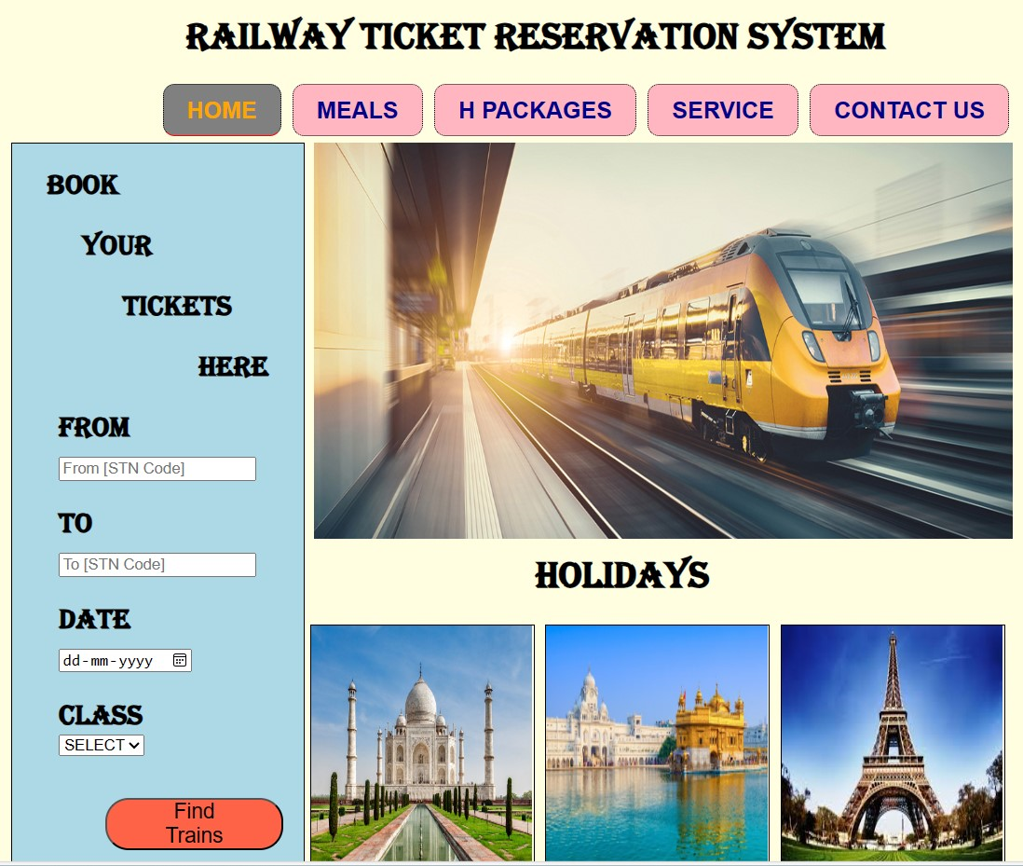

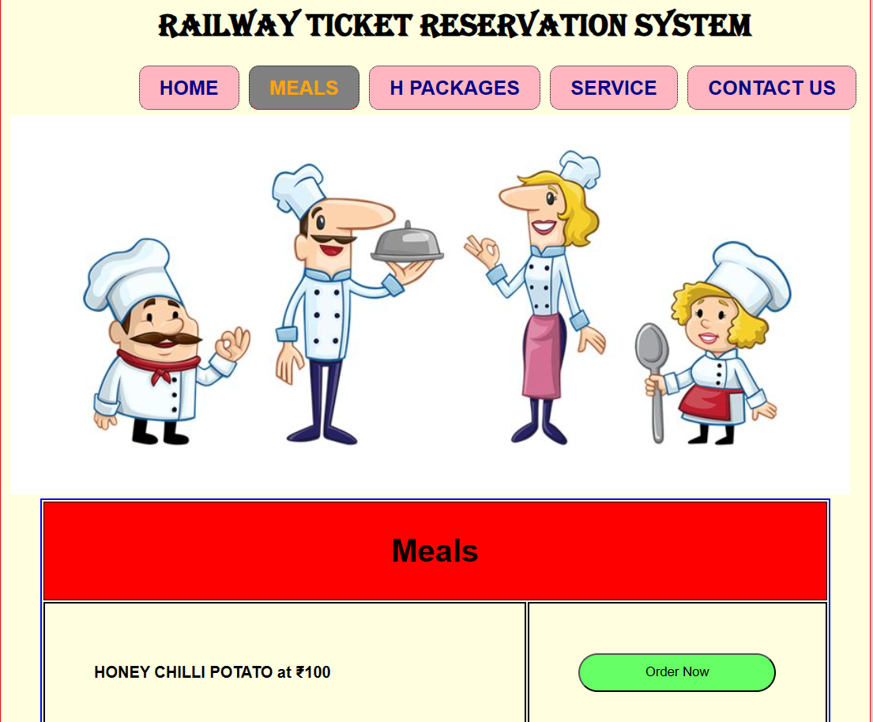

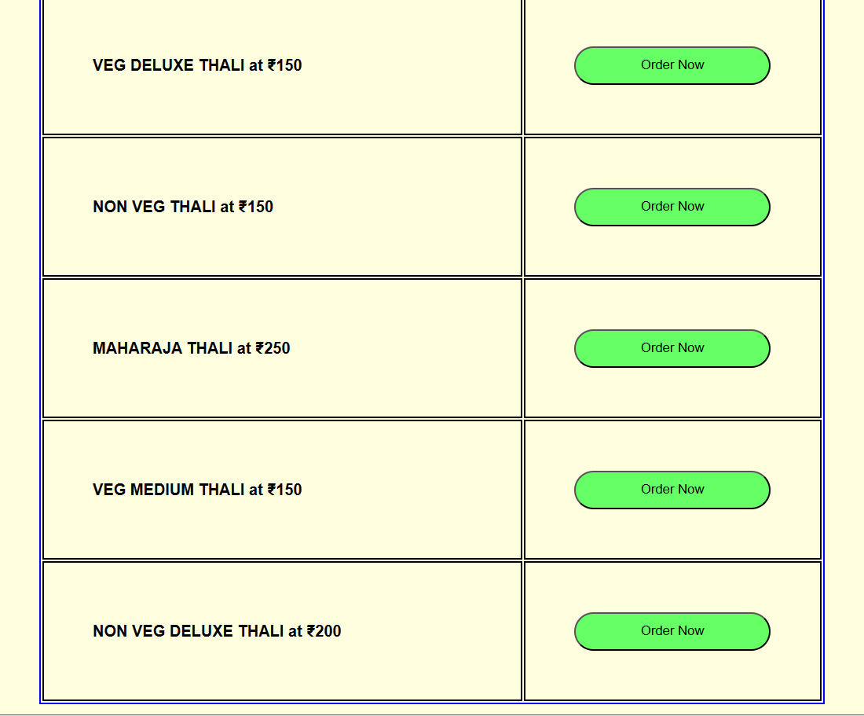

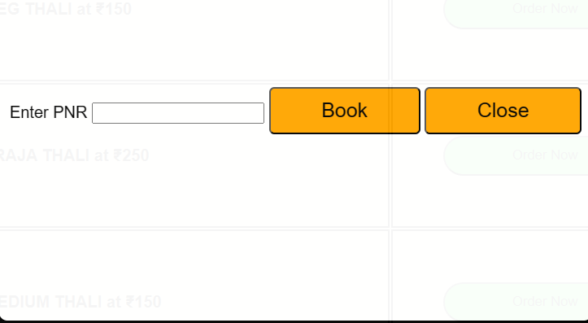

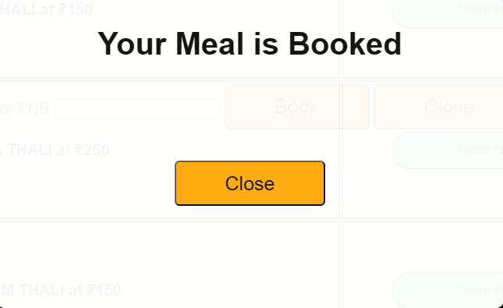

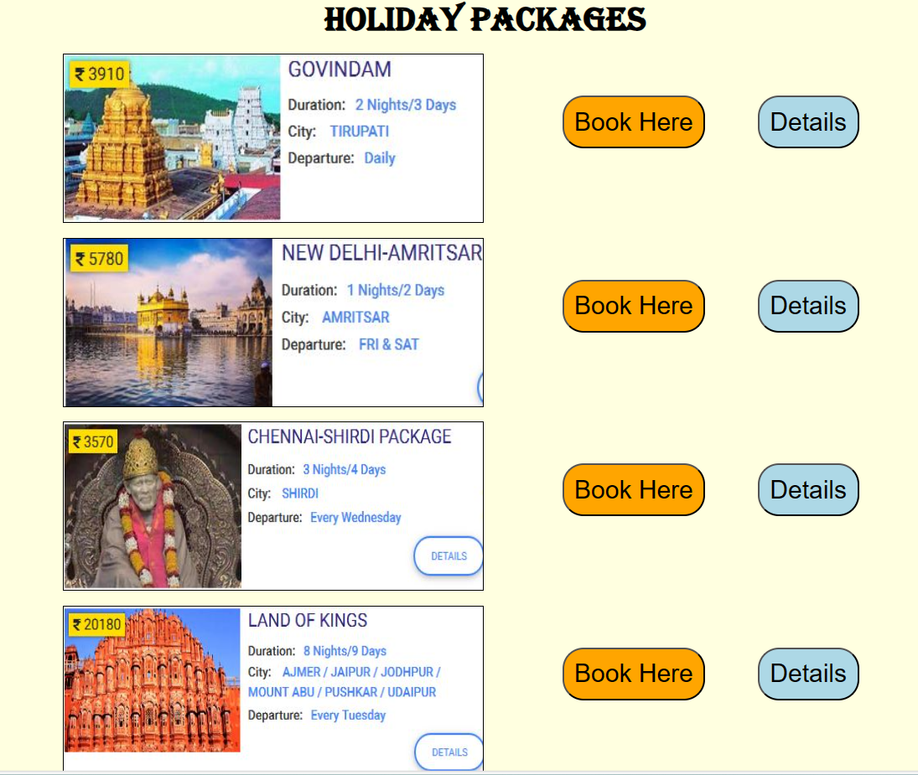

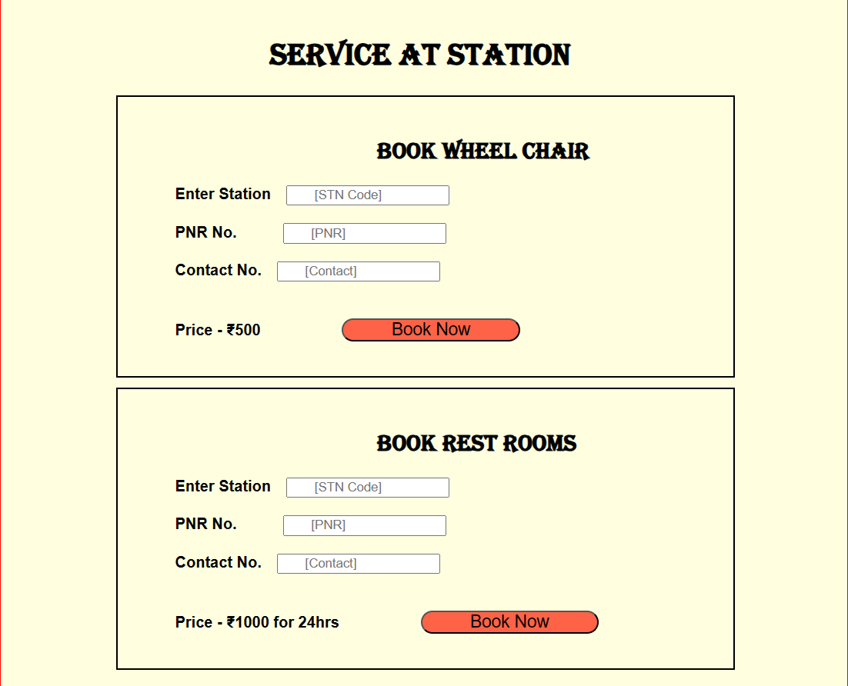

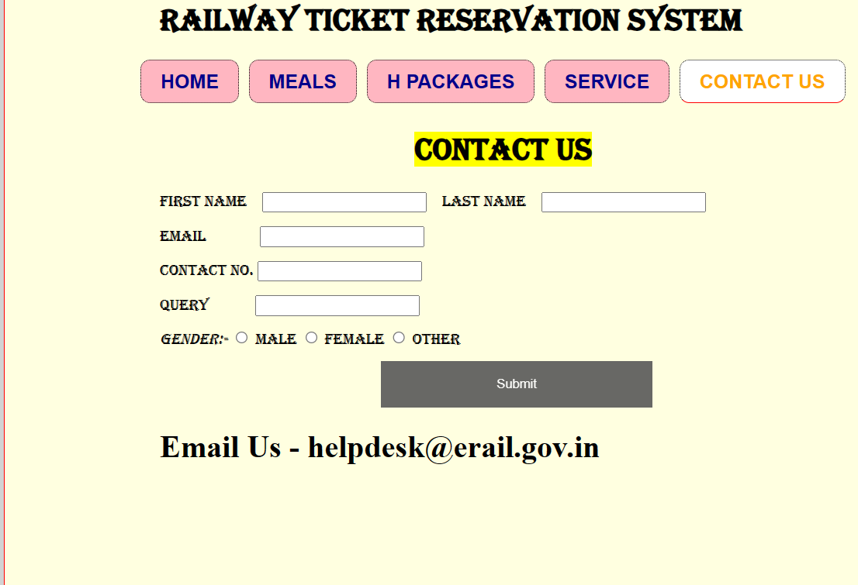

**CONCLUSION:**

The design and implementation of a railway booking system involve a thoughtful integration of various elements to ensure a seamless and user-friendly experience. From the intuitive user interface that captures essential details to the robust validation and booking logic implemented through JavaScript, each element plays a crucial role in the overall functionality. The clear and concise display of booking details and confirmation messages enhances user satisfaction, while the responsive design ensures accessibility across different devices.

Moreover, the potential integration with server-side logic and databases adds a layer of complexity, enabling features such as user authentication, secure payment processing, and the storage of booking information. The emphasis on security elements, including data encryption, underscores the commitment to safeguarding sensitive user information.

Ultimately, a well-executed railway booking system goes beyond mere transactional functionality. It embodies a harmonious combination of form and function, creating an efficient, secure, and enjoyable platform for users to plan their journeys. As technology evolves, the adaptability of the system to future enhancements and the continuous pursuit of user-centric improvements will be key to its sustained success in the dynamic landscape of online booking services.