**Understanding the Bayes Theorem .**

**Step1: Calculate the Prior Probability**

**Step 2: Calculate the Conditional Probability**

**Finally the given data point belongs to the class “No”(Not Play).**

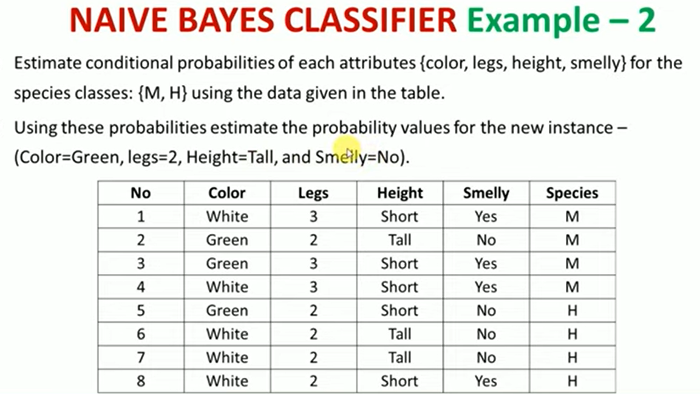

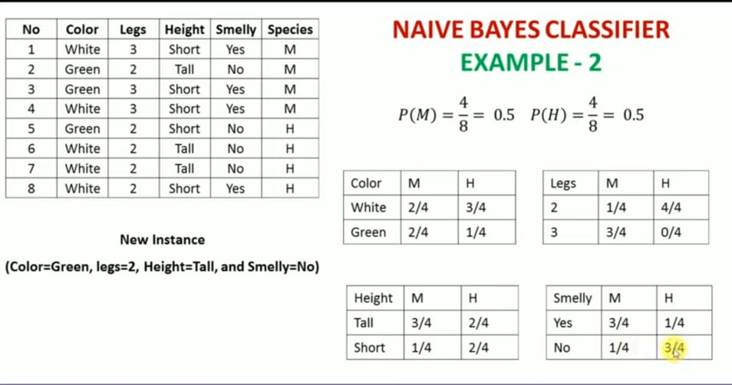

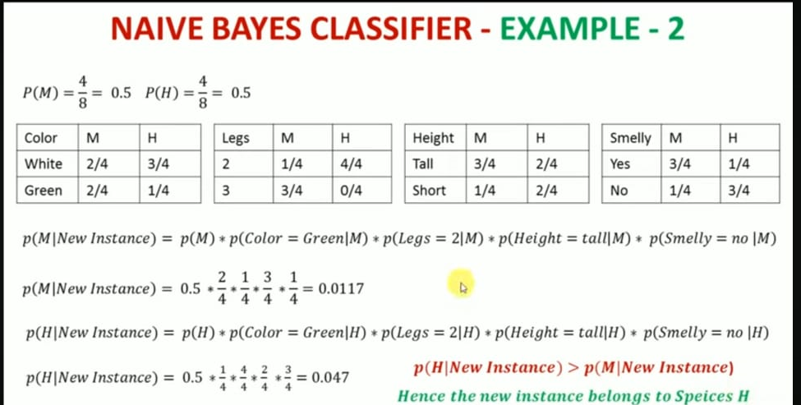

**Types of Naive Bayes**

Now let’s discuss different types of Naive Bayes algorithm and which is used when. So, we have three types

**1.Gaussian Naive Bayes**

This type of Naive Bayes is used when variables are continuous in nature. It assumes that all the variables have a normal distribution. So if you have some variables which do not have this property, you might want to transform them to the features having distribution normal.

**2.Multinomial Naive Bayes**

Next comes the multinomial Naive Bayes. This is used when the features represent the frequency.

Suppose you have a text document and you extract all the unique words and create multiple features where each feature represents the count of the word in the document. In such a case, we have a frequency as a feature. In such a scenario, we use multinomial Naive Bayes.

It ignores the non-occurrence of the features. So, if you have frequency 0 then the probability of occurrence of that feature will be 0 hence multinomial naive Bayes ignores that feature. It is known to work well with text classification problems.

**3.Bernoulli Naive Bayes**

This is used when features are binary. So, instead of using the frequency of the word, if you have discrete features in 1s and 0s that represent the presence or absence of a feature. In that case, the features will be binary and we will use Bernoulli Naive Bayes.

Also, this method will penalize the non-occurrence of a feature, unlike multinomial Naive Bayes.

**Advantages of Naive Bayes**

1. Here are some advantages of the Naive Bayes algorithm.
2. This algorithm is easier to build and simpler to understand.
3. It is much faster than the other algorithms as it is just calculating the probabilities.
4. Naive Bayes is easily scalable hence widely used in the industry.
5. It is a popular choice for text classification problems.

**Disadvantages of Naive Bayes Classifier**

* Assumes that features are independent, which may not always hold in real-world data.
* Can be influenced by irrelevant attributes.
* May assign zero probability to unseen events, leading to poor generalization.

**Applications of Naive Bayes Classifier**

* **Spam Email Filtering**: Classifies emails as spam or non-spam based on features.
* **Text Classification**: Used in sentiment analysis, document categorization, and topic classification.
* **Medical Diagnosis:** Helps in predicting the likelihood of a disease based on symptoms.
* **Credit Scoring:** Evaluates creditworthiness of individuals for loan approval.
* **Weather Prediction**: Classifies weather conditions based on various factors.