Delivery Route Graph CRUD – Package Delivery Service

Kundhana
dept.School of SCDS
Sai University
Chennai, India
Srisaikundhana.c-29@scds.saiuniversity.edu.in
Rakshitha
dept. School of SCDS
Sai University
Chennai, India
rakshitha.p-29@scds.saiuniversity.edu.in

Abstract—The Delivery Route Graph CRUD system is developed to efficiently manage package delivery routes using graph data structures. In this system, locations are represented as nodes, and the routes connecting them are represented as edges with associated distance values. The application is implemented using the C programming language and supports complete CRUD (Create, Read, Update, Delete) operations for effective route management. An adjacency matrix is used to represent the graph, enabling quick access and easy updates to route data. The system includes a user-friendly, menu-driven interface that simplifies managing delivery networks. This project highlights how fundamental data structures can be applied to solve real-world problems in logistics and transportation systems.
Keywords— Graph, Delivery Route Management, CRUD Operations, Adjacency Matrix, C Programming, Data Structures, Route Optimization, Logistics System, Network Modeling, Algorithm Design

I.INTRODUCTION

In today’s rapidly developing world, efficient logistics and transportation systems are essential for the timely delivery of goods and services. Delivery companies manage multiple locations and complex route networks, making manual route handling difficult and prone to errors. To overcome these challenges, graph data structures are widely used. A graph is a non-linear data structure consisting of nodes and edges, where nodes represent locations and edges represent routes connecting them. Graphs are highly suitable for modelling real-world systems such as road networks, delivery systems, and communication networks. This project presents a Delivery Route Management System implemented in C programming, which enables users to efficiently manage delivery routes using CRUD operations while providing practical exposure to real-world applications of data structures.
II. PROBLEM STATEMENT
Managing delivery routes manually presents several challenges, especially when dealing with many locations. Without a proper system, it becomes difficult to maintain accurate route information, leading to confusion and inefficiency. Errors in route selection can result in delayed deliveries, increased fuel consumption, and higher operational costs. Additionally, updating route information dynamically is a complex task in manual systems. For example, if a route changes due to traffic conditions or road closures, updating this information across all records becomes tedious and time-consuming. There is also a lack of proper tracking and searching mechanisms, making it difficult to verify whether a route exists or not. Therefore, there is a need for an automated system that can efficiently manage delivery routes. Such a system should allow easy addition, deletion, modification, and retrieval of route information. It should also minimize human errors, improve accuracy, and enhance overall system performance.
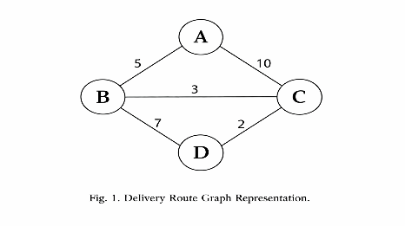
III.OBJECTIVES
The primary objective of this project is to develop an efficient Delivery Route Management System using graph data structures. The system aims to simplify the process of managing delivery routes and provide a structured approach to handling complex route networks. Another important objective is to implement CRUD operations that allow users to easily create, read, update, and delete route information. This ensures flexibility and ease of use. The project also aims to reduce manual effort and minimize errors associated with traditional route management methods. Furthermore, the system is designed with a menu-driven interface to make it user-friendly and accessible even to users with basic programming knowledge. Lastly, the project aims to demonstrate the practical application of data structures and algorithms in solving real-world problems, particularly in logistics and transportation systems.
IV.DATA STRUCTURE USED

The core data structure used in this project is a graph. A graph is an abstract data type that is used to represent relationships between different entities. In the context of this project, each delivery location is represented as a node (vertex), and the route between two locations is represented as an edge. Each edge is associated with a weight, which represents the distance between two locations. This weighted graph helps in understanding the cost or distance involved in traveling between locations. Graphs are highly flexible and can represent complex relationships efficiently. Using a graph structure allows the system to handle multiple routes and connections in a scalable manner. It also provides a foundation for implementing advanced algorithms such as shortest path finding, which can be added as future enhancements to the system.

V. SYSTEM DESIGN

The system is designed using an adjacency matrix representation of a graph. An adjacency matrix is a two-dimensional array where both rows and columns represent nodes (locations). Each element in the matrix indicates the presence or absence of an edge between two nodes, along with its weight (distance). If there is a route between two locations, the corresponding matrix entry stores the distance value. If no route exists, the value is set to zero. This representation allows quick access to route information and simplifies the implementation of CRUD operations. The system also includes a menu-driven interface that allows users to interact with the program easily. Users can select different options to perform operations such as adding, displaying, updating, deleting, or searching for routes. The design ensures simplicity, efficiency, and ease of use.
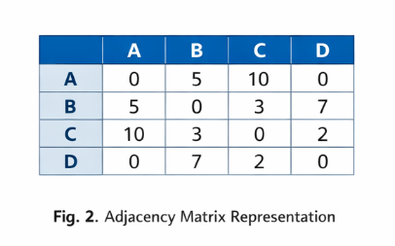

VI. ALGORITHM

The system is built around a set of algorithms that implement CRUD operations on the graph. The “Add Route” operation involves inserting a new edge between two nodes with a specified distance. The adjacency matrix is updated accordingly to reflect this change. The “Display Routes” operation traverses the matrix and prints all existing routes along with their distances. The “Update Route” operation allows users to modify the distance between two locations by updating the corresponding matrix value. The “Delete Route” operation removes a route by setting the matrix value to zero. The “Search Route” operation checks whether a route exists between two locations by verifying the matrix entry. These algorithms ensure efficient handling of route data and provide flexibility in managing the delivery network.

VII. IMPLEMENTATION

The system is implemented using the C programming language, which is known for its efficiency and control over system resources. The graph is represented using a two-dimensional array (adjacency matrix), and structures are used to organize related data.Separate functions are defined for each operation, such as adding, displaying, updating, deleting, and searching routes. This modular approach improves code readability and maintainability.A menu-driven interface is implemented using loops and conditional statements, allowing users to interact with the system easily. The program continuously prompts the user to choose an operation until they decide to exit.This implementation demonstrates how fundamental programming concepts such as arrays, functions, loops, and conditionals can be combined with data structures to create a practical and efficient system.

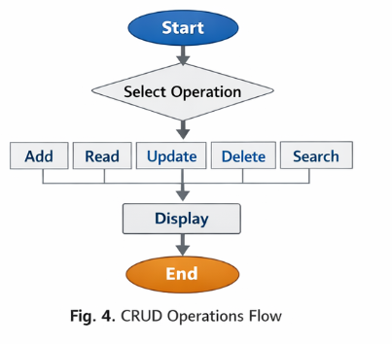

VIII. RESULTS / OUTPUT

The Delivery Route Graph CRUD system was successfully developed and tested. The system performs all CRUD operations efficiently, allowing users to manage delivery routes with ease. Routes can be added, updated, deleted, and displayed without any difficulty. The use of an adjacency matrix ensures quick access to route data, resulting in fast execution of operations. The system significantly reduces manual effort and minimizes errors associated with traditional methods. The menu-driven interface makes the system user-friendly and easy to operate. Overall, the results show that the system is effective in managing delivery routes and can be used as a foundation for more advanced applications.

IX. CONCLUSION

The Delivery Route Graph CRUD system demonstrates the effectiveness of graph data structures in solving real-world problems related to logistics and transportation. By representing locations as nodes and routes as edges, the system efficiently models complex delivery networks. The implementation of CRUD operations provides flexibility and ease of use, allowing users to manage routes dynamically. The adjacency matrix representation simplifies data storage and retrieval, making the system efficient and reliable. This project highlights the importance of data structures and algorithms in developing practical solutions. It also opens the door for future enhancements, such as implementing shortest path algorithms, real-time tracking, and integration with modern technologies. Overall, the project successfully achieves its objectives and provides a strong foundation for further development in delivery management systems.

