Full-stack with Angular and Spring boot.

# Pre-requisites

1. Install NPM (Node package manager) from the website (https://nodejs.org/en/).

Command line to verify post installation: npm -version

1. Install visual studio code from the website (https://code.visualstudio.com/download)

# Quick Overview of Modern JavaScript, TypeScript and Angular CLI

1. Understanding Full Stack Application Architecture

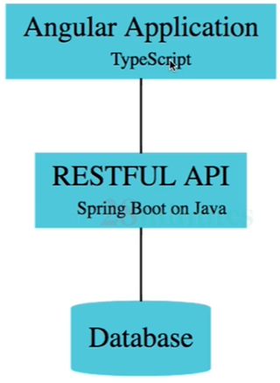

1. Quick Overview of Modern JavaScript and TypeScript

TypeScript = Javascript + Strong typing.

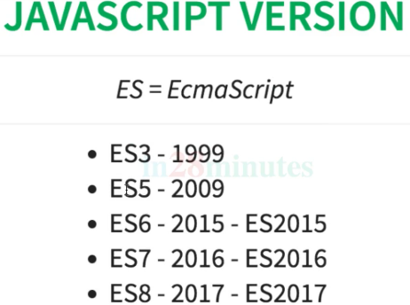

1. Installing Angular CLI
   1. Use the following website to know more about Angular CLI : <https://cli.angular.io/>
   2. To install angular cli, use the following command (run as admin)

npm install -g @angular/cli@7.0.3

* 1. Post the installation of CLI, use the following command to verify

ng version

1. Creating and Launching Angular Application with Angular CLI
   1. To create a new angular project use the command

ng new <project_name>

make the routing as Yes

stylesheet as CSS by default.

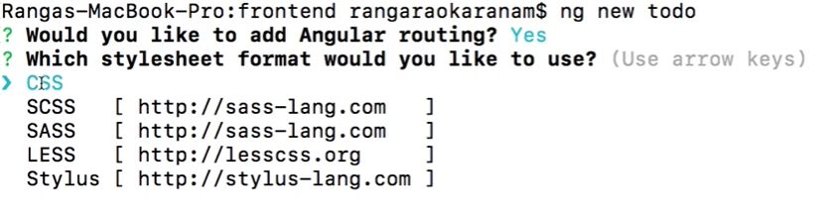

* 1. Navigate into the new project folder as specified in the previous step, Eg cd todo.
  2. Use the following command to build and start the new application created

ng serve

* 1. Launch your application using the following url in your chrome browser.

<http://localhost:4200>

Git Hub Repo of the whole course: <https://github.com/in28minutes/full-stack-with-angular-and-spring-boot>