CyPERS is a multi user and multi transactional application with Rich Internet Application (RIA) feel. The main technical challenges to address by the architecture are following,

1. Work-area based on User role & responsibilities
2. Different Input Mechanism (e-Pen, touch screen, table-PC etc)
3. Medication HIT ranking (based on doctor, group, hospital, etc)
4. “Software as Service” (SAS) based model.
5. Integration with existing system / data repository.
6. Automatic Patient record Work-flow.
7. Emergency Alters/Notification based on Patient Record
8. Data Mining for Medication, Diagnosis.

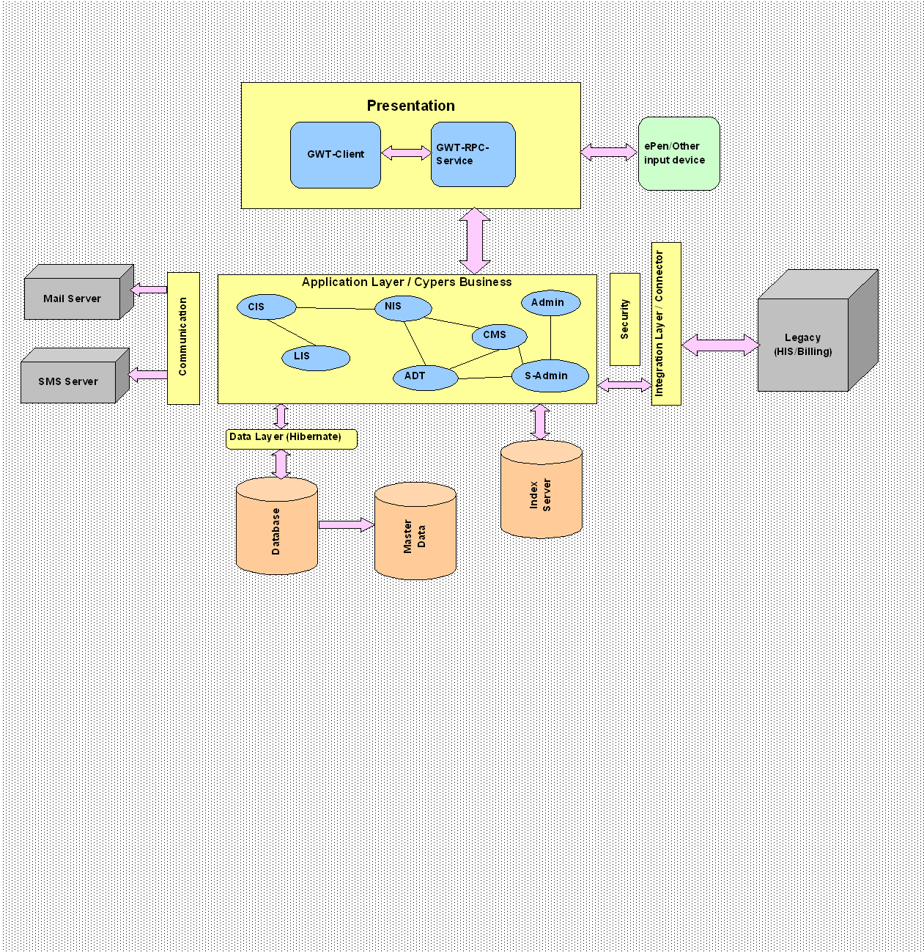

**ADTR** captures all patient centric information into CyPERS. Most of the patient information gathered is fetched by other modules from ADTR. ADTR tasks are handled by either hospital management executives or doctor secretaries. Following are the major functionality provided under ADTR:

1. Patient Registration with UHID no. generation
2. Appointment scheduler for outpatient visits
3. Out Patient visit management
4. Patient admission
5. Generate an IP ID in addition to UHID for In Patients
6. Bed allotment post admission
7. Allow transfer of patients between doctors and or beds
8. Provide Patient search based on various parameters – Quick and Advanced Search
9. Patient Discharge – both clinical & administrative

**CMS** offers a convenient way for doctors to enter, review, and continuously update all clinical information connected with any patient.

**Doctor Information System** (DIS) enables clinicians to enter, review, and continuously update all information connected with any patient. With DIS, one can order lab tests, medications, diets, radiology tests and procedures, record a patient’s allergies or adverse reactions to medications, request and track consults, and enter progress notes, diagnoses, and treatments for each encounter, and enter discharge summaries. Close integration with the “Incomplete Tasks” in CMS allows better record keeping and compliance with Clinical Guidelines and medical record requirements.

DIS not only allows hospital personnel to keep comprehensive patient records, it also enables clinicians, managers, and QA staff to review and analyze the data gathered on any patient in a way that directly supports clinical decision-making.

The departments covered by DIS are as follows:

1. OP
2. General Care wards
3. ICU and
4. ER

The care providers/users of DIS are as follows:

1. Senior Medical Staff/Consultant

2. Junior Medical Staff

3. Surgeon

4. Anesthetist

5. Nutritionist/Dietician

6. Social Worker and

7. Physiotherapist

**Laboratory Information System** (LIS) module is a clinically oriented system designed to provide data to health care personnel. It assists the Pathology and Laboratory Medicine Service in managing and automating the workload and reporting process. The Laboratory module supports the following areas: **Hematology, Biochemistry, Microbiology, Immunology, Pathology and Blood Bank**

Users of LIS are as follows:

1. Laboratory Doctor
2. Senior Technician
3. Technician and
4. Management Executive

**Radiology Information System** (RIS) assists with the functions related to processing patients for imaging examinations. It automates the entire range of diagnostic functions performed in imaging departments, including order entry of requests, registration of patients for exams, processing of exams, recording of reports/results, verification of reports on-line and displaying/printing results for clinical staff.

Users of Radiology Information System are as follows:

1. Radiologist
2. Senior Technician
3. Technician
4. Management Executive

**Others** would consist of capturing and documenting following investigation results:

1. Neurology
2. Pulmonary
3. Cardiology
4. Others (all other investigations apart from those listed above)