UML

- What is UML?

UML (Unified Modeling Language) developed as a graphical language for visualizing, specifying, constructing and documenting the artifact of the software intensive System.

Five Major view of UML are (USB IE)

- User
- Structural
- Behavioral
- Implementation
- Environment

User:
Use Case Diagram

Structural:
Class Diagram
Object Diagram

Behavioral:
Interaction Diagrams (Sequence and Collaboration)
Activity Diagram
State - Transition Diagram

Implementation: (I-C)
Component Diagram

Environment: (E-D)
Deployment Diagram

What are diagrams using in project are below (RADIO/D).

Requirement phase: RE-SCUO
Use Case, Class, Object and Sequence

Architecture phase: AR-CO2
Component and Collaboration

Design phase: DE-SACS
Class, Sequence, State and Activity

Implementation phase:I-C
Component

Deployment phase:
Deployment

UML Diagrams:

Use Case Diagram:

Use Case is set of scenario that describing an interaction between user and system. A use case diagram displays the relationship among actors and use cases. The two main components of a use case diagram are use cases and actors.
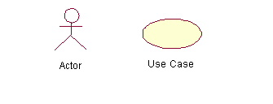

When to Use: Use Cases Diagrams
Use cases are used in almost every project. They are helpful in exposing requirements and planning the project. During the initial stage of a project most use cases should be defined, but as the project continues more might become visible.
Example:

Here the example is buyer and seller how to interact with the systems

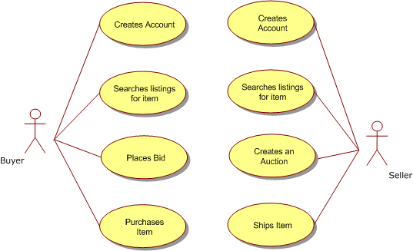

Reuse the Use Case:
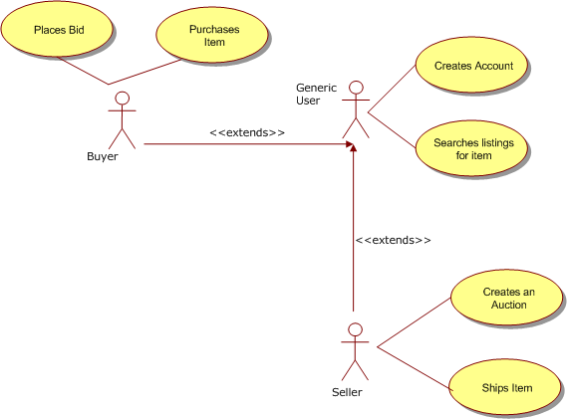

Class Diagram:

Class diagram typically describe the object Type and their relationship (Generalization, Association and Aggregation).
Class is composed into 3 types that are
- name
- attributes
- Operations.
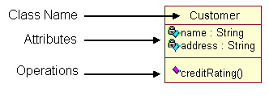
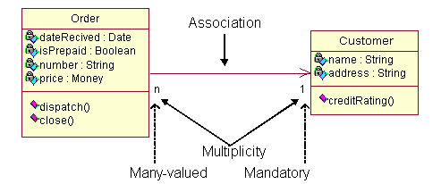

The association relationship is the most common relationship in a class diagram. The association shows the relationship between instances of classes. For example, the class Order is associated with the class Customer. The multiplicity of the association denotes the number of objects that can participate in then relationship.¹ For example, an Order object can be associated to only one customer, but a customer can be associated to many orders.
Another common relationship in class diagrams is a generalization. A generalization is used when two classes are similar, but have some differences. Look at the generalization below:
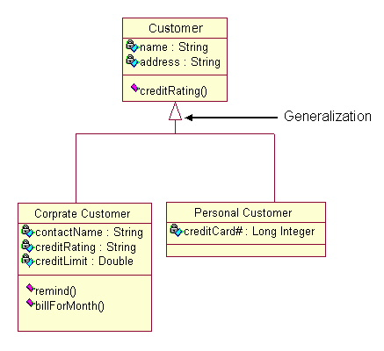
In this example the classes Corporate Customer and Personal Customer have some similarities such as name and address, but each class has some of its own attributes and operations. The class Customer is a general form of both the Corporate Customer and Personal Customer classes.¹ This allows the designers to just use the Customer class for modules and do not require in-depth representation of each type of customer.
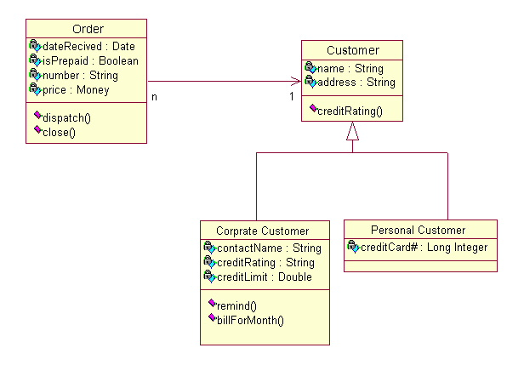

When to Use: Class Diagrams:
Class diagrams are used in nearly all Object Oriented software designs. Use them to describe the Classes of the system and their relationships to each other.
Sequence Diagram:

Sequence diagrams generally show the sequence of events that occur.
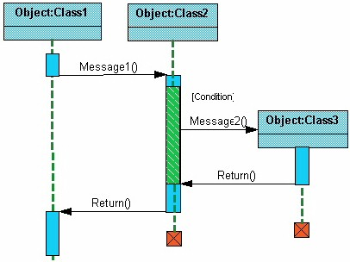

Collaboration diagram:

Collaboration diagrams demonstrate how objects are statically connected.

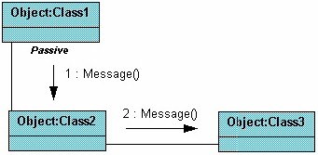

State Diagram:

State diagrams are used to describe the behavior of a system. State diagrams describe all of the possible states of an object as events occur. Each diagram usually represents objects of a single class and tracks the different states of its objects through the system.
State diagrams have very few elements.
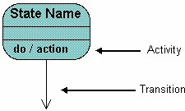
Below is an example of a state diagram might look like for an Order object. When the object enters the Checking state it performs the activity "check items." After the activity is completed the object transitions to the next state based on the conditions [all items available] or [an item is not available]. If an item is not available the order is canceled. If all items are available then the order is dispatched. When the object transitions to the Dispatching state the activity "initiate delivery" is performed. After this activity is complete the object transitions again to the Delivered state.
Initial State
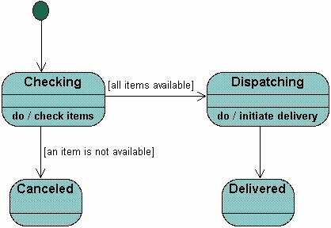

Activity Diagram:
Activity diagrams describe the workflow behavior of a system. Activity diagrams are similar to state diagrams because activities are the state of doing something.
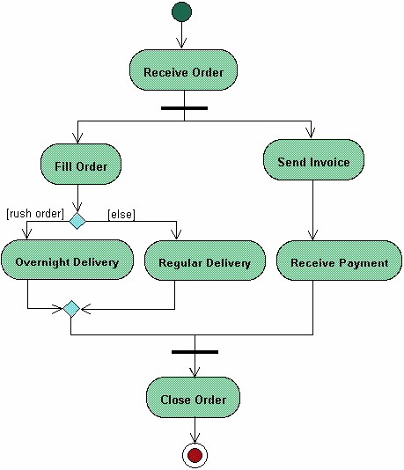

Relationship:
There is more Relationship in UML that are
- Abstraction
- Aggregation
- Association
- Binding
- composition
- Dependency
- Generalization
- Realization

Aggregation (‘Has – a’):

Aggregation is a special type of ‘has-a’ relationship between classes and Weak relation between the two classes means when then one entity is deleted then other object will not get affected.
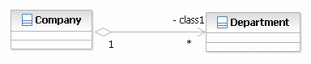

Association:

Association defines the relationship between two or more classes. These generally relates to the one object having instance or reference of another object inside it. Associations in UML can be implemented using following ways:
1. Multiplicity
2. Aggregation
3. Composition
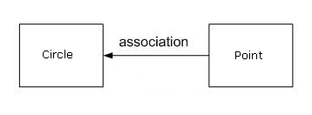

Public class Cirlce{
Protected Point pointObj;
}
Public class Point{
private int X_POS = 0;
public int getXpos() {
return this.X_POS;
}
public void setXpos(int xpos) {
this.X_POS = xpos;
}
}
Generalization (‘Is - a’):
Generalization nothing but (‘is-a’) relations between two classes means parent and child relation.
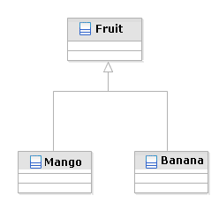
Dependency:
Dependency relationship is a relationship in which one element, the client, uses or depends on another element, the supplier.
