

CyPERS
BRD02 – ADMISSION, DISCHARGE, TRANSFER AND REGISTRATION
Use Case v1.0



June 03, 2010
Authored by:
Ignis Technology Solutions Private Ltd.

Information contained in this document is classified Ignis Technology Solution Private Ltd... Confidential Proprietary. Only authorized Ignis Technology Solutions Private Ltd. personnel shall have access to the information contained in this document unless business needs dictate, otherwise. It is the responsibility of the person knowing the information contained in this document to ensure confidentiality of information contained in it and securing this document from unauthorized access at all times.
DOCUMENT INFORMATION
Author | Darshan BA
Reviewer | Dr. Umesh Gupta
Approver | Dr. Umesh Gupta
Approved Date

CHANGE HISTORY
Version # | Release Date | Sections Changed | Author | Change Description
0.1 | June 11, 2010 | All | Darshan BA | Draft Version
0.1 | June 15, 2010 | Registration | Darshan BA | Replaced screen for registration screen
1.0 | June 22, 2010 | All | Darshan B.A | Incorporated client feedback

Acronyms
Acronym | Definition
CMS | Care Management System
CyPERS | Cyber patient electronic record system
ADTR | Admission, Discharge, Transfer and Registration
ME | Management Executive

Table of Contents

1.Introduction 4
2.1. Use Case Model 5
2.2. UC 2.1 Registration 6
2.2.1 Functional Requirements 6
2.2.2 Validations 7
2.2.3 Basic Workflow 7
2.2.4 Screen Layout 8
2.3. UC 2.2 OP Visit 9
2.3.1 Assumptions 9
2.3.2 Functional Requirements 9
2.3.3 Validations 10
2.3.4 Basic Workflow 10
2.3.5 Screen Layout 11
2.4. UC 2.3 Setup Appointment 12
2.4.1 Assumptions 12
2.4.2 Functional Requirements 12
2.4.3 Basic Workflow 13
2.4.4 Screen Layout 14
2.5.1 Assumptions 16
2.5.2 Functional Requirements 16
2.5.3 Validations 17
2.5.4 Basic workflow 17
2.5.5 Screen Layout 18
2.5. uc 2.5 patient transfer 19
2.6.1 Assumptions 19
2.6.2 Functional Requirements 19
2.6.3 Validations 20
2.6.4 basic Workflow 20
2.6.5 Screen Layout 21
2.6. uc 2.6 patient discharge 23
2.7.1 Assumptions 23
2.7.2 Functional Requirements 23
2.7.3 Validations 24
2.7.4 basic Workflow 24
2.7.5 Screen Layout 24
2.7. uc 2.7 Quick search 26
2.8.1 Assumptions 26
2.8.2 Functional Requirements 26
2.8.3 Validations 27
2.8.4 Basic Workflow 27
2.8.5 Screen Layout 28
2.8. uc2.8 OP Slot Setup 30
2.9.1 Assumptions 30
2.9.2 Functional Requirements 30
2.9.3 Validations 30
2.9.4 Basic Workflow 30
2.9.5 Screen Layout 31

Introduction
ADTR captures all patient centric information into CyPERS. Most of the patient information gathered is fetched by other modules from ADTR. ADTR tasks are handled by either hospital management executives or doctor secretaries. Following are the major functionality provided under ADTR:
- Patient Registration with UHID no. generation
- Appointment scheduler for out patient visits
- Out Patient visit management
- Patient admission
- Generate an IP ID in addition to UHID for In Patients
- Bed allotment post admission
- Allow transfer of patients between doctors and or beds
- Provide Patient search based on various parameters – Quick and Advanced Search
- Patient Discharge – both clinical & administrative

Use Cases

Use Case Model

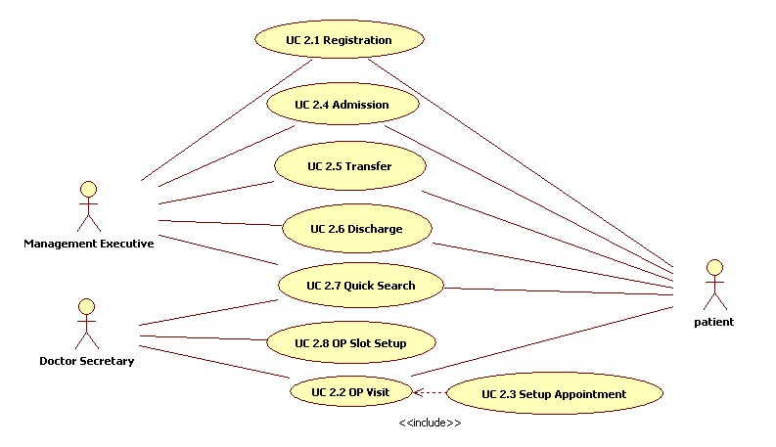

UC 2.1 Registration
Use Case No. | CyPERS/UC/2.1
Name | Patient Registration
Actors | Management Executive (ME)
Description | Patient approaches the registration counter at the hospital to register before visiting the doctor. Patient Registration is a onetime activity.
Trigger | Patient approaches the counter staff to get registered in order to visit a doctor
Pre Conditions | - ME has logged into the system  - ME has identified the patient through UC 2.7 Quick Search and clicked on “Registration” icon

Functional Requirements
No. | Description
2.1FR1.0 | Patient approaches registration counter.
2.1FR2.0 | ME collects the following information for registration  - Demographic Information: Name, DOB, Age, Gender, Nationality, Occupation, Designation, Company, Next of Kin, Relation, Ph. No  - Telephone/Email ID/Referral information: Present & Permanent Address, Telephone, Email ID and referral information  - Insurance Information: Insurance Provider / TPA / Corp, Policy No., scanned copy of policy (upload to system)  - Passport & Visa Information: For other than Indian nationality
2.1FR3.0 | ME can select check box if Permanent and Present address are same. In such a case, the fields in Permanent Address gets auto populated with those in present address
2.1FR4.0 | ME can upload scanned copy of insurance policy into system through Upload option.
2.1FR4.0A | Upon clicking Upload button, a pop up opens for ME to select the insurance policy image and upload
2.1FR5.0 | In case the nationality selected is other than Indian, a section to capture Passport and Visa information must appear
2.1FR6.0 | Upon clicking Register button, the system will validate the information (Pls. refer validations section below). Appropriate error messages should be displayed.
2.1FR6.0A | Prompt ME with a Registration confirmation message
2.1FR6.0B | Upon selecting Yes, system registers the patient and displays the registered patient information along with newly generated UHID (Ref: Proposed Screen 2.1A)
2.1FR6.0C | Registration Summary screen to consist 2 buttons namely “Setup Appointment” and “Admission” for ME to navigate to respective screens, post registration
2.1FR6.0D | UHID: Auto generate based on the following combination  The UHID should consist of two parts: The first part consists of three digits that identify the facility. This number is generated by the system as soon as a facility is enrolled by Super-admin. It remains constant for a facility. The second part of the UHID is of six digits auto generated by the system, starting from number 100001
2.1FR6.0E | Upon selecting No the info entered remains unregistered.
2.1FR7.0 | At any point of time ME can cancel the registration process by selecting Reset button. This will clear all the fields already entered in the screen.

Validations
No | Description
2.1VAL1.0 | Mandatory Fields:  First Name, DOB, Age, Gender, Present Address except line 2.  If Permanent address is not same as Present address, all fields except line 2 are mandatory.  If Nationality selected is other than Indian, Passport and Visa Information section to be captured mandatorily
2.1VAL2.0 | DOB: Calendar option
2.1VAL3.0 | Age: Auto generate if DOB entered. If age entered, automatically generate approximate DOB as 01/01/yyyy
2.1VAL4.0 | Name, Occupation, Designation, Company, Next of Kin, Relation, Insurance Provider/TPA, Policy No.: Free Text Box

Basic Workflow

- ME selects Registration icon in the left pane and presented with Registration screen in working area
- ME captures following registration info:
  - Demographic Information
  - Contact Information and
  - Insurance Information
  - Passport and Visa Information
- Selects either Register or Cancel button
- Upon registration
  - Generate a UHID
  - Summarize the registration information with buttons to navigate to Setup Appointment or Admission screen
- Upon selecting cancel, do not proceed to register ie. await ME’s inputs

Screen Layout
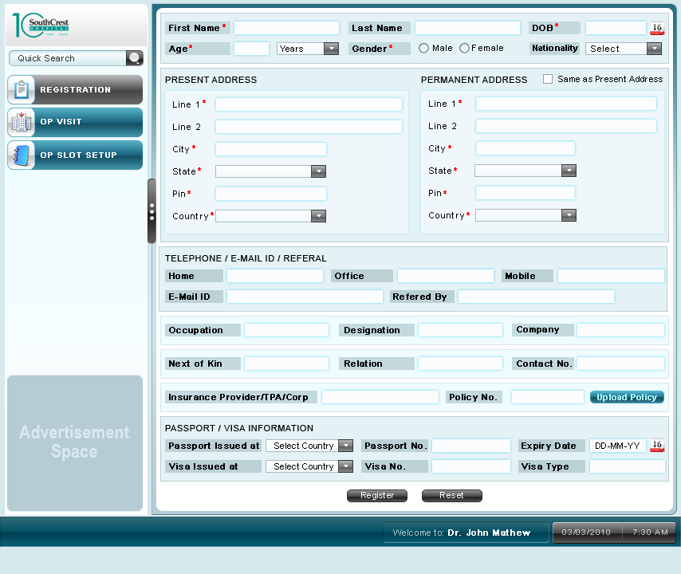

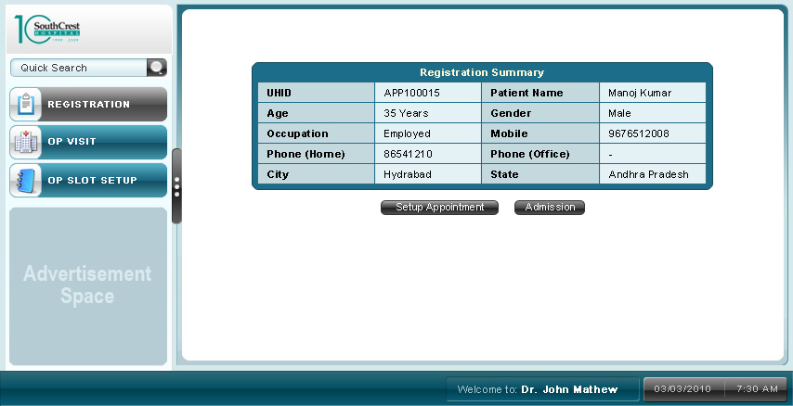

UC 2.2 OP Visit

Use Case No. | CyPERS/UC/2.2
Name | Out Patient Visit
Actors | Management Executive (ME) or Doctor Secretary and Patient
Description | The Patient appointment is verified and directed to appropriate doctor for consultation
Trigger | Patient approaches the counter and requests to visit a doctor
Pre Conditions | - ME has logged into the system  - ME has identified the patient through UC 2.7 Quick Search and clicked on “OP Visit” icon

Assumptions
No | Description
2.2AS1.0 | Patient Registration is mandatory to visit a doctor

Functional Requirements
No. | Description
2.2FR1.0 | By default ME is presented with a list of all out patient appointments scheduled for current day
2.2FR1.0A | List to consist of foll headings:  - UHID  - Patient Name  - Appointment No.  - Doctor to visit  - Date of visit  - Time of visit  - Purpose of visit and
2.2FR2.0 | ME to be provided with a search option to search patient appointment from the list
2.2FR2.0A | ME to search for a patient through one or more of foll. parameters:  - UHID  - Patient Name  - Appointment Number  - Doctor to Visit (smart search)  - Date of Visit  - Mobile No.
2.2FR3.0 | Radio button besides each patient in the list to be provided for ME to select and notify respective doctor, the arrival of patient
2.2FR3.0A | Upon selecting “Confirm Arrival” button for a registered patient, the patient name in ME’s screen and doctor’s “To Do List” to get color coded alerting doctor, the arrival of patient
2.2FR3.0B | Upon selecting “Confirm Arrival” button for an unregistered patient, ME to be directed to registration screen (UC 2.1 Patient Registration), and upon successful registration, and then confirm arrival (2.2 FR 3.0A)
2.2FR3.0C | Upon selecting “Setup Appointment”
2.2FR4.0 | ME to be provided with option to Cancel an appointment by selecting appropriate button
2.2FR5.0 | If an unregistered patient already taken appointment gets registered without furnishing the appointment details, ME or DS to be provided with option to key in UHID of registered patient in the OP visit list (as the list in not updated with patient registration information). Upon adding the UHID, the appointment to get linked with the patient UHID.

Validations
No | Description
2.2VAL1.0 | UHID field should accept alpha numeric characters
2.2VAL2.0 | Patient Name field - alphabets only
2.2VAL3.0 | Appointment Number – numeric only

Basic Workflow
- ME clicks on OP Visit icon in left pane
- ME is presented with a list of all appointments scheduled for the day.
- Identifies the patient
  - Directly from the list (manual search and selection) or
  - Through filters, to narrow down list to exact or near matching patients. Filter list through one or more of the following parameters:
    - UHID
    - Patient Name
    - Appointment No.
    - Doctor to visit (Smart Search and entry option)
    - Date of visit
    - Mobile No.
- Select Radio button besides the identified patient to do one of the following:
  - Confirm Arrival
  - Cancel Appointment
  - Setup Appointment
- Select Confirm Arrival button to indicate to doctor, arrival of patient. The patient information in ME’s list and doctor’s To Do List will get color coded indicating patient arrival
- If patient selected to confirm arrival is un registered, direct user to registration screen and upon successful registration, go to step 5
- ME can cancel a scheduled appointment by selecting Cancel Appointment button. Internally, the system would release the booked slot for further appointment scheduling.
- In case, an unregistered patient who has already taken appointment, directly gets registered without furnishing appointment information, following will be the workflow:
  - Patient completes registration process as mentioned in UC 2.1 Registration and gets a UHID
  - Patient then approaches DS and furnishes UHID and appointment details – Name, Appointment No or Time of visit
  - DS identifies the appropriate patient and keys in the UHID
  - Appointment to now get linked with the patient UHID
  - Goto step 5

Screen Layout
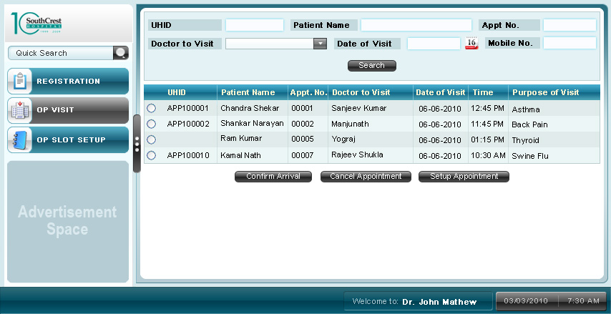

UC 2.3 Setup Appointment

Use Case No. | CyPERS/UC/2.3
Name | Setup Appointment
Actors | Management or Management Executive (ME) or Doctor Secretary (DS) and Patient
Description | Hospital can schedule appointments for out patients through this screen
Trigger | Patient requests for an appointment with a doctor for a particular date and time
Pre Conditions | - ME has logged into the system  - ME has identified the patient through UC 2.7 Quick Search

Assumptions
No. | Description
2.3AS1.0 | User is made aware of the doctor to visit
2.3AS2.0 | Doctor’s visiting dates and time are made available to CyPERS
2.3AS3.0 | This screen always opens as a pop up

Functional Requirements
No. | Description
2.3FR1.0 | DS to be provided with option to setup appointment for following types of patients:  - Registered patients  - Un registered patients
2.3FR2.0 | If a registered patient is selected for appointment setup, patient demographics to get loaded at the top of working area else DS to capture the Patient First Name, Last Name and Mobile No. and proceed further
2.3FR3.0 | DS selects the doctor department and doctor of choice from respective combo boxes and in the order mentioned
2.3FR4.0 | Doctors list in combo box gets generated based on department selected
2.3FR5.0 | Doctor’s visit days are displayed in the text box
2.3FR6.0 | Doctor’s working calendar gets displayed for user to select the date from
2.3FR7.0 | Based on the date selected, doctor’s visiting hours are displayed. It is divided into various time slots
2.3FR8.0 | User selects one of the available time slots for the patient. If a slot is already booked (color coded), it cannot be assigned to any other patient.
2.3FR9.0 | Booking information gets summarized below with following information:  - Date of Appointment  - Time of Appointment  - UHID  - Patient Name  - Purpose of visit: User has to enter information in the free text box provided  Note: In case of un registered patient, UHID field will be blank
2.3FR10.0 | User conveys above information to patient and confirms by clicking “Confirm Appointment” button
2.3FR11.0 | Upon confirming the appointment, the summary as in 2.3FR9.0 to pop up along with Appointment No.
2.3FR12.0 | - Appointment No. so generated to be unique across the hospital/facility ie. no two appointment nos. can be same for a given date.  - Appointment no. to start with 0001 everyday
2.3FR13.0 | The particular time slot gets booked (color coded) and cannot be booked or assigned again to any other patient unless it gets  - modified or  - canceled
2.3FR14.0 | At any point of time during scheduling, user can cancel the appointment by clicking “Reset” button. This will clear all the fields entered.
2.3FR15.0 | A check box (by default unchecked) to be provided for DS to setup appointment for walk in patients. Upon checking the box, DS can generate an appointment for selected patient irrespective of slot availability.

Basic Workflow
Setup Appointment for Registered Patient
- DS selects patient through Quick search1 or Quick Search2 result screen and clicks on Setup Appointment button
- DS is then presented with setup Appointment screen (Ref: Setup Appointment 1)
- DS selects department and doctor from combo box
- System to display selected doctor’s days of visit to hospital
- ME selects one of the dates from the calendar for appointment booking
- Doctor’s time slots are presented for ME to select
- ME selects a time slot of patient choice. If not available, go to step no. 5
- Selected slot gets blocked for the patient (color coded)
- A summary of appointment is displayed for confirmation.
- If acceptable to patient, confirm the appointment, else go to step 6

Setup Appointment for Unregistered Patient
- DS enters OP Visit screen and clicks on Setup Appointment Button
- DS is then presented with setup Appointment screen (Ref: Setup Appointment 2)
- DS captures Patient First Name, Last Name and Mobile No.
- DS selects department and doctor from combo box
- System to display selected doctor’s days of visit to hospital
- ME selects one of the dates from the calendar for appointment booking
- Doctor’s time slots are presented for ME to select
- ME selects a time slot of patient choice. If not available, go to step no. 5
- Selected slot gets blocked for the patient (color coded)
- A summary of appointment is displayed for confirmation. Here UHID field remains blank as patient is not yet registered.
- If acceptable to patient, confirm the appointment, else go to step 6

Screen Layout

Setup Appointment 1
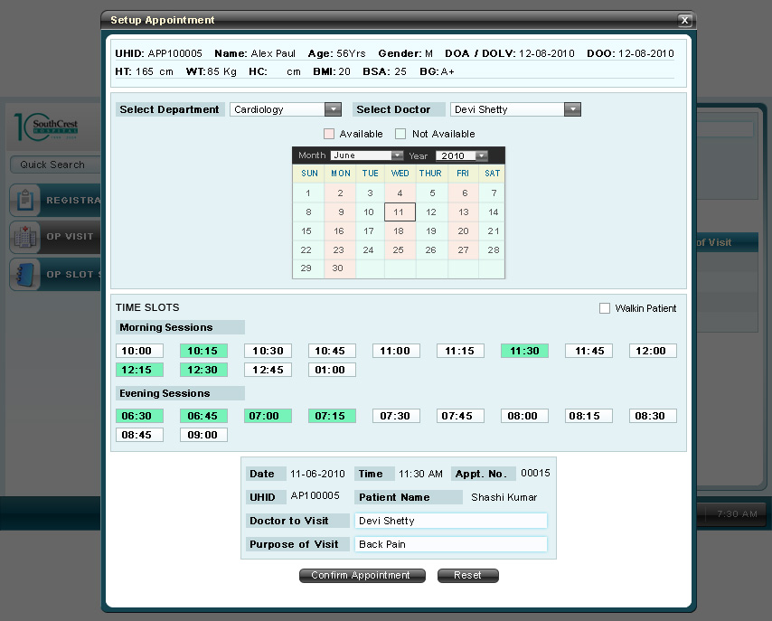
Setup Appointment 2
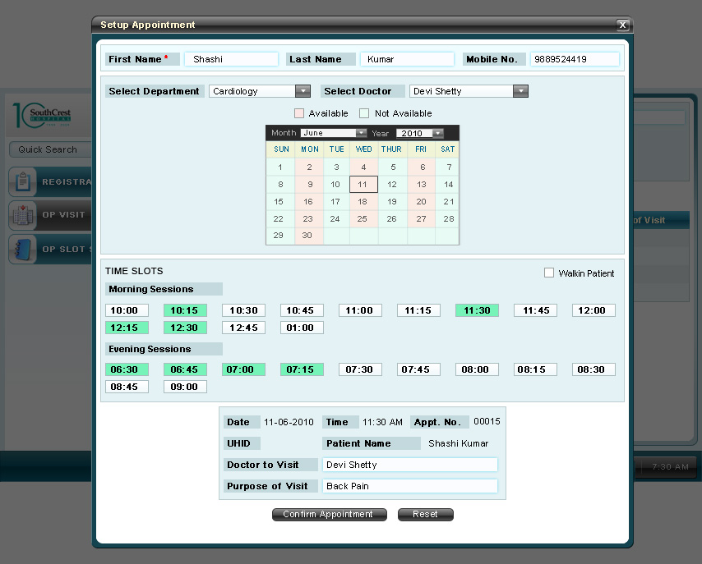
UC 2.4 admission
Use Case No. | CyPERS/UC/2.4
Name | Admission
Actors | Management Executive (ME), Patient
Description | This screen enables admission of a patient to hospital based on doctor orders.
Trigger | Patient approaches the counter to get admitted at hospital
Pre Conditions | - ME has logged into the system  - Doctor has ordered for patient admission  - ME has identified the patient through UC 2.7 Quick Search and selected Admission button

Assumptions
No | Description
2.4AS1.0 | A bed is classified based on the following parameters only – Ward Category & Ward Name

Functional Requirements
No. | Description
2.4FR1.0 | Patient approaches the admission counter and furnishes the foll. information necessary for admission
2.4FR2.0 | Doctor(s) attending the patient for treatment
2.4FR3.0 | Free text box to enter referral information – referred doctor and or hospital
2.4FR4.0 | Select Ward Category and Ward Name from combo boxes
2.4FR5.0 | Upon clicking the button “Select Bed”, a pop up opens up listing all the available beds in the ward category and type selected. Based on the patient’s preference a particular bed is selected. Upon clicking ”Allot” button, selected bed gets allotted to patient. At any point of time during allotment, ME should be able to cancel the selection and close pop up
2.4FR6.0 | Bed No. gets auto filled based on the bed allotted as above
2.4FR7.0 | Payment mode can be selected from combo box. Payment mode can be Cash – If patient is making all the payments  Govt. Body/PSU/Corp – If all payments are made by employer of patient  TPA – If all payments are made by patient insurer
2.4FR7.0A | If Paying option is selected from combo box, another field Advance Paid appears for patient to make some advance payment
2.4FR7.0B | If TPA/Govt. Body/PSU/Corp option is selected, following fields will appear auto filled (if these info are captured at the time of registration)  - TPA/Govt. Body/PSU/Corp Name  - Policy No.  ME can edit this information or enter afresh in the respective fields. If edited, this information will be over written with that captured during registration.  Also, ME has to take an approval from respective TPA/Govt. Body/PSU/Corp for admission and enter Approval No. in the text box.
2.4FR8.0 | Upon clicking Admit the admission information gets registered and patient status as admitted. At any point of time during admission, ME can terminate the process by clicking Cancel button thus resetting all the fields as blank.
2.4FR9.0 | Upon successful admission, an Inpatient ID (IP ID) apart from UHID gets generated. In-patients are tracked by their IP ID’s. IP ID is unique and valid for that particular admission only
2.4FR9.0A | Upon successful admission, system to send an SMS to Doctor 1 and Doctor 2 seleeted during admission
2.4FR9.0B | Upon successful admission, a pop up opens up summarizing the admission information

Validations
No | Description
2.4VAL1.0 | Doctor 1, Doctor 2, Referred By & Insurance Provider / TPA / Corp – Fields should accept only alphabets
2.4VAL2.0 | Approval – Alpha-numeric
2.4VAL3.0 | Advance Paid field should accept only numerals and always prefixed with “Rs.”
2.4VAL4.0 | Doctor 1 – Mandatory field

Basic workflow
- ME has identified patient for admission
- Clicks on Admission button
- Working area of screen is loaded with admission form
- ME selects the doctor(s) who would be attending the patient
- If patient is referred by another doctor or hospital, ME to enter it in the free text box
- Select Ward Category and Ward Type from respective combo boxes
- Click button to select bed
- Select bed No. from pop up
- Select Allot button to allot selected bed to patient or Cancel button to cancel bed allotment
- Select Payment mode through combo box
- If payment mode is either Insurance Provider/TPA/Corp enter Name of Insurance Provider/TPA/Corp, Policy No., Approval code in respective text boxes. Also upload scanned copy of policy into system
- Finally Admit the Patient and generate an IP ID or cancel the entire admission process
- Upon successful admission summarize admission information

Screen Layout
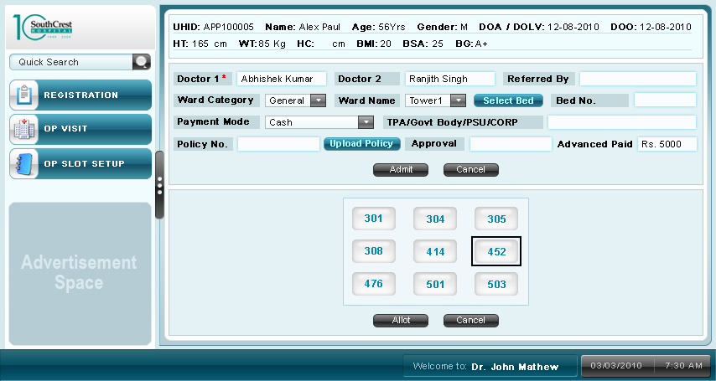
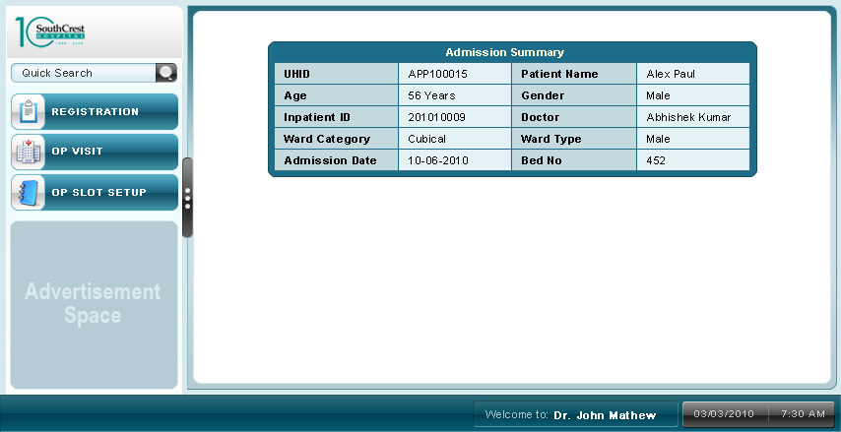

uc 2.5 patient transfer
Use Case No. | CyPERS/UC/2.5
Name | Patient Transfer
Actors | Management Executive (ME), In Patient (IP)
Description | An In patient can request to transfer between beds and or doctors (for various reasons) through this screen
Trigger | IP requests for a transfer between beds and or doctors
Pre Conditions | - ME has logged into the system  - ME has identified the patient through UC 2.7 Quick Search and selected Patient Transfer button

Assumptions
No | Description
2.5AS1.0 | A bed is classified based on the foll. parameters only – Ward Category & Ward Name
2.5AS2.0 | Patient has to provide a document proof for change of doctor to ME upon which ME would initiate transfer of patient between doctors

Functional Requirements
No. | Description
2.5FR1.0 | In Patient approaches the admission counter and requests for either or all of the following:  - Transfer between beds  - Transfer between doctors
2.5FR2.0 | Scenario 1: Transfer of patient between beds
2.5FR2.0A | Based on the in patient selected display their occupied bed details:  - Bed No.  - Ward Category  - Ward Name  - Bed Allotment Date  - Bed Allotment Time
2.5FR2.0B | Provide combo boxes to select Ward Category and Ward Name
2.5FR2.0C | List out all the available beds in selected ward and category as a pop up for ME to select from, for the IP
2.5FR2.0D | ME can Allot a bed from the pop up. At any point of time during allotment, ME should be able to Cancel the allotment and close pop up
2.5FR2.0E | Upon selecting a bed, display new bed details:  - Bed No.  - Ward Category  - Ward Name
2.5FR2.0F | ME should be able to capture foll. info also:  - Request Receipt date and Request fulfillment date in separate fields. Request Receipt date field should be an entry box while Request fulfillment date field gets auto generated based on the time of transfer.  - Reason for delay if any
2.5FR2.0G | Finally, ME can Transfer or Cancel the activity through appropriate buttons.
2.5FR2.0H | Upon Transfer, the occupied bed details are replaced with new bed details in patient records
2.5FR2.0I | Upon Cancel, all the fields should get reset and await ME’s inputs afresh
2.5FR2.0J | Upon successful bed transfer system to internally store date and time of transfer as this would appear as in 2.5FR2.0A for subsequent transfers that may arise
2.5FR2.0K | Upon successful transfer, system to SMS the doctor(s) taking care of patient (Doctor 1 & Doctor 2)
2.5FR3.0 | Scenario 2: Transfer of patient between doctors
2.5FR3.0A | The “From Doctor” field gets auto populated based on patient current records. It is the doctor treating the patient currently
2.5FR3.0B | ME can select the “To Doctor” field through a Smart Search text box which functions as follows:  Upon keying first few letters of doctor in the text box, all doctor names starting with those letters get displayed as drop down list for ME to select from. As the ME keys in more letters the list should get refined or narrowed down to display the exact or near matching names.
2.5FR3.0C | ME to enter reason for transfer between doctors in free text box
2.5FR3.0D | Finally, ME can Transfer or Cancel the activity through appropriate buttons.
2.5FR3.0E | Upon Transfer, the patient records should get updated with new doctor details
2.5FR3.0F | Upon successful transfer, system to send SMS to both the doctors
2.5FR3.0G | Upon Cancel, all the fields should get reset and await ME’s inputs afresh

Validations
No | Description
2.5VAL1.0 | Request Receipt & fulfillment date fields should accept date in dd-mm-yyyy format only ie numerals and special character “-“

basic Workflow
- ME has identified IP for transfer
- Clicks on Transfer icon in the left pane
- System displays IP’s current bed details:
  - Bed No.
  - Ward Category
  - Ward Name
  - Bed Allotment Date and time
- IP might request for one or all of the following:
  - Transfer between beds
  - Transfer between doctors
- If IP requests for transfer of bed then
  - ME to select ward category and ward Name from combo boxes
  - Pop up opens displaying available bed nos. for above selection criteria
  - ME selects one of the bed nos. and allots it to patient.
  - Enter Request Received date
  - Request Fulfilled date would auto populate with current date
  - Enter Reason for delay in transfer if any in free text box
  - Select Transfer button to complete transfer process or Cancel to abort transfer
- If IP requests for transfer between doctors
  - From Doctor field would have auto populated
  - Select To Doctor from text box (smart search)
  - Enter reason for transfer in free text box
  - Select Transfer button to complete transfer process or Cancel to abort transfer

Screen Layout
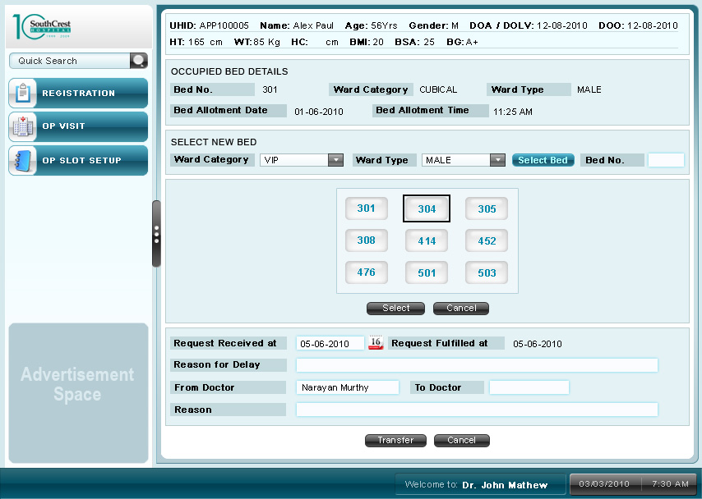

uc 2.6 patient discharge
Use Case No. | CyPERS/UC/2.6
Name | Patient Discharge
Actors | Management Executive (ME), In Patient (IP)
Description | The administrative discharge happens through this screen. Here ME collects the final bill amount and discharges the patient from hospital
Trigger | IP approaches the counter for discharge from hospital
Pre Conditions | - ME has logged into the system  - ME has identified the patient through UC 2.7 Quick Search and selected “Patient Discharge” icon  - Currency prefix is all money related fields is “Rs.”

Assumptions
No | Description
2.6AS1.0 | ME has obtained necessary approvals in case of payment mode being either Insurance Provider/TPA/Corp

Functional Requirements
No. | Description
2.6FR1.0 | ME is provided with Clinical Discharge Status (read only field) as  - Approved or  - Pending  The clinical discharge status will show as Approved once the doctor (treating the patient) generates a discharge summary through their screen. Else status will remain Pending
2.6FR2.0 | ME to be provided with fields to enter Bill Amount and Discount (in %) given if any
2.6FR3.0 | Advance Paid field should get auto populated with that entered during patient admission.
2.6FR4.0 | Bill Pending value to get auto generated based on foll. formula:  Bill Pending = (Bill Amount – Discount %*Bill Amount) – Advance Paid
2.6FR5.0 | If any discount is offered to patient, name of person authorizing / approving it to be captured in Authorized By field, else leave it blank
2.6FR6.0 | Amount Received field to be provided, for ME to enter the collected amount.
2.6FR6.0A | If payment mode is either TPA/Govt. Body/PSU/Corp, the Amount Received field to be auto filled with Bill Pending amount
2.6FR7.0 | Finally, ME can Discharge IP or Cancel at any point of time
2.6FR7.0A | Discharge to be allowed only if following conditions are met, else show appropriate alert messages:  - Clinical Discharge Status is Approved  - Amount received > or = Bill Pending
2.6FR8.0 | Upon successful discharge, system to send SMS to doctor(s) taking care of patient (Doctor 1 and Doctor 2)

Validations
No | Description
2.6VAL1.0 | Bill mount, Discount, Amount Received fields to accept numerals and with decimals

basic Workflow
- ME selects Discharge icon in the left pane
- If clinical discharge status is approved, ME can proceed to discharge, else cannot discharge patient
- Discharge workflow varies based on the foll. modes of payment selected during admission:
  - Cash
  - Corp
  - TPA
  - Govt. Body
  - PSU
- If mode of payment selected is Paying, then
  - Enter Bill amount
  - Advance Paid field get auto populated
  - Enter the discount percentage given if any
  - Capture name of person authorizing the discount offered
  - Bill Pending field gets populated based on above inputs
  - Finally, ME enters the amount received
  - Discharge IP or Cancel the process
- If mode of payment selected is either TPA/Govt. Body/PSU/Corp, then
- Enter bill amount
- Advance collected if any gets auto populated
- Bill Pending to auto populate
- Discharge IP or Cancel the process

Screen Layout
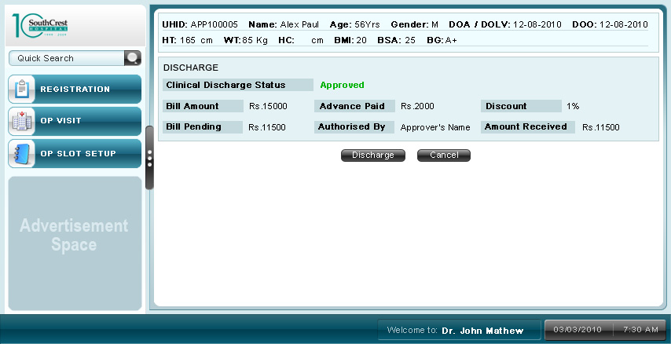

uc 2.7 Quick search
Use Case No. | CyPERS/UC/2.7
Name | Quick Search
Actors | Management Executive (ME) or Doctor Secretary
Description | Quick Search is generally used to search a patient in the system through one of the known parameters.
Trigger | ME would want to select a patient to perform one or more of the following:  - Setup Appointment  - Admission  - Discharge  - Transfer
Pre Conditions | - ME has logged into the system

Assumptions
No | Description
2.7AS1.0 | Patient has already registered with CyPERS

Functional Requirements
No. | Description
2.7FR1.0 | ME to be provided with a field to search patient on any one of the search parameters:  - UHID  - Patient Name or  - Mobile No.
2.7FR2.0 | Search results to be displayed in tabular form with foll. headings:  - UHID  - Registration Date  - Name  - Age  - Gender  - City  - State  - Phone No.  - Patient Type (In Patient / Out Patient)
2.7FR3.0 | In case a patient could not be identified through quick search, ME can use the advanced search section at the top of the screen to perform a detailed search with a combination of following parameters:  - UHID  - Patient Name  - Gender (Male / Female)  - Patient Type: (In Patient / Out Patient)  - Age Between  - Mobile No.
2.7FR4.0 | System to load the demographics of patient if result output is a single record, else provide radio button to select a patient from the results list
2.7FR5.0 | Following are the patient demographics to be displayed in the top pane of screen:  - UHID  - Name  - DOB  - Age  - Gender  - Date of Last Visit (DOLV) if any  - Date of Admission (DOA) if any  - Date of Operation (DOO) if any  - DICU: if any  - Ht.  - Wt.  - HC (Head Circumference): in case of child patient of age less than 1 year  - BMI: Basal Metabolic Index  - BSA: Body Surface Area  - LMP: Last Menstrual Period date. This field to appear only in case of female patients  - GA: Display Gestational Age in case of pregnant women patient
2.7FR6.0 | If patient selected is out patient, ME to be able to click on one of the following buttons:  - Setup Appointment  - Admission  If patient selected is an in patient, ME to be able to click on one of the following buttons:  - Transfer  - Discharge

Validations
No | Description
2.7VAL1.0 | UHID, Mobile No. and Age fields to accept only numerals
2.7VAL2.0 | Patient Name field to accept only alphabets

Basic Workflow
- ME logs into the system
- Enters patient UHID or Name or Mobile No. and clicks search button
- If search result lists only one patient record, load the patient demographics and provide
  - Setup Appointment and Admission buttons if patient selected is out patient else
  - Transfer and Discharge buttons if patient selected is in patient
- If search result lists multiple patient records,
  - Select appropriate patient from list through radio button
  - Click on any one of the following buttons:
    - Setup Appointment
    - Admission
    - Transfer
    - Discharge
- If ME is unable to identify a patient from step 3 and 4, he can perform a detail search by selecting a combination of following parameters in the top section of working area:
  - UHID
  - Patient Name
  - Gender (Male / Female)
  - Patient Type: (In Patient / Out Patient)
  - Age Between
  - Phone No.
- ME can fill in one or more of the above parameters to search for patient
- Go to step 3 or 4 based on result output

Screen Layout

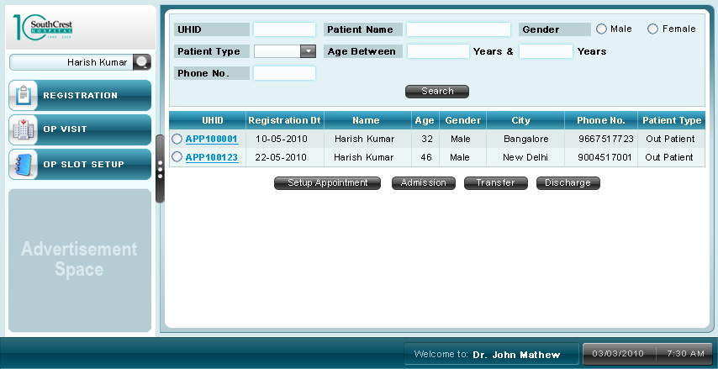
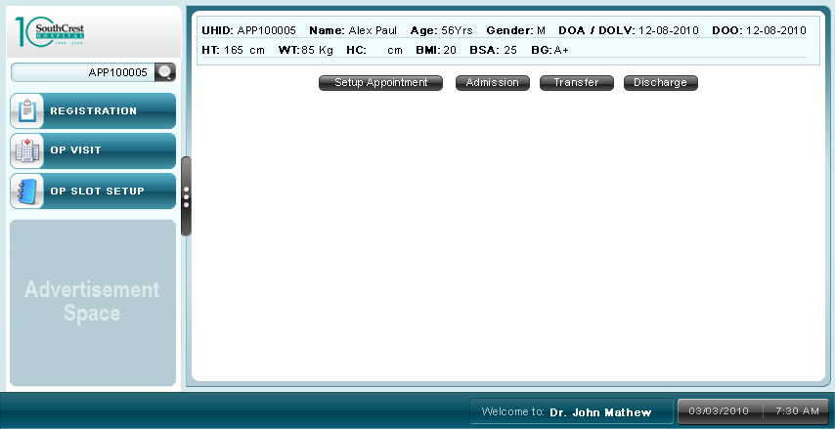

uc2.8 OP Slot Setup
Use Case No. | CyPERS/UC/2.8
Name | OP Slot Setup
Actors | Management Executive (ME) or Doctor Secretary (DS)
Description | DS would schedule respective doctor’s schedule for a given period of time for out patient consultation. At any point of time the schedule can be modified
Trigger | - A new doctor has been registered in the system  - Need to schedule doctor for a selected period of time
Pre Conditions | DS has logged into the system

Assumptions
No | Description
2.8AS1.0 | Doctor is available on all days of the year. Hence all the days in the screen to be checked by default

Functional Requirements
No. | Description
2.8FR1.0 | Provide DS with options to select a doctor based on the department
2.8FR2.0 | Provide option for DS to enter duration of each visit
2.8FR3.0 | DS to select days in a week and enter time in a day, availability of doctor
2.8FR4.0 | “Schedule” and “Reset” buttons to appear if scheduling is done for the first time else provide “Modify” with fields pre populated with information last entered
2.8FR5.0 | A calendar option for DS to select From and To dates of his / her unavailability at hospital

Validations
No | Description
2.8VAL1.0 | Time fields in the table to accept numbers and special characters “-“ and “,” and in the prescribed format only
2.8VAL2.0 | Time frame for each visit to accept only numbers – restrict upto 2 numbers only

Basic Workflow
- DS logs into the system
- Selects department and doctor from respective combo boxes
- Enter timeframe for each visit in minutes
- 2 possible scenarios:
  - DS setting up scheduler for doctor for 1st time
  - On going scheduling process
- If it is 1st time scheduling,
  - DS to select (check box) doctor’s days of visit to hospital in a week
  - Enter time of availability of doctor in the day in required format
  - Select “Schedule” button to setup schedule else “Reset” to clear all the fields and start again
- If scheduling is on an on going basis,
  - DS is provided with fields pre populated with that last entered
  - DS can modify the fields
  - Select “Modify” button to make changes to schedule
- Selects “From” and “To” dates of unavailability of doctor

Screen Layout
