

CyPERS
BRD07 – CRS
Use Case v1.0



Sep 30, 2010
Authored by:
Ignis Technology Solutions Private Ltd.

Information contained in this document is classified Ignis Technology Solution Private Ltd... Confidential & Proprietary. Only authorized Ignis Technology Solutions Private Ltd. personnel shall have access to the information contained in this document unless business needs dictate, otherwise. It is the responsibility of the person knowing the information contained in this document to ensure confidentiality of information contained in it and securing this document from unauthorized access at all times.
DOCUMENT INFORMATION
Author | Darshan BA
Reviewer | Dr. Umesh Gupta
Approver | Dr. Umesh Gupta
Approved Date

CHANGE HISTORY
Version # | Release Date | Sections Changed | Author | Change Description
0.1 | July 28, 2010 | All | Darshan BA | Draft Version
0.2 | Aug 23, 2010 | Manage Investigations | Darshan BA | Changed content and added new use case – Manage Investigation Master
0.3 | Sep 09, 2010 | New | Darshan BA | Added new functionality – Register, Change Orders
1.0 | Sep 30, 2010 | Refer change request log | Darshan BA | Changes in functionality and workflow as per change request log

Acronyms
Acronym | Definition
LIS | Laboratory Information System
RIS | Radiology Information System
ME | Management Executive
CyPERS | Cyber patient electronic record system
TAT | Turn Around Time
CRS | Clinical Reporting System (LIS+RIS+Others)

Table of Contents

1.Introduction 4
2.Use Cases 5
2.1. Use Case Model 5
2.2. UC 7.1 order List 6
2.2.1. Assumptions 6
2.2.2. Functional Requirements 6
2.2.3. Validations 7
2.2.4. Basic Workflow 7
2.2.5. Screen Layout 8
2.3. UC 7.2 To DO list 9
2.3.1. ASSUMPTIONS 9
2.3.2. Functional Requirements 9
2.3.3. Basic Workflow 9
2.3.4. screen layout 10
2.4. UC 7.3 Pending List 11
2.4.1. Assumptions 11
2.4.2. Functional Requirements 11
2.4.3. Validations 12
2.4.4. Basic Workflow 12
2.4.5. Screen Layout 13
2.5. UC 7.4 Report list 14
2.5.1. Assumptions 14
2.5.2. Functional Requirements 14
2.5.3. Basic Workflow 14
2.5.4. Screen Layout 15
2.6. UC 7.5 Manage Investigation Master 16
2.6.1. Assumptions 16
2.6.2. Functional Requirements 16
2.6.3. Basic Workflow 17
2.6.4. Alternate Workflow 17
2.6.5. Screen Layout 18
2.7. UC 7.6 Register for Investigation 20
2.7.1. Assumptions 20
2.7.2. Functional Requirements 20
2.7.3. Basic Workflow 20
2.7.4. Screen Layout 21
2.8. UC 7.7 Change Order 22
2.8.1. Assumptions 22
2.8.2. Functional Requirements 22
2.8.3. Basic Workflow 22
2.8.4. Screen Layout 23
2.9. UC 7.8 Order for Investigation 24
2.9.1. Assumptions 24
2.9.2. Functional Requirements 24
2.9.3. Basic Workflow 24
2.9.4. screen layout 25

Introduction
Laboratory Information System (LIS) module is a clinically oriented system designed to provide data to health care personnel. It assists the Pathology and Laboratory Medicine Service in managing and automating the workload and reporting process. The Laboratory module supports the following areas: Hematology, Biochemistry, Microbiology, Immunology, Pathology and Blood Bank
Users of LIS are as follows:
- Laboratory Doctor
- Senior Technician
- Technician and
- Management Executive

Radiology Information System (RIS) assists with the functions related to processing patients for imaging examinations. It automates the entire range of diagnostic functions performed in imaging departments, including order entry of requests, registration of patients for exams, processing of exams, recording of reports/results, verification of reports on-line and displaying/printing results for clinical staff.
Users of Radiology Information System are as follows:
- Radiologist
- Senior Technician
- Technician
- Management Executive

Others would consist of capturing and documenting following investigation results:

- Neurology
- Pulmonary
- Cardiology
- Others (all other investigations apart from those listed above)

Use Cases

Use Case Model

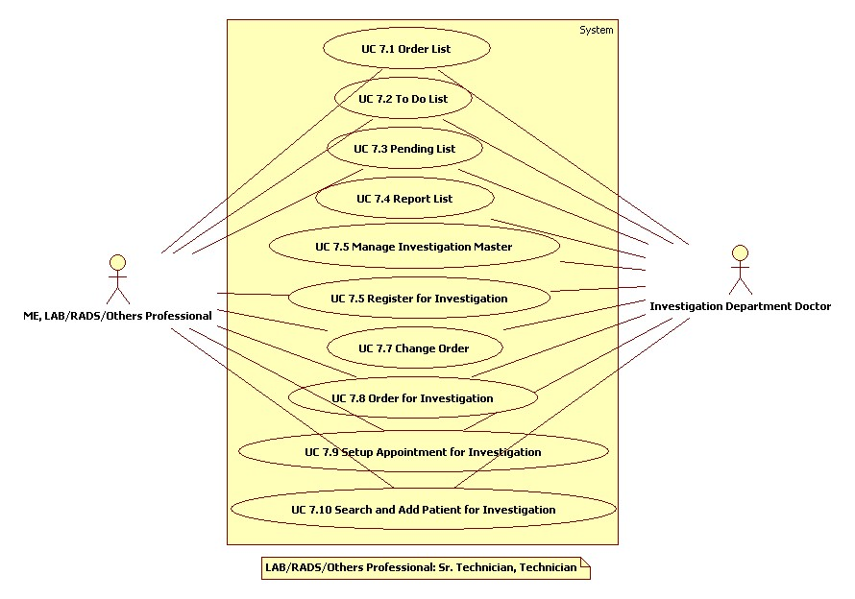

UC 7.1 order List
Use Case No. | CyPERS/UC/7.1
Name | Order List
Actors | Management Executive (ME), LAB/RADS/Others Professional, Investigation Department Doctor
Description | User can view the list of patients for whom care providers have ordered for specific test. User also Register patients and manage appointment scheduling for investigations through this screen
Trigger | User has selected Order List button from the screen which is also the “My Screen” for ME
Pre Conditions | - User has logged into the system  - Care Providers have ordered specific Tests to certain patients

Assumptions

Functional Requirements
7.1AS1.0 | Order list of user to consist of Patients for whom appointments have been scheduled by user as well as those for whom appointments are yet to be scheduled
7.1AS2.0 | At any point of time, only one pop up to appear for user
7.1AS3.0 | Default sorting of Patients for Lab & Others is by UHID whereas for Rads it is by date and time of investigation scheduled
No. | Description
7.1FR1.0 | Order list to consist of patients of foll. categories in separate tables:  - In Patients  - Emergency Room (ER) Patients and  - Out Patients  At any given point of time, only one table to appear expanded while others to be collapsed
7.1FR2.0 | Each table to consist of following broad headings:  - UHID  - Patient Name  - Bed No. – this heading to appear only for In Patients  Above information to get fetched from care provider Orders
7.1FR3.0 | User to be able to click on a UHID to open up another table below the row (accordion form) with following columns:  - Test Name  - Priority and  - Scheduled Date and Time – Display date and time if scheduled, else show blank space
7.1FR4.0 | Patient Name row for whom priority ordered is "Stat" should be color coded in all users list to make user aware of same
7.1FR5.0 | Radio buttons to be provided besides each test for user to perform one or more of the following:  - Sample / Patient Received  - Register  - Setup Appointment and  - Cancel Appointment
7.1FR6.0 | Upon selecting Sample / Patient Received button, selected test row to move to To Do List
7.1FR7.0 | Upon clicking Register button, system to pop up screen as in BRD02_UC_ADTR, UC 2.1 Registration for user to register patient. UHID so generated to follow a different series
7.1FR7.0A | Upon selecting Setup Appointment button, a pop up to open up for user to set up appointment for conducting test (as in BRD02_UC_ADTR, UC 2.3 Setup Appointment). Upon setting up the appointment, the order to appear in the order list according to the date and time scheduled for investigation
7.1FR7.0B | The Setup Appointment screen to have following fields instead of “Select Department” and “Select Doctor” (in BRD02_UC_ADTR, UC 2.3 Setup Appointment)  - Test Name – pre populated with that captured in To Do List (7.1FR1.0)  - Select Test Equipment – Combo Box to select an equipment in case of multiple test equipments
7.1FR8.0 | Doctor to Visit field to be replaced by Test Name in the summary section
7.1FR9.0 | User to be provided with option to cancel a scheduled appointment by selecting “Cancel Appointment” button. This should leave the test unscheduled (which would get dropped automatically after 48 hrs) in the user’s To Do list
7.1FR10.0 | If a patient for whom an investigation is ordered does not turn up, such patient names to get dropped from the Order list automatically post 48 hours of appearing in this list

Validations
No | Description
7.1VAL1.0 | Upon selecting “Cancel Appointment” button, system to check and allow cancellation only if an appointment is setup for selected patient. Else prompt appropriate message.

Basic Workflow

- User logs in with his/her user credentials and clicks on Order list button
- Based on the priority of Test as ordered by care provider, user selects the Test Name through the radio button to either acknowledge Sample / Patient Received or Register or Setup Appointment or Cancel Appointment
  - User clicks on Sample / Patient Received upon receiving the test sample (in case of Lab) or Patient (in case of Rads / Others) to acknowledge the same
  - User clicks Register button to register a patient with external prescriptions / Test orders and not yet registered with hospital
  - User clicks Setup Appointment, and fills in the information as in UC 7.6 Setup Appointment for Investigation to generate a UHID for patient that follows a different series
  - User clicks on Cancel Appointment, to delete a scheduled appointment

Screen Layout

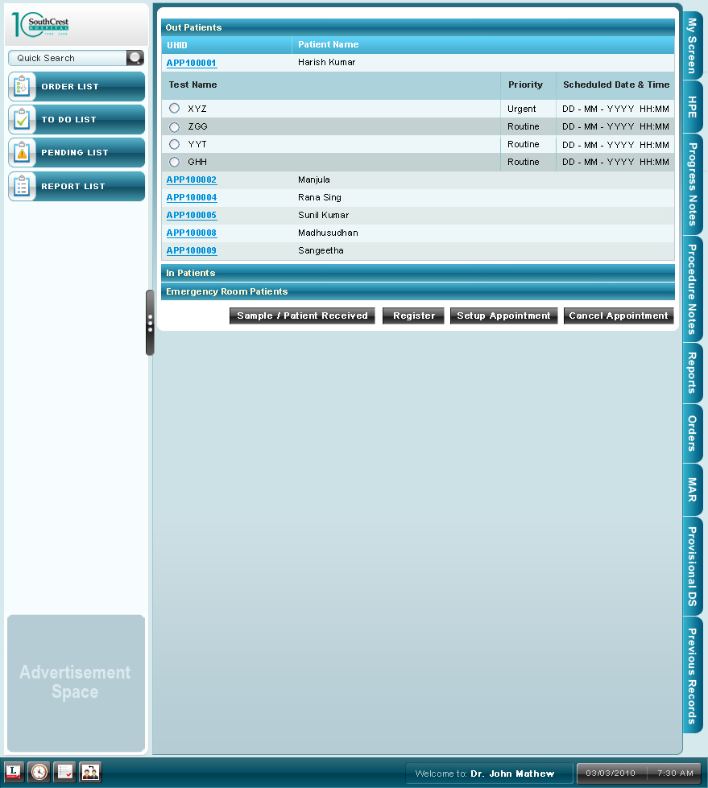

UC 7.2 To DO list

ASSUMPTIONS
Use Case No. | CyPERS /UC/7.2
Name | To Do List
Actors | Management Executive (ME), LAB/RADS/Others Professional, Investigation Department Doctor
Description | To DO list consists of test names of patients whose sample has been received or patient received by the investigation department and due for conducting the test
Pre Conditions | The user has logged into the system
Trigger | User has selected To Do List button from the screen which is also the “My Screen” for Technician
No | Description
7.2AS1.0 | At any point of time, only one pop up to appear for user
7.2AS2.0 | Default sorting of Patients for Lab & Others is by UHID whereas for Rads it is by date and time of investigation scheduled

Functional Requirements
No. | Description
7.2FR1.0 | To Do list to consist of Patients and their test information in the format as in Order List. These are test names of patients who have been acknowledged as Sample / Patient Received in UC 7.1 Order List, 7.1FR5.0
7.2FR2.0 | User to be able to click on a UHID to open up another table below the row (accordion form) with following columns:  - Test Name  - Priority and  - Scheduled Date and Time – Display date and time if scheduled, else show blank space
7.2FR3.0 | Patient Name row for whom priority ordered is "Stat" should be color coded in all the lists to make user aware of same
7.2FR4.0 | Radio buttons to be provided besides each test for user to perform one or more of the following:  - Acknowledge as Test Done or  - Change Order
7.2FR5.0 | Upon selecting Test Done button, selected test row to move to Pending List
7.2FR6.0 | Upon selecting Change Order button, screen as in UC 7.9 Change Orders to open as a pop up

Basic Workflow

- User logs in with his/her user credentials and clicks on To Do List button
- Based on the priority of Test or scheduled date and time of investigation, user conducts the test and acknowledges it as done by selecting the appropriate test through the radio button and click ing the button “Test Done”
- Alternately, user can select a test through the radio button and click on “Change Order” button

screen layout
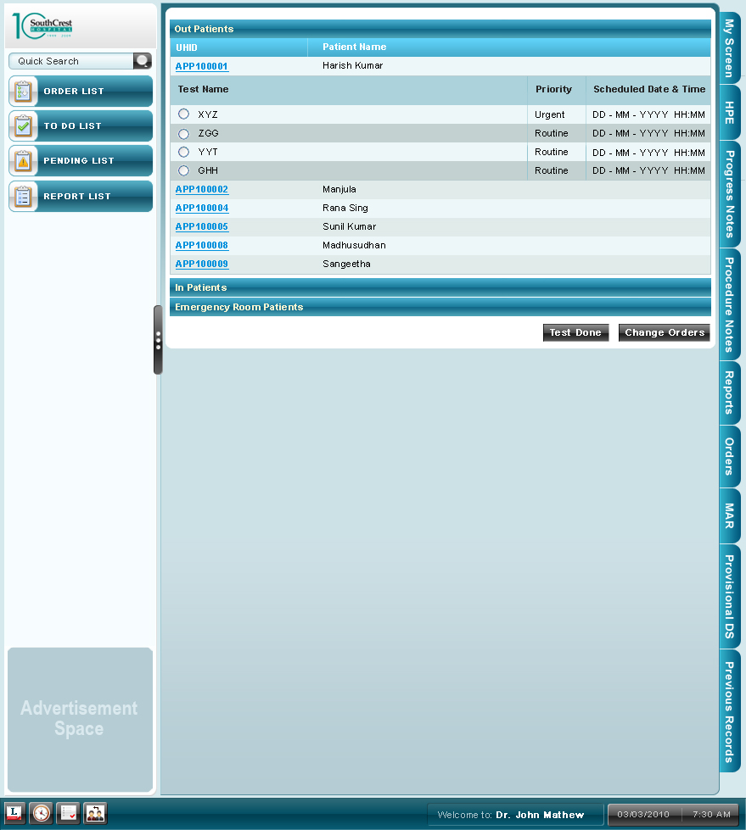

UC 7.3 Pending List

Assumptions
Use Case No. | CyPERS/UC/7.3
Name | Pending List
Actors | Management Executive (ME), LAB/RADS/Others Professional, Investigation Department Doctor
Description | User can view a list of patients for whom tests have been conducted. Also user can upload test results here
Trigger | User has selected Pending List button from the screen. It is also the “My Screen” for Sr. Technician
Pre Conditions | User has logged into the system
No | Description
7.3AS1.0 | At any point of time, only one pop to appear opened to user
7.3AS2.0 | Default sorting of Patients for Lab & Others is by UHID whereas for Rads it is by date and time of investigation scheduled

Functional Requirements
No. | Description
7.3FR1.0 | Pending List to consist of Patients and their test information in the format as in Order List. These are Patients whose tests have been conducted and user has selected as “Test Done” in UC 7.2 To Do List, 7.2FR4.0
7.3FR2.0 | User to be able to click on a UHID to open up another table below the row (accordion form) with following columns:  - Test Name  - Priority  - Report  - Upload  An icon besides the test name to be provided which upon clicking to pop out patient instructions captured if any in UC 7.7 Manage Investigation Master
7.3FR2.0A | Patient Name row for whom priority ordered is "Stat" should be color coded in all the lists to make user aware of same
7.3FR2.0B | Report: This column is used by the user to enter the test results. User to enter the result in this field only if the result format is either numerical / +ve & -ve
7.3FR2.0C | Upload: For some tests, the results will be stored in files (Either scanned or typed), such results will be uploaded onto CyPERS using ‘Upload’ button
7.3FR3.0 | After entering the investigation results, user to select particular test through radio button and select “Done” button at the bottom of table
7.3FR4.0 | If results are entered by other than Sr. Technician or Investigation Department doctor, and upon clicking Done, selected patient and test information to move to “Report List” for a Sr. Technician or Investigation department doctor to verify and finalize report
7.3FR5.0 | If a Sr. technician or investigation department doctor enters the test results, it needs no further verification. Upon clicking “Done” patient name to disappear from his list and appear in the DIS screen of the respective patient and also in the Right tabs under the reports tab

Validations
N/A

Basic Workflow
- Upon conducting the test and obtaining results, user navigates to respective test row in the list
- Enters results or uploads it
- Selects radio button besides the test name
- Clicks on “Done” button below the list

Screen Layout
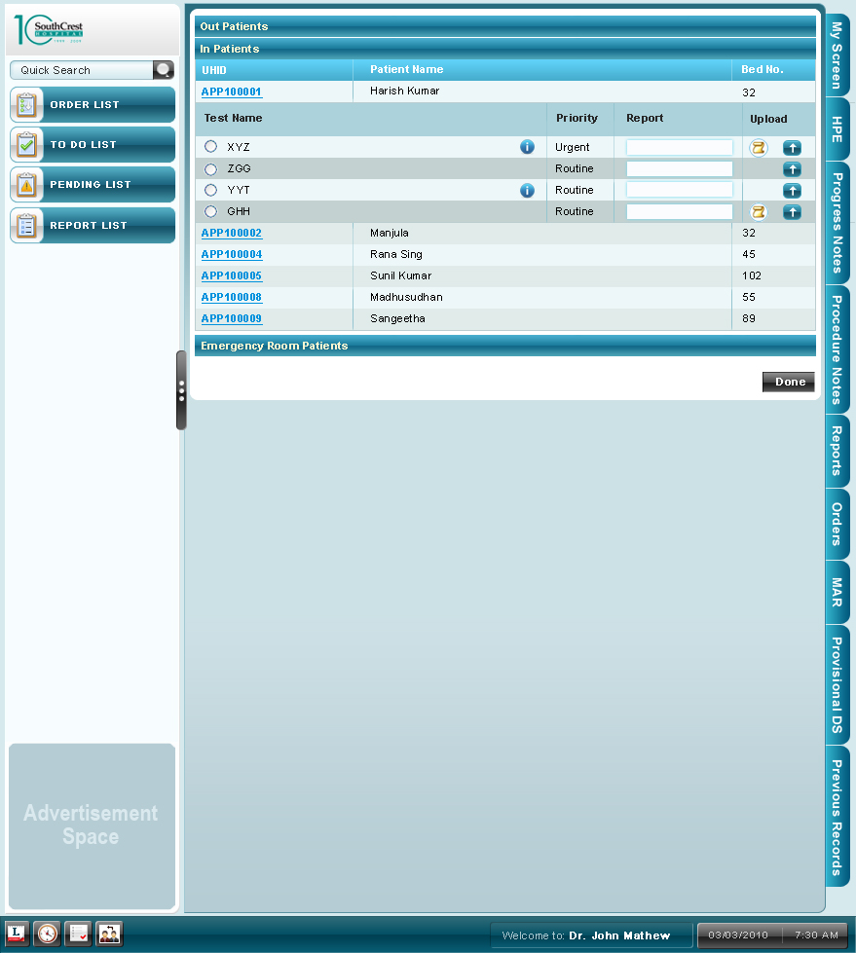

UC 7.4 Report list

Use Case No. | CyPERS /UC/7.4
Name | Report List
Actors | Investigation Department Doctor
Description | User can verify the results entered or uploaded and finalize it through the screen. User can also edit the results entered
Pre Conditions | The user has logged into the system
Trigger | User has selected Report List button from the screen which is also the “My Screen” for Investigation Department Doctor

Assumptions
No. | Description
7.4AS1.0 | User has entered or uploaded the test results
7.4AS2.0 | This will be user’s “My Screen” upon login
7.4AS3.0 | Default sorting of Patients for Lab & Others is by UHID whereas for Rads it is by date and time of investigation scheduled

Functional Requirements
No. | Description
7.4FR1.0 | Report List to consist of Patients and their test information in the format as in Pending List. These are Patients whose tests results are entered or uploaded as in UC 7.3 Pending List
7.4FR2.0 | Patient Name row for whom priority ordered is "Stat" should be color coded in all the lists to make user aware of same
7.4FR3.0 | User to be able to view the test results entered or uploaded and edit them if needed
7.4FR4.0 | Finally, user to select particular test through radio button and select “Done” button at the bottom of table
7.4FR5.0 | Upon clicking “Done” patient name to disappear from his list and appear in the DIS screen of the respective patient and also in the Right tabs under the reports tab

Basic Workflow
- The user logs into CyPERS
- Clicks on a patient UHID to view the test information below
- Verifies the test results entered or uploaded
- If required, user edits the test results that appear in editable form
- Selects “Done” button

Screen Layout

UC 7.5 Manage Investigation Master

Use Case No. | CyPERS /UC/7.5
Name | Manage Investigation Master
Description | This is an icon located at the bottom of the screen exclusively for below mentioned actor. User can Create or modify investigation master information through this feature
Actors | Investigation Department Doctor
Pre Conditions | The user has logged into the system
Trigger | The user logs into CyPERS  User clicks on the icon in the footer to load this screen

Assumptions
7.5AS1.0 | Screen opens as a pop up

Functional Requirements
No. | Description
7.5FR1.0 | To begin with, provide user to select a radio button (Yes / No) to indicate whether master being created is for a Profile Test or not. By default radio button selected to be No
7.5FR1.0A | Upon selecting No, user to capture following information  - Test Name – Free text box for user to key in Test Name  - Investigation Department – By default, system to display the department name to which user is associated and without any edit option  - Sub Department – Combo box for user to select sub department based on the investigation department displayed  - Provide text boxes for user to enter Normal Range, Critical Low, Critical High values, Turn Around Time (TAT) in hours or days, Price of test and Patient Instruction Sheet  - Combo box to select unit of measurement of result for test being created
7.5FR1.0B | Upon selecting Yes, user to capture following information  - Profile Test Name – Free text box for user to key in Profile Test Name  - Investigation Department – By default, system display the department name to which user is associated and without any edit option  - Sub Department – Combo box for user to select sub department based on the investigation department displayed  - Combo box to select Test Name to add to Profile test and an Add button to add multiple tests to profile  - Provide text box for user to enter TAT for the Profile test. TAT for profile test to auto populate based on the longest TAT of the individual tests  - Provide text boxes for user to enter Price of test and Patient Instruction Sheet
7.5FR2.0 | User to be provided with option to Modify a test master through smart search option ie upon entering few characters of test name, system to list all test names starting with those characters. Upon selecting one of them, load appropriate information in other fields of the screen
7.5FR3.0 | Finally, user can Save or Cancel the information captured

Basic Workflow
- User clicks on Manage Investigation Master icon
- Selects Yes if Profile Test master is being created or modified else selects No
- Upon selecting Yes,
  - Enters the Profile Test Name
  - Selects sub department from combo box
  - Selects Tests to add to Profile
  - Enters the Price of the Profile Test
  - Enters information in Patient Instruction sheet if necessary
- Upon selecting No,
  - Enters the Test Name
  - Selects sub department and Unit of measurement of results from combo boxes
  - Enters the Normal Range, Critical Low, Critical High values, Price of test and Patient Instruction information in respective text boxes
- Clicks on Save button to save entries or Cancel to exit screen without updating the information entered

Alternate Workflow
- User clicks on Manage Investigation Master icon
- Selects Yes if Profile Test master is being created or modified else selects No
- Upon selecting Yes / No,
- Enters first few characters of the Test Name already created
- Edit the necessary fields that would have populated (based on test selected) in edit mode
- Click on Save button to save entries or Cancel to exit screen without updating the information entered

Screen Layout
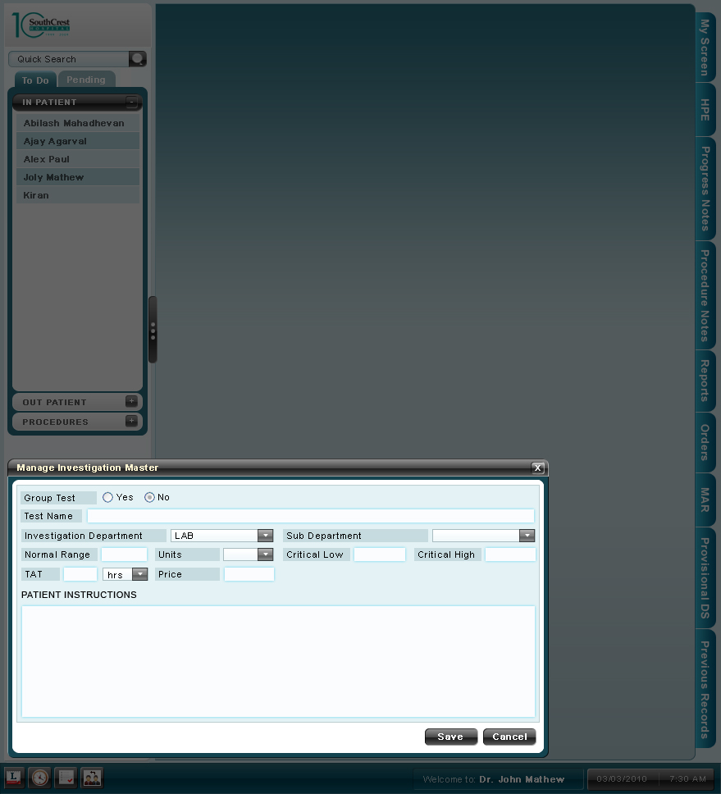
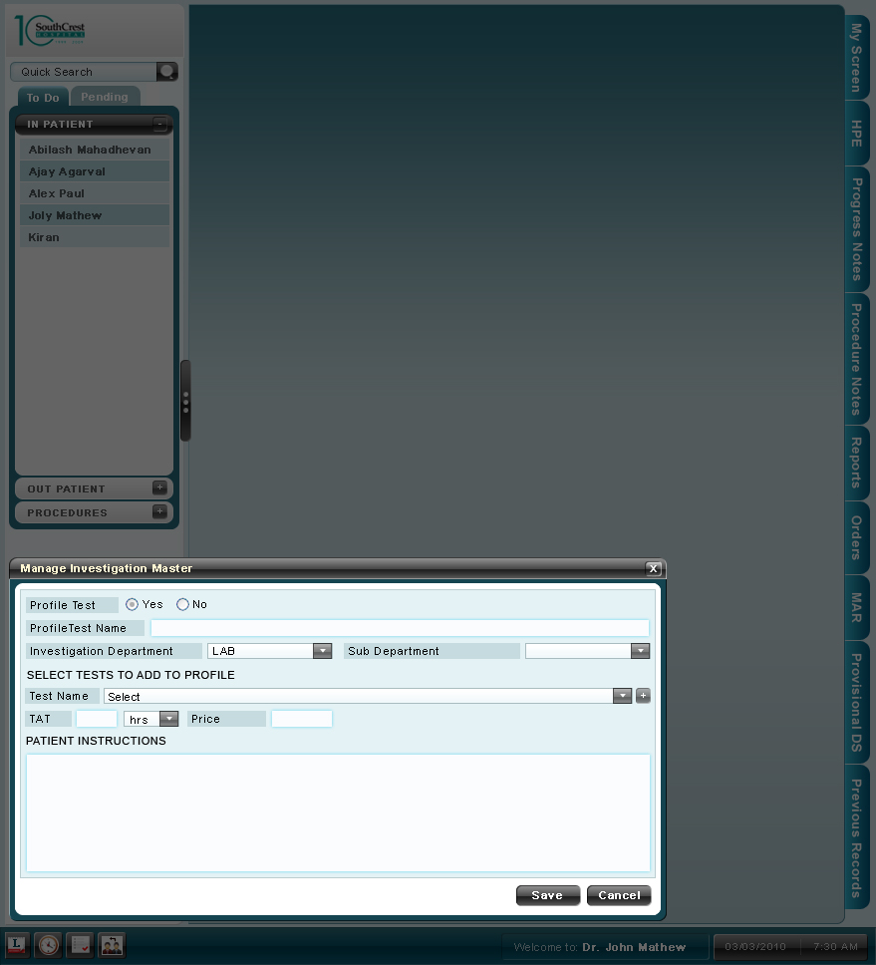

UC 7.6 Register for Investigation

Use Case No. | CyPERS /UC/7.6
Name | Register for Investigation
Description | User can register patients who approach the investigation department directly to undergo any investigation
Actors | ME at Investigation Department
Pre Conditions | The user has logged into the system
Trigger | The user logs into CyPERS  User clicks on Register button in “View Receptionist To Do List” screen

Assumptions
7.6AS1.0 | Patient has a physical prescription copy from a care provider other than those in the hospital network ie. external prescription
7.6AS2.0 | Screen opens as a pop up

Functional Requirements
No. | Description
7.6FR1.0 | User to be provided with the registration screen as in document BRD02_UC_ADTR, 2.1FR2.0
7.6FR2.0 | Upon Registration, display a Registration summary as in document BRD02_UC_ADTR, 2.1FR2.0
7.6FR3.0 | The registration summary screen to consist of a
7.6FR4.0 | UHID so generated to be different from those generated through normal registration (as in BRD02_UC_ADTR) ie UHID series to be different for registration through this screen

Basic Workflow
- User clicks on Register button
- User captures all the registration information as described in the functional requirement section
- Selects Register button to register or Reset button to clear the selected fields
- Post Registration summarize the registration information

Screen Layout

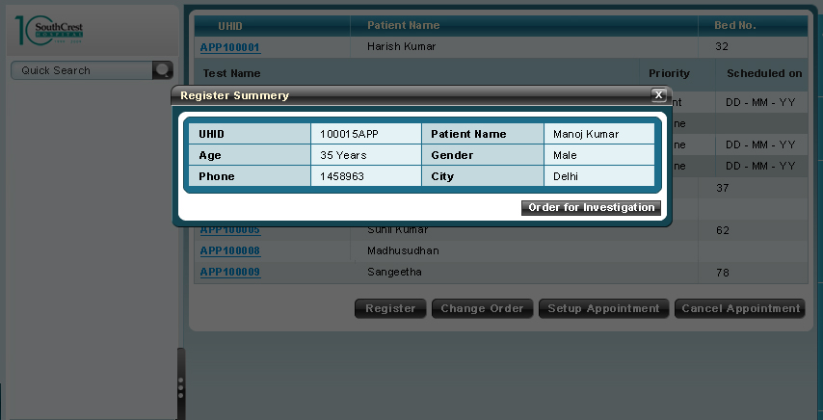

UC 7.7 Change Order

Use Case No. | CyPERS /UC/7.7
Name | Change Order
Description | User can change the investigation order ordered by care provider to particular investigation department
Actors | ME at Investigation Department
Pre Conditions | - The user has logged into the system  - Care Provider has ordered for an investigation
Trigger | - The user logs into CyPERS  - User clicks on Change Orders button in “View Receptionist To Do List” screen

Assumptions
7.7AS1.0 | Screen opens as a pop up
7.7AS2.0 | User has taken necessary approvals offline from concerned care providers to change orders
7.7AS3.0 | User is confined to ordering investigation orders pertaining to his / her investigation department only

Functional Requirements
No. | Description
7.7FR1.0 | System to display following existing order information:  - Test Name  - Priority
7.7FR2.0 | User to be provided with combo boxes to select new  - Test Name  - Priority
7.7FR3.0 | A text box, to enter reason for changing investigation order information
7.7FR4.0 | Finally, buttons to Change the investigation Order information or Cancel the activity
7.7FR5.0 | New investigation Order information to appear in To Do List of user ie. ME (receptionist) in place of existing order information
7.7FR6.0 | If scheduling is already done for existing investigation, scheduling to get cancelled automatically. Also, user has to re schedule for the new order

Basic Workflow
- User clicks on Change Order button
- User to select new order information from combo boxes viz. Test Name and Priority
- Enter reason for change in orders
- Selects Change Order button to change the order or Cancel button to cancel the activity

Screen Layout

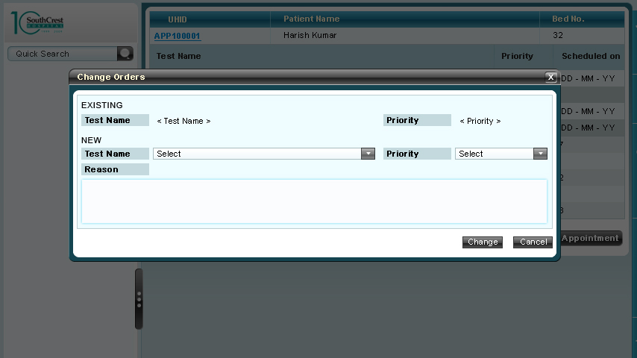

UC 7.8 Order for Investigation

Use Case No. | CyPERS /UC/7.8
Name | Order for Investigation
Description | User can order for investigations for patients who have registered through UC 7.6 Register for Investigation
Actors | ME at Investigation Department
Pre Conditions | The user has logged into the system
Trigger | The user logs into CyPERS  User clicks on Order for Investigation button in “Registration Summary” screen

Assumptions
7.8AS1.0 | Patient has a physical prescription copy from a care provider other than those in the hospital network ie. external prescription
7.8AS2.0 | Screen opens as a pop up
7.8AS3.0 | User is confined to ordering investigation orders pertaining to his / her investigation department only

Functional Requirements
No. | Description
7.8FR1.0 | User to be able to select Sub Department, Test Name and Priority of Test from respective combo boxes
7.8FR2.0 | TAT, Price and Patient Instructions of Test to appear based on Test selected
7.8FR3.0 | Provide an add button for user to order for multiple tests
7.8FR4.0 | Finally buttons to Order Investigation or Cancel order. Upon ordering for investigation, order information to appear in To Do list of user

Basic Workflow
- User clicks on Order for Investigation button
- User to select Sub Department, Test Name and Priority from respective combo boxes
- Selects Add button to order for multiple tests
- Finally, select Order or Cancel button

screen layout
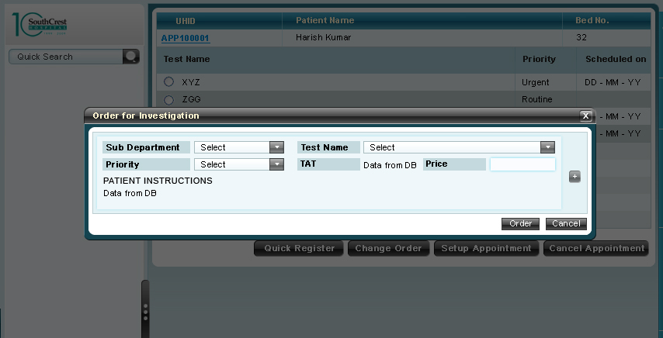

UC 7.9 Search and Add Patient for Investigation

ASSUMPTIONS
Use Case No. | CyPERS /UC/7.9
Name | Search & Add Patient for Investigation
Description | Through this option user can search and add patient to their To Do list
Actors | Receptionist/Management Executive
Pre Conditions | The user has logged into the system
Trigger | User has logged into his/her working screen ie. View To Do List and wants to add a patient to the list
No | Description
7.9AS1.0 | Patient being searched for has already registered with hospital
7.9AS2.0 | At any point of time, user to be able to view one pop up only

Functional Requirements
No. | Description
7.9FR1.0 | User must be able to search for patient name using the quick search
7.9FR2.0 | User must be able to add the patient’s name to his/her To Do list
7.9FR3.0 | The search functionality would be the same as in BRD02_UC_ADTR, UC2.7 Quick Search.
7.9FR4.0 | Search results to get displayed in a pop up with Order for Investigation button. Upon clicking the button, the screen as in UC 7.8 Order_for_Investigation to pop up

Basic Workflow

- The user logs into CyPERS
- The user would either type in the patient’s name or the UHID in the quick search
- Upon finding the desired patient’s name, the user would click on the patient UHID
- Now the patient name would be displayed in the To Do List of user

UC 7.3 Setup Appointment for Investigation

Assumptions
Use Case No. | CyPERS/UC/7.10
Name | Setup Appointment for Investigation
Actors | ME
Description | ME can set up an appointment for an ordered Test / Investigation through this screen
Trigger | ME has selected a patient and clicked on Setup Appointment button in UC 7.1 Order List
Pre Conditions | ME has logged into the system
No | Description
7.10AS1.0 | Appointment has not yet been setup for selected patient
7.10AS2.0 | The screen opens up as a pop up

Functional Requirements
No. | Description
7.10FR1.0 | User to set up appointment for conducting test as in BRD02_UC_ADTR, UC 2.3 Setup Appointment
7.10FR2.0 | The screen to have following field labels instead of “Select Department” and “Select Doctor” (in BRD02_UC_ADTR, UC 2.3 Setup Appointment)  - Test Name – pre populated with that captured in To Do List (7.1FR1.0)  - Select Test Equipment – Combo Box to select an equipment in case of multiple test equipments
7.10FR3.0 | Doctor to Visit field to be replaced by Test Name in the summary section

Validations
No | Description
7.10VAL1.0 | As in BRD02_UC_ADTR, UC 2.3 Setup Appointment

Basic Workflow
- For workflow, refer BRD02_UC_ADTR, UC 2.3 Setup Appointment

Screen Layout
