

CyPERS
BRD10 – Care Management System
Use Case v1.0



June 03, 2010
Authored by:
Ignis Technology Solutions Private Ltd.

Information contained in this document is classified Ignis Technology Solution Private Ltd... Confidential Proprietary. Only authorized Ignis Technology Solutions Private Ltd. personnel shall have access to the information contained in this document unless business needs dictate, otherwise. It is the responsibility of the person knowing the information contained in this document to ensure confidentiality of information contained in it and securing this document from unauthorized access at all times.
DOCUMENT INFORMATION
Author | Anand Dhanya
Reviewer | Darshan
Approver
Approved Date

CHANGE HISTORY
Version # | Release Date | Sections Changed | Author | Change Description
0.1 | June 09, 2010 | All | Anand Dhanya | Draft Version
1.0 | June 24, 2010 | Search, Alert, Message Icon, Search and add icon. | Anand Dhanya | Updated with client feedback and inputs

Acronyms
Acronym | Definition
CIS | Clinician Information system
CyPERS | Cyber patient electronic record system
Sr Doctor | Senior Doctor
Jr Doctor | Junior Doctor

Table of Contents

1.Introduction 4
2.Proposed Screen for CMS module 5
3.Use Cases 6
3.1. Use Case Model 6
3.2. UC10.1 To-Do list 7
3.1.1 Functional Requirements 7
3.1.2 Basic Workflow 7
3.1.3 Classification of User’s To Do List 7
3.3. UC 10.2 Pending List 8
3.1.4 Functional Requirements 8
3.1.5 basic Workflow 8
3.1.6 Classification of User’s Pending List 8
3.4. UC 10.3 Alert 9
3.1.7 Functional Requirements 9
3.1.8 basic Workflow 9
3.1.9 Alternative Workflow 9
3.1.10 Screen Layout 10
3.5. UC 10.4 Leave Icon 12
3.1.11 Assumptions 12
3.1.12 Functional Requirements 12
3.1.13 basic Workflow 12
3.1.14 Screen Layout 13
3.6. UC 10.5 Message ICon 14
3.2.1 Assumptions 14
3.2.2 Functional Requirements 14
3.2.3 basic Workflow 14
3.2.4 Screen Layout 14
3.7. UC 10.6 Search and add Patient Icon 15
3.3.1 Assumptions 15
3.3.2 Functional Requirements 15
3.3.3 basic Workflow 16
3.3.4 Alternative Workflow1 16
3.3.5 Alternative Workflow2 16
3.3.6 SCReen layout 16
3.8. UC 10.7 Setup appointment Icon 17
3.4.1 Assumptions 17
3.4.2 Functional Requirements 17
3.4.3 basic Workflow 17
3.4.4 SCReen layout 18
3.9. UC 10.8 Operations list 19
3.5.1 Assumptions 19
3.5.2 Functional Requirements 19
3.5.3 basic Workflow 19
3.5.4 SCReen layout 20

Introduction
Care Management offers a convenient way for health care providers to view on single screen pertinent information & tasks of all patients assigned to them.
The various users of CMS module of CyPERS are as follows:
- Sr. & Jr. Medical Staff
- Nutritionist / Dietician
- Physiotherapist
- Social Worker and
- Nurse

It provides the users with following:
- Today’s Tasks: These are to do list for the day for care providers.
- Pending Tasks: Tasks which the user was supposed to do but not done yet, will move to this list.

The tasks are a list of patients that the user has to work on. The task list is different for different users as it is based on the user profile. Based on the user, Today’s Tasks can further be categorized into:
- In Patient
- Out Patient and
- Procedures

Junior Medical Staff and Nurses are provided with an option to add patients to their work list based on
- Sr. Medical Staff
- Ward Name or
- Specialty

Proposed Screen for CMS module
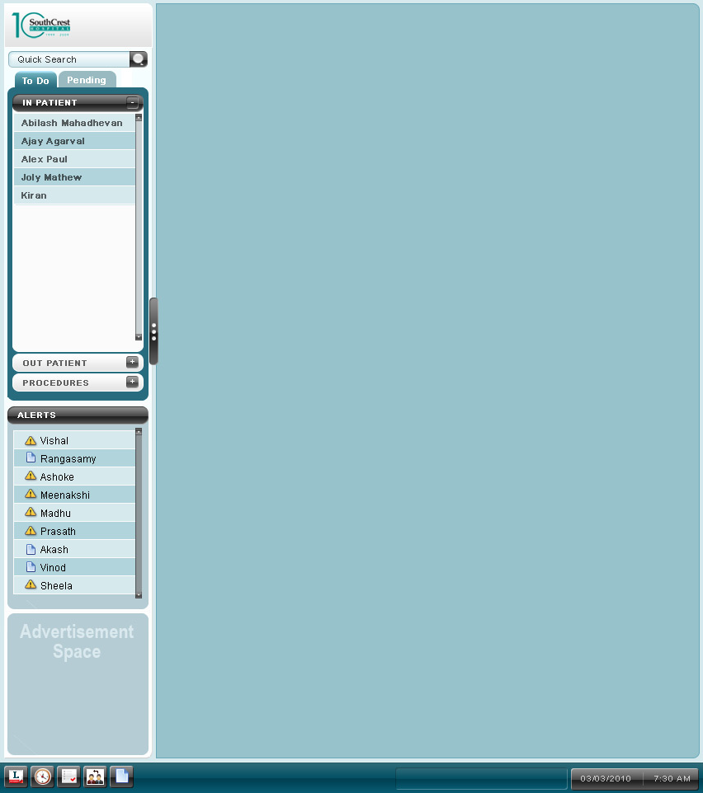

Use Cases

Use Case Model

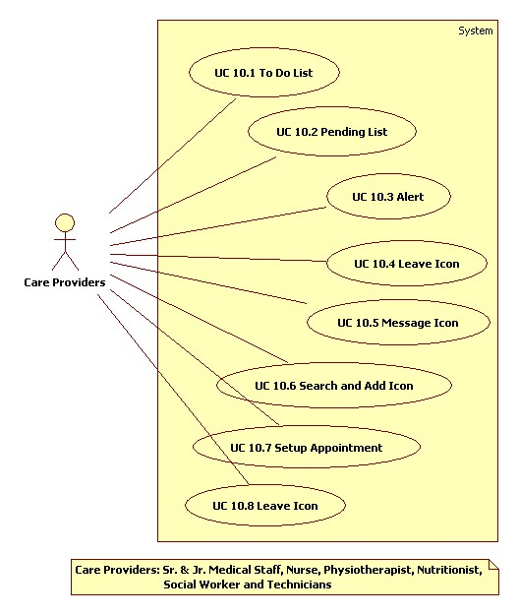

UC10.1 To-Do list
Use Case No. | CyPERS /UC10.1
Name | To-Do list
Description | This is the list of patients for which there is a task that needs to be done by the care provider.
Actors | Care providers (Doctor, Jr Doctor, Lab Doctor, Nurse, Anesthetist, Surgeon, Technician, Dietician, Physiotherapist)
Pre Conditions | - The user has logged into CyPERS.  - User has identified the patient through UC 2.7 Quick Search and added to To-Do list
Trigger | Care provider logs into CyPERS.

Functional Requirements
No. | Description
10.1FR1.0 | The user should have option to see the list of patients in two tabs: To-Do and Pending.
10.1FR2.0 | The To-Do and Pending list of patients would be further classified based on the type of user.
10.1FR3.0 | The classification would be Inpatient, Outpatient and Procedures; this would be different for different type of user.
10.1FR4.0 | The patient names would appear on To-Do list sorted by the time of appointment/scheduling.

Basic Workflow
- The user logs into CyPERS
- The user clicks on a patient name in one of the 3 expandable sub tabs (inpatient, Outpatient and Procedures) under the To-Do tab.
- A screen would open in the Work area(Covered in further modules)

Classification of User’s To Do List
For a classification of users and their To-Do list, refer the spread sheet below.
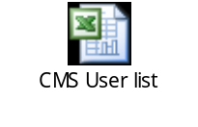

UC 10.2 Pending List
Use Case No. | CyPERS /UC/10.2
Name | Pending List
Description | This lists consist of names of patients for whom there is a task pending that needs to be done by the care provider.
Actors | Care providers.(Doctor, Jr Doctor, Lab Doctor, Nurse, Anesthetist, Surgeon, Technician, Dietician, Physiotherapist)
Pre Conditions | The user has logged into the system
Trigger | Care provider logs into the system and clicks on the pending tab.

Functional Requirements
No. | Description
10.2FR1.0 | Once the user logs into the system, the Pending list would appear on the adjacent tab of the To-Do list on the left panel of the screen.
10.2FR2.0 | The Pending list of patients would be further classified based on the type of user.
10.2FR3.0 | The list of patients classified into Inpatient, Outpatient and Procedures; this would be different for different type of user.
10.2FR4.0 | The patient names would appear on Pending list sorted by the time, since when the task has been pending.

basic Workflow
- The user logs into CyPERS.
- The user clicks on a patient name in one of the 3 expandable sub tabs (inpatient, Outpatient and Procedures) under the Pending tab.
- A screen would open in the Work area (Covered in further modules).

Classification of User’s Pending List
For a classification of users and their pending list, refer the spread sheet below.

UC 10.3 Alert
Use Case No. | CyPERS /UC/10.3
Name | Alert
Description | This section of the screen is used to view the critical results of certain test and also to view messages sent by other care providers.
Actors | Care providers.(Doctor, Jr Doctor, Lab Doctor, Nurse, Anesthetist, Surgeon, Technician, Dietician, Physiotherapist)
Pre Conditions | The user has logged into CyPERS
Trigger | Care provider logs into CyPERS

Functional Requirements
No. | Description
10.3FR1.0 | The alert section would be located below the To-Do list.
10.3FR2.0 | The alert section will list the patient names, for whom test result/results would have crossed a pre defined critical range. Alert content: Test Name and Test Results
10.3FR3.0 | The alert section will have names of care providers who have sent a message to the current user.
10.3FR4.0 | The 2 types of alerts to be differentiated by icons provided besides each alert
10.3FR5.0 | Alert to get deleted after 48 hrs. of display or post viewing by care provider, which ever is earlier.
10.3FR6.0 | Upon clicking an alert, the information should get displayed in a pop up

basic Workflow
- User logs into CyPERS
- User clicks on a name with the alert icon across it.
- A popup screen would appear with test name and results.
- User would view the result and close the pop up. This would remove that alert from the alert section of the user.

Alternative Workflow
- User logs into CyPERS
- User clicks on a name with the message icon across it.
- A popup screen would appear with the message sent by the user.
- User would view the result and close the pop up. This would remove that message from the alert section of the user.

Screen Layout

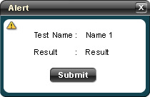

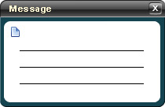

Icons and their Functionality:
- Leave: When a user clicks on this icon, the alert field would disappear and a leave scheduler would come in its place. The leave scheduler would have the following fields:
    - Calendar : to select the dates
    - Name: By default will be the name of the user who has logged in and a dropdown list of all the other users to whom, the current user id associated, so that the user can apply for leave on another user’s behalf.
    - A submit button
Icon:
- Setup Appointment: When a user clicks on this icon, a pop up screen would appear wherein the user would be able to schedule a patient for clinical activities. The fields in this section would be same as the scheduler fields of the ADTR module.
Icon:

- Operations list: When a user clicks on this icon, a pop up screen with various OTs and the list of operations scheduled for the day would appear. This list is generated by system automatically based on the scheduling done for the OTs.
Icon:

- Search and Add: This Icon would appear only for Doctors, Jr Doctor and Nurse. When a user clicks this icon a popup screen would appear. The Change Dept popup would have the following fields:
    - Department: This would be a dropdown list of all the departments in a hospital.
    - Doctor Name: This will be a dropdown list of all the Senior doctors.(This option is only for the Jr Doctor)
    - A submit button
Icon:

Other Icons to be included in further modules:
    - New born registration: This icon would appear when a patient is diagnosed for pregnancy. Once the baby is delivered, by clicking this icon, the baby can be registered in CyPERS.
    - Other Procedures

UC 10.4 Leave Icon
Use Case No. | CyPERS /UC/10.4
Name | Leave Icon
Description | This icon is used by the doctors to apply leave.
Actors | Care providers.(Sr. Medical Staff, Jr. Medical Staff, Nurse, Anesthetist, Surgeon, Technician, Dietician, Physiotherapist)
Pre Conditions | The user has logged into CyPERS
Trigger | User logs into CyPERS and clicks on the leave icon.

Assumptions
No | Description
10.4AS1.0 | Only Sr. Medical staff can apply leave through this icon
10.4AS2.0 | Leave icon screen to open as a pop up

Functional Requirements
No. | Description
10.4FR1.0 | There should be an icon for the user to apply leave
10.4FR2.0 | Doctor can apply leave for self
10.4FR3.0 | Management Executive or Doctor Secretary or Jr. Doctor or Nurse can apply leave on behalf of a doctor
10.4FR4.0 | Once the leave is applied, the days should be blocked in scheduling screen so that no clinical activity is scheduled for the user during his/her leave.
10.4FR5.0 | If appointments are scheduled for a date of leave application, all such appointments to get cancelled
10.4FR6.0 | Upon mouse over the icon, ‘Apply Leave’ tool tip should appear.

basic Workflow
      - User logs into CyPERS
      - User would click on the leave icon at the bottom panel of the screen.
      - A leave scheduler popup would open with the following fields:
        - Calendar : to select the dates
        - Doctor: Text box to select doctor (smart search)
      - After filling in the data the user would click on the submit button.
      - A confirmation window will open for the user to confirm the leave application.

Screen Layout
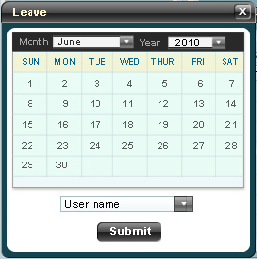

UC 10.5 Message ICon
Use Case No. | CyPERS /UC/10.5
Name | Message Icon
Description | This icon is used by a care provider to send a short message to other care providers.
Actors | Sr. Medical Staff, Jr. Medical Staff, Nurse, Anesthetist, Surgeon, Technician, Dietician, Physiotherapist
Pre Conditions | The user has logged into CyPERS
Trigger | Care provider logs into CyPERS and clicks on the Message icon.

Assumptions
No | Description
10.5AS1.0 | Message icon opens as a pop up

Functional Requirements
No. | Description
10.5FR1.0 | There should be an icon for the user to send short messages to other care providers.
10.5FR2.0 | The user should be able to type in a short message, select a care provider’s name and send the message across.
10.5FR3.0 | The contacts would be a list of all Sr. Medical Staff, Jr. Medical Staff, Nurses, Anesthetists, Surgeons, Technicians, Dieticians and Physiotherapists
10.5FR4.0 | Upon mouse over the icon, ‘Send a message’ tool tip should appear.

basic Workflow
- User logs into CyPERS
- User would click on the message icon at the bottom panel of the screen.
- The user would type in the message in the empty text field.
- After filling in the message the user would select the contact from the contacts dropdown list, this could be the name of individual doctor (Jr doctor and Sr doctor), nurses (This would send the message to all the nurses) or All.
- After selecting the contact, the user would click on submit button ant the message would be sent and a context menu would appear confirming that the message was sent.

Screen Layout
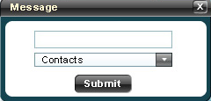

UC 10.6 Search and add Patient Icon
Use Case No. | CyPERS /UC/10.6
Name | Search and Add Patient
Description | This is an icon used by the user when he/she wants to change their department, location or doctor under whom they are working.
Actors | Jr Medical Staff, Nurse
Pre Conditions | The user has logged into CyPERS
Trigger | User logs into CyPERS and clicks on Search and Add icon located at the bottom of screen

Assumptions
No | Description
10.6AS1.0 | The screen opens as a pop up

Functional Requirements
No. | Description
10.6FR1.0 | There should be an icon for the user to add patients (in case of new user) or replace patients in his/her To Do list based on Doctor, Specialty or Bed Category
10.6FR2.0 | Upon clicking this icon, a popup should appear
10.6FR3.0 | From pop up, user to be able to add patients based on one of the foll. types:  - Doctor  - Specialty or  - Bed Category
10.6FR4.0 | If type selected is Doctor, display a list box besides to display all the consultants for user to select from. User to be able to select multiple consultants from list box
10.6FR5.0 | In case the type selected is Specialty, patients of all consultants in that specialty to get added to user’s To Do list
10.6FR6.0 | In case the type selected is Bed Category, system to display another combo box for user to select ward name. Based on the combination selected, system to display occupied bed nos. in a dropdown list for user to select bed nos. User to be provided with option to select multiple bed nos. from dropdown list
10.6FR7.0 | Upon mouse over on the icon, ‘Search & Add’ tool tip should appear

basic Workflow
- User logs into CyPERS
- User would click on the Search and add icon from the bottom panel to open a pop up
- The user would select Doctor from combo box
- The user would select the name of the doctor from the Name combo box
- The user can select multiple doctor names at a time
- Finally the user would click on the submit button.
- To Do list of user to get replaced with all the patients under the doctor(s)

Alternative Workflow1
- User logs into CyPERS
- User would click on the Search and add icon from the bottom panel, a popup would be displayed.
- The user would select Bed Category from combo box
- Select a bed category from sub sequent combo box
- The user would select Ward Name from associated combo box
- Upon selecting ward name, another dropdown with list of the occupied bed numbers under selected combination would appear, the user can select a single bed number, multiple bed numbers or all the beds under the ward.
- Finally the user would click on the submit button
- To Do list of user to get replaced with patient names of selected bed nos.

Alternative Workflow2
- User logs into CyPERS
- User would click on the Search and add icon from the bottom panel, a popup would be displayed.
- The user would select Specialty from combo box
- The user would select the name of the specialty from combo box
- Finally the user would click on the submit button
- To Do list of user to get replaced with patient names in that specialty

SCReen layout

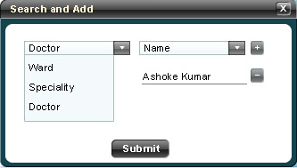

UC 10.7 Setup appointment Icon
Use Case No. | CyPERS /UC/10.7
Name | Setup Appointment Icon
Description | This is an icon used by the care providers when they want to schedule a patient for a clinical activity.
Actors | Sr. Medical Staff
Pre Conditions | The user has logged into CyPERS  Doctor Name to be selected by default and user need not select doctor
Trigger | User logs into CyPERS and clicks on Setup Appointment icon.

Assumptions
No | Description
10.7AS1.0 | Screen opens as pop up
10.7AS2.0 | Sr. Medical Staff can setup appointments only for registered patients. For un registered patients, doctor will direct them either to DS or ME for setting up appointments

Functional Requirements
No. | Description
10.7FR1.0 | There should be an icon for the user to schedule appointments.
10.7FR2.0 | Upon clicking this icon, a popup should be loaded.
10.7FR3.0 | There should be option for the user to quick search the patient either by name or UHID.
10.7FR4.0 | There should be option for the user to select the department and doctor.
10.7FR5.0 | The user should be able to select the date, time and complete the scheduling
10.7FR6.0 | Upon mouse over the icon, ‘Search & Add’ tool tip should appear.

basic Workflow
- User logs into CyPERS
- User would click on Setup Appointment icon from the bottom panel, a popup would be displayed.
- The user would fill in the following fields:
  - Patient Name: This would be a field having the quick search functionality, wherein the user can either type the patient’s name, mobile no. or UHID, a list would appear from which the name can be selected.
  - Once the patient name is selected, the demographics of that patient would be displayed next.
  - Department: This would be a dropdown list of all the departments.
  - Doctor: This would be a drop down list of all the doctors in that particular department.
  - Visit days: Once the doctor is selected, a calendar would be displayed showing the days when the doctor is available.
  - Time slots: once the day is selected, a list of time slots would appear when the doctor is available on that day.
- Finally the user would click on the submit button.
- A confirmation window will open for the user to confirm the scheduling done.

SCReen layout

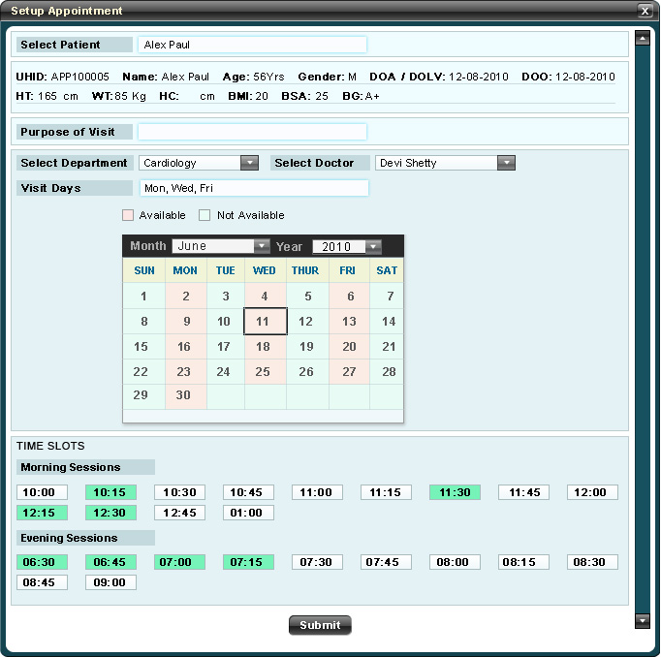

UC 10.8 Operations list
Use Case No. | CyPERS /UC/10.8
Name | Operations list
Description | This is an icon used by the user to see the list of operations scheduled for the day in all Operation Theaters of the hospital.
Actors | Sr. and Jr. Medical Staff, Lab Doctor, Nurse, Anesthetist, Surgeon, Technician.
Pre Conditions | The user has logged into CyPERS.
Trigger | User logs into CyPERS and clicks on the Operations list icon.

Assumptions
No | Description
10.8AS1.0 | Operations list can be generated only for current day

Functional Requirements
No. | Description
10.8FR1.0 | There should be an icon for the user to view the list of operations scheduled in various operation theaters at hospital for current date
10.8FR2.0 | Upon clicking this icon, a popup should be loaded.
10.8FR3.0 | The pop up should show the OT type and the time when a procedure is scheduled in all OT’s of hospital.
10.8FR4.0 | Upon mouse over the icon, ‘Operations list’ tools tip should appear.

basic Workflow
- User logs into CyPERS
- User would click on the Operations list icon from the bottom panel, a popup would be displayed.
- The user would view the list of operations scheduled in various Operations theaters and either print the list or close the window after viewing the list.

SCReen layout
