**Flowchart of the Application**

**1. Server Client Architecture**:  
The Client(s) connect to the server to communicate with the server and other clients

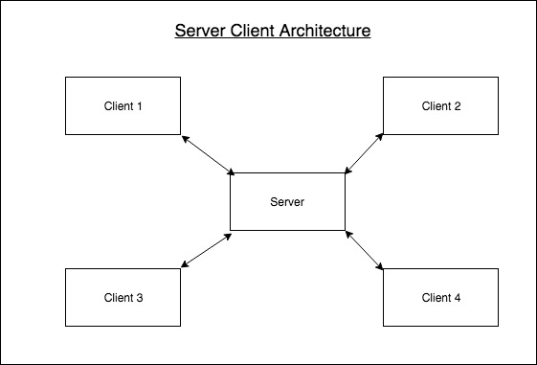

**2. Client Signup**:

For the first time the client need to sign up to create a login credentials.

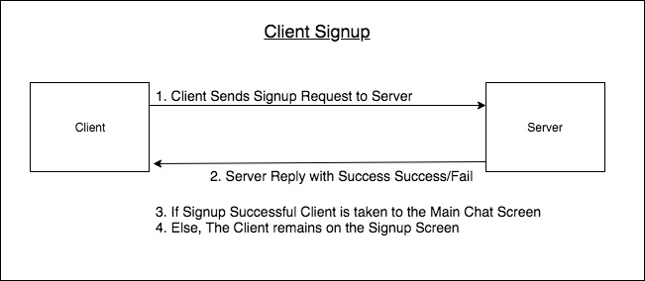

**3. Client Login**:

The Client Login to the server to communicate with other Clients.

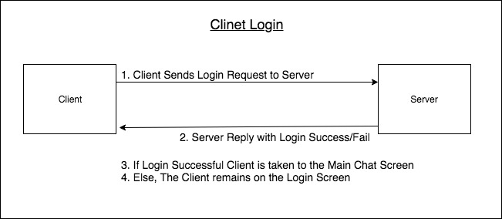

**4. Client Send Online DataPacket to tell the Server that the Client is ONLINE:**

The Client receives as a Reply from the server List of Online Clients and Offline Clients.

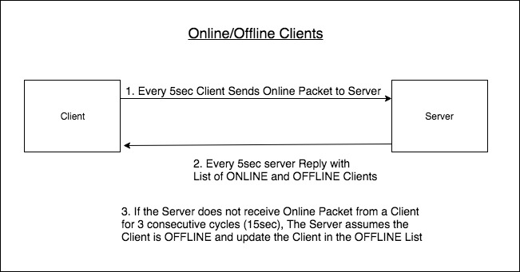

**5. Sending Text Message from Clinet-1 to Client-2**

Client-1 sends a text message to Client-2

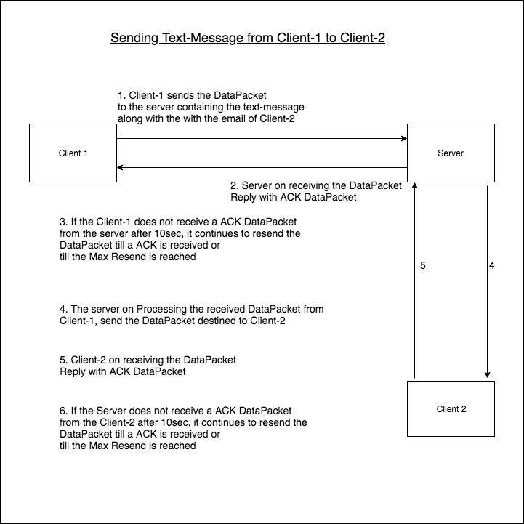

**6. Sending Multimedia-Message Image from Clinet-1 to Client-2**

Client-1 sends an image to Client-2

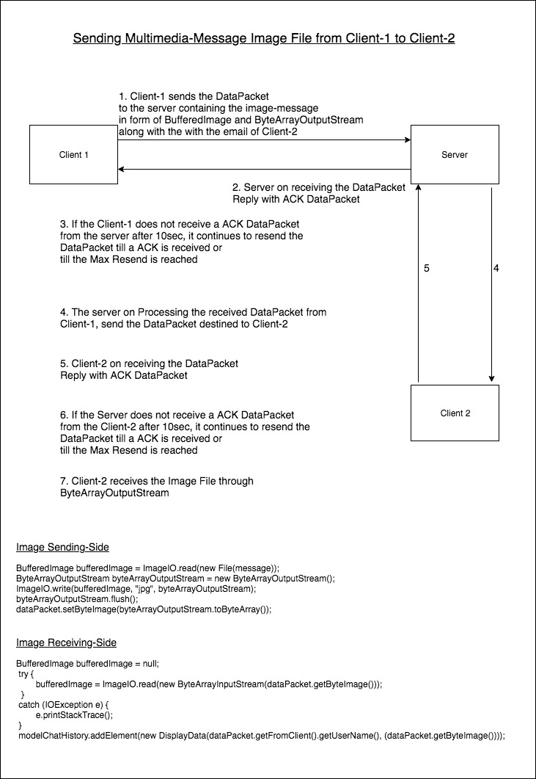

**7. Sending Broadcast Message from Clinet-1 to all other Client(s)**

Client-1 sends a Broadcast Message to all other Clients

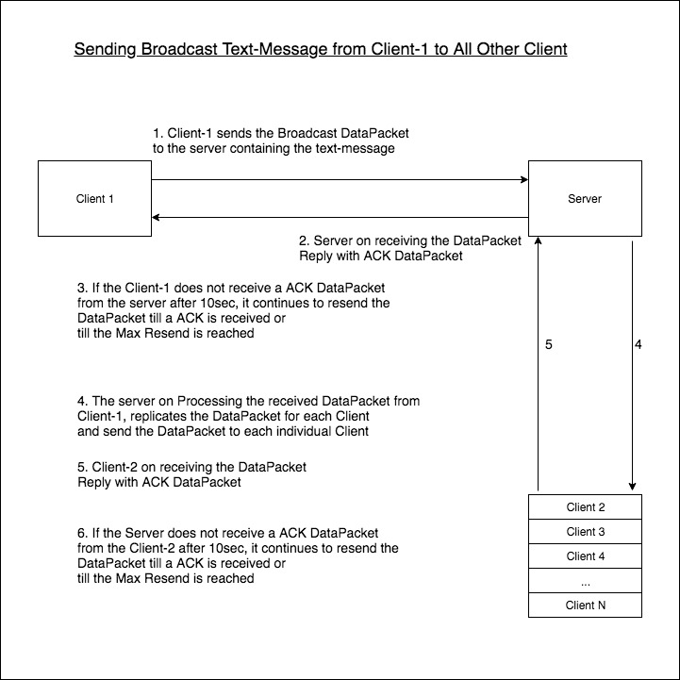

**(**Ref: All this flow charts are created on the online tool www.draw.io**)**