Git & GitHub
DevOps Assignment
Name: Aditya Kundu
Course: TutDude DevOps
Tools used: Git, GitHub (SSH), VS Code, PowerShell, Flask, MongoDB Atlas
Date: 1 November 2026
GitHub: https://github.com/kunduaditya758-prog/Git_and_GitHub_AdityaKundu

Objective
Practise the full Git workflow (SSH setup, branching, merging, conflict resolution, sequential commits, git reset and rebasing) using my Flask project from the previous assignment.

Branches Used
• main: final code
• AdityaKundu: first branch with the Flask project files (Task 1)
• AdityaKundu_new: updated JSON data for /api (Task 2)
• master_1: To-Do page, then the Item ID, Item UUID and Item Hash fields (Task 3 and 4)
• master_2: /submittodoitem backend route (Task 3)

Final Code
app.py
import json
import os

from dotenv import load_dotenv
from flask import Flask, jsonify, redirect, render_template, request, url_for
from pymongo import MongoClient

load_dotenv()

app = Flask(__name__)

client = MongoClient(os.getenv("MONGO_URI"), serverSelectionTimeoutMS=5000)
db = client["flask_assignment"]
collection = db["submissions"]

@app.route("/api")
def api():
file_path = os.path.join(app.root_path, "data.json")
with open(file_path, "r") as f:
data = json.load(f)
return jsonify(data)

@app.route("/submittodoitem", methods=["POST"])
def submit_todo_item():
data = request.form or request.get_json(silent=True) or {}
item_name = data.get("itemName", "").strip()
item_description = data.get("itemDescription", "").strip()

if not item_name or not item_description:
return jsonify({"error": "itemName and itemDescription are required"}), 400

try:
db["todo_items"].insert_one({"itemName": item_name, "itemDescription": item_description})
return jsonify({"message": "To-Do item saved successfully"}), 201
except Exception as e:
return jsonify({"error": f"Could not save item: {e}"}), 500

@app.route("/", methods=["GET", "POST"])
def form():
if request.method == "POST":
name = request.form.get("name", "").strip()
email = request.form.get("email", "").strip()

if not name or not email:
return render_template("form.html", error="Name and email are required")

try:
collection.insert_one({"name": name, "email": email})
return redirect(url_for("success"))
except Exception as e:
return render_template("form.html", error=f"Could not save data: {e}")

return render_template("form.html")

@app.route("/success")
def success():
return render_template("success.html")

@app.route("/todo")
def todo():
return render_template("todo.html")

if __name__ == "__main__":
app.run(debug=True)

templates/todo.html
<!DOCTYPE html>
<html>
<head>
<title>To-Do</title>
</head>
<body>
<h1>Add a To-Do Item</h1>

<form action="/submittodoitem" method="POST">
<label>Item Name:</label>
<input type="text" name="itemName">
<br><br>
<label>Item Description:</label>
<input type="text" name="itemDescription">
<br><br>
<label>Item ID:</label>
<input type="text" name="itemId">
<br><br>
<label>Item UUID:</label>
<input type="text" name="itemUuid">
<br><br>
<label>Item Hash:</label>
<input type="text" name="itemHash">
<br><br>
<button type="submit">Add Item</button>
</form>
</body>
</html>

data.json
[
{"id": 1, "name": "Docker", "category": "Containers"},
{"id": 2, "name": "Kubernetes", "category": "Orchestration"},
{"id": 3, "name": "Terraform", "category": "Infrastructure as Code"},
{"id": 4, "name": "GitHub Actions", "category": "CI/CD"},
{"id": 5, "name": "Prometheus", "category": "Monitoring"}
]

form.html and success.html are the same as in my Flask & MongoDB assignment and are included in the zip.

Task 1: Repository Setup & First Branch

Step 1: Create a new GitHub repository
Task: Create a new GitHub repository.
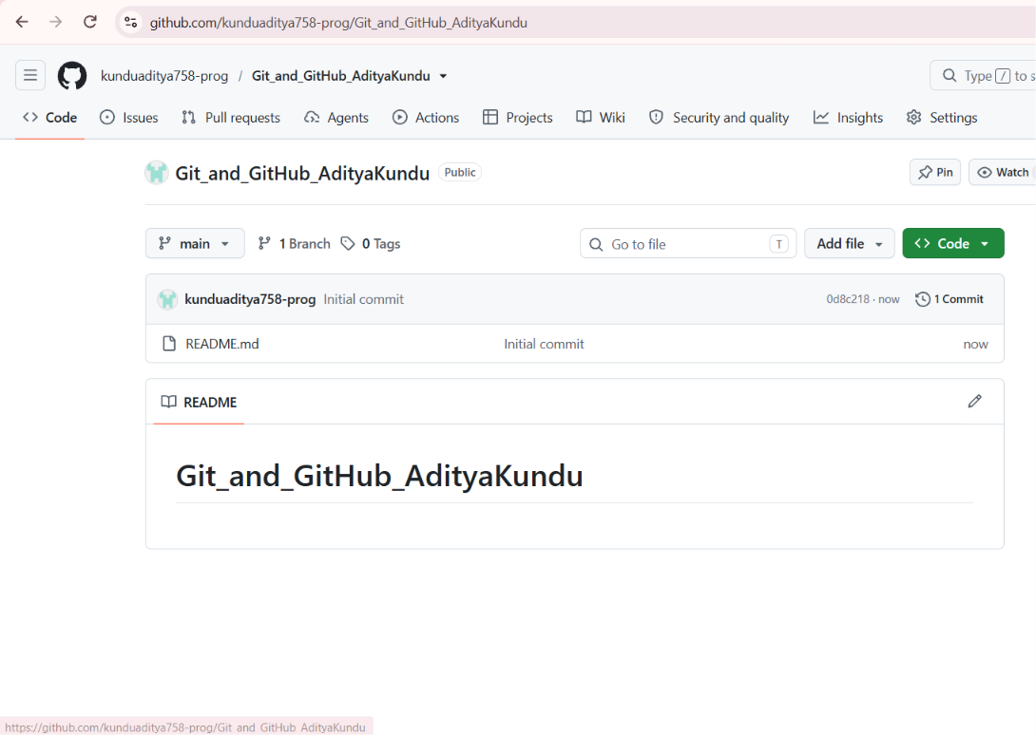
Explanation: I created a public repository named Git_and_GitHub_AdityaKundu and ticked "Add a README", so the repository starts with one commit on the main branch and can be cloned straight away.

Step 2: Clone the repository using SSH
Task: Clone the repository to your local machine using SSH (generate an SSH key if needed, and add the public key to your GitHub account).
Commands:
ssh -T git@github.com
git clone git@github.com:kunduaditya758-prog/Git_and_GitHub_AdityaKundu.git
cd Git_and_GitHub_AdityaKundu

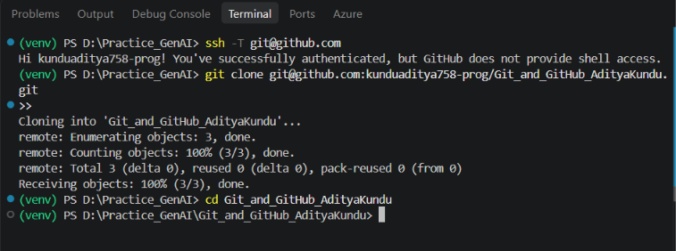
Explanation: I had already created an ed25519 SSH key (ssh-keygen -t ed25519) and added the public key (.pub file) to GitHub under Settings > SSH and GPG keys. ssh -T git@github.com confirms the key works: GitHub replies with my username. I then cloned using the git@github.com address, which uses SSH instead of HTTPS, so no password is needed for push and pull.

Steps 3 to 5: Create a branch, add the Flask files, commit and merge
Task: Create a new branch named after your username. Add your Flask project files to this branch. Commit the changes and merge the branch into the main branch.
Commands:
git switch -c AdityaKundu
# copied .gitignore, .env.example, app.py, data.json, requirements.txt and templates/ from my Flask project
git status
git add .
git commit -m "Add Flask project files"
git switch main
git merge AdityaKundu
git log --oneline --graph --all
git push origin main
git push origin AdityaKundu

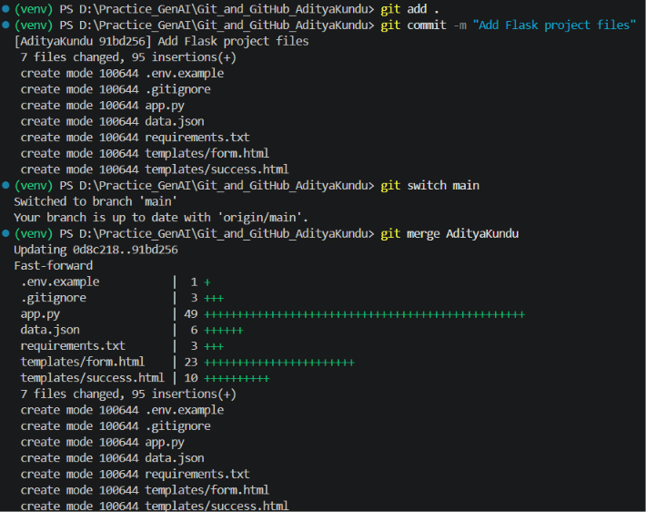
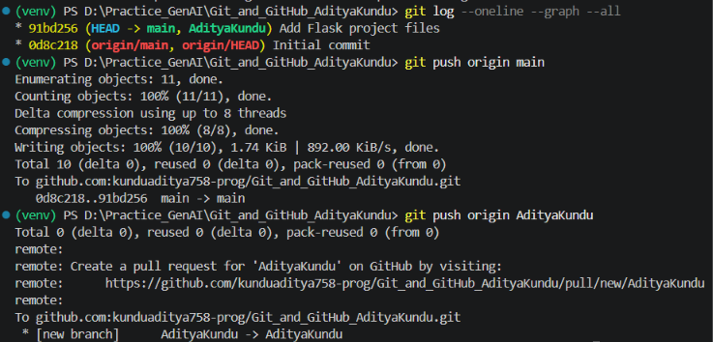
Explanation: git switch -c creates the branch AdityaKundu and moves to it. I copied the .gitignore file first, so the .env file (which has the MongoDB password) is ignored. It does not appear in git status or in the commit; the commit has 7 files and .env is not one of them. After committing, I switched to main and merged. The merge was a fast-forward, because main had no new commits after the branch was created, so Git only moved the main pointer forward to the new commit. Finally I pushed both branches to GitHub. The second push shows "Total 0" because the commit was already uploaded with main; only the branch name had to be created.

Task 2: Update JSON & Resolve Conflicts

Steps 6 and 7: Create the _new branch and update the JSON
Task: Create a new branch named _new. Update the content of the JSON file used for the /api route in this branch.
Commands:
git switch -c AdityaKundu_new
# data.json: Jenkins changed to GitHub Actions, and Prometheus added as id 5
git add data.json
git commit -m "Update API data: add GitHub Actions and Prometheus"

# on main, the same Jenkins line was also changed, so that the merge has a real conflict
git switch main
# data.json: "CI/CD" changed to "CI/CD Server"
git add data.json
git commit -m "Update Jenkins category"

Explanation: In AdityaKundu_new I changed the id 4 item from Jenkins to GitHub Actions and added Prometheus as id 5. To practise conflict resolution properly, I also changed the same line on main (the Jenkins category). Now both branches have changed the same line in different ways, so the merge will give a conflict.

Step 8: Merge the _new branch into main
Task: Merge the _new branch into the main branch.
Commands:
git merge AdityaKundu_new

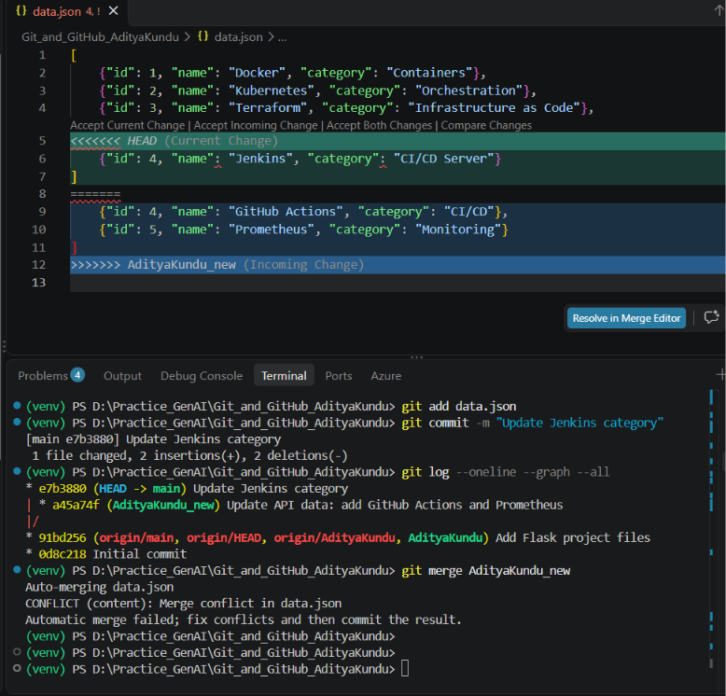
Explanation: The graph shows the two branches going in different directions from the same commit. Git could not merge data.json by itself because both branches changed the same line, so it stopped with "CONFLICT (content): Merge conflict in data.json". VS Code shows the conflict markers: the part between <<<<<<< HEAD and ======= is the main version (Current Change), and the part between ======= and >>>>>>> AdityaKundu_new is the incoming version from the _new branch.

Step 9: Resolve the conflict by accepting the _new changes
Task: If there are conflicts during the merge, resolve them by accepting the changes from the _new branch.
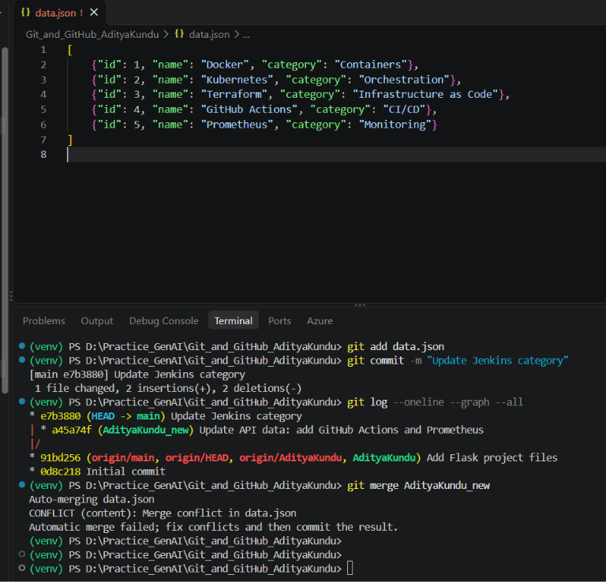
Explanation: I clicked "Accept Incoming Change" in VS Code, which keeps the version from AdityaKundu_new and removes the conflict markers. The file now has 5 tools, including GitHub Actions and Prometheus. I checked the saved file with Get-Content before staging it.

Step 10: Stage, commit and push
Task: Add the resolved changes to the staging area, commit them, and push the updates to the remote repository.
Commands:
git add data.json
git commit -m "Merge AdityaKundu_new: resolve conflict, keep _new changes"
git log --oneline --graph --all
git push origin main
git push origin AdityaKundu_new

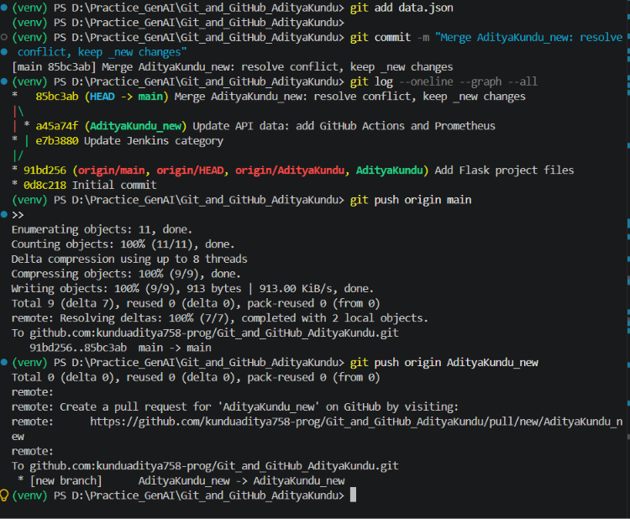
Explanation: git add marks the conflict as resolved and git commit creates the merge commit 85bc3ab. This was a 3-way merge: both branches had new commits, so Git compared the common base commit with the two branch tips and made a new merge commit with two parents. The graph shows the two lines joining at this commit. Then I pushed main and the _new branch.
Result: /api returns the updated JSON
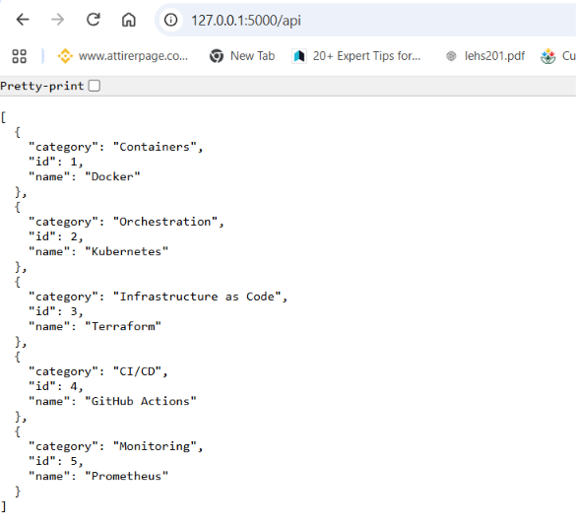
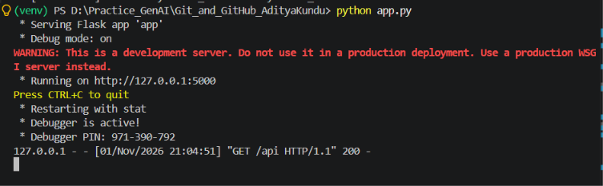
After the merge, /api returns 5 tools from the resolved data.json, and the log shows GET /api with status 200.
GitHub after Task 1 and Task 2
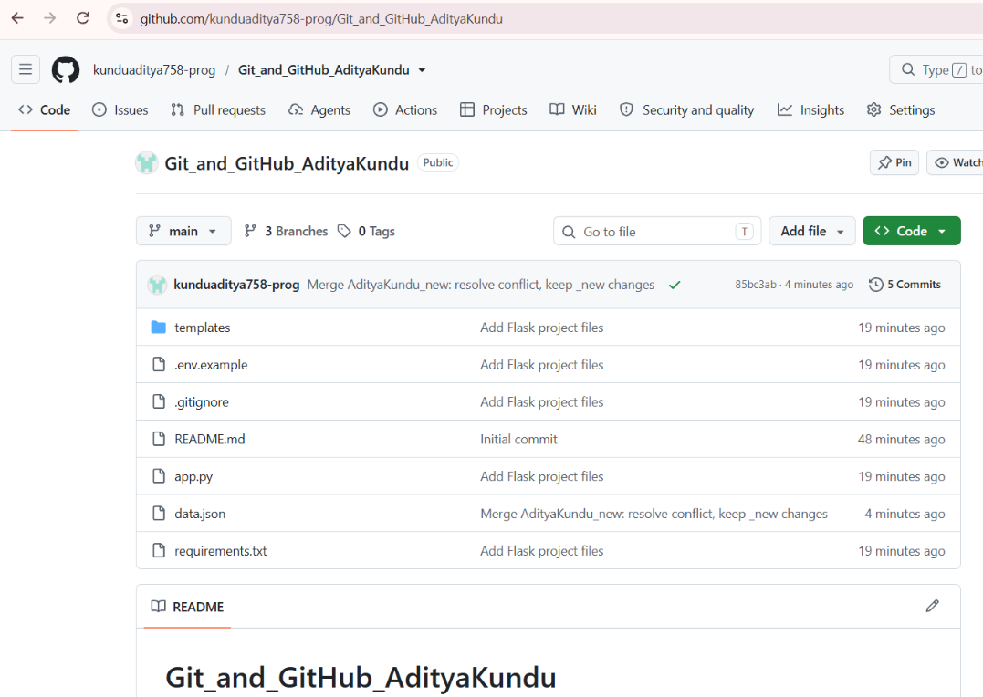
GitHub shows 3 branches and 5 commits. data.json has the merge commit message. The .env file is not in the repository, only .env.example.

Task 3: Parallel Feature Development

Steps 11 and 12: Create master_1 and master_2, build the To-Do page in master_1
Task: Create two branches, master_1 and master_2, from the main branch. In master_1, create a To-Do page in the frontend with a form containing the fields Item Name and Item Description.
Commands:
git switch main
git branch master_1
git branch master_2
git switch master_1
# created templates/todo.html and added the /todo route at the bottom of app.py
git add .
git commit -m "Add To-Do page with Item Name and Item Description"
git log --oneline --graph --all

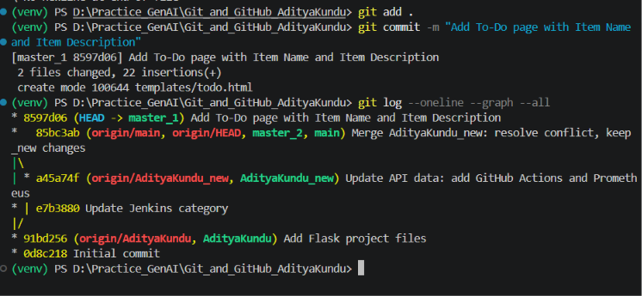
Explanation: Both branches were created from the same main commit (85bc3ab). In master_1 I created templates/todo.html with a form that has Item Name and Item Description fields. The form sends the data with POST to /submittodoitem. I also added a /todo route at the bottom of app.py that shows this page. The log shows that only master_1 has moved ahead; main and master_2 are still on 85bc3ab.

Step 13: Backend API in master_2
Task: In master_2, create a backend route named /submittodoitem that accepts itemName and itemDescription via a POST request and stores these details in a MongoDB database.
Commands:
git switch master_2
# added the /submittodoitem route after the /api route in app.py
git diff
git add app.py
git commit -m "Add /submittodoitem API to store to-do items in MongoDB"
git log --oneline --graph --all

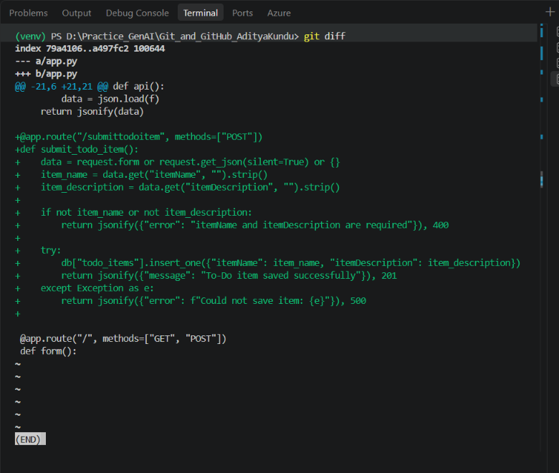
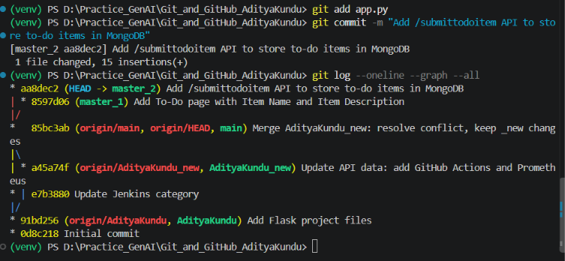
Explanation: The /submittodoitem route accepts only POST. It reads itemName and itemDescription from the form (or from a JSON body), and returns 400 if either one is empty. Otherwise it saves them with insert_one() in the todo_items collection and returns 201 (Created). If MongoDB cannot be reached, the except block returns 500 with the error. The log now shows master_1 and master_2 as two separate lines from the same commit.

Step 14: Merge master_1 and master_2 into main
Task: Merge the changes from both master_1 and master_2 into the main branch.
Commands:
git switch main
git merge master_1
git merge master_2
git log --oneline --graph --all
Get-Content app.py

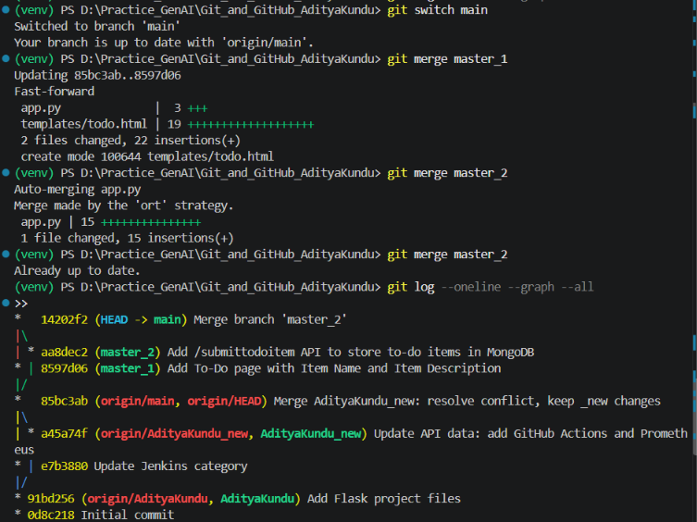
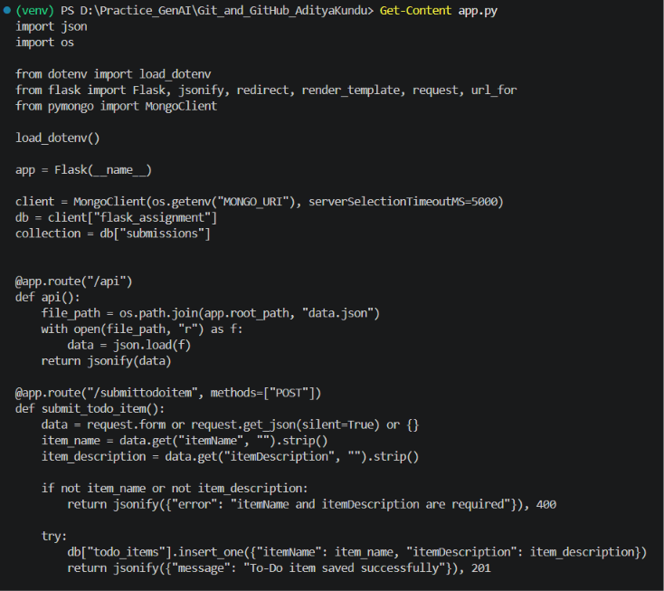
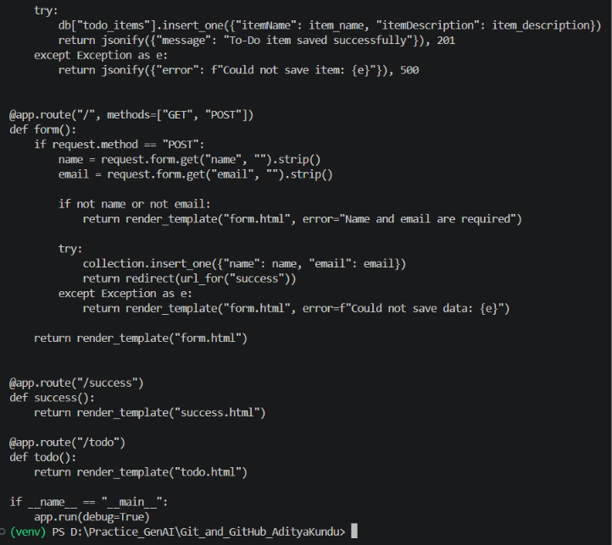
Explanation: The first merge (master_1) was a fast-forward because main had no new commits. The second merge (master_2) was a 3-way merge, because now main and master_2 had both moved ahead, so Git made the merge commit 14202f2 ("Merge made by the 'ort' strategy"). There was no conflict even though both branches changed app.py: master_1 added code at the bottom of the file and master_2 added code at the top, after /api. Git merges line by line, so changes in different parts of the same file are merged automatically. app.py now has both routes.
Testing the merged code
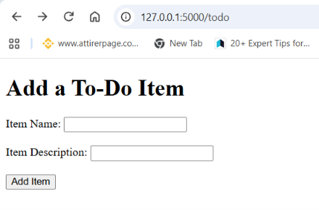
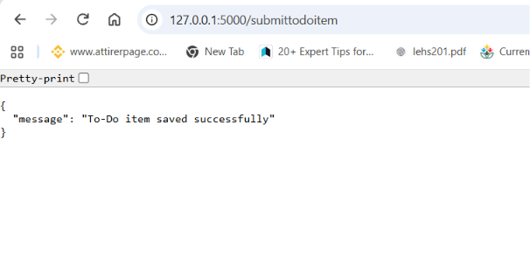
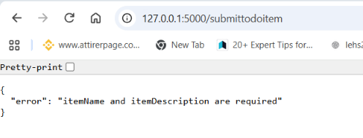
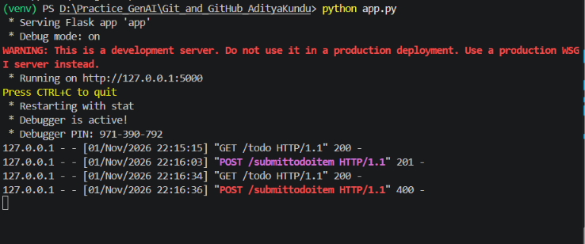
The /todo page shows the form. A filled form returns "To-Do item saved successfully" (201), and an empty form returns the error message (400). The Flask log shows both requests.
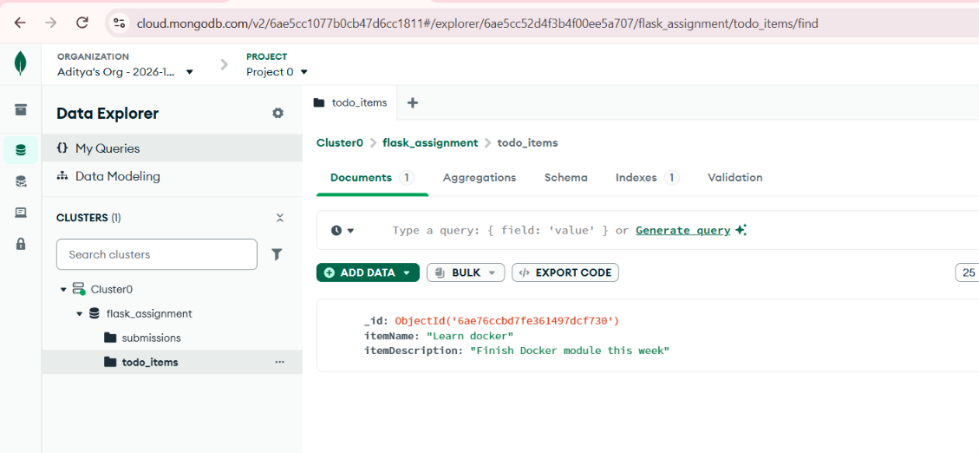
MongoDB Atlas shows the saved item in the todo_items collection of the flask_assignment database. This confirms that the frontend from master_1 and the backend from master_2 work together after the merge.
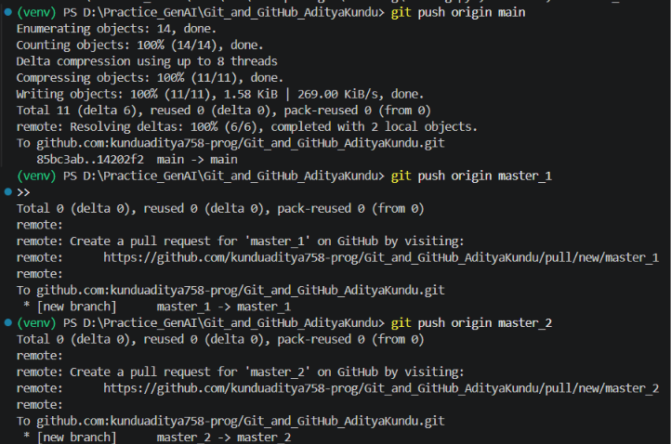
Pushed main, master_1 and master_2 to GitHub.

Task 4: Sequential Commits, Reset & Rebase

Steps 15 and 16: Add Item ID, Item UUID and Item Hash in master_1, one commit each
Task: Add the fields Item ID, Item UUID and Item Hash to the To-Do form in master_1. Add and commit each field separately.
Commands:
git switch master_1
git merge main

# added Item ID to todo.html
git diff
git commit -am "Add Item ID field to To-Do form"
# added Item UUID
git diff
git commit -am "Add Item UUID field to To-Do form"
# added Item Hash
git commit -am "Add Item Hash field to To-Do form"
git log --oneline -5

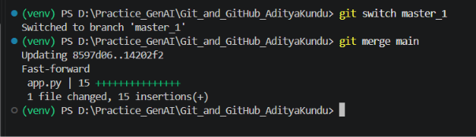
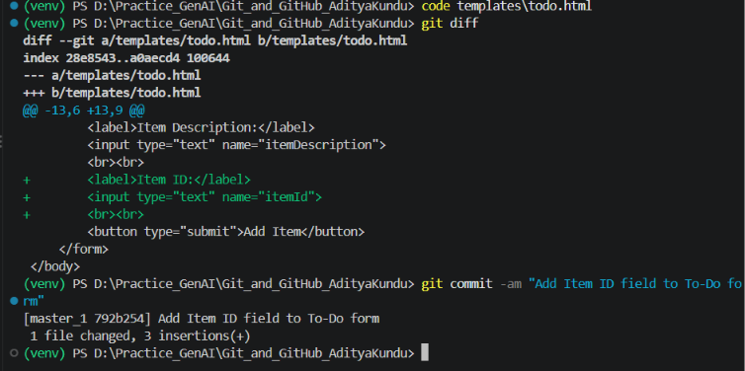
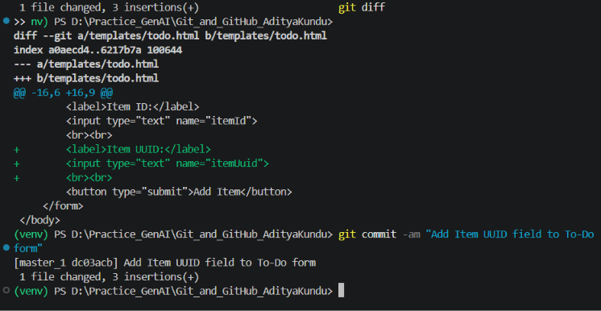
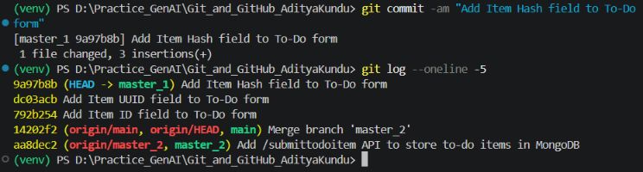
Explanation: First I brought master_1 up to date with main (fast-forward), so it also has the backend route from master_2. Then I added one field at a time to todo.html. Each git diff shows only the 3 new lines for that field, and each one went into its own commit: 792b254 (Item ID), dc03acb (Item UUID) and 9a97b8b (Item Hash). git commit -am stages and commits files that Git already tracks in one step.

Step 17: Merge master_1 into main
Task: Merge the master_1 branch into the main branch.
Commands:
git switch main
git merge master_1
git log --oneline --graph --all -8

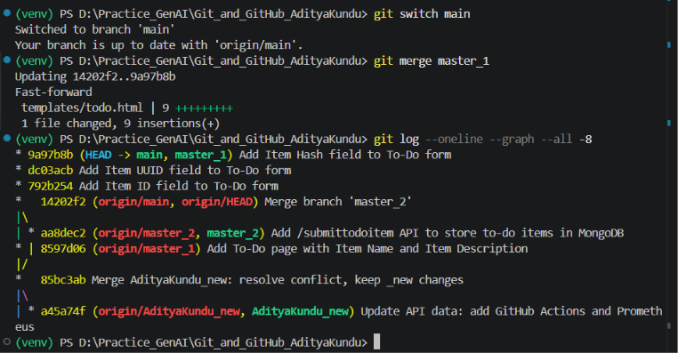
Explanation: This was a fast-forward merge: main had no new commits, so it moved forward to 9a97b8b and now has all three field commits.

Step 18: git reset --soft to the Item ID commit and re-commit
Task: In the main branch, roll back to the commit where only the Item ID field was added. Use git reset --soft to ensure changes remain staged, then re-commit this state and merge it to main.
Commands:
git reset --soft 792b254
git status
git log --oneline -3
git commit -m "Re-commit Item UUID and Item Hash after soft reset"
git log --oneline --graph --all -8

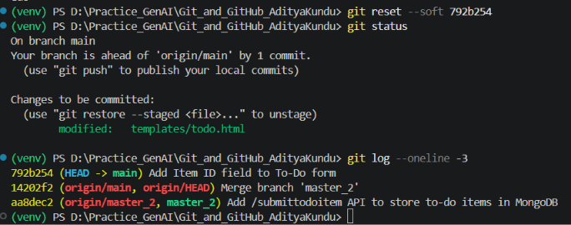
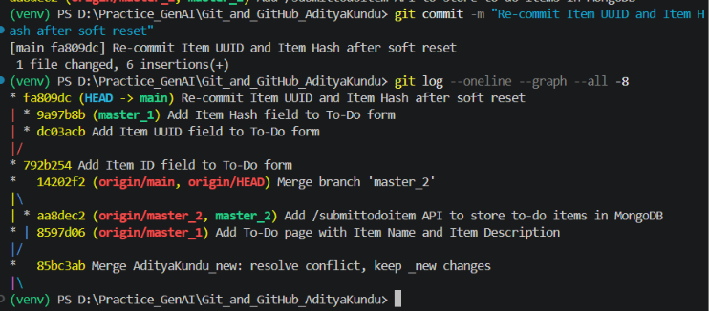
Explanation: git reset --soft 792b254 moved main back to the Item ID commit. The UUID and Hash commits are no longer on main, but their changes were not lost: git status shows templates/todo.html under "Changes to be committed", so the changes stayed in the staging area. This is the difference between the reset types: --soft keeps the changes staged, --mixed (default) keeps them in the working folder but unstaged, and --hard deletes them. I then re-committed the staged changes directly on main as one commit, fa809dc (6 insertions = UUID + Hash). Now main has Item ID followed by one combined commit, while master_1 still has the UUID and Hash commits separately. I did not push in between, because reset changes history.

Step 19: Rebase master_1 onto the updated main
Task: Rebase the updated main branch changes onto master_1 using git rebase main master_1. Preserve individual commits (do not squash).
Commands:
git rebase main master_1
# conflict on the UUID commit, resolved in VS Code
Select-String -Path templates\todo.html -Pattern '<<<<<<<|=======|>>>>>>>'
git add templates\todo.html
git rebase --continue
git log --oneline --graph -6 master_1
Get-Content templates\todo.html

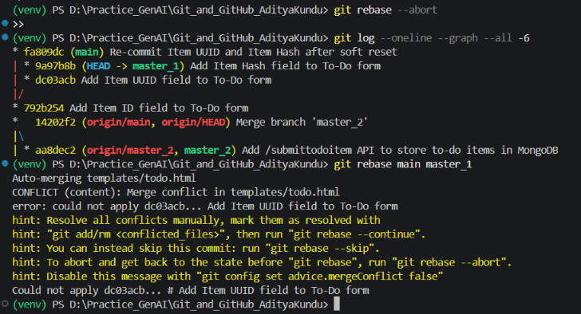
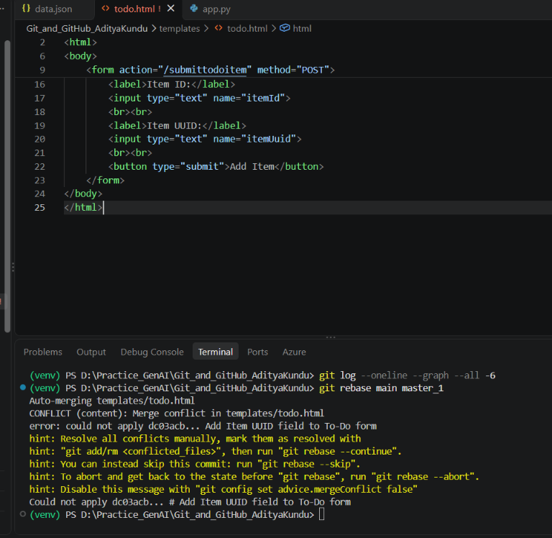
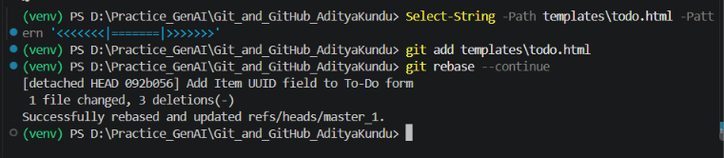
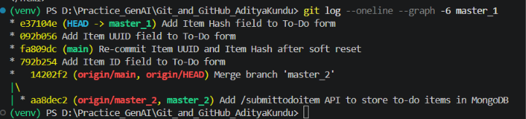
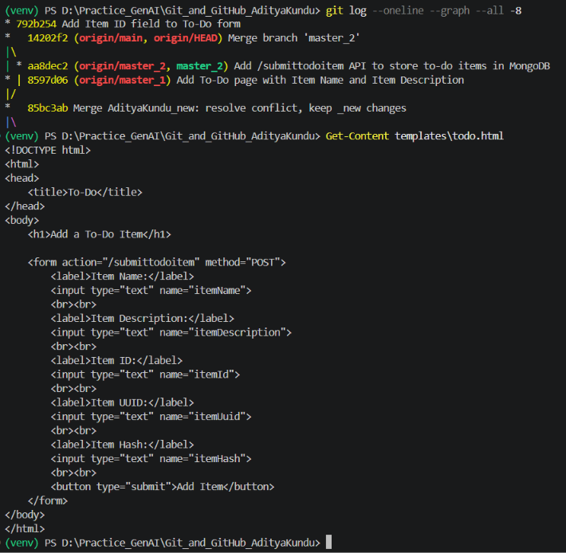
Explanation: git rebase main master_1 takes the commits that are on master_1 but not on main (the UUID and Hash commits) and replays them one by one on top of main. The first one gave a conflict, because main's re-commit already had the UUID and Hash lines in the same place. During a rebase, "Current" is main (the base) and "Incoming" is the master_1 commit being replayed. I accepted the incoming change, so this commit keeps only the UUID step, and the next commit adds the Hash field back. Before git add I checked with Select-String that no conflict markers were left. git rebase --continue then applied the Hash commit without any conflict and printed "Successfully rebased". The final log is a straight line: Item ID > re-commit (main) > Add Item UUID > Add Item Hash. The two commits are preserved separately (not squashed), with new IDs (092b056 and e37104e), because rebase rewrites commits. The final todo.html has all five fields, each once.

Push
Commands:
git push origin main
git push origin master_1

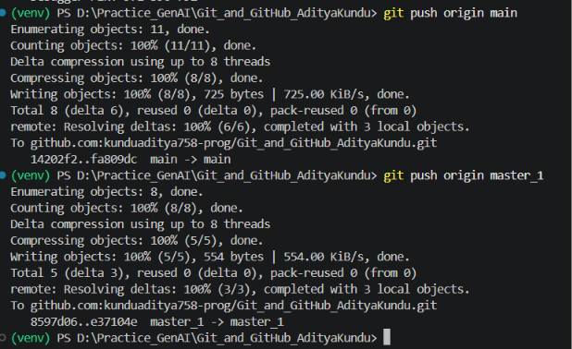
Explanation: Both pushes were normal, not force pushes. The reset and the rebase only changed commits that had not been pushed yet, and the new main (fa809dc) and master_1 (e37104e) both come after the commits already on GitHub.

Summary
I cloned the repository using SSH, added my Flask project on a separate branch and merged it with a fast-forward. I created a real merge conflict on data.json and resolved it by keeping the _new branch changes. I built a frontend To-Do page and a backend MongoDB route on two parallel branches and merged both into main without conflicts. Finally I made one commit per form field, used git reset --soft to roll main back while keeping the changes staged, re-committed them, and rebased master_1 onto main while keeping its commits separate. The .env file with the database password was never committed.

