Linux Basics
DevOps Assignment
Name: Aditya Kundu
Course: TutDude DevOps
Environment: Ubuntu 24.04.1 LTS on WSL2 (Windows)
Date: 26 October 2026
GitHub: https://github.com/kunduaditya758-prog/Linux_Basics_AdityaKundu

Objective
Practise essential Linux command-line operations: file and directory management, viewing files, searching, archiving, downloading, permissions, and environment variables.

Setup
I created one main folder named Linux_Basics_AdityaKundu in my home directory and did all the tasks inside it.
mkdir Linux_Basics_AdityaKundu
cd Linux_Basics_AdityaKundu
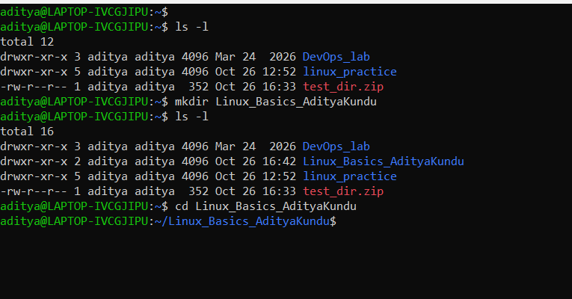

1. Creating and Renaming Files/Directories

Task 1
Task: Create a directory named test_dir using mkdir.
Commands:
mkdir test_dir
ls -l
Screenshot:
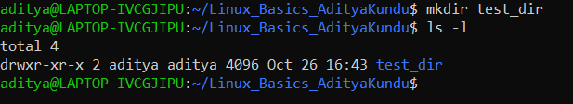
Explanation: I used the mkdir command to create a new folder named test_dir. Then I ran ls -l to check it. The "d" at the start of the line shows that test_dir is a directory.

Task 2
Task: Inside test_dir, create an empty file called example.txt.
Commands:
touch test_dir/example.txt
cd test_dir
ls -l
Screenshot:
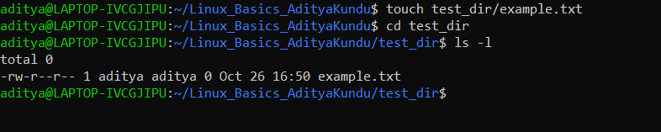
Explanation: I used the touch command with the path test_dir/example.txt to create an empty file inside test_dir. The ls -l output shows the file size is 0, which means the file is empty.

Task 3
Task: Rename example.txt to renamed_example.txt using mv.
Commands:
mv example.txt rename_example.txt
mv rename_example.txt renamed_example.txt
ls -l
Screenshot:
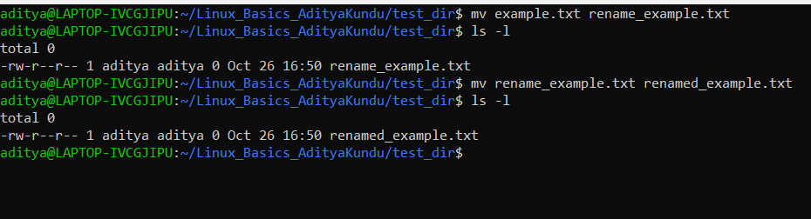
Explanation: Linux does not have a separate rename command, so I used mv to rename the file in the same folder. By mistake, I first named it rename_example.txt. I fixed it by running mv again to change it to renamed_example.txt. The final ls -l shows the correct name.

2. Viewing File Contents

Task 4
Task: Use cat to display the contents of /etc/passwd.
Commands:
cat /etc/passwd
Screenshot:
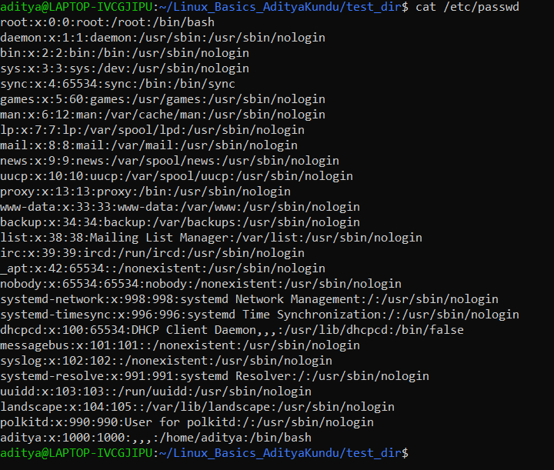
Explanation: I used the cat command to show the full content of /etc/passwd. This file has the list of all users on the system. Each line is one user, and the details are separated by ":".

Task 5
Task: Display only the first 5 lines of /etc/passwd using head.
Commands:
head -n 5 /etc/passwd
Screenshot:
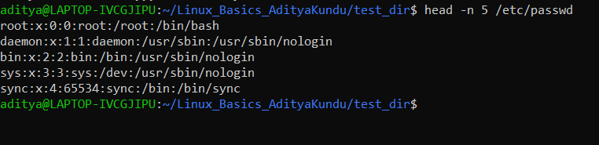
Explanation: I used head with -n 5 to show only the first 5 lines of /etc/passwd. By default head shows 10 lines, so -n is used to set the number of lines.

Task 6
Task: Display only the last 5 lines of /etc/passwd using tail.
Commands:
tail -n 5 /etc/passwd
Screenshot:
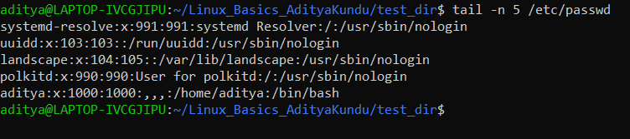
Explanation: I used tail with -n 5 to show only the last 5 lines of /etc/passwd. New users are added at the end of this file, which is why my user "aditya" is in the last line.

3. Searching for Patterns

Task 7
Task: Use grep to find all lines containing the word "root" in /etc/passwd.
Commands:
grep -i root /etc/passwd
Screenshot:
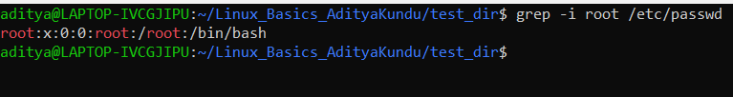
Explanation: I used grep to find all lines that have the word "root" in /etc/passwd. I added -i so that both small and capital letters (root, ROOT, Root) are matched. Only one line matched, and grep highlights "root" in red at all three places in that line.

4. Zipping and Unzipping

Task 8 and 9
Task: Compress the test_dir directory into test_dir.zip using zip. Unzip test_dir.zip into a new directory named unzipped_dir.
Commands:
zip -r test_dir.zip test_dir
unzip test_dir.zip -d unzipped_dir
ls -R unzipped_dir
Screenshot:
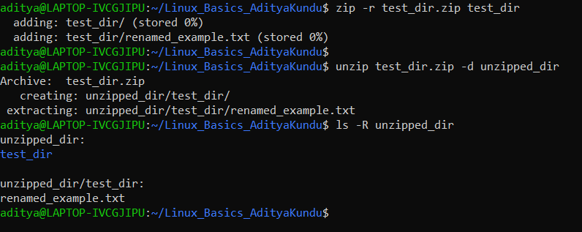
Explanation: Task 8: I used zip -r to compress the test_dir folder into test_dir.zip. The -r option is needed so that the folder and all the files inside it are added. The file shows "stored 0%" because it is empty, so there was nothing to compress. Task 9: I used unzip with -d unzipped_dir to extract the zip into a new folder called unzipped_dir. Then I used ls -R to list the files inside it. It shows that test_dir and renamed_example.txt were extracted correctly.

5. Downloading Files

Task 10
Task: Use wget to download a file from a URL.
Commands:
wget https://raw.githubusercontent.com/github/gitignore/main/Python.gitignore
ls
Screenshot:
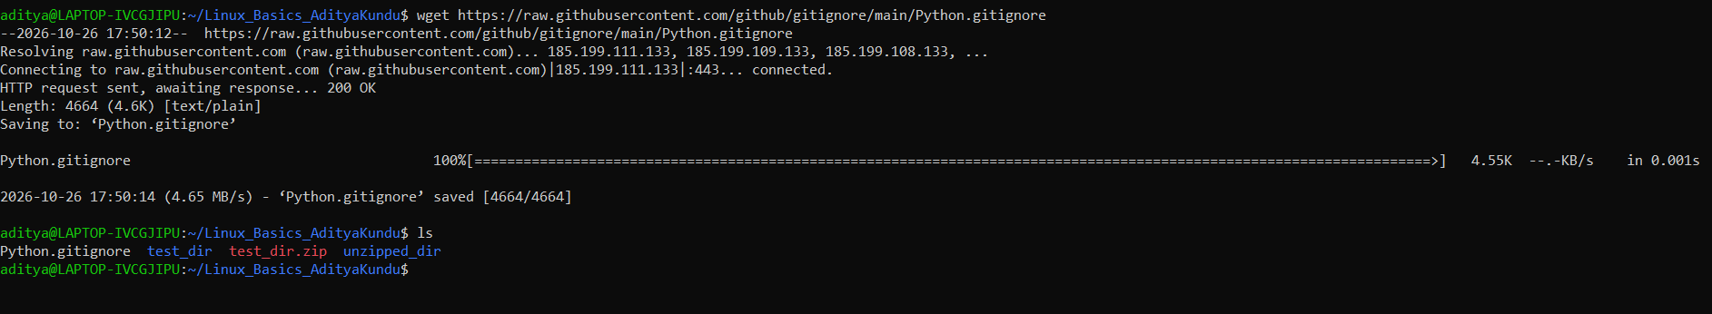
Explanation: The example URL in the assignment (https://example.com/sample.txt) is not a real file, so I used a real text file from GitHub. wget saves the file automatically with the name from the end of the URL, so it was saved as Python.gitignore. The output shows "200 OK", which means the download worked. The ls command shows the file in my folder.

6. Changing Permissions

Task 11
Task: Create a file named secure.txt and change its permissions to read-only for everyone using chmod.
Commands:
touch secure.txt
ls -l
sudo chmod u-w secure.txt
ls -l
Screenshot:
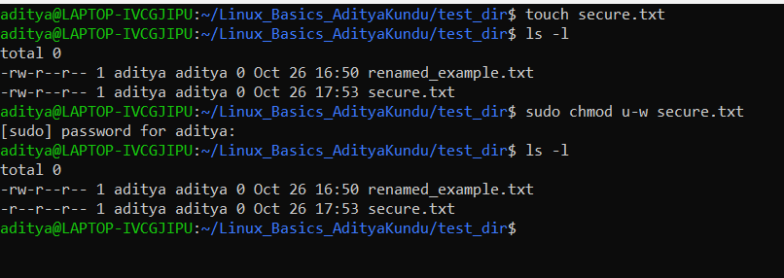
Explanation: I created secure.txt using touch, then used chmod u-w to remove write permission from the owner. Group and others already had only read permission, so now the file is read-only for everyone. The ls -l output shows -r--r--r--.

7. Working with Environment Variables

Task 12
Task: Use export to set a new environment variable called MY_VAR with the value "Hello, Linux!".
Commands:
export MY_VAR='Hello, Linux!'
echo $MY_VAR
bash -c 'echo "Child process sees: $MY_VAR"'
Screenshot:
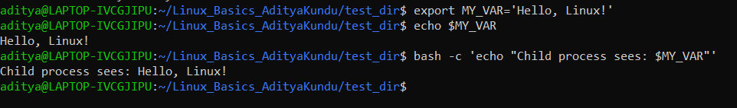
Explanation: I used export to create MY_VAR with the value "Hello, Linux!". I used single quotes because "!" has a special meaning in bash, and single quotes stop that. echo $MY_VAR shows the value. I also ran a new bash process with bash -c, and it could see the variable too. This proves export made it an environment variable.

Final Folder Structure
This screenshot shows all the files and folders created in this assignment.
ls -lR ~/Linux_Basics_AdityaKundu
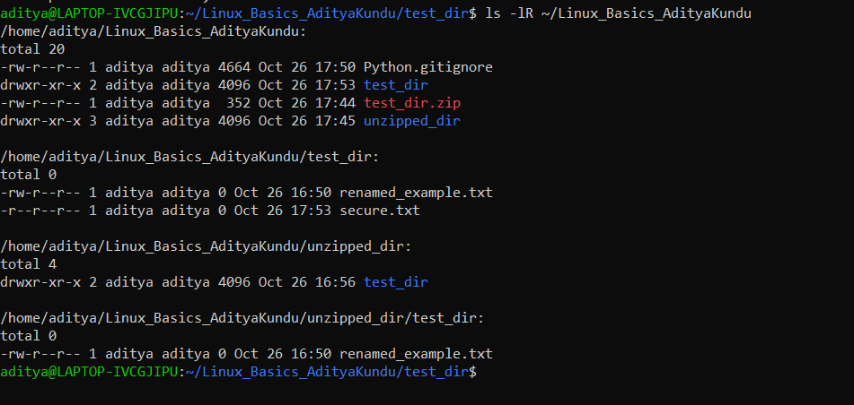

Summary
In this assignment I practised the basic Linux commands: mkdir, touch and mv for files and folders, cat, head and tail to view files, grep to search, zip and unzip for archives, wget to download a file, chmod to change permissions, and export to set an environment variable. All 12 tasks were completed on Ubuntu 24.04 running on WSL2.

