Python & Bash
DevOps Assignment
Name: Aditya Kundu
Course: TutDude DevOps
Tools used: Python 3, VS Code (Windows)
Date: 29 October 2026
GitHub: https://github.com/kunduaditya758-prog/Python_and_Bash_AdityaKundu

Objective
Practise core Python programming: conditionals, dictionaries, and file handling (reading and writing files).

Setup
I created a folder named Python_and_Bash_AdityaKundu and wrote each task as a separate .py file inside it. I ran the scripts from the VS Code terminal.

Task 1: Grade Checker
Task: Take a score as input and print the grade: 90+ is A, 80-89 is B, 70-79 is C, 60-69 is D, and below 60 is F. Use if / else to decide the grade.
Code (grade_checker.py):
score = int(input("Enter your score :"))
if score >= 90 :
print("You scored A grade")
elif score >= 80 :
print("You scored B grade")
elif score >= 70 :
print("You scored C grade")
elif score >= 60 :
print("You scored D grade")
else :
print("Sorry you are Fail")

Screenshot:
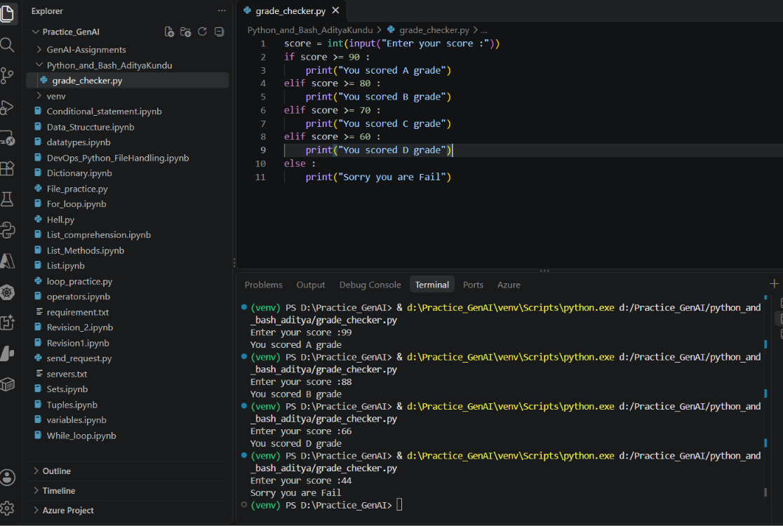
Explanation: I used input() to take the score from the user and int() to change it into a number, because input() always gives a string. Then I used if, elif and else to check the score from the highest grade to the lowest. Python checks the conditions from top to bottom and stops at the first one that is True, so each score gets only one grade. I tested it with 99, 88, 66 and 44 to check A, B, D and Fail.

Task 2: Student Grades
Task: Create a dictionary where the keys are student names and the values are their grades. Allow the user to add a new student and grade, update an existing student's grade, and print all student grades, using a dictionary and if / else.
Code (student_grades.py):
students = {"aditya" : "A" ,"priya" : "A" ,"neha" : "B" ,"aman" : "D"}
while True:
print("\n1. Add student")
print("2. Update grade")
print("3. Show all grades")
print("4. Exit")
choice = int(input("Enter your choice :"))
if choice == 4 :
print ("Thank you for coming")
break
elif choice == 1 :
name = input("Enter name of the student :")
grade = input("Enter grade of the student :")
students[name] = grade
print("Student added")

elif choice == 2 :
name = input("Enter the name of student :")
if name in students :
grade = input("Enter grade of the student :")
students[name] = grade
print("Grade Updated")
else :
print("student not found")

elif choice == 3 :
for name,grade in students.items() :
print("All grades of students are :\n",name ,"->",grade)
else :
print(" Invalid Choice please select from 1 to 4")

Screenshot:
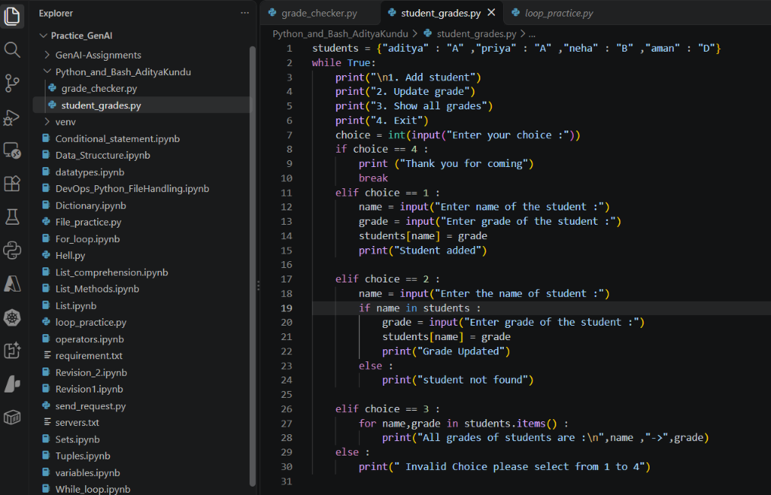
Terminal output (full test run):
1. Add student
2. Update grade
3. Show all grades
4. Exit
Enter your choice :3
All grades of students are :
aditya -> A
All grades of students are :
priya -> A
All grades of students are :
neha -> B
All grades of students are :
aman -> D

1. Add student
2. Update grade
3. Show all grades
4. Exit
Enter your choice :1
Enter name of the student :Shiva
Enter grade of the student :C
Student added

1. Add student
2. Update grade
3. Show all grades
4. Exit
Enter your choice :2
Enter the name of student :neha
Enter grade of the student :A
Grade Updated

1. Add student
2. Update grade
3. Show all grades
4. Exit
Enter your choice :2
Enter the name of student :Rahul
student not found

1. Add student
2. Update grade
3. Show all grades
4. Exit
Enter your choice :3
All grades of students are :
aditya -> A
All grades of students are :
priya -> A
All grades of students are :
neha -> A
All grades of students are :
aman -> D
All grades of students are :
Shiva -> C

1. Add student
2. Update grade
3. Show all grades
4. Exit
Enter your choice :5
Invalid Choice please select from 1 to 4

1. Add student
2. Update grade
3. Show all grades
4. Exit
Enter your choice :4
Thank you for coming

Explanation: I stored the student names and grades in a dictionary. A while True loop shows the menu again and again until the user picks 4, which stops the loop with break. For add and update, I used students[name] = grade. For update, I first check if name in students, so a wrong name shows "student not found". For showing all grades, I used a for loop with .items() to get each name and grade. Any other number shows "Invalid Choice".

Task 3: Write to a File
Task: Write a program to create a text file and write some content to it, using file functions like open() and write().
Code (write_file.py):
with open("serversinfo.txt","w") as f :
f.write("Our Servers List:\n")
f.write("1.Web01\n")
f.write("2.Dev01\n")
f.write("3.App01\n")
f.write("4.UAT01\n")
f.write("5.Prod01\n")

print("File serversinfo has been created sucessfully!!")

Screenshot:
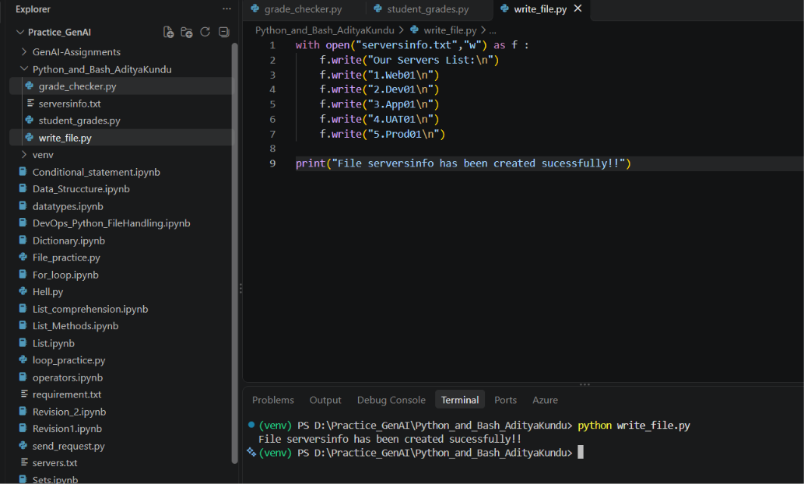
Explanation: I used open() with "w" (write) mode inside a with block to create serversinfo.txt, and write() to add each line. I put \n at the end of every line so that each server comes on a new line. The with block closes the file automatically, and the print message after it confirms that the file was created. I ran the script from inside the assignment folder, so the file was created in the same folder.

Task 4: Read from a File
Task: Open the file in read mode and use file.read() to read and display its content.
Code (read_file.py):
with open("serversinfo.txt","r") as f :
content = f.read()
print(content)

Screenshot:
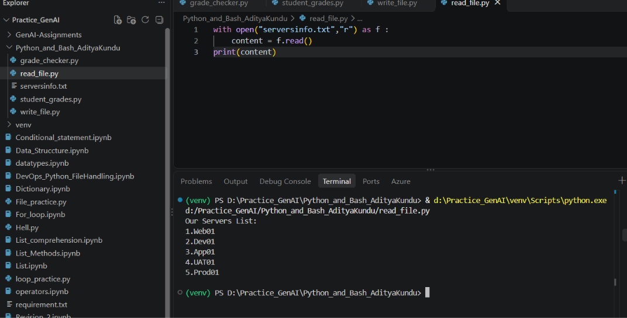
Explanation: I opened serversinfo.txt in "r" (read) mode using a with block. f.read() reads the whole file as one string and stores it in the content variable. Then I printed content, and it shows all the lines that were written in Task 3.

Summary
In this assignment I practised if / elif / else for the grade checker, a dictionary with a while loop menu for adding, updating and showing student grades, and file handling with open(), write() and read() to create a file and read it back. All four tasks were tested and work as expected.

