**MACHINE LEARNING**

**ASSIGNMENT 2**

REPORT

by

# Lavudya Prudhvi Raj(22CS60R58)

&

# Akash Kundu(22CS60R38)

Department of Computer Science & Engineering, Indian Institute of Technology Kharagpur

**Report1(Q1):**

* PCA Plot

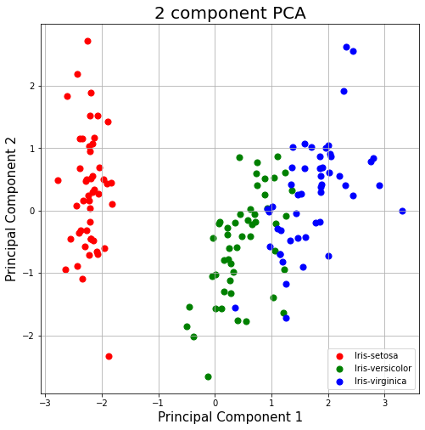

By selecting 2 components,95% of total variance is preserved

* K-means Clustering

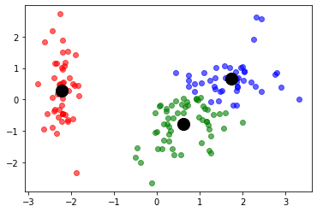

**Report2(Q2):**

* Given data

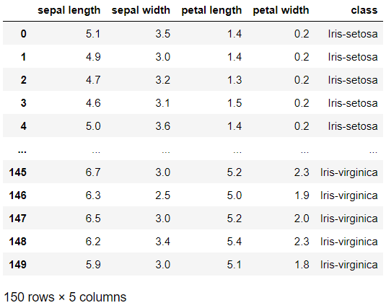

* Data after Standard Scalar Normalization

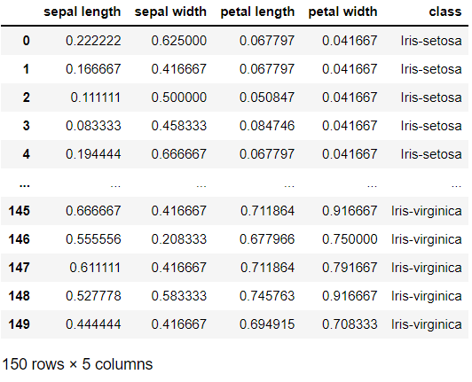

* Accuracy for SVM Models:

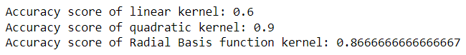

* Accuracy of MLP Classifier Models:

1. 1 hidden layer with 16 nodes
2. 2 hidden layers with 256 and 16 nodes respectively.



* Learning rate vs accuracy(Best of MLP Models):

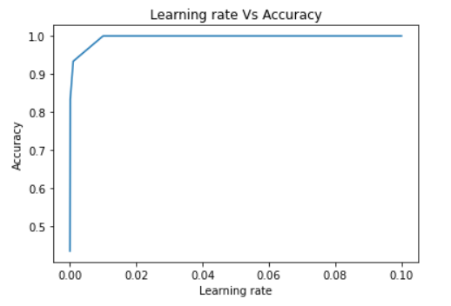

* Best feature using Backward Elimination(k=no.of features):

1. k=1:('petal width')
2. k=2:('petal length', 'petal width')
3. k=3:('sepal width', 'petal length', 'petal width')
4. k=4:('sepal length', 'sepal width', 'petal length', 'petal width')

* Ensemble Learning(Max voting technique)

Accuracy of SVM using quadratic polynomial kernel: 0.9666666666666667

Accuracy of SVM using Radial Basis function kernel: 1.0

Accuracy of best model of part3: 0.7666666666666667

Accuracy of max voting technique using the above 3 models: 1.0

**References:**

1. <https://towardsdatascience.com/pca-using-python-scikit-learn-e653f8989e60>
2. <https://scikit-learn.org/stable/modules/svm.html>
3. <https://scikit-learn.org/stable/modules/generated/sklearn.neural_network.MLPClassifier.html>
4. https://www.analyticsvidhya.com/blog/2021/04/backward-feature-elimination-and-its-implementation/