PERSON–2 : Arduino

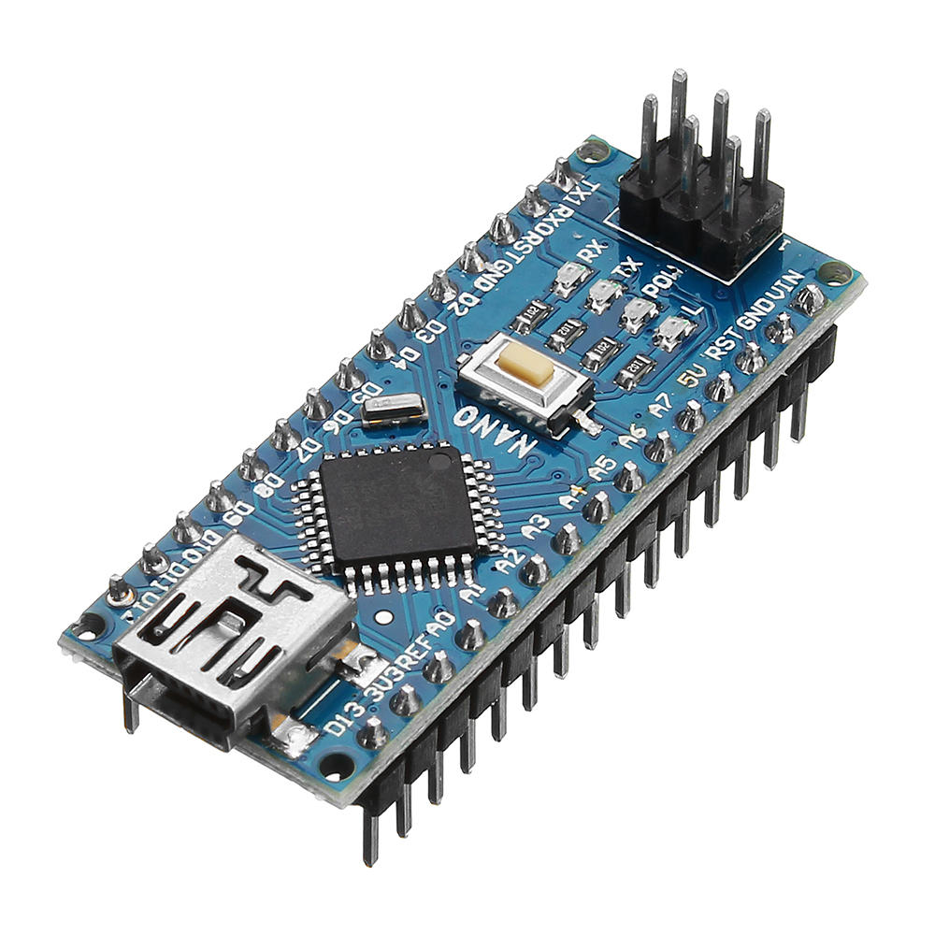

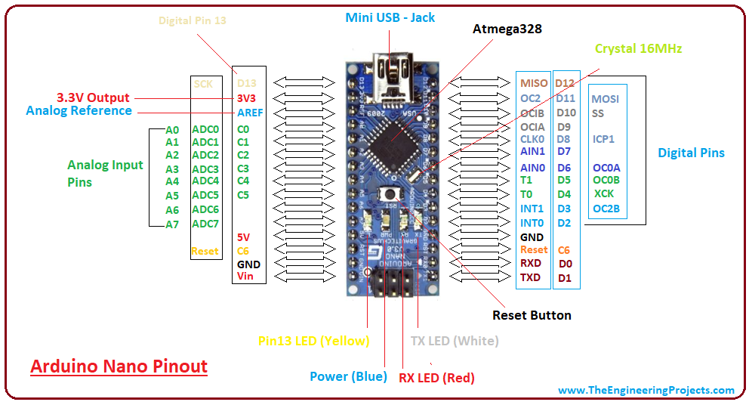

What is Arduino?
Arduino is a microcontroller board used to control electronic components like LED, buzzer, motor, relay, Bluetooth, etc., by using a program (code).
In simple words:
Arduino is the brain of the project – it decides when LED should glow and when buzzer should sound.

Use of Arduino in Smart Helmet Project
In this project, Arduino does the following jobs:
- Checks helmet condition (helmet worn or not)
- Controls LED
- Controls Buzzer
- Sends signal to bike side (through Bluetooth / relay – other persons handle that)
- Runs the logic written in code
Without Arduino, the project will not work.

Role of Person–2 in the Project
Person–2 is responsible for:
- Writing Arduino code
- Uploading code to Arduino
- Connecting LED & Buzzer to Arduino
- Testing whether LED & buzzer work correctly
- Helping other persons by explaining signals & pins
Person–2 is the technical support + programmer of the team.

Components Handled by Person–2
- Arduino UNO
- USB cable
- Breadboard
- LED
- Buzzer
- Resistor (220Ω for LED)
- Jumper wires

Flow Chart for Person–2 (Arduino Logic)
Flow Chart Explanation (Helmet Side)
START
↓
Power ON Arduino
↓
Initialize LED & Buzzer pins
↓
Check helmet condition
↓
Is helmet worn?
↓ ↓
YES NO
↓ ↓
Blink LED Do nothing
Sound buzzer once
↓
Send signal to bike
↓
END
This flow chart is implemented using Arduino code.

How Person–2 Writes the Code
Steps to Write Code
- Open Arduino IDE
- Select:
  - Board → Arduino UNO
  - Port → COM port
- Write code using:
  - setup() → runs once
  - loop() → runs continuously

How LED & Buzzer are Linked (Concept Only)
Component | Arduino Pin | Purpose
LED | Digital Pin (ex: D8) | Visual indication
Buzzer | Digital Pin (ex: D9) | Sound indication
GND | GND | Common ground
Person–2 decides the pin numbers in code and connects accordingly.

When LED & Buzzer Should Work
Condition used by Person–2:
- When helmet is worn:
  - LED blinks once
  - Buzzer beeps once
  - This confirms:
Helmet worn properly
Arduino working correctly

Testing Work of Person–2
Tests Done by Person–2
- Power Arduino using USB
- Upload test code
- Check:
  - LED ON/OFF
  - Buzzer sound
- If both work:
  - Code is correct
  - Connections are correct
This testing is done before connecting Bluetooth or bike side.

Uploading Code – When & How
When to Upload Code
- After all connections are done
- After checking correct pin numbers
- Before final demo
How to Upload Code
- Connect Arduino to laptop
- Click Verify (✔) in Arduino IDE
- Click Upload (➡) button
- Wait for “Done Uploading” message
Only Person–2 uploads code to avoid mistakes.

How Person–2 Helps Other Team Members
- Explains pin connections
- Shares signal logic
- Helps Bluetooth person understand data flow
- Helps hardware person check power & ground
Person–2 acts as a bridge between software and hardware.

