SVN

1. **Creating a SVN Project**

* Create a folder
* Right click on folder and select “TortoieseSVN”
* And select “Create repository here”

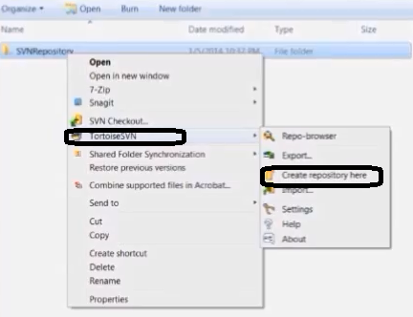

* Click on “Create folder structure and click on “OK”

1. **Importing a Project**

* Create a folder and files which files we are going to import into SVN
* Right click on folder, select “TortoieseSVN” and select “Import

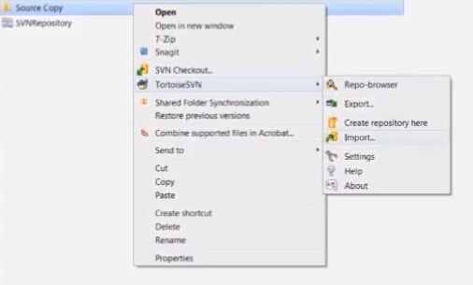

* Verify the SVN repository path and enter import message and click on “OK

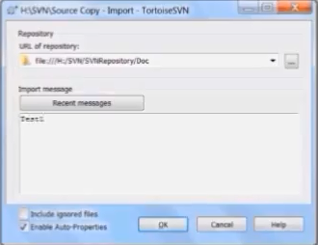

* To verify imported files in SVN repository, right click select “TortoieseSVN” and select “Repo-browser”
* It shows the SVN repository URL or specify the correct URL
* It displays SVN repository explorer

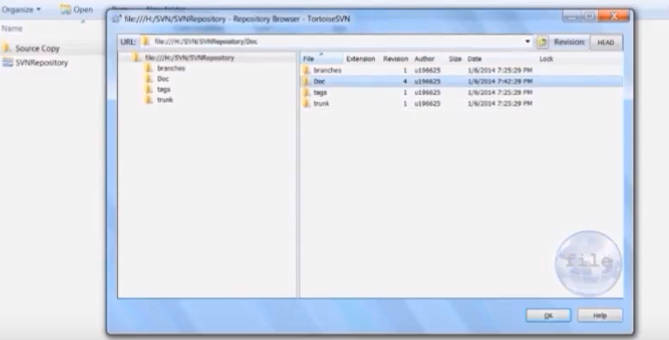

* Click on right side pan Doc folder , it displays files in the Doc folder

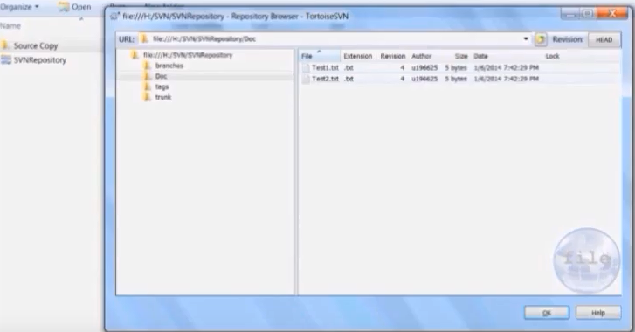

1. **Checking out a Working Copy**

* Go to SVR Repository explorer, right click on Doc folder and select “Checkout..”

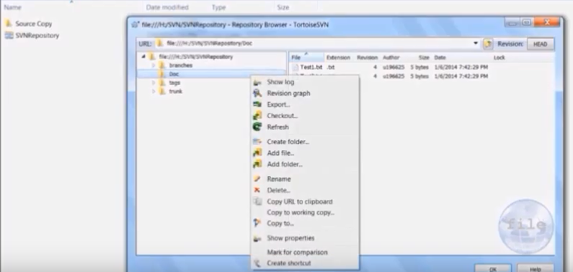

* Specify the Checkout directory in Checkout dialog and click on “OK”

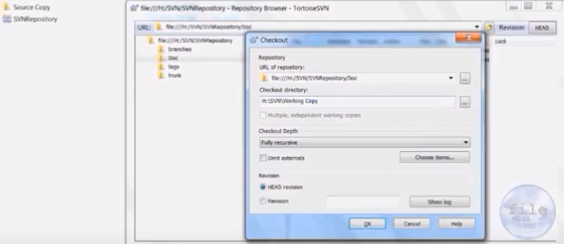

* It Creates folder Working Copy with default .svn extension with files in the working directory

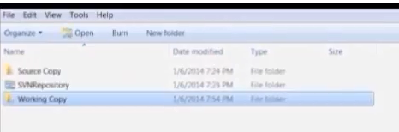

* Click on Working Copy folder

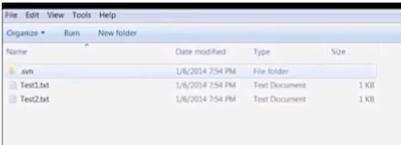

1. **Making Changes**

* Make changes in the Working Copy folder files and close
* Right click on Working Copy folder and select “SVN Commit..”
* Select the file which you want to version control and click on “OK”
* We will find changes reflected in the SVN repository
* To check changes reflected in the SVN repository, Right click select “TortoieseSVN” and select “Repo-browser

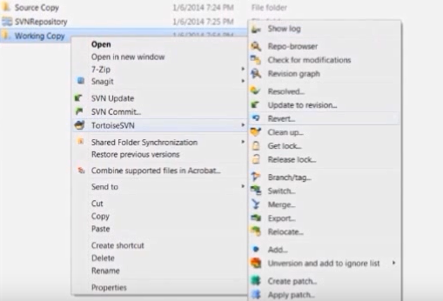

* In SVN repository explorer , right click on Doc folder and select refresh and verify changes in specified file

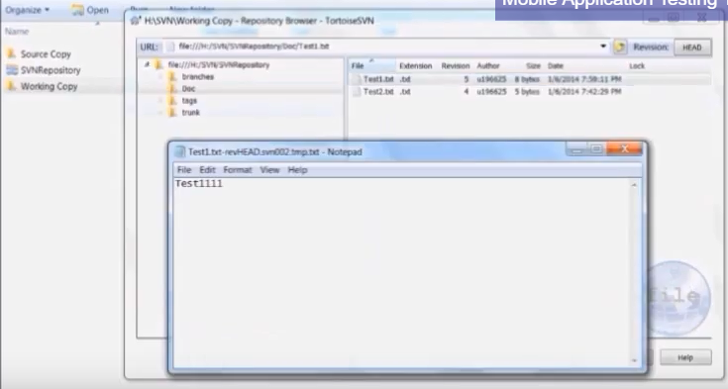

1. **Adding Files**

* Create a file in the Working Copy folder
* Right click on Working Copy folder, select “TortoieseSVN” and select “Add”

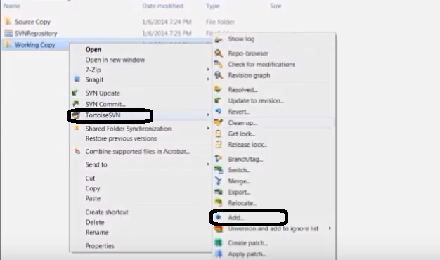

* It displays file added and click on “OK”
* To commit into the SVN repository server, right click on Working Copy folder and select “SVN Commit…”

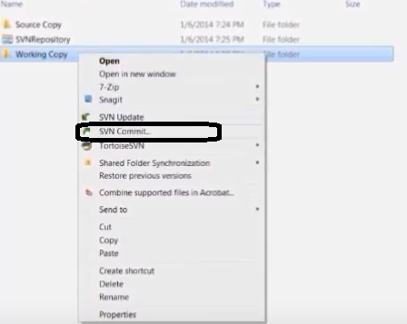

* Select the file to be committed and click on “OK”

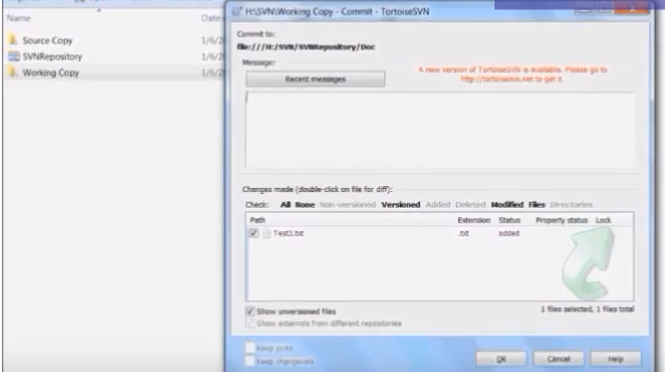

* To verify added file in the SVN Repository server, right click select “TortoieseSVN” and select “Repo-browser”.
* Click on the Doc folder there we will find the added file

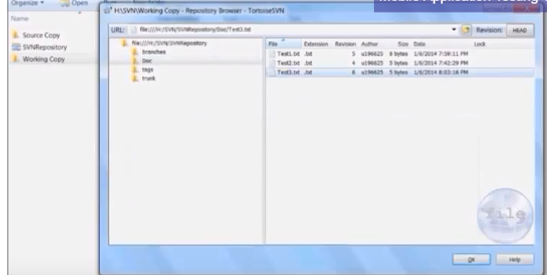

1. **View the Project History**

* Right click on Working Copy folder , select “TortoieseSVN” and select “Show log”

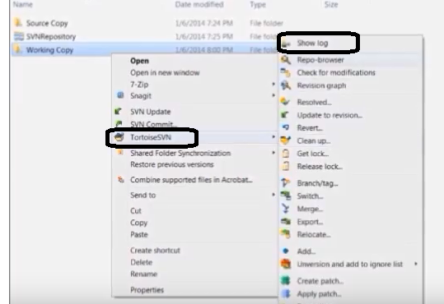

* Displays the log history of Working Copy folder

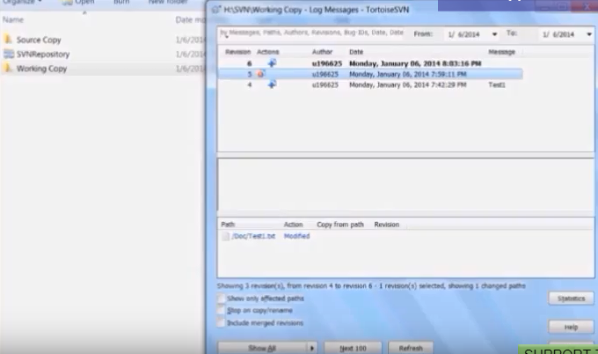

1. **Undoing Changes**

* Before commit changes into the SVN Server, we can undo changes into the file
* Right click on Working Copy folder, select “TortoieseSVN” and select

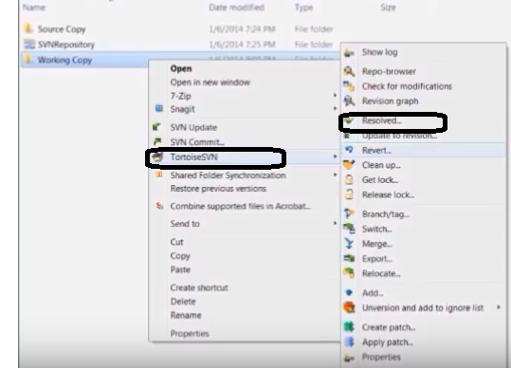

Github