1. springboot 原理
2. 使用spring.factories文件配置需要加载的组建信息

在 自动装载包下面

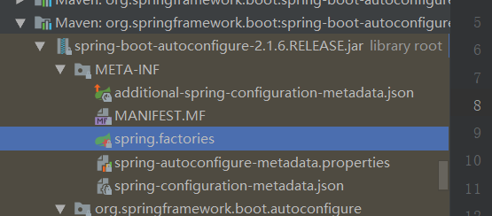

# Initializers  
org.springframework.context.ApplicationContextInitializer=\  
org.springframework.boot.autoconfigure.SharedMetadataReaderFactoryContextInitializer,\  
org.springframework.boot.autoconfigure.logging.ConditionEvaluationReportLoggingListener  
  
# Application Listeners  
org.springframework.context.ApplicationListener=\  
org.springframework.boot.autoconfigure.BackgroundPreinitializer  
  
# Auto Configuration Import Listeners  
org.springframework.boot.autoconfigure.AutoConfigurationImportListener=\  
org.springframework.boot.autoconfigure.condition.ConditionEvaluationReportAutoConfigurationImportListener  
  
# Auto Configuration Import Filters  
org.springframework.boot.autoconfigure.AutoConfigurationImportFilter=\  
org.springframework.boot.autoconfigure.condition.OnBeanCondition,\  
org.springframework.boot.autoconfigure.condition.OnClassCondition,\  
org.springframework.boot.autoconfigure.condition.OnWebApplicationCondition  
  
# Auto Configure  
org.springframework.boot.autoconfigure.EnableAutoConfiguration=\  
org.springframework.boot.autoconfigure.admin.SpringApplicationAdminJmxAutoConfiguration,\  
org.springframework.boot.autoconfigure.aop.AopAutoConfiguration,\  
org.springframework.boot.autoconfigure.amqp.RabbitAutoConfiguration,\  
org.springframework.boot.autoconfigure.batch.BatchAutoConfiguration,\  
org.springframework.boot.autoconfigure.cache.CacheAutoConfiguration,\  
org.springframework.boot.autoconfigure.cassandra.CassandraAutoConfiguration,\  
org.springframework.boot.autoconfigure.cloud.CloudServiceConnectorsAutoConfiguration,\  
org.springframework.boot.autoconfigure.context.ConfigurationPropertiesAutoConfiguration,\  
org.springframework.boot.autoconfigure.context.MessageSourceAutoConfiguration,\  
org.springframework.boot.autoconfigure.context.PropertyPlaceholderAutoConfiguration,\  
org.springframework.boot.autoconfigure.couchbase.CouchbaseAutoConfiguration,\  
org.springframework.boot.autoconfigure.dao.PersistenceExceptionTranslationAutoConfiguration,\  
org.springframework.boot.autoconfigure.data.cassandra.CassandraDataAutoConfiguration,\  
org.springframework.boot.autoconfigure.data.cassandra.CassandraReactiveDataAutoConfiguration,\  
org.springframework.boot.autoconfigure.data.cassandra.CassandraReactiveRepositoriesAutoConfiguration,\  
org.springframework.boot.autoconfigure.data.cassandra.CassandraRepositoriesAutoConfiguration,\  
org.springframework.boot.autoconfigure.data.couchbase.CouchbaseDataAutoConfiguration,\  
org.springframework.boot.autoconfigure.data.couchbase.CouchbaseReactiveDataAutoConfiguration,\  
org.springframework.boot.autoconfigure.data.couchbase.CouchbaseReactiveRepositoriesAutoConfiguration,\  
org.springframework.boot.autoconfigure.data.couchbase.CouchbaseRepositoriesAutoConfiguration,\  
org.springframework.boot.autoconfigure.data.elasticsearch.ElasticsearchAutoConfiguration,\  
org.springframework.boot.autoconfigure.data.elasticsearch.ElasticsearchDataAutoConfiguration,\  
org.springframework.boot.autoconfigure.data.elasticsearch.ElasticsearchRepositoriesAutoConfiguration,\  
org.springframework.boot.autoconfigure.data.jdbc.JdbcRepositoriesAutoConfiguration,\  
org.springframework.boot.autoconfigure.data.jpa.JpaRepositoriesAutoConfiguration,\  
org.springframework.boot.autoconfigure.data.ldap.LdapRepositoriesAutoConfiguration,\  
org.springframework.boot.autoconfigure.data.mongo.MongoDataAutoConfiguration,\  
org.springframework.boot.autoconfigure.data.mongo.MongoReactiveDataAutoConfiguration,\  
org.springframework.boot.autoconfigure.data.mongo.MongoReactiveRepositoriesAutoConfiguration,\  
org.springframework.boot.autoconfigure.data.mongo.MongoRepositoriesAutoConfiguration,\  
org.springframework.boot.autoconfigure.data.neo4j.Neo4jDataAutoConfiguration,\  
org.springframework.boot.autoconfigure.data.neo4j.Neo4jRepositoriesAutoConfiguration,\  
org.springframework.boot.autoconfigure.data.solr.SolrRepositoriesAutoConfiguration,\  
org.springframework.boot.autoconfigure.data.redis.RedisAutoConfiguration,\  
org.springframework.boot.autoconfigure.data.redis.RedisReactiveAutoConfiguration,\  
org.springframework.boot.autoconfigure.data.redis.RedisRepositoriesAutoConfiguration,\  
org.springframework.boot.autoconfigure.data.rest.RepositoryRestMvcAutoConfiguration,\  
org.springframework.boot.autoconfigure.data.web.SpringDataWebAutoConfiguration,\  
org.springframework.boot.autoconfigure.elasticsearch.jest.JestAutoConfiguration,\  
org.springframework.boot.autoconfigure.elasticsearch.rest.RestClientAutoConfiguration,\  
org.springframework.boot.autoconfigure.flyway.FlywayAutoConfiguration,\  
org.springframework.boot.autoconfigure.freemarker.FreeMarkerAutoConfiguration,\  
org.springframework.boot.autoconfigure.gson.GsonAutoConfiguration,\  
org.springframework.boot.autoconfigure.h2.H2ConsoleAutoConfiguration,\  
org.springframework.boot.autoconfigure.hateoas.HypermediaAutoConfiguration,\  
org.springframework.boot.autoconfigure.hazelcast.HazelcastAutoConfiguration,\  
org.springframework.boot.autoconfigure.hazelcast.HazelcastJpaDependencyAutoConfiguration,\  
org.springframework.boot.autoconfigure.http.HttpMessageConvertersAutoConfiguration,\  
org.springframework.boot.autoconfigure.http.codec.CodecsAutoConfiguration,\  
org.springframework.boot.autoconfigure.influx.InfluxDbAutoConfiguration,\  
org.springframework.boot.autoconfigure.info.ProjectInfoAutoConfiguration,\  
org.springframework.boot.autoconfigure.integration.IntegrationAutoConfiguration,\  
org.springframework.boot.autoconfigure.jackson.JacksonAutoConfiguration,\  
org.springframework.boot.autoconfigure.jdbc.DataSourceAutoConfiguration,\  
org.springframework.boot.autoconfigure.jdbc.JdbcTemplateAutoConfiguration,\  
org.springframework.boot.autoconfigure.jdbc.JndiDataSourceAutoConfiguration,\  
org.springframework.boot.autoconfigure.jdbc.XADataSourceAutoConfiguration,\  
org.springframework.boot.autoconfigure.jdbc.DataSourceTransactionManagerAutoConfiguration,\  
org.springframework.boot.autoconfigure.jms.JmsAutoConfiguration,\  
org.springframework.boot.autoconfigure.jmx.JmxAutoConfiguration,\  
org.springframework.boot.autoconfigure.jms.JndiConnectionFactoryAutoConfiguration,\  
org.springframework.boot.autoconfigure.jms.activemq.ActiveMQAutoConfiguration,\  
org.springframework.boot.autoconfigure.jms.artemis.ArtemisAutoConfiguration,\  
org.springframework.boot.autoconfigure.groovy.template.GroovyTemplateAutoConfiguration,\  
org.springframework.boot.autoconfigure.jersey.JerseyAutoConfiguration,\  
org.springframework.boot.autoconfigure.jooq.JooqAutoConfiguration,\  
org.springframework.boot.autoconfigure.jsonb.JsonbAutoConfiguration,\  
org.springframework.boot.autoconfigure.kafka.KafkaAutoConfiguration,\  
org.springframework.boot.autoconfigure.ldap.embedded.EmbeddedLdapAutoConfiguration,\  
org.springframework.boot.autoconfigure.ldap.LdapAutoConfiguration,\  
org.springframework.boot.autoconfigure.liquibase.LiquibaseAutoConfiguration,\  
org.springframework.boot.autoconfigure.mail.MailSenderAutoConfiguration,\  
org.springframework.boot.autoconfigure.mail.MailSenderValidatorAutoConfiguration,\  
org.springframework.boot.autoconfigure.mongo.embedded.EmbeddedMongoAutoConfiguration,\  
org.springframework.boot.autoconfigure.mongo.MongoAutoConfiguration,\  
org.springframework.boot.autoconfigure.mongo.MongoReactiveAutoConfiguration,\  
org.springframework.boot.autoconfigure.mustache.MustacheAutoConfiguration,\  
org.springframework.boot.autoconfigure.orm.jpa.HibernateJpaAutoConfiguration,\  
org.springframework.boot.autoconfigure.quartz.QuartzAutoConfiguration,\  
org.springframework.boot.autoconfigure.reactor.core.ReactorCoreAutoConfiguration,\  
org.springframework.boot.autoconfigure.security.servlet.SecurityAutoConfiguration,\  
org.springframework.boot.autoconfigure.security.servlet.SecurityRequestMatcherProviderAutoConfiguration,\  
org.springframework.boot.autoconfigure.security.servlet.UserDetailsServiceAutoConfiguration,\  
org.springframework.boot.autoconfigure.security.servlet.SecurityFilterAutoConfiguration,\  
org.springframework.boot.autoconfigure.security.reactive.ReactiveSecurityAutoConfiguration,\  
org.springframework.boot.autoconfigure.security.reactive.ReactiveUserDetailsServiceAutoConfiguration,\  
org.springframework.boot.autoconfigure.sendgrid.SendGridAutoConfiguration,\  
org.springframework.boot.autoconfigure.session.SessionAutoConfiguration,\  
org.springframework.boot.autoconfigure.security.oauth2.client.servlet.OAuth2ClientAutoConfiguration,\  
org.springframework.boot.autoconfigure.security.oauth2.client.reactive.ReactiveOAuth2ClientAutoConfiguration,\  
org.springframework.boot.autoconfigure.security.oauth2.resource.servlet.OAuth2ResourceServerAutoConfiguration,\  
org.springframework.boot.autoconfigure.security.oauth2.resource.reactive.ReactiveOAuth2ResourceServerAutoConfiguration,\  
org.springframework.boot.autoconfigure.solr.SolrAutoConfiguration,\  
org.springframework.boot.autoconfigure.task.TaskExecutionAutoConfiguration,\  
org.springframework.boot.autoconfigure.task.TaskSchedulingAutoConfiguration,\  
org.springframework.boot.autoconfigure.thymeleaf.ThymeleafAutoConfiguration,\  
org.springframework.boot.autoconfigure.transaction.TransactionAutoConfiguration,\  
org.springframework.boot.autoconfigure.transaction.jta.JtaAutoConfiguration,\  
org.springframework.boot.autoconfigure.validation.ValidationAutoConfiguration,\  
org.springframework.boot.autoconfigure.web.client.RestTemplateAutoConfiguration,\  
org.springframework.boot.autoconfigure.web.embedded.EmbeddedWebServerFactoryCustomizerAutoConfiguration,\  
org.springframework.boot.autoconfigure.web.reactive.HttpHandlerAutoConfiguration,\  
org.springframework.boot.autoconfigure.web.reactive.ReactiveWebServerFactoryAutoConfiguration,\  
org.springframework.boot.autoconfigure.web.reactive.WebFluxAutoConfiguration,\  
org.springframework.boot.autoconfigure.web.reactive.error.ErrorWebFluxAutoConfiguration,\  
org.springframework.boot.autoconfigure.web.reactive.function.client.ClientHttpConnectorAutoConfiguration,\  
org.springframework.boot.autoconfigure.web.reactive.function.client.WebClientAutoConfiguration,\  
org.springframework.boot.autoconfigure.web.servlet.DispatcherServletAutoConfiguration,\  
org.springframework.boot.autoconfigure.web.servlet.ServletWebServerFactoryAutoConfiguration,\  
org.springframework.boot.autoconfigure.web.servlet.error.ErrorMvcAutoConfiguration,\  
org.springframework.boot.autoconfigure.web.servlet.HttpEncodingAutoConfiguration,\  
org.springframework.boot.autoconfigure.web.servlet.MultipartAutoConfiguration,\  
org.springframework.boot.autoconfigure.web.servlet.WebMvcAutoConfiguration,\  
org.springframework.boot.autoconfigure.websocket.reactive.WebSocketReactiveAutoConfiguration,\  
org.springframework.boot.autoconfigure.websocket.servlet.WebSocketServletAutoConfiguration,\  
org.springframework.boot.autoconfigure.websocket.servlet.WebSocketMessagingAutoConfiguration,\  
org.springframework.boot.autoconfigure.webservices.WebServicesAutoConfiguration,\  
org.springframework.boot.autoconfigure.webservices.client.WebServiceTemplateAutoConfiguration,\  
com.fangkun.core.controller.HelloServiceAutoConfiguration  
# Failure analyzers  
org.springframework.boot.diagnostics.FailureAnalyzer=\  
org.springframework.boot.autoconfigure.diagnostics.analyzer.NoSuchBeanDefinitionFailureAnalyzer,\  
org.springframework.boot.autoconfigure.jdbc.DataSourceBeanCreationFailureAnalyzer,\  
org.springframework.boot.autoconfigure.jdbc.HikariDriverConfigurationFailureAnalyzer,\  
org.springframework.boot.autoconfigure.session.NonUniqueSessionRepositoryFailureAnalyzer  
  
# Template availability providers  
org.springframework.boot.autoconfigure.template.TemplateAvailabilityProvider=\  
org.springframework.boot.autoconfigure.freemarker.FreeMarkerTemplateAvailabilityProvider,\  
org.springframework.boot.autoconfigure.mustache.MustacheTemplateAvailabilityProvider,\  
org.springframework.boot.autoconfigure.groovy.template.GroovyTemplateAvailabilityProvider,\  
org.springframework.boot.autoconfigure.thymeleaf.ThymeleafTemplateAvailabilityProvider,\  
org.springframework.boot.autoconfigure.web.servlet.JspTemplateAvailabilityProvider

1. 加载流程核心类是AutoConfigurationImpoetSelector.java文件

1 .获取spring.factories 文件 并且读取文件 -----> 2. 读取文件后将相关的配置类进行class.loader ，如果当前类不存在那么会抛出异常 classNotfoundException 并且记录到相关数组集合中 ---> 3. 获取exclusion = { classname } 然后在 第2步匹配的集合基础上 删除需要剔除classname 的类，前match} ---> 4.根据BeanFactoryAware 进行 初始化过滤后的类，将相关的类放到容器下面

核心类关系图

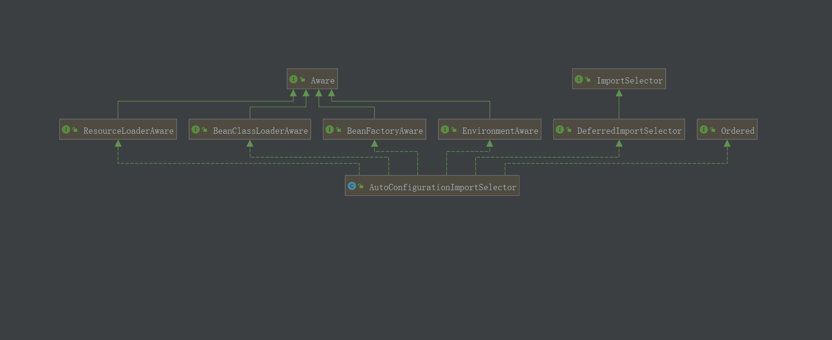

1. 对象剔除逻辑

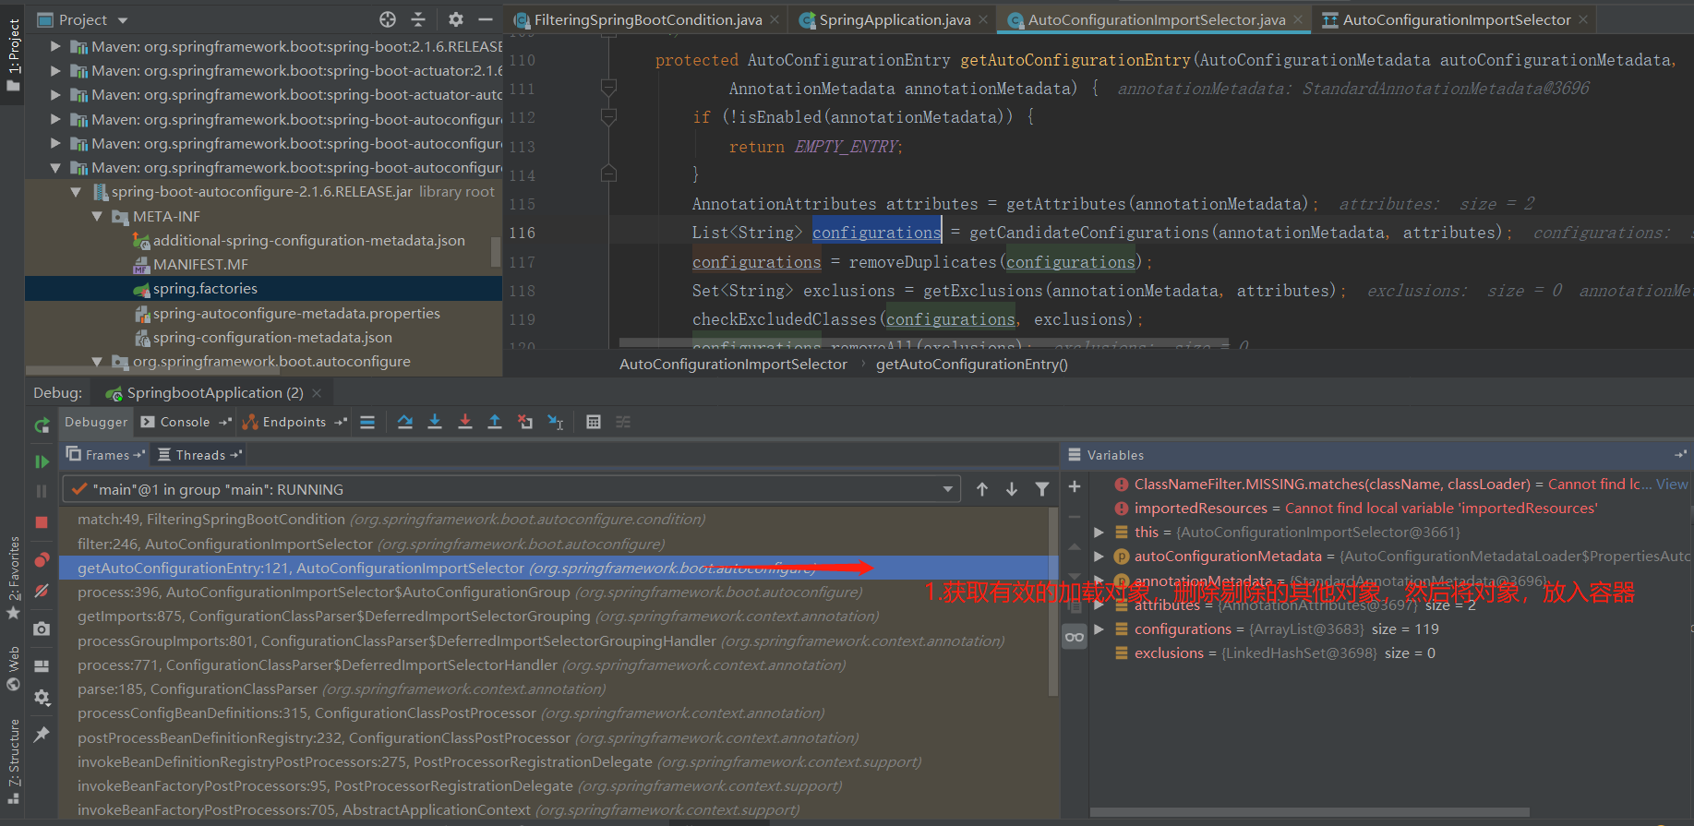

1. 添加自定义配置对象

