10GBASE-SR SFP+ 850nm 300m Transceiver
P/N: QT-SFP+-SR
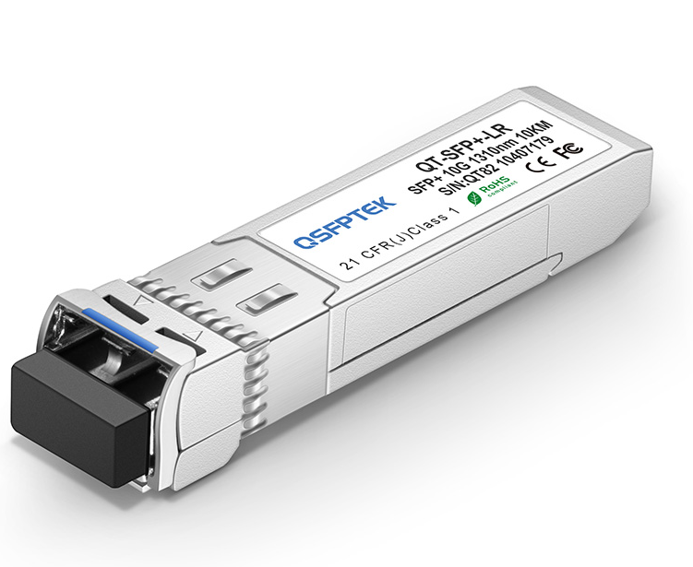

PRODUCT FEATURES

- Optical interface compliant to IEEE 802.3ae 10GBASE-SR
- Electrical interface compliant to SFF-8431
- Hot Pluggable
- 850nm VCSEL transmitter, PIN photo-detector
- Maximum link length of 300m on 2000MHz/km MMF
- Operating case temperature: Commerical: 0 to 70 °C , Industrial:-40 to 85 °C
- All-metal housing for superior EMI performance
- Advanced firmware allow customer system encryption information to be stored in transceiver
- Cost effective SFP+ solution, enables higher port densities and greater bandwidth
- Duplex LC receptacle
- RoHS compliant and lead free

APPLICATIONS

- 10GBASE-SR at 10.3125Gbps
- 10GBASE-SW at 9.953Gbps
- Other optical links

Absolute maximum rating
These values represent the damage threshold of the module.Stress in excess of any of the individual Absolute Maximum Ratings can cause immediate catastrophic damage to the module even if all other parameters are within Recommended Operating Conditions.
Parameters | Symbol | Min. | Max. | Unit
Maximun Supply Voltage | V_{CC} | 0 | +3.6 | V
Storage Temperature | Tc | -40 | +85 | °C
Operating Case Temperature | Tc | -5 | +75 | °C
Relative Humidity | RH | 5 | 95 | %

Optical characteristics
The following optical characteristics are defined over the Recommended Operating Environment unless otherwise specified.
Parameter | Symbol | Min | Typical | Max | Unit | Notes
Transmitter
Center Wavelength | λt | 840 | 850 | 860 | nm
RMS spectral width | Pm | - | - | Note 1 | nm
Average Optical Power | Pavg | -6.5 | - | -0.5 | dBm | 2
Extinction Ratio | ER | 3.5 | - | - | dB | 3
Transmitter Dispersion Penalty | TDP | - | - | 3.9 | dB
Relative Intensity Noise | Rin | - | - | -128 | dB/Hz | 12dB reflection
Optical Return Loss Tolerance |  | - | - | 12 | dB
Receiver
Center Wavelength | λr | 840 | 850 | 860 | nm
Receiver Sensitivity | Psens | - | - | -11.1 | dBm | 4
Stressed Sensitivity in OMA |  | - | - | -7.5 | dBm | 4
Los function | Los | -30 | - | -12 | dBm
Overload | Pin | - | - | -1.0 | dBm | 4
Receiver Reflectance |  | - | - | -12 | dB

Notes :
1.Trade-offs are available between spectral width, center wavelength and minimum OMA.
2. The optical power is launched into MMF
3. Measured with a PRBS 2³¹-1 test pattern @10.3125Gbps
4. Measured with a PRBS 2³¹-1 test pattern @10.3125Gbps, BER≤10^{-12.}

Electrical characteristics
The following electrical characteristics are defined over the Recommended Operating Environment unless otherwise specified.
Parameter | Symbol | Min. | Typical | Max | Unit | Notes
Power Supply Voltage | V_{CC} | 3.135 | 3.300 | 3.465 | V
Data Rate |  | - | 10.3125 | - | Gbps
Power Consumption |  | - | 600 | 800 | mW
Transmitter
Input differential impedance | Rin |  | 100 |  | Ω | 1
Single Ended Output Voltage Tolerance |  | -0.3 | - | 4.0 | V
Common mode voltage tolerance |  | 15 | - | - | mV
Tx Input Diff Voltage | VI | 180 |  | 1200 | mV | 2
Tx Fault | VoL | -0.3 |  | 0.4 | V | At 0.7mA
Data Dependent Input Jitter | DDJ |  |  | 0.10 | UI
Data Input Total Jitter | TJ |  |  | 0.28 | UI
Receiver
Single Ended Output Voltage Tolerance |  | -0.3 | - | 4.0 | V
Rx Output Diff Voltage | Vo | 300 |  | 850 | mV | 2
Rx Output Rise and Fall Time | Tr/Tf | 30 |  |  | ps | 20% to 80%
Total Jitter | TJ |  |  | 0.70 | UI
Deterministic Jitter | DJ |  |  | 0.42 | UI

Notes :
1.TX data input pins. AC coupling.
2. Into 100 ohms differential termination.

Pin definition
The SFP+ modules are hot-pluggable. Hot pluggable refers to plugging in or unplugging a module while the host board is powered. The SFP+ host connector is a 0.8 mm pitch 20 position right angle improved connector specified by SFF-8083, or stacked connector with equivalent with equivalent electrical performance. Host PCB contact assignment is shown in Figure 2 and contact definitions are given in Table 2. SFP+ module contacts mates with the host in the order of ground, power, followed by signal as illustrated by Figure 3 and the contact sequence order listed in Table 2.

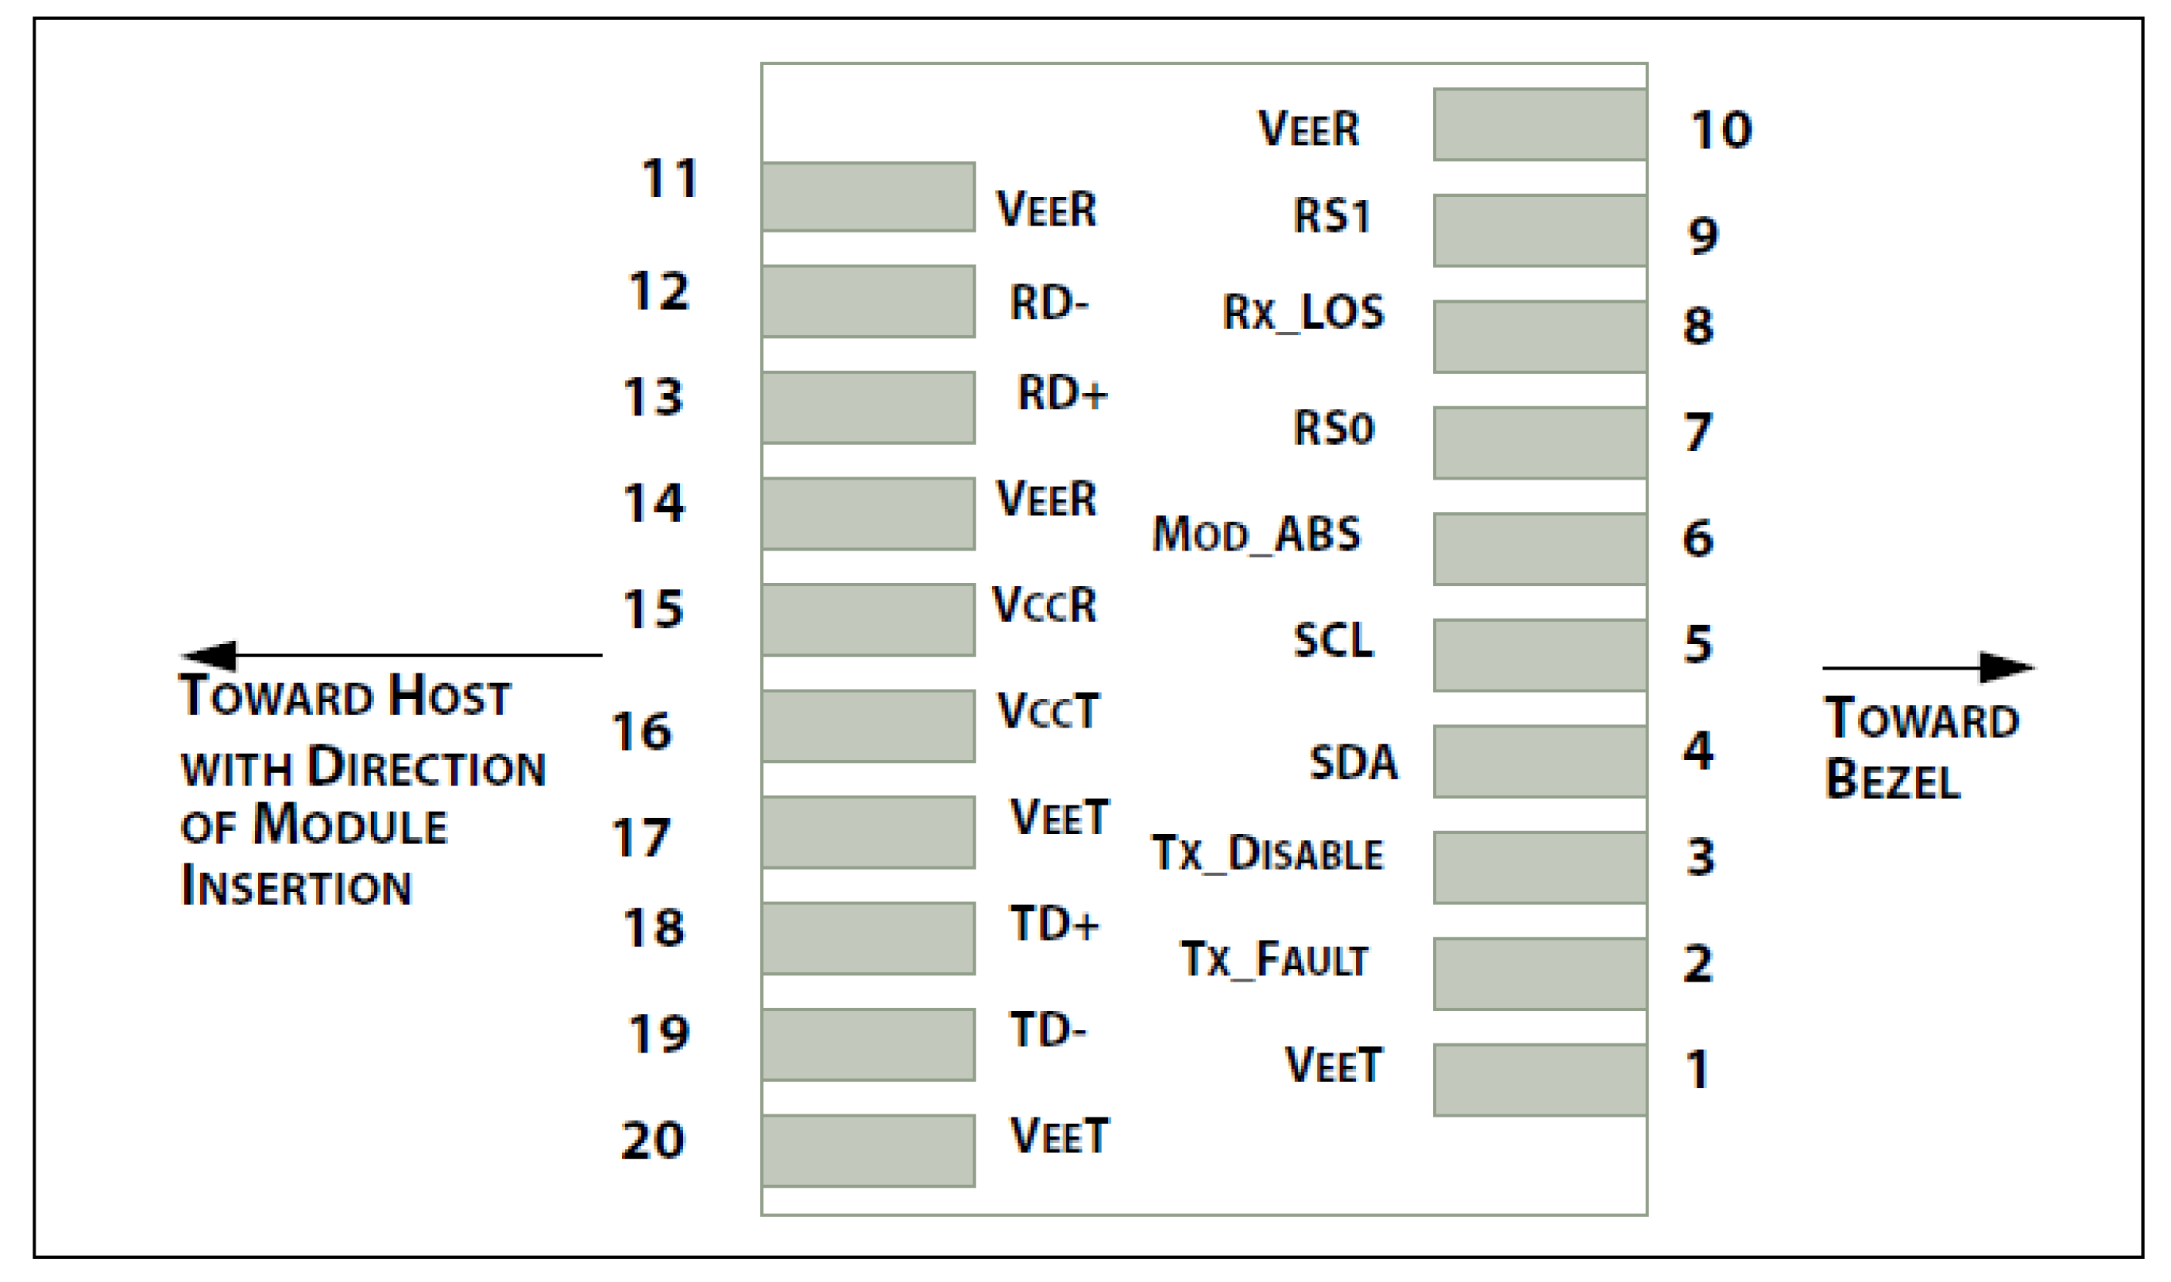

Figure 1: Interface to Host PCB

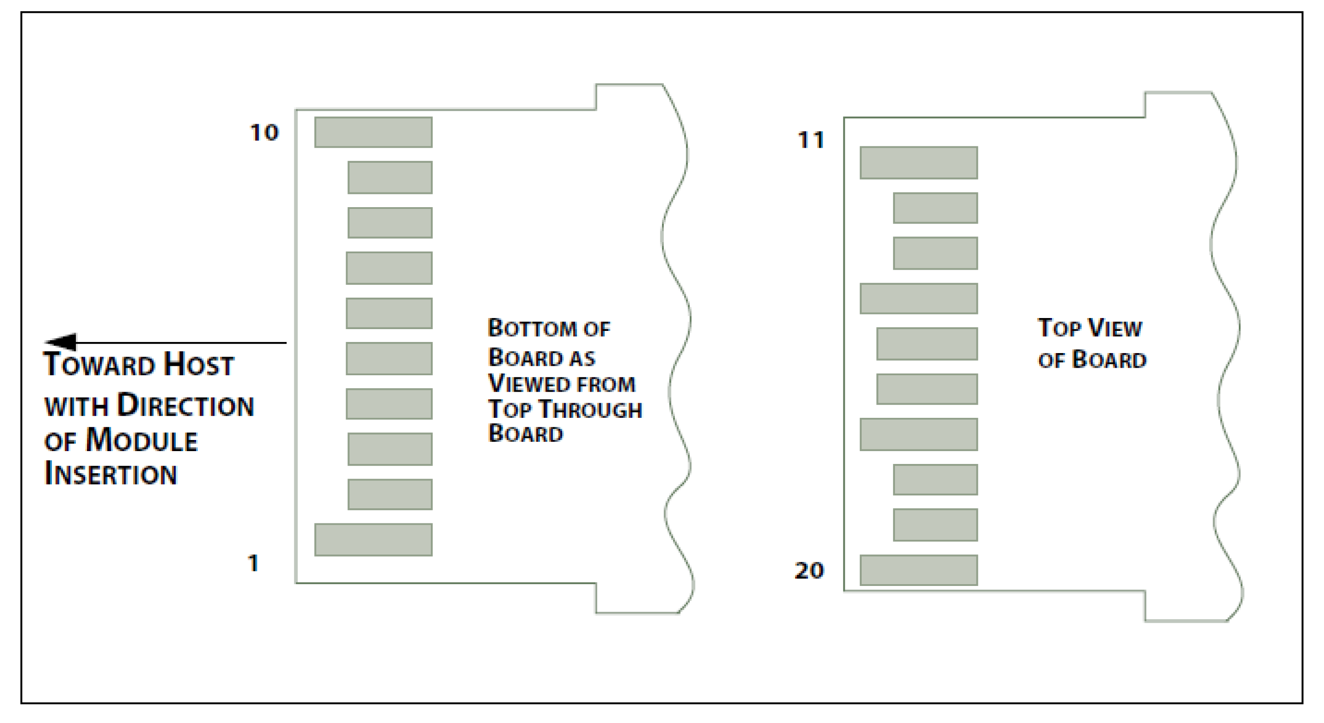

Figure2: Module Contact Assignment

Pin Descriptions
Pin | Symbol | Name/Description | Ref.
1 | VEET | Transmitter Ground (Common with Receiver Ground) | 1
2 | TFAULT | Transmitter Fault. | 2
3 | TDIS | Transmitter Disable. Laser output disabled on high or open. | 3
4 | SDA | 2-wire Serial Interface Data Line (MOD-DEF2) | 4
5 | SCA | 2-wire Serial Interface Clock (MOD-DEF1) | 4
6 | MOD_ABS | Module Absent, connected to VEET or VEER | 4
7 | RS0 | No connection required
8 | LOS | Loss of Signal indication. Logic 0 indicates normal operation. | 5
9 | RS1 | No connection required
10 | VEER | Receiver Ground (Common with Transmitter Ground) | 1
11 | VEER | Receiver Ground (Common with Transmitter Ground) | 1
12 | RD- | Receiver Inverted DATA out. AC Coupled
13 | RD+ | Receiver Non-inverted DATA out. AC Coupled
14 | VEER | Receiver Ground (Common with Transmitter Ground) | 1
15 | VCCR | Receiver Power Supply
16 | VCCT | Transmitter Power Supply
17 | VEET | Transmitter Ground (Common with Receiver Ground) | 1
18 | TD+ | Transmitter Non-Inverted DATA in. AC Coupled.
19 | TD- | Transmitter Inverted DATA in. AC Coupled.
20 | VEET | Transmitter Ground (Common with Receiver Ground) | 1

Notes:
1. Circuit ground is internally isolated from chassis ground.
2. TFAULT is an open collector/drain output, which should be pulled up with a 4.7k – 10k Ohms resistor on the host board if intended for use. Pull up voltage should be between 2.0V to Vcc + 0.3V. A high output indicates a transmitter fault caused by either the TX bias current or the TX output power exceeding the preset alarm thresholds. A low output indicates normal operation. In the low state, the output is pulled to <0.8V.
3. Laser output disabled on TDIS >2.0V or open, enabled on TDIS <0.8V.
4. Should be pulled up with 4.7k – 10kohms on host board to a voltage between 2.0V and 3.6V.
MOD_ABS pulls line low to indicate module is plugged in.
5. LOS is open collector output. Should be pulled up with 4.7k – 10kohms on host board to a voltage
between 2.0V and 3.6V. Logic 0 indicates normal operation; logic 1 indicates loss of signal.

Mechanical Specifications
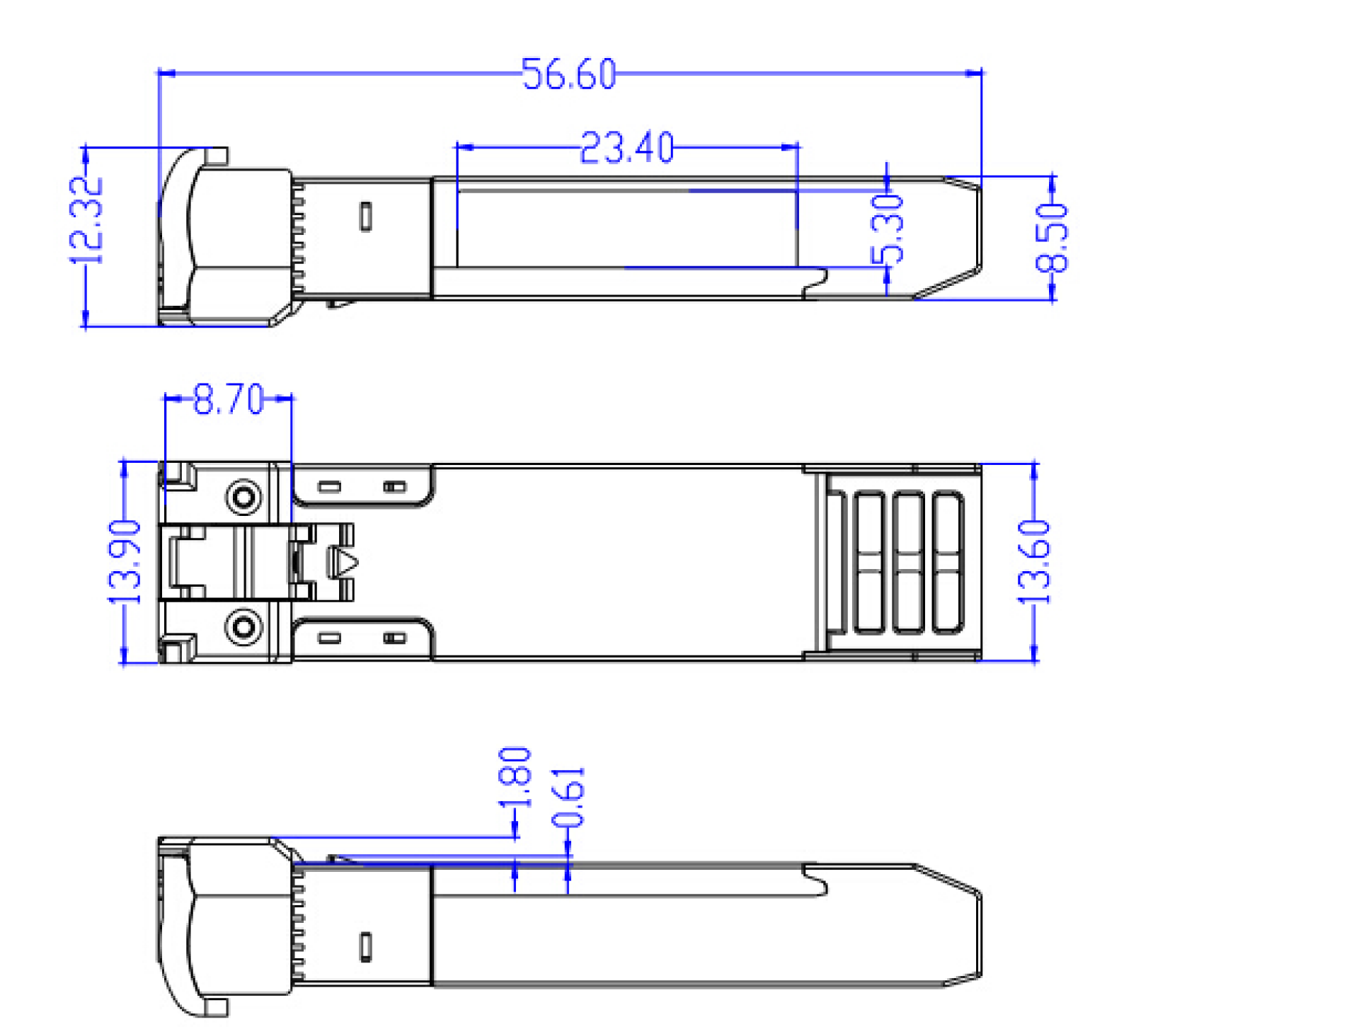
Figure3: . Mechanical Dimensions

Regulatory Compliance
QSFPTEK SFP+ transceiver is designed to be Class I Laser safety compliant and is certified per the following standards:

Feature | Agency | Standard | Certificate / Comments
Laser Safety | FDA | CDRH 21 CFR 1040 and Laser Notice No. 50 | Xxxxxx-xxxxx
Product Safety | BST | EN xxxxx | BSTxxxxxx
Environmental protection | CCIC | RoHS xxxxx | RET xxxxx
EMC | WALTEK | ENxxxxx | WTxxxxxx

Ordering information

Part Number | Product Description
QT-SFP+-SR | SFP+, 10Gbps, 850nm, MMF, 300M, DDM, LC connector, 0 °C ~ 70 °C
QT-SFP+-LR | SFP+, 10Gbps, 1310nm, SMF, 10KM, DDM, LC connector, 0 °C ~ 70 °C
QT-SFP+-ER | SFP+, 10Gbps, 1550nm, SMF, 40KM, DDM, LC connector, -5 °C ~ 70 °C
QT-SFP+-ZR | SFP+, 10Gbps , 1550nm, SMF, 80KM, DDM, LC connector, -5 °C ~ 70 °C

