Responder Write-up
By Wahu

Introduction

Windows dominates the operating system world, which makes it a prime target for attacks. Most organizations run their networks with Active Directory, and authentication often still relies on NTLM alongside Kerberos.
In this lab, we will exploit a File Inclusion vulnerability on a Windows web server to capture a NetNTLMv2 hash using Responder. Then we will use John the Ripper to try cracking it. The exercise also covers how NTLM authentication works and how Responder grabs these hashes (important) for understanding real-world attacks that do not look obvious at first.

Enumeration

We will begin by scanning the host for any open ports and running services with an Nmap scan. We will be using the following flags for the scan:
-p- : This flag scans for all TCP ports ranging from 0-65535
-sV: Attempts to determine the version of the service running on a port
--min-rate 1000: This is used to specify the minimum number of packets Nmap should send per second; it speeds up the scan as the number goes higher
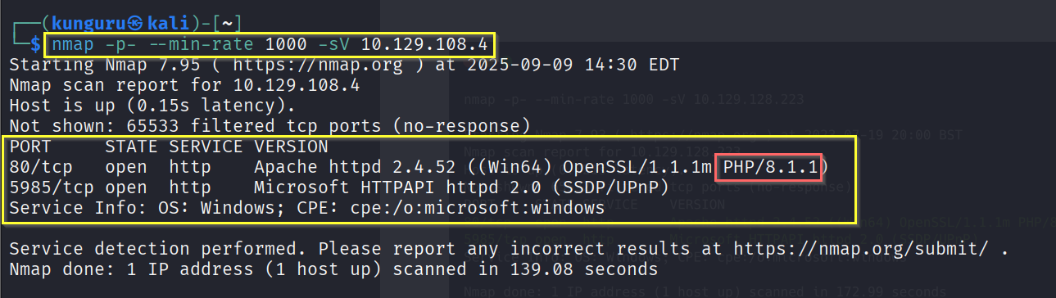
The machine is using Windows as its operating system.
Two ports were detected as open having Apache web server running on port 80 along with WinRM on port 5985.
Windows Remote Management (WinRM) is a built-in Windows feature that lets people control computers over a network. It allows admins to send commands, manage settings, and monitor systems without being physically near them.
For a penetration tester, this matters because if login details were found for someone with WinRM access, it could be used to open a remote PowerShell session on that computer, essentially giving control from afar.
On opening Firefox and putting http://[target ip], the browser returns a message about being unable to find that site. Looking in the URL bar, it now shows http://unika.htb .
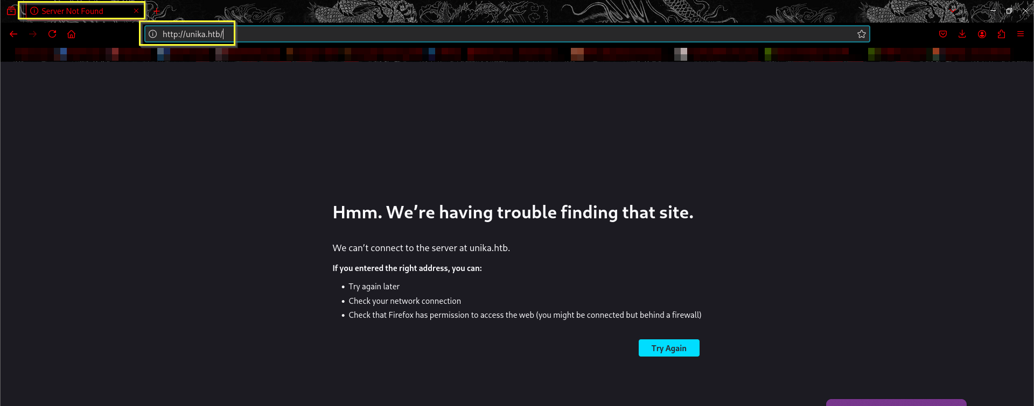
The website has redirected the browser to a new URL, and your host does not know how to find unika.htb. This webserver is employing name-based Virtual Hosting for serving the requests
Name-Based Virtual hosting is a method for hosting multiple domain names (with separate handling ofeach name) on a single server.
This allows one server to share its resources, such as memory and processor cycles, without requiring all the services to be used by the same hostname.
The web server checks the domain name provided in the Host header field of the HTTP request and sends a response according to that.
The /etc/hosts file is used to resolve a hostname into an IP address & thus we will need to add an entry in the /etc/hosts file for this domain to enable the browser to resolve the address for unika.htb .
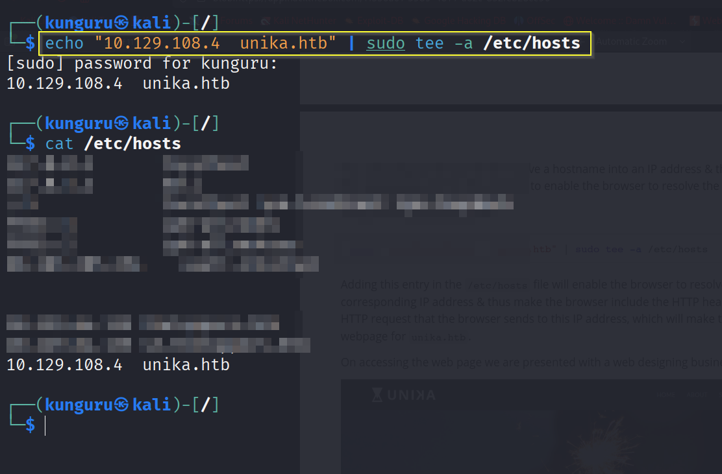
Adding this entry in the /etc/hosts file will enable the browser to resolve the hostname unika.htb to the corresponding IP address & thus make the browser include the HTTP header Host: unika.htb in every HTTP request that the browser sends to this IP address, which will make the server respond with the webpage for unika.htb

Checking the site out, we see nothing of particular interest. Although, we notice a language selection option on the navbar EN and changing the option to FR takes us to a French version of the website.
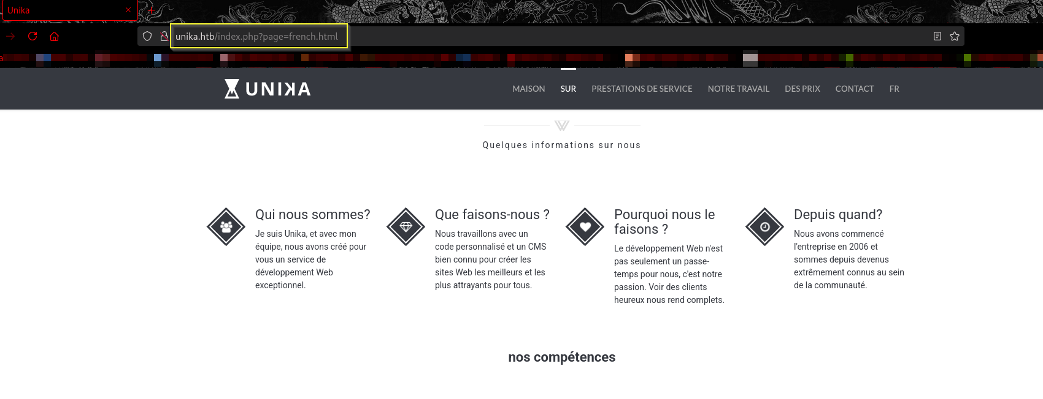
Noticing the URL, we can see that the french.html page is being loaded by the page parameter, which may potentially be vulnerable to a Local File Inclusion (LFI) vulnerability if the page input is not sanitized.

File Inclusion Vulnerability

Dynamic websites build pages using user input, like form data or cookies. Sometimes, they include other files based on this input.
Local File Inclusion (LFI) happens when an attacker tricks the site into loading files from the server that were not meant to be exposed (like sensitive system files) by manipulating the file path. In some cases, this can even lead to running malicious code.
Remote File Inclusion (RFI) is similar, but instead of local files, the attacker gets the site to load files from an external source over the internet (e.g., via HTTP or FTP).
We test the page parameter to see if we can include files on the target system in the server response. We will test with some commonly known files that will have the same name across networks.
One of the most common files that a penetration tester might attempt to access on a Windows machine to verify LFI is the hosts file, WINDOWS\System32\drivers\etc\hosts (this file aids in the local translation of host names to IP addresses).
The ../ string is used to traverse back a directory, one at a time. Thus multiple ../ strings are included in the URL so that the file handler on the server traverses back to the base directory i.e. C:\
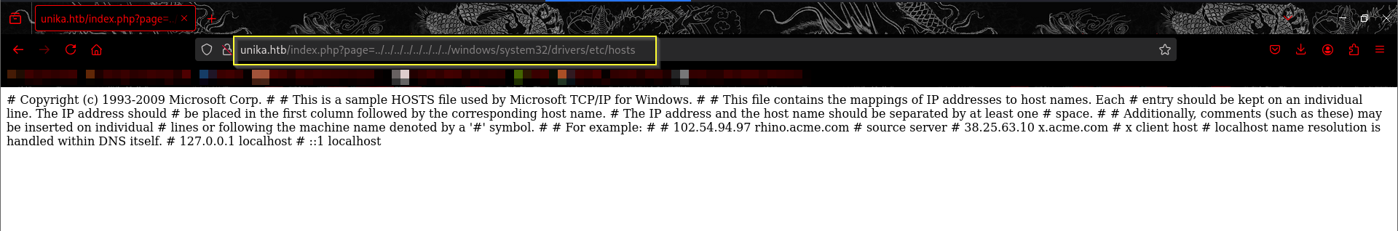
Great, LFI is possible as we can view the contents of the C:\windows\system32\drivers\etc\hosts file in the response.
The file inclusion, in this case, was made possible because in the backend the include() method of PHP is being used to process the URL parameter page for serving a different webpage for different languages. Moreover, because no proper sanitization is done on this page parameter, we were able to pass malicious input and therefore view the internal system files.

Challenge Capture

We know that this web page is vulnerable to the file inclusion vulnerability and is being served on a Windows machine. Thus, there exists a potential for including a file on our attacker workstation. If we select a protocol like SMB, Windows will try to authenticate to our machine, and we can capture the NetNTLMv2.
NTLM is a collection of authentication protocols created by Microsoft. It is a challenge-response authentication protocol used to authenticate a client to a resource on an Active Directory domain.
It is a type of single sign-on (SSO) because it allows the user to provide the underlying authentication factor only once, at login.
The NTLM authentication process is done in the following way:
1. The client sends the user name and domain name to the server.
2. The server generates a random character string, referred to as the challenge.
3. The client encrypts the challenge with the NTLM hash of the user password and sends it back to the server.
4. The server retrieves the user password (or equivalent).
5. The server uses the hash value retrieved from the security account database to encrypt the challenge string. The value is then compared to the value received from the client. If the values match, the client is authenticated.

Using Responder

Verify that the Responder.conf is set to listen for SMB requests.
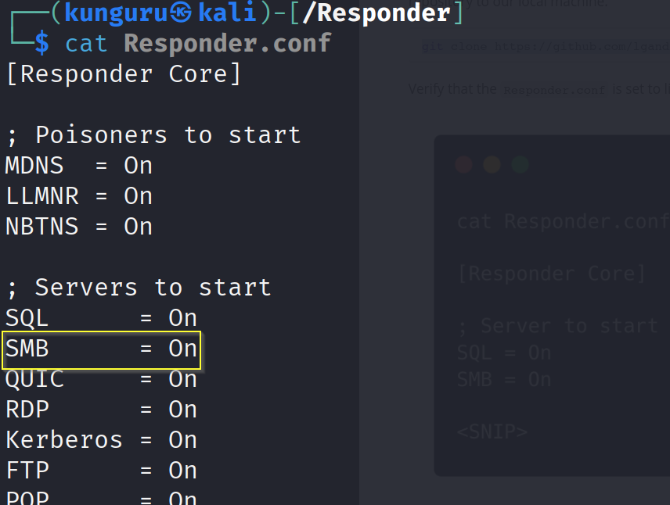
With the configuration file ready, we can proceed to start Responder with python3 , passing in the interface to listen on using the -I flag:
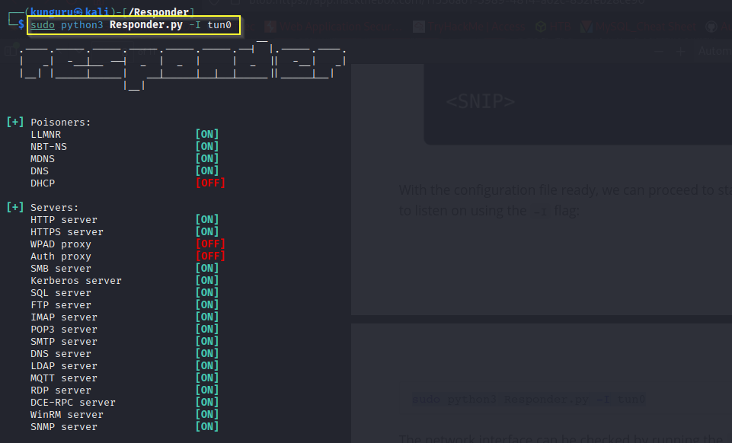
With the Responder server ready, we tell the server to include a resource from our SMB server by setting the page parameter as follows via the web browser.
After sending our payload through the web browser we get an error about not being able to load the requested file.
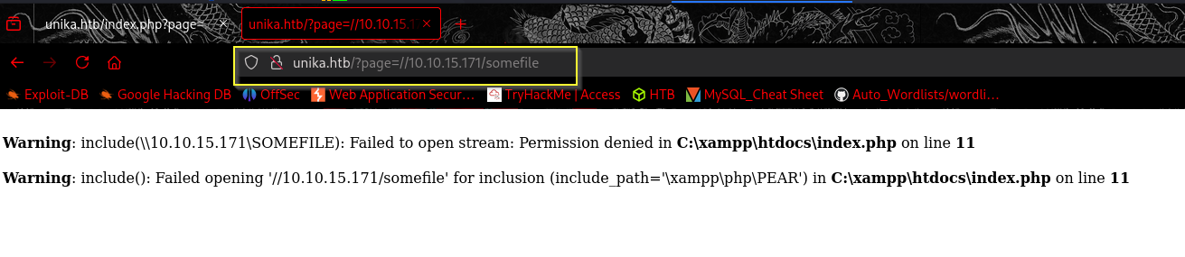
But on checking our listening Responder server we can see we have a NetNTLMv for the Administrator user.
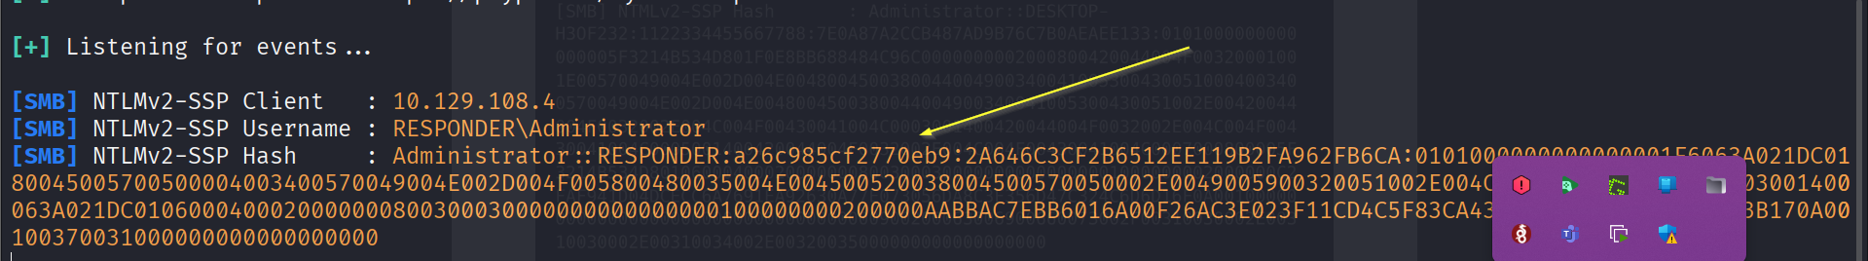
The NetNTLMv2 includes both the challenge (random text) and the encrypted response.
We can dump the hash into a file and attempt to crack it with john, which is a password hash-cracking utility.

We pass the hash file to john and crack the password for the Administrator account. The john command-line tool automatically identifies the hash type.
