

CAPSTONE PROJECT REPORT
Report 6 – Software User Guides

– Hanoi, Jan 2025 –

I. Record of Changes 4
Add Appendix A 4
Add Installation Instruction 4
Source Alignment Note 5
II. Release Package & User Guides 5
1. Deliverable Package
1.1 Package Contents 5
1.2 Technology Stack 6
1.3 Runtime Topology 7
2. Installation Guides 7
2.1 System Requirements 7
2.1.1 Hardware Requirements 7
2.1.2 Software Requirements 8
2.1.3 Default Ports 8
2.2 Installation Instruction 9
2.2 Installation Instructions 9
2.2.1 Obtain the Source Code 9
2.2.2 Install Node.js Dependencies 9
2.2.3 Configure Backend Environment 9
2.2.4 Configure Frontend Environment 10
2.2.5 Start MongoDB 11
2.2.6 Seed Initial Data 11
2.2.7 Start the Backend 11
2.2.8 Start the Python Camera/RFID Bridge (Current Archive) 11
2.2.9 Start the Frontend 12
2.2.10 Recommended Startup Order and Verification 12
2.2.11 Default Seed Accounts 13
2.3 Installation Troubleshooting 13
3. User Manual 14
3.1 System Overview 14
3.1.1 Role Mapping in the Current Build 14
3.1.2 Navigation by Current UI Role 15
3.2 Guest Driver / Public Portal 16
3.2.1 View Parking Availability 17
3.2.2 Look Up a Parking Session and Pay 17
3.2.3 Extend a Public Parking Session 17
3.2.4 Register, Login and Reset Password 17
3.3 Registered Member / Customer Portal 18
3.3.1 Manage Personal Profile 19
3.3.2 Register and Maintain Vehicles 19
3.3.3 Purchase or Renew a Parking Package 19
3.3.4 View Parking Sessions and Receipts 20
3.3.5 Transaction History and Unpaid Sessions 20
3.3.6 Notifications 20
3.4 Security Guard / Staff Operations 21
3.4.1 Operational Dashboard 22
3.4.2 Live Camera Monitor and Barrier Controls 22
3.4.3 RFID Card Inventory 23
3.4.4 Zones and Parking Slots 23
3.4.5 Shift Schedule and Incident Handling 23
3.5 Core Parking Workflows 24
3.5.1 Member Entry (Business-Intent Flow) 24
3.5.2 Guest Entry with RFID 24
3.5.3 Exit, Payment and Session Completion 25
3.5.4 Mismatch, Lost RFID and Recognition Exceptions 25
3.6 System Administrator 26
Figure 7. System Administrator workflow 26
3.6.1 User and Role Management 27
3.6.2 Vehicle Verification Requests 27
3.6.3 Subscription Plan Administration 27
3.6.4 Pricing and System Configuration 27
3.6.5 Reports & Analytics 27
3.7 Current Implementation Notes / Known Gaps 27
3.8 Current Frontend Route Reference 28
3.9 User/Operational Troubleshooting 29
Appendix A — Source Basis for This Report 30

TABLE CONTENT
List of Figures
Figure 1. Runtime topology verified from the current repository and TDS.
Figure 2. Public Portal – Landing Page & Real-Time Availability Overview
Figure 3. Public Portal – Facility Occupancy & Slot Availability Section
Figure 4. User Authentication – Login Dialog
Figure 5. User Authentication – Customer Self-Registration Form
Figure 6. User Authentication – OTP Password Reset Dialog
Figure 7. Customer Portal – Personal Profile & Security Management (/profile)
Figure 8. Customer Portal – Registered Vehicles List (/vehicles)
Figure 9. Customer Portal – New Vehicle Registration Modal
Figure 10. Customer Portal – Subscription Packages & Plans (/subscriptions)
Figure 11. Customer Portal – Parking Sessions Management (/sessions)
Figure 12. Customer Portal – Transaction History (/transactions)
Figure 13. Security Guard Workstation – Dual-Lane Gate Console Overview (/staff-desk)
Figure 14. Staff Desk – Lane 1 Vehicle Entry Processing & Manual Plate Confirmation (Xe vào)
Figure 15. Staff Desk – Live Member Vehicle Exit Verification & Automatic Barrier Release
Figure 16. Staff Desk – Guest Exit Session & RFID Card Verification
Figure 17. Staff Desk – Checkout Payment with VietQR / PayOS Integration
Figure 18. Security Guard – Operational Overview Dashboard (/overview)
Figure 19. Security Guard – Shift Attendance & Monthly Schedule (/shifts)
Figure 20. Staff Operations – RFID Card Inventory Management (/rfid)
Figure 21. Staff Operations – Real-Time Parking Slots & Quota Pools (/parking-slots)
Figure 22. Staff Operations – Customer Dispute Requests Management (/disputes)
Figure 23. System Administrator – System Overview Dashboard (/overview)
Figure 24. System Administrator – User & Role Permission Management (/users)
Figure 25. System Administrator – Create New User Account Modal
Figure 26. System Administrator – Customer Vehicle Verification & Approval Queue (/vehicles)
Figure 27. System Administrator – Subscription Plans Administration (/subscriptions)
Figure 28. System Administrator – Parking Capacity & Maximum Slot Count Setup (/parking-slots)
Figure 29. System Administrator – Day & Night Pricing Tariff Configuration (/pricing)
Figure 30. System Administrator – Automated Notification Templates Management (/pricing)
Figure 31. System Administrator – Business Reports & Analytics Export (/reports)
Figure 32. System Administrator – Security & Operational Audit Trail (/audit-logs)

I. Record of Changes
Date | A*  M, D | In charge | Change Description
10/8/2026 | A | duongdxhe186372 | Add Release Package & User Guides
11/8/2026 | A | duongdxhe186372 | Add Runtime Topology
10/8/2026 | A | thanhdhhe180811 | Add Workflow Guest , Register Member , Staff , Admin
11/8/2026 | A | thanhdhhe180811 | Add Appendix A
10/8/2026 | A | hieupxhe150075 | Add Installation Guides & User Manual
11/8/2026 | A | hieupxhe150075 | Add Installation Instruction
*A - Added M - Modified D - Deleted

II. Release Package & User Guides

1. Deliverable Package
1.1 Package Contents
No. | Deliverable Item | Description / Location | Version / Status
1 | Source code package | AI-Integrated-Car-Parking-Management-System-iPARK--main (1).zip; monorepo root with frontend/, backend/, ai-service/, scripts/ | 0.1.0
2 | Frontend source | frontend/ — Next.js application and role-based dashboard | 0.1.0
3 | Backend source | backend/ — Express/TypeScript REST API, MongoDB models and jobs | 0.1.0
4 | Camera/RFID bridge | ai-service/app.py + requirements.txt — Python camera, OCR and RFID bridge | Current archive
5 | Database initialization | backend/scripts/seed.mjs and reinitialization/migration scripts | Current archive
6 | README | README.md / repository README.md | Current archive
7 | Report 1 | Vision & Scope Document — iPARK | v1.0.0
8 | Report 2 | Project Management Plan — iPARK | v1.0.0
9 | Report 3 | Software Requirements Specification (SRS) | v1.0.0 / in progress source
10 | Report 3.2 | Screen Design Specification | v1.0.0 / in progress source
11 | Report 4 | Technical Design Specification (TDS) | v1.0.0 / in progress source
12 | Scope / UC references | Scope_Report and Medium_UC_FINAL | Working project references
13 | Report 6 | This Software User Guides document | v1.0.0

1.2 Technology Stack
Component | Technology in Current Repository | Version / Requirement | Default Endpoint
Frontend | Next.js + React | Next.js 15.3.8; React 19.2.4 | http://localhost:3000
Backend | Express.js + TypeScript | Express 5.2.1; TypeScript 5.6.3 | http://localhost:4000
Database | MongoDB via Mongoose | Mongoose 9.6.3; MongoDB local or Atlas | localhost:27017 (local)
Camera/RFID bridge | Python Flask + PaddleOCR + OpenCV + PySerial | Flask >=3.0; PaddleOCR >=1.7; OpenCV >=4.8; PySerial >=3.5 | http://localhost:5050
Payment | PayOS QR checkout/webhook | External service | Backend integration
Email | SMTP (OTP/notifications) | External service | Backend integration
Authentication | Cookie session/JWT, Google OAuth; backend 2FA endpoints | jose / otplib | Backend integration
Legacy / separate AI contract | AI_SERVICE_URL retained by backend/frontend config | Default port 5000; matching service not present in uploaded archive | http://127.0.0.1:5000

1.3 Runtime Topology
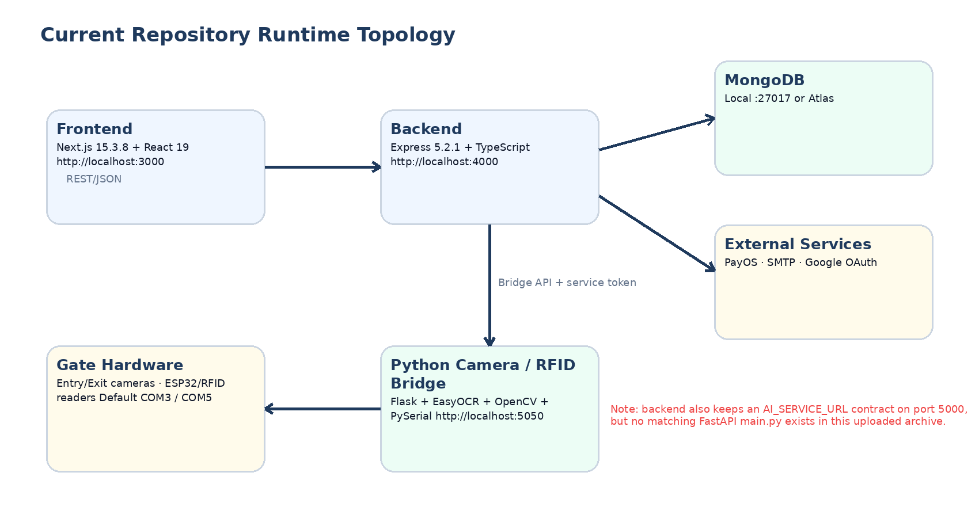
Figure 1. Runtime topology verified from the current repository and TDS.

2. Installation Guides

2.1 System Requirements
The following requirements are sufficient for the current development build. The hardware bridge is optional for users who only need the web/API functions, but required to demonstrate live camera/RFID gate behavior.

2.1.1 Hardware Requirements
Item | Minimum / Recommended | Notes
Processor | 64-bit Intel Core i5 or equivalent; i7 recommended | OCR and camera processing benefit from additional CPU resources.
Memory | 8 GB minimum; 16 GB recommended | Run frontend, backend, MongoDB and Python bridge concurrently.
Storage | 10 GB or more free | Dependencies, uploads, logs and OCR model cache can grow during development.
Network | Stable Internet connection | Needed for initial package installation and external PayOS/SMTP/OAuth integrations.
Camera / RFID hardware | Optional for web-only; required for full gate demo | Current bridge defaults to camera indexes 0/1 and serial ports COM3/COM5.

2.1.2 Software Requirements
- Node.js 20 or later and npm 10 or later (README requirement).
- Python 3.10–3.12 for the Python bridge.
- MongoDB local server or a MongoDB Atlas connection.
- Git for repository cloning (optional if the release ZIP is used).
- Windows 10/11 is the most direct environment for the current bridge defaults because it uses DirectShow and COM ports by default. Web/API components are not inherently Windows-only.
- Tesseract is mentioned by the README, but the current ai-service/app.py uses PaddleOCR; Tesseract is not required by that current bridge file.

2.1.3 Default Ports
Port | Service | Required in Current Archive? | Notes
3000 | Next.js frontend | Yes | NEXT_PUBLIC_API_URL points to backend /api.
4000 | Express backend | Yes | Main REST API; /api/health is a simple health check.
5050 | Python camera/RFID bridge | For full gate demo | Live MJPEG streams, RFID scan/manage endpoints and barrier controls.
27017 | MongoDB local | If local MongoDB is used | Not used when connecting to Atlas.
5000 | Separate AI service contract | Not included in uploaded archive | Referenced by README/AI_SERVICE_URL; do not expect it to start from current ai-service/app.py.

2.2 Installation Instruction

2.2 Installation Instructions

2.2.1 Obtain the Source Code
Option A — clone the repository:
git clone https://github.com/kunhtml/AI-Integrated-Car-Parking-Management-System-iPARK-.git
cd AI-Integrated-Car-Parking-Management-System-iPARK-

Option B — extract the supplied release archive and open its repository root:
AI-Integrated-Car-Parking-Management-System-iPARK-.zip
└── AI-Integrated-Car-Parking-Management-System-iPARK/
├── frontend/
├── backend/
├── ai-service/
└── package.json

2.2.2 Install Node.js Dependencies
cd AI-Integrated-Car-Parking-Management-System-iPARK
npm install

The root package is an npm workspace containing frontend and backend packages. The current root package version is 0.1.0.

2.2.3 Configure Backend Environment
# macOS / Linux
cp backend/.env.example backend/.env
# Windows PowerShell
Copy-Item backend\.env.example backend\.env

Security warning: the supplied backend/.env.example contains populated values that look like credentials. This report intentionally does not reproduce them. Rotate/replace all secrets, SMTP credentials, OAuth credentials, database credentials, payment keys and service tokens before sharing or deploying the project.

Variable Group | Variables to Configure | Recommended Development Value / Purpose
Server | PORT, FRONTEND_URL | 4000; http://localhost:3000
Database | MONGODB_URI, MONGODB_DB | Local URI or Atlas URI; database bai-do-xe
Authentication | JWT_SECRET, TOTP_ISSUER | Use a new non-default secret; issuer iPARK
Bridge integration | CAMERA_SERVICE_URL, SERVICE_TOKEN | http://127.0.0.1:5050; token must match bridge BRIDGE_SERVICE_TOKEN
AI contract | AI_SERVICE_URL | Default http://127.0.0.1:5000; only useful wh`en a matching service is deployed
SMTP | SMTP_HOST, SMTP_PORT, SMTP_USER, SMTP_PASS, SMTP_FROM | Required for real password-reset OTP email and notifications
Google OAuth | GOOGLE_CLIENT_ID, GOOGLE_CLIENT_SECRET, GOOGLE_CALLBACK_URL | Optional; callback normally http://localhost:4000/api/auth/google/callback
PayOS | PAYTOS_USE, PAYTOS_CLIENT_ID, PAYTOS_API_KEY, PAYTOS_CHECKSUM_KEY, PAYOS_WEBHOOK_URL | Use your own PayOS credentials. Public HTTPS webhook is required for external callbacks in production.
Camera RTSP | RTSP_ENTRY_*, RTSP_EXIT_* | Only needed for RTSP/device integrations that use these backend values.

2.2.4 Configure Frontend Environment
# macOS / Linux
cp frontend/.env.example frontend/.env.local
# Windows PowerShell
Copy-Item frontend\.env.example frontend\.env.local

NEXT_PUBLIC_API_URL=http://localhost:4000/api
NEXT_PUBLIC_AI_API_URL=http://localhost:5000
NEXT_PUBLIC_BRIDGE_URL=http://localhost:5050

The current frontend uses NEXT_PUBLIC_API_URL for the main API and NEXT_PUBLIC_BRIDGE_URL for live camera/RFID bridge functions. NEXT_PUBLIC_AI_API_URL remains in the environment example for the separate AI contract.

2.2.5 Start MongoDB
For local MongoDB:
mongod

For MongoDB Atlas, do not start a local server; set MONGODB_URI in backend/.env to the Atlas connection string.

2.2.6 Seed Initial Data
cd AI-Integrated-Car-Parking-Management-System-iPARK
npm run seed

The current seed script creates/upserts: one admin, three staff accounts, sample vehicles, pricing configuration, devices, the unified parking zone ('Bãi đỗ xe tổng'), 30 parking slots, subscription plans, notification data and notification templates.
Current seed pricing code uses a day rate of 5,000 VND, night rate of 10,000 VND and gracePeriod = 0. This differs from older README text that mentions “free for the first 20 minutes”.

2.2.7 Start the Backend
# Option A: from repository root
npm run dev -w backend
# Option B
cd backend
npm run dev

Expected address: http://localhost:4000. Health check: http://localhost:4000/api/health

2.2.8 Start the Python Camera/RFID Bridge (Current Archive)
cd AI-Integrated-Car-Parking-Management-System-iPARK
python -m venv .venv
# Windows PowerShell
.\.venv\Scripts\Activate.ps1
pip install -r ai-service\requirements.txt
The current app.py reads values using os.getenv. The uploaded file does not call load_dotenv(), so set the values in the shell/OS environment (or in your IDE launch configuration) before running it.
$env:BACKEND_URL="http://localhost:4000"
$env:BRIDGE_SERVICE_TOKEN="<same value as backend SERVICE_TOKEN>"
$env:SERIAL_PORT_IN="COM3"
$env:SERIAL_PORT_OUT="COM5"
$env:CAMERA_INDEX_IN="0"
$env:CAMERA_INDEX_OUT="1"
$env:FLASK_PORT="5050"
python ai-service\app.py

Bridge verification: open http://localhost:5050/api/cameras/health. If physical cameras/readers are absent, the bridge can start but will report unavailable devices.
Do not use “python -m uvicorn main:app --port 5000” for this uploaded archive unless a separate main.py FastAPI service is added. That command appears in README/scripts/run-ai.mjs, but the matching main.py is absent from the current archive.

2.2.9 Start the Frontend
# Option A: from repository root
npm run dev -w frontend
# Option B
cd frontend
npm run dev

Expected address: http://localhost:3000

2.2.10 Recommended Startup Order and Verification
Order | Component | Verification
1 | MongoDB / Atlas | Backend can connect without MongoDB errors.
2 | Backend | GET http://localhost:4000/api/health returns an OK response.
3 | Python bridge (for gate demo) | GET http://localhost:5050/api/cameras/health responds; serial/camera status may be offline if hardware is absent.
4 | Frontend | Open http://localhost:3000; public landing page loads.
5 | External services (as needed) | Test SMTP OTP, Google OAuth and PayOS using deployment credentials.

2.2.11 Default Seed Accounts
Email | Password | Role | Use
admin@ipark.vn | admin | Admin | Full administration demo account
nv.1@ipark.vn | 123456 | Staff | Operations / gate staff
nv.2@ipark.vn | 123456 | Staff | Operations / gate staff
nv.3@ipark.vn | 123456 | Staff | Operations / gate staff

These credentials are development seed values. Change them for any environment that is shared, deployed or demonstrated outside the development team.

2.3 Installation Troubleshooting
Problem | Likely Cause | Corrective Action
Frontend cannot reach backend | Backend not running, wrong NEXT_PUBLIC_API_URL, or CORS origin mismatch | Start backend; verify port 4000; keep frontend on allowed local origins 3000/3001/3002 or update backend CORS configuration.
MongoDB connection fails | Invalid local service/Atlas URI or network/DNS issue | Start mongod or replace MONGODB_URI with a valid reachable connection.
OTP email not received | SMTP is not configured or credentials rejected | Configure SMTP_* values and use an application-specific password when required by the provider.
PayOS remains pending locally | Webhook cannot reach localhost from the Internet | Use the UI payment-status check where supported or expose a public HTTPS webhook for full callback testing.
Bridge shows offline | ai-service/app.py is not running or NEXT_PUBLIC_BRIDGE_URL is wrong | Start bridge on 5050 and verify /api/cameras/health.
Camera image missing | Camera index/backend unavailable or device in use | Check CAMERA_INDEX_IN/OUT, CAMERA_BACKEND and close other camera applications.
RFID scan unavailable | COM port incorrect/busy or ESP32 not connected | Check SERIAL_PORT_IN/OUT and Windows Device Manager; restart bridge after changing ports.
README AI command fails | Current archive has no FastAPI main.py | Use current Flask bridge command documented in Section 2.2.8 or provide the separate AI service explicitly.

3. User Manual
This User Manual provides practical, screen-by-screen operational guidance for all actors interacting with the AI-Integrated Car Parking Management System (iPARK). The guide details exact user interface layouts, interactive elements, step-by-step operating procedures, system responses, and operational handling for each functional module. As the primary deployment target uses a Vietnamese user interface, all on-screen button labels, tab titles, and system messages are cited verbatim within quotation marks accompanied by clear procedural instructions.

3.1 System Overview & Role Navigation
iPARK manages parking facilities through four primary functional domains based on authenticated privileges:
• Guest Driver / Public Visitor: Public access via web portal to check real-time facility parking availability and vacancies, and access account authentication/registration.
• Registered Customer / Member: Vehicle owners with verified accounts who register personal vehicles, purchase recurring monthly subscription packages, track check-in/out parking history, and download electronic invoices.
• Security Guard / Gate Operator (Staff): On-duty gate personnel who operate the primary Staff Desk workstation, monitor dual-lane entry/exit ANPR cameras, issue and receive guest circulating RFID cards, execute manual barrier overrides, collect fees, and log operational incidents.
• System Administrator: Operational management responsible for user account provisioning, customer vehicle approval workflows, tariff configuration, notification templates, subscription plan catalogs, dispute audits, and revenue/occupancy analytics.
System Navigation Standards: Common UI Standards:
• Toast Feedback: All asynchronous state updates display instant notification toasts in the top-right viewport (Green for success, Red for validation/network errors, Blue for informational updates).
• Status Color Codes: Active/Valid items appear in Green, Pending/In-Review in Amber, and Locked/Expired items in Red.
• Dual-Factor Authentication (2FA): Administrative and security-critical actions are protected via email-based OTP verification.

3.2 Guest Driver / Public Portal
The Public Portal delivers instantaneous parking availability information accessible from any mobile browser or desktop workstation without requiring prior authentication.
3.2.1 Real-Time Parking Availability & Facility Status (Figure 2 & Figure 3)
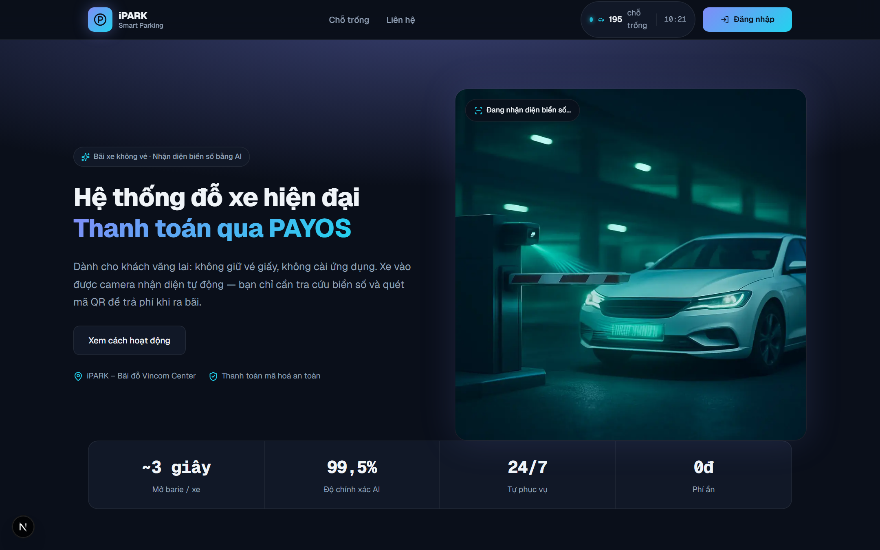
Figure 2. Public Portal – Landing Page & Real-Time Availability Overview

Screen Description for Figure 2: Figure 2 displays the public landing page header and hero banner accessible at http://localhost:3000/. Arriving drivers can immediately observe high-level facility status, brand identity, and the top navigation bar containing access shortcuts.
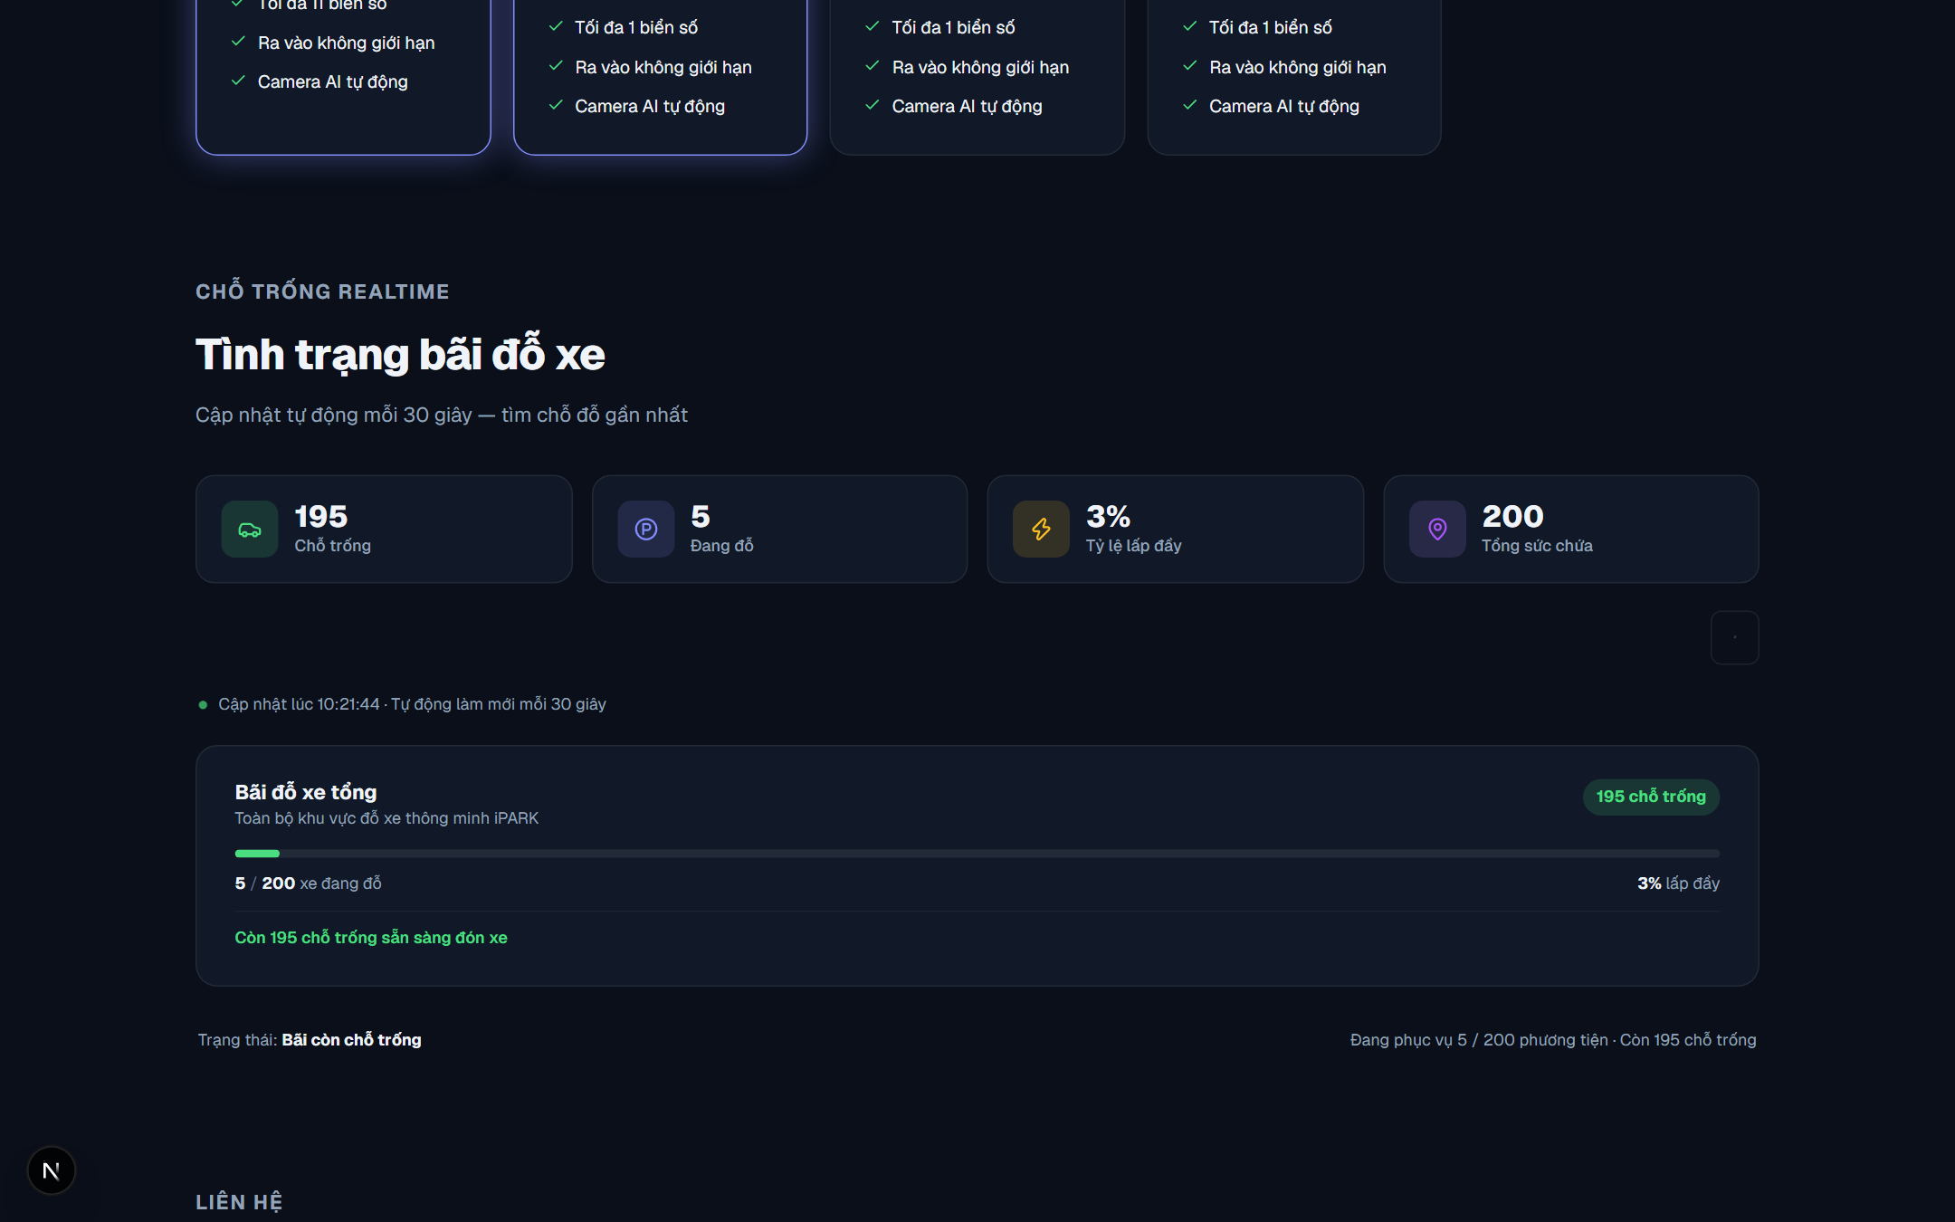
Figure 3. Public Portal – Facility Occupancy & Slot Availability Section

Screen Elements in Figure 3: Figure 3 displays the detailed facility occupancy section located directly below the hero banner. Visible elements include the aggregate KPI indicator bar (Tổng chỗ: 200, Đang trống, Đã đỗ, Tỷ lệ lấp đầy), the unified facility overview card ('Bãi đỗ xe tổng'), search filter input, and the automatic 30-second data refresh polling indicator.
Operating Instructions for Figure 2 and Figure 3:
Step 1 (Access Portal): Open http://localhost:3000/ on any mobile browser or desktop computer as shown in Figure 2.
Step 2 (Inspect Overview KPI): Review the top status card to confirm total vacant spaces across the facility.
Step 3 (Check Facility Card): Scroll down to the 'Tình trạng bãi đỗ xe' section shown in Figure 3. Review the 'Bãi đỗ xe tổng' card displaying current occupancy percentage and remaining vacancies.
Step 4 (Drive to Gate): If vacant spaces remain, proceed to the physical entrance gate. If the facility shows 100% capacity, drivers are alerted before arrival.
3.2.2 User Authentication Workflows (Figures 4, 5, and 6)
The authentication modal provides access for registered customers, staff, and administrators, and supports customer self-registration and OTP password recovery. Each visual state is detailed below:
Screen State 1: A. System Login Interface (Figure 4)
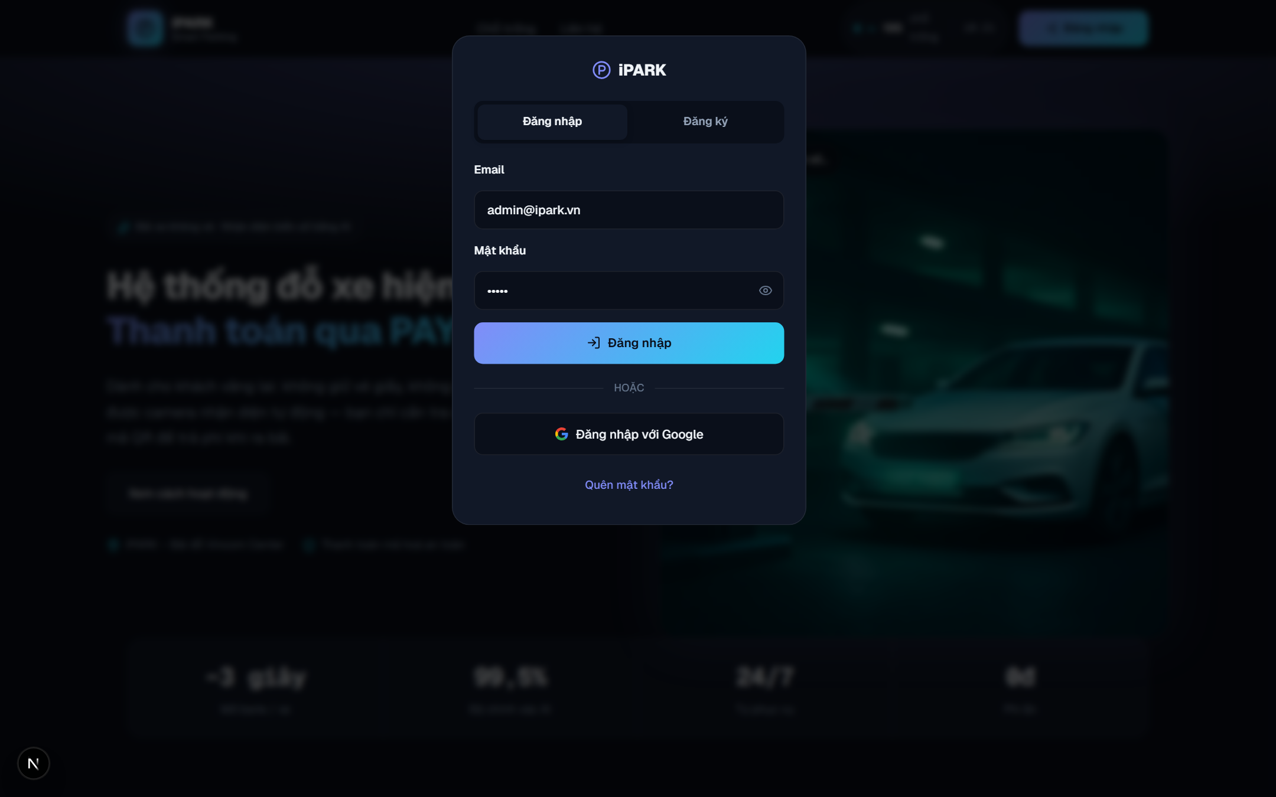
Figure 4. User Authentication – Login Dialog

Screen Elements in Figure 4: Figure 4 shows the primary sign-in dialog. Visible interface components include the active 'Đăng nhập' tab, text fields for 'Email' and 'Mật khẩu', a password visibility toggle (eye icon), the blue 'Đăng nhập' action button, a 'Quên mật khẩu?' recovery link, and the tab shortcut to 'Đăng ký'.
Operating Instructions for Figure 4:
Step 1 (Input Credentials): Click 'Đăng nhập' on the top navigation bar or visit http://localhost:3000/login to open Figure 4. Enter your registered email into 'Email' and password into 'Mật khẩu'.
Step 2 (Verify Password): Optionally click the eye icon inside the password field to verify your input.
Step 3 (Submit Login): Click the blue 'Đăng nhập' button. The system validates credentials, establishes a secure session cookie, and routes you directly to your assigned portal (Customer -> /profile, Staff -> /staff-desk, Admin -> /overview).
Screen State 2: B. Customer Account Registration Form (Figure 5)
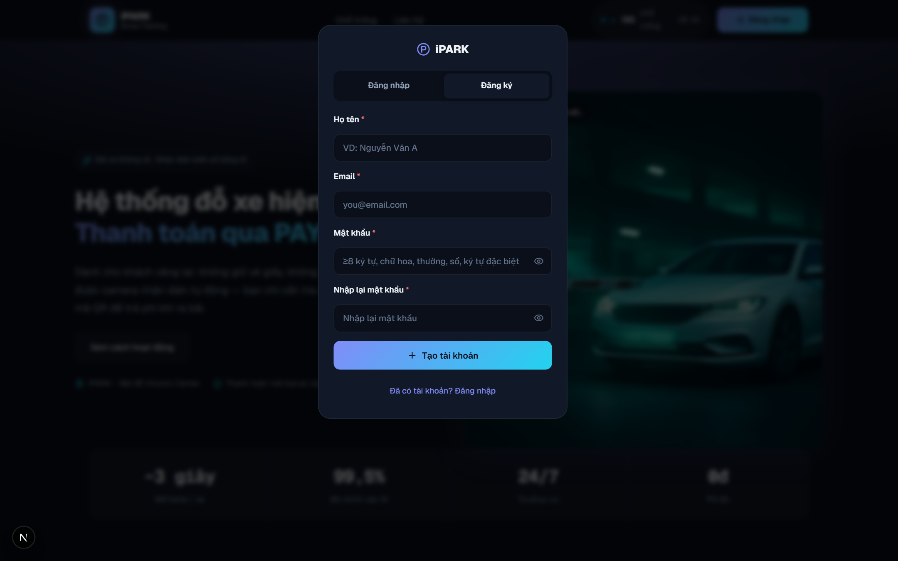
Figure 5. User Authentication – Customer Self-Registration Form

Screen Elements in Figure 5: Figure 5 displays the customer self-registration view activated by clicking the 'Đăng ký' tab. Visible elements include registration inputs for 'Họ và tên' (Full Name), 'Email', 'Mật khẩu' (Password), 'Số điện thoại' (Phone Number), the mandatory terms acceptance checkbox, and the 'Tạo tài khoản' submit button.
Operating Instructions for Figure 5:
Step 1 (Open Registration Form): In the authentication modal, click the 'Đăng ký' tab as shown in Figure 5.
Step 2 (Fill Personal Details): Enter your full name into 'Họ và tên', valid email into 'Email', contact phone into 'Số điện thoại', and create a secure password in 'Mật khẩu'.
Step 3 (Agree to Terms): Tick the checkbox 'Tôi đồng ý với điều khoản sử dụng'.
Step 4 (Complete Registration): Click the blue 'Tạo tài khoản' button. The system registers the customer profile, immediately logs in, and opens the Customer Portal (/profile).
Screen State 3: C. Password Recovery via Email OTP (Figure 6)
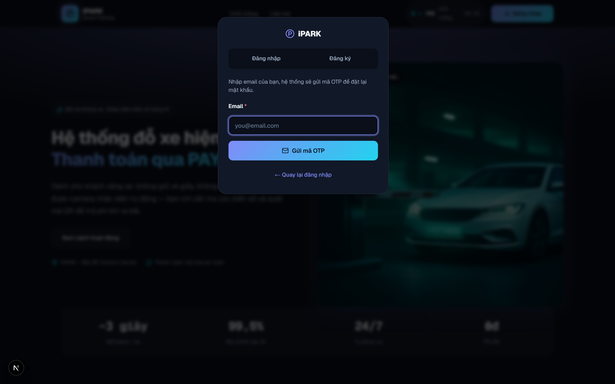
Figure 6. User Authentication – OTP Password Reset Dialog

Screen Elements in Figure 6: Figure 6 displays the password reset view. Visible elements include the 'Email' input field, the 'Gửi mã OTP' trigger, the 6-digit 'Mã OTP' input box, the 'Mật khẩu mới' field, and the confirmation button 'Xác minh & đặt lại'.
Operating Instructions for Figure 6:
Step 1 (Trigger Reset Form): Click the 'Quên mật khẩu?' link visible in Figure 4 to switch to the recovery interface in Figure 6.
Step 2 (Request OTP): Type your registered account email into 'Email' and click 'Gửi mã OTP'. Check your email inbox for the 6-digit code.
Step 3 (Enter Code & New Password): Enter the 6-digit code into 'Mã OTP', type your new password into 'Mật khẩu mới', and click 'Xác minh & đặt lại'.
Step 4 (Return to Login): A green success notification confirms the update, and the dialog returns to Figure 4 for you to sign in with your new password.

3.3 Registered Member / Customer Portal
The Customer Portal serves long-term parkers and residents, enabling vehicle registration, subscription plan purchases, digital receipt tracking, and account management.
3.3.1 Manage Personal Profile & Security (Figure 7)
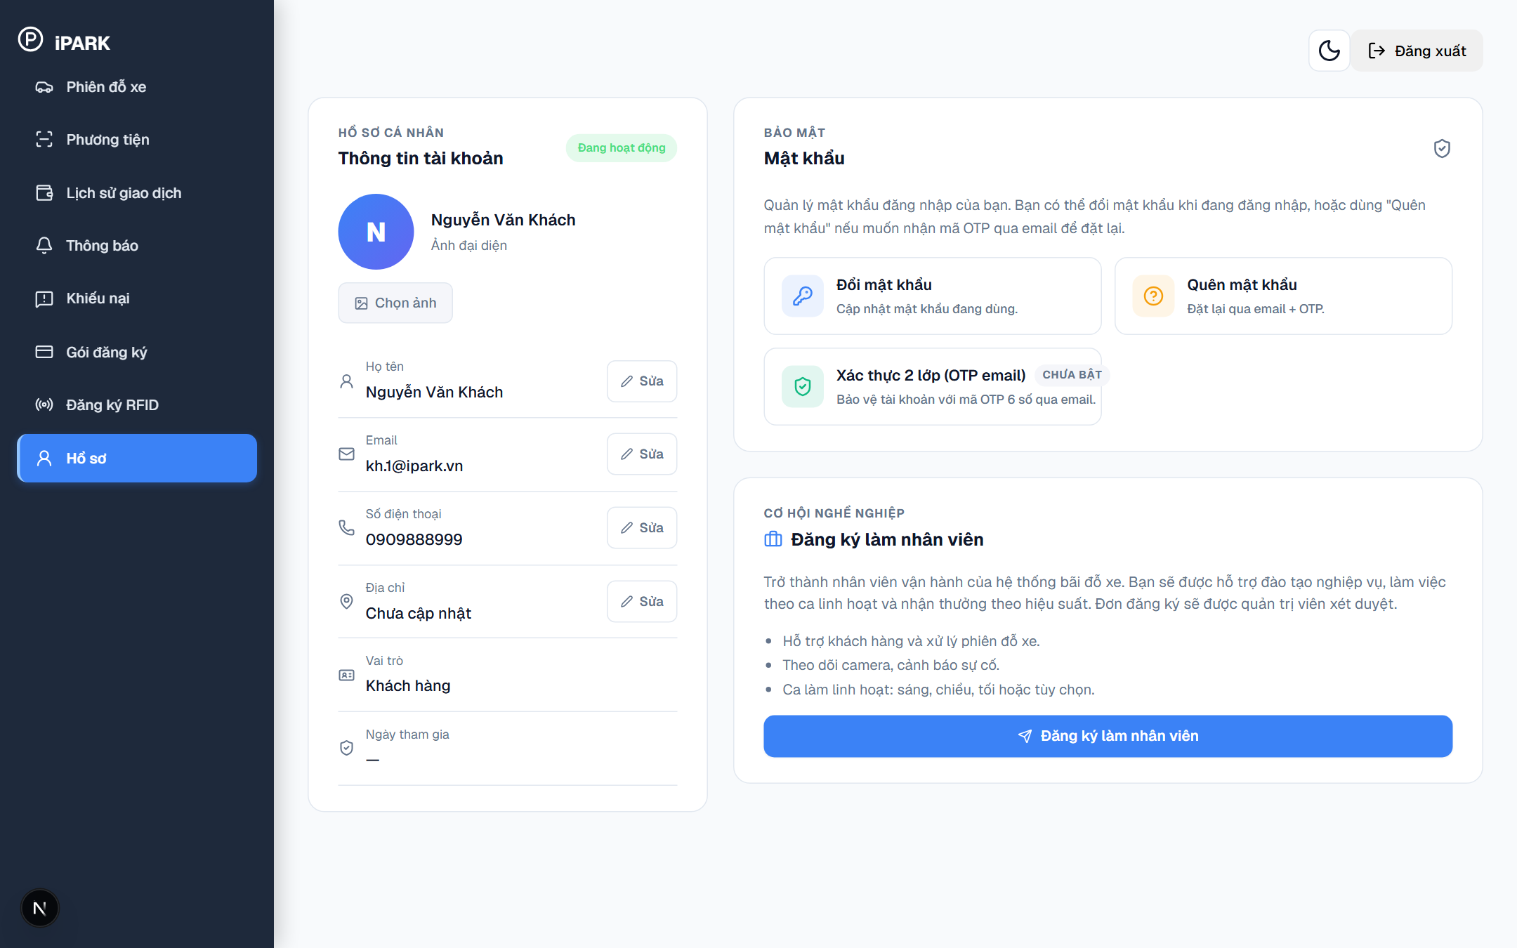
Figure 7. Customer Portal – Personal Profile & Security Management (/profile)

Screen Elements in Figure 7: Figure 7 displays the personal account profile screen accessible at http://localhost:3000/profile. Visible elements include the user avatar, account status badge ('Đang hoạt động'), personal information cards ('Họ tên', 'Email', 'Số điện thoại', 'Địa chỉ'), editable pen icons, the 'Đổi mật khẩu' password update form, and the 2FA status indicator.
Operating Instructions for Figure 7:
Step 1 (View Account Standing): On Figure 7, verify the green 'Đang hoạt động' account badge and review registered contact information.
Step 2 (Edit Contact Details): On Figure 7, click the pen icon beside any editable field (e.g., 'Số điện thoại', 'Địa chỉ'), input new details, and click 'Lưu thay đổi'.
Step 3 (Update Password): On Figure 7, scroll down to the 'Đổi mật khẩu' section, enter your current password, type the new password, confirm it, and click 'Cập nhật mật khẩu'.
3.3.2 Vehicle Management & Registration (Figure 8 & Figure 9)
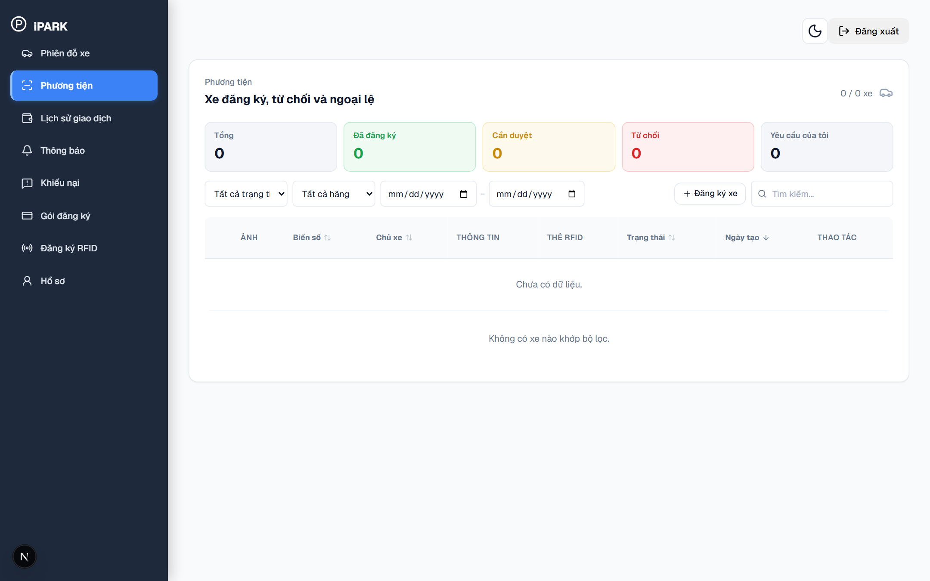
Figure 8. Customer Portal – Registered Vehicles List (/vehicles)

Screen Elements in Figure 8: Figure 8 displays the customer vehicle management screen accessible at http://localhost:3000/vehicles. Visible elements include status metric cards ('Tổng', 'Đã đăng ký', 'Cần duyệt', 'Từ chối', 'Yêu cầu của tôi'), filter dropdowns for status and brand, the vehicle table with columns ('ẢNH', 'Biển số', 'Chủ xe', 'THÔNG TIN', 'THẺ RFID', 'Trạng thái', 'Ngày tạo', 'THAO TÁC'), and the blue action button 'Đăng ký xe'.
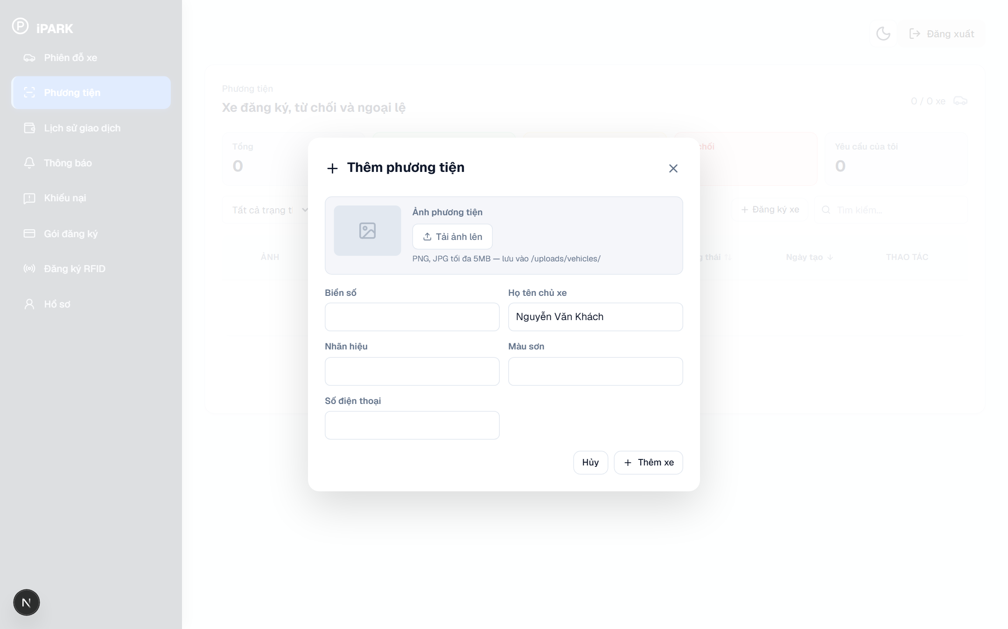
Figure 9. Customer Portal – New Vehicle Registration Modal

Screen Elements in Figure 9: Figure 9 displays the 'Thêm phương tiện' modal opened after clicking 'Đăng ký xe' on Figure 8. Visible elements include the vehicle photo upload area ('Ảnh phương tiện' with 'Tải ảnh lên' button for PNG/JPG <= 5MB), text input fields for 'Biển số' (mandatory plate number), 'Họ tên chủ xe' (prefilled owner name), 'Nhãn hiệu' (brand/make), 'Màu sơn' (color), 'Số điện thoại' (contact phone), and two action buttons at the bottom: 'Hủy' and 'Thêm xe'.
Operating Instructions for Figure 8 and Figure 9:
Step 1 (Open Vehicle Screen): On Figure 8, view the vehicle summary metrics and inspect currently registered or pending vehicles in the table.
Step 2 (Trigger Registration Modal): On Figure 8, click the blue button 'Đăng ký xe' located above the table to open the 'Thêm phương tiện' dialog shown in Figure 9.
Step 3 (Upload Vehicle Photo): On Figure 9, click 'Tải ảnh lên' under 'Ảnh phương tiện' to upload an image of your car or vehicle document (PNG/JPG up to 5MB).
Step 4 (Fill Vehicle Information): On Figure 9, type your license plate into 'Biển số' (e.g., 30A77770), verify your name in 'Họ tên chủ xe', enter manufacturer into 'Nhãn hiệu', color into 'Màu sơn', and contact number into 'Số điện thoại'.
Step 5 (Save Vehicle Request): On Figure 9, click the blue button 'Thêm xe'. The vehicle is saved and appears on Figure 8 with status 'Cần duyệt' pending administrator review.
3.3.3 Purchase Subscription Packages (Figure 10)
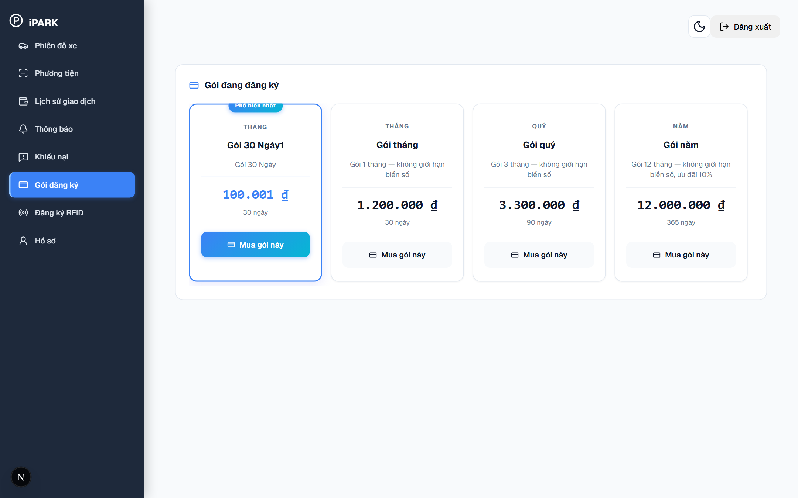
Figure 10. Customer Portal – Subscription Packages & Plans (/subscriptions)

Screen Elements in Figure 10: Figure 10 displays the subscription catalog screen accessible at http://localhost:3000/subscriptions. Visible elements include available monthly and quarterly package cards (e.g., 'Gói Tháng Tiêu Chuẩn', 'Gói 3 Tháng'), package fee badges, duration, included privileges, and the action button 'Mua gói này'.
Operating Instructions for Figure 10:
Step 1 (Browse Packages): On Figure 10, review available monthly packages and pricing terms.
Step 2 (Select Plan): On Figure 10, click the 'Mua gói này' button on the desired subscription package card.
Step 3 (Choose Approved Vehicle): In the vehicle selector dialog, pick an approved vehicle registered in your profile.
Step 4 (Complete Payment): Scan the dynamic PayOS VietQR code on your mobile banking app. Upon payment confirmation, the subscription status switches to 'Đang hoạt động' immediately.
3.3.4 Parking Sessions History (Figure 11)
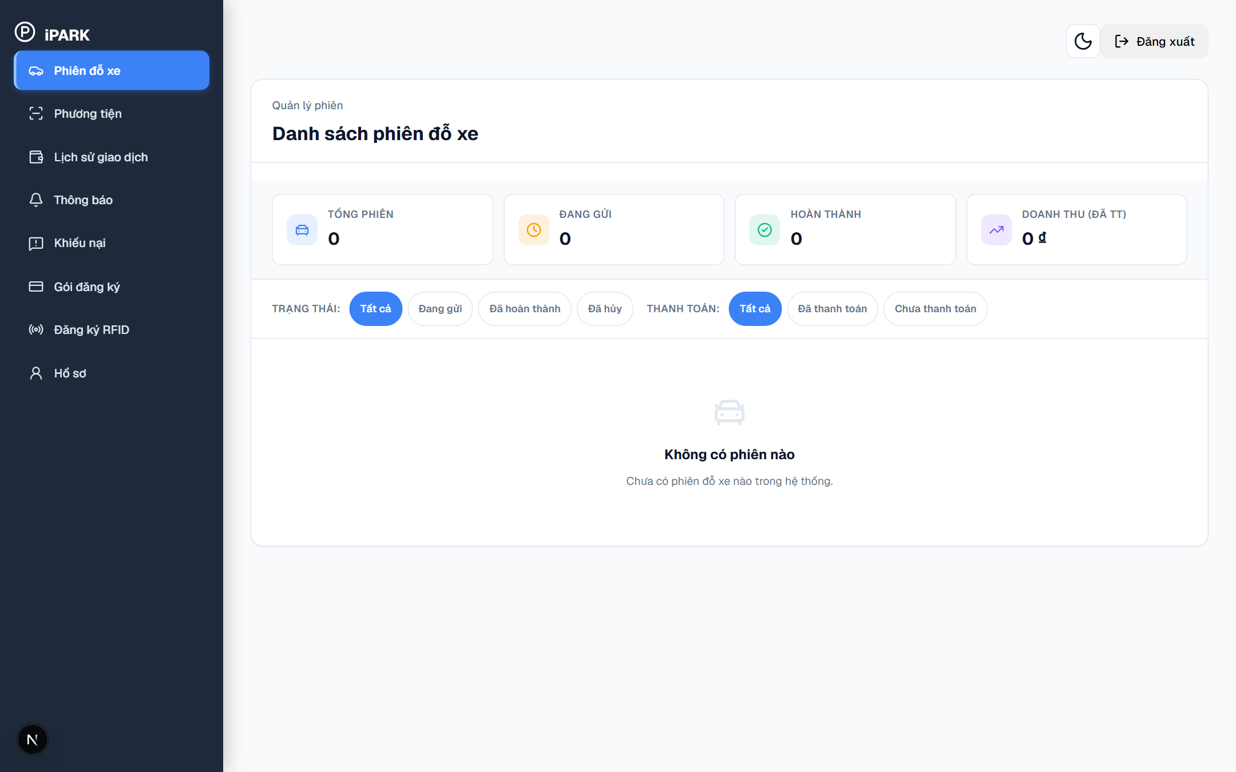
Figure 11. Customer Portal – Parking Sessions Management (/sessions)

Screen Elements in Figure 11: Figure 11 displays the parking session history screen accessible at http://localhost:3000/sessions via sidebar menu 'Phiên đỗ xe'. Visible elements include metric summary cards ('TỔNG PHIÊN', 'ĐANG GỬI', 'HOÀN THÀNH', 'DOANH THU (ĐÃ TT)'), filter tabs for TRẠNG THÁI ('Tất cả', 'Đang gửi', 'Đã hoàn thành', 'Đã hủy'), filter tabs for THANH TOÁN ('Tất cả', 'Đã thanh toán', 'Chưa thanh toán'), and the list of active/past sessions.
Operating Instructions for Figure 11:
Step 1 (Access Parking Sessions): On Figure 11, click 'Phiên đỗ xe' on the left navigation bar to view historical parking activity.
Step 2 (Inspect Metrics): On Figure 11, review the top metric cards to see total parking sessions, active in-lot sessions, and completed sessions.
Step 3 (Filter by Session Status): On Figure 11, click on filter tabs like 'Đang gửi' to see vehicles currently parked or 'Đã hoàn thành' to review past completed trips.
3.3.5 Transaction History & Payment Records (Figure 12)
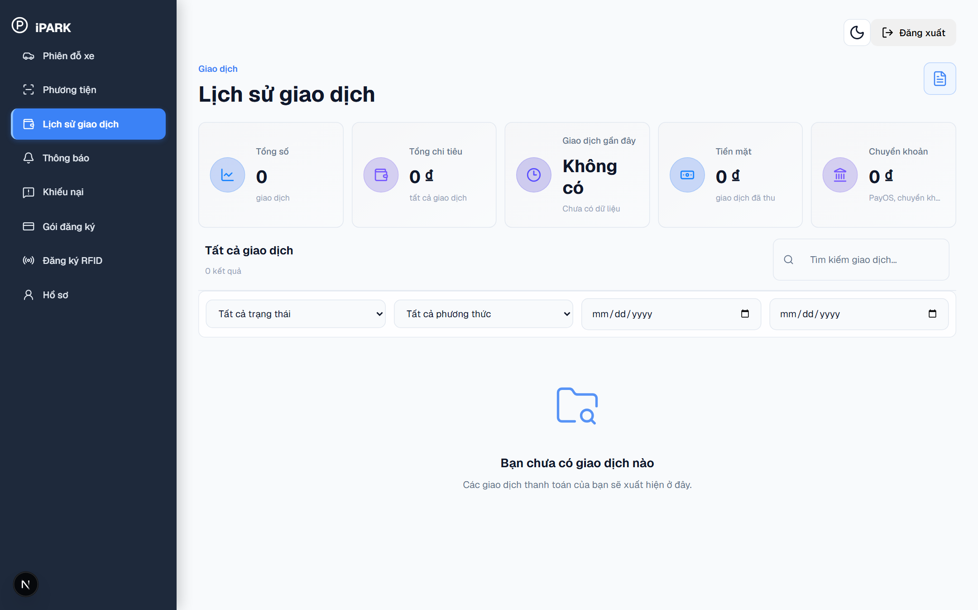
Figure 12. Customer Portal – Transaction History (/transactions)

Screen Elements in Figure 12: Figure 12 displays the transaction payment history screen accessible at http://localhost:3000/transactions via sidebar menu 'Lịch sử giao dịch'. Visible elements include financial summary cards ('Tổng số giao dịch', 'Tổng chi tiêu', 'Tiền mặt', 'Chuyển khoản'), filter dropdowns for status ('Chờ thanh toán', 'Đã thanh toán', 'Thất bại', 'Đã hủy') and payment method ('PayOS', 'Tiền mặt'), and the transaction history table.
Operating Instructions for Figure 12:
Step 1 (Review Financial Summary): On Figure 12, review total transaction counts and cumulative parking expenditure.
Step 2 (Filter Payment Records): On Figure 12, filter records by payment status or payment channel (PayOS vs. Cash) to audit transaction receipts.

3.4 Security Guard / Staff Operations
Security guards and gate operators are responsible for active lane control, verifying license plates detected by ANPR AI cameras, issuing/collecting circulating RFID cards, and managing barrier gates.
3.4.1 Staff Desk Workstation — Dual-Lane Gate Console (Figures 13, 14, 15, 16, and 17)
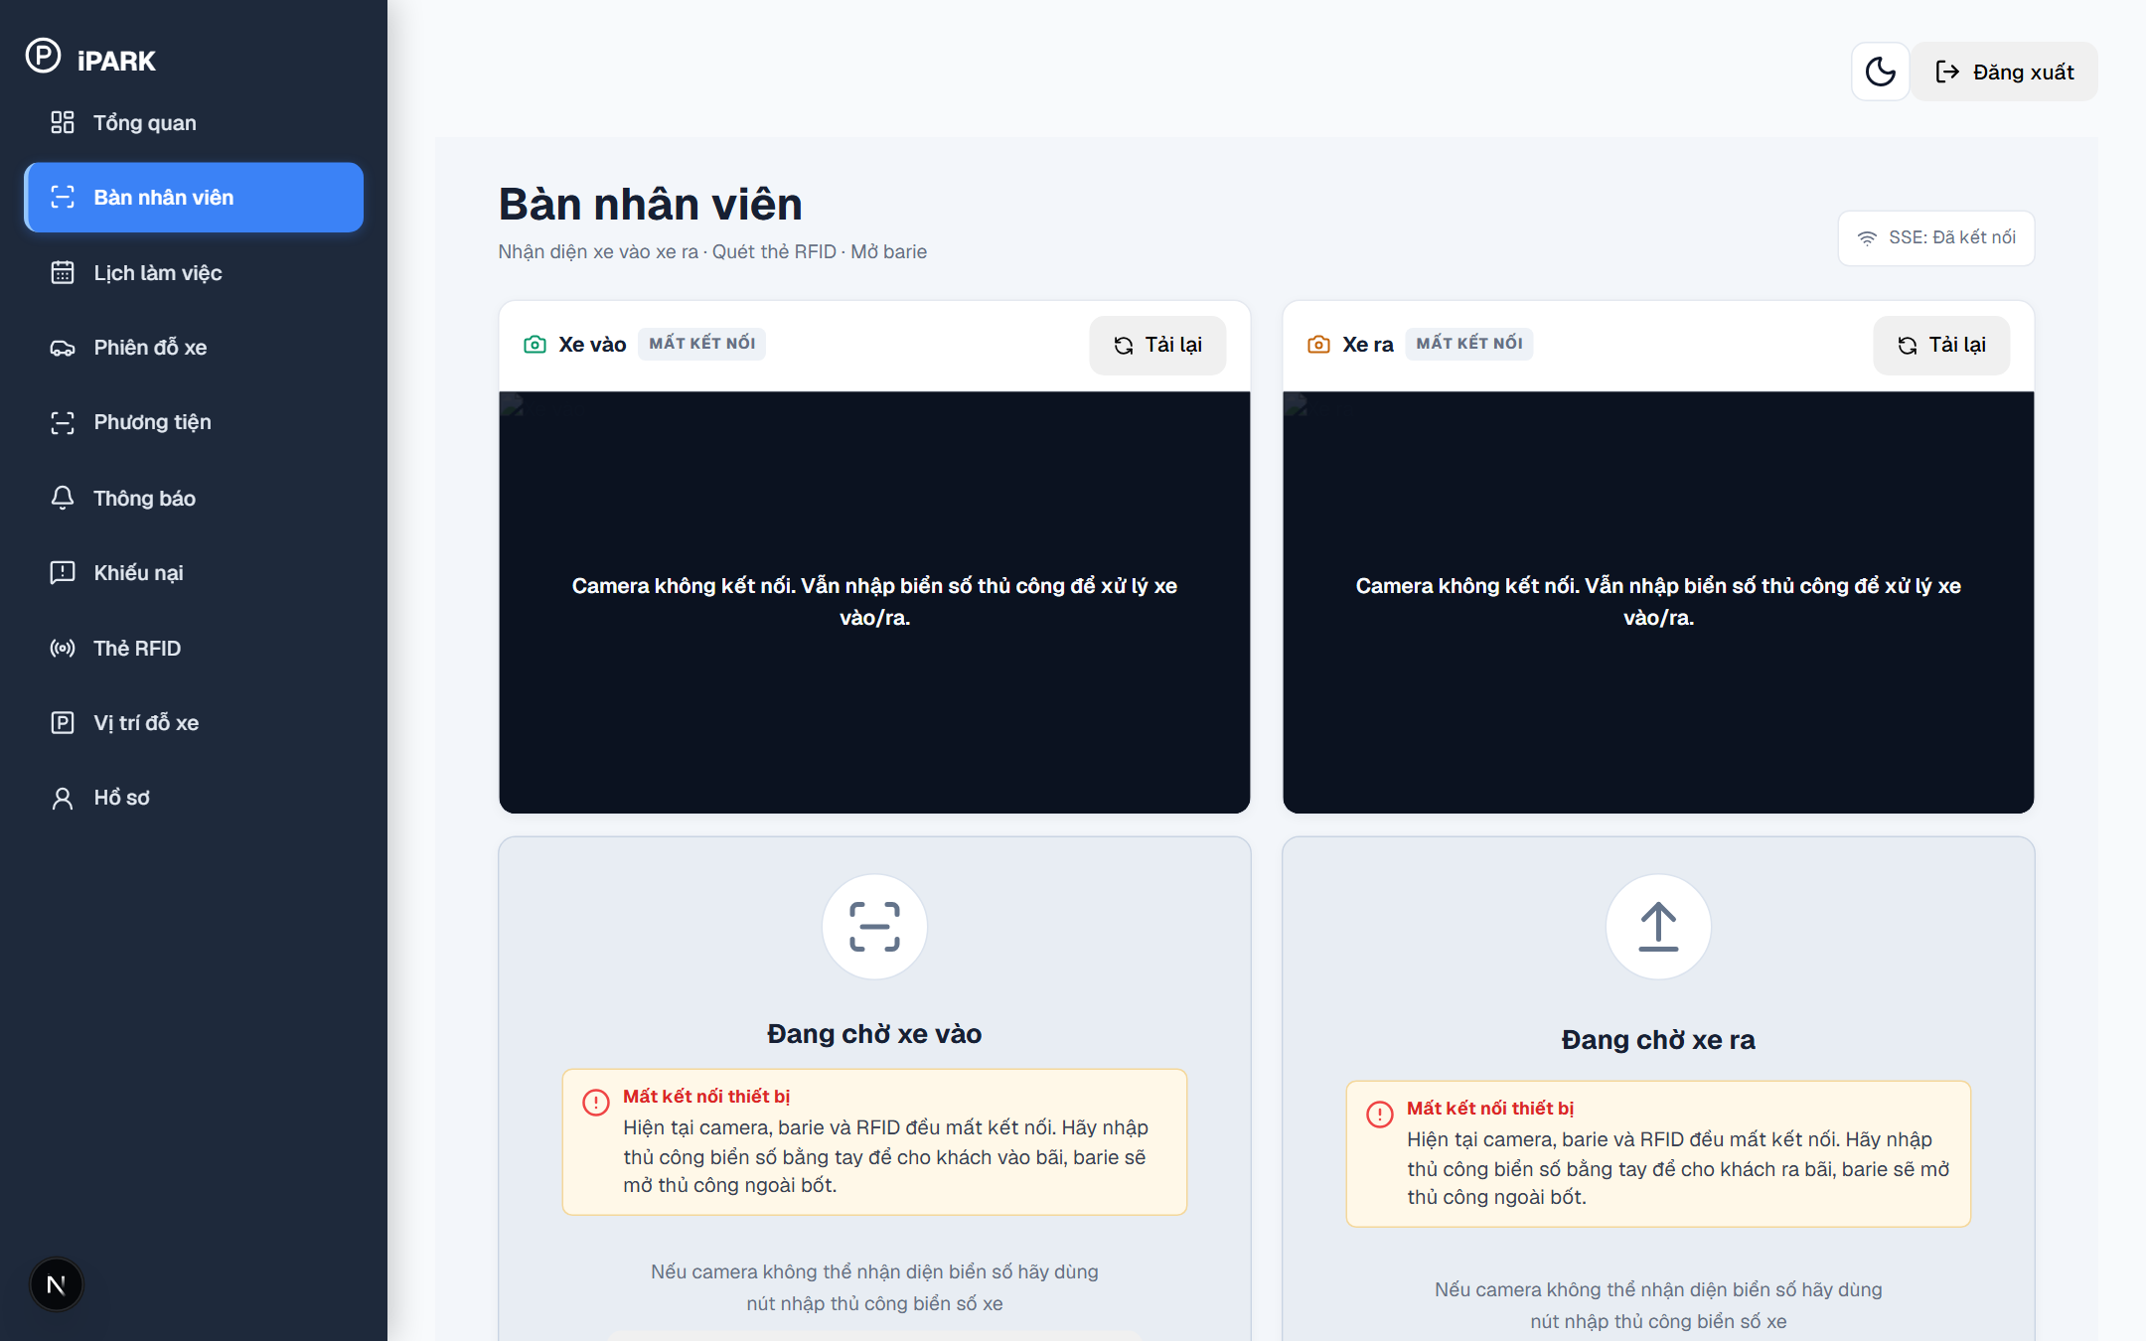
Figure 13. Security Guard Workstation – Dual-Lane Gate Console Overview (/staff-desk)

Screen Elements in Figure 13: Figure 13 displays the operational dual-lane control console accessible at http://localhost:3000/staff-desk. Visible elements include the SSE live connection badge ('SSE: Đã kết nối'), the left lane column for Lane 1 ('Xe vào') with camera preview and vehicle waiting state, and the right lane column for Lane 2 ('Xe ra') with camera preview, recognized plate card, and barrier control triggers.
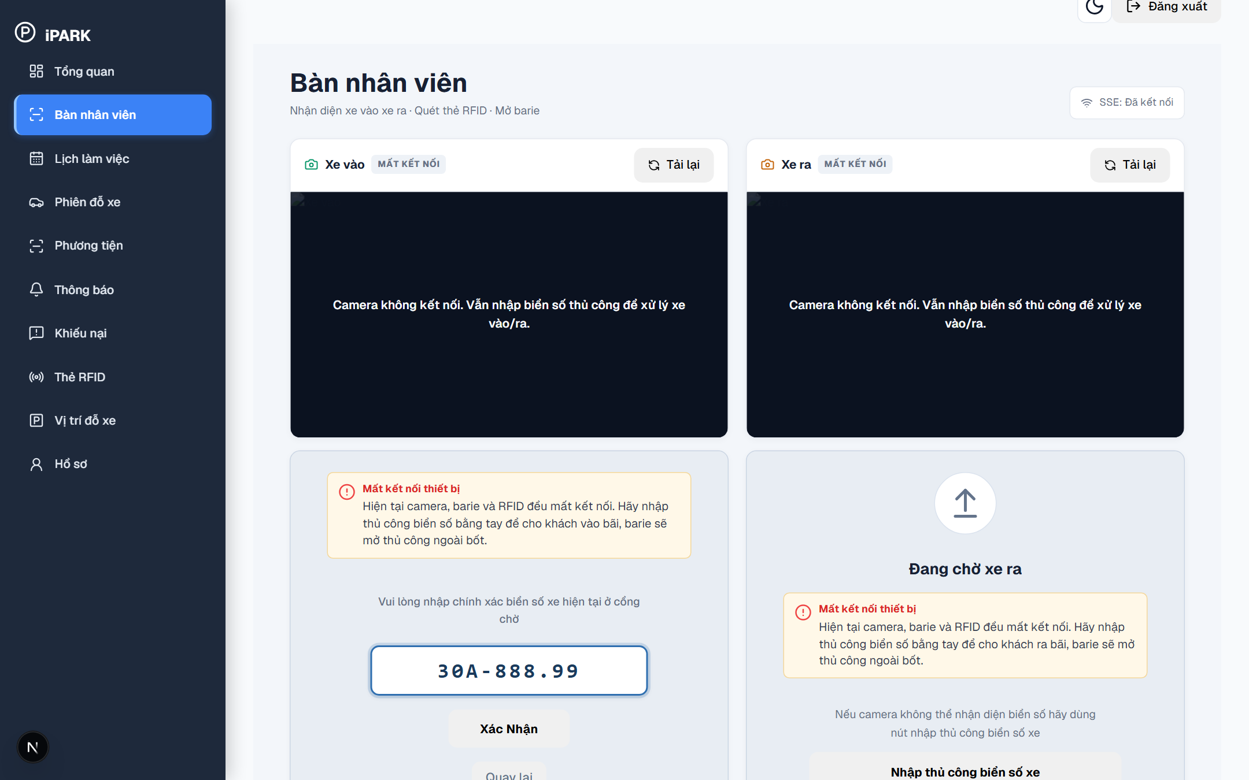
Figure 14. Staff Desk – Lane 1 Vehicle Entry Processing & Manual Plate Confirmation (Xe vào)

Screen Elements in Figure 14: Figure 14 displays the Lane 1 entry processing state ('Xe vào'). Visible elements include the entry lane header with direction badge, the camera capture viewport, the manual plate input field (e.g., '30A-888.99') used when camera OCR is obscured, the confirmation button 'Xác Nhận', and the prompt instructing guards to tap an RFID card on the reader to create a new session.
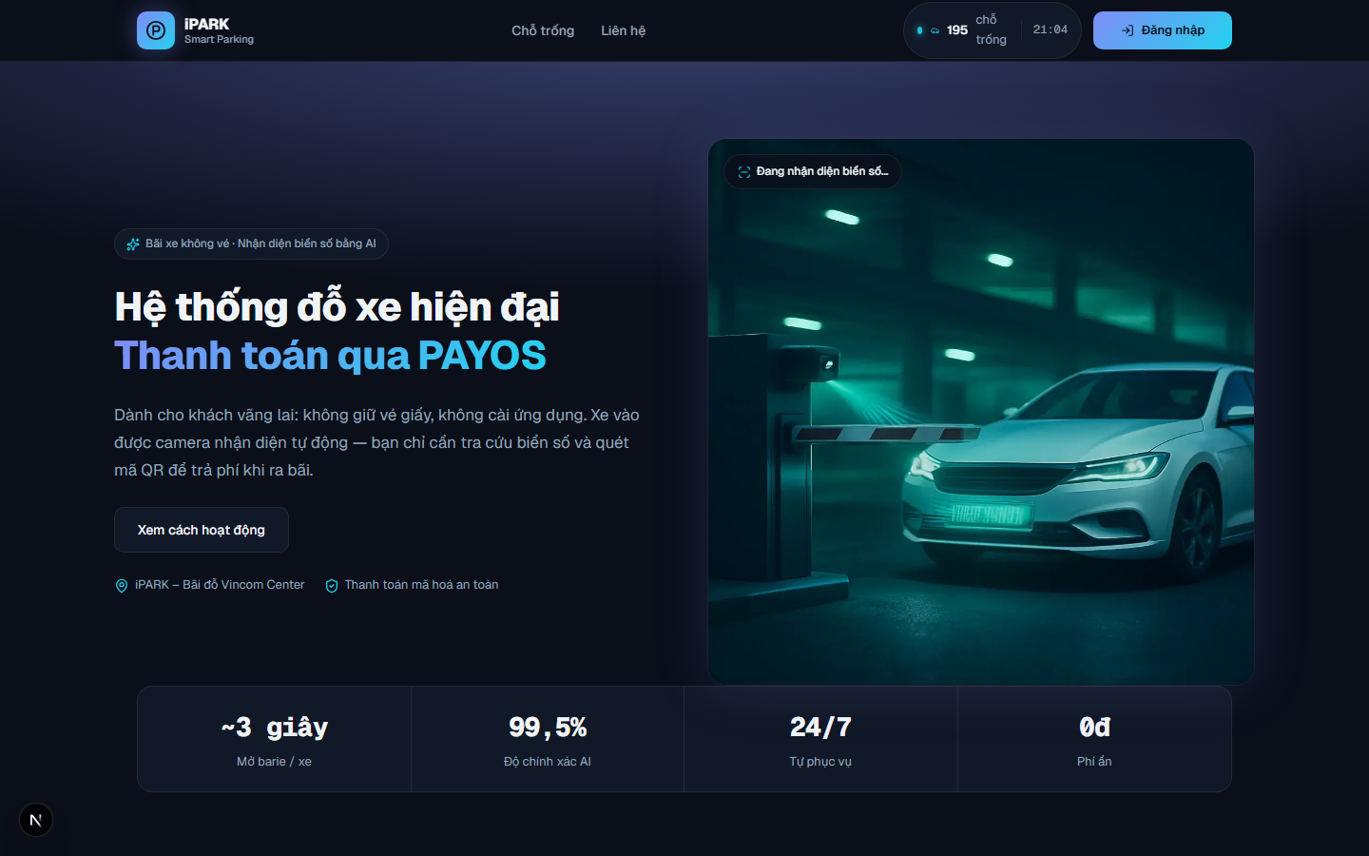
Figure 15. Staff Desk – Live Member Vehicle Exit Verification & Automatic Barrier Release

Screen Elements in Figure 15: Figure 15 displays the live member exit verification state on Lane 2 ('Xe ra'). Visible elements include the recognized license plate, the green member validation badge ('Hợp lệ - Miễn phí gói tháng'), active subscription validity, 0 VND fee due, and automatic barrier release trigger.
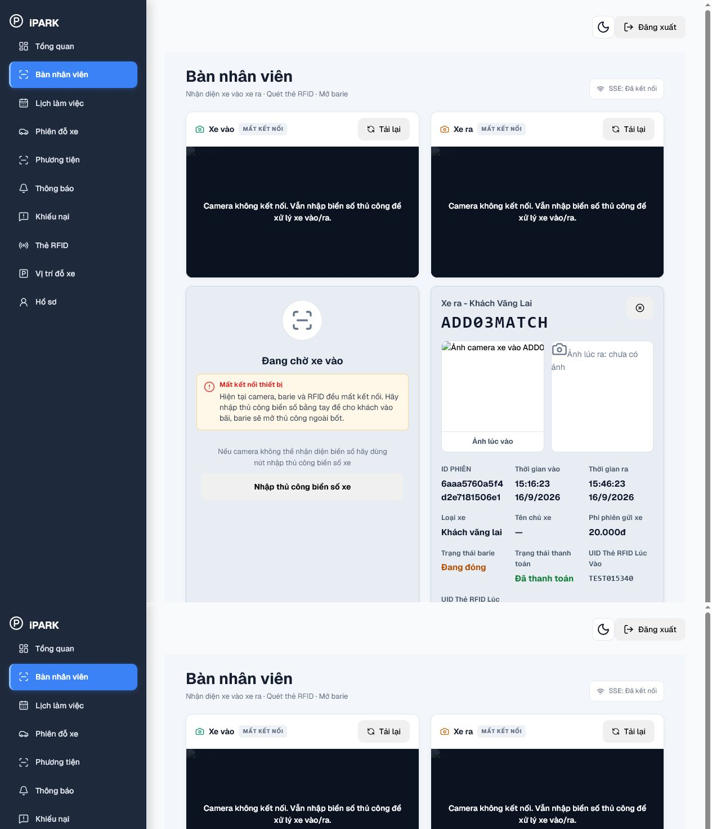
Figure 16. Staff Desk – Guest Exit Session & RFID Card Verification

Screen Elements in Figure 16: Figure 16 displays the casual guest exit verification on Lane 2 ('Xe ra'). Visible elements include side-by-side comparison of entry snapshot and exit camera feed, matched RFID card UID, parked duration, and accrued parking fee calculated by tariff rules.
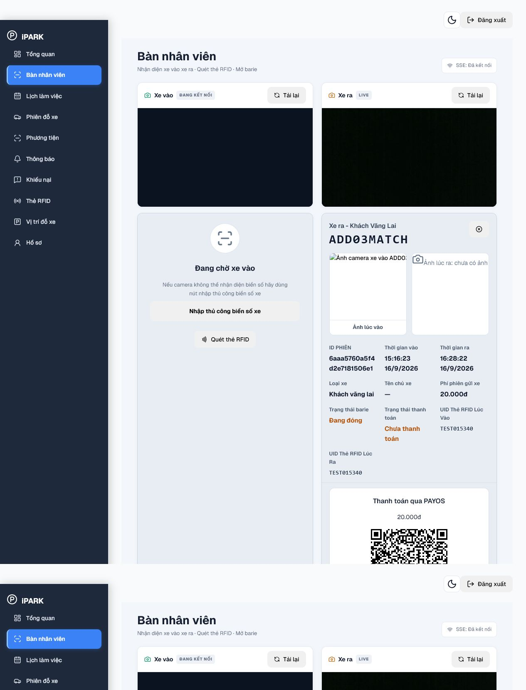
Figure 17. Staff Desk – Checkout Payment with VietQR / PayOS Integration

Screen Elements in Figure 17: Figure 17 displays the on-desk checkout dialog. Visible elements include dynamic PayOS VietQR code, exact fee amount, payment status listener, and the cash collection fallback button ('Thu tiền mặt').
Operating Instructions for Figures 13, 14, 15, 16, and 17:
Step 1 (Process Vehicle Entry (Lane 1 - Figure 13 & Figure 14)): On Figure 13 and Figure 14, when a vehicle arrives at the entry gate, the camera triggers ANPR detection. If the plate is recognized automatically, guard taps an unallocated RFID card on the reader to bind UID and open barrier. If OCR is obscured, click 'Nhập thủ công biển số xe' on Figure 14, enter plate number, tap RFID card, and click 'Xác Nhận' to open the entry barrier.
Step 2 (Process Member Touchless Exit (Lane 2 - Figure 15)): On Figure 15, when a subscribed member vehicle reaches exit Lane 2, ANPR verifies the active subscription, shows 0 VND due, and automatically commands the exit barrier to open.
Step 3 (Process Guest Card Exit (Lane 2 - Figure 16)): On Figure 16, take the circulating RFID card from the driver and tap it on the desk reader. The console displays the matched entry image and calculates the fee.
Step 4 (Collect Payment & Release Barrier (Figure 17)): On Figure 17, present the PayOS VietQR for banking scan or click 'Thu tiền mặt' for cash payment. Once payment is confirmed, the barrier opens, the session completes, and the slot is released.
3.4.2 Staff Operational Overview & Shift Work Schedule (Figure 18 & Figure 19)
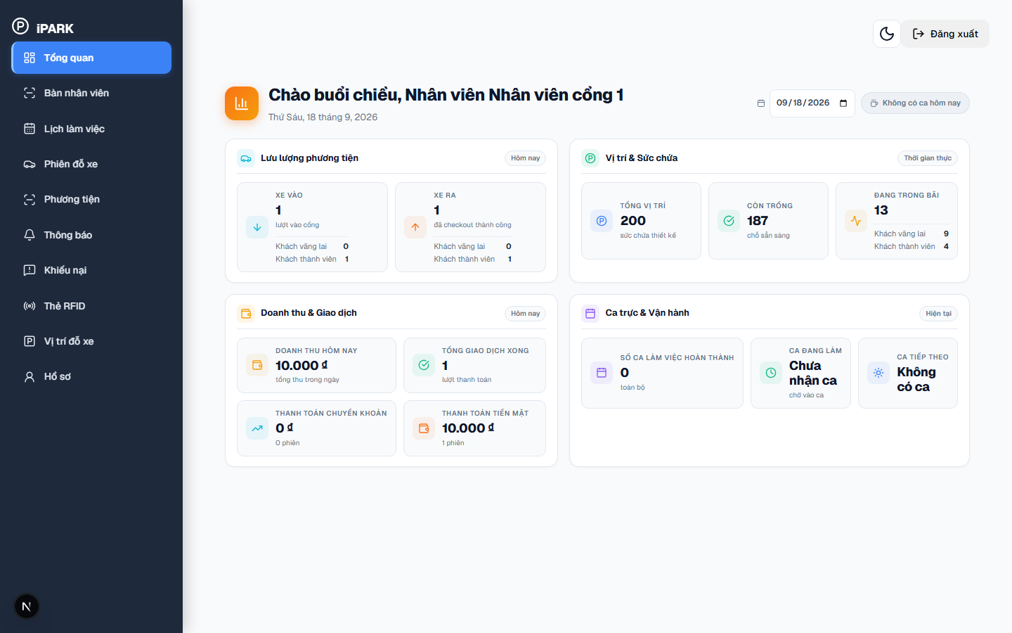
Figure 18. Security Guard – Operational Overview Dashboard (/overview)

Screen Elements in Figure 18: Figure 18 displays the operational shift dashboard accessible at http://localhost:3000/overview. Visible elements include the staff greeting banner ('Chào buổi chiều, Nhân viên Nhân viên cổng 1'), current date display, and four primary operational metric blocks: 1) Lưu lượng phương tiện (XE VÀO: lượt vào cổng, Khách vãng lai, Khách thành viên; XE RA: đã checkout thành công, Khách vãng lai, Khách thành viên); 2) Vị trí & Sức chứa (TỔNG VỊ TRÍ: 200 sức chứa thiết kế, CÒN TRỐNG: chỗ sẵn sàng, ĐANG TRONG BÃI: phân tách vãng lai vs thành viên); 3) Doanh thu & Giao dịch (DOANH THU HÔM NAY, TỔNG GIAO DỊCH XONG, THANH TOÁN CHUYỂN KHOẢN, THANH TOÁN TIỀN MẶT); 4) Ca trực & Vận hành (SỐ CA LÀM VIỆC HOÀN THÀNH, CA ĐANG LÀM, CA TIẾP THEO).
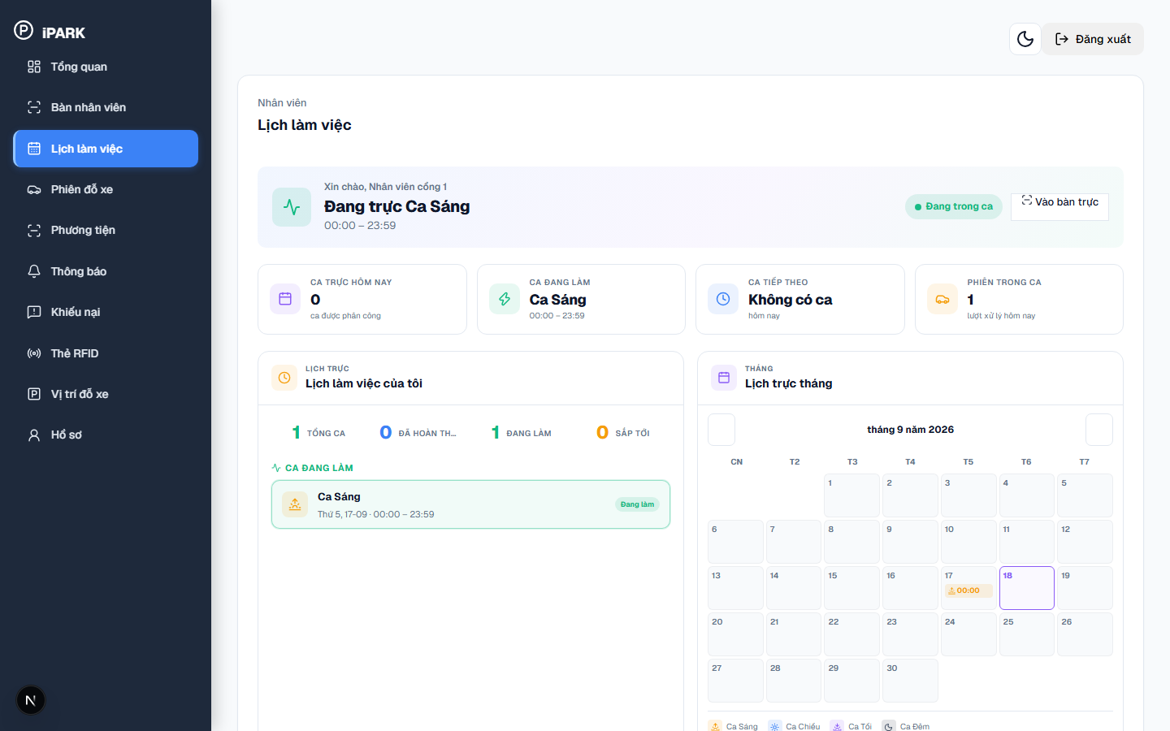
Figure 19. Security Guard – Shift Attendance & Monthly Schedule (/shifts)

Screen Elements in Figure 19: Figure 19 displays the shift schedule and check-in management screen accessible at http://localhost:3000/shifts via sidebar menu 'Lịch làm việc'. Visible elements include the active shift banner ('Đang trực Ca Sáng 00:00 – 23:59', 'Đang trong ca' status badge, direct action button 'Vào bàn trực'), shift metric summary cards ('CA TRỰC HÔM NAY', 'CA ĐANG LÀM', 'CA TIẾP THEO', 'PHIÊN TRONG CA'), weekly shift counters ('TỔNG CA', 'ĐÃ HOÀN THÀNH', 'ĐANG LÀM', 'SẮP TỚI'), and the interactive monthly calendar ('Lịch trực tháng') with shift tags for Ca Sáng, Ca Chiều, Ca Tối, Ca Đêm.
Operating Instructions for Figure 18 and Figure 19:
Step 1 (Inspect Real-Time Facility Metrics): On Figure 18, check real-time gate traffic under 'Lưu lượng phương tiện' (vehicle inflow and outflow counts) and verify remaining vacant slots under 'Vị trí & Sức chứa'.
Step 2 (Audit Shift Financial Collections): On Figure 18, review daily financial collections under 'Doanh thu & Giao dịch', comparing PayOS digital transfer revenue against physical cash collected during the shift.
Step 3 (Verify Assigned Shift & Attendance): On Figure 19, inspect your scheduled shift hours (e.g., Ca Sáng 00:00–23:59) and verify the green 'Đang trong ca' attendance badge.
Step 4 (Enter Gate Control Workstation): On Figure 19, click the blue button 'Vào bàn trực' to open the dual-lane gate console (/staff-desk) and begin operating gate barriers.
3.4.3 RFID Card Inventory Management (Figure 20)
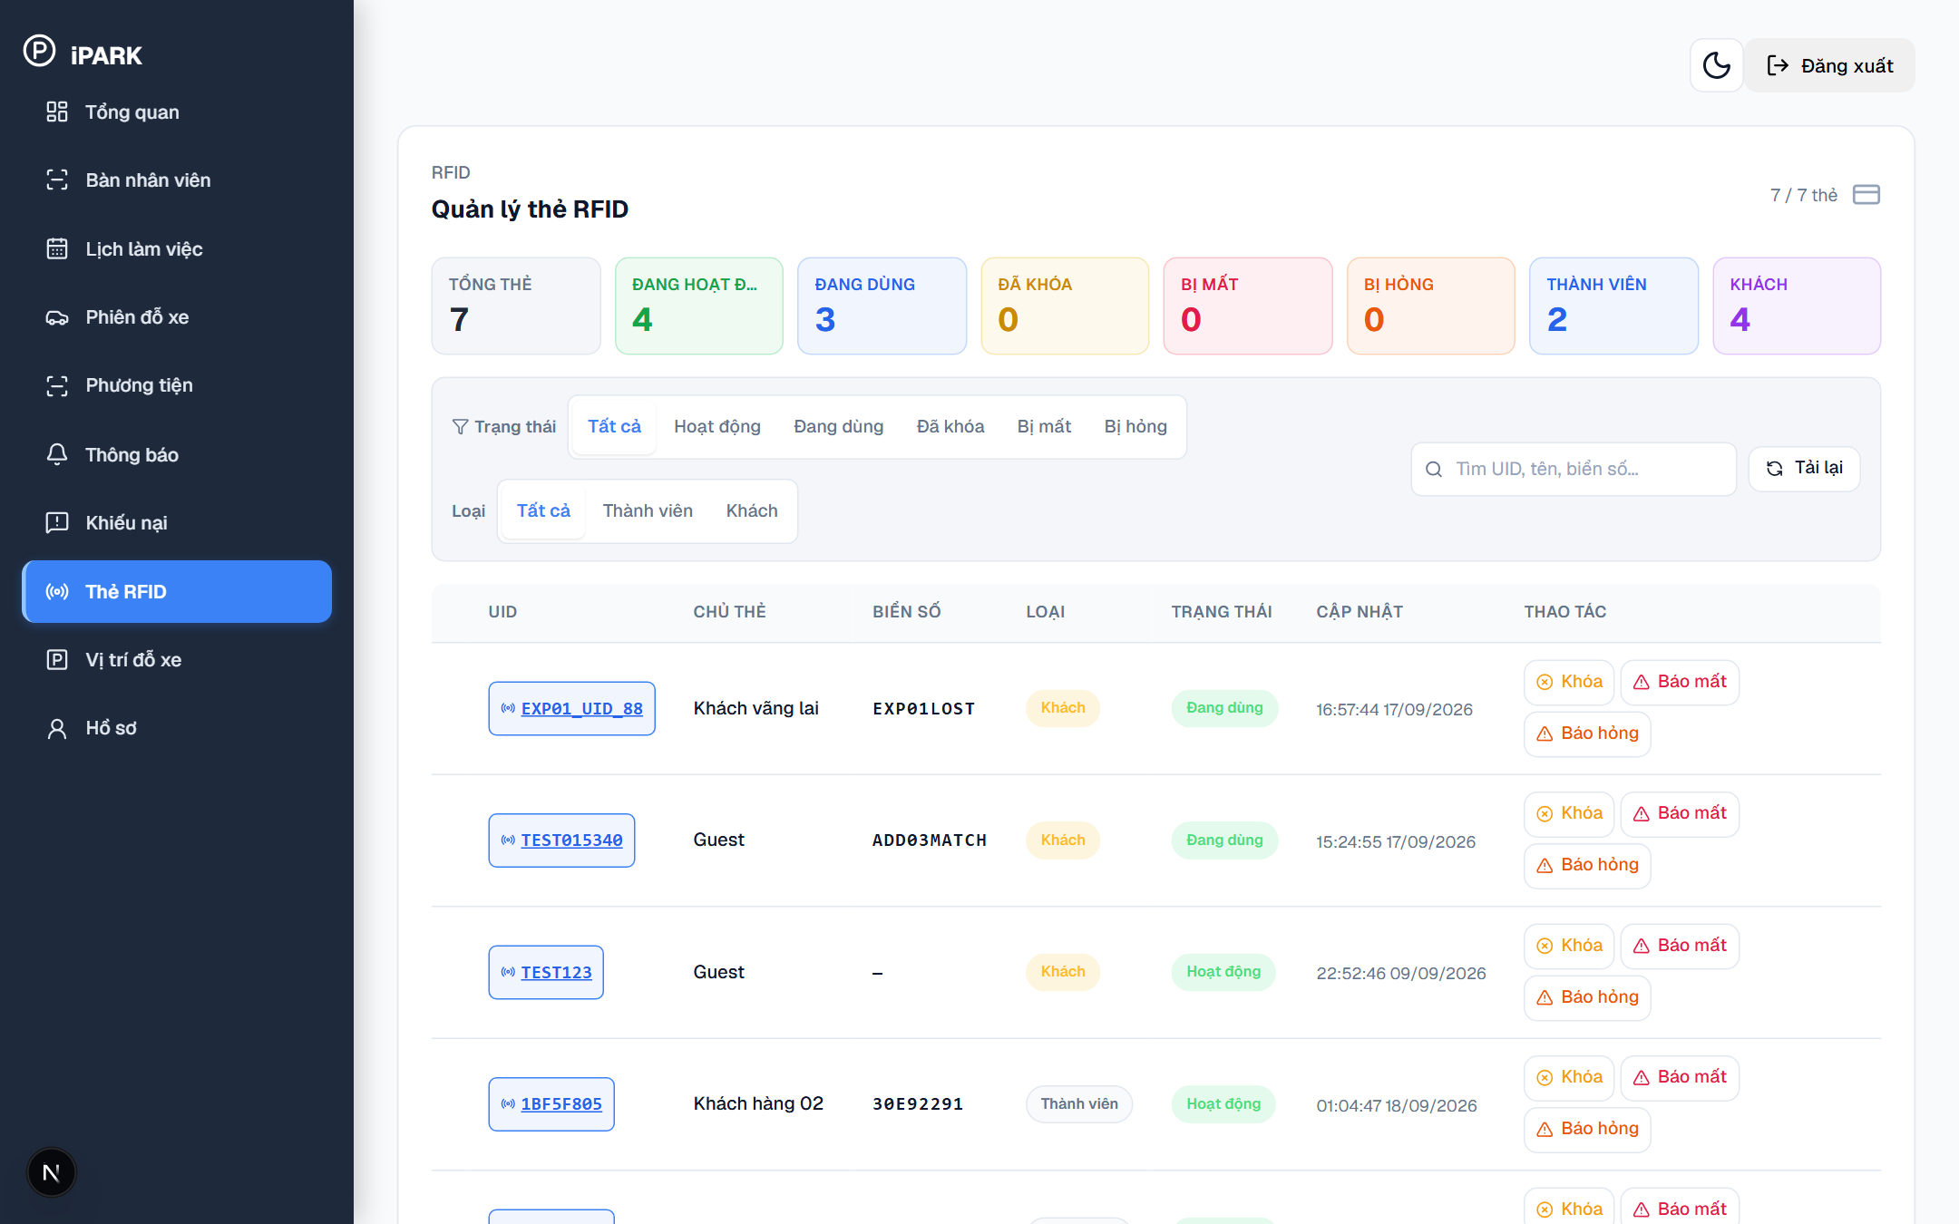
Figure 20. Staff Operations – RFID Card Inventory Management (/rfid)

Screen Elements in Figure 20: Figure 20 displays the RFID card management screen accessible at http://localhost:3000/rfid. Visible elements include the card inventory table showing columns for Card UID, Card Type ('Khách vãng lai' / 'Cư dân'), Status badges ('Sẵn sàng', 'Đang sử dụng', 'Bị khóa'), and card management action buttons.
Operating Instructions for Figure 20:
Step 1 (Check Inventory Table): On Figure 20, inspect the count of available cards in the 'Sẵn sàng' pool ready for guest issuance.
Step 2 (Search & Lock Card): On Figure 20, search by card UID or license plate, and click 'Khóa thẻ' if a card is reported missing.
3.4.4 Parking Slots Quota Monitoring & Real-Time Visual Map (Figure 21)
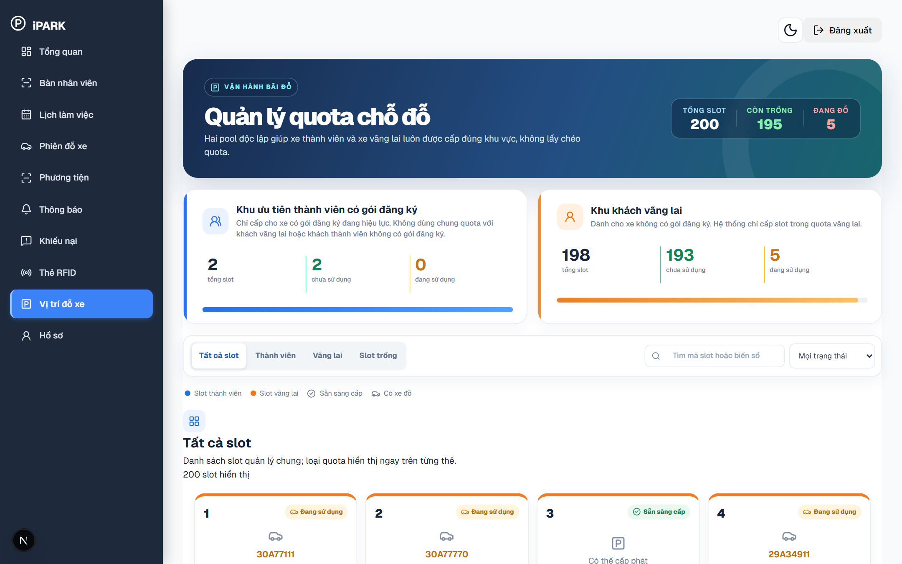
Figure 21. Staff Operations – Real-Time Parking Slots & Quota Pools (/parking-slots)

Screen Elements in Figure 21: Figure 21 displays the operational parking slot management interface accessible at http://localhost:3000/parking-slots via sidebar menu 'Vị trí đỗ xe'. Visible elements include the quota overview banner ('TỔNG SLOT': 200, 'CÒN TRỐNG', 'ĐANG ĐỖ'), the two segregated quota pools: 'Khu ưu tiên thành viên có gói đăng ký' (dedicated subscriber quota) and 'Khu khách vãng lai' (casual driver quota), filter buttons for slot pools and states ('Sẵn sàng cấp', 'Đang sử dụng', 'Bảo trì'), and the interactive card grid representing all individual parking spots.
Operating Instructions for Figure 21:
Step 1 (Inspect Quota Allocation): On Figure 21, observe the total capacity counter and verify available vacancies in both the Member Pool and Guest Pool.
Step 2 (Filter by Slot State): On Figure 21, click filter tabs ('Slot trống', 'Slot thành viên', 'Slot vãng lai') to highlight available or occupied slots.
Step 3 (Inspect Parked Vehicle Details): On Figure 21, click on any active slot card to inspect vehicle plate number, parking duration, and customer type.
3.4.5 Customer Disputes Support & Resolution (Figure 22)
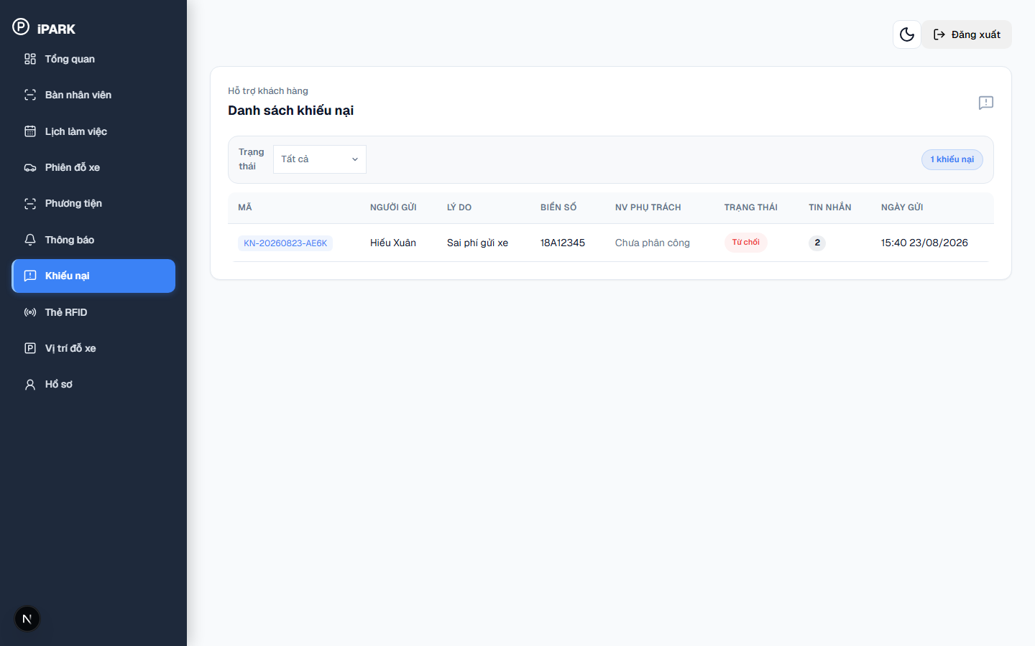
Figure 22. Staff Operations – Customer Dispute Requests Management (/disputes)

Screen Elements in Figure 22: Figure 22 displays the customer dispute management screen accessible at http://localhost:3000/disputes via sidebar menu 'Khiếu nại' ('Hỗ trợ khách hàng – Danh sách khiếu nại'). This screen lists complaints submitted by customers regarding parking issues (such as 'Sai phí gửi xe', 'Sai thời gian vào/ra', 'Nhận dạng biển số sai', 'Thanh toán trùng / chưa ghi nhận', 'Hư hỏng - mất mát tài sản'). Visible elements include the status filter tabs ('Tất cả', 'Mới', 'Đang xử lý', 'Đã xử lý', 'Từ chối'), the total complaint counter ('1 khiếu nại'), and the complaints table with columns: 'MÃ' (e.g., KN-20260823-AE6K), 'NGƯỜI GỬI', 'LÝ DO', 'BIỂN SỐ', 'NV PHỤ TRÁCH', 'TRẠNG THÁI', 'TIN NHẮN', and 'NGÀY GỬI'.
Operating Instructions for Figure 22:
Step 1 (Access Dispute Center): On Figure 22, click 'Khiếu nại' on the sidebar to review support requests submitted by drivers.
Step 2 (Filter by Processing Status): On Figure 22, use status tabs like 'Mới' to review newly submitted complaints or 'Đang xử lý' to follow up on pending cases.
Step 3 (Inspect Dispute Details & Respond): On Figure 22, click on a dispute row to view customer explanations, attached photo evidence, and message history, then assign handling staff or update status to 'Đã xử lý' / 'Từ chối'.

3.5 Core End-to-End Parking Workflows
Member Workflow: Workflow 1 — Member Touchless Access Workflow (ANPR-First):
Step 1 (Approach): Member vehicle approaches entry lane at 10-15 km/h.
Step 2 (AI Capture): ANPR camera captures plate image and sends to PaddleOCR service.
Step 3 (Verification): Backend queries MongoDB subscriptions collection: checks active plate and expiration date.
Step 4 (Automated Clearance): System logs check-in session with customerType='member', fee=0, triggers hardware relay to lift barrier.
Step 5 (Exit): At exit lane, camera captures plate, verifies open session, confirms 0 VND due, and raises exit barrier touchlessly.
Guest Workflow: Workflow 2 — Guest Parking Lifecycle with Circulating RFID:
Step 1 (Entry Capture): Guest approaches entry lane. ANPR captures license plate.
Step 2 (Card Swipe): Guard taps unallocated RFID card. Backend binds UID to license plate, creates parking session with status='Đang gửi', and barrier opens.
Step 3 (Exit & Payment): At exit, driver hands card to guard. Console matches session, computes fee, and displays VietQR.
Step 4 (Checkout & Release): Upon banking transfer confirmation, barrier opens, session completes, and card is sanitized for reuse.

3.6 System Administrator Portal
The Administrator Portal gives facility managers and system admins complete control over security accounts, vehicle verifications, tariff pricing, subscriptions, and financial reports.
3.6.1 Administrator Overview Dashboard (Figure 23)
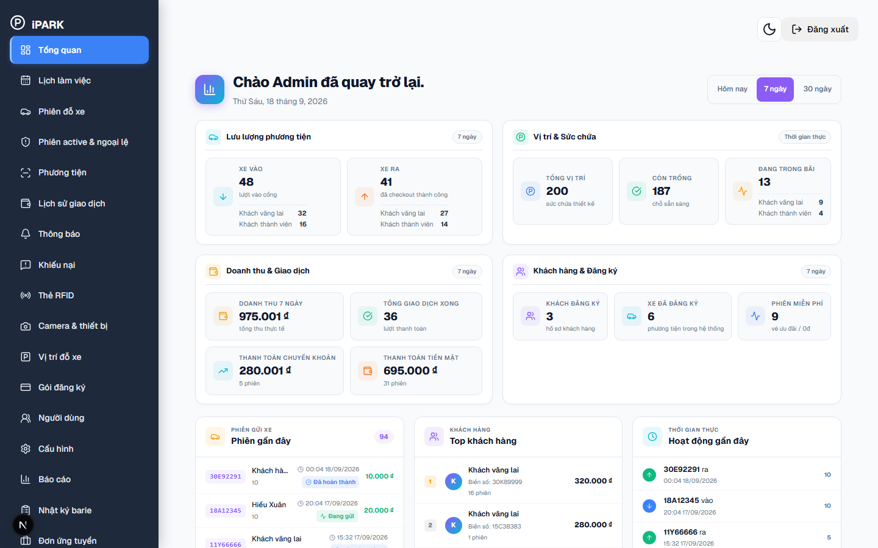
Figure 23. System Administrator – System Overview Dashboard (/overview)

Screen Elements in Figure 23: Figure 23 displays the comprehensive administrative overview dashboard accessible at http://localhost:3000/overview via sidebar menu 'Tổng quan'. Visible elements include the top welcome header ('Chào Admin đã quay trở lại.'), date range filter buttons ('Hôm nay', '7 ngày', '30 ngày'), and four primary KPI metric cards: 1) 'Lưu lượng phương tiện' (XE VÀO: lượt vào cổng, tách riêng Khách vãng lai & Khách thành viên; XE RA: đã checkout thành công, tách riêng Vãng lai & Thành viên); 2) 'Vị trí & Sức chứa' (TỔNG VỊ TRÍ: 200 sức chứa thiết kế, CÒN TRỐNG: chỗ sẵn sàng, ĐANG TRONG BÃI: phân tách vãng lai vs thành viên); 3) 'Doanh thu & Giao dịch' (DOANH THU tổng thu thực tế, TỔNG GIAO DỊCH XONG, THANH TOÁN CHUYỂN KHOẢN, THANH TOÁN TIỀN MẶT); 4) 'Khách hàng & Đăng ký' (KHÁCH ĐĂNG KÝ, XE ĐÃ ĐĂNG KÝ, PHIÊN MIỄN PHÍ). Below the KPI metrics, the screen displays three real-time activity panels: 'PHIÊN GỬI XE - Phiên gần đây', 'KHÁCH HÀNG - Top khách hàng', and 'THỜI GIAN THỰC - Hoạt động gần đây'.
Operating Instructions for Figure 23:
Step 1 (Select Reporting Timeframe): On Figure 23, click on 'Hôm nay', '7 ngày', or '30 ngày' at the top of the dashboard to switch the analytics calculation window.
Step 2 (Monitor Vehicle Throughput & Capacity): On Figure 23, inspect the 'Lưu lượng phương tiện' and 'Vị trí & Sức chứa' cards to observe live incoming/outgoing traffic and current vacant slot counts.
Step 3 (Review Financial Channel Breakdown): On Figure 23, review the 'Doanh thu & Giao dịch' section to audit total revenue collected via bank transfer (PayOS) versus physical cash.
Step 4 (Audit Recent In-Gate / Out-Gate Activity): On Figure 23, monitor the 'Phiên gần đây' table and 'Hoạt động gần đây' stream to track vehicle license plates entering and exiting the parking facility in real time.
3.6.2 User Management & Account Provisioning (Figure 24 & Figure 25)
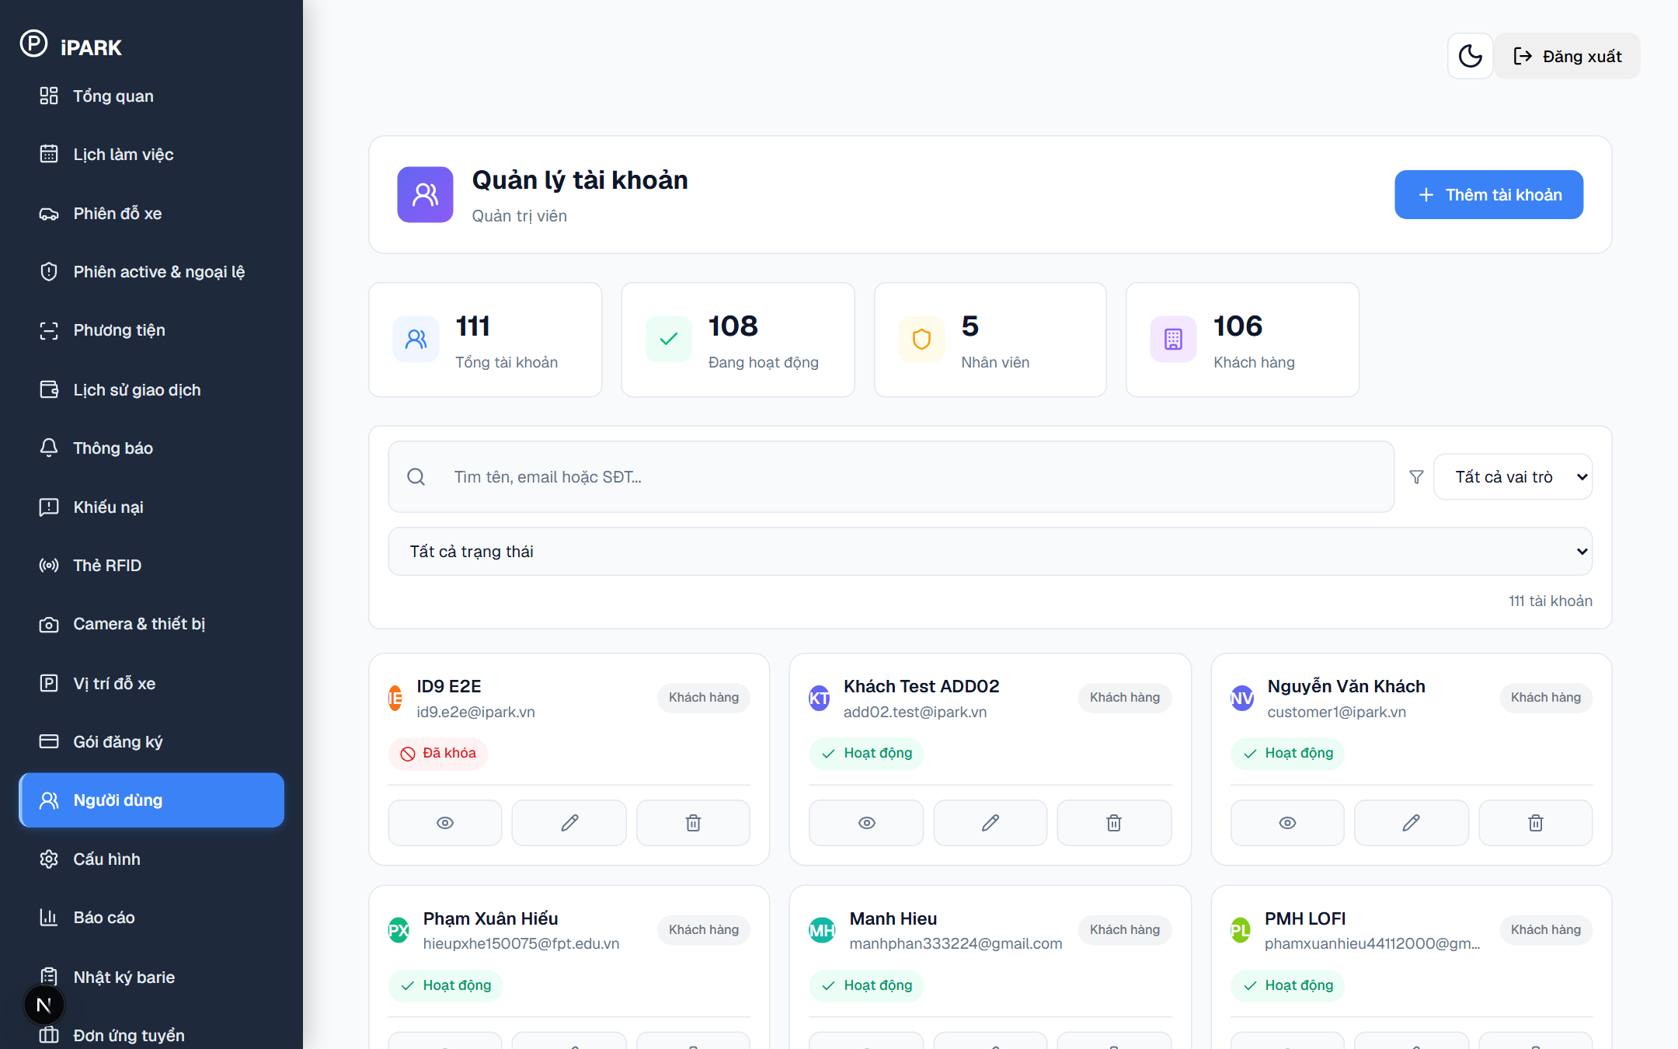
Figure 24. System Administrator – User & Role Permission Management (/users)

Screen Elements in Figure 24: Figure 24 displays the user account administration screen accessible at http://localhost:3000/users. Visible elements include the searchable user table with columns for Full Name, Email, Phone, Role badge ('Admin', 'Staff', 'Customer'), Account Status ('Đang hoạt động', 'Đã khóa'), user edit actions, and the primary action button 'Tạo tài khoản mới'.
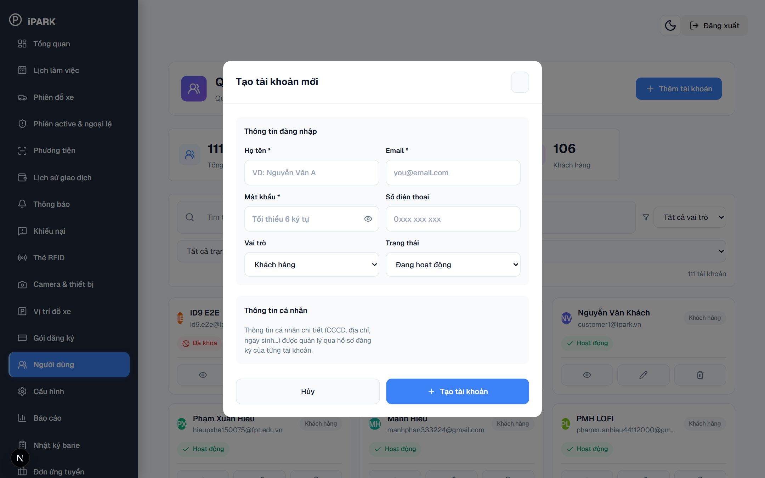
Figure 25. System Administrator – Create New User Account Modal

Screen Elements in Figure 25: Figure 25 displays the user account creation modal opened after clicking 'Tạo tài khoản mới' on Figure 24. Visible elements include text input fields for 'Họ và tên', 'Email', 'Số điện thoại', 'Mật khẩu', role selector dropdown ('Staff', 'Customer'), and the 'Lưu tài khoản' action button.
Operating Instructions for Figure 24 and Figure 25:
Step 1 (Audit Existing Accounts): On Figure 24, review current accounts and use the role filter to inspect staff and customer distribution.
Step 2 (Open Creation Modal): On Figure 24, click the blue button 'Tạo tài khoản mới' to display the form shown in Figure 25.
Step 3 (Enter Account Specifications): On Figure 25, fill in full name, corporate email address, phone number, select assigned role (e.g., 'Staff'), and set the initial password.
Step 4 (Save & Activate): On Figure 25, click 'Lưu tài khoản'. The new staff profile is created and appears in the table on Figure 24.
3.6.3 Customer Vehicle Verification Queue (Figure 26)
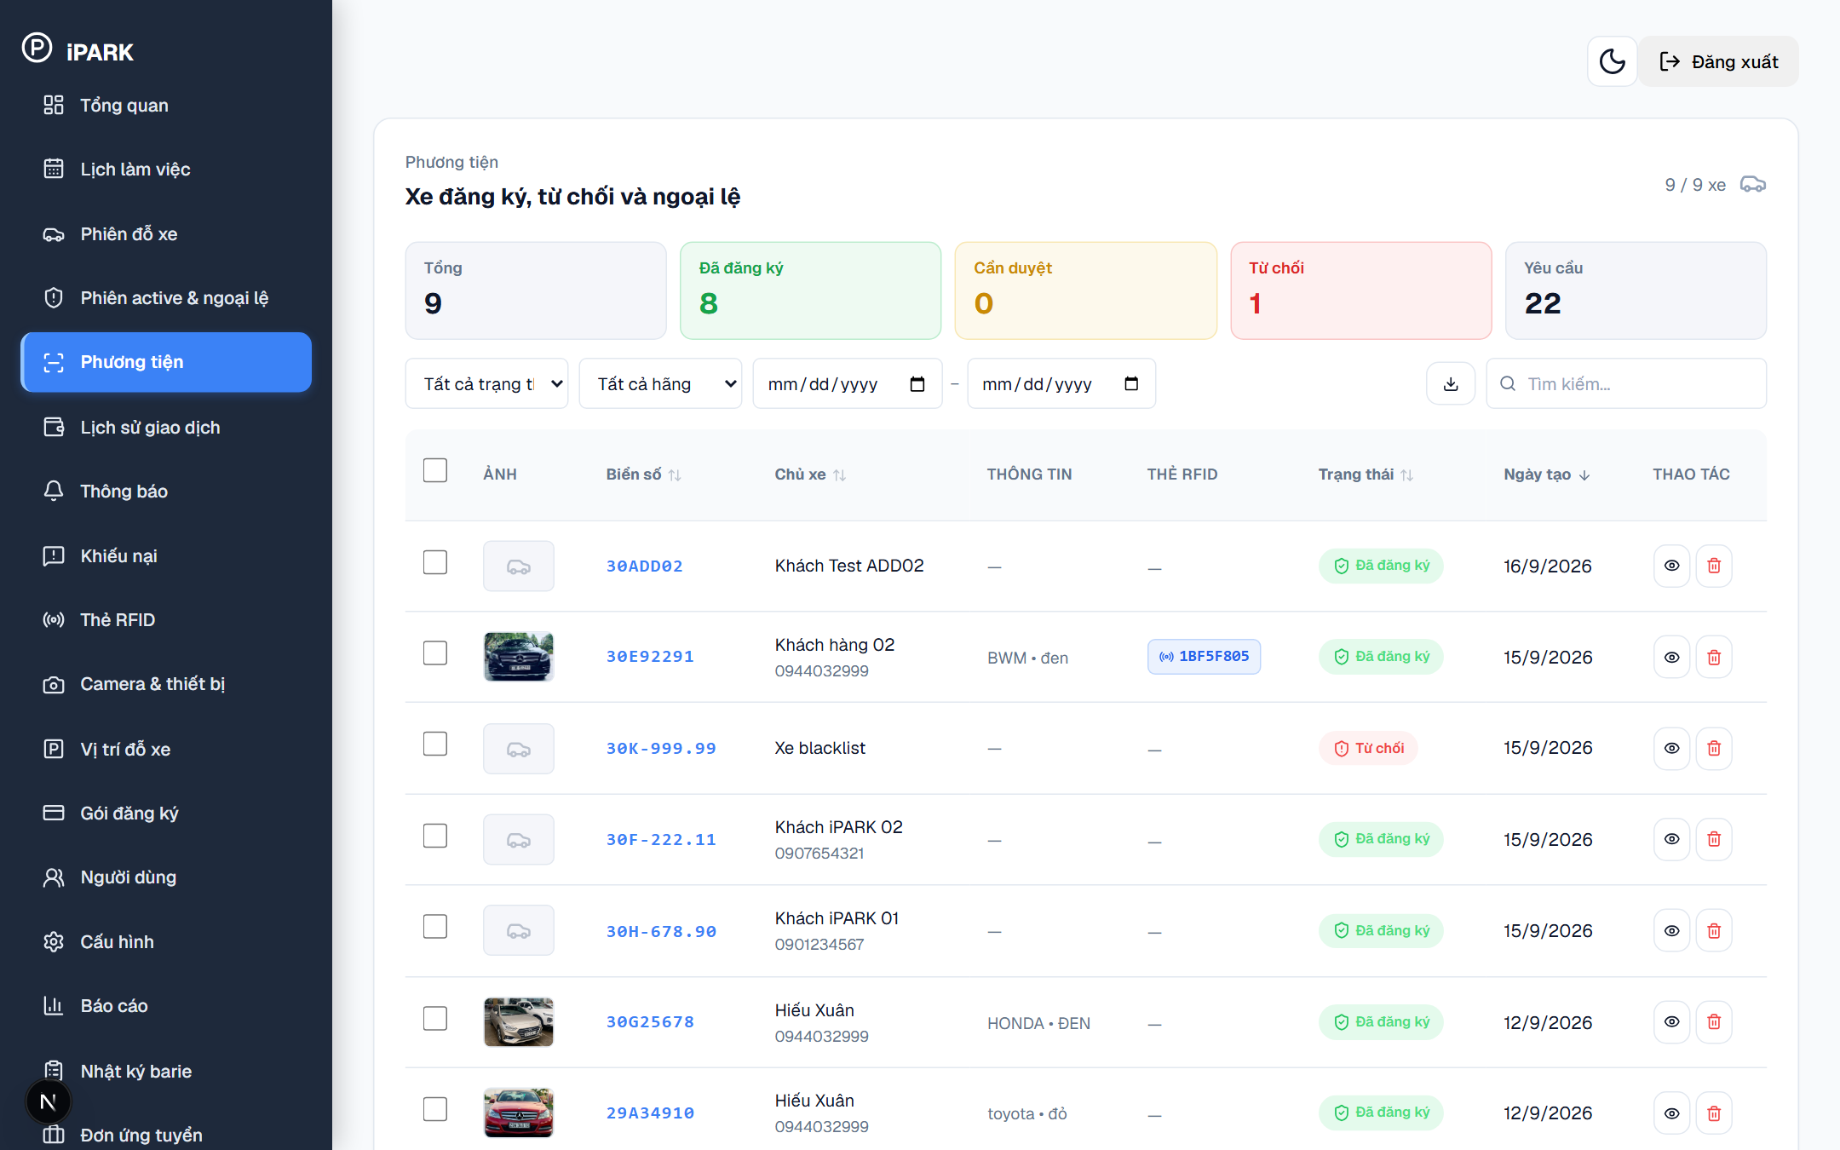
Figure 26. System Administrator – Customer Vehicle Verification & Approval Queue (/vehicles)

Screen Elements in Figure 26: Figure 26 displays the administrative vehicle approval queue accessible at http://localhost:3000/vehicles under the 'Yêu cầu duyệt xe' tab. Visible elements include pending request cards displaying Customer Name, License Plate, Vehicle Category, document photo thumbnail (Cavet image), submission timestamp, and decision buttons 'Duyệt' (Approve) and 'Từ chối' (Reject).
Operating Instructions for Figure 26:
Step 1 (Select Pending Request): On Figure 26, select a vehicle registration item in the queue awaiting verification.
Step 2 (Examine Document Thumbnail): On Figure 26, click on the registration certificate thumbnail to inspect the high-resolution photo and verify matching license plate numbers.
Step 3 (Execute Decision): On Figure 26, click 'Duyệt' to approve the vehicle for monthly subscription eligibility, or click 'Từ chối' to reject with a recorded justification.
3.6.4 Subscription Plans Administration (Figure 27)
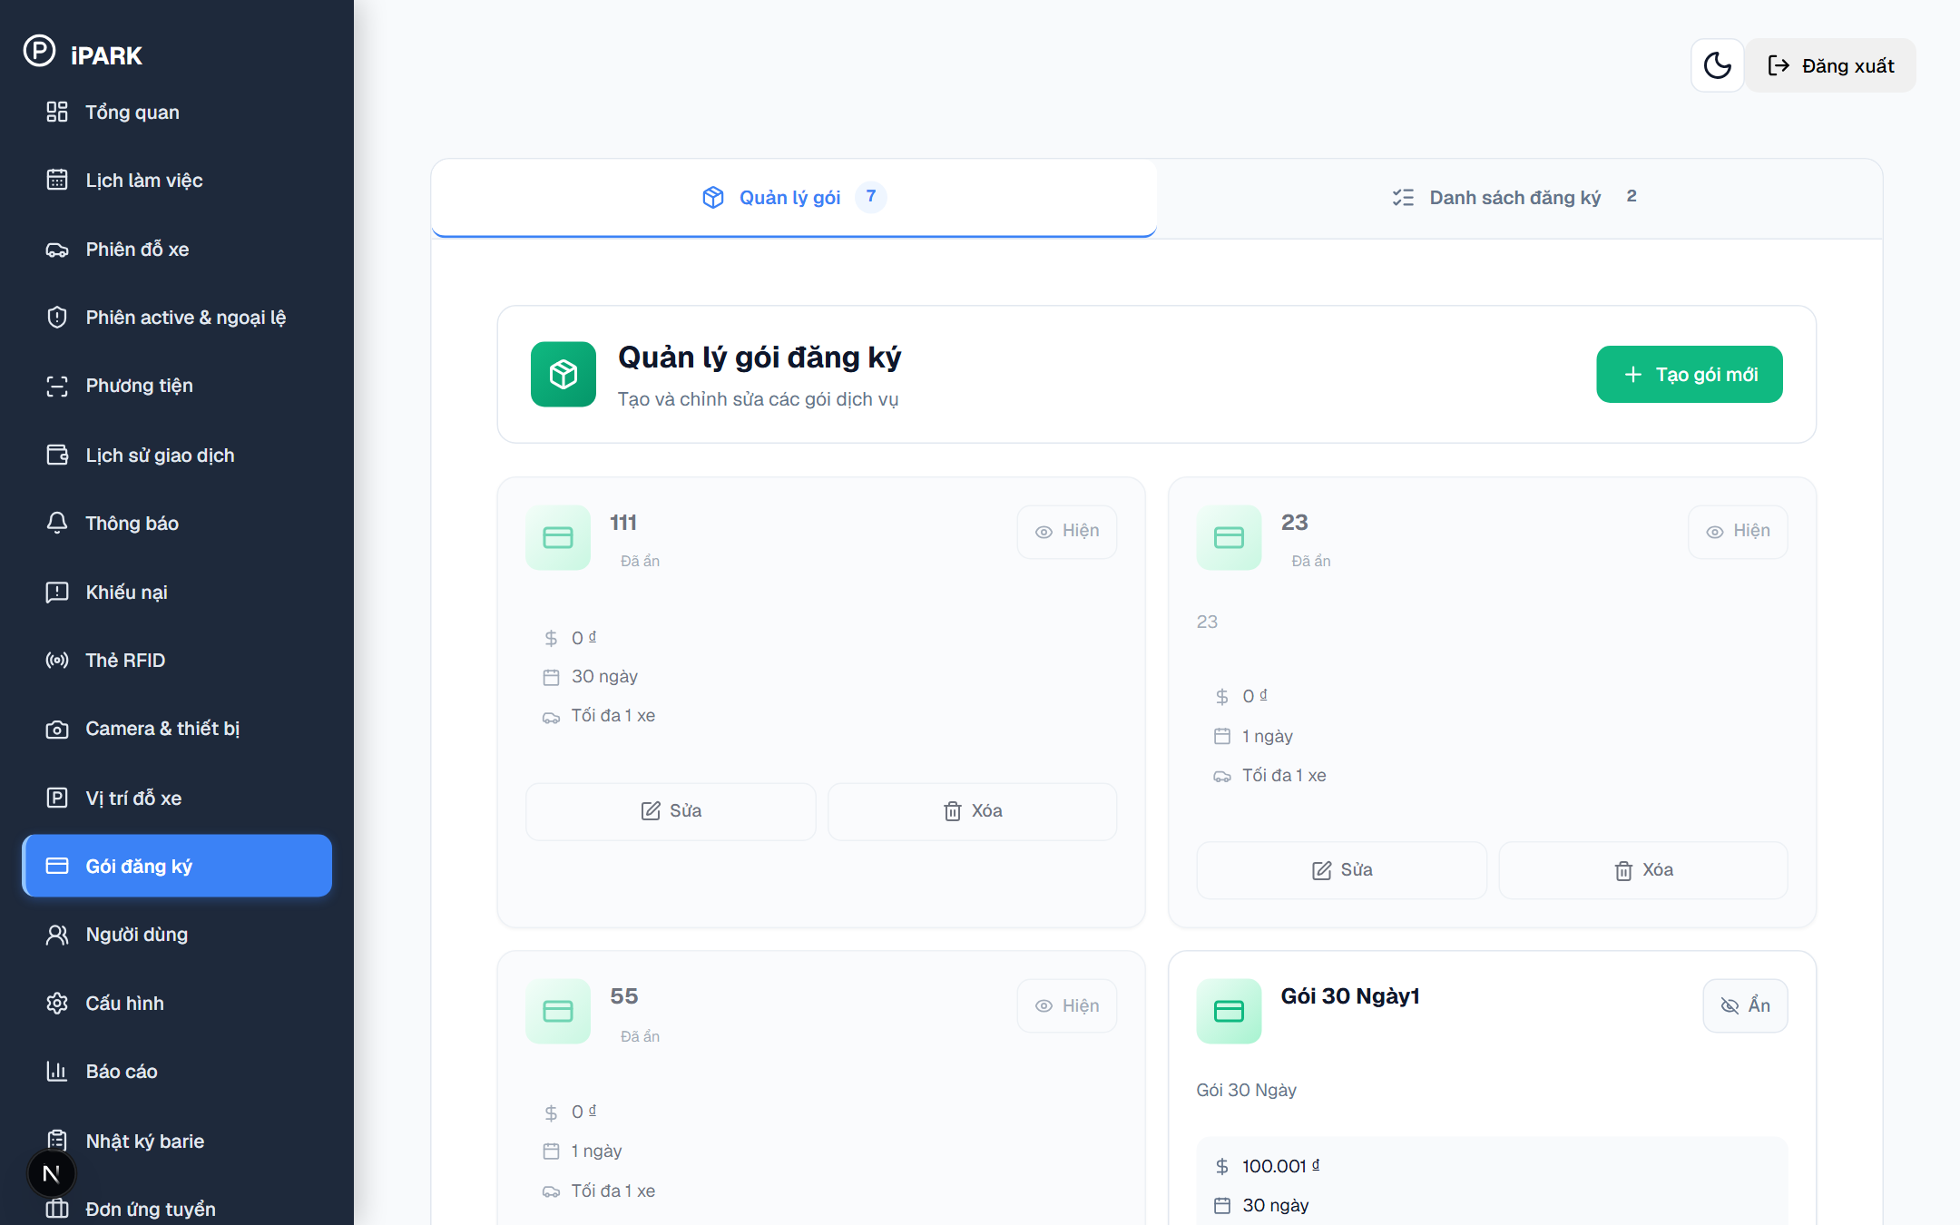
Figure 27. System Administrator – Subscription Plans Administration (/subscriptions)

Screen Elements in Figure 27: Figure 27 displays the subscription package management catalog accessible at http://localhost:3000/subscriptions. Visible elements include package administration cards showing Plan Name, Monthly Fee, Duration (days), eligible vehicle category, visibility toggle, and the action button 'Tạo gói mới'.
Operating Instructions for Figure 27:
Step 1 (Inspect Plan Catalog): On Figure 27, review existing subscription packages and check active pricing terms.
Step 2 (Create New Package): On Figure 27, click 'Tạo gói mới', define plan name, validity duration in days, and monthly fee, then save to publish to customer portals.
3.6.5 Facility Capacity & Total Parking Slots Configuration (Figure 28)
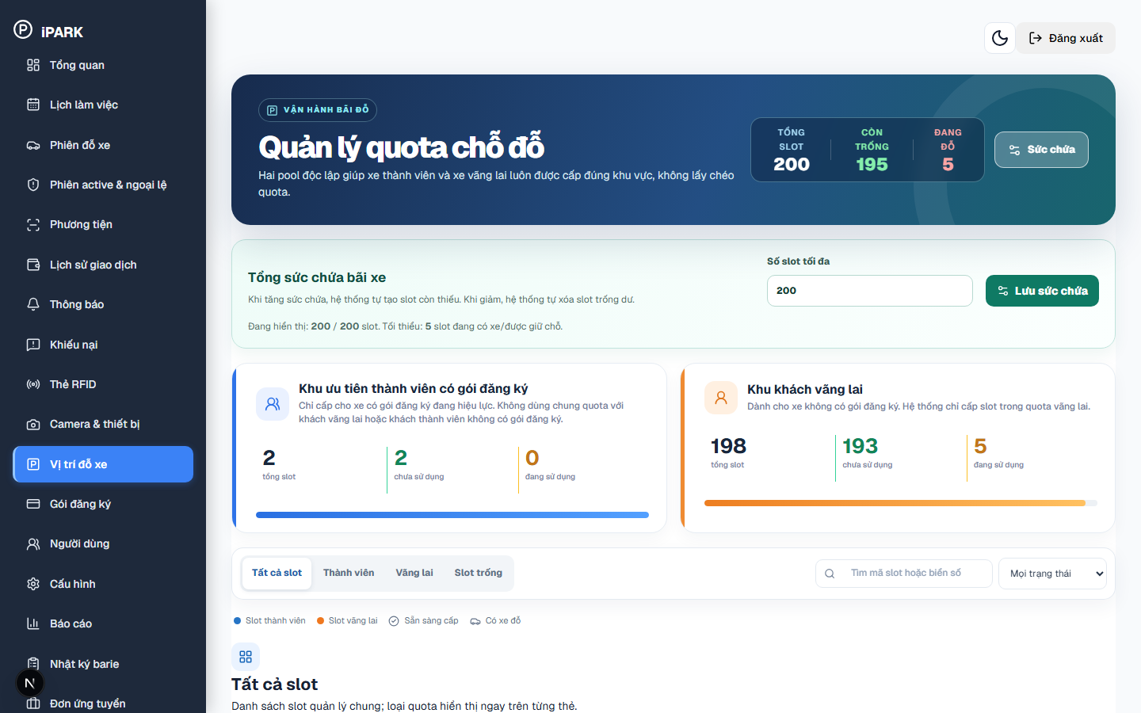
Figure 28. System Administrator – Parking Capacity & Maximum Slot Count Setup (/parking-slots)

Screen Elements in Figure 28: Figure 28 displays the parking capacity configuration form on the slot management console accessible at http://localhost:3000/parking-slots by clicking the 'Sức chứa' settings button. This form controls the physical capacity of the parking lot. Visible elements include the form header 'Tổng sức chứa bãi xe', system guidance text explaining automated slot creation/deletion ('Khi tăng sức chứa, hệ thống tự tạo slot còn thiếu. Khi giảm, hệ thống tự xóa slot trống dư.'), the number input field 'Số slot tối đa' (configured to 200), the operational safety constraint hint ('Đang hiển thị: 200 / 200 slot. Tối thiểu: 5 slot đang có xe/được giữ chỗ.' — this prevents the administrator from reducing the total lot capacity below the number of vehicles currently parked in the facility), and the submission button 'Lưu sức chứa'.
Operating Instructions for Figure 28:
Step 1 (Open Slot Management Console): On the left navigation menu, click 'Vị trí đỗ xe' (/parking-slots).
Step 2 (Open Capacity Setup Form): On the top right of the hero banner, click the 'Sức chứa' button (with gear icon) to expand the capacity configuration form shown in Figure 28.
Step 3 (Enter Maximum Slot Count): In the 'Số slot tối đa' input field on Figure 28, type the desired total number of parking spaces (e.g., 200). Note that the system enforces a safety threshold: you cannot configure a total capacity smaller than the slots currently occupied (shown on Figure 28 as 'Tối thiểu: 5 slot đang có xe/được giữ chỗ') to prevent deleting slots that currently contain parked vehicles.
Step 4 (Save & Synchronize Slots): Click the blue button 'Lưu sức chứa' on Figure 28. The system automatically creates missing slot IDs or prunes excess vacant slots, synchronizing the entire facility grid instantly.
3.6.6 System Pricing Tariff & Notification Templates Configuration (Figure 29 & Figure 30)
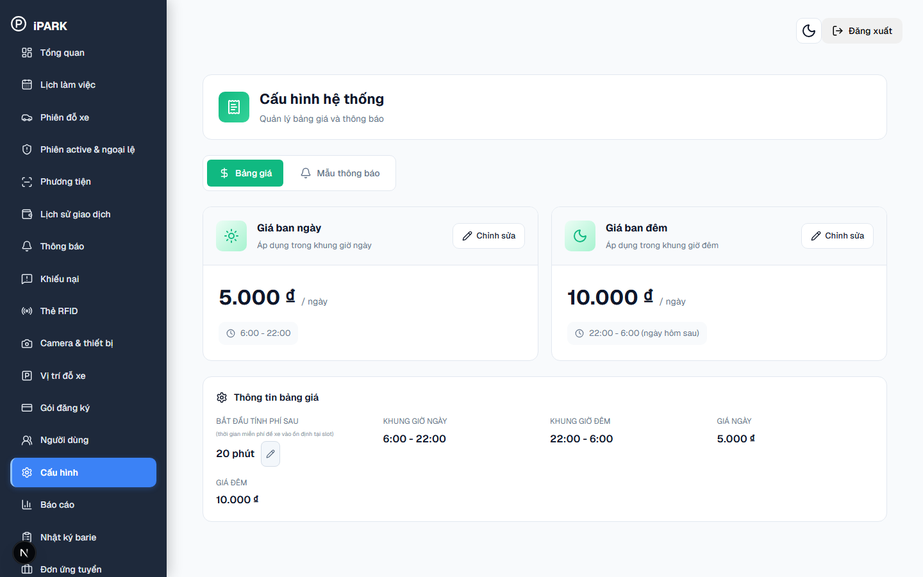
Figure 29. System Administrator – Day & Night Pricing Tariff Configuration (/pricing)

Screen Elements in Figure 29: Figure 29 displays the day and night tariff setup interface under the 'Bảng giá' tab accessible at http://localhost:3000/pricing via sidebar menu 'Cấu hình'. Visible elements include the tab bar ('Bảng giá', 'Mẫu thông báo'), the 'Giá ban ngày' card (5.000 ₫ / ngày, 6:00 - 22:00), the 'Giá ban đêm' card (10.000 ₫ / ngày, 22:00 - 6:00), the 'Bắt đầu tính phí sau' grace period input (20 phút), and 'Chỉnh sửa' action buttons.
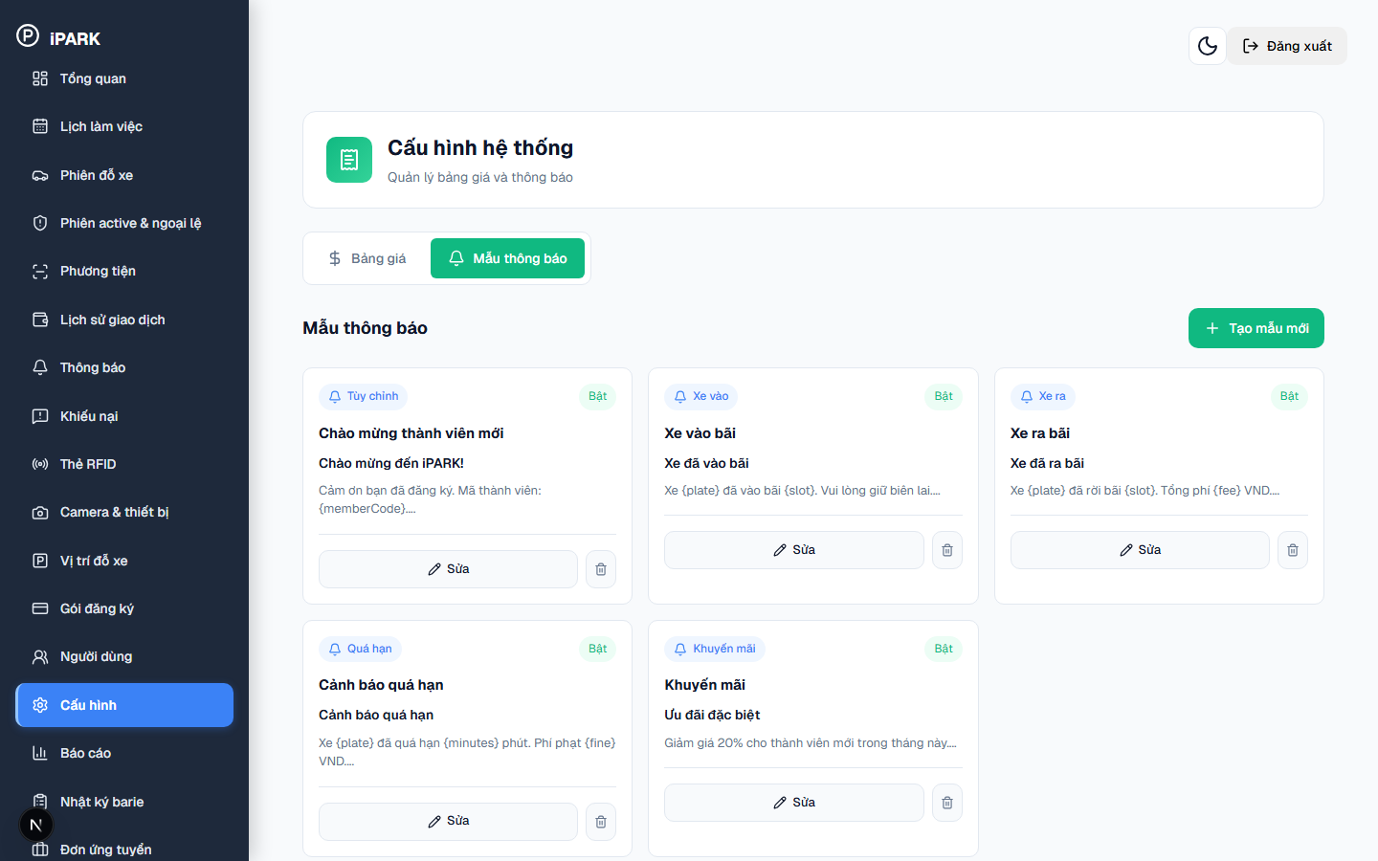
Figure 30. System Administrator – Automated Notification Templates Management (/pricing)

Screen Elements in Figure 30: Figure 30 displays the notification template catalog opened after clicking the 'Mẫu thông báo' tab on Figure 29. Visible elements include the header action button 'Tạo mẫu mới', and template cards categorized by triggers with status switches ('Bật'): 1) 'Tùy chỉnh' (Chào mừng thành viên mới); 2) 'Xe vào' (Xe vào bãi: thông báo vị trí slot và nhắc giữ biên lai); 3) 'Xe ra' (Xe ra bãi: thông báo rời bãi và tổng phí); 4) 'Quá hạn' (Cảnh báo quá hạn: thông báo số phút quá hạn và tiền phạt); 5) 'Khuyến mãi' (Ưu đãi đặc biệt giảm giá tháng); and the 'Sửa' action buttons.
Operating Instructions for Figure 29 and Figure 30:
Step 1 (Configure Day & Night Tariffs): On Figure 29, click 'Chỉnh sửa' on the Day or Night pricing card to update hourly rates or timeframe boundaries.
Step 2 (Set Free Grace Window): On Figure 29, adjust the free grace duration under 'Bắt đầu tính phí sau' (default 20 minutes) and click 'Lưu'.
Step 3 (Open Notification Templates Tab): On Figure 29, click the 'Mẫu thông báo' tab to switch to the template management interface shown in Figure 30.
Step 4 (Edit or Create Notification Template): On Figure 30, click 'Sửa' on an existing template or click 'Tạo mẫu mới' to define automated notifications with dynamic tags such as {plate}, {slot}, {fee}, {minutes}.
3.6.7 Business Reports & Analytics Export (Figure 31)
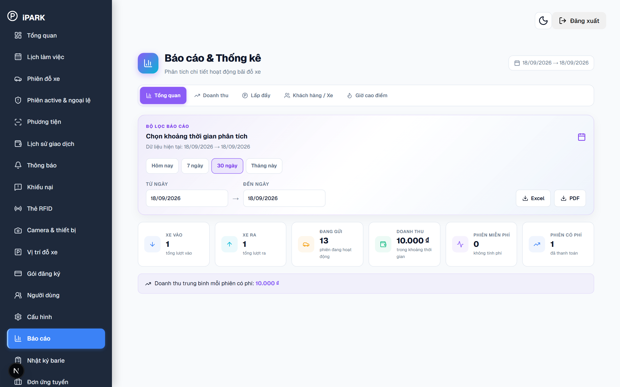
Figure 31. System Administrator – Business Reports & Analytics Export (/reports)

Screen Elements in Figure 31: Figure 31 displays the comprehensive reporting and analytics interface accessible at http://localhost:3000/reports. Visible elements include date range preset filters ('Hôm nay', 'Tuần này', 'Tháng này'), revenue trend charts, occupancy utilization curves, and export buttons for 'Xuất Excel' (.xlsx) and 'Xuất PDF'.
Operating Instructions for Figure 31:
Step 1 (Select Reporting Range): On Figure 31, choose the desired reporting timeframe using the date preset buttons.
Step 2 (Inspect Financial Breakdown): On Figure 31, examine revenue distributions across casual fees, subscriptions, and gate collections.
Step 3 (Export Audit Files): On Figure 31, click 'Xuất Excel' to download raw transaction spreadsheets, or click 'Xuất PDF' for executive summary reports.
3.6.8 Security & Operational Audit Logs (Figure 32)
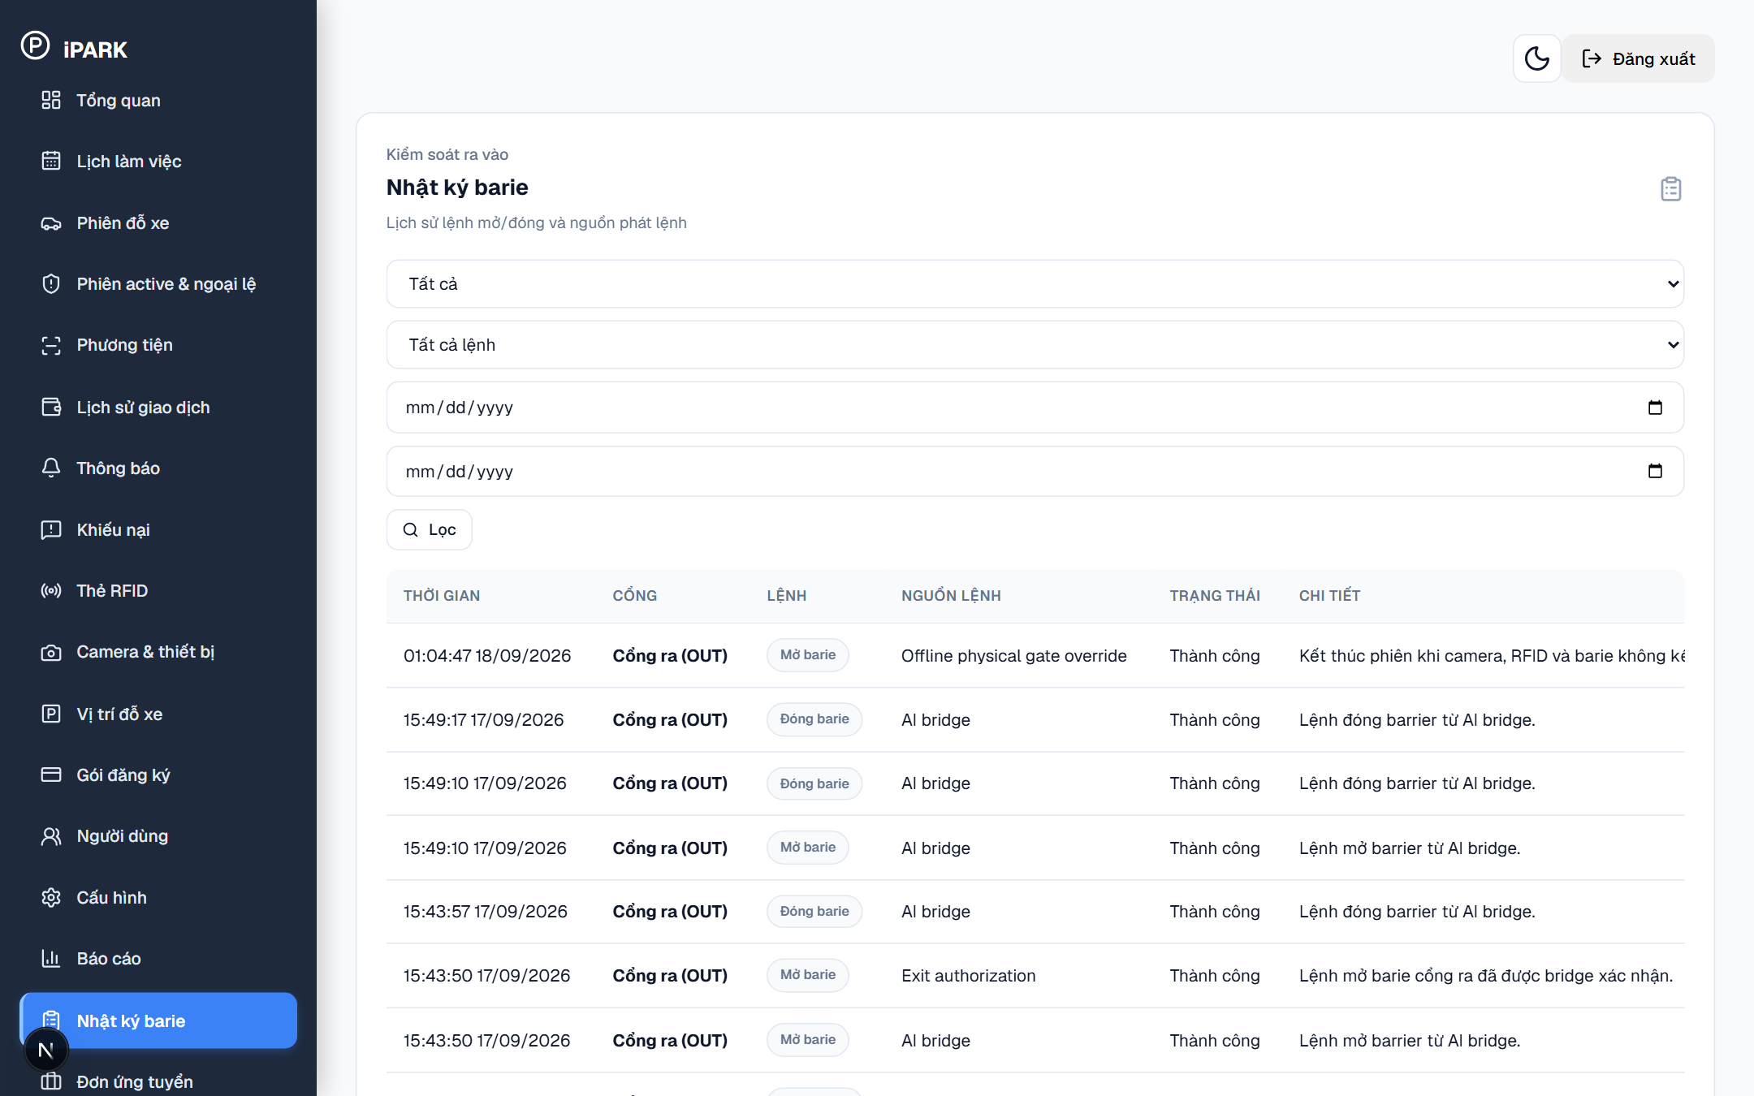
Figure 32. System Administrator – Security & Operational Audit Trail (/audit-logs)

Screen Elements in Figure 32: Figure 32 displays the system security and barrier operation audit log accessible at http://localhost:3000/audit-logs. Visible elements include chronological event logs showing Event Timestamp, Staff Actor Email, Client IP Address, Action Type ('Manual Barrier Lift', 'Tariff Updated', 'User Role Changed'), and reason details.
Operating Instructions for Figure 32:
Step 1 (Filter Security Events): On Figure 32, filter audit entries by actor or action category to identify anomalous activity.
Step 2 (Verify Manual Overrides): On Figure 32, review every recorded manual barrier opening event to confirm guard justification.

3.7 Current Implementation Notes & Operational Characteristics
Operational observations based on the current validated deployment build:
• Camera AI Bridge Architecture: Lane cameras connect via the Python bridge (ai-service/app.py) on port 5050. The bridge executes DirectShow capture and PaddleOCR inference, returning recognized plates to Node.js backend on port 4000.
• Touchless Member Access: Vehicles with approved registrations and active subscriptions are recognized by ANPR in < 300ms, triggering automatic barrier release without physical cards.
• VietQR Instant Settlement: Dynamic VietQR codes generated through PayOS webhook synchronization confirm banking payments within 1-2 seconds, eliminating cash handling friction.

3.8 Frontend Route & Permission Matrix
Complete matrix of verified frontend routes, page titles, and required role access:
• / (Landing Page): Public – Real-time parking availability, facility capacity overview, and authentication entry.
• /login: Public – Centralized authentication fallback page.
• /profile: Customer / Staff / Admin – Personal account management and password security.
• /vehicles: Customer – Vehicle management and registration; Admin – Vehicle verification queue.
• /subscriptions: Customer – Package purchasing; Admin – Subscription plan catalog administration.
• /sessions: Customer / Staff / Admin – Parking session records, status tracking, and duration.
• /parking-sessions: Admin / Manager – Active sessions & exception handling.
• /transactions: Customer – Personal payment records; Admin – Complete financial ledger.
• /staff-desk: Staff (Guard) – Workstation dual-lane barrier console, ANPR preview, and RFID scanner.
• /cameras: Staff / Admin – Live multi-camera surveillance and ANPR stream health.
• /rfid: Staff / Admin – Circulating RFID card inventory and status tracking.
• /parking-slots: Staff / Admin – 2D visual parking slot occupancy grid.
• /disputes: Staff / Admin – Exception handling, plate mismatch alerts, and lost card incidents.
• /overview: Staff – Shift operational metrics; Admin – Executive KPI revenue dashboard.
• /capacity-config: Admin – Day/Night pricing tariff and penalty parameter settings.
• /reports: Admin – Revenue analytics, occupancy trends, and XLSX/PDF export.
• /audit-logs: Admin – Security tracking and manual barrier override audits.

3.9 Troubleshooting & Operational FAQ
Operational resolution guide for common field scenarios:
• Scenario 1 — ANPR Camera Fails to Recognize Muddy / Bent Plate: Solution: Guard inspects vehicle on live video feed. In Lane 1, guard types plate number manually and taps RFID card. In Lane 2, guard uses 'Điều chỉnh biển số' to correct unrecognized characters and proceeds with checkout.
• Scenario 2 — Driver Reports Lost RFID Card at Exit: Solution: Guard opens 'Tra cứu' on Staff Desk, searches by vehicle license plate to retrieve entry session. The system calculates parking fee + 50,000 VND lost card penalty. Upon payment, guard opens barrier and sets card status to 'Bị mất' in /rfid.
• Scenario 3 — VietQR Payment Confirmed on Driver Bank but Barrier Stays Closed: Solution: Guard clicks 'Kiểm tra thanh toán' on the checkout card to force a direct query to PayOS server. If bank transfer cleared, status updates to 'Đã thanh toán' and barrier opens immediately.
• Scenario 4 — Total Facility Power or Network Outage: Solution: Guards switch to manual barrier key operation. All entry/exit times and vehicle license plates are recorded on physical paper logs and entered into /assisted-registration once power is restored.

Appendix A — Source Basis for This Report
- bai-do-xe-main.zip — current source archive; package manifests, routes, components, seed script, Python bridge and environment examples.
- README.md — installation and feature overview; retained as a reference but checked against the current archive.
- Scope_Report.docx — ANPR-first scope, actors, RFID/VietQR/security/operations model and later use-case list.
- Medium_UC_FINAL.docx — Medium UC review/status reference.
- Report 1_Vison&ScopeDocument.docx — product background and scope context.
- Report 2_Project_Plan.docx — project plan, technology/training and quality targets.
- Report 3.0_SRS.docx — scenarios, features, rules and requirements content.
- Report 3.2_ScreenDesignSpec.docx — information architecture, role navigation and screen design references.
- Report 4_TDS.docx — architecture and implementation boundaries, including the Node backend and Python bridge distinction.

