# Correlation Engine User Manual

## Overview

“Correlation Engine” is an online statistical tool for mining the correlation between multiple items. Input the data file and options customized by yourself, you could get the visualized result.

## Procedures

### Input Data File

In the “Input Data File” area, click “Choose File” button, open the data file, and then click “Upload” button, wait until the alert message which indicate whether the uploading is succeed

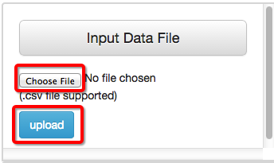

### Customize Options

In the “Option” Area, customize options you like.

* Mode:
* “One vs One” – only compare two items
* “One vs Many” – compare one item with another set of items
* “Many vs Many” – compare each two items in a set of items
* Algorithm:
* “Pearson” – Pearson Correlation
* “Time Series Analysis” – analyze the cross correlation, mining the lag relation between time seires data, only supported in “One vs One” mode
* Data:
* “Data by Column” – compare data by Column, the first row would be header
* “Data by Row” – compare data by Row, the first column would be header
* Data area, choose data you like to analyze, you could either select them and click “preview” or “calculate”, or easily drag&drop items to “Drop Area”

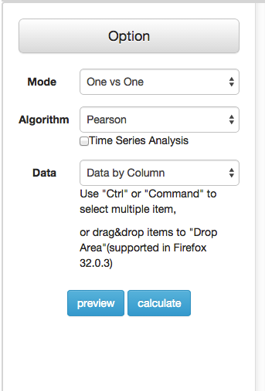

### Preview

You could preview the data in Preview Area once you click “Preview” or Drap&Drop the items.

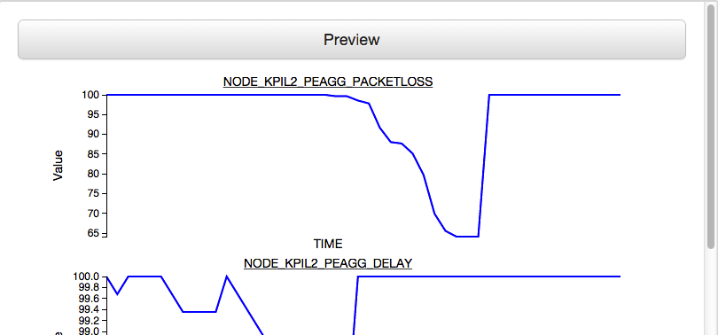

### Get the result

For “One vs One” mode and “Time Series Analysis”, you could get the cross correlation result, and the lag with the highest correlation coefficient.

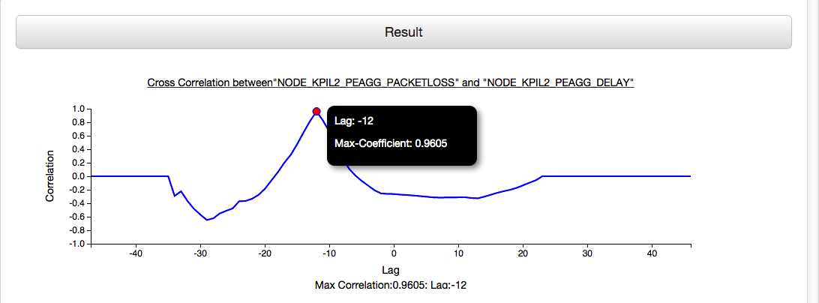

For “One vs Many” mode, you could get a chart of the correlation result.

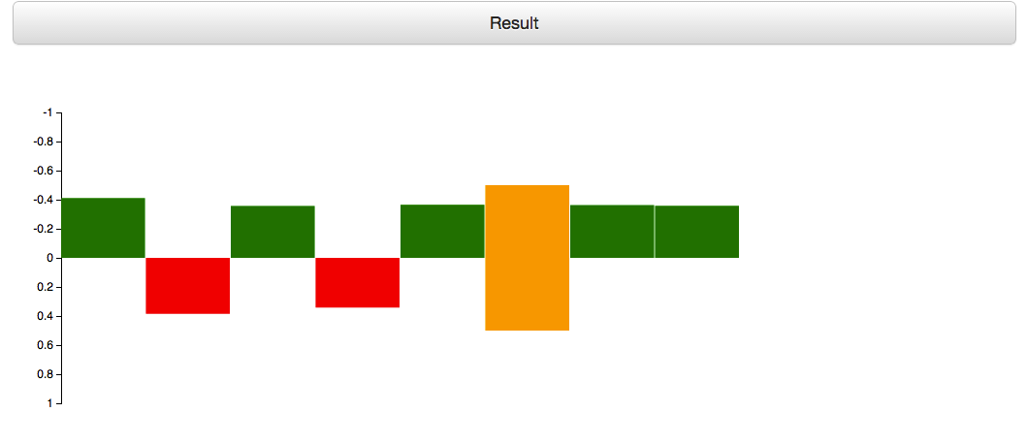

For “Manay vs Many” mode, you could get a correlation matrix, which is represented by a heat map.

