
MINISTRY OF EDUCATION & TRAINING
HO CHI MINH CITY UNIVERSITY OF TECHNOLOGY

Course Project Report
Mario Mini Game

Discipline: INFORMATION TECHNOLOGY
Major: INFORMATION TECHNOLOGY

Supervisor: Huỳnh Lê Chiêu Phú

Course: Windows Programming

Student 1: Trần Duy Thành ID: 2380602052 Class: 23DTHQA1
Student 2: Nguyễn Đình Quốc ID: 2380601854 Class: 23DTHQA1
Student 3: Lê Nguyễn Bảo Khang ID: 2380600979 Class: 23DTHQA1

April 1st

Acknowledgement
First, we would like to sincerely thank our instructor Mr. Huỳnh Lê Chiêu Phú for his dedicated guidance and support throughout the development of this project. His instructions helped us understand key concepts in Windows programming and game development.
During the project, we encountered various challenges, especially in implementing real-time game logic, collision detection, and audio handling. However, thanks to the valuable feedback and encouragement from our instructor, we were able to overcome these difficulties.
This project not only strengthened our technical knowledge but also improved our teamwork and problem-solving skills. We truly appreciate all the support and guidance provided.
Thank you very much.

Ho Chi Minh city, Marh 26th , 2026.
People wrote this report.
Trần Duy Thành
Lê Nguyễn Bảo Khang
Nguyễn Đình Quốc
Nguyễn Đình Phước

Table of Contents
Acknowledgement 2
Chapter 1: Overview 4
1.1. Overview of the project 4
1.2. Project Objectives 4
Chapter 2 : Requirement & Design 4
2.1 Functional Requirements 4
2.2 Non-Functional Requirements 4
2.3 System Architecture 5
2.4 Use Case Diagram 5
2.5 Activity Diagram 6
Chapter 3 : Game Logic & Theory 6
3.1 Game Loop 6
3.2 Input Handling 6
3.3 Collision Detection 7
3.4 Score System 7
Chapter 4 : Implementation 7
4.1 Initialization 7
4.2 Game Flow 7
4.3 Core Components 7
Chapter 5 : Performance & Testing 7
5.1 Performance 7
5.2 Responsivenes 7
5.3 Stability 7
Chapter 6 : Conclusion 8
REFERENCES 9

Chapter 1: Overview

Overview of the project
Mario Mini Game is a simple 2D platform game developed using C# and Avalonia UI. The player can control a character to move, jump, collect coins, and avoid enemies.

Project Objectives
The main goals of this project include:
- Building a playable 2D game with basic mechanics
- Practicing event-driven programming in C#
- Understanding how game loops and rendering work
- Designing a simple but clear user interface

Chapter 2: Requirement & Design

2.1 Functional Requirements
The game includes the following main features:
- Main menu (Start Game, Exit)
- Character movement (left, right, jump)
- FPS parameters
- Platform environment with gravity
- Obstacles and enemies
- Score system (coins)
- Game Over and Victory screen
- Restart game

2.2 Non-Functional Requirements

Besides functionality, the system also meets some technical requirements:

Runs smoothly on Windows 10 or newer

Maintains at least 30 FPS

Responds quickly to user input

Loads quickly when starting

Uses a reasonable amount of memory

Does not crash during normal gameplay

2.3 System Architecture
The system is designed in a simple way:
- UI Layer: MainWindow (menu, display)
- Game Logic: GameController (core logic)
- Game Objects: Player, Enemy, Coin
- Support Systems: Sound and Background
This structure makes the code easier to manage.
2.4 Use Case Diagram

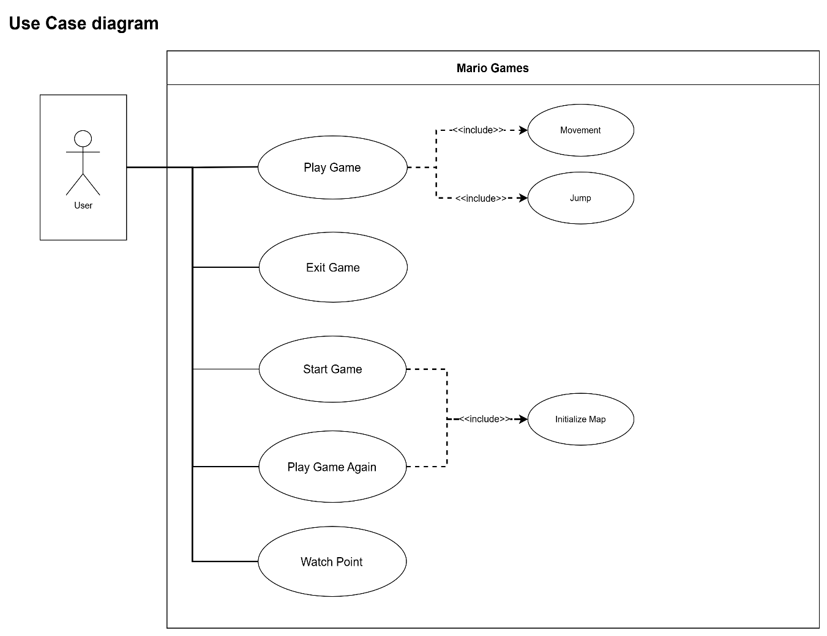

The Use Case diagram shows that the user can:
- Start the game
- Play the game (move and jump)
- Exit the game
- Play game again
- Watch Point

2.5 Activity Diagram

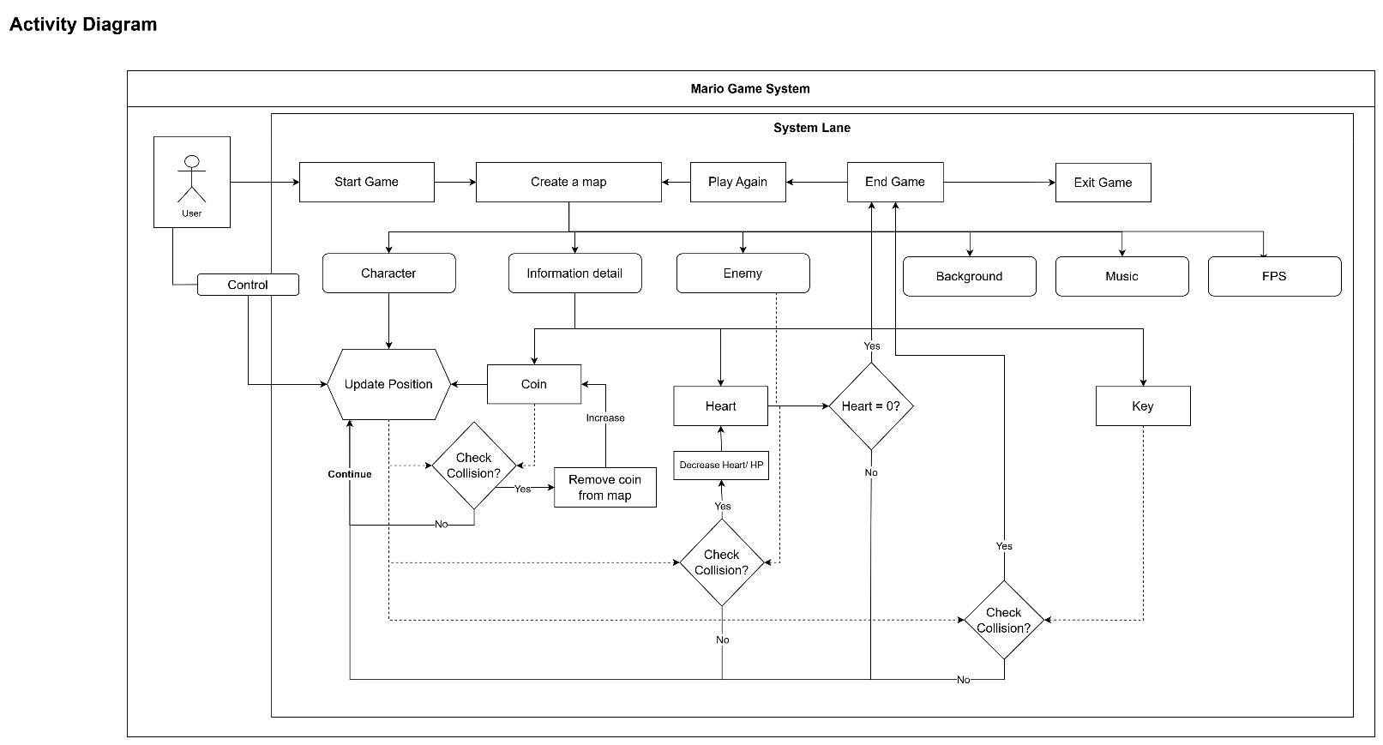
The Activity Diagram describes the game flow:
- Start game → Initialize map
- Player controls character
- System updates position
- Check collision (coin, enemy, key)
- Update score or reduce health
- End game when conditions are met

Chapter 3: Game Logic & Theory

3.1 Game Loop
The game uses a loop implemented with DispatcherTimer running at 39-42 FPS
Each frame updates:
- Character movement
- Collision detection
- Score system

3.2 Input Handling
Keyboard inputs are handled using:
- Left / Right → Move
- Space → Jump
The system ensures real-time response to user actions.

3.3 Collision Detection
Collision detection is used for:
- Player vs Coin → increase score
- Player vs Enemy → lose health
- Player vs Ground → stop falling
- Player vs Key → win game

3.4 Score System
The score increases when collecting coins.
It is displayed on screen and updated continuously during gameplay.

Chapter 4: Implementation

4.1 Initialization
- Load UI
- Load images and sounds
- Initialize GameController
- Start game loop

4.2 Game Flow
Start Game → Play → Win / Game Over

4.3 Core Components
- GameController: manages game logic
- Player: handles movement
- Enemy: creates challenges
- GameSound: handles background music

Chapter 5: Performance & Testing

5.1 Performance
The game runs at approximately 40 FPS, ensuring smooth gameplay

5.2 Responsivenes
Keyboard input is processed quickly with minimal delay.

5.3 Stability
The game runs continuously without crashing during testing.

Chapter 6: Conclusion
This project helped us understand basic game development concepts such as game loop, collision detection, and UI design. It also improved our coding and problem-solving skills.

Group Leader Signature: _____________________
Date: ___________________

REFERENCES

