Detection and Classification of Brain Tumor using Machine Learning

Abhiti Labroo1, Aman Gupta2, Aman Sharma3

1,2 Third Year Student, 3 Assistant Professor

Department of CSE, Jaypee University of Information Technology

Solan, India

***Abstract*— Brain Tumor is one of the most thorough illnesses in clinical science and the fatality rate is quite high for them. Doctors are the main gateway for human inspection of the MRI scans for the brain tumor which is infact a traditional approach. The sheer amount of data through these scans are immeasurable, hence this procedure is quite unfeasible. Therefore, it is essential and critical to have automatic, reliable and precise classification strategies in place to lessen or reduce the fatality rate of the patients.Tumor detection and classification approaches have been developed to aid radiologists in saving time and achieving demonstrated accuracy**.

**In this project, with the assistance of a comparison of models Convolutional Neural Network (CNN) and VGG-16 under machine learning the tumor is detected and is classified into its types like gliomas, meningioma, and pituitary tumors. The accurate and precise distinction among the three types of brain tumors signify a very crucial phase of the medical diagnostic procedure and later successful examination of patients**

**Keywords— *Fatality rate, Magnetic Resonance Image(MRI), Convolutional Neural Network and VGG-16.***

1. **INTRODUCTION**

Brain tumor is one of the most thorough and painstaking sicknesses in clinical science. Tumor primarily represents unusual and unruly development of cells inside the body. Brain tumor connotes a deformed mass of tissue wherein the cells duplicate suddenly and ceaselessly within the brain tissues.[1] Brain Tumor isn't region explicit nor does it have a particular shape nor size. Based on development and separation of cells when contrasted with typical cells the tumor is distinguished into two type’s benign and malignant tumor. For benign tumors, the care is rather easy by eliminating the particular infectious sites. Then again, malignant tumors are perilous so much that they can regrow in your mind even after their removal.[3]

A compelling and productive examination has forever been a vital worry for the radiologist in the untimely period of tumor development. The system of MRI includes no aggravation or radiation and is a painless brain image process[2].For the better survival chances, early detection and prompt care and treatment is a must and would be in the best interest of patients.[4] The dataset for the comparison model contains MRI scans, they give improved outcomes than other imaging procedures like Computed Tomography (CT), because of their higher differentiation in delicate tissue in human brains.[5] And this strategy isn't restricted for only distinguishing growth inside the brain however can examine the entire inner construction of human body to recognize any cancer. This strategy enjoys an extraordinary benefit of "not utilizing ionized radiation" as done in X-Rays, which makes numerous harmful impacts. Rather it utilizes magnetic fields and radio waves for the formation of images of internal body structure.[6]

The new literature concentrates on the fact and also has revealed that programmed mechanized recognition and diagnosis of the sickness, in view of clinical imaging study and it could be considered a decent option as it would get a tried precision. The ML based calculations in radiology and other medical science fields assume a significant part to analyze the illness in a much easier manner as never done and thus giving a plausible option in contrast to biopsy for brain tumor.

Moreover, in the event that these algorithms can give robust and quantitative estimations of growth portrayal of tumors, these robotized estimations will considerably guide the medical administration of brain tumors by liberating doctors from the tedious task of the manual portrayal of growths.During the course of this project, it was endeavored at detecting and classifying the brain tumor and contrasting the outcomes classification of brain tumor with use of pre-trained Keras models like VGG16 and using Convolutional Neural Network architecture.

II. RELATED WORK

Badža and Barjaktarović(2020)[7] - According to the authors the model used T1-weighted contrast-enhanced MRIs as a dataset. The Brain Tumor classification model was designed by the authors using a CNN performed on the platform MATLAB R 2018 a.K-fold cross-validation methods to test or validate the network’s performance. Two distinct methodologies were executed.The principal approach was to arbitrarily partition the information into 10 equivalent parts so every cancer classification was similarly present in each part, alluded to as record-wise cross-validation.The subsequent methodology was to haphazardly partition the information into 10 equivalent segments where the information from a sole subject must be viewed as in one of the sets. Each set, hence, contained information or data from several subjects no matter what the cancer class, alluded to as subject-wise cross-validation. Performance metrics that were used in this paper were accuracy, recall, F1-score, and precision and they were visualised with help of the confusion matrix.

Rehman et al. (2020) [8] The authors in this model used three datasets for the proposed model for training and its validation. BRATS 2015, BRATS 2017, and BRATS 2018 were the chosen ones. The proposed methodology by the authors was majorly divided into three major steps,first and foremost one was new convolutional neural network architecture which was basically build upon brain tumor extraction, the second one was the pre-trained VGG19 which was based on extraction of features, and lastly pearson correlation when combined along with FNN features selection which was used for final classification. Various parameters were utilized by the author for validation of the dataset like accuracy, frequency of error that is error rate, and computation time.

Irmak (2020)[9] - In this model, four unique datasets, which were accessible from public information domains, were utilized. RIDER, REMBRANDT, TCGA-LGG and 3064 T1-weighted contrast-enhanced images were four datasets that were used. The first of these CNN models utilized in this paper concludes that a given MRI picture of a patient has a brain tumor or not. The second convolutional neural network model arranges the tumor into its further types. The third CNN model made by the authors intended to classify glioma brain tumors into three grades. The performance of the model is assessed involving the five fold cross - validation process for all the three CNN models. Many performance metrics were used in this paper.

Khan et al. (2021)[10] first and foremost suggested a CNN model which was proposed as several layer architecture but later a pre-trained Densenet model was undertaken because in conventional CNN, the connection between layers and the data transferred through these layers was exceptionally aggregated. The primary strength of this proposed model by the authors was the determination of the most ideal attributes utilizing MGA and Entropy-Kurtosis-based methods.The combination of the ideal elements to additionally work on the proposed accuracy was its another strength.

Szegedy et al. (2015)[11] As per the authors who developed a profound convolutional neural network design called Inception, which was liable for setting the new model for classification and diagnosis in a challenge in 2014 which was called ImageNet visual recognition.The primary accomplishment of this proposed model was the better use of resources inside the network.

Simonyan and Zisserman(2014)[12] The impact of the convolutional network on precision in the large scope image recognition setting was explored by the authors during their research. The primary commitment was an intensive assessment of networks of increasing depth using architecture with quite small convolution filters (3X3), which mirrored that a huge enhancement for the earlier architectures could be accomplished by pushing the depth to 16–19 weight layers training more modest forms of VGG with less weight layers.

Jue et al. (2020) [13] The dataset was prepared through a basic eight convolutional layer for the CNN. They were based on transfer learning concepts.During the phase of image processing of this model the authors proposed to remove inconsistencies from the images and they were cropped. The technique used for the above implementation was canny edge detection technique which comes under OpenCV.

Ghahfarrokhi and Khodadadi (2020)[14]-For this particular model, the pre-processing played an important role. For determination of the tumor position. Fuzzy’s C-mean algorithm was implemented by authors. T1-weighted contrast-enhanced MRI scans were used as the input by authors. Based on the results, Pattern net classifier outperformed SVM and KNN.The criteria for the measurement of all three classifiers were accuracy, sensitivity and specificity.

Krizhevsky et al.(2012)[15] The deep CNN was accomplished for classification of the enhanced images in the 2010 contest that was called ImageNet LSVRC into different classes. To make training quicker, the author used non-saturating neurons and an extremely effective GPU for execution. To decrease the overfitting in the model, authors of the proposed model utilized a dropout layer that ended up being successful.

III. PROPOSED METHODOLOGY

The proposed methodology for this project is divided into three phases. Each phase signifies the progress of the model.

**A. Phase I (Data Preprocessing) :** This phase of a building model mainly focused on data processing of the dataset. Data processing is considered a crucial part because raw data or dataset found in real life usually have inconsistencies like formatting, human errors, and can also be incomplete. Data preprocessing is one of the ways to resolve such issues and makes datasets more complete and efficient to perform data analysis on.

Data processing performed on both VGG-16 and CNN model was similar. The dataset used for this model was Magnetic Resonance Images (MRI) which consisted of various types of brain tumor and also a class for no tumor i.e. healthy MRI scans. The major steps involved in the data processing were to read the images, resizing all the images to a standard size.

**B. Phase II (Model Building) :** This phase of a building model mainly focused on model selection and parameter setting for both the VGG-16 and CNN model.

Convolutional Neural Networks are uncommonly multifaceted neural networks. It is a reasonable recognition methodology applied in pattern recognition and image processing.[16] It utilizes a common weight network design to duplicate a biological brain network. CNN is generally utilized in the domain of computer vision problems. The input layer, convolution layer, max pooling layer, connected layer, and classification layer are the five key layers that make up a CNN structure. CNN concentrates and characterizes attributes utilizing a progression of successive trainable layers that are stacked one on top of the other. In the feature extraction section of the CNN, we typically find the convolutional and pooling layers though in the classification part, fully connected and classification layers are found.

In our comparison model, we utilized convolution on the input data utilizing a convolution filter to produce a feature map. As a convolution filter, a 5×5 kernel is used and the strides were set equivalent to (2,2) for all layers after the first layer. Padding was set to ‘same’ and it is used for this operation. The above steps have been executed for the comparison model and stride used characterizes how much the convolution filter is moved at each progression.Padding when set to ‘same’, signifies padding applied to the input image so the input data gets completely covered by the filter and indicated stride. Five convolution layers are included that are (C1, C2, C3, C4, C5) with a size of kernel kept equivalent of 1 * (5×5), 2 * (3x3), 2 * (2x2), Five subsampling layers were also present (S1, S2, S3, S4, S5) with 2×2 size of pooling window.

Pooling decreases the number of parameters being used, which reduces training time.To reduce overfitting, Dropout is used which is a regularization method [18].Dropout is just utilized during the model's training stage.As indicated by the dropout rate, certain arbitrarily chosen neurons are ignored during the training stage, i.e.their contribution to enacting downstream neurons is closed down on the forward pass, and no weight updates are applied to the neurons on the regressive or backward pass.

VGG16 is a Convolutional Neural Network design that performed well in the 2014 ILSVRC contest.It is one of the finest vision model designs that have ever been proposed. The most characteristic element of VGG16 is that, as opposed 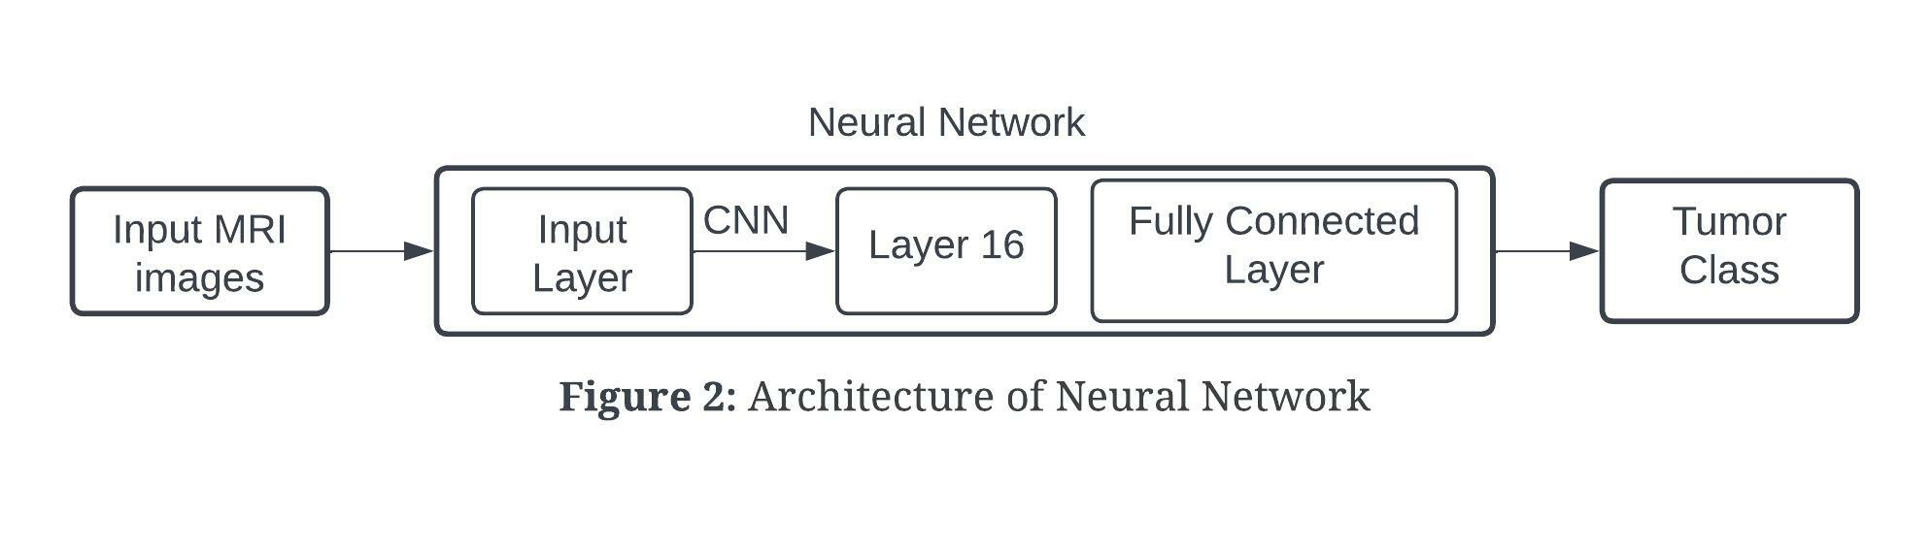

to having countless hyper-parameters, they zeroed in on having 3x3 filter convolution layers having stride that was equal to 1 and continuously used something similar padding and maxpool layer of 2x2 filter having stride 2. All through the architecture ,the convolution and max pool layers are organized similarly. The architecture has two Fully Connected Layers in the end, which was followed by a softmax for output. The 16 in VGG16 alludes to the actuality that it contains 16 layers with various different weights.

**Figure 1** illustrates the flow of the comparison model with methodology described above.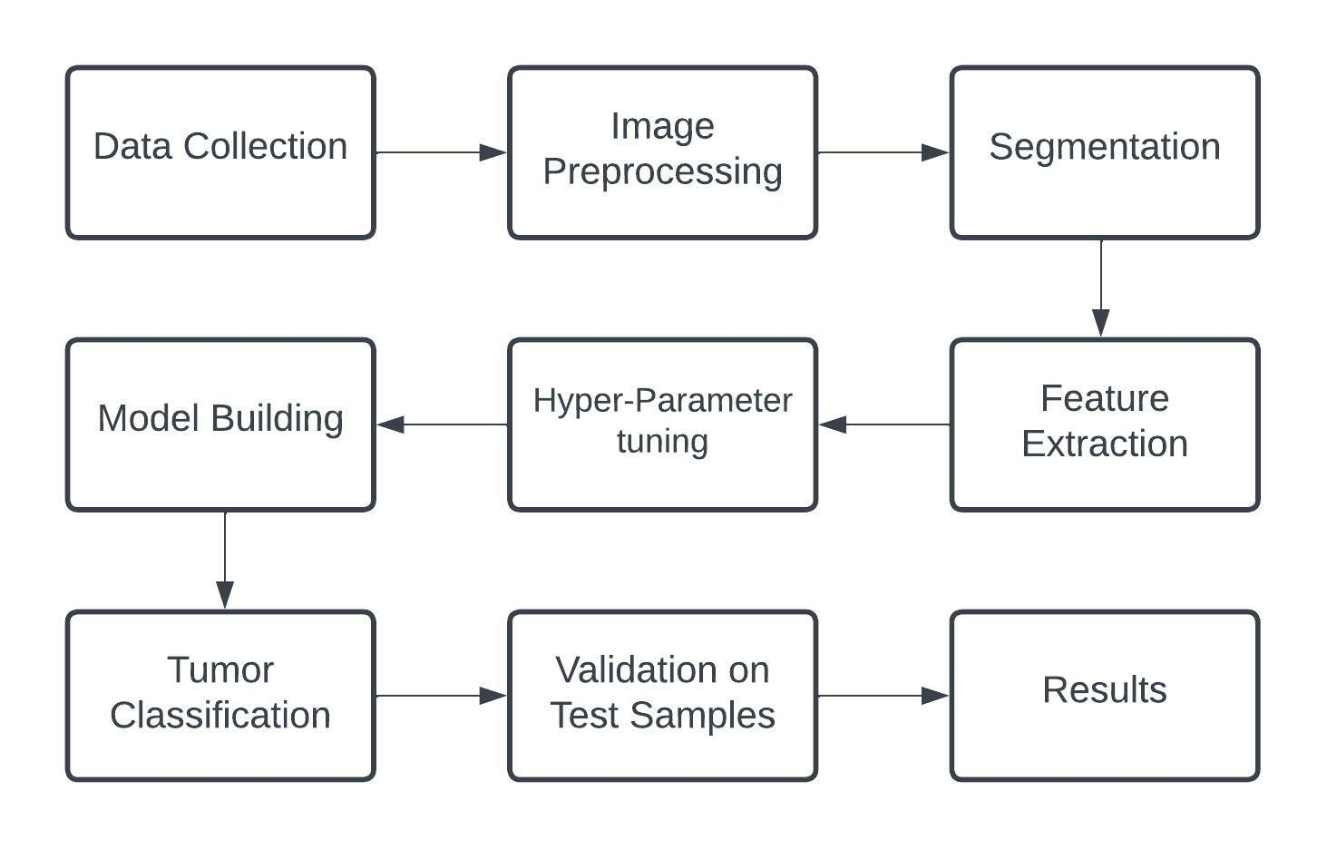

**C. Phase III (Pseudo Code/Algorithm) :** The Pseudo code for different parts of the algorithm.

**Pseudo code 1** Pre Processing:

1. Func create_training_data(): *#Function for creating training data array*

2. class_num <- category_index #Getting category labels for Images

3. For image in images

4. img_array <- read_image

5. new_array <- resize_image(img_array) #resizing images

6. training_data <- append(new_array,class_num)

**Pseudo code 2** Model building:

1. model <- init_sequential().

2. Add input layer.

3. Add convolution layer, set filters(64 or 128 or 256), kernel size(3x3 or 5x5),etc.

4. Add a max pooling layer, set pool size(2x2), etc.

5. Add dropout layer, set the dropout percent.

6. Repeat steps 3-5 as required.

7. Flatten the output of these layers.

8. Add dense and dropout layers.

9. Get classification as output

IV. RESULTS AND DISCUSSIONS

**A. Dataset:** For the comparison model , the dataset used is a kaggle dataset[17]. The dataset has Magnetic Resonance Images of the brain. The project is intended to have a multi-class classification due to which the dataset has 4 classes.The dataset was already divided into training and testing sets. In the training set there are 2870 files(826 files for glioma tumor, 822 files for meningioma tumor and 827 files pituitary tumor and 395 files for no tumor) and for the testing set there are 394. files(100 files for glioma tumor, 115 files for meningioma tumor and 74 files pituitary tumor and 105 files for no tumor).

The training to testing set ratio is approximated to 88% : 12%.

**B. Performance Parameters:** The success of a model is determined by its performance indicators. A thorough examination can expose model and architectural flaws, as well as providing crucial information for selecting the optimal algorithms, frameworks, and platforms. It also aids in performance enhancements.

Performance parameters used for both VGG-16 and CNN model were accuracy, precision , recall and F1 score.

Table 1 illustrates the comparison of various performance parameters on VGG-16 and CNN.

**Table: 1** Comparison of Performance Measures

|  |  |  |  |  |
| --- | --- | --- | --- | --- |
| **Model Name** | **Accuracy (%)** | **Recall (%)** | **Precision**  **(%)** | **F1-Score**  **(%)** |
| **VGG-16** | 76 | 75 | 81 | 73 |
| **CNN** | 93.558 | 93 | 95 | 94 |

Figure 3 presents a graphical representation of the performance parameters for two deep learning models between comparisons.

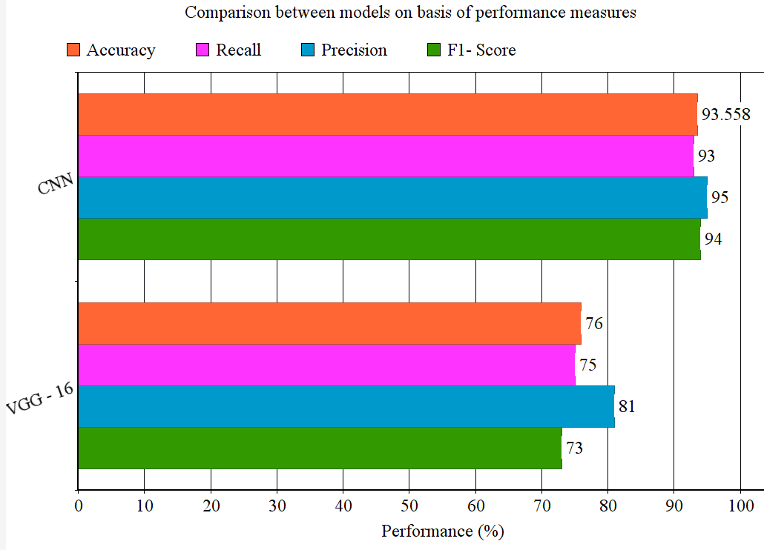

**Figure: 3** Comparison graph between Deep learning models

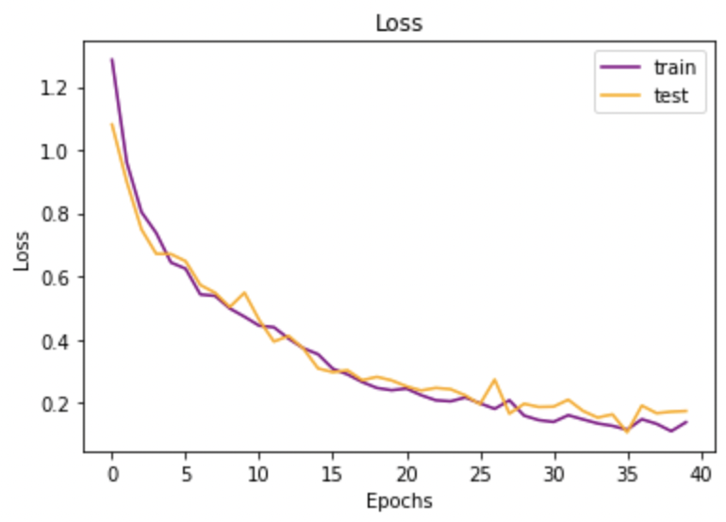

**Figure: 4** Loss for training and testing in case of CNN

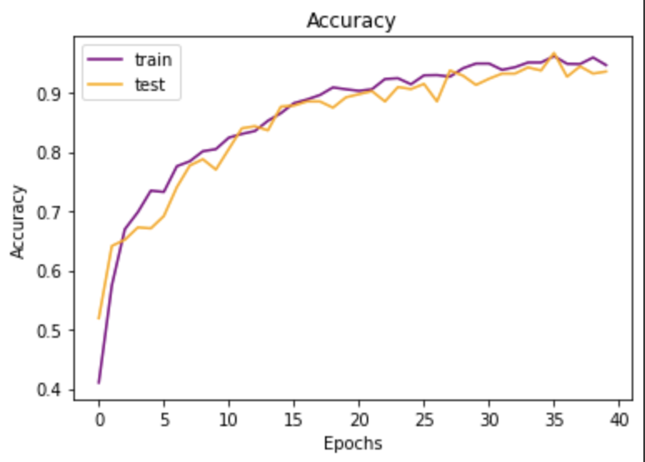

**Figure: 5** Accuracy for training and testing in case of CNN

Figure 4 and Figure 5 graphically represents the loss incurred and accuracy attained during the training and testing in case of CNN model.

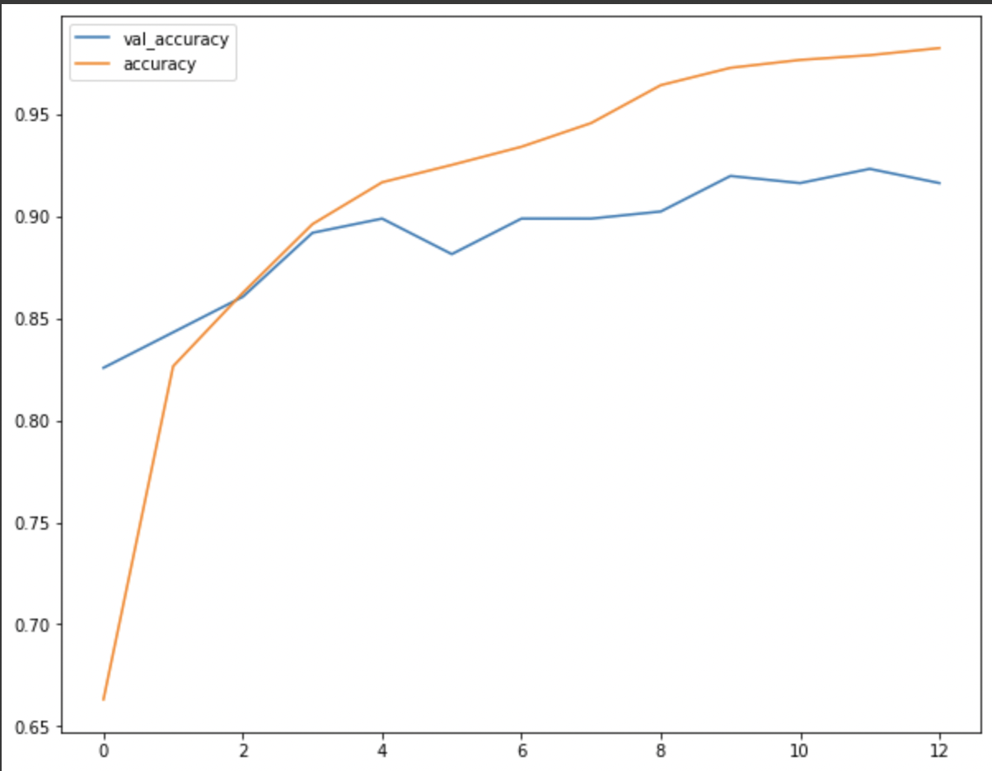

**Figure: 6** Accuracy for Training and Testing in case of VGG-16

Fig. 6 graphically represents the Validation accuracy and accuracy attained during the training phase of VGG-16.

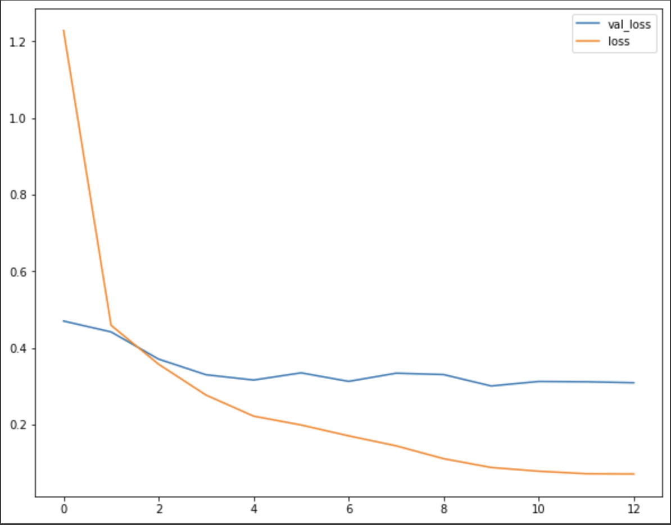

**Figure: 7** Loss for Training and Testing in case of VGG-16

Figure 7 graphically represents the Validation loss and loss incurred during the training phase of VGG-16.

With the help of above experimental results that are based on performance parameters ,it is deduced how well VGG-16 and CNN performed on different criterias. The results show that CNN has outperformed VGG-16 which is a keras pre-trained model.

V. CONCLUSION AND FUTURE SCOPE

In light of the preceding section, it can be stated that the output generated for both the VGG-16 and CNN models is quite exact and clear.The processing of each step has an impact on performance metrics, primarily accuracy computed at the end. Finally, this model completes the task of brain tumor classification.There are various ways for identifying and classifying brain tumors, however the current model depends on the standard neural network strategy for detecting and classifying brain tumors, because the brain tumor detection and classification images are dependent on nearby pixels. The CNN method is successful at detecting and classifying brain tumours, and it has a fairly high accuracy in the case of VGG-16 as well. Potential future scope of this comparison model is opting for more optimized and higher accuracy deep learning algorithms for brain tumor detection and further on its classification.

VII. REFERENCES

[1] Ali Isina, Cem Direkoglu , Melike Sah, ''Review of MRI based brain tumor image segmentation using deep learning methods", Procedia Computer Science Vol.102 317 - 324.

[2] Ayuni Fateeba Muda, Norbasbimah Mobd Saad, S. A. R. Abu Bakar, Sobri Muda and Abdullab A. R., "Brain

Lesion Segmentation Using Fuzzy C-Means on

Diffusion-Weigbted Imaging, ARP Journal of

Engineering and Applied Sciences, Vol. 10, NO.3,

February 2015 ISS 1819-6608.

[3] Abbas, K., Khan, P. W., Ahmed, K. T., & Song, W.-C. (2019). Automatic Brain Tumor Detection in Medical Imaging using Machine Learning. 2019 International Conference on Information and Communication Technology Convergence (ICTC). doi:10.1109/ictc46691.2019.893974.

[4] Hemanth, G., Janardhan, M., & Sujihelen, L. (2019). Design and Implementing Brain Tumor Detection Using Machine Learning Approach. 2019 3rd International Conference on Trends in Electronics and Informatics (ICOEI). doi:10.1109/icoei.2019.8862553.

[5] JP. Poonam, Review of image processing techniques for automatic detection of tumor in human brain, International Journal of Computer Science and Mobile Computing, 2(11), pp. 117-122, 2013.

[6] Somwanshi, D., Kumar, A., Sharma, P., & Joshi, D. (2016). An efficient brain tumor detection from MRI images using entropy measures. 2016 International Conference on Recent Advances and Innovations in Engineering (ICRAIE). doi:10.1109/icraie.2016.7939554.

[7] Badža, M. M., & Barjaktarović, M. Č. (2020). Classification of Brain Tumors from MRI Images Using a Convolutional Neural Network. Applied Sciences, 10(6), 1999. doi:10.3390/app10061999.

[8] Rehman, A., Khan, M. A., Saba, T., Mehmood, Z., Tariq, U., & Ayesha, N. (2020). Microscopic brain tumor detection and classification using 3D CNN and feature selection architecture. Microscopy Research and Technique. doi:10.1002/jemt.23597.

[9] Irmak, E. (2021). Multi-Classification of Brain Tumor MRI Images Using Deep Convolutional Neural Network with Fully Optimized Framework. Iranian Journal of Science and Technology, Transactions of Electrical Engineering, 45(3), 1015–1036. doi:10.1007/s40998-021-00426-9.

[10] Muhammad Imran Sharif;Muhammad Attique Khan;Musaed Alhussein;Khursheed Aurangzeb;Mudassar Raza; (2021). A decision support system for multimodal brain tumor classification using deep learning . Complex &amp; Intelligent Systems, (), –. doi:10.1007/s40747-021-00321-0.

[11] Szegedy C, Liu W, Jia Y, Sermanet P, Reed S, Anguelov D, Erhan D, Vanhoucke V, Rabinovich A. Going deeper with convolutions. InProceedings of the IEEE conference on computer vision and pattern recognition 2015 (pp. 1-9).

[12] Simonyan K, Zisserman A. Very deep convolutional networks for large-scale image recognition. arXiv preprint arXiv:1409.1556. 2014 Sep 4.

[13] Khan HA, Jue W, Mushtaq M, Mushtaq MU. Brain tumor classification in MRI image using convolutional neural network. Math. Biosci. Eng. 2020 Sep 1;17(5):6203-16.

[14] Salem Ghahfarrokhi, S., & Khodadadi, H. (2020). Human brain tumor diagnosis using the combination of the complexity measures and texture features through magnetic resonance image. Biomedical Signal Processing and Control, 61, 102025. doi:10.1016/j.bspc.2020.102025.

[15] Krizhevsky, A., Sutskever, I., & Hinton, G. E. (2017). ImageNet classification with deep convolutional neural networks. Communications of the ACM, 60(6), 84–90. doi:10.1145/3065386.

[16] T. Liu, S. Fang, Y. Zhao, P. Wang, and J. Zhang, “Implementation of training convolutional neural networks,” arXiv preprint arXiv:1506.01195, 2015.

[17] Bhuvan, S. (2020). [Brain Tumor Classification (MRI)] [Data Set]. Kaggle

[18] N. Srivastava, G. Hinton, A. Krizhevsky, I. Sutskever, and R. Salakhutdinov,“Dropout: a simple way to prevent neural networks from overfitting,” The Journal of Machine Learning Research, vol. 15, no. 1, pp. 1929–1958, 2014.