DOKUMENTASI EKSTERNAL  External Documentation | 
PROYEK
Project
MATAKULIAH COMP6144 – Web Programming
Web Programming

SEMESTER GANJIL 2019/2020
Odd Semester Year 2019/2020

Judul Proyek
[Assignment / Project] Title
- Bjora

Abstrak [50 – 200 words]
Abstract
- Bjora is famous announcer company in Indonesia. To have a better engagement with their customers, Bjora company wants to create a website for their QnA (question-and-answer) website. In that website, user could find any information discussed by the community.

Pendahuluan
Introduction
- Proyek ini semoga dapet 100.

Dokumentasi
Report / Documentation
- Model
  - Answer
    - question_id -> has one Question
    - owner_id
    - answer
  - Message
    - recipient_id -> has one User
    - sender_id -> has one User
    - message
  - Question
    - owner_id -> has one User
    - status (open/closed)
    - topic (only from available TopicOption)
    - question
  - TopicOption
    - topic
  - User
    - role (admin/member)
    - name
    - email
    - password
    - gender
    - address
    - date_of_birth
    - profile_picture
  - DETAIL 1
- Controller
  - A note on User Update controller, I INTENTIONALLY allowed for the password and profile_picture to be empty in the form. This is so that users that do not want to change the password won’t have to type their password (since passwords are hashed). And so that users don’t need to always have their profile_picture on them. Please do not deduct the project score and instead consider this as a hidden creativity.
- Middleware
  - Banyak middleware sehingga validasi visual tidak hanya dilakukan secara visual (penghilangan tombol)
- Screenshots
- Home Page
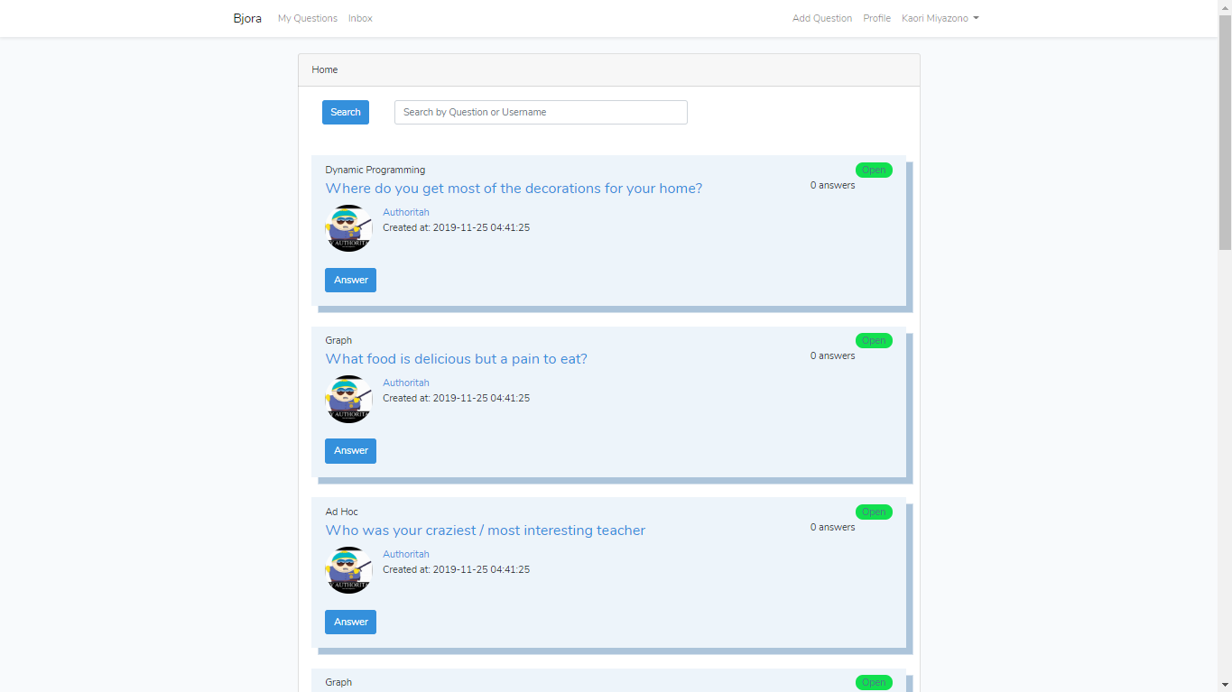
- Searched
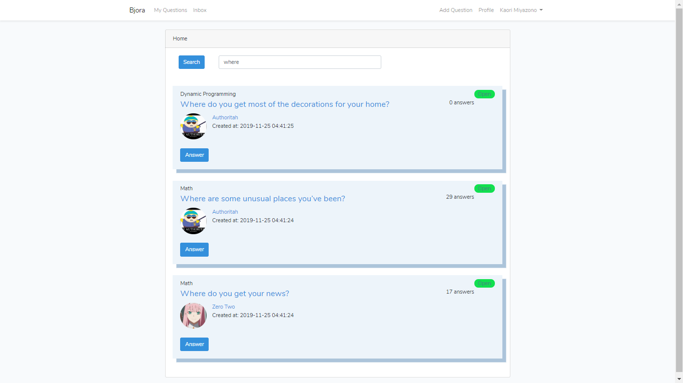
- Pagination on the Home Page
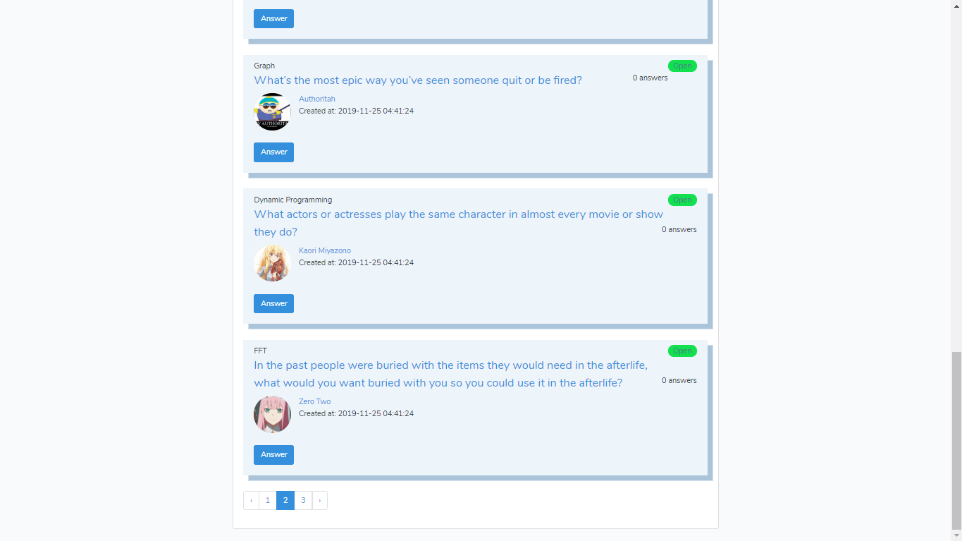
- My Questions (view all questions created by the user). Also with pagination
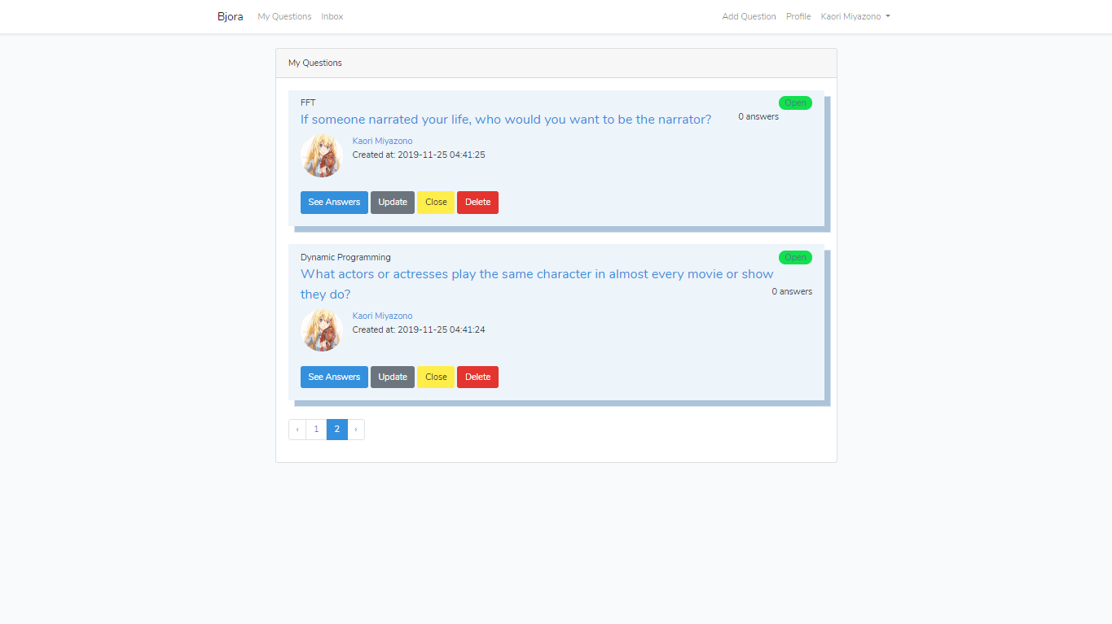
- Questions page
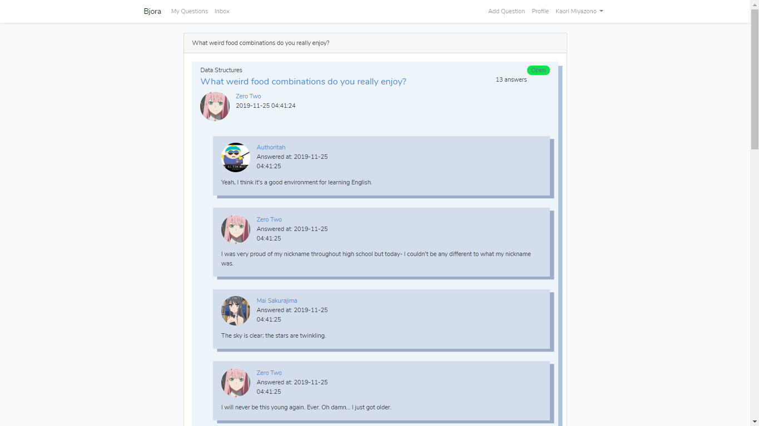
- Logged in users can answer and edit their answers (edit and delete)
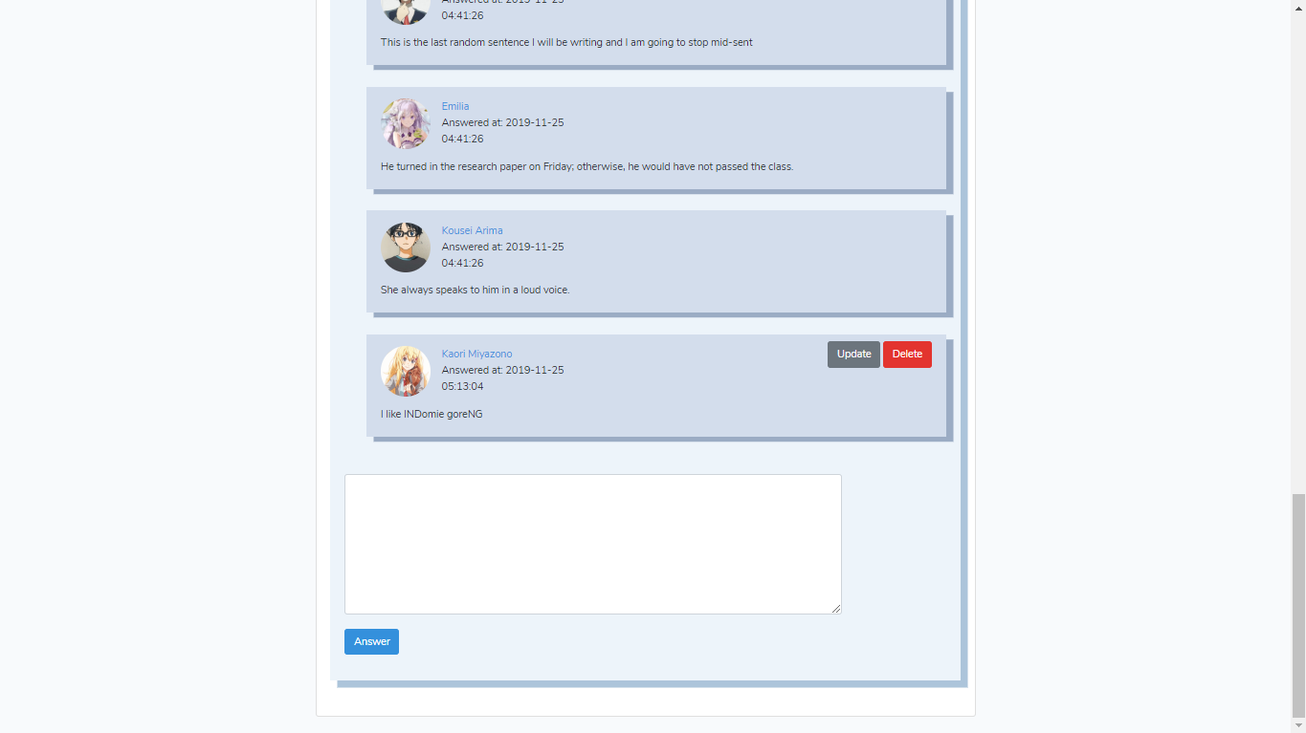
- Update answer page
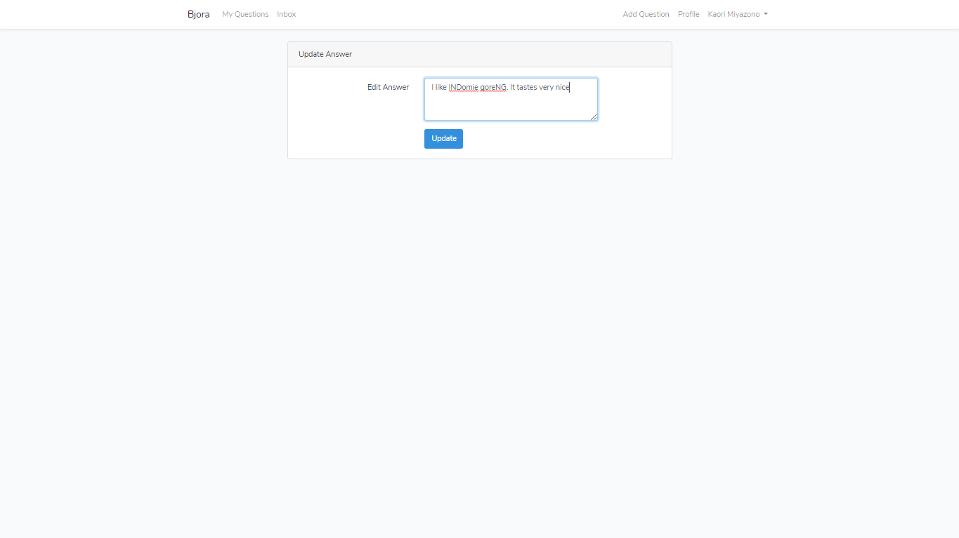
- Options for question topic
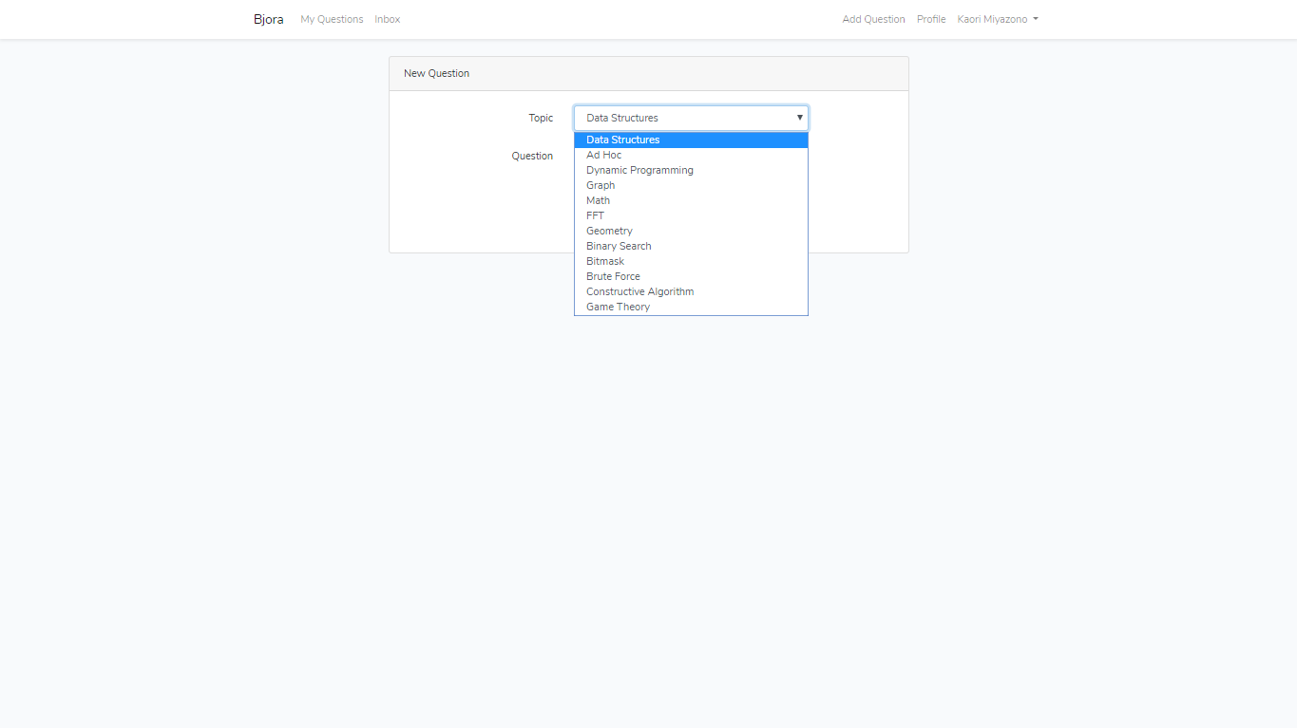
- Add question
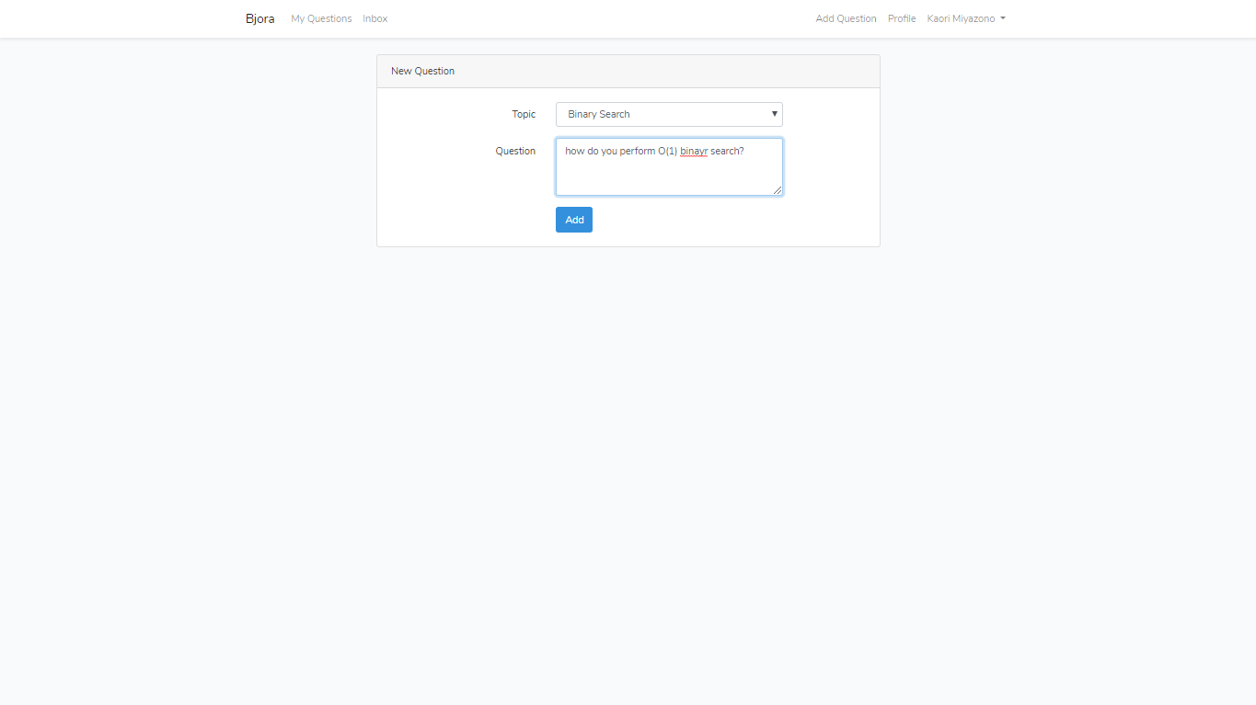
- Edit question
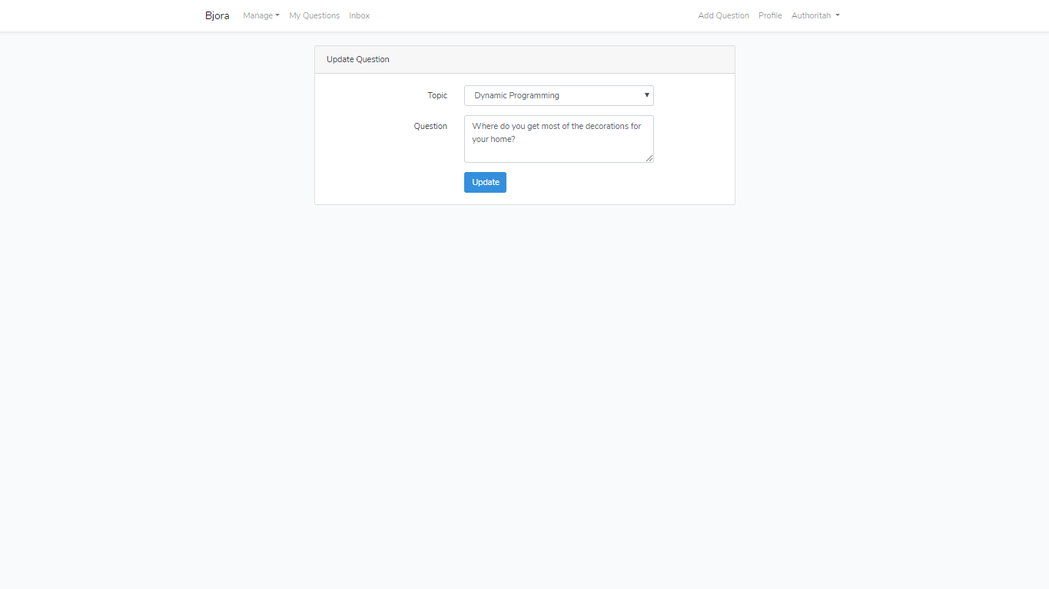
- Viewing your own profile
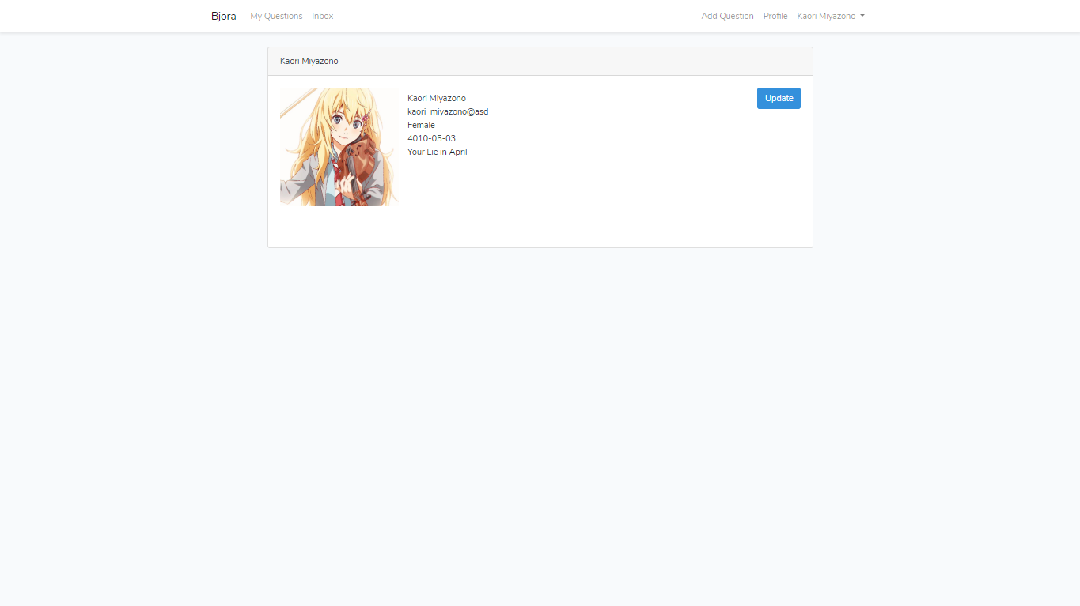
- Updating profile (note the password and profile_picture is optional)
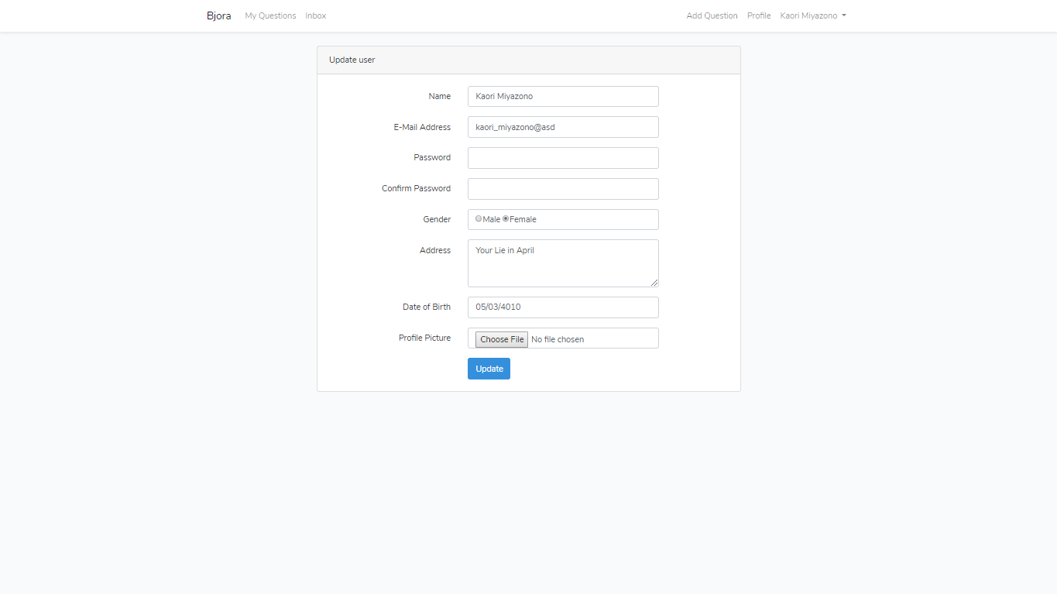
- Viewing other profile
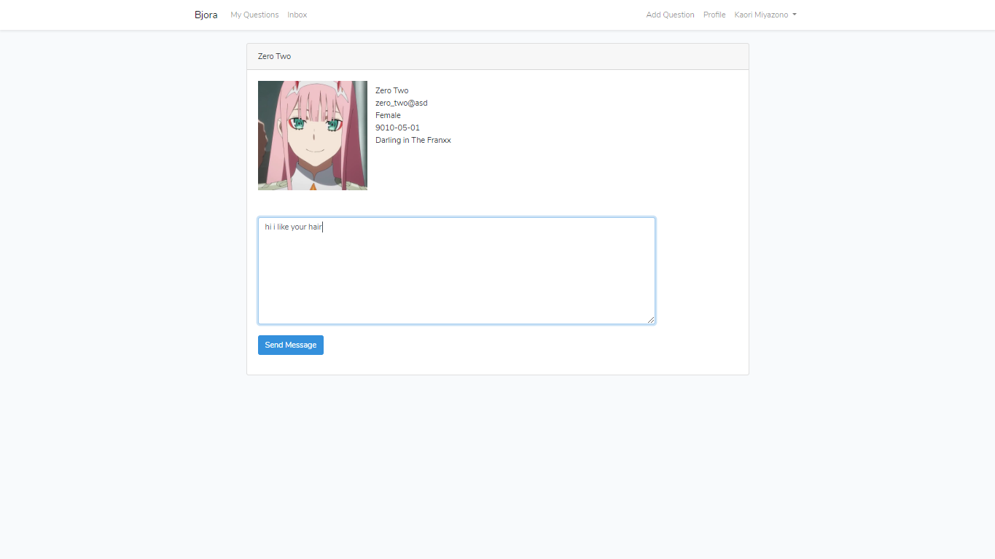
- Inbox page
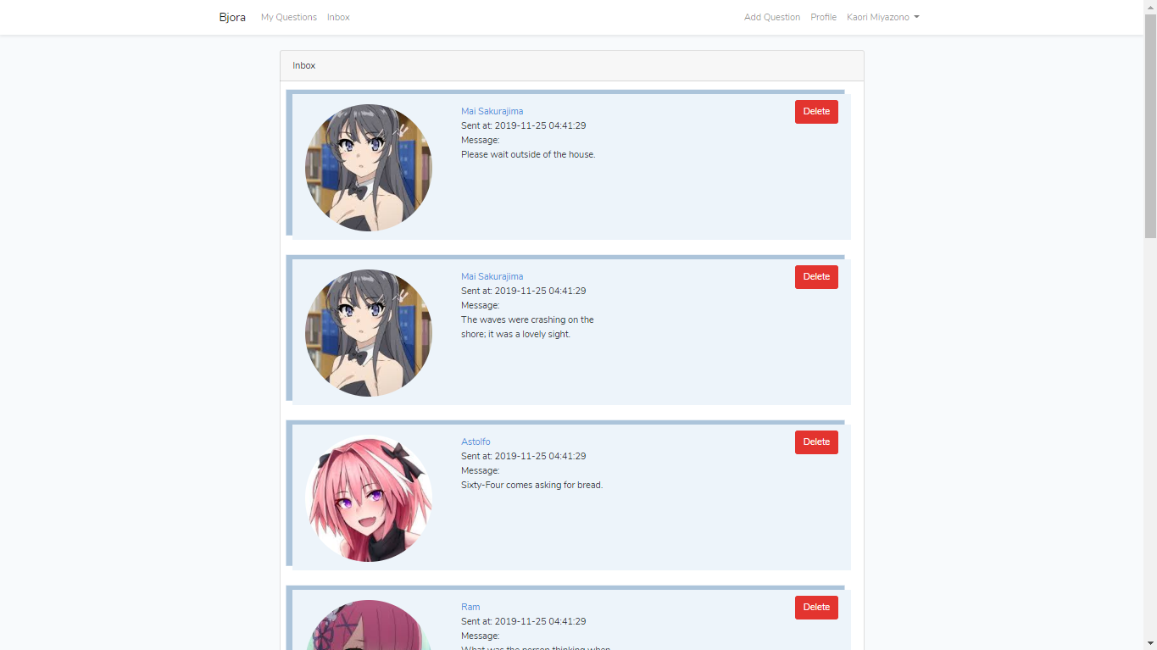
- Manage users (admin)
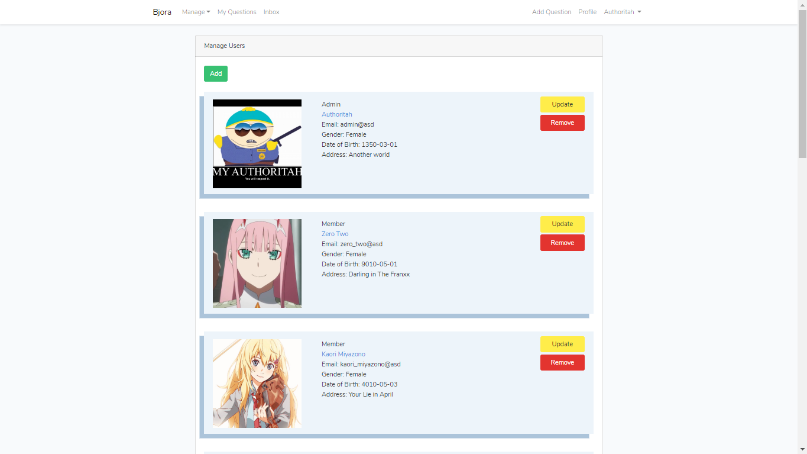
- Add user page (notice the role option)
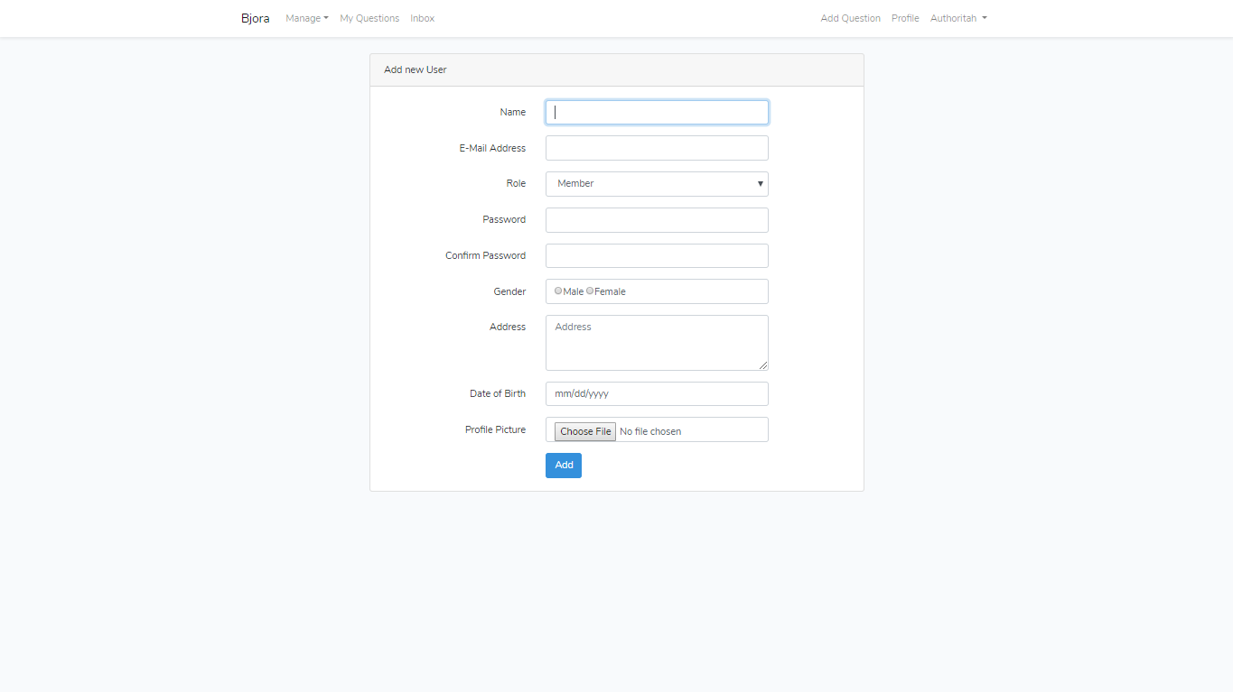
- Update user page (notice the role option)
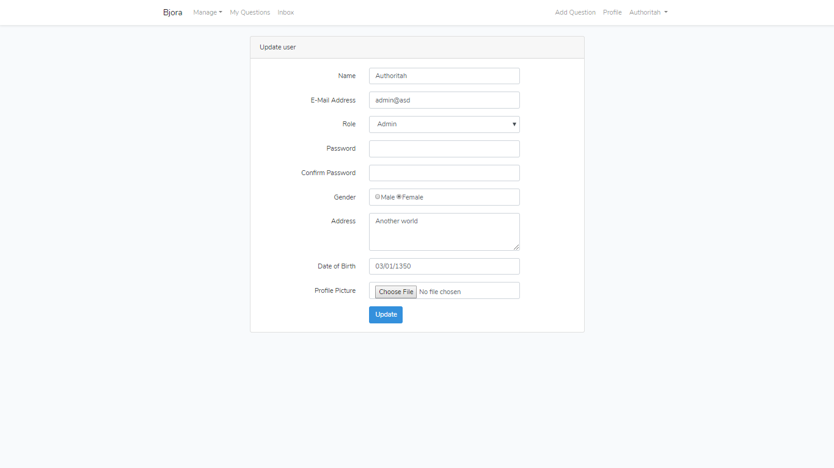
- Closing a question
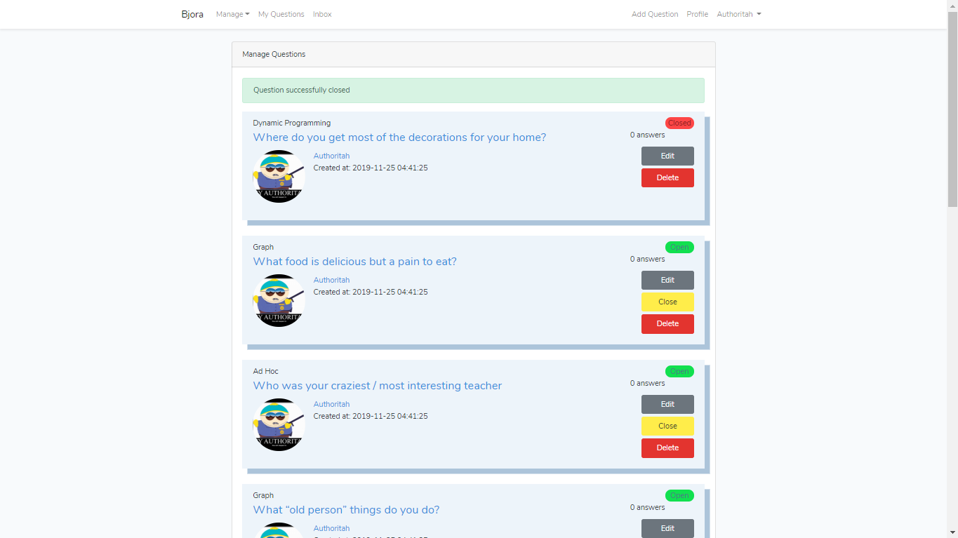
- Manage topics
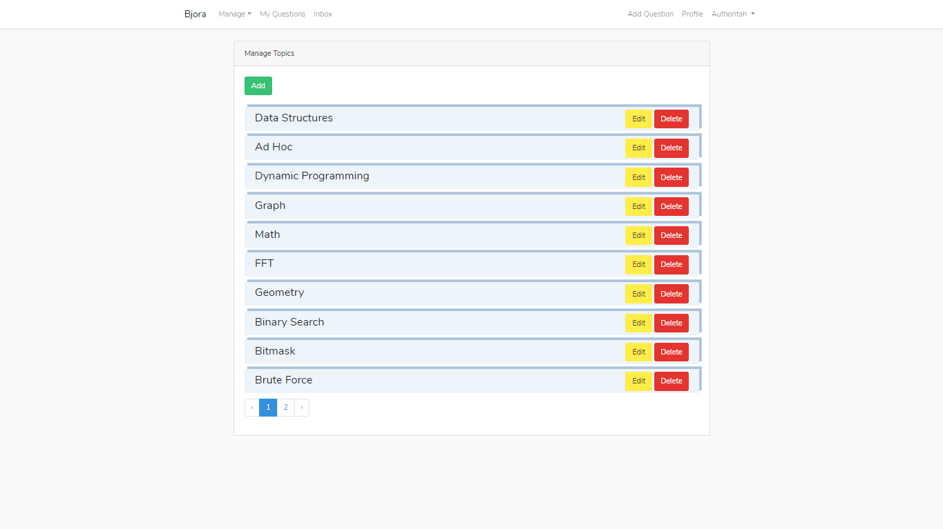
- Update topics
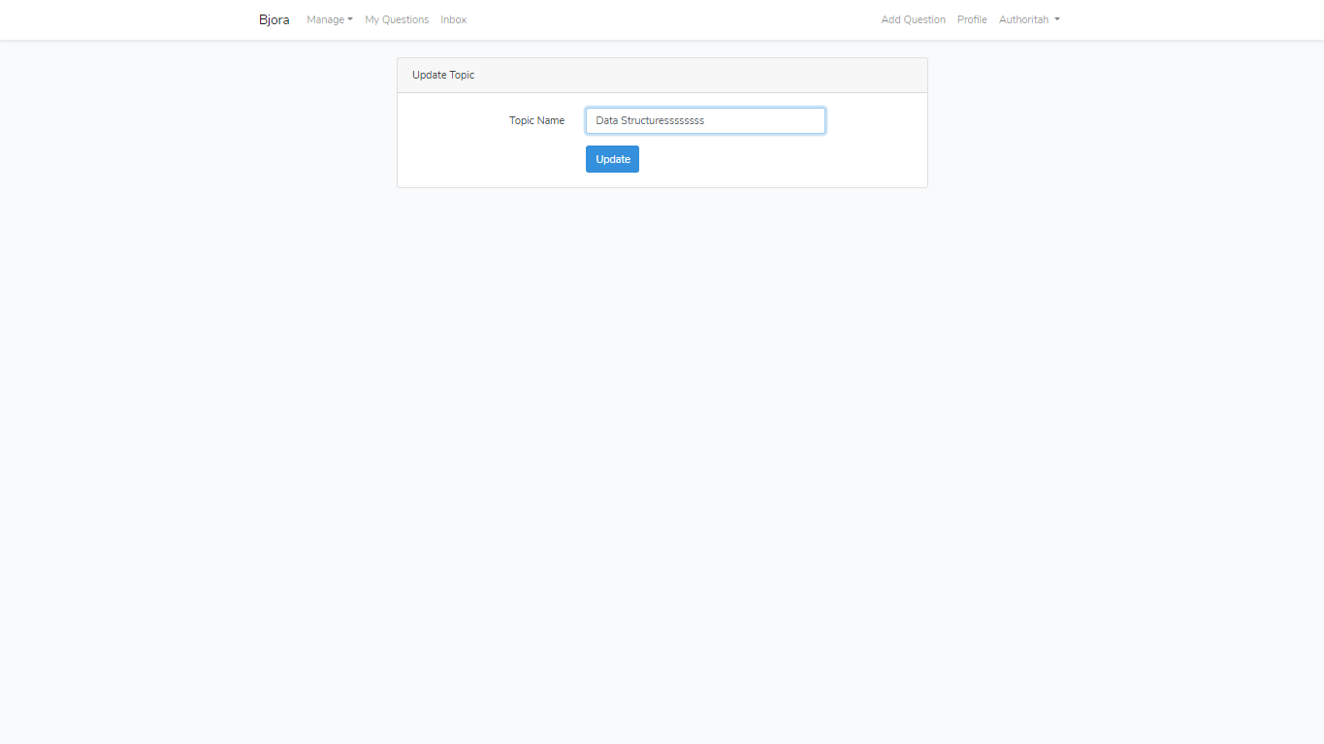
- Add topics
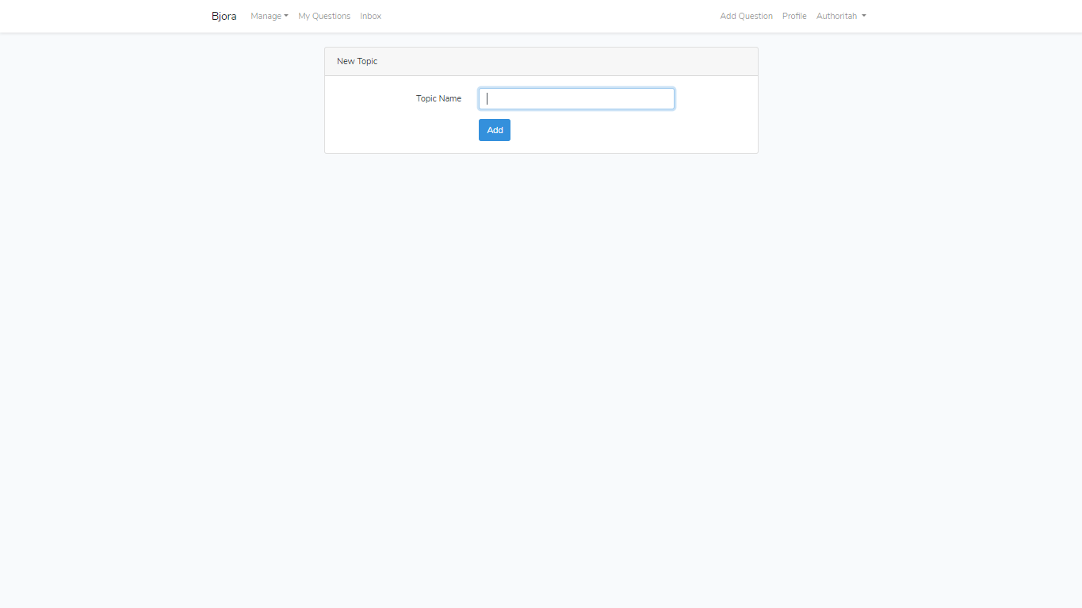

Referensi
References
- Google image

Disiapkan Oleh,
Prepared by,
- 2101664132 - William Gunawan Eka

