Sarath Chandra kunisetty – [skkh2@umkc.edu](mailto:skkh2@umkc.edu)

GitHub link: https://github.com/kunisettysarath/WebMobileProgramming-Spring22/tree/main/WebDevelopment/ICP's/ICP3

Dharma Teja Konidena - [dkbmy@umsystem.edu](mailto:dkbmy@umsystem.edu)

GitHub link: <https://github.com/Dharmateja183/Web-and-Mobile-programming-spring-2022/tree/main/Webpart/ICP2>

**ICP 3**

**Objective:**

The objective of this ICP3 is to understand what is a responsive webpage the basics of HTML and CSS by creating webpage with specified list of elements.

**Index.html:**

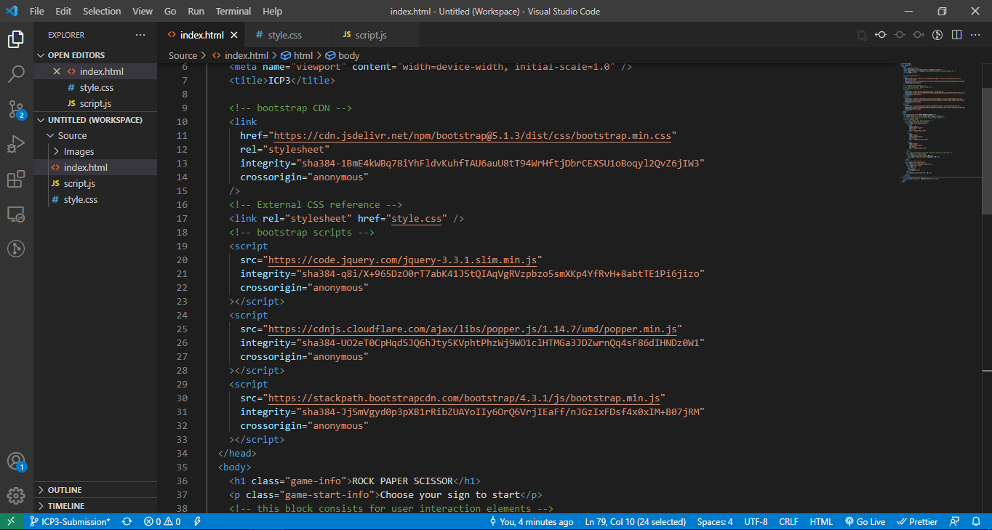

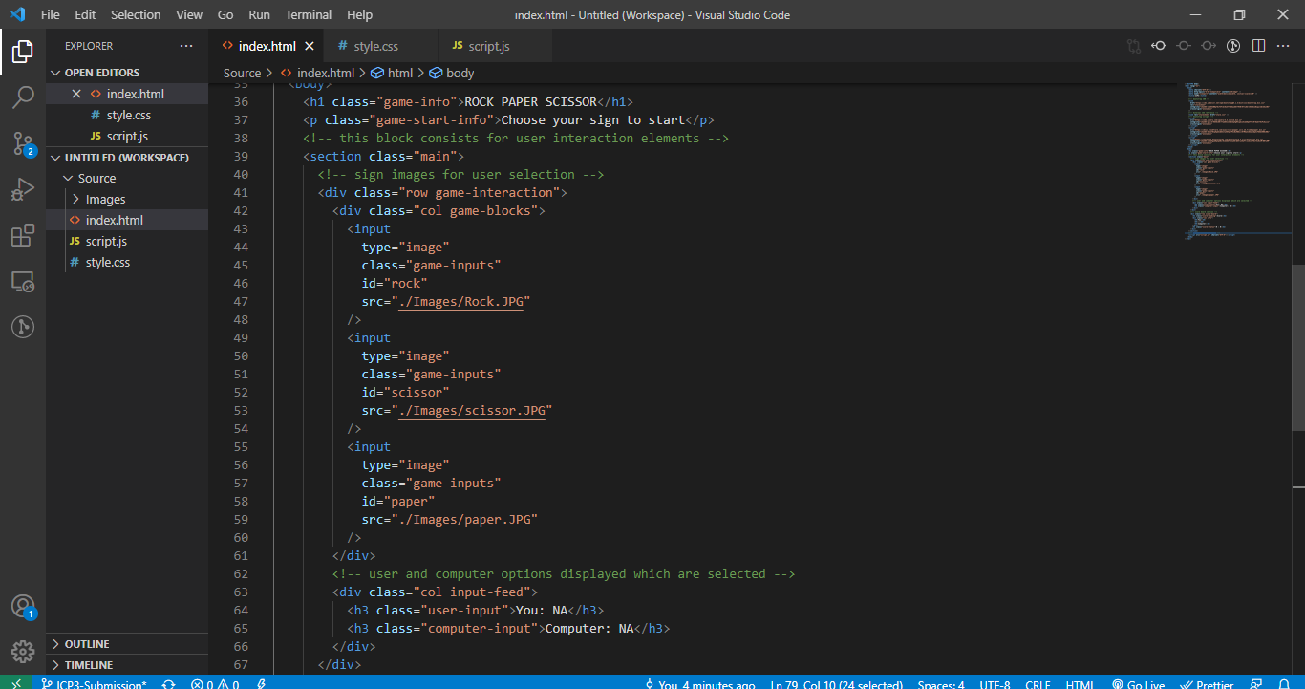

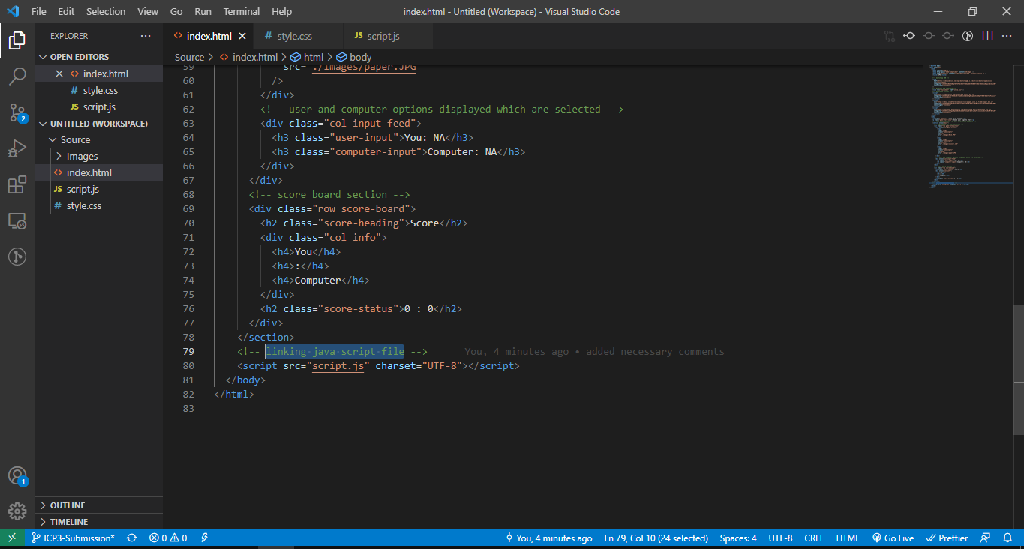

**Style.css:**

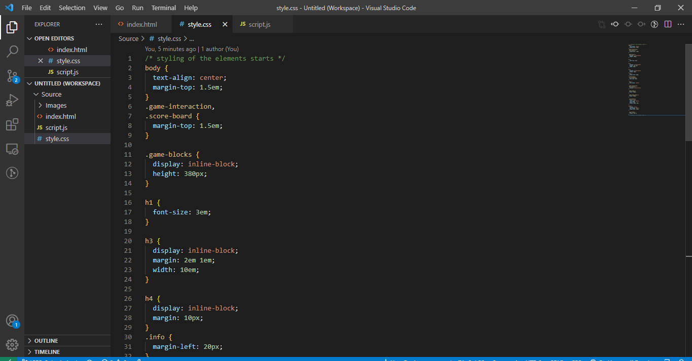

**Script.js:**

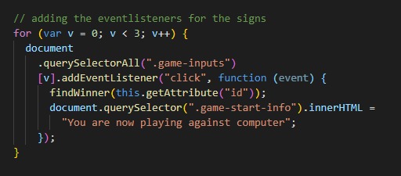

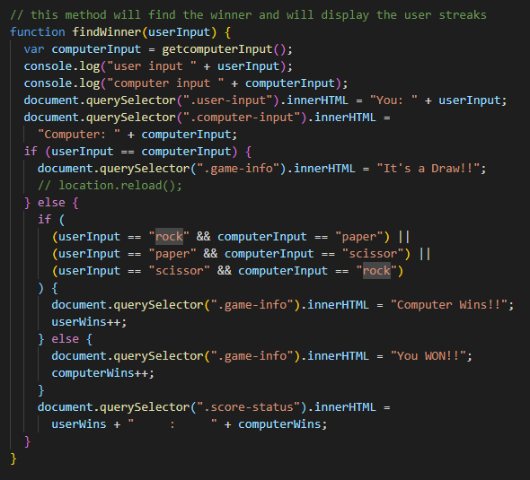

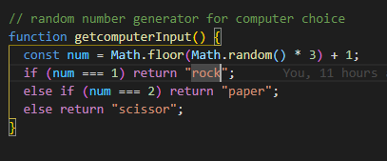

**Output:**

