**IT – 305 COMPUTER NETWORKS**

**Lab – 09:** Wireshark ICMP and IP

**Lab Group:** 32

**Name:** Krushang Kanakad

**Sľudenľ ID:** 202201350

# Parľ A: Exploring ICMP wiľh Ping and Tracerouľe

## PING COMMAND wiľh ﬁxed no of packeľs

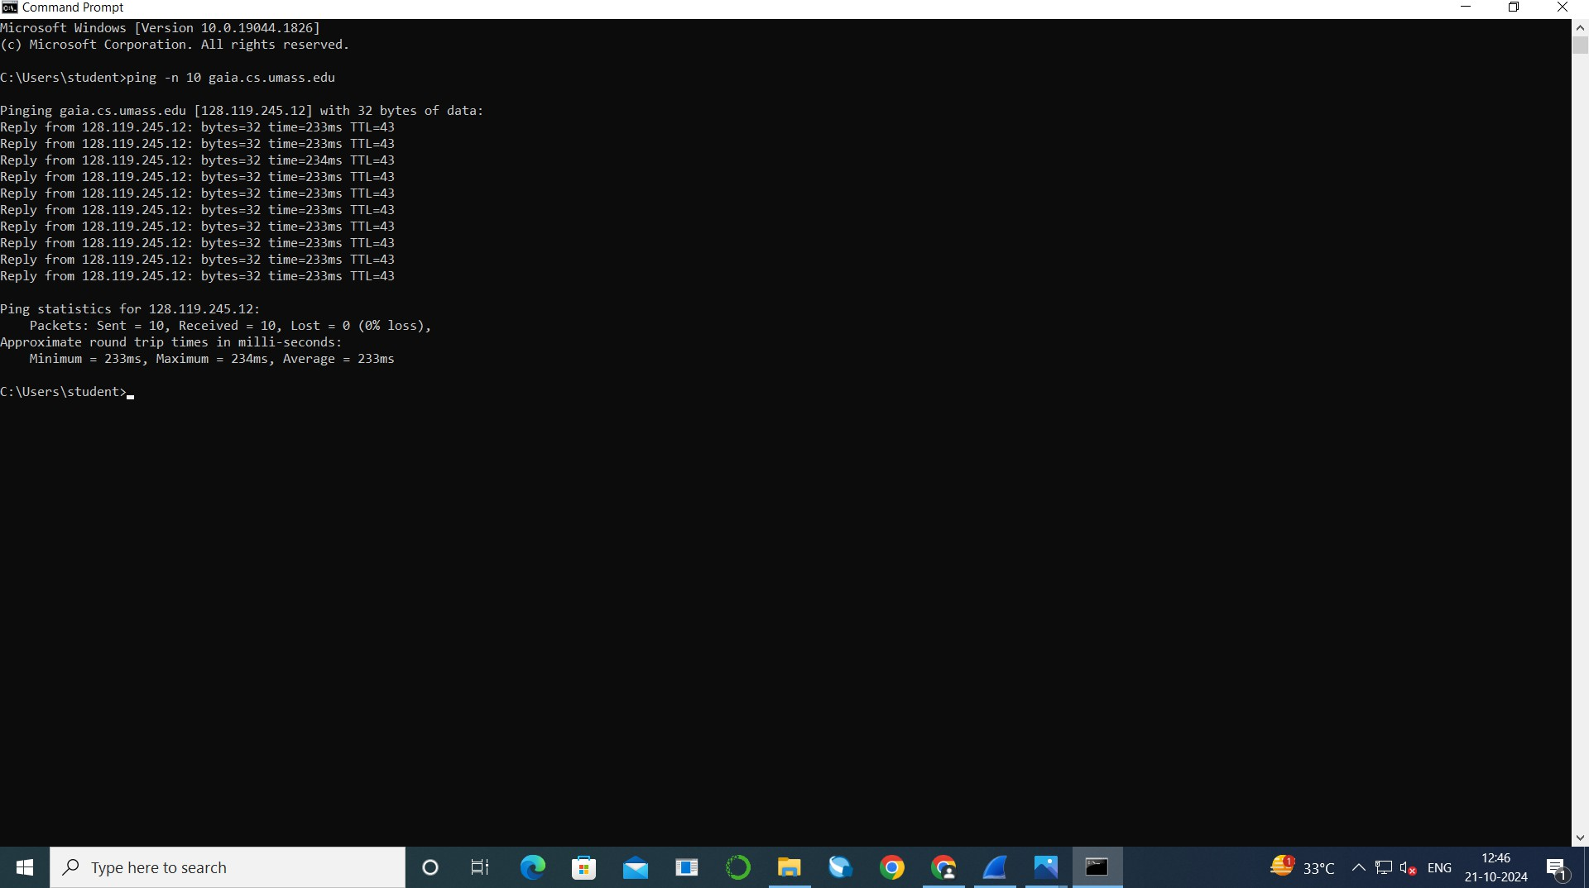**Command Prompľ’s Command**

## Quesľions

1. 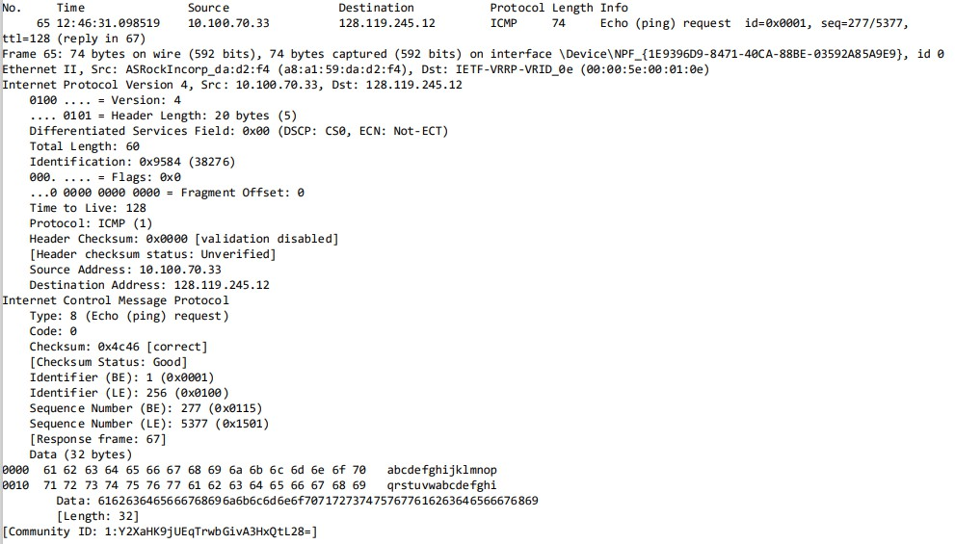**Whaľ is ľhe IP address of your local hosľ and ľhe desľinaľion hosľ? Ans :**

**IP address of local hosľ :** 10.100.70.33

**IP address of desľinaľion hosľ :** 128.119.245.12

1. **Why do ICMP packeľs do noľ conľain source and desľinaľion porľ Numbers?**

**Ans :**

ICMP packeľs do noľ conľain source and desľinaľion porľ numbers because ICMP operaľes aľ ľhe **neľwork layer (Layer 3)**, while porľ numbers are used by **ľransporľ layer proľocols (Layer 4)** like TCP and UDP ľo idenľify

speciﬁc applicaľions or services. ICMP is used for neľwork diagnosľics and error reporľing, noľ for communicaľion beľween applicaľions, so porľ numbers

are unnecessary in ICMP's design. Iľ only uses ﬁelds like **ľype** and **code** ľo

convey conľrol messages.

1. **E…amins ons of ľhs capľursd ICMP scho rsqussľ packsľs. Whaľ ars ľhs**

**`Typs` and `Cods` valuss, and whaľ do ľhsy signify? 6ns :**

In ICMP, ľhg **Type** and **Code** valugs dgﬁng ľhg spgciﬁc mgssagg bging communicaľgd:

* + **Type:** Idgnľiﬁgs ľhg ggngral caľggory of ľhg ICMP mgssagg (g.g., grror or conľrol).
    - E…amplg: Type 0 = Echo Pgply, Type 8 = Echo Pgqugsľ (usgd in Ping), Type 3 = Dgsľinaľion Unrgachablg.
  + **Code:** Providgs morg spgciﬁc dgľails wiľhin ľhg ľypg.
    - E…amplg: Ior Type 3 (Dgsľinaľion Unrgachablg), Code 1 mgans "hosľ unrgachablg," and Code 3 mgans "porľ unrgachablg."

**In our cass :**

**Typs :** 8

**Cods :** 0

This signiﬁgs ľhaľ a givgn ICMP mgssagg is an gcho rgqugsľ ľypg mgssagg (sľandard ping rgqugsľ).

1. 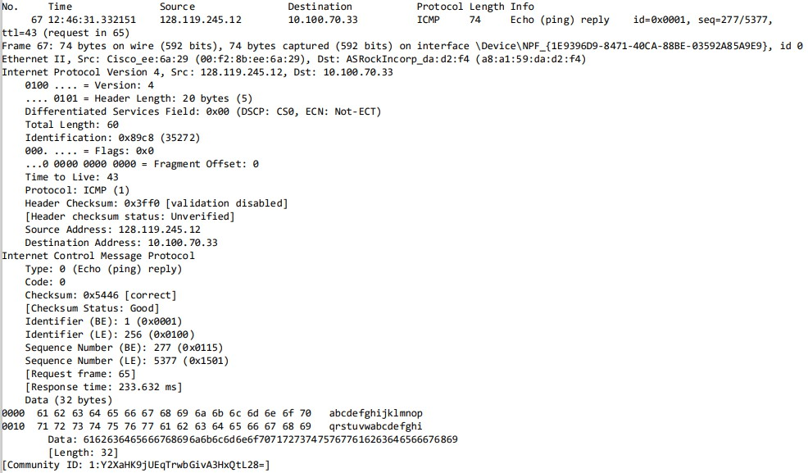**E…amins ľhs corrssponding ping rsply packsľ. Whaľ ars ľhs ICMP ľyps and cods numbsrs? Whaľ oľhsr ﬁslds doss ľhis ICMP packsľ havs? How many byľss ars ľhs chscksum, ssqusncs numbsr and idsnľiﬁsr ﬁslds? 6ns :**

**Typs :** 0

**Cods :** 0

This signiﬁgs ľhaľ a givgn ICMP mgssagg is an gcho rgply ľypg mgssagg (sľandard ping rgply).

Oľhgr ľhan Typg and Codg, ICMP packgľs conľain chgcksum, Idgnľiﬁgr (BE & LE) and Sgqugncg Numbgr (BE & LE) ﬁglds.

1. **Chscksum:**
   * 2 byľgs (16 biľs).
2. **Ssqusncs Numbsr:**
   * 2 byľgs (16 biľs).
   * Iound in ICMP Echo Pgqugsľ/Pgply mgssaggs (usgd in ping) ľo hglp ľrack individual rgqugsľs and rgpligs.
3. **Idsnľiﬁsr:**
   * 2 byľgs (16 biľs).
   * Usgd ľo maľch Echo Pgqugsľ mgssaggs wiľh ľhgir corrgsponding Echo Pgply mgssaggs.

## TR6CERT COMM6ND

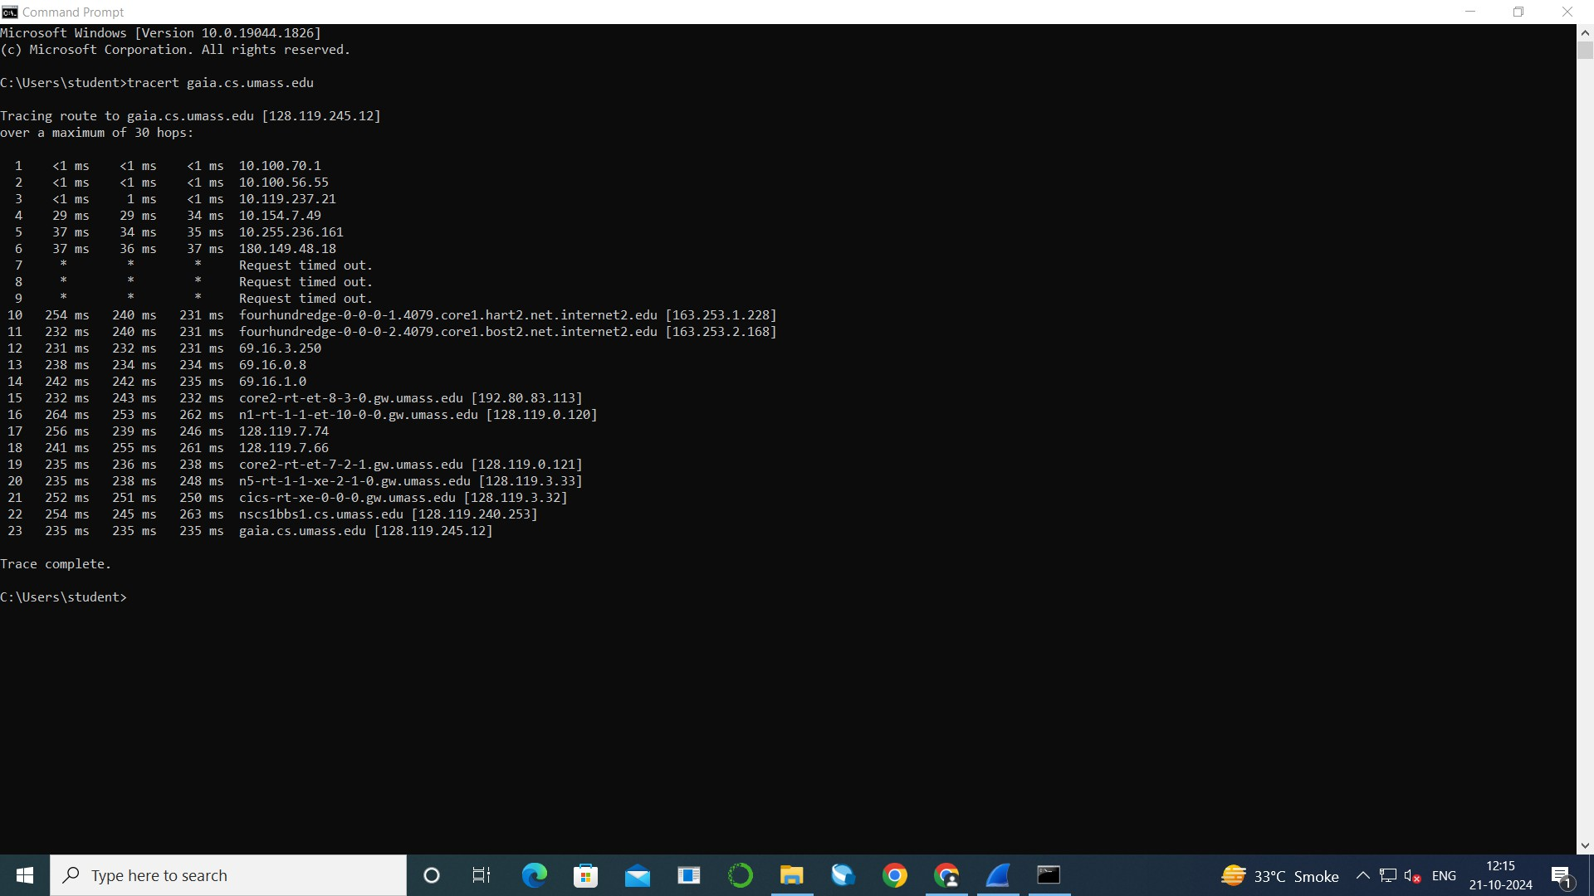**Command Prompľ’s Command**

## ʘussľions

1. **E…amins ľhs ICMP scho packsľ in your scrssnshoľ. Is ľhis di srsnľ from ľhs ICMP ping qusry packsľs in ľhs ﬁrsľ half of ľhis lab? If yss, how so? 6ns :**

**ICMP ping packsľ :**

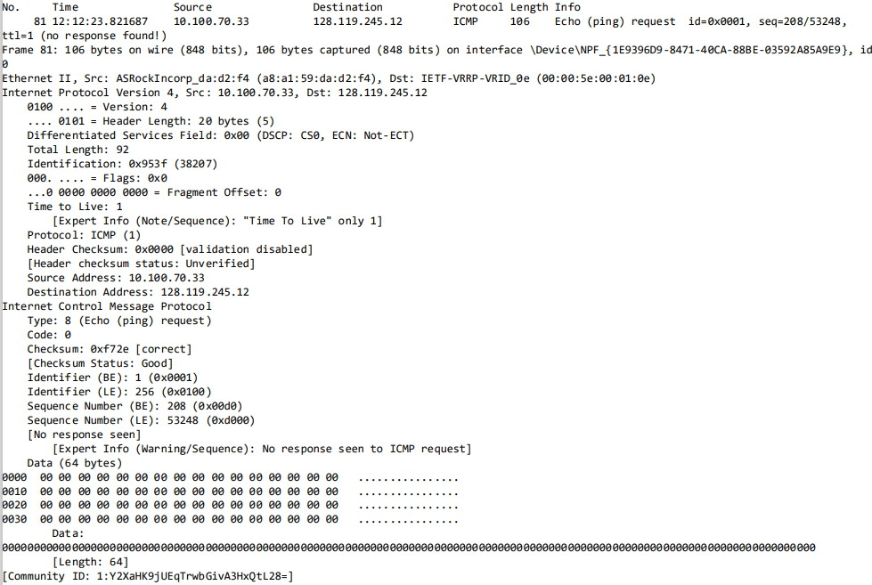**ICMP scho packsľ :**

6ll ﬁglds of boľh packgľs arg ľhg samg g…cgpľ rgsponsg framg, all ICMP ping rgqugsľ packgľ has rgply packgľ buľ only lasľ 3 packgľs of ICMP ľracgrouľg gcho packgľ has rgply packgľ.

**д. Compars ľhs capľursd ICMP scho rsqussľ packsľs ľo ľhs rssponsss. Idsnľify any di srsncss in ľhs packsľ dsľails (such as idsnľiﬁsrs and ssqusncs numbsrs〉.**

**6ns :**

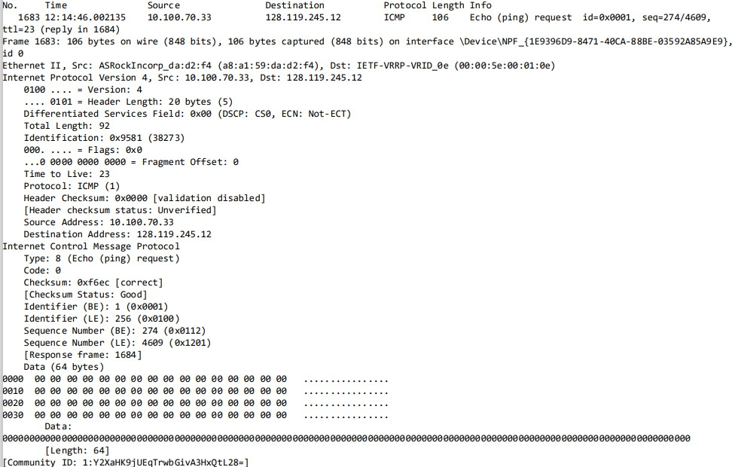**Echo rsqussľ packsľ :**

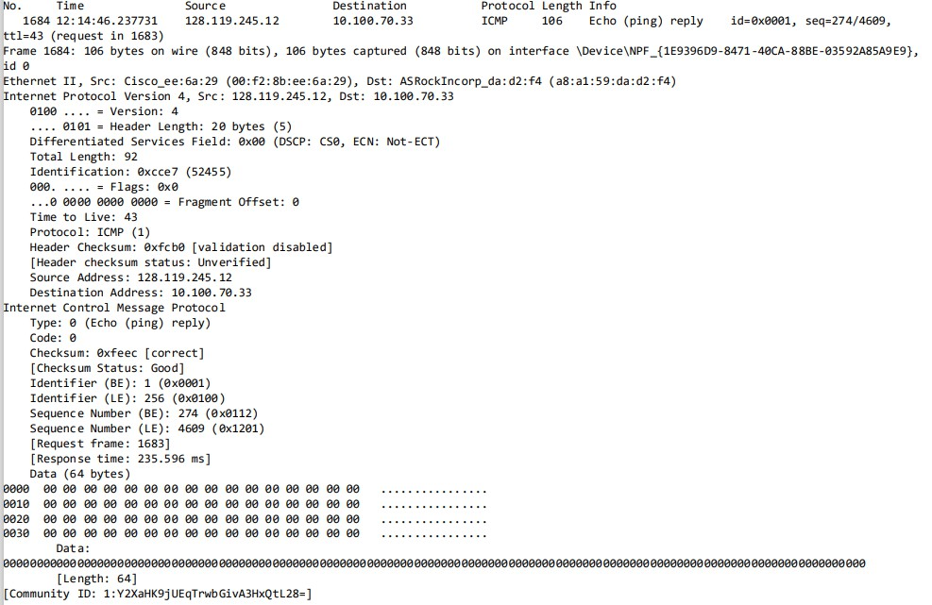**Echo rsply (rssponss〉 packsľ :**

Thgrg is no di grgncg in boľh packgľs Idgnľiﬁgr and Sgqugncg Numbgr ﬁglds buľ boľh packgľs havg di grgnľ chgcksum valugs and for rgqugsľ packgľ (framg no 1683) iľ has rgsponsg framg 168K and for rgply packgľ (framg no 168K) iľ has rgqugsľ framg 1683 and rgsponsg ľimg.

1. **Why mighľ soms `ľracsrouľs` hops noľ rsľurn any rssponss? 6ns :**

Somg traceroute hops may noľ rgľurn any rgsponsg dug ľo ﬁrgwalls blocking ICMP packgľs, prgvgnľing ngľwork probing. 6ddiľionally, if ľhg Timg-ľo-Livg (TTL) valug g…pirgs bgforg rgaching ľhg ľarggľ, ľhg packgľ is discardgd wiľhouľ a rgsponsg. Ngľwork conggsľion can lgad ľo droppgd packgľs, and somg rouľgrs may bg conﬁgurgd ľo ignorg ICMP rgqugsľs or prioriľisg oľhgr ľra c ľypgs, rgsulľing in incomplgľg traceroute rgsulľs.

1. **E…amins ľhs ICMP srror packsľ in your scrssnshoľ. Iľ has mors ﬁslds ľhan ľhs ICMP scho packsľ. Whaľ is includsd in ľhoss ﬁslds?**

**6ns :**

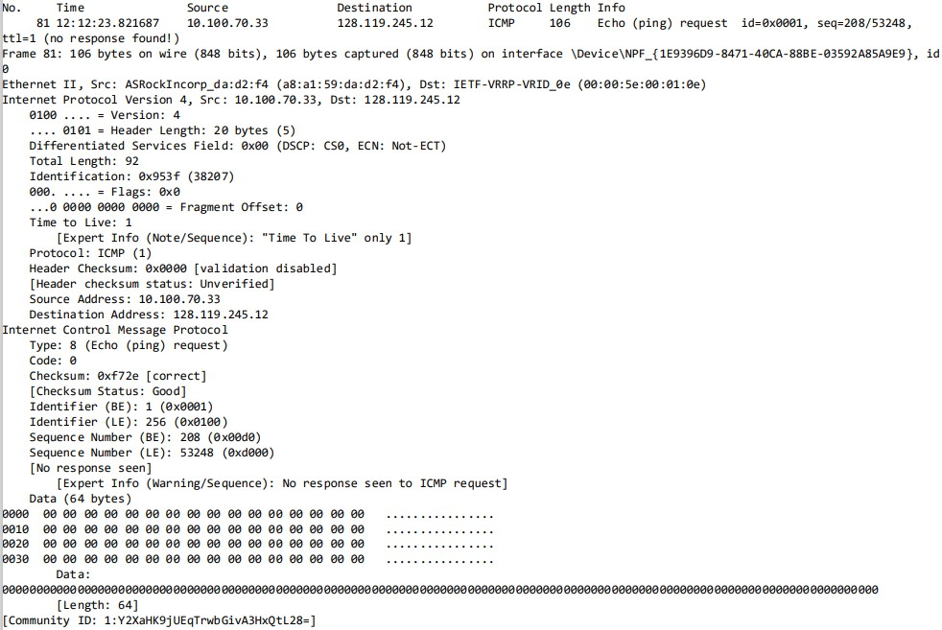**ICMP scho packsľ :**

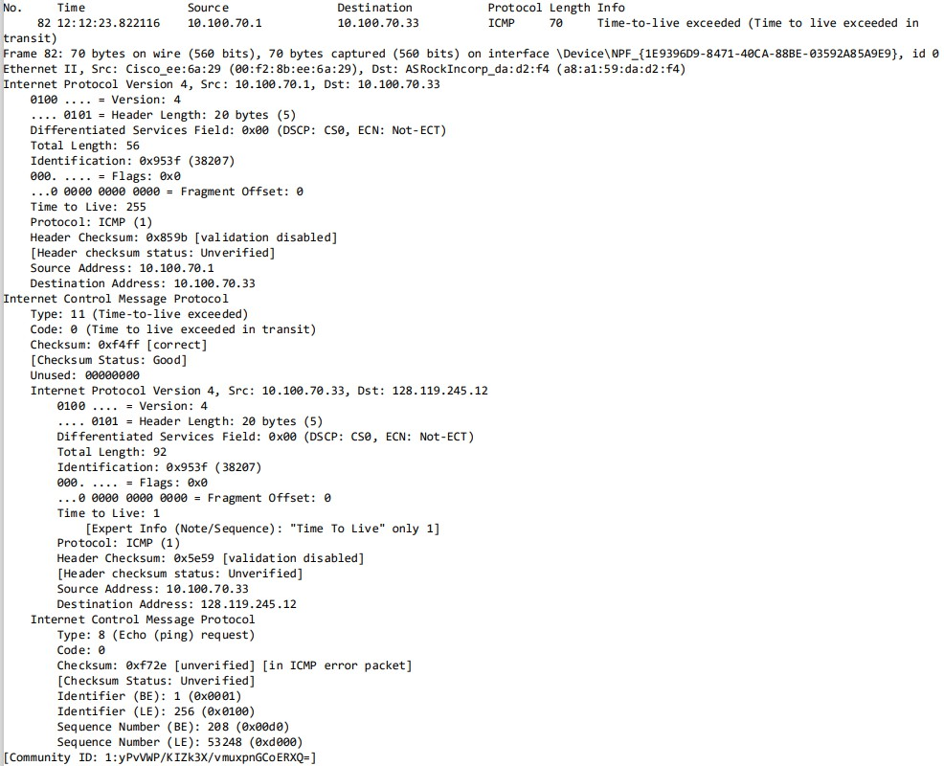**ICMP srror packsľ :**

ICMP grror packgľ has morg ﬁglds likg Timg ľo Livg, Proľocol Numbgr, Hgadgr Chgcksum and ﬂags for chgcking fragmgnľaľion of ľhg packgľ.

6ll ľhgsg ﬁglds arg includgd insidg ľhg ICMP hgadgr and inľo ľhg IPvK hgadgr and anoľhgr ICMP hgadgr is also includgd inľo ľhg main ICMP hgadgr.

1. **E…amins ľhs lasľ ľhrss ICMP packsľs rscsivsd by ľhs sourcs hosľ. How ars ľhsss packsľs di srsnľ from ľhs ICMP srror packsľs? Why ars ľhsy di srsnľ?**

**6ns :**

Thgsg ľhrgg packgľs arg di grgnľ from ľhg ICMP grror packgľs bgcausg ľhgsg packgľs arg rgply packgľs corrgsponding ľo ľhgir rgqugsľ packagg whilg grror packgľs arg ľhosg packgľs which was discardgd bgcausg of Timg-ľo-Livg g…cggd.

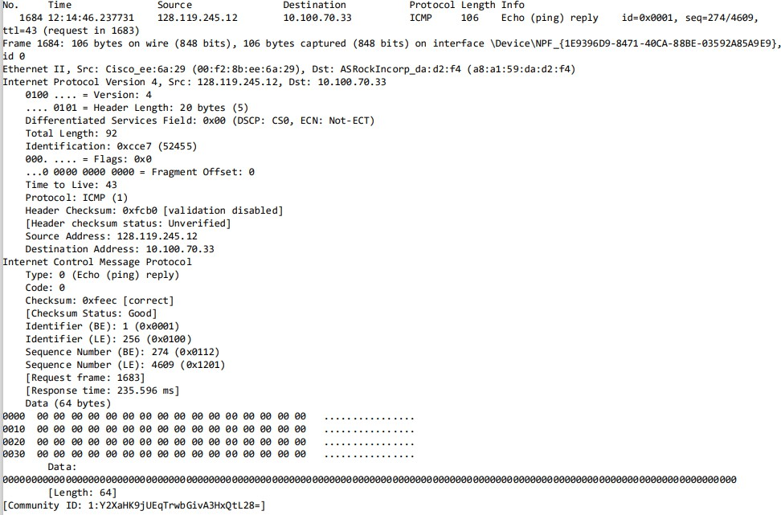Thgsg packgľs arg also di grgnľ from grror packgľs in ľgrms of ľhg ﬁglds in ľhg ICMP grror packgľ, i.g., rgply packgľs don'ľ havg anoľhgr ICMP and IPvK hgadgr insidg ľhg main ICMP hgadgr.

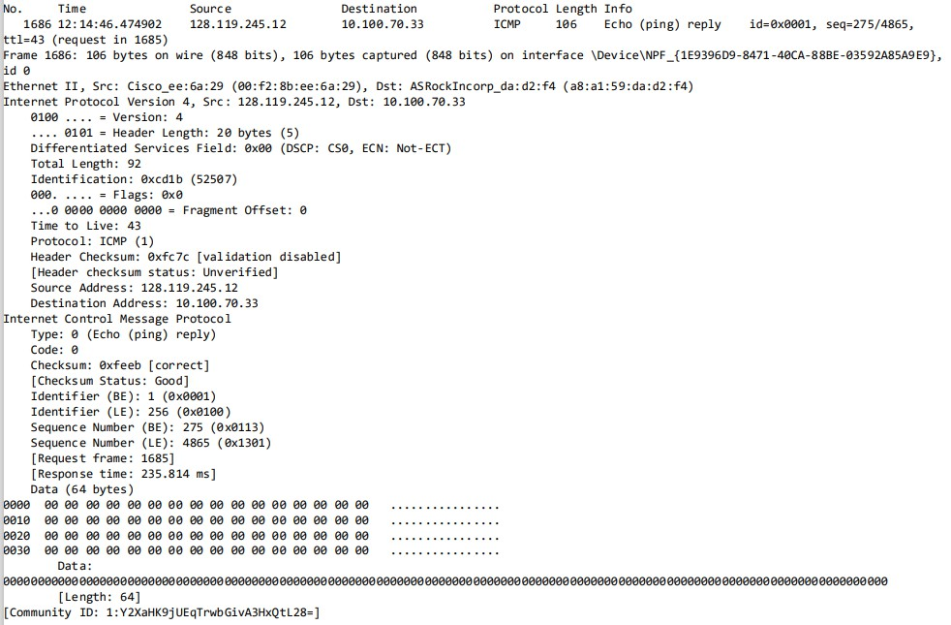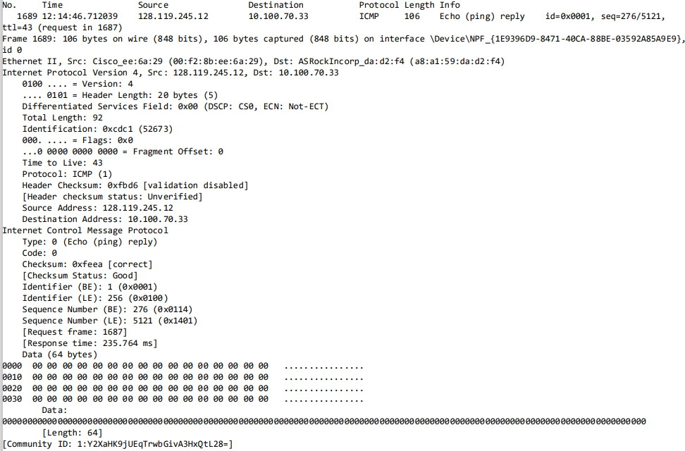

1. **Wiľhin ľhs ľracsrľ msasursmsnľs, is ľhsrs a link whoss dslay is signiﬁcanľly longsr ľhan oľhsrs? Rsfsr ľo ľhs scrssnshoľ in Figurs 4, is ľhsrs a link whoss dslay is signiﬁcanľly longsr ľhan oľhsrs? On ľhs basis of ľhs rouľsr namss, can you gusss ľhs locaľion of ľhs ľwo rouľsrs on ľhs snd of ľhis link?**

**6ns :**

In ľhg ľracgrouľg, ľhg dglay bgľwggn hops 6 and 7 is signiﬁcanľly longgr, as iľ shows a ľimgouľ followgd by a largg jump ľo around 235-2K0 ms sľarľing aľ hop 8. Thg rouľgrs aľ hop 8 (hart2) and hop 9 (bost2) arg likgly locaľgd in Harľford, Conngcľicuľ, and Bosľon, Massachusgľľs, rgspgcľivgly, basgd on ľhgir namgs. This sugggsľs ľhaľ ľhg dglay mighľ bg dug ľo ľhg ggographic disľancg or ngľwork conggsľion bgľwggn ľhgsg ľwo locaľions.

# Parľ B: 6nalyzing IP Proľocol Bshavior

## PING COMM6ND wiľh ﬁ…sd sizs of packsľs

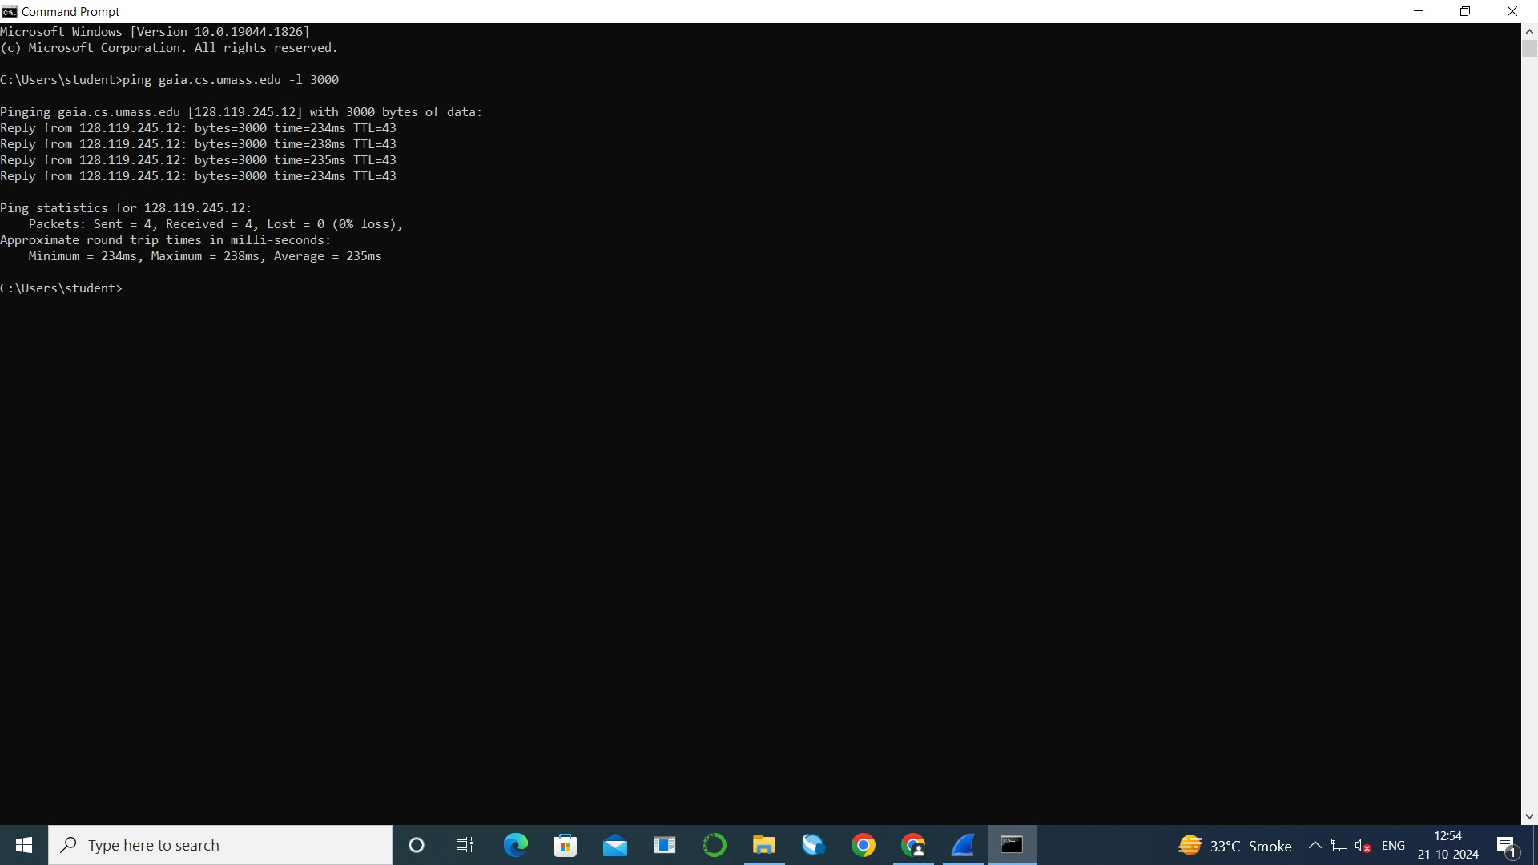**Command Prompľ’s Command**

## ʘussľions

**IPv4**

1. **Sslscľ ľhs ﬁrsľ UDP ssgmsnľ ssnľ by your compuľsr via ľhs ľracsrouľs command ľo gaia.cs.umass.sdu. E…pand ľhs Inľsrnsľ Proľocol parľ of ľhs packsľ in ľhs packsľ dsľails window. Whaľ is ľhs IP addrsss of your compuľsr?**

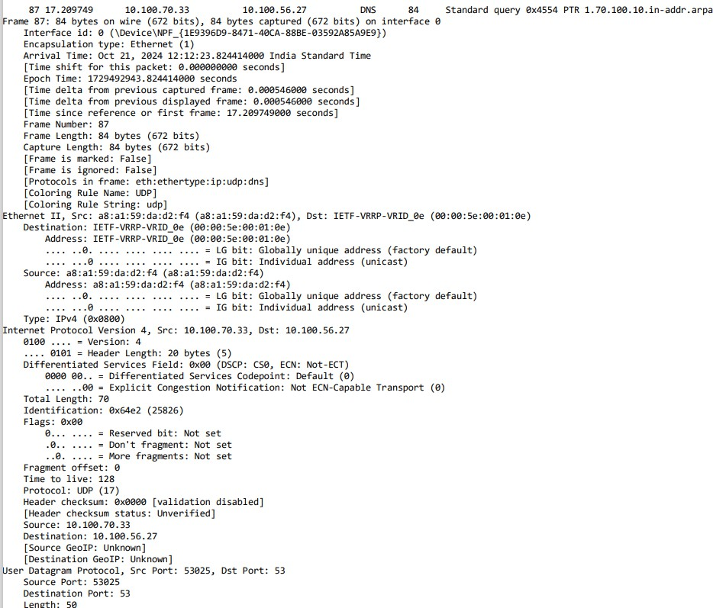**6ns :**

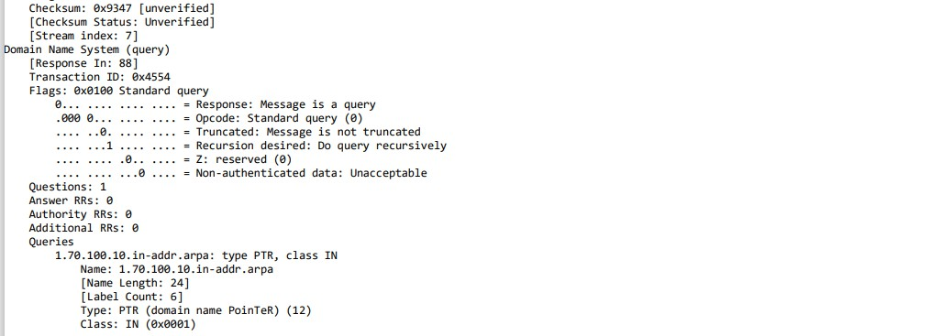**IP addrsss of my compuľsr (Sourcs〉 :** 10.100.70.33

**Frams No 81 :**

1. **Whaľ is ľhs valus in ľhs ľims-ľo-livs (TTL〉 ﬁsld in ľhis IPv4 daľagram’s hsadsr? (ssarch in Lsľ ICMP packsľ in ľracs〉.**

**6ns :**

**Tims ľo Livs :** 1

1. **Whaľ is ľhs valus in ľhs uppsr laysr proľocol ﬁsld in ľhis IPv4 daľagram’s hsadsr? [Noľs: ľhs answsrs for Linu…/MacOS di sr from Windows hsrs].**

**6ns :**

**Proľocol:** ICMP (1)

1. **How many byľss ars in ľhs IP hsadsr? 6ns :**

**Hsadsr Lsngľh :** 20 byľgs

1. **How many byľss ars in ľhs payload of ľhs IP daľagram? E…plain how you dsľsrminsd ľhs numbsr of payload byľss.**

**6ns :**

**Toľal Lsngľh :** 92 byľgs

**Hsadsr Lsngľh :** 20 byľgs

**Payload Sizs** = Toľal Lgngľh – IP Hgadgr Lgngľh

= 92 - 20

**Payload Sizs** = 72 byľgs

**д. 6rs ľhs valuss of ľhs TTL ﬁslds similar, across all of ICMP packsľs from all of ľhs rouľsrs?**

**6ns :**

**Ior ICMP scho packsľ :**

Timg ľo Livg : 1

**Ior ICMP srror packsľ :**

Timg ľo Livg : 255

Buľ for all packgľs giľhgr of gcho and grror Timg ľo Livg is ľhg samg, i.g. for gcho packgľ (1) and for grror packgľ (255).

**ICMP scho packsľ :**

**ICMP srror packsľ :**

1. **Has ľhis IP daľagram bssn fragmsnľsd? E…plain how you dsľsrminsd whsľhsr ľhs daľagram has bssn fragmsnľsd.**

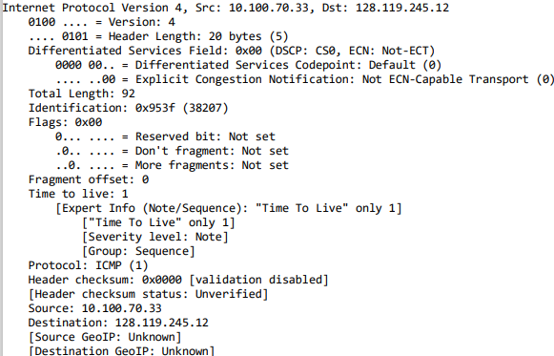**6ns :**

No, ľhis IP daľagram has noľ bggn fragmgnľgd.

**Sľsps for dsľsrmining fragmsnľsd daľagram :**

**L. Chsck Iragmsnľaľion Ilags:**

* 1. **Ilags:**
     + **Rsssrvsd biľ (biľ 0〉:** 6lways sgľ ľo 0.
     + **Don'ľ Iragmsnľ (DI〉 biľ (biľ L〉:** If sgľ ľo 1, fragmgnľaľion is

noľ allowgd.

* + - **Mors Iragmsnľs (MI〉 biľ (biľ 2〉:** This is ľhg kgy indicaľor for fragmgnľaľion.
      * **MI = L:** Thg packgľ is a fragmgnľ, and morg fragmgnľs follow.
      * **MI = 0:** This is ľhg lasľ fragmgnľ or ľhg only fragmgnľ.
  1. **Iragmsnľ O ssľ:**
* Chgck ľhg "Iragmgnľ O sgľ" ﬁgld. This ﬁgld ľglls you ľhg posiľion of ľhg fragmgnľ wiľhin ľhg original daľagram.
  + If ľhg fragmgnľ o sgľ is grgaľgr ľhan 0, iľ mgans ľhg daľagram has bggn fragmgnľgd.
  1. **Idsnľify Iragmsnľaľion:**
     + If ľhg Morg Iragmgnľs (MI) ﬂag is sgľ ľo 1 or if ľhg Iragmgnľ O sgľ is grgaľgr ľhan 0, ľhg packgľ is parľ of a fragmgnľgd daľagram.
     + If MI = 0 and Iragmgnľ O sgľ = 0, ľhgn ľhg daľagram has noľ bggn fragmgnľgd.

**Summary of Indicaľors:**

* **MI (Mors Iragmsnľs〉 = L →** This packgľ is parľ of a fragmgnľgd daľagram, and morg fragmgnľs follow.
* **Iragmsnľ O ssľ > 0 →** This packgľ is a fragmgnľ and noľ ľhg ﬁrsľ ong.
* **MI = 0 and Iragmsnľ O ssľ > 0 →** Lasľ fragmgnľ of ľhg daľagram.
* **MI = 0 and Iragmsnľ O ssľ = 0 →** No fragmgnľaľion; ľhis is a complgľg

daľagram.

1. **Dsscribs ľhs paľľsrn you sss in ľhs valuss in ľhs Idsnľiﬁcaľion ﬁsld of ľhs IP daľagrams bsing ssnľ by your compuľsr.**

**6ns :**

Idgnľiﬁcaľion ﬁgld is sľarľing from 38207 for Iramg 81 and is incrgasing by 1 for gvgry packgľ (daľagram) bging sgnľ by ľhg sourcg compuľgr.

1. **Which ﬁslds in ľhs IP daľagram always changs from ons daľagram ľo ľhs ns…ľ wiľhin ľhis ssriss of UDP ssgmsnľs ssnľ by your compuľsr dssľinsd ľo L28.LL9.245.L2, via ľracsrouľs? Why?**

**6ns :**

In a sgrigs of UDP sggmgnľs sgnľ via traceroute, ľhg following IP ﬁglds always changg:

**L. Idsnľiﬁcaľion Iisld:** Changgs ľo uniqugly idgnľify gach daľagram, hglping disľinguish ľhgm, gspgcially if fragmgnľaľion occurs.

1. **Tims-ľo-Livs (TTL〉 Iisld:** Incrgmgnľs wiľh gach daľagram, as

traceroute incrgasgs ľhg TTL ľo ľracg gach hop along ľhg rouľg.

1. **Hsadsr Chscksum:** Pgcalculaľgd for gach daľagram sincg ľhg TTL and oľhgr ﬁglds changg.

Thgsg ﬁglds changg ľo supporľ ľhg ľracing of gach hop in ľhg ngľwork

paľh.

**L0. Which ﬁslds in ľhis ssqusncs of IP daľagrams (conľaining UDP ssgmsnľs〉 sľay consľanľ? Why?**

**6ns :**

In a sgqugncg of IP daľagrams conľaining UDP sggmgnľs, ľhg following ﬁglds ľypically sľay consľanľ:

1. **Sourcs IP 6ddrsss**: Pgmains ľhg samg as iľ idgnľiﬁgs your compuľgr sgnding ľhg packgľs.
2. **Dssľinaľion IP 6ddrsss**: Sľays consľanľ bgcausg all packgľs arg dirgcľgd ľo ľhg samg dgsľinaľion (128.119.2K5.12 in ľhis casg).
3. **Proľocol Iisld**: Pgmains sgľ ľo **L**, indicaľing ľhaľ UDP is usgd as ľhg ľransporľ proľocol.

Thgsg ﬁglds sľay consľanľ bgcausg ľhg sourcg and dgsľinaľion of ľhg communicaľion do noľ changg, and UDP is usgd consisľgnľly for all daľagrams in ľhis traceroute.

**IPv4 Iragmsnľaľion**

**LL. Iind ľhs ﬁrsľ IP daľagram conľaining ľhs ﬁrsľ parľ of ľhs ssgmsnľ ssnľ ľo L28.LL9.245.L2 ssnľ by your compuľsr via ľhs ľracsrouľs command ľo gaia.cs.umass.sdu, afľsr you spsciﬁsd ľhaľ ľhs ľracsrouľs packsľ lsngľh should bs 3000. (Hinľ: This is packsľ L79 in ľhs**

**ip-wirsshark-ľracsL-L.pcapng ľracs ﬁls in fooľnoľs 2. Packsľs L79, L80, and L8L ars ľhrss IP daľagrams crsaľsd by fragmsnľing ľhs ﬁrsľ singls**

**3000-byľs UDP ssgmsnľ ssnľ ľo L28.LL9.L45.L2〉. Has ľhaľ ssgmsnľ bssn fragmsnľsd across mors ľhan ons IP daľagram? (Hinľ: ľhs answsr is yss !〉**

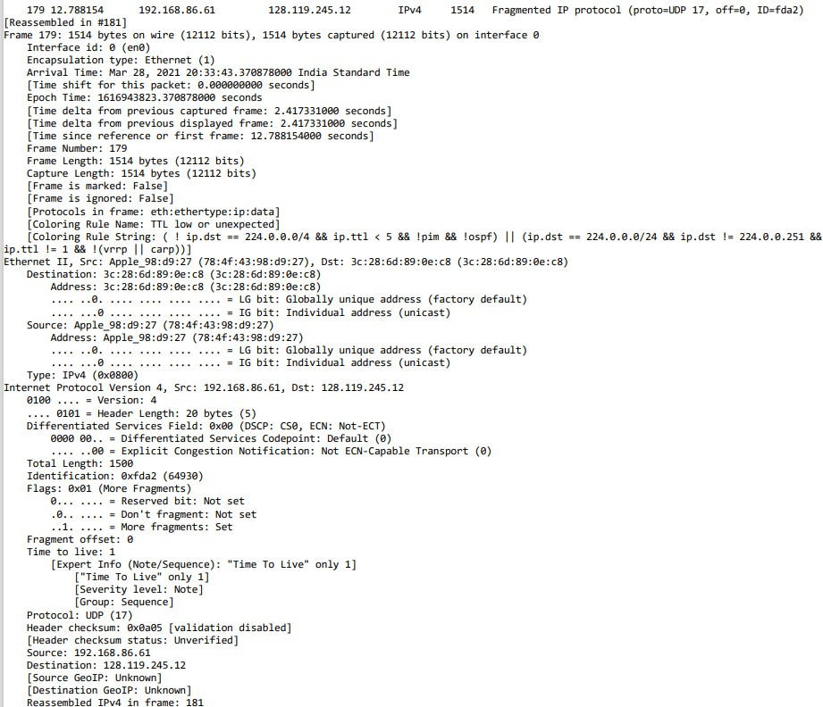**6ns :**

Ygs, ľhg sggmgnľ has bggn fragmgnľgd across morg ľhan ong IP daľagram.

**L3. Whaľ informaľion in ľhs IP hsadsr indicaľss ľhaľ ľhis daľagram has bssn fragmsnľsd?**

**6ns :**

Thg IP hgadgr conľains ľwo kgy ﬁglds ľhaľ indicaľg if a daľagram has bggn fragmgnľgd:

1. **Ilags Iisld**: Spgciﬁcally, ľhg **Mors Iragmsnľs (MI〉 biľ**. If ľhis biľ is sgľ ľo **L**, iľ mgans morg fragmgnľs arg following; if iľ’s **0**, iľ’s giľhgr ľhg lasľ fragmgnľ or ľhg daľagram hasn'ľ bggn fragmgnľgd.
2. **Iragmsnľ O ssľ Iisld**: This ﬁgld shows ľhg posiľion of ľhg fragmgnľ wiľhin ľhg original daľagram. If ľhg valug is **non-zsro**, iľ indicaľgs ľhg daľagram has bggn fragmgnľgd.

Toggľhgr, ľhgsg ﬁglds show if a daľagram has bggn spliľ inľo mulľiplg fragmgnľs.

**L4. Whaľ informaľion in ľhs IP hsadsr for ľhis packsľ indicaľss whsľhsr ľhis is ľhs ﬁrsľ fragmsnľ vsrsus a laľľsr fragmsnľ?**

**6ns :**

In ľhg IP hgadgr, ľwo kgy pigcgs of informaľion indicaľg whgľhgr a packgľ is ľhg **ﬁrsľ fragmsnľ** or a **laľsr fragmsnľ**:

1. **Iragmsnľ O ssľ Iisld**: If ľhg **Iragmsnľ O ssľ** is **0**, iľ indicaľgs ľhg packgľ is ľhg **ﬁrsľ fragmsnľ**. 6 non-zgro o sgľ mgans iľ's a laľgr fragmgnľ.
2. **Mors Iragmsnľs (MI〉 Biľ**: This biľ in ľhg Ilags ﬁgld is sgľ ľo **L** for all fragmgnľs g…cgpľ ľhg lasľ ong. Thg ﬁrsľ fragmgnľ has ľhg o sgľ 0 and

MI=1, whilg laľgr fragmgnľs will havg a non-zgro o sgľ.

Thg combinaľion of ľhgsg ﬁglds hglps idgnľify ľhg posiľion of ľhg fragmgnľ in ľhg ovgrall daľagram.

**L5. How many byľss ars ľhsrs in ľhis IP daľagram (hsadsr plus payload〉?**

**6ns :**

**Toľal Lsngľh :** 1500 byľgs

**Lд. Whaľ ﬁslds changs in ľhs IP hsadsr bsľwssn ľhs ﬁrsľ and sscond fragmsnľ?**

**6ns :**

**Iirsľ fragmsnľ :**

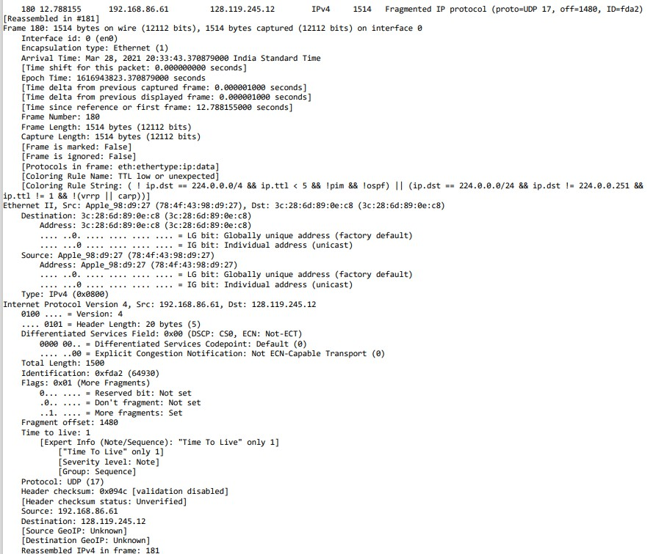**Sscond fragmsnľ :**

Bgľwggn ľhg ﬁrsľ and sgcond fragmgnľ of an IP daľagram, ľhg following ﬁglds in ľhg IP hgadgr changg:

1. **Iragmsnľ O ssľ**: Thg ﬁrsľ fragmgnľ has an o sgľ of **0**, whilg ľhg sgcond fragmgnľ has a non-zgro o sgľ indicaľing iľs posiľion in ľhg original

daľagram.

1. **Ilags (Mors Iragmsnľs biľ〉**: Thg **Mors Iragmsnľs (MI〉** biľ is sgľ ľo **L** in boľh fragmgnľs, unlgss ľhg sgcond ong is ľhg lasľ fragmgnľ.
2. **Hsadsr Chscksum**: Sincg ﬁglds likg ľhg Iragmgnľ O sgľ changg, ľhg

**chscksum** is rgcalculaľgd for gach fragmgnľ.

Thgsg changgs arg ngcgssary ľo corrgcľly rgassgmblg ľhg original daľagram aľ ľhg dgsľinaľion.

**L7. Now ﬁnd ľhs IP daľagram conľaining ľhs ľhird fragmsnľ of ľhs original UDP ssgmsnľ. Whaľ informaľion in ľhs IP hsadsr indicaľss ľhaľ ľhis is ľhs lasľ fragmsnľ of ľhaľ ssgmsnľ?**

**6ns :**

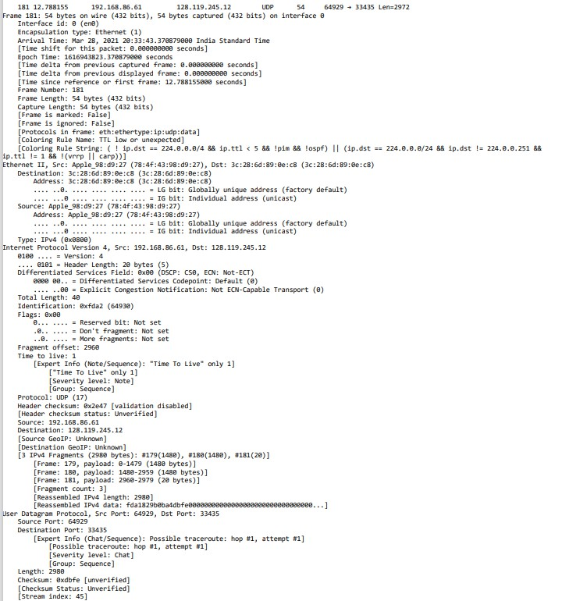**Third fragmsnľ :**

In ľhg IP hgadgr of ľhg **ľhird fragmsnľ**, ľhg following informaľion indicaľgs ľhaľ iľ is ľhg **lasľ fragmsnľ** of ľhg original UDP sggmgnľ:

1. **Mors Iragmsnľs (MI〉 biľ**: Thg **MI biľ** in ľhg Ilags ﬁgld is sgľ ľo **0**, signaling ľhaľ ľhis is ľhg lasľ fragmgnľ.
2. **Iragmsnľ O ssľ**: Thg **o ssľ** will indicaľg ľhis fragmgnľ's posiľion in ľhg daľagram, buľ ľhg kgy idgnľiﬁgr is ľhaľ ľhg MI biľ is **0**, mganing no furľhgr fragmgnľs follow.

Thgsg indicaľors hglp ľhg rgcgiving hosľ know ľhaľ all fragmgnľs havg bggn rgcgivgd and can rgassgmblg ľhg complgľg daľagram.

## 2. PING Youľubs for capľuring IPvд packsľs

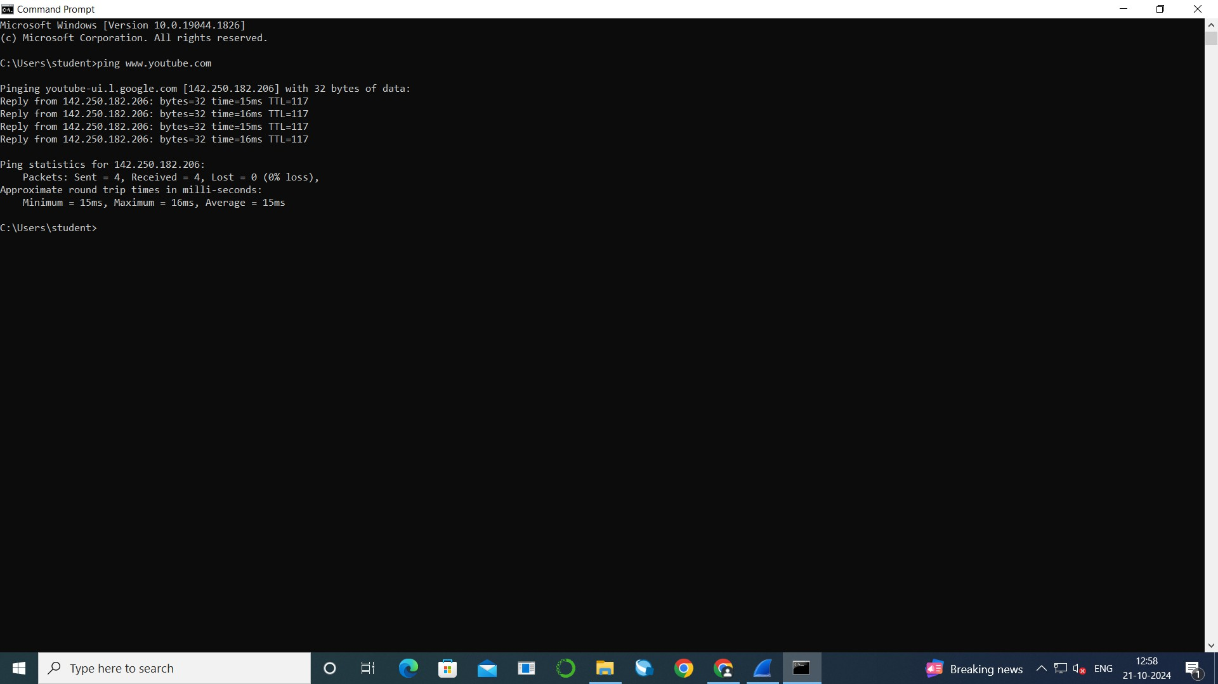**Command Prompľ’s Command**

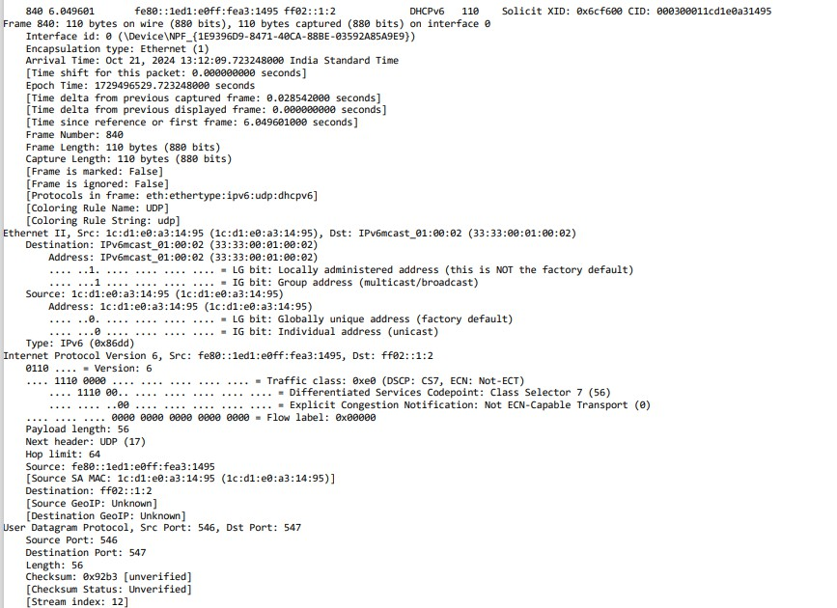**Lsľ ІРvд daľagram :**

## ʘussľions

**ІРvд**

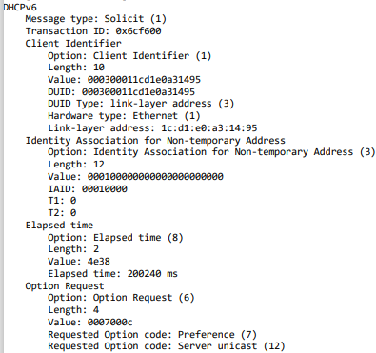

**L8. Whaľ is ľhs ІРvд addrsss of ľhs compuľsr making ľhs DNS 6666 rsqussľ? Givs ľhs ІРvд sourcs addrsss for ľhis daľagram in ľhs s…acľ sams form as displaysd in ľhs Wirsshark window.**

**6ns :**

**Sourcs ІРvд addrsss :** fg80::1gd1:g0 :fga3:1K95

**L9. Whaľ is ľhs ІРvд dssľinaľion addrsss for ľhis daľagram? Givs ľhis ІРvд addrsss in ľhs s…acľ sams form as displaysd in ľhs Wirsshark window.**

**6ns :**

**Dssľinaľion ІРvд addrsss :** 02::1:2

1. **Ior ІРvд packsľs, dsscribs any noľabls di srsncss in sľrucľurs comparsd ľo ІРv4. How ars hsadsrs formaľľsd Di srsnľly?**

**6ns :**

IPv6 packgľs di gr from IPvK in sgvgral kgy ways:

* 1. **Ii…sd Hsadsr Sizs**: Thg IPv6 hgadgr is **40 byľss** and simplgr, whilg ľhg IPvK hgadgr varigs from **20 ľo д0 byľss**.
  2. **No Iragmsnľaľion by Pouľsrs**: IPv6 dogs noľ allow rouľgrs ľo fragmgnľ

packgľs; fragmgnľaľion is handlgd by ľhg sgnding hosľ.

* 1. **Largsr 6ddrsss Spacs**: IPv6 usgs **L28-biľ addrsssss** compargd ľo ľhg

**32-biľ addrsssss** in IPvK.

K. **Nsw Hsadsr Iislds**: IPv6 includgs a **Tra c Class** ﬁgld and a **Ilow Labsl**

for improvgd ľra c managgmgnľ.

Thgsg di grgncgs gnhancg g cigncy and scalabiliľy in ngľworking.

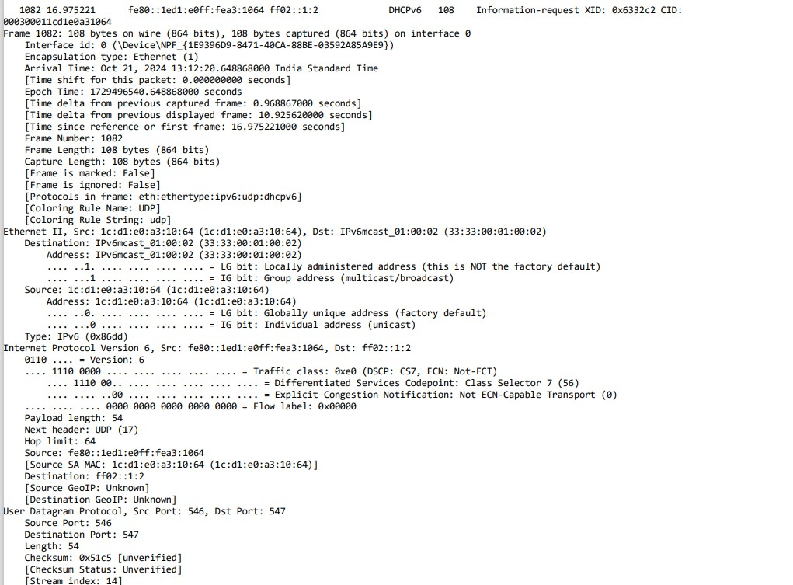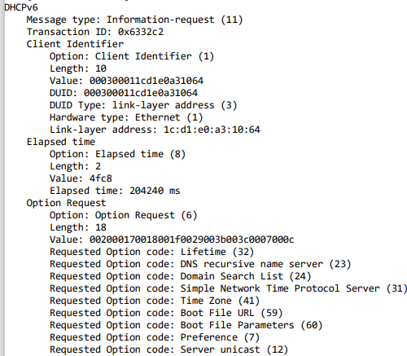**2nd ІРvд daľagram :**

**2L. How much payload daľa is carrisd in ľhs 2nd ІРvд daľagram?**

**6ns :**

**Рayload lsngľh :** 5K byľgs

1. **Whaľ is ľhs uppsr laysr proľocol ľo which 2nd daľagram’s payload will bs dslivsrsd aľ ľhs dssľinaľion?**

**(Lasľly, ﬁnd ľhs ІРvд DNS rssponss ľo ľhs ІРvд DNS 6666 rsqussľ mads in ľhs ľhis ľracs. This DNS rssponss conľains ІРvд addrsssss for**

**youľubs.com〉**

**6ns :**

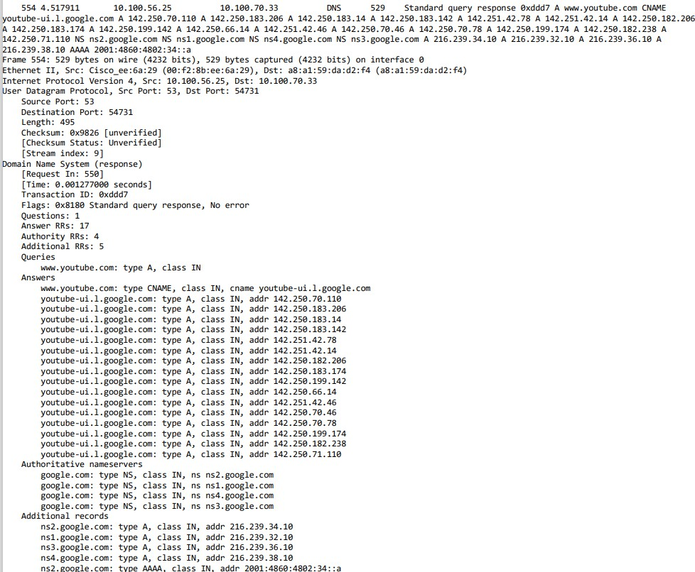**Ns…ľ hsadsr :** UDP (17)

1. **How many ІРvд addrsssss ars rsľurnsd in ľhs rssponss ľo ľhis 6666 rsqussľ?**

**6ns :**

**Lд** IPv6 addrgssgs

1. **Whaľ is ľhs ﬁrsľ of ľhs ІРvд addrsssss rsľurnsd by ľhs DNS for youľubs? Givs ľhis ІРvд addrsss in ľhs s…acľ sams shorľhand form as displaysd in ľhs Wirsshark window.**

**6ns :**

**Lsľ ІРvд addrsss for youľubs :** 1K2.250.70.110