**MOCK END-TERM EXAMINATION**

**EL 401 SEMICONDUCTOR DEVICES**

**Q1.** Calculate the The built-in potential (Vbi) of the PN Junction diode?

(Take ND=1014 cm−3, NA=1016 cm−3  ni=1010 cm−3, ϵs=11.8 and kT=26 meV)

Q2. For P-type semiconductor, EfP-Ei = 0.25 eV, calculate the number of HOLES in the material?

Q3.

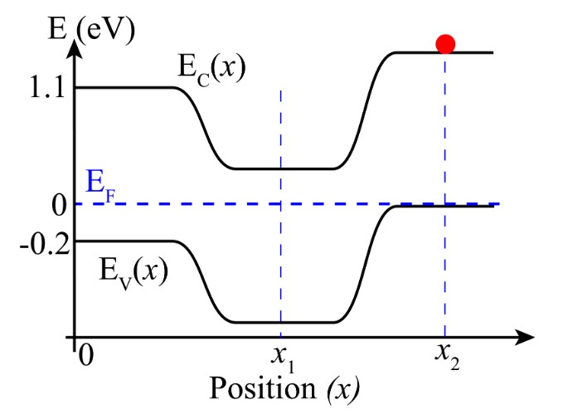

What is KE of electron at point X2?

Q4.

Consider a p1 — p2 silicon ”isotype” junction with a doping profile as shown in the figure below. Choose the correct band diagram representing the junction from the options given below.

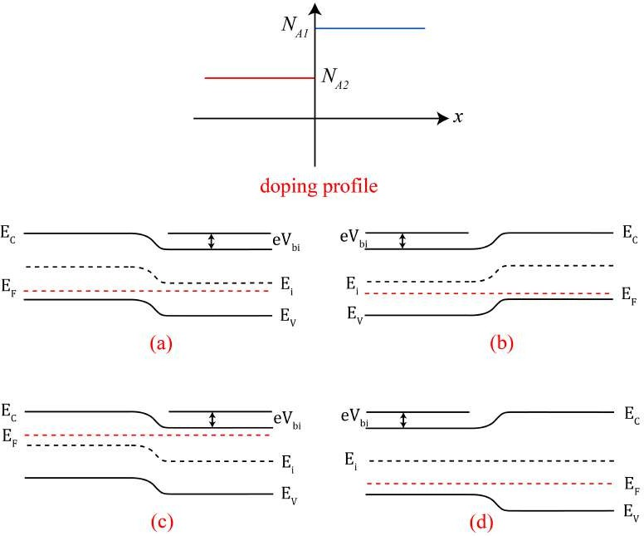

Ans = B

Q5.

The doping concentrations in an abrupt silicon pn junction at T = 300 K are N*a* = 1012 cm*—*3 and N*d* = 1016 cm*—*3. Take the intrinsic concentration of undoped silicon as n*i* = 1 ⇥ 1010 cm*—*3, kT/q = 25 mV at 300 K, ✏*Si* = 11.9, ✏0 = 8.85 ⇥ 10*—*14 Fcm*—*1, and the depletion width (w) of the pn junction as 24.6 µm.

Q6. The doping profile of a hypothetical silicon pn junction is shown in the figure below. Based on the doping profile, answer the questions that follow.

