Programming with Python & Problem Solving
(05MC0107)
Lab Manual (2026-27)

Program: M.C.A.
Semester: 1
Name of the Student: Maheta Kunjal Vijaybhai Enrolment No.: 92600584022

INDEX

Lab | Program | Date | Remarks | Signature
1 | Write a program to demonstrate basic input and output operations in Python.
2 | Write a program to illustrate the use of different data types and type casting.
3 | Write a program to perform arithmetic relational and logical operations using Python operators.
4 | Write a program to demonstrate string operations including slicing formatting and built-in string functions.
5 | Write a program to create and manipulate lists using indexing slicing and list comprehensions.
6 | Write a program to illustrate the use of tuples and sets with basic operations.
7 | Write a program to create a dictionary and demonstrate dictionary methods and iteration.
8 | Write a program to explain mutable and immutable objects in Python.
9 | Write a program to define and use userdefined functions with different types of arguments.
10 | Write a program to demonstrate recursion using factorial or Fibonacci series.
11 | Write a program to demonstrate conditional statements using if if-else and if-elif-else.
12 | Write a program to check whether a number is  positive negative or zero using nested conditions.
13 | Write a program to generate a multiplication table using a for loop.
14 | Write a program to find the sum of digits of a number using a while loop.
15 | Write a program to demonstrate the use of break continue and pass statements.
16 | Write a program to iterate over lists strings and dictionaries using loops.
17 | Write a program to demonstrate list dictionary and set comprehensions.
18 | Write a program to illustrate variable scope using local global and nonlocal variables.
19 | Write a program to demonstrate iterators and
 | iterables in Python.
20 | Write a program to generate a sequence of numbers using generator functions and yield keyword.
21
22
23
24
25
26
27
28
29
30
31
32
33
34
35
36
37
38
39
40
41
42
43
44
45
46
47
48
49
50

Practical No. 1
Write a program to demonstrate basic input and output operations in Python.

Aim/ Objective:
To write a Python program that demonstrates basic input and output operations, by accepting a number from the user using input() and displaying it using print().

Source Code:
# Write a program to demonstrate basic input and output operations in Python.

a=input("Enter A number:")
print("The number is :",a)

Output:
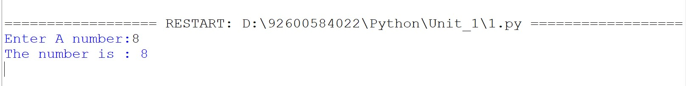
Conclusion:
Thus, the Python program successfully demonstrates basic input and output operations. The program takes a number as input from the user and displays the entered number as output.

Practical No. 2
Write a program to illustrate the use of different data types and type casting.

Aim/ Objective:
To understand different data types in Python and demonstrate type casting by converting values from one data type to another.

Source Code:
# Write a program to illustrate the use of different data types and type casting.

i=10
flt=10.5
text="Hiii"
bool1=True
print("int :",i,type(i))
print("float :",flt,type(flt))
print("text :",text,type(text))
print("bool :",bool1,type(bool1))
print()
print("Type casting")
a=20
b=float(a)
c=str(b)
d=bool(c
print("Integer to float :",b,type(b))
print("Float to String :",c,type(c))
print("String to Bool :",d,type(d))

Output:

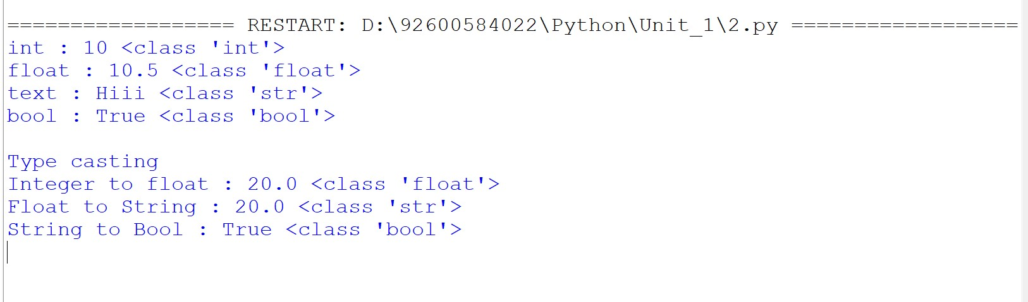
Conclusion :
The program successfully demonstrates Python data types and type casting.

Practical No. 3
Write a program to perform arithmetic relational and logical operations using Python operators.

Aim/ Objective:
To perform and understand arithmetic, relational, and logical operations using Python operators.

Source Code:

# Write a program to perform arithmetic relational and logical operations using Python operator

print("Arithmetic operators")
a=10
b=3
print()
print("Addition :",a+b)
print("Subtraction :",a-b)
print("Multiplication :",a*b)
print("Division :",a/b)
print("Modulus :",a%b)
print("Exponentation :",a**b)
print("Floor division :",a//b)
print()
print("Relational operators")
print()
print("Equal to :",a==b)
print("Not equal to:",a!=b)
print("Less than:",a<b)
print("Greater than:",a>b)
print("Less than equal to:",a<=b)
print("Greater than equal to:",a>=b
print()
print("Logical operators")
print(
print("And :",a>b and b>0)
print("Or :",a>b or b>0)
print("Not :",not(b>0))

Output:

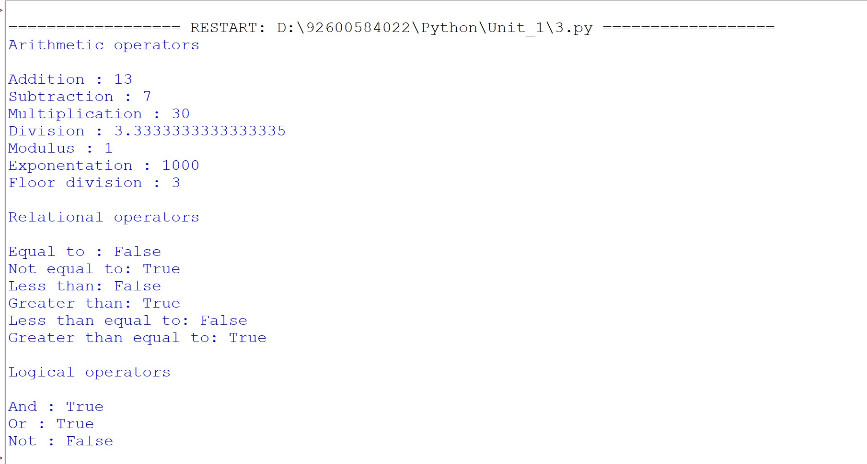

Conclusion :
The program successfully illustrates the use of various Python data types and type conversion.

Practical No. 4
Write a program to demonstrate string operations including slicing formatting and built-in string functions.

Aim/ Objective:
To write a Python program to demonstrate various string operations such as concatenation, repetition, indexing, slicing, membership, and comparison.
To demonstrate commonly used built-in string functions for manipulating and analyzing strings efficiently.

Source Code:
# Write a program to demonstrate string operations including slicing formatting and built-in string functions.

text = "Python"
print("String Operations :- ")
print("Concatenation:" + text + " Programming")
print("Repetion : " + text * 2)
print("Indexing:" + text[0])
print("Slicing :" + text[1:4])

#Membership
print("Py" in text)

# Comparison
print(text == "Python")

# Length
print(len(text))

print("====================================")
print("String built in functions :-")

text = "hello python"

print("Original String:", text)
print("Upper:", text.upper())
print("Lower:", text.lower())
print("Capitalize:", text.capitalize())
print("Title:", text.title())
print("Strip:", text.strip())
print("Replace:", text.replace("python", "World"))
print("Find 'python':", text.find("python"))
print("Count 'o':", text.count("o"))
words = text.strip().split()
print("Split:", words)
print("Join:", "-".join(words))
print("Startswith ' he':", text.startswith(" he"))
print("Endswith ' ':", text.endswith(" "))
print("Is Alpha:", "Python".isalpha())
print("Is Digit:", text.isdigit())
print("Length:", len(text))

Output:
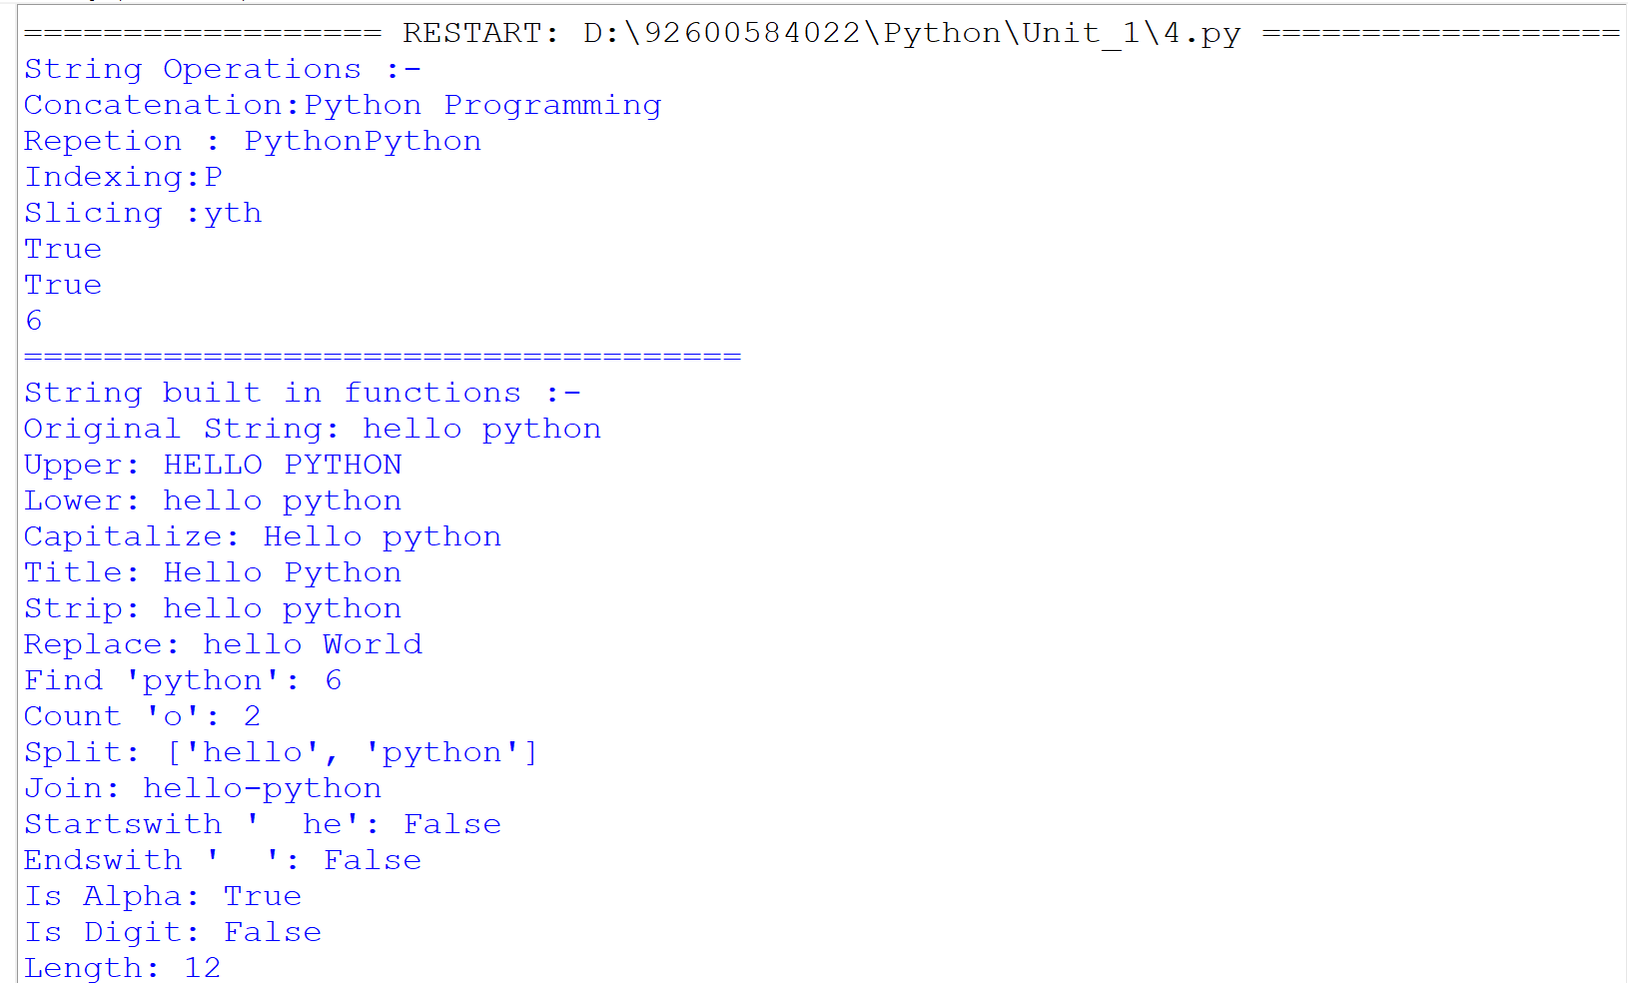

Conclusion:
Thus, the program successfully demonstrates various string operations and built-in string functions in Python. It helps in understanding how strings can be accessed, manipulated, searched, and analyzed efficiently.

Practical No. 5
Write a program to create and manipulate lists using indexing slicing and list comprehensions.
Aim/ Objective:
To write a Python program to create and manipulate lists using indexing, slicing, and list comprehensions. The program demonstrates how to access, extract, and process list elements efficiently.

Source Code:
# Write a program to create and manipulate lists using indexing slicing and list comprehensions.

college = ["MCA","MBA","MCOM","M.ED","M.PHARM"]

#indexing
print("First Field : "+college[0])
print("First Field : "+college[-1])

#slicing
print("Slice fields: ",college[2:])
print("Slice fields: ",college[2:4])
print("Slice fields: ",college[:4])

#List Comprehension
numbers = [1,2,3,4,5]
square = [x*x for x in numbers]

print("Numbers:", numbers)
print("Squares:", square)

Output:
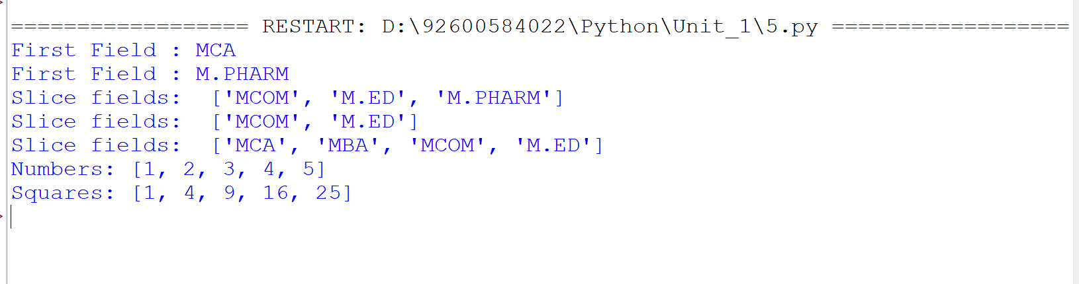

Conclusion:
Thus, the program successfully demonstrates list indexing, slicing, and list comprehension in Python. It helps in understanding how list elements can be accessed and manipulated efficiently.

Practical No. 6
Write a program to illustrate the use of tuples and sets with basic operations.

Aim/ Objective:
To understand and implement tuples and sets in Python by performing common operations on them. The program demonstrates accessing tuple elements and modifying sets using built-in operations.

Source Code:
# Write a program to illustrate the use of tuples and sets with basic operations.

t1=(10,20,"hii",2.5,'d')
print("Type :",type(t1))

print("Tuple :",t1)

print("Indexing : ",t1[0])
print("Negative Indexing : ",t1[-1])
print("Slicing : ",t1[2:5])

print("Concatenation : ",t1+("hello",20))
print("Repetition : ",t1*2)
print("Length : ",len(t1))
print("Count : ",t1.count("hii"))

s1={10,20,30,'hiii',2.3}
s1.add(25)
print(s1)
Output:
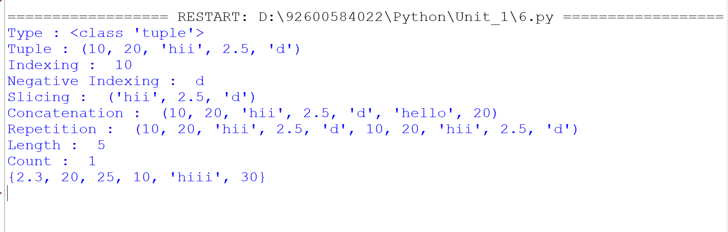

Conclusion:
The program successfully demonstrates the use of tuples and sets along with their basic operations. It provides an understanding of tuple handling and set manipulation in Python.
Practical No. 7
Write a program to create a dictionary and demonstrate dictionary methods anditeration.

Aim/ Objective:
To create and work with a dictionary in Python using different dictionary methods. The program demonstrates accessing keys and values, updating dictionary elements, and iterating through key-value pairs.

Source Code:
# Write a program to create a dictionary and demonstrate dictionary methods anditeration.

student = {
"Name": "Kunjal",
"Age": 20,
"Course": "Python"
}

print("Original Dictionary:")
print(student)

print()

print("Keys:")
print(student.keys())

print()

print("Values:")
print(student.values())

print()

print("Items:")
print(student.items())

print()

student.update({"City": "Rajkot"})
print("After Update:")
print(student)

print()
print("Iterating through Dictionary:")
for key, value in student.items():
print(key, ":", value)
Output:
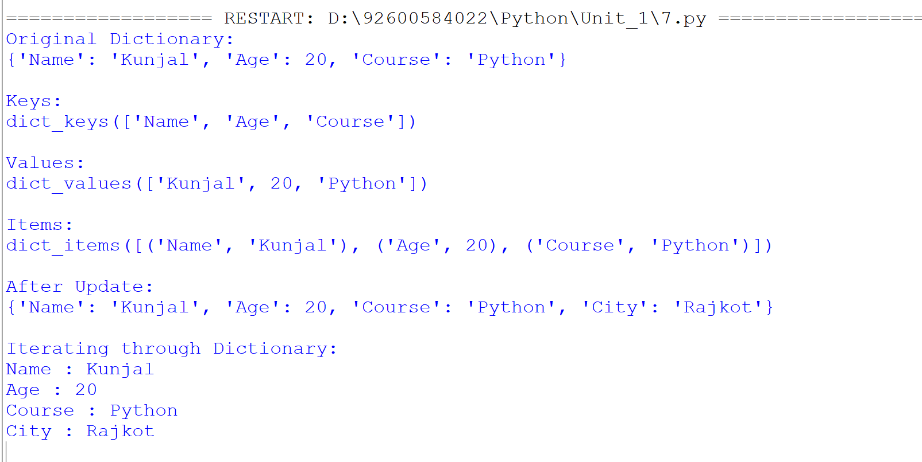

Conclusion:
The program successfully demonstrates dictionary creation, built-in methods, updating elements, and iteration in Python. It helps in understanding how data stored as key-value pairs can be accessed and processed.

Practical No. 8
Write a program to explain mutable and immutable objects in Python.

Aim/ Objective:
To understand the difference between mutable and immutable objects in Python by performing operations on different data types. The program demonstrates which objects can be changed after creation and which require a new object for modification.

Source Code:
# Write a program to explain mutable and immutable objects in Python.

print("===== MUTABLE OBJECTS =====")

# List
list1 = [10, 20, 30]
list1.append(40)
print("List:", list1)

# Dictionary
dict1 = {"Name": "Kunjal", "Age": 20}
dict1["City"] = "Rajkot"
print("Dictionary:", dict1)

# Set
set1 = {1, 2, 3}
set1.add(4)
print("Set:", set1)

print("\n===== IMMUTABLE OBJECTS =====")

# Integer
num = 10
num = num + 5
print("Integer:", num)

# Float
f = 12.5
f = f + 2.5
print("Float:", f)

# String
str1 = "Python"
str2 = str1 + " Programming"
print("Original String:", str1)
print("New String:", str2)

# Tuple
tuple1 = (10, 20, 30)
print("Tuple:", tuple1)

# Boolean
flag = True
flag = False
print("Boolean:", flag)

# Complex Number
c = 2 + 3j
c = c + 1
print("Complex:", c)

Output:
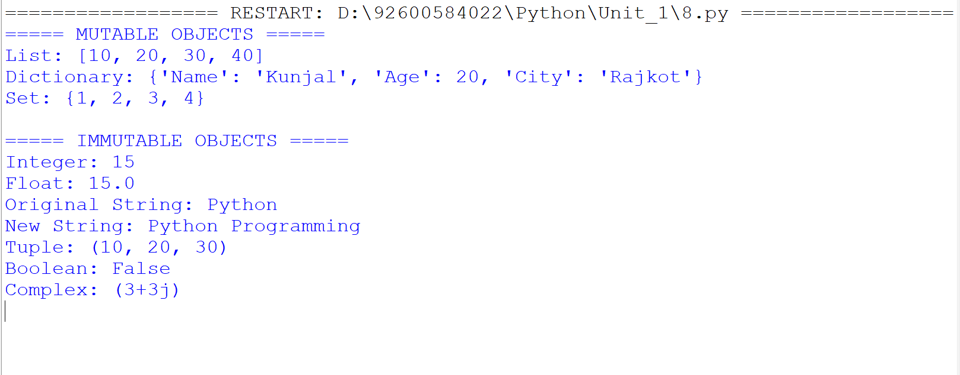

Conclusion:
The program successfully demonstrates mutable and immutable objects in Python. It shows that lists, dictionaries, and sets can be modified directly, while integers, floats, strings, tuples, booleans, and complex numbers cannot be changed directly.
Practical No. 9
Write a program to define and use user-defined functions with different types of arguments.

Aim/ Objective:
To create and use user-defined functions in Python with different types of arguments. The program demonstrates positional, keyword, default, and variable-length arguments for passing data to functions.

Source Code:
# Write a program to define and use user-defined functions with different types of arguments.

#define user-defined functions
def greetings():
print("Welcome to python...")

# 1.Positional Arguments

def add(a,b):
print("Sum:",a+b)
add(10,20)

# 2.Keyword Arguments

def student(name,surname):
print("Your name is ",name,surname)
student(name="kunjal",surname="maheta")

# 3.Default Arguments

def details(name,subject="python"):
print("welcome to ",subject,name,"!!")
details(name="Kunjal")

# 4.Variable-Length Arguments

def total(*numbers):
print(numbers)

total("kunjal","maheta")
total(10, 20, 30, 40)

Output:
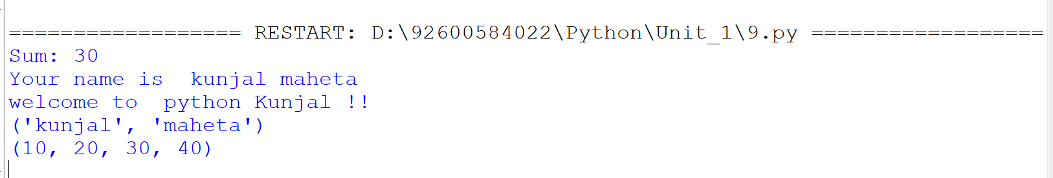

Conclusion:
The program successfully demonstrates how user-defined functions work with different types of arguments in Python. It helps in understanding flexible ways of passing values to functions and makes programs more organized and reusable.

Practical No. 10
Write a program to demonstrate recursion using factorial or Fibonacci series..

Aim/ Objective:
To write a Python program to demonstrate recursion using a factorial function. The program shows how a function can repeatedly call itself until a specified base condition is reached.

Source Code:
# Write a program to demonstrate recursion using factorial or Fibonacci series.

def factorial(n): #(3)(2)(1)
if n == 0 or n == 1: #third time it will becomes true
return 1
else:
return n * factorial(n - 1) #3*f(3-1) #2*f(2-1)

num = int(input("Enter a number: "))#3
result = factorial(num)
print("Factorial of", num, "=", result)

Output:

Conclusion:
The program successfully demonstrates the concept of recursion in Python by calculating the factorial of a number. It shows how recursive function calls continue until the base condition is satisfied.

Practical No. 11
Write a program to demonstrate conditional statements using if if-else and if-elif-else

Aim/ Objective:
To write a Python program to demonstrate the use of conditional statements for evaluating a student's result. The program uses if, if-else, and if-elif-else conditions to determine the appropriate grade based on the percentage.

Source Code:
# Write a program to demonstrate conditional statements using if if-else and if-elif-else.

name = input("Enter Student Name: ")

m1 = int(input("Enter marks of Subject 1: "))
m2 = int(input("Enter marks of Subject 2: "))
m3 = int(input("Enter marks of Subject 3: "))
m4 = int(input("Enter marks of Subject 4: "))
m5 = int(input("Enter marks of Subject 5: "))

total = m1 + m2 + m3 + m4 + m5
percentage = total / 5

print("\n----- STUDENT RESULT -----")
print("Student Name :", name)
print("Total Marks :", total, "/500")
print("Percentage :", percentage, "%")

if percentage >= 90:
print("Grade : A+")
elif percentage >= 80:
print("Grade : A")
elif percentage >= 70:
print("Grade : B")
elif percentage >= 60:
print("Grade : C")
elif percentage >= 35:
print("Grade : D")
else:
print("Grade : F (Fail)")

Output:
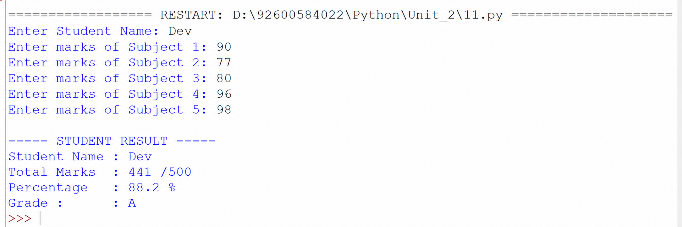

Conclusion:
The program successfully demonstrates conditional statements in Python by calculating the student's total, percentage, and grade. It shows how different conditions can be used to make decisions based on the given marks.

Practical No. 12
Write a program to check whether a number is positive negative or zero using nested conditions.

Aim/ Objective:
To write a Python program to determine whether a given number is positive, negative, or zero using conditional statements. The program demonstrates how conditions can be used to classify a number based on its value.

Source Code:
# Write a program to check whether a number is positive negative or zero using nested conditions.
a=int(input("Enter number a:"))
if a>0:
print(" You entered positive number")
elif a<0:
print("You entered is nagetive number")
else:
print("You entered is zero")

Output:
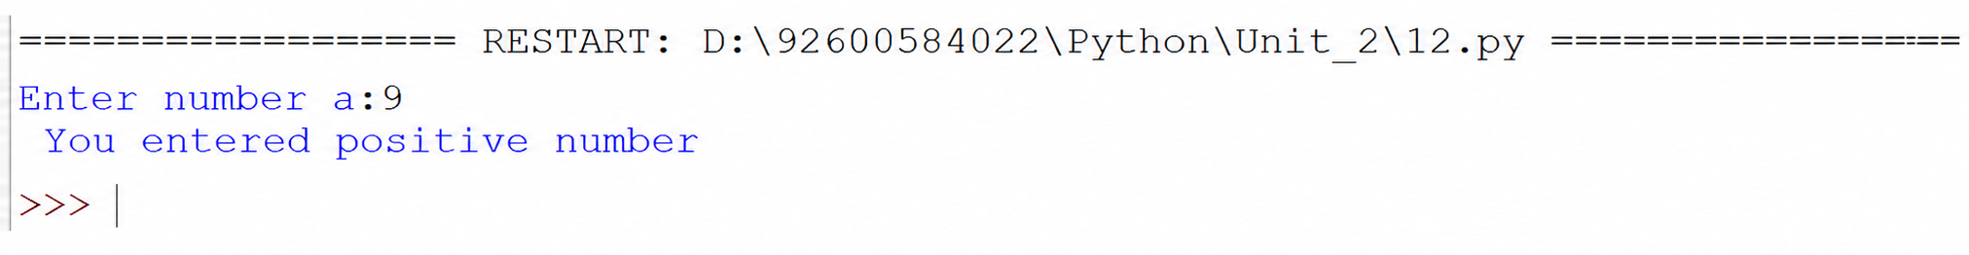

Conclusion:
The program successfully checks and identifies whether the entered number is positive, negative, or zero. It demonstrates the use of conditional statements for making decisions based on numerical values.

Practical No. 13
Write a program to generate a multiplication table using a for loop

Aim/ Objective:
To write a Python program to generate the multiplication table of a given number using a for loop. The program demonstrates repetitive calculations using iteration and supports both integer and decimal values.

Source Code:
# Write a program to generate a multiplication table using a for loop.
num = input("Enter a number: ")
if "." in num:
num = float(num)
else:
num = int(num)
for i in range(1, 11):
print(num, "*", i, "=", num * i)
Output:
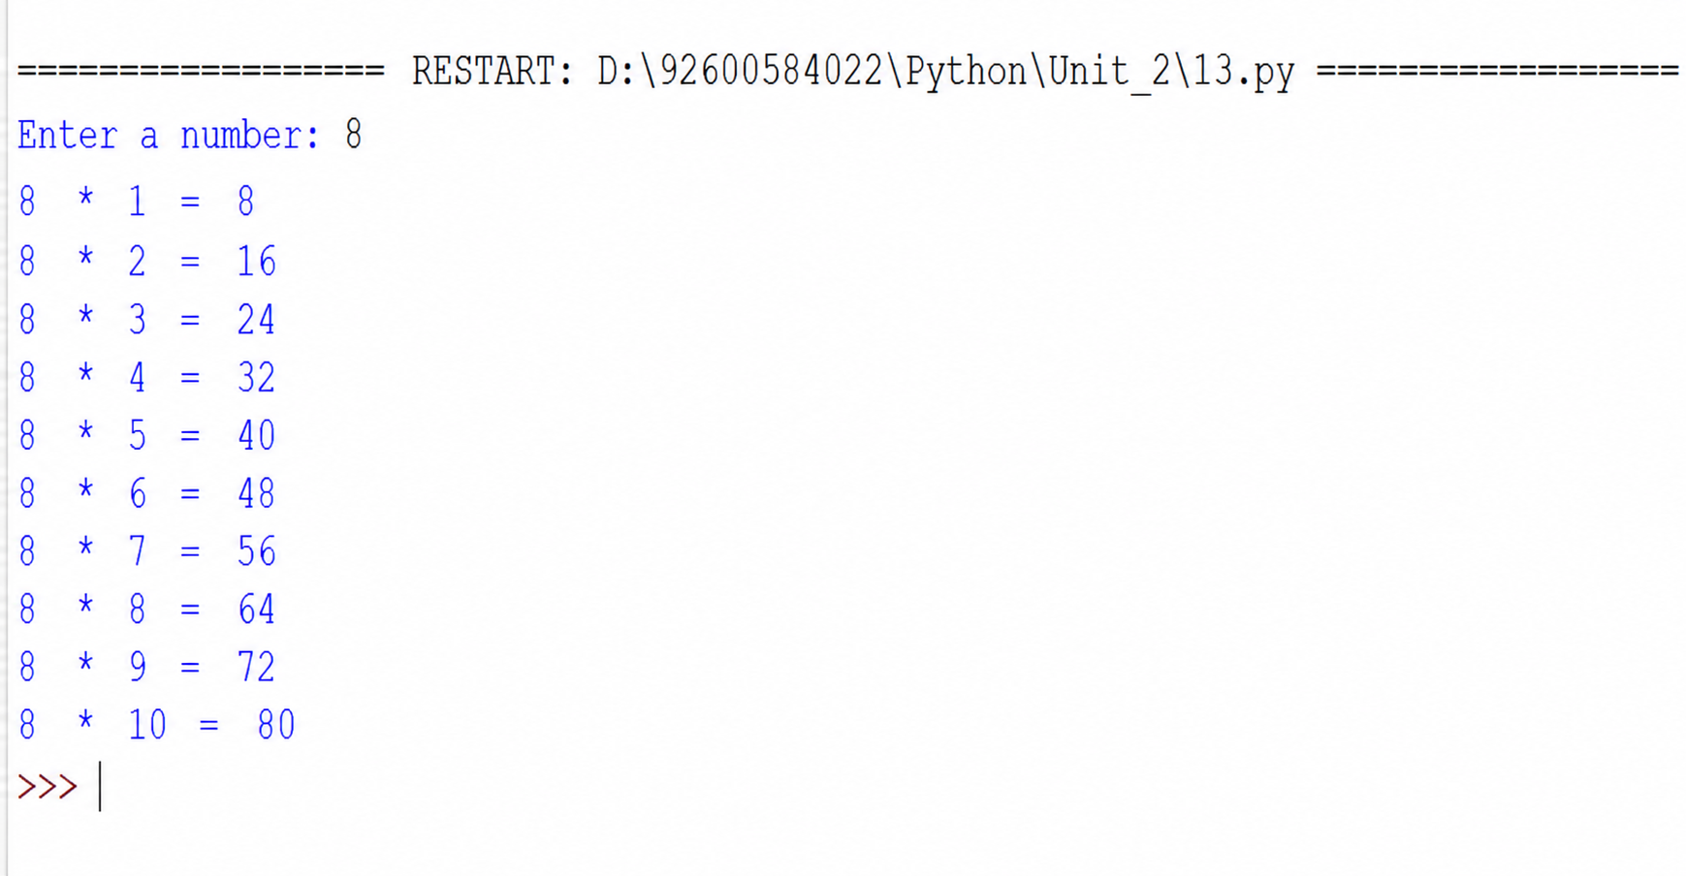
Conclusion:
The program successfully generates the multiplication table of a given number using a for loop. It demonstrates the use of iteration to perform repetitive calculations and can handle both integer and decimal numbers.

Practical No. 14
Write a program to find the sum of digits of a number using a while loop

Aim/ Objective:
To develop a Python program that calculates the sum of individual digits of a given integer using a while loop. The program also checks whether the entered value is a valid integer.

Source Code:
# Write a program to find the sum of digits of a number using a while loop.

num = input("Enter a Number: ") #1234

if num.isdigit():
num = int(num)

sum = 0

while num > 0: #1234>0
digit = num % 10 #1234%10(remainder)= 4,3,2,1
sum = sum + digit #sum=0+4= 4,7,9,10
num = num // 10 #num=1234//10= 123,12,1

print("Sum of Digits =", sum)

else:
print("Warning! Entered number must be an integer.")

Output:

Conclusion:
The program successfully finds the sum of the digits of the entered number. It demonstrates the use of a while loop along with % and // operators for processing each digit.

Practical No. 15
Write a program to demonstrate the use of break continue and pass statements
Aim/ Objective:
To write a Python program to demonstrate the working of break, continue, and pass statements. The program shows how these statements control the execution of a loop in different ways.

Source Code:
# Write a program to demonstrate the use of break continue and pass statements.

print("Break Statement")
for i in range(1, 6):
if i == 3:
break
print(i)
print("\nContinue Statement")
for i in range(1, 6):
if i == 3:
continue
print(i)
print("\nPass Statement")
for i in range(1, 6):
if i == 3:
pass
print(i)

Output:
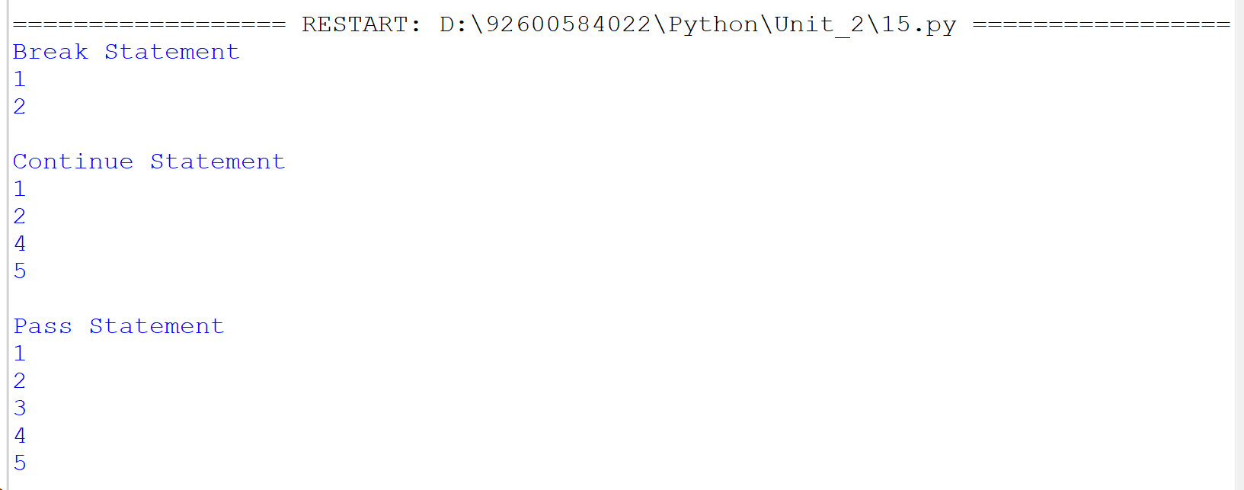
Conclusion:
The program successfully demonstrates the use of break, continue, and pass in Python. It shows that break stops the loop, continue skips the current iteration, and pass performs no action.

Practical No. 16
Write a program to iterate over lists strings and dictionaries using loops
Aim/ Objective:
To write a Python program demonstrating how loops iterate through lists, strings, and dictionaries by accessing their elements, characters, and key-value pairs sequentially.

Source Code:
# Write a program to iterate over lists strings and dictionaries using loops.

#iterate over lists
fruits=["Apple","Banana","Mango"]
print("Print Fruits:")
for i in fruits:
print(i)

#iterate over strings
name="python"
for ch in name:
print(ch)

# Iterate over a Dictionary
print("Iterating over a Dictionary:")
student = {
"Name": "Kunjal", "Age": 20,"Course": "MCA"
}

for key,value in student.items():
print(key, ":", value)
Output:
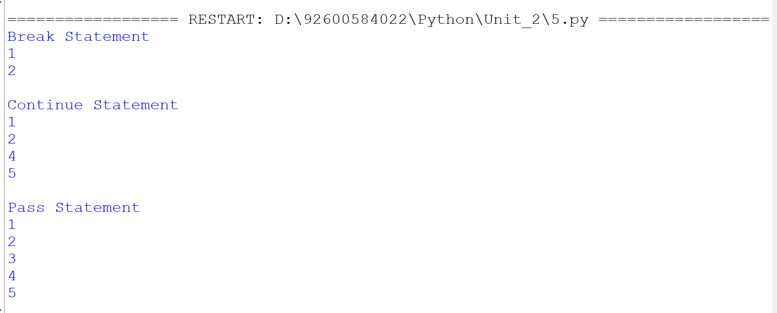
Conclusion:
The program successfully demonstrates the use of break, continue, and pass in Python. It shows that break stops the loop, continue skips the current iteration, and pass performs no action.
Practical No. 17
Write a program to demonstrate list dictionary and set comprehension
Aim/ Objective:
To write and execute a Python program to demonstrate list, dictionary, and set comprehensions for creating collections efficiently.

Source Code:
# Write a program to demonstrate list dictionary and set comprehensions.

print("List Comprehension")
numbers = [10, 20, 30, 40, 50]
square_list = [x * x for x in numbers]
print(square_list)

print()

print("Dictionary Comprehension")
square_dict = {x: x * x for x in numbers}
print(square_dict)

print()

print("Set Comprehension")
square_set = {x * x for x in numbers}
print(square_set)

Output:
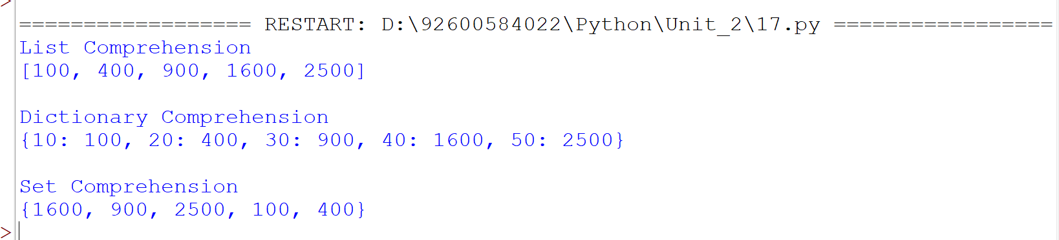
Conclusion:
The program successfully demonstrates list, dictionary, and set comprehensions in Python and shows how they can be used to generate collections from existing data in a concise and efficient manner.

Practical No. 18
Write a program to illustrate variable scope using local global and nonlocal variables.
Aim/ Objective:
To write and execute a Python program to demonstrate list, dictionary, and set comprehensions for creating collections efficiently.

Source Code:
# Write a program to illustrate variable scope using local global and nonlocal variables.

x = 10 # Global

def outer():
y = 20 # Local

def inner():
nonlocal y
y = 30 # Changes the variable of outer()
print("Nonlocal variable y =", y)
print("Global variable x =", x)

inner()
print("Local variable y =", y)
outer()
print("Global variable x =", x)

Output:

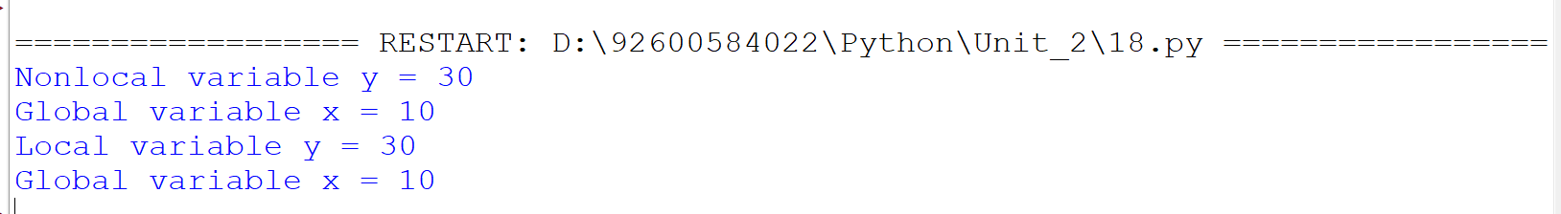
Conclusion:

The program successfully illustrates the use of local, global, and nonlocal variables in Python. It demonstrates how the nonlocal keyword modifies a variable from the enclosing function, while the global variable can be accessed from different functions.
Practical No. 19
Write a program to demonstrare iterator and iterables in python
Aim/ Objective:
To write and execute a Python program to understand iterables and iterators and demonstrate how elements can be accessed one by one using the iter() and next() functions.

Source Code:

# Write a program to demonstrate iterators and iterables in Python.

# Iterable
numbers = [10,20,30]

print("Iterable object:",numbers)

# iterator
it = iter(numbers)

print("\nElements using iterator:")
print(next(it))
print(next(it))
print(next(it))

Output:
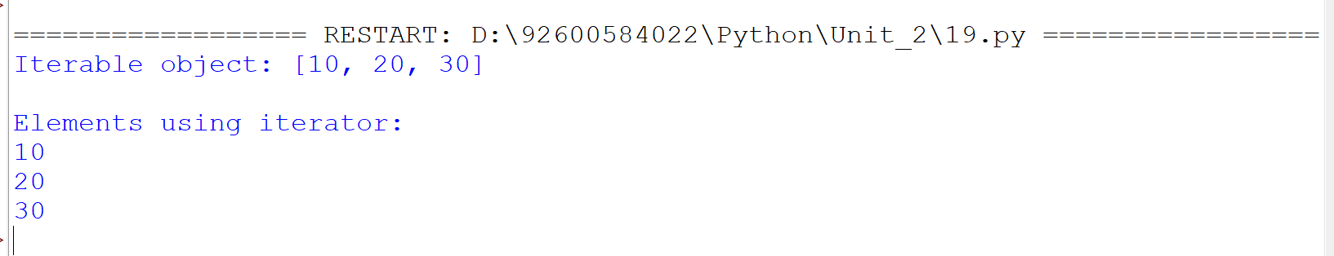
Conclusion:
The program successfully demonstrates the difference between an iterable and an iterator in Python. It shows how an iterable list can be converted into an iterator and how its elements can be retrieved sequentially using next().

Practical No. 20
Write a program to generate a sequence of numbers using generator functions and yield keyword

Aim/ Objective:
To write and execute a python program to demonstrate generator function and the yeield keyword for producing a sequence of number one at a time.

Source Code:
# Write a program to generate a sequence of numbers using generator functions and yield keyword.

def generate_numbers(n):
for i in range(1, n + 1):
yield i

n = int(input("Enter the limit: "))
numbers = generate_numbers(n)
print("Generated sequence:")
for num in numbers:
print(num)

Output:

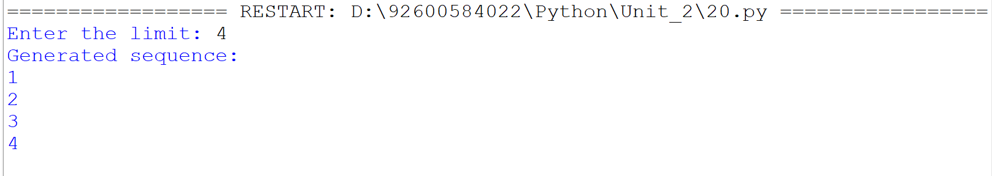
Conclusion:
The program successfully demonstrates how a generator function uses the yield keyword to generate values sequentially, allowing efficient handling of sequences without storing all the values in memory at once.

