Q1 #include <iostream>
using namespace std;
int main() {
string a,b;
cout<<"Enter two strings: ";
cin >>a;
cin >>b;
int count[26]={0};
for(int i=0; i<=a.length(); i++){
count[a[i]-'a']++;
count[b[i]-'a']--;
}
for(int i=0; i<26; i++)
if(count[i]!=0){
cout << "Not Anagram";
return 0;}
cout << "Anagram";
return 0;
}

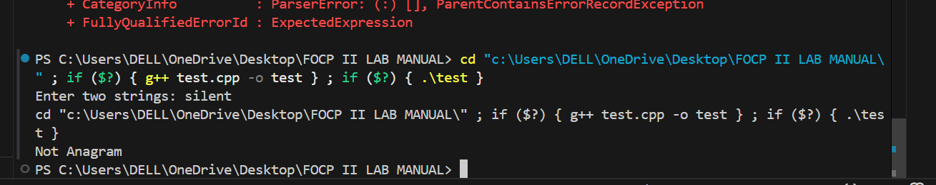
Q2 #include <iostream>

using namespace std;

int main() {
int n = 4;

for(int i = 1; i <= n; i++) {
for(int space = 1; space <= n - i; space++) {
cout << " ";
}

for(int j = 1; j < i; j++) {
cout << j;
}

for(int j = i; j >= 1; j--) {
cout << j;
}

cout << endl;
}

return 0;
}