**Project Functionality Screen**

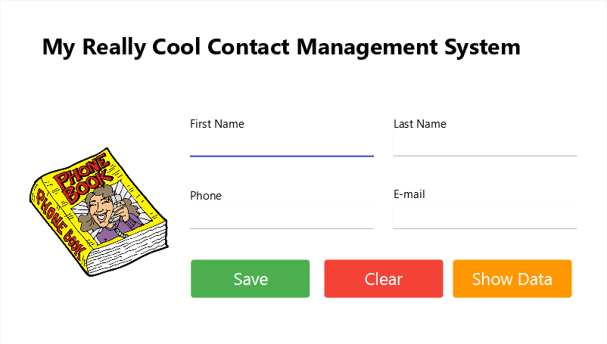

Fig 1.1 Main Screen

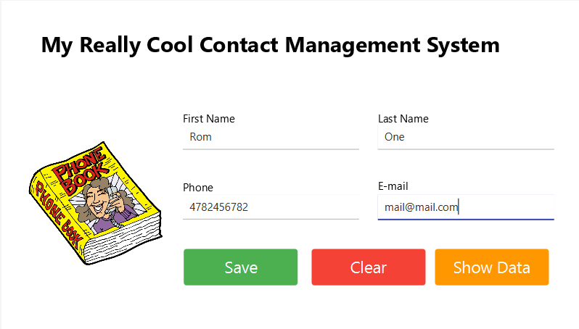

Fig 1.2 Form data

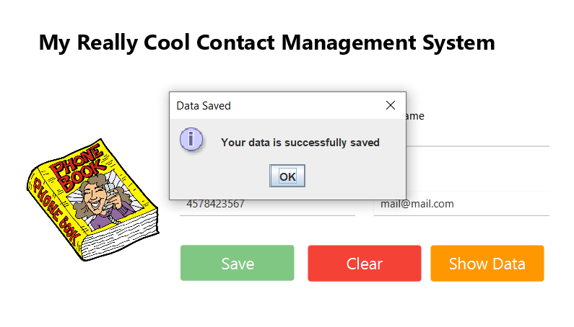

Fig 1.3 Successfully submit data

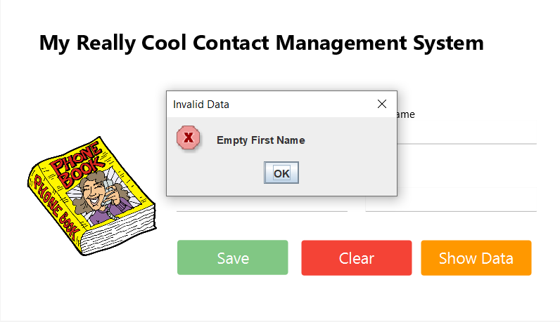

Fig 1.4 empty first name error

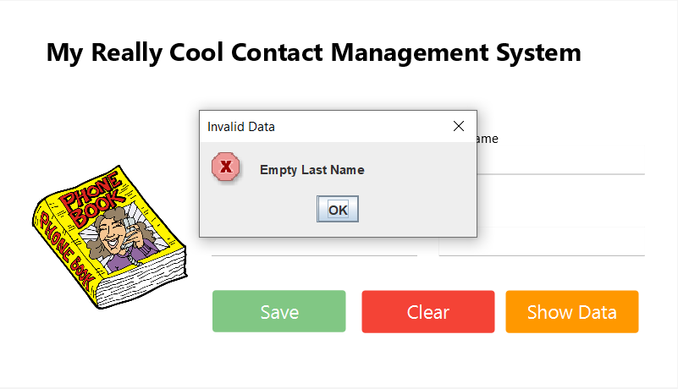

Fig 1.5 Empty last name error

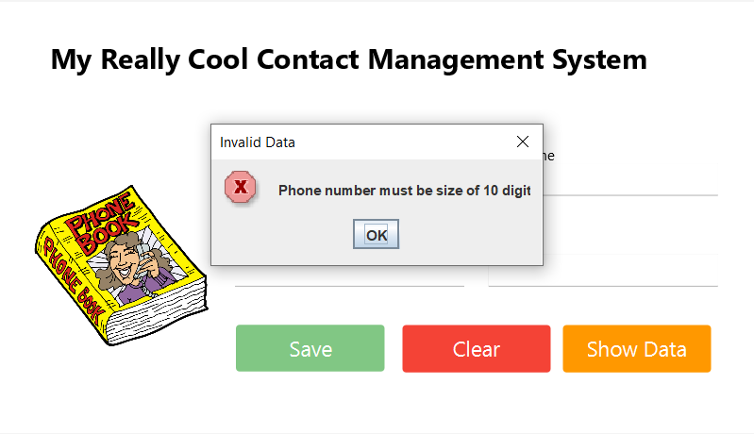

Fig 1.6 Invalid phone number size error

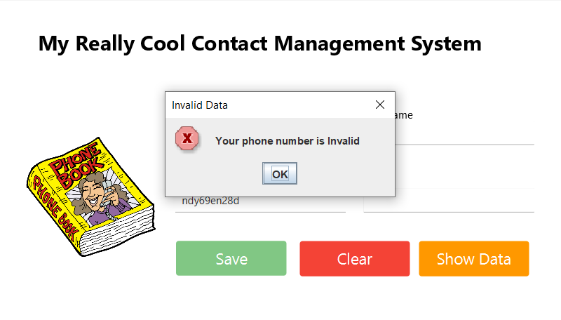

Fig 1.7 Invalid phone number error

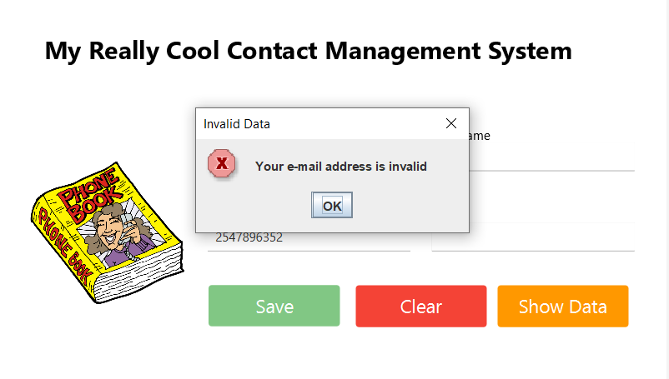

Fig 1.8 Invalid email error

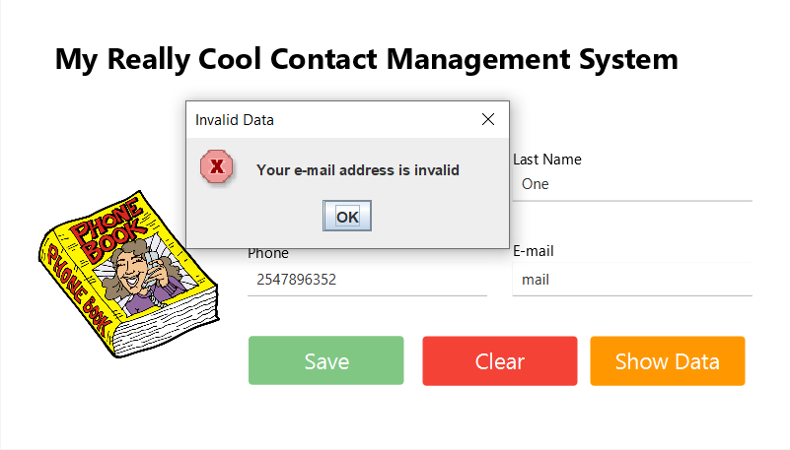

Fig 1.9 Invalid email address format error

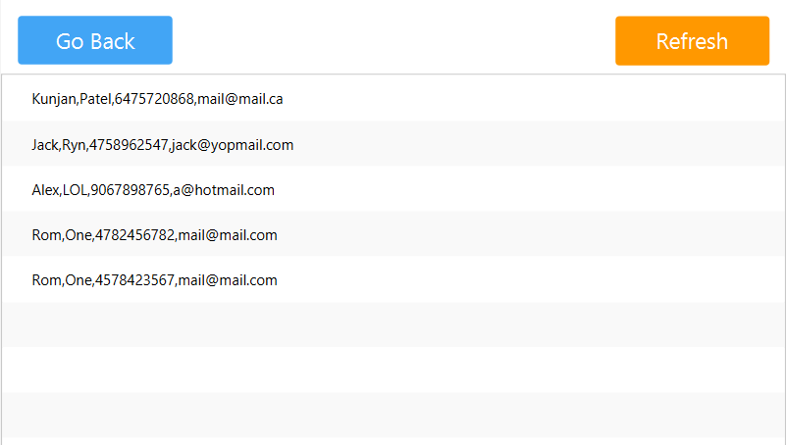

Fig 1.10 Show data screen