

Project Documentation

**DronAcharya**

(Drone Spraying service System)

Bachelors Of Information Technology (B.Sc. IT)

5th Semester

Presented By

22BSIT015 Kunj Chapadiya

22BSIT026 Vansh Dobariya

Faculty of Computer Science

Smt. Chandaben Mohanbhai Patel Institute of Computer Science

Charotar University of Science And Technology

**Table of Contents**

|  |  |  |  |
| --- | --- | --- | --- |
| **Sr. No** |  | **Subject** | **Page Number** |
| **1** |  | **Project Profile** | **03** |
| **2** |  | **Introduction to tools** | **05** |
| **3** |  | **System Study** | **07** |
|  |  | Existing System | **08** |
|  |  | Proposed System | **08** |
|  |  | Scope of the Proposed System | **09** |
|  |  | Aim and Objective of the Proposed System | **09** |
|  |  | Feasibility Study | **09** |
|  |  | Operational Feasibility | **09** |
|  |  | Technical Feasibility | **09** |
|  |  | Economical Feasibility | **09** |
| **4** |  | **System Analysis** | **10** |
|  |  | Requirements Specification (along with System Modules) | **11** |
|  |  | Use Case Diagram | **12** |
|  |  | Class Diagram | **13** |
| **5** |  | **System Design** | **14** |
|  |  | Data Dictionary | **15** |
| **6** |  | **System Testing** | **18** |
|  |  | Testing Strategies | **19** |
|  |  | Test Cases | **19** |
| **7** |  | **Future Enhancements** | **20** |
| **8** |  | **References** | **22** |

# PROJECT PROFILE

## Project Profile

**Project Name: DronAcharya** (Drone Sparying Service System)

**Type of Application:** Web Application

**Project Description:** The drone spraying service system provides service to the farmer for spraying fertilizer in the field and also analyzes crop health, information about the fertilizer, and many more functions to create a user-friendly, reliable, and improved operational efficiency of the system.

##### Team Size: 2

**Front End:** HTML, CSS, JavaScript, Bootstrap, Tailwind, jQuery

**Back End:** PHP, MySQL

**Tools used:** Vs code, Xampp

# INTRODUCTION TO TOOLS

## Introduction to Tools & Technology

### Front End:

* + - * In web development, the front-end of a website or web application is responsible for providing the user interface and user experience. The front-end is built using several technologies such as HTML, CSS, JavaScript, and jQuery. These technologies work together to create a seamless and interactive experience for users.
      * **HTML**, or Hypertext Markup Language, is the backbone of any web page. It provides the structure and content of the web page, defining what text, images, and other media are included on the page.
      * **CSS**, or Cascading Style Sheets, is used to control the visual appearance of the web page. It is used to define the colors, fonts, layout, and other design elements of a web page.
      * **Bootstrap** is a popular front-end framework of CSS that provides built-in components and styles for building responsive web pages and applications.
      * **Tailwind CSS** is a utility-first CSS framework that provides low-level utility classes to build custom designs directly in your HTML. It simplifies styling by offering a range of predefined classes for layout, spacing, colors, and typography, enabling rapid development and easy maintenance of responsive and visually consistent web applications.
      * **JavaScript** is a programming language used to create dynamic and interactive elements on a web page. With JavaScript, developers can handle user input, and update the content of the web page dynamically.
      * **jQuery** is a JavaScript library that simplifies the process of working with HTML documents, handling events and manipulating the DOM (Document Object Model) in easy way

### Back End:

* + **PHP** or Hypertext Preprocessor is a popular server-side scripting language used to build dynamic web applications. It is open-source, easy to learn, and for making it an excellent choice for web development. With PHP, developers can create and manage server-side applications, connect to databases, and handle user input.
  + **MySQL** is a relational database management system used to store and manage data. MySQL is highly secure, and reliable. With MySQL, developers can create, read, update, and delete data from a database using SQL, a Structured query language used to interact with databases.

# SYSTEM STUDY

## System Study

### Existing System:

* + - * Users place spraying service requests through phone calls or web sites.
      * A drone spraying service typically involves a use of GPS and automated flight paths to ensure accurate and efficient spraying.
      * Live tracking and status updates for operational efficiency.

### Proposed System:

* + - * The following are two users of the system: -

##### Admin

* + - * + **Operator**
        + **User**

##### Admin’s role: -

* + - * + The admin section can have access to all the features of the system.
        + The admin section can allow the admin to manage operator’s information, including adding or removing operator members, updating operator roles or responsibilities.
        + Monitor and generate reports on system usage, drone performance, and service metrics.
        + Ensure all operations with relevant regulations and safety standards.
        + In short, admin can have access to whole system.

##### Operator’s role: -

* + - * + The operator section can have limited access to the system based on their role and responsibilities.
        + Control and monitor drones during spraying operations. Ensure proper execution of tasks according to the service request.
        + Record data related to each spraying operation, including location, amount of substance used, and any anomalies.
        + The operator send report as a reference to the user via email for knowing the status of spraying service is active or not.
* User’s Role: -
  + - * + Submit and manage requests for drone spraying services, including specifying details such as location, type of spraying, and timing.
        + Handle payment for services through the system. View and manage invoices and billing history.
        + Track the status of their service requests in real-time. Monitor the progress of the drone's operation if applicable.
        + Provide feedback on the service and request support if issues arise.

### Scope of Proposed System:

* + - * Admin can access all details and manipulate all.
      * After getting the field details from the user, then mostly all work is computerized.
      * Less manual work in system.

### Aims and Objective of Proposed System:

* + - * To automate administrative tasks and improve spraying service efficiency.
      * To enhance the customer experience and provide timely updates on operation status.
      * To provide the admin with tools for effective spraying service management.

### Feasibility Study:

#### Operational Feasibility: -

* + - * + **Safety and Regulations:** Drone operations, especially for spraying, are subject to strict regulations due to potential risks to people, property, and the environment. Adherence to these regulations will significantly impact operational feasibility.
        + **Infrastructure:** The availability of necessary infrastructure, such as charging stations, landing zones, and communication networks, is crucial for drone operations.
        + **Weather Conditions:** Drone spraying is highly dependent on weather conditions. Adverse weather can disrupt operations and affect the effectiveness of spraying.

#### Technical Feasibility: -

* + - * + **Precision and Accuracy:** Ensuring accurate and targeted spraying is essential to avoid over-application and environmental impact. Advanced technologies like GPS and sensors are crucial for this.
        + **Payload Capacity:** Drones need to be able to carry sufficient payload (e.g., pesticides, fertilizers) for effective spraying. This might require larger or specialized drones
        + **Battery Life:** Drones need to have adequate battery life to complete spraying missions without frequent recharging. Battery technology and energy efficiency are key factors

#### Economic Feasibility: -

* + - * + **Initial Investment:** The cost of acquiring drones, specialized equipment, and necessary software can be significant.
        + **Maintenance and Repairs:** Drones require regular maintenance and repairs, which can add to operational costs.
        + **Return on Investment:** The economic feasibility of a drone spraying system will depend on factors like the cost-effectiveness of spraying compared to traditional methods, the potential for increased yields, and the ability to reduce labor costs.

# SYSTEM ANALYSIS

## Requirement Specification (along with System Module)

### Authentication Module:

* + - * Login: - Users (Admin, Drone Operator, and Customer) must log in to access the system.
        + Admin has full access to manage the system.
        + Drone Operator can manage and perform assigned spraying tasks.
        + Customers can request spraying services and track the progress.

### Drone Management Module:

* + - * + Admin can view, add, edit, and remove drones in the system.
        + Drone Operator can view assigned drones and update their status (e.g., ready, in maintenance).
        + The system can display drone details like model, capacity, and status.
        + Admin can add, edit, and remove fields/areas for spraying operations.

### Spraying Task Module:

* + - * + Admin can schedule new spraying tasks, assign drones and operators, and modify or cancel tasks.
        + Drone Operator can view and accept/reject assigned tasks and update task progress (e.g., in progress, completed).
        + Customer can request spraying tasks, view task status, and track drone activity during the operation.
        + The system can automatically notify customers about the task progress.

### Drone Flight and Control Module:

* + - * + Drone Operator can plan flight paths, review flight conditions, and monitor drones during operations.
        + System can provide real-time tracking of drone status (location, altitude, speed) during flights.
        + Admin can intervene in case of emergencies and view all flight operations.
        + Customer can view real-time tracking of drones during their spraying tasks.

### Chemical Management Module:

* + - * + Admin can manage the inventory of spraying chemicals (add, update, and remove chemicals).
        + Drone Operator can view chemical usage and ensure sufficient supply for tasks.
        + System can track chemical usage for each task and update inventory levels automatically.

### Reporting Module:

* + - * + Admin and Drone Operator can generate various reports (e.g., drone usage, task completion, chemical usage).
        + Customer can generate reports on their fields, completed tasks, and chemical usage.
        + Reports can be exported in multiple formats (e.g., PDF, Excel) for further analysis.

## Use Case Diagram

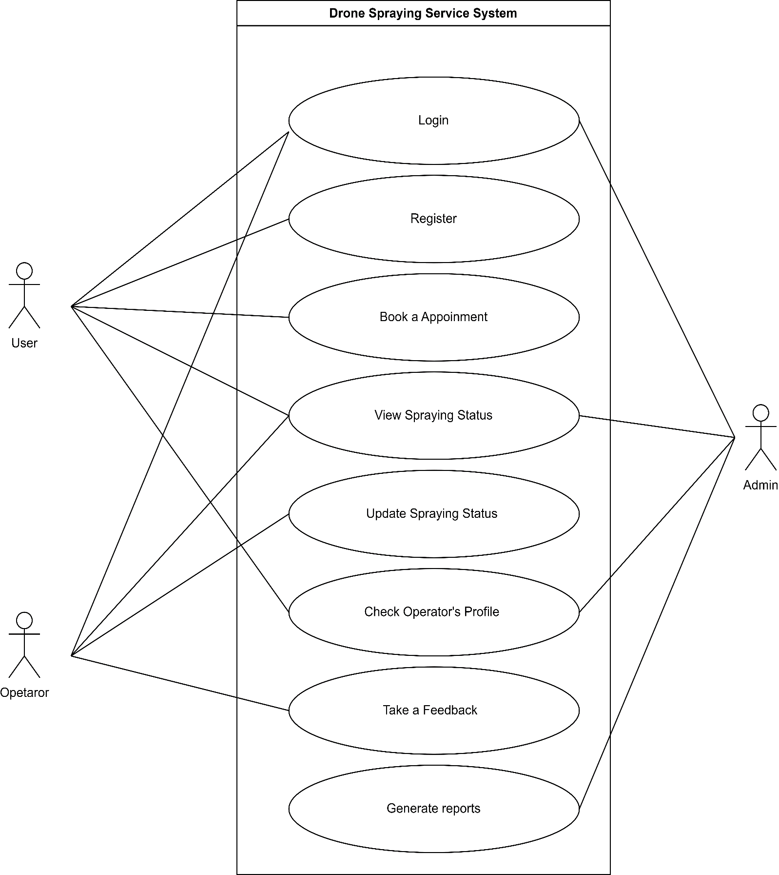

* **Class Diagram**

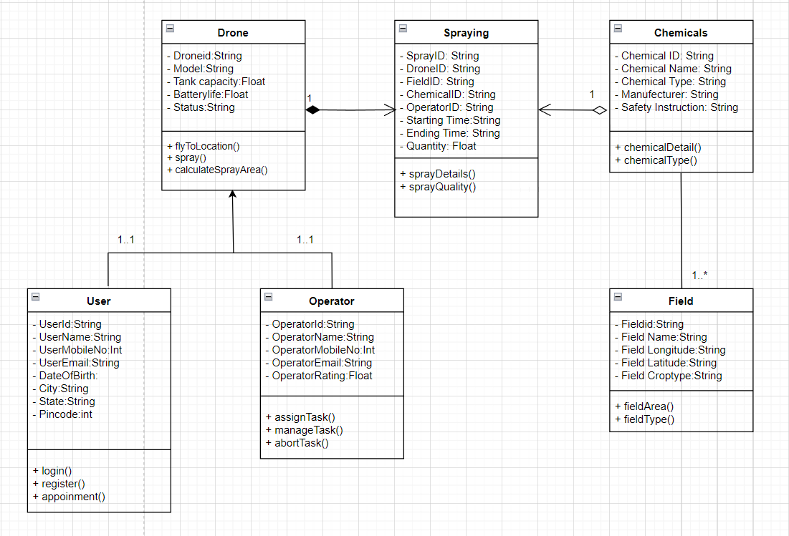

# SYSTEM DESIGN

## Data Dictionary

### Drone Table: -

|  |  |  |  |
| --- | --- | --- | --- |
| **Column** | **Type** | **Constraint** | **Description** |
| DroneID | Varchar (10) | Primary key | Unique ID for Chem |
| Model | varchar (50) | Not Null | Model specific model |
| Tank capacity | float | Not Null;0> | Capacity to store fertilize |
| Battery Life | Float | Not Null | The branch date, when it was  established |
| Ip | varchar (30) | Not Null | Ip address |

* **User Table: -**

|  |  |  |  |  |  |  |
| --- | --- | --- | --- | --- | --- | --- |
| **Column** | **Type** | | **Constraint** | | **Description** | |
| ID | int (11) | | Primary key | | Unique ID for Users | |
| Full Name | varchar (30) | | Not Null | | Full name of user  member | |
| Contact | bigint (12) | | Not Null | | Contact number of  user member | |
| Email | varchar (30) | | Not Null | | Email address of  user member | |
| Password | varchar (100) | | Not Null | | Password of user  member | |
| Date of Birth | date | | Not Null | | User’s Date of Birth | |
| Aadhar no | Int (12) | | Not null | | For identify purpose | |
| State | | varchar (35) | | Not Null | | State where branch  is located |
| City | | varchar (30) | | Not Null | | User’s City |
| Zip | | int (7) | | Not Null | | User’s City Zip code |

* **Field Table: -**

|  |  |  |  |
| --- | --- | --- | --- |
| **Column** | **Type** | **Constraint** | **Description** |
| FieldID | int (11) | Primary key | Unique ID for Field |
| Field name | varchar (20) | Not Null | Field name for spraying |
| Field Longitude | varchar2(30) | Not Null (Valid Coordinates) | Longitudes for spraying |
| Field Latitude | varchar2(30) | Not Null (Valid Coordinates) | Latitudes for spraying |
| Field Area | float | Not Null,0> | Area of field |
| Field Crop type | bigint (11) | Not Null | Crop type in field |

* **Operator Table: -**

|  |  |  |  |
| --- | --- | --- | --- |
| **Column** | **Type** | **Constraint** | **Description** |
| Operator ID | int (11) | Primary key | Unique ID for Operators |
| Operator Name | varchar (20) | Not Null | Name of Operator |
| Operator No | Int (10) | Not Null | Mobile no. of Operator |
| Operator Email | varchar (20) | Not Null (Valid Email format) | Email of Operator |
| Operator Rating | float | Not Null | Operator Rating for user’s |

* **Chemical Table: -**

|  |  |  |  |
| --- | --- | --- | --- |
| **Column** | **Type** | **Constraint** | **Description** |
| Chemical ID | int (11) | Primary key | Unique ID for Chemicals |
| Chemical Name | varchar (20) | Not Null | Name of Chemical |
| Chemical Type | Int (10) | Not Null | Types of Chemicals |
| Chemical Manufacturer | varchar (20) | Not Null | Manufacturer of Chemical |
| Safety instructions | varchar (100) | Not Null | Safety Instriction of  Chemical |

|  |  |  |  |
| --- | --- | --- | --- |
| **Column** | **Type** | **Constraint** | **Description** |
| Spraying ID | int (11) | Primary key | Unique ID for Sparys |
| Drone ID | Varchar (10) | Foreign key (Drone Table) | Unique ID for Drone |
| Operator ID | int (11) | Foreign key (Operator Table) | Unique ID for Operator |
| Field ID | int (11) | Foreign key (Field Table) | Unique ID for Field |
| Chemical ID | int (11) | Foreign key (Chemical Table) | Unique ID for Chemicals |
| Date | Date | Not Null | Date of Spraying Service |
| Time | Time | Not Null | Time of Spraying Service |
| Quantity | Float | Not Null,0> | Quantity which uses for Spraying Service |

* **Spraying Schedule Table: -**

# SYSTEM TESTING

## Black box test strategy: -

* Admin can add new user member, can change and search the existing user member’s details and also remove the user member. Black box testing is a technique of software testing which examines the functionality of software without peering into its internal structure or coding. The primary source of black box testing is a specification of requirements that is stated by the customer.
* In this method, tester selects a function and gives input value to examine its functionality, and checks whether the function is giving expected output or not. If the function produces correct output, then it is passed in testing, otherwise failed. The test team reports the result to the development team and then tests the next function. After completing testing of all functions if there are severe problems, then it is given back to the development team for correction.
  + **Test cases -**

|  |  |  |  |  |  |
| --- | --- | --- | --- | --- | --- |
| **Sr.no** | **Scenario** | **Purpose** | **Input** | **Expected Output** | **Status** |
| 1. | Login | To enter in system | Email and Password | Success | Ok |
| 2. | Setup Drone Route | To define the route for the drone | Field coordinates, Altitude, Speed | Success | Ok |
| 3. | Select Spraying Mode | To choose the type of spraying | Spraying mode (e.g., mist, spray), Chemical type | Success | Ok |
| 4. | Start Spraying Operation | To initiate spraying on the defined route | Confirm route and spraying parameters | Drone starts spraying | Ok |
| 5. | Monitor Spraying Status | To check the drone's spraying status | Enter valid  Drone ID and Field ID | Real-time status updates | Ok |
| 6. | |  | | --- | | Generate Spraying Report |  |  | | --- | |  | | To get the report of the spraying operation | Enter two dates | Detailed spraying repor | Ok |

# FUTURE ENHANCEMENT

## Future Enhancement: -

* **Automated Weather Adaptation:**
  + - * Automatically adjust the spraying schedule and parameters based on real-time weather data to ensure optimal spraying conditions.
* **Collect Soil and Crop Data:**
  + - * Enhance the system to allow the drone to collect soil and crop health data during spraying, providing valuable insights for future agricultural planning.
* **Advanced Obstacle Detection:**
  + - * Upgrade the drone's obstacle detection system to enhance safety and enable operations in more challenging environments.
* **Automated Flight Path Optimization:**
  + - * Implement AI-based algorithms to automatically optimize the drone's flight path for more efficient coverage and reduced resource usage.

# REFERENCES

## References: -

* <https://stackoverflow.com/>
* <https://www.w3schools.com/>
* <https://www.youtube.com/>
* <https://getbootstrap.com/>

# THANK YOU