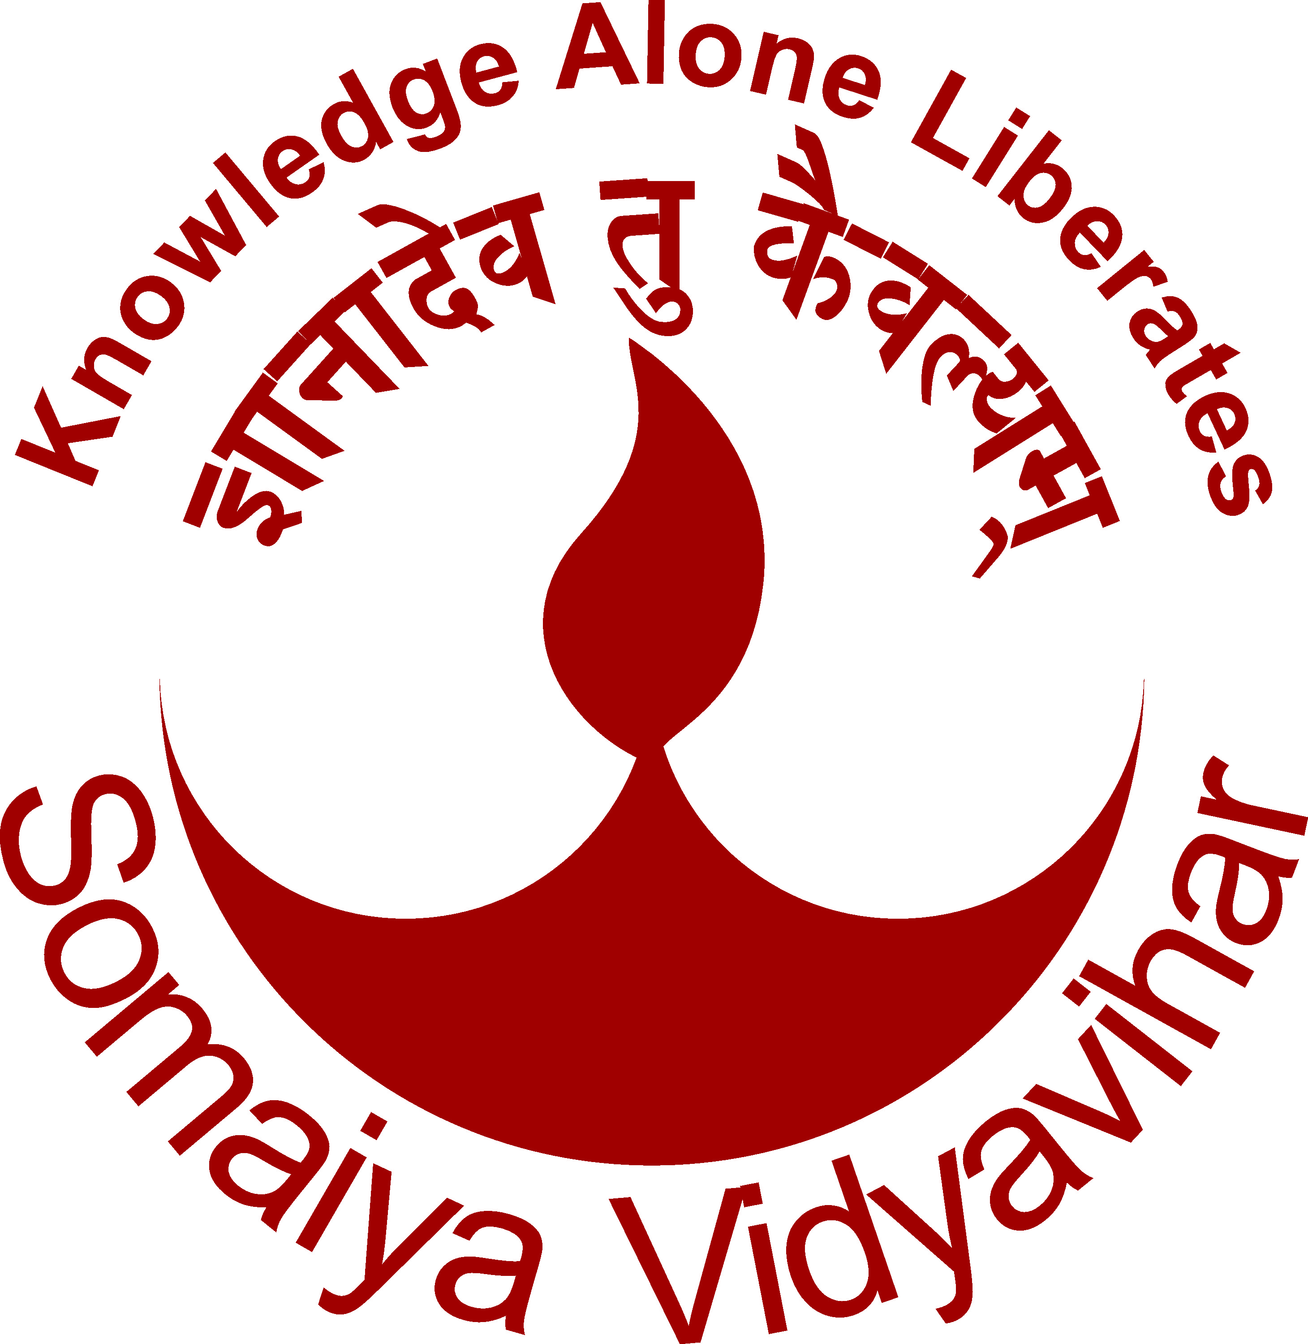 | Roll No.: 1814036 |  | B. Tech | 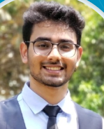
 | Name : Jai Anish Mehta
 | Address for communication: 901/Alexandria, Skyline Oasis, Premier Road, Vidya Vihar West, Mumbai: - 400 086
 | DOB:04/02/2000 | Mobile No: 9987810402
 | E-mail: jai.mehta@somaiya.edu / mehta.jai4@gmail.com
 | Department: Information Technology

Examination | University/Board | Institute/College | Year of Passing | YPI
SY | Mumbai | KJ Somaiya College of Engineering (Vidyavihar) | 2020 | 9.09
FY | Mumbai | KJ Somaiya College of Engineering (Vidyavihar) | 2019 | 8.39
HSC | Mumbai | KJ Somaiya College of Science and Commerce | 2018 | 86.62%
ICSE | Mumbai | P.G.Garodia School ICSE | 2016 | 92.33%

Internships
Organization | From | To | No of Weeks/Hours
IT Department KJSCE | 14/06/2019 | 08/07/2019 | 40 Hours
Shrijay Cashews and Allied Products Pvt Ltd | 05/06/2020 | 05/08/2020 | 08 Weeks
KJSCE ROBOCON | 04/06/2020 | 12/07/2020 | 60 hours

Extra Courses/Certification Done
Organization | Name of course/Certification | Year | Other details
Coursera (Deeplearning.ai) | Neural Networks and Deep Learning | 2020 | Completed
Coursera (Deeplearning.ai) | Improving Deep Neural Networks: Hyperparameter tuning, Regularization, Optimization | 2020 | Completed
Coursera (Deeplearning.ai) | Structuring Machine Learning Projects | 2020 | Completed
Coursera (University of Michigan) | Using Databases with Python | 2020 | Completed
Coursera (University of Michigan) | Using Python to Access Web Data | 2020 | Completed
Udemy | Python for Data Science and Machine Learning | 2020 | Completed
Udemy | Python and Django Full Stack Web Development | 2020 | Completed
Udemy | Complete Python Programming Bootcamp | 2020 | Completed

Positions and Responsibility Undertaken in KJSCE
Public Relations Officer – PUSH KJSCE | 2020

Extracurricular Activities
Social
I have been a part of Leo Club of Jagdusha Hills(youth wing of the Lions Club, a community service club) as a general member of the club. | 2010
I have been general body member of the Rotaract Club of Mumbai Ghatkopar(youth wing of the Rotary Club, a community service club) in term 2019-2020. Currently I am the Sports Director for the Rotaract Club of Mumbai Ghatkopar for the term 2020 to 2021 | 2020-2021
Sports
I have played Badminton for 7 years professionally | 2009-2016
Hobbies
Physical Fitness and Nutrition, Spirituality

Other Activities: Academic Projects/Presentations/Publications/Participation in Competitions
Details of Activity | Year
Plant Leaf Disease Detection Project (ongoing project) | 2020
Fence Following Robot: Mini Project | 2020

