EXECUTIVE CHURN ANALYSIS REPORT & INSIGHTS

PART 1 :- SQL ANALYSIS

- Database Setup

CREATE DATABASE ChurnAnalysis;
USE ChurnAnalysis;

CREATE TABLE CustomerSubscriptions (
CustomerID VARCHAR(10),
Name VARCHAR(50),
Age INT,
Gender VARCHAR(20),
SubscriptionType VARCHAR(20),
SubscriptionDate DATE,
LastLoginDate DATE,
TotalSessions INT,
FeedbackScore INT,
IsChurned INT
);

select * from CustomerSubscriptions;

- Data Analysis Queries

- Total Number of Active vs Churned Customers (by SubscriptionType)

SELECT SubscriptionType,
SUM(CASE WHEN IsChurned = 0 THEN 1 ELSE 0 END) AS ActiveCustomers,
SUM(CASE WHEN IsChurned = 1 THEN 1 ELSE 0 END) AS ChurnedCustomers
FROM CustomerSubscriptions
GROUP BY SubscriptionType;

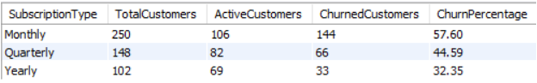

- Average FeedbackScore by SubscriptionType and Gender

SELECT SubscriptionType, Gender, ROUND(AVG(FeedbackScore),2) AS AverageFeedbackScore
FROM CustomerSubscriptions
GROUP BY SubscriptionType, Gender
ORDER BY SubscriptionType, Gender;

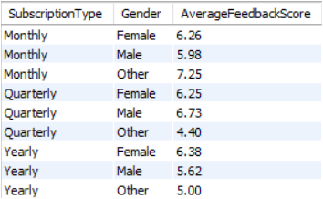

- List Customers Who Attended < 5 Sessions AND Gave Feedback < 5

SELECT CustomerID, Name, TotalSessions, FeedbackScore
FROM CustomerSubscriptions
WHERE TotalSessions < 5
AND FeedbackScore < 5;

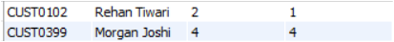

- Identify Customers Who Haven't Logged In for the Past 60 Days

SELECT CustomerID, Name, LastLoginDate, DATEDIFF(CURDATE(), LastLoginDate) AS DaysInactive
FROM CustomerSubscriptions
WHERE DATEDIFF(CURDATE(), LastLoginDate) > 60;

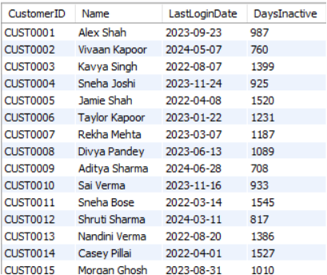

- Churn Rate by SubscriptionType

SELECT SubscriptionType, COUNT(*) AS TotalCustomers, SUM(IsChurned) AS ChurnedCustomers,
ROUND((SUM(IsChurned) * 100.0) / COUNT(*), 2) AS ChurnRatePercent
FROM CustomerSubscriptions
GROUP BY SubscriptionType;

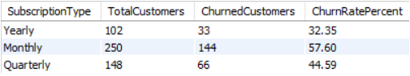

- Top 10 Customers with Longest Subscriptions

SELECT CustomerID, Name, SubscriptionType, SubscriptionDate
FROM CustomerSubscriptions
ORDER BY SubscriptionDate ASC
LIMIT 10;

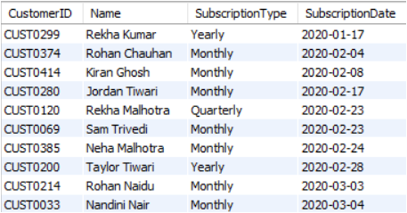

- Age Group Wise Churn Analysis

SELECT CASE
WHEN Age BETWEEN 18 AND 25 THEN '18-25'
WHEN Age BETWEEN 26 AND 35 THEN '26-35'
WHEN Age BETWEEN 36 AND 45 THEN '36-45'
WHEN Age BETWEEN 46 AND 60 THEN '46-60'
ELSE '60+'
END AS AgeGroup,
COUNT(*) AS TotalCustomers, SUM(IsChurned) AS ChurnedCustomers, ROUND((SUM(IsChurned) * 100.0) / COUNT(*), 2) AS ChurnRatePercent
FROM CustomerSubscriptions
GROUP BY AgeGroup
ORDER BY AgeGroup;

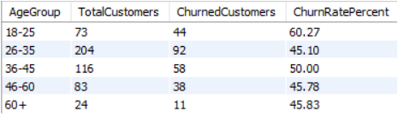

PART 2 :- EXCEL DASHBOARD AND INSIGHTS

- Dashboard
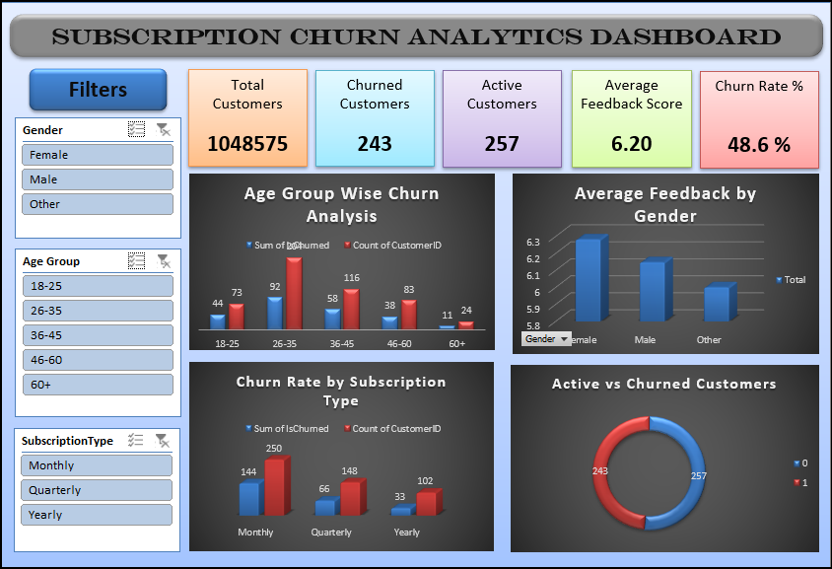

Dataset: CustomerSubscriptions.xlsx
Dashboard Source: Excel/Power BI Analytics Dashboard

- [1] KEY PERFORMANCE INDICATORS (KPIs)

• Total Customer Base: 500 total subscribers analyzed.
• Active Account Volume: 257 customers remain active (51.40%).
• Churned Account Volume: 243 customers have cancelled (48.60%).
• Average Customer Satisfaction: 6.07 / 10 overall feedback score.
• Average Customer Engagement: 310.87 days since last user login.

- [2] CRITICAL EXECUTIVE INSIGHTS DERIVED FROM DASHBOARD

• Contract Type Vulnerability:
Monthly subscriptions represent an extreme loyalty risk, producing a massive 57.60% churn rate In comparison, Yearly contracts provide the highest stability with only a 32.35% churn rate.

• High-Risk Youth Demographics:
The 18–25 age group is abandoning the platform faster than any other cohort, leading all segments with a 60.27% churn rate. While the 26–35 tier contains the largest volume of users it accounts for the
highest absolute loss with 92 total cancellations.

• Behavior & Sentiment Thresholds:
The scatter plot reveals a strong negative correlation between usage and churn. Customers who log fewer than 5 total sessions and give a feedback score under 5 show a nearly 100% historical churn velocity.

- [3] ACTIONABLE BUSINESS SUGGESTIONS

• Contract Migration Incentives:
Launch an automated email campaign offering a 20% discount or one month
free to Monthly subscribers who migrate to a Quarterly or Yearly contract.

• Gen-Z Engagement Pivot:
Revamp the wellness/fitness library with short, gamified challenges and
mobile-first social sharing tools to curb the 60.27% youth churn rate.

• Automated Database Guardrails:
Set up an automated alert system. If a new user logs fewer than 3 sessions
in their first 30 days, flag the account for direct customer service
outreach to prevent cancellation.

