Prem Raj
USN: 1NT20IS121

1. Activity Lifecycle

@Override
protected void onStart() {
super.onStart();
Toast.makeText(this, "ACTIVITY STARTED", Toast.LENGTH_SHORT).show();
}
@Override
protected void onPause() {
super.onPause();
Toast.makeText(this, "ACTIVITY PAUSED", Toast.LENGTH_SHORT).show();
}

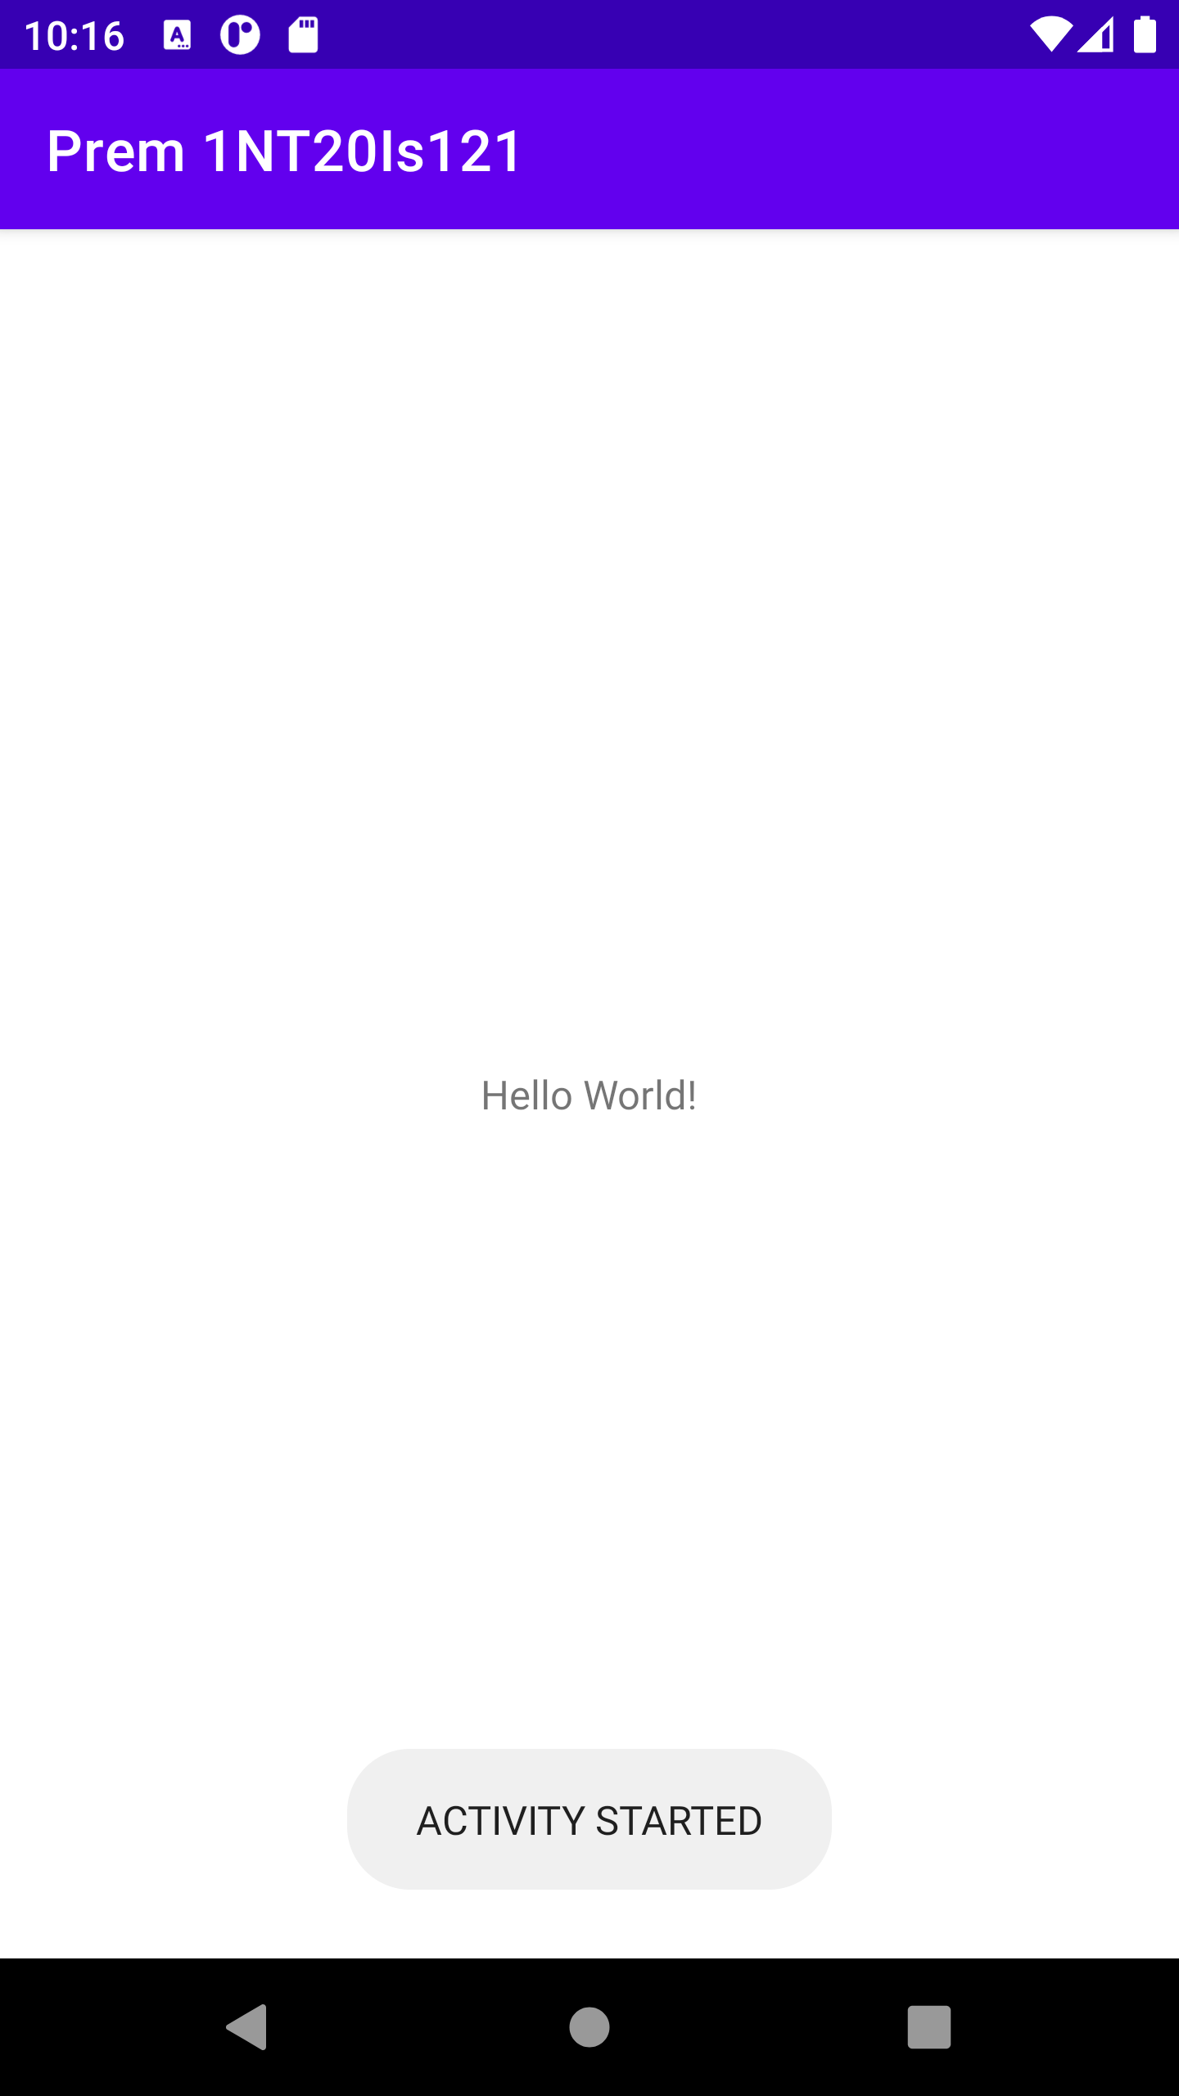

2. List View

@Override
protected void onCreate(Bundle savedInstanceState) {
super.onCreate(savedInstanceState);
setContentView(R.layout.activity_main);
ListView myList ;
String countryList[] ;
myList = findViewById(R.id.list) ;
countryList = getResources().getStringArray(R.array.Country) ;
ArrayAdapter<String> arrayAdapter = new ArrayAdapter<String>(this,
R.layout.support_simple_spinner_dropdown_item, countryList);
myList.setAdapter(arrayAdapter);
}

<ListView
android:id="@+id/list"
android:layout_width="409dp"
android:layout_height="729dp"
android:layout_marginStart="1dp"
android:layout_marginTop="1dp"
android:layout_marginEnd="1dp"
android:layout_marginBottom="1dp"
app:layout_constraintBottom_toBottomOf="parent"
app:layout_constraintEnd_toEndOf="parent"
app:layout_constraintStart_toStartOf="parent"
app:layout_constraintTop_toTopOf="parent" >

<string-array name="Country">
<item>India</item>
<item>Zambia</item>
<item>USA</item>
<item>Myanmar</item>
<item>Germany</item>
</string-array>

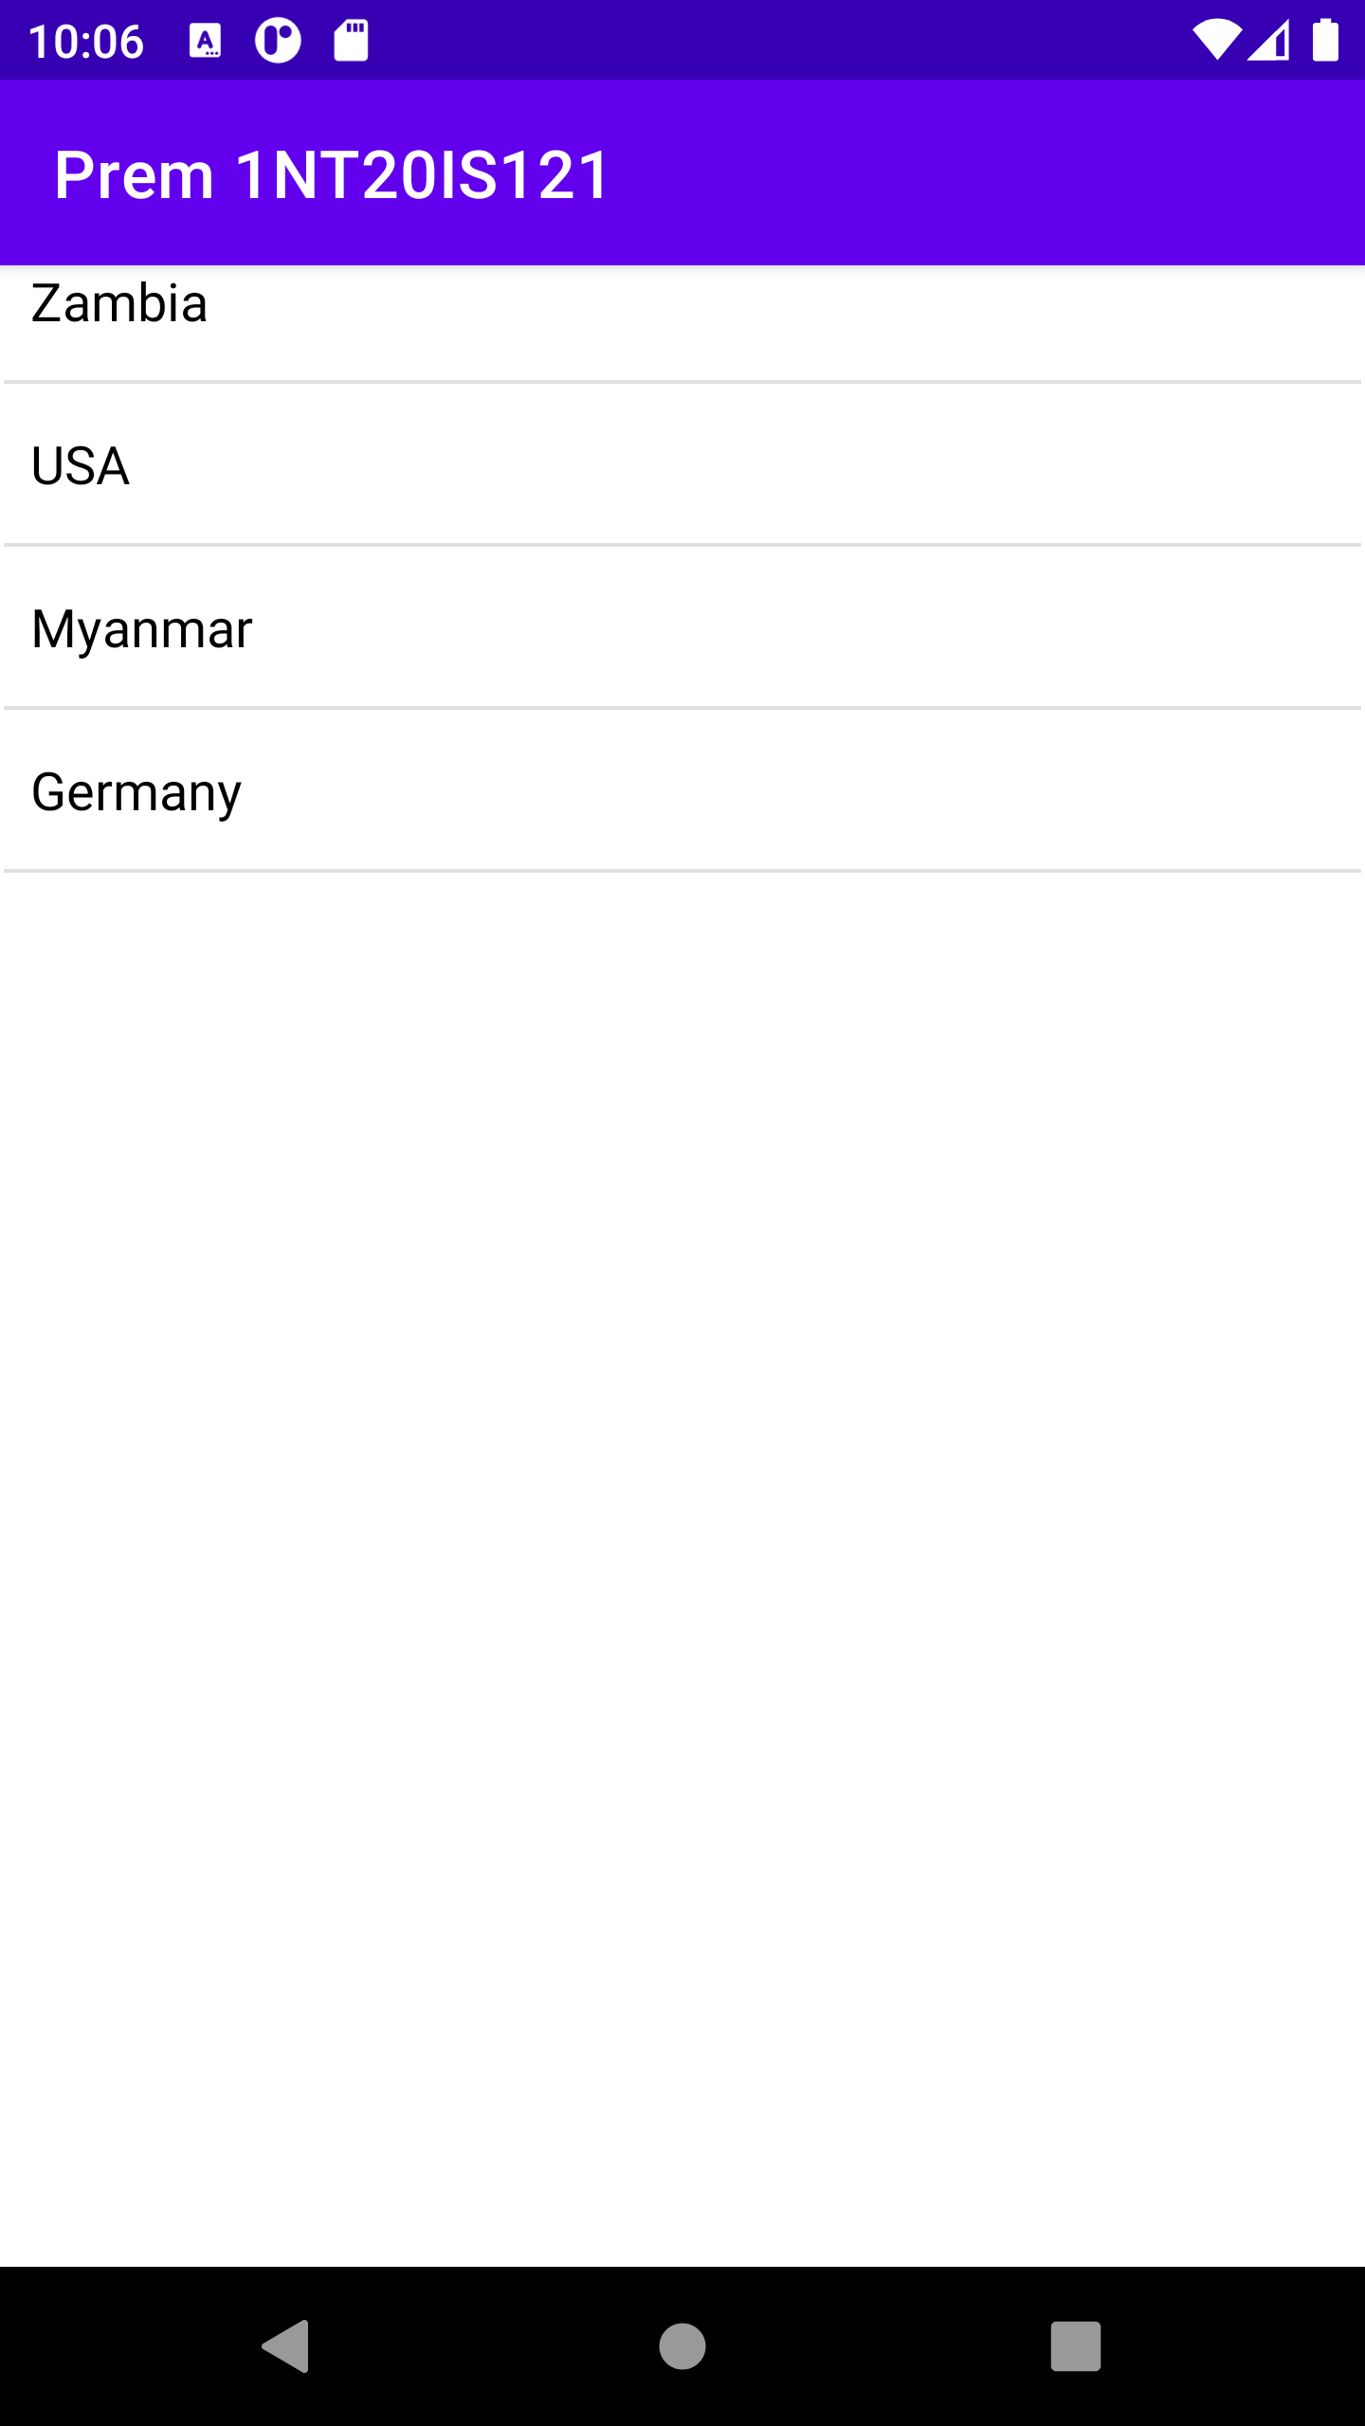

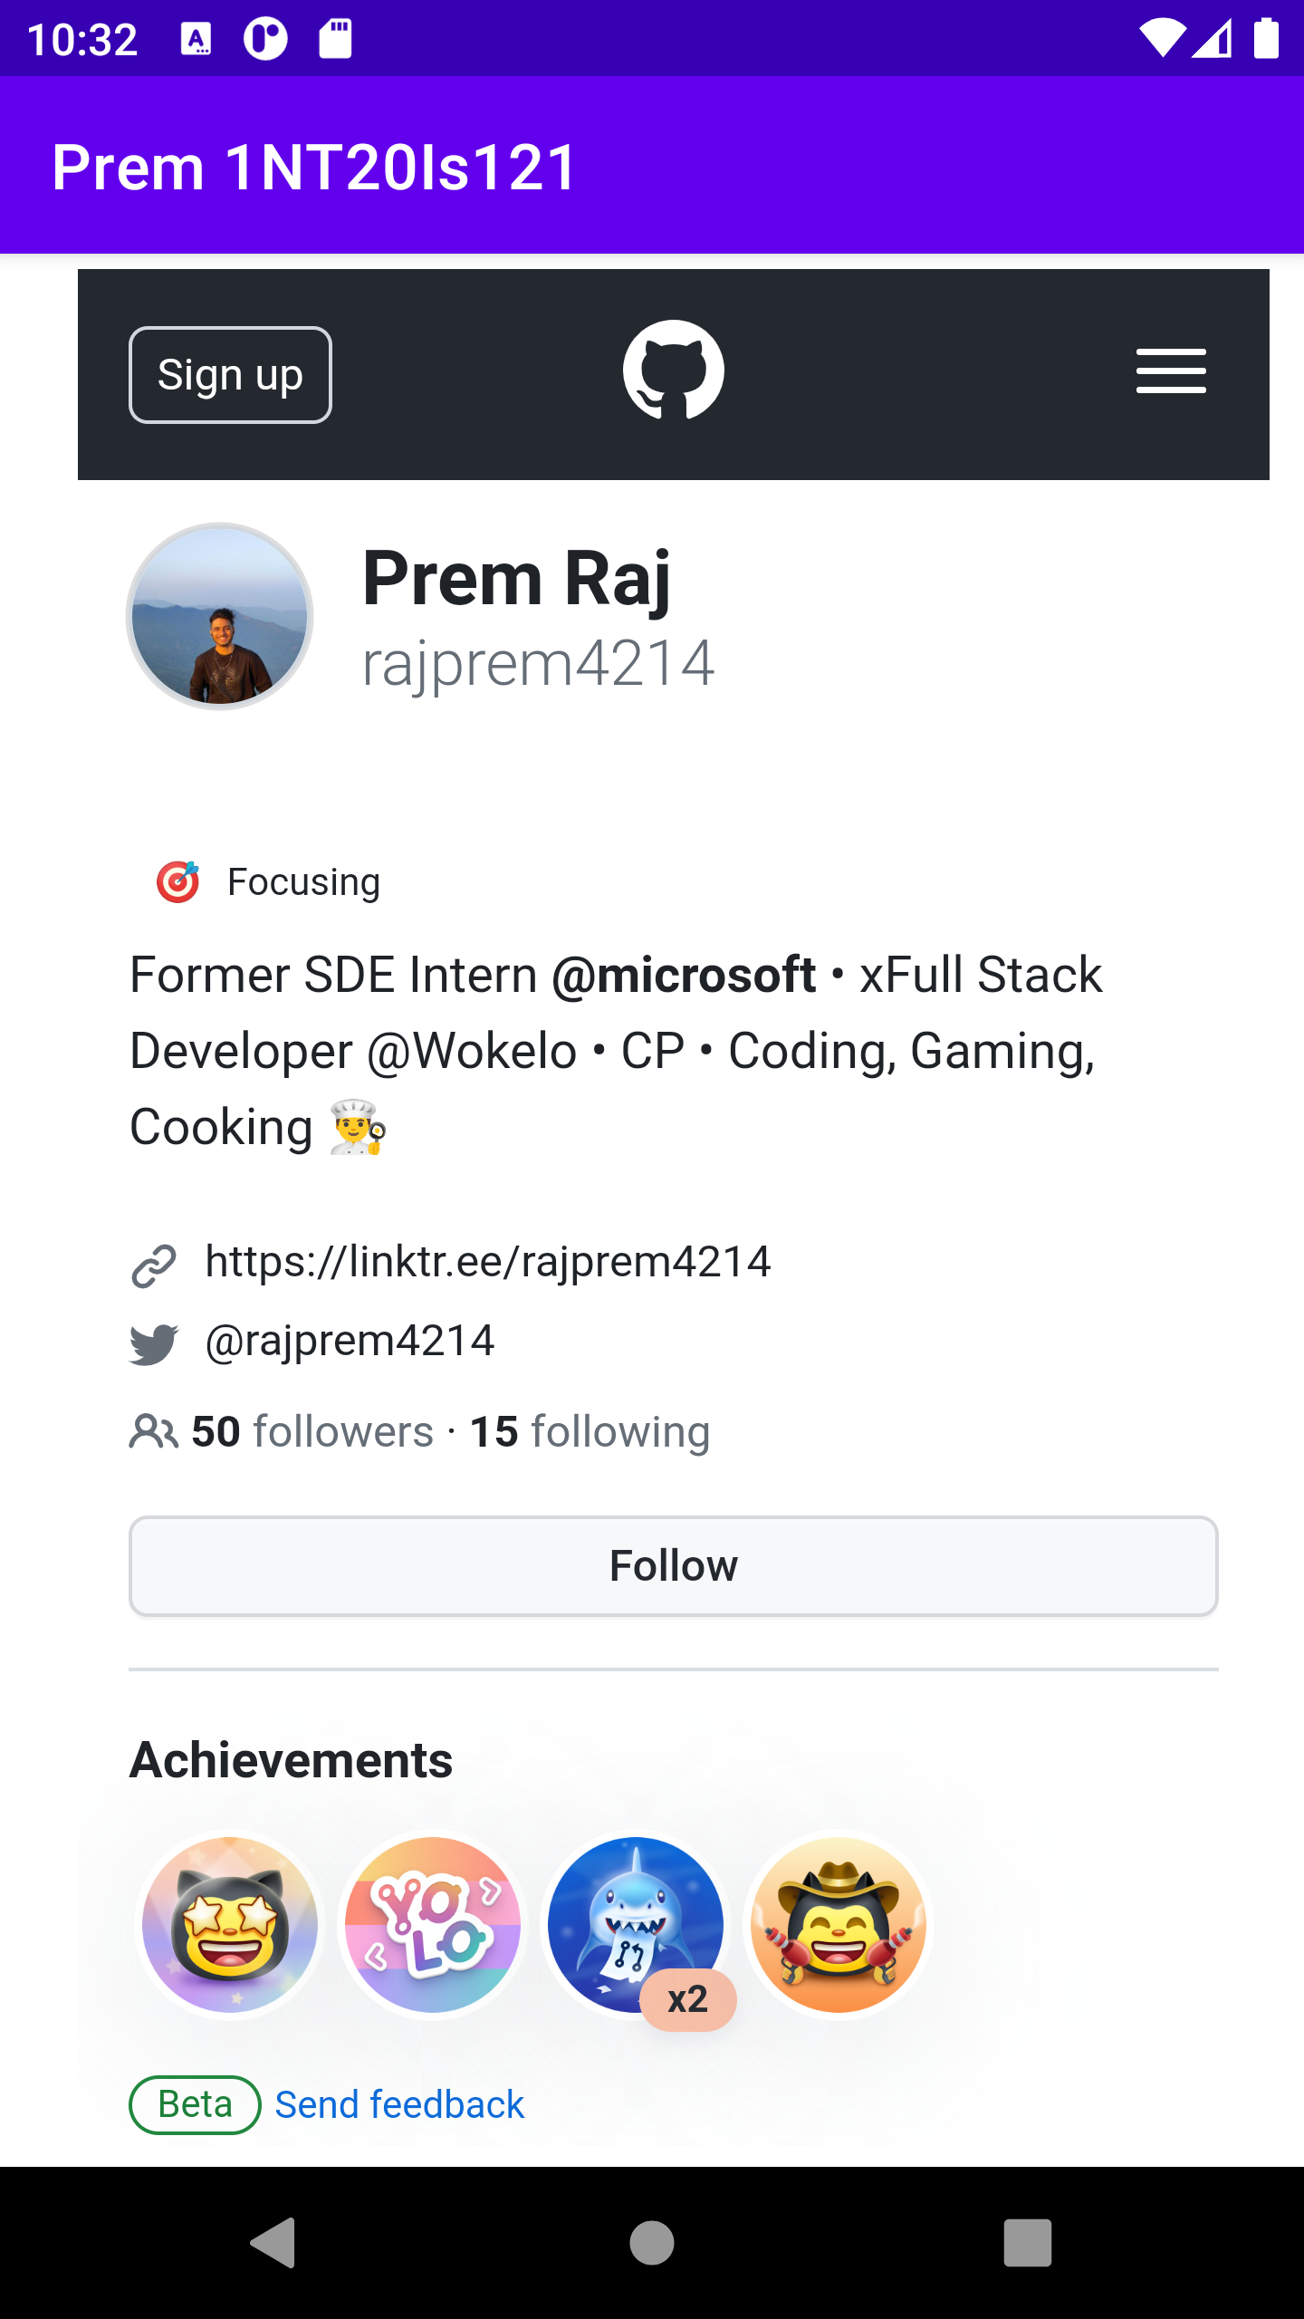
3. Web View

@Override
protected void onCreate(Bundle savedInstanceState) {
super.onCreate(savedInstanceState);
setContentView(R.layout.activity_main);
WebView wv = findViewById(R.id.web);
wv.loadUrl("https://github.com/rajprem4214");
}

<WebView
android:id="@+id/web"
android:layout_width="376dp"
android:layout_height="592dp"
android:layout_marginStart="1dp"
android:layout_marginTop="1dp"
android:layout_marginEnd="1dp"
android:layout_marginBottom="1dp"
app:layout_constraintBottom_toBottomOf="parent"
app:layout_constraintEnd_toEndOf="parent"
app:layout_constraintHorizontal_bias="0.711"
app:layout_constraintStart_toStartOf="parent"
app:layout_constraintTop_toTopOf="parent"
app:layout_constraintVertical_bias="0.394" />

