Shivam Maurya
1nt20is155

Calci

XML Code :-

<?xml version="1.0" encoding="utf-8"?>
<LinearLayout xmlns:android="http://schemas.android.com/apk/res/android"
xmlns:app="http://schemas.android.com/apk/res-auto"
xmlns:tools="http://schemas.android.com/tools"
android:layout_width="match_parent"
android:layout_height="match_parent"
android:orientation="vertical"
tools:context=".MainActivity">
<EditText
android:id="@+id/editText"
android:layout_width="match_parent"
android:layout_height="wrap_content"
android:ems="10"
android:inputType="textPersonName"
android:layout_weight="1"
android:background="@color/cardview_dark_background"
android:gravity="right|center"
android:textSize="40pt"
android:text="0" />
<TableLayout
android:layout_width="match_parent"
android:layout_height="wrap_content">
<TableRow
android:layout_width="match_parent"
android:layout_height="wrap_content">
<Button
android:id="@+id/button22"
android:layout_width="30pt"
android:layout_height="33pt"
android:layout_marginTop="1pt"
android:layout_marginRight="1pt"
android:layout_weight="1"
android:background="@color/black"
android:onClick="acEvent"
android:text="AC" />
<Button
android:id="@+id/buPlusMinus"
android:layout_width="30pt"
android:layout_height="33pt"
android:layout_marginTop="1pt"
android:layout_marginRight="1pt"
android:layout_weight="1"
android:background="@color/black"
android:onClick="numberEvent"
android:text="+/-" />
<Button
android:id="@+id/buDivide"
android:layout_width="30pt"
android:layout_height="33pt"
android:layout_marginTop="1pt"
android:layout_marginRight="1pt"
android:layout_weight="1"
android:background="@color/black"
android:onClick="operatorEvent"
android:text="/" />
<Button
android:id="@+id/buMultiply"
android:layout_width="30pt"
android:layout_height="33pt"
android:layout_marginTop="1pt"
android:layout_marginRight="1pt"
android:layout_weight="1"
android:background="@color/black"
android:onClick="operatorEvent"
android:text="*" />
</TableRow>
<TableRow
android:layout_width="match_parent"
android:layout_height="wrap_content">
<Button
android:id="@+id/bu7"
android:layout_width="30pt"
android:layout_height="33pt"
android:layout_marginTop="1pt"
android:layout_marginRight="1pt"
android:layout_weight="1"
android:background="@color/black"
android:onClick="numberEvent"
android:text="7" />
<Button
android:id="@+id/bu8"
android:layout_width="30pt"
android:layout_height="33pt"
android:layout_marginTop="1pt"
android:layout_marginRight="1pt"
android:layout_weight="1"
android:background="@color/black"
android:onClick="numberEvent"
android:text="8" />
<Button
android:id="@+id/bu9"
android:layout_width="30pt"
android:layout_height="33pt"
android:layout_marginTop="1pt"
android:layout_marginRight="1pt"
android:layout_weight="1"
android:background="@color/black"
android:onClick="numberEvent"
android:text="9" />
<Button
android:id="@+id/button24"
android:layout_width="30pt"
android:layout_height="33pt"
android:layout_marginTop="1pt"
android:layout_marginRight="1pt"
android:layout_weight="1"
android:background="@color/black"
android:onClick="percentEvent"
android:text="%" />
</TableRow>
<TableRow
android:layout_width="match_parent"
android:layout_height="wrap_content" >
<Button
android:id="@+id/bu4"
android:layout_width="30pt"
android:layout_height="33pt"
android:layout_marginTop="1pt"
android:layout_marginRight="1pt"
android:layout_weight="1"
android:background="@color/black"
android:onClick="numberEvent"
android:text="4" />
<Button
android:id="@+id/bu5"
android:layout_width="30pt"
android:layout_height="33pt"
android:layout_marginTop="1pt"
android:layout_marginRight="1pt"
android:layout_weight="1"
android:background="@color/black"
android:onClick="numberEvent"
android:text="5" />
<Button
android:id="@+id/bu6"
android:layout_width="30pt"
android:layout_height="33pt"
android:layout_marginTop="1pt"
android:layout_marginRight="1pt"
android:layout_weight="1"
android:background="@color/black"
android:onClick="numberEvent"
android:text="6" />
<Button
android:id="@+id/buPlus"
android:layout_width="30pt"
android:layout_height="33pt"
android:layout_marginTop="1pt"
android:layout_marginRight="1pt"
android:layout_weight="1"
android:background="@color/black"
android:onClick="operatorEvent"
android:text="+" />
</TableRow>
<TableRow
android:layout_width="match_parent"
android:layout_height="wrap_content" >
<Button
android:id="@+id/bu1"
android:layout_width="30pt"
android:layout_height="33pt"
android:layout_marginTop="1pt"
android:layout_marginRight="1pt"
android:layout_weight="1"
android:background="@color/black"
android:onClick="numberEvent"
android:text="1" />
<Button
android:id="@+id/bu2"
android:layout_width="30pt"
android:layout_height="33pt"
android:layout_marginTop="1pt"
android:layout_marginRight="1pt"
android:layout_weight="1"
android:background="@color/black"
android:onClick="numberEvent"
android:text="2" />
<Button
android:id="@+id/bu3"
android:layout_width="30pt"
android:layout_height="33pt"
android:layout_marginTop="1pt"
android:layout_marginRight="1pt"
android:layout_weight="1"
android:background="@color/black"
android:onClick="numberEvent"
android:text="3" />
<Button
android:id="@+id/buMinus"
android:layout_width="30pt"
android:layout_height="33pt"
android:layout_marginTop="1pt"
android:layout_marginRight="1pt"
android:layout_weight="1"
android:background="@color/black"
android:onClick="operatorEvent"
android:text="-" />
</TableRow>
<TableRow
android:layout_width="match_parent"
android:layout_height="match_parent" >
<Button
android:id="@+id/bu0"
android:layout_width="46pt"
android:layout_height="33pt"
android:layout_marginTop="1pt"
android:layout_marginRight="1pt"
android:layout_weight="2"
android:background="@color/black"
android:onClick="numberEvent"
android:text="0" />
<Button
android:id="@+id/buDot"
android:layout_width="46pt"
android:layout_height="33pt"
android:layout_marginTop="1pt"
android:layout_marginRight="1pt"
android:layout_weight="2"
android:background="@color/black"
android:onClick="numberEvent"
android:text="." />
<Button
android:id="@+id/button36"
android:layout_width="46pt"
android:layout_height="33pt"
android:layout_marginTop="1pt"
android:layout_marginRight="1pt"
android:layout_weight="2"
android:background="@color/black"
android:onClick="equalEvent"
android:text="=" />
</TableRow>
</TableLayout>
</LinearLayout>

Java Code :-

package com.example.calculator;
import androidx.appcompat.app.AppCompatActivity;
import android.os.Bundle;
import android.view.View;
import android.widget.EditText;
public class MainActivity extends AppCompatActivity {
boolean isNewOp = true;
EditText edl;
String oldNumber;
String op;
@Override
protected void onCreate(Bundle savedInstanceState) {
super.onCreate(savedInstanceState);
setContentView(R.layout.activity_main);
edl = findViewById(R.id.editText);
}
public void numberEvent(View view) {
if (isNewOp)
edl.setText("");
isNewOp = false;
String number = edl.getText().toString();
switch (view.getId()) {
case R.id.bu1:
number += "1";
break;
case R.id.bu2:
number += "2";
break;
case R.id.bu3:
number += "3";
break;
case R.id.bu4:
number += "4";
break;
case R.id.bu5:
number += "5";
break;
case R.id.bu6:
number += "6";
break;
case R.id.bu7:
number += "7";
break;
case R.id.bu8:
number += "8";
break;
case R.id.bu9:
number += "9";
break;
case R.id.bu0:
number += "0";
break;
case R.id.buDot:
number += ".";
break;
case R.id.buPlusMinus:
number = "-" + number;
break;
}
edl.setText(number);
}
public void operatorEvent (View view) {
isNewOp = true;
oldNumber= edl.getText().toString();
switch (view.getId()) {
case R.id.buDivide:
op = "/";
break;
case R.id.buMultiply:
op = "*";
break;
case R.id.buPlus:
op = "+";
break;
case R.id.buMinus:
op = "-";
break;
}
}
public void equalEvent (View view) {
String newNumber = edl.getText().toString();
double result = 0.0;
switch (op) {
case "+":
result = Double.parseDouble(oldNumber) + Double.parseDouble(newNumber);
break;
case "-":
result = Double.parseDouble(oldNumber) - Double.parseDouble(newNumber);
break;
case "*":
result = Double.parseDouble(oldNumber) * Double.parseDouble(newNumber);
break;
case "/":
result = Double.parseDouble(oldNumber) / Double.parseDouble(newNumber);
break;
}
edl.setText(result + "");
}
public void acEvent(View view)
{
edl.setText("0");
isNewOp = true;
}
public void percentEvent(View view)
{
double no = Double.parseDouble(edl.getText().toString())/100;
edl.setText(no+"");
isNewOp = true;
}
}

Output :-

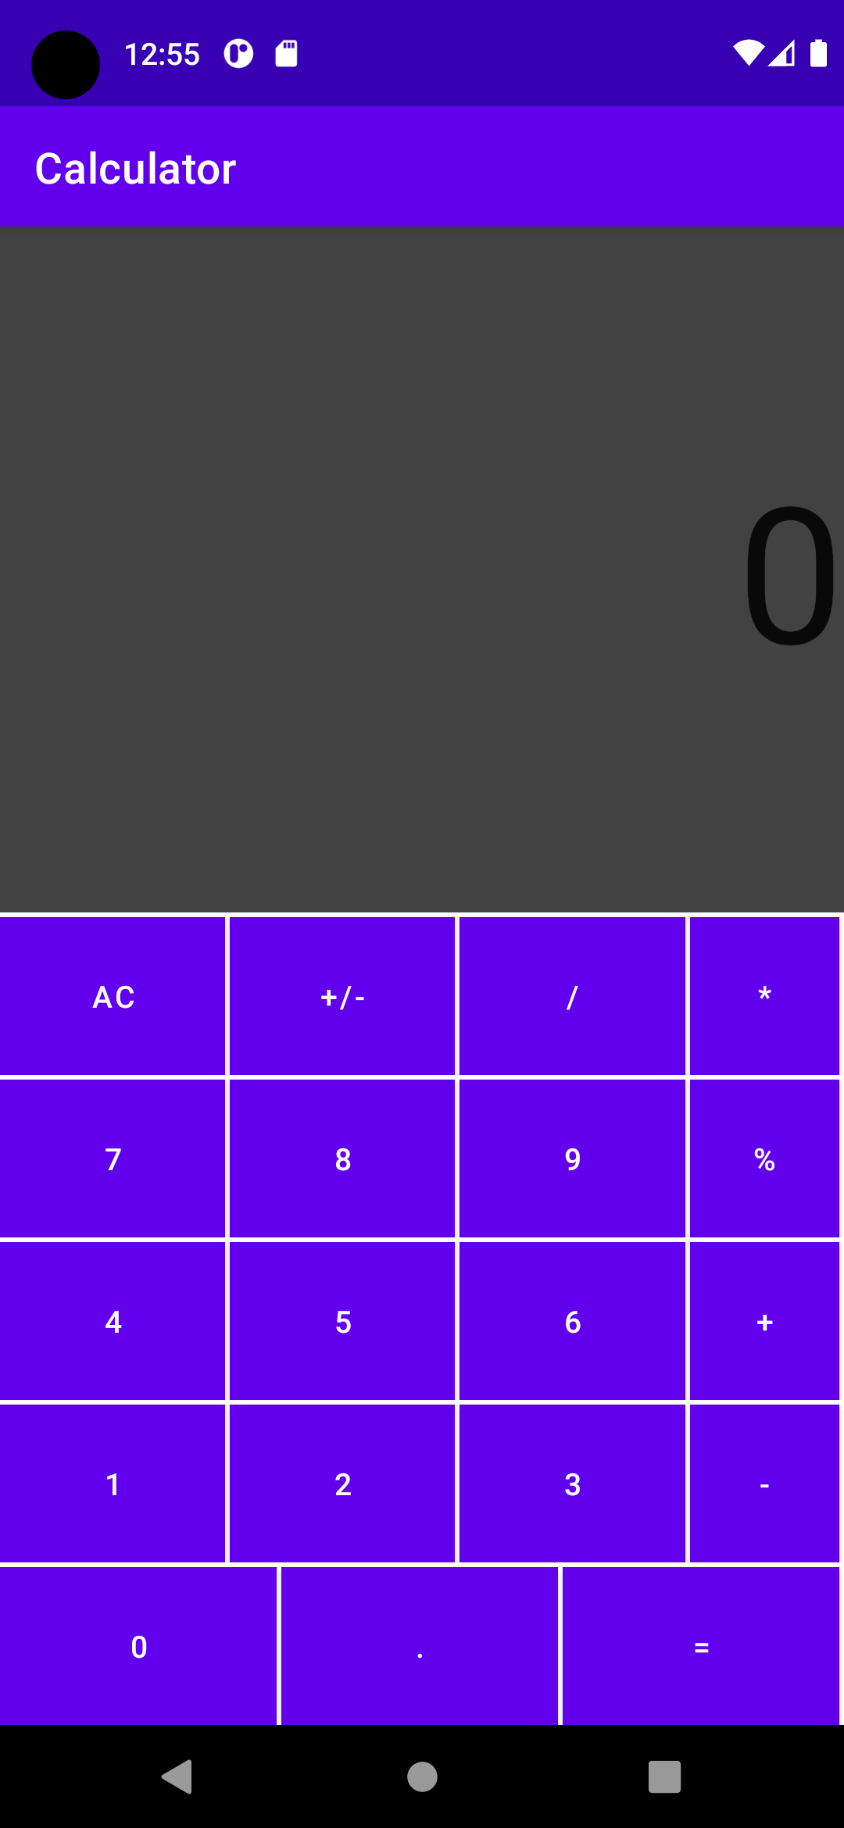

Multiplication Operator :-
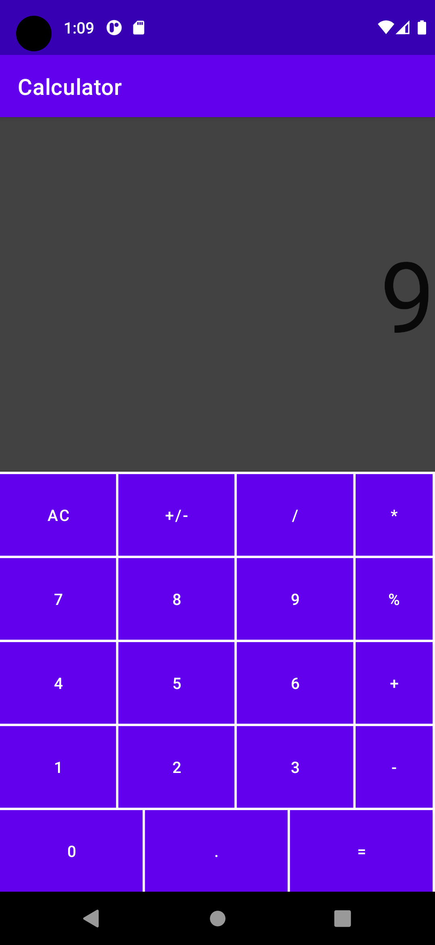
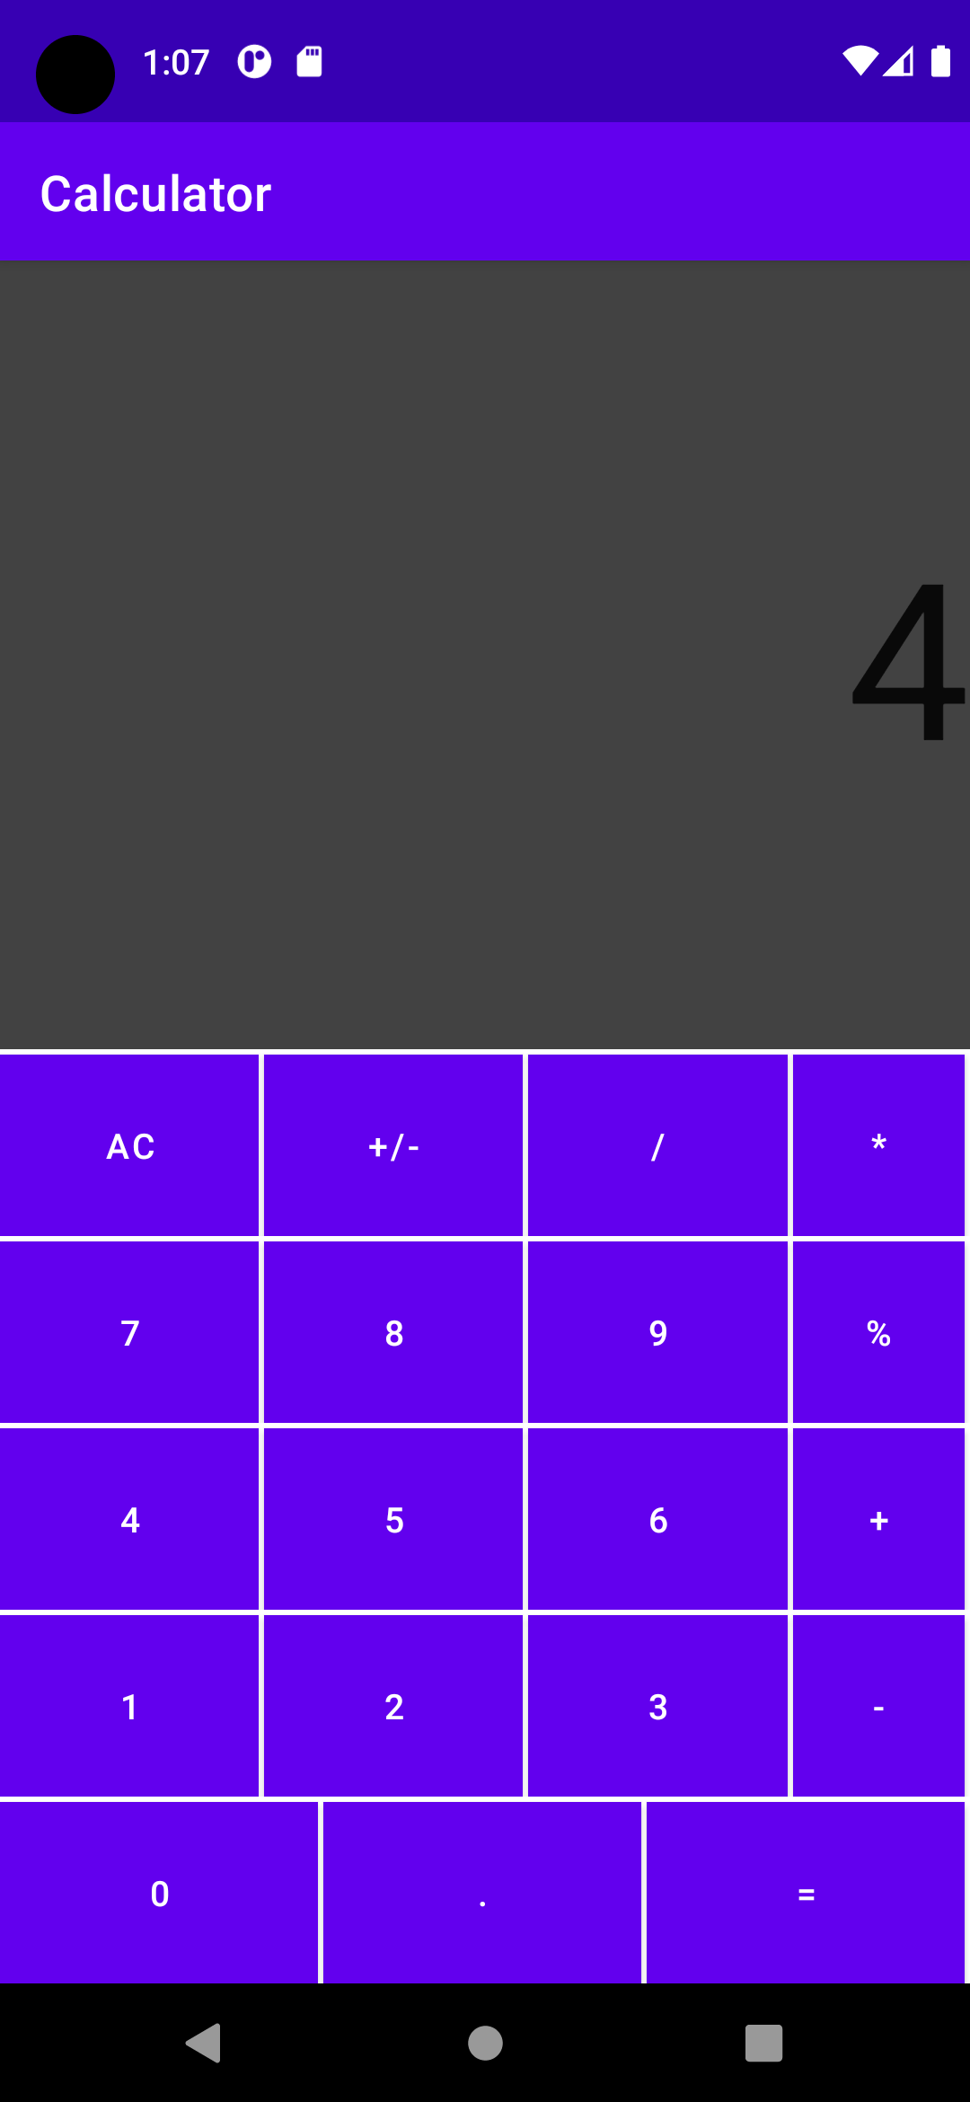

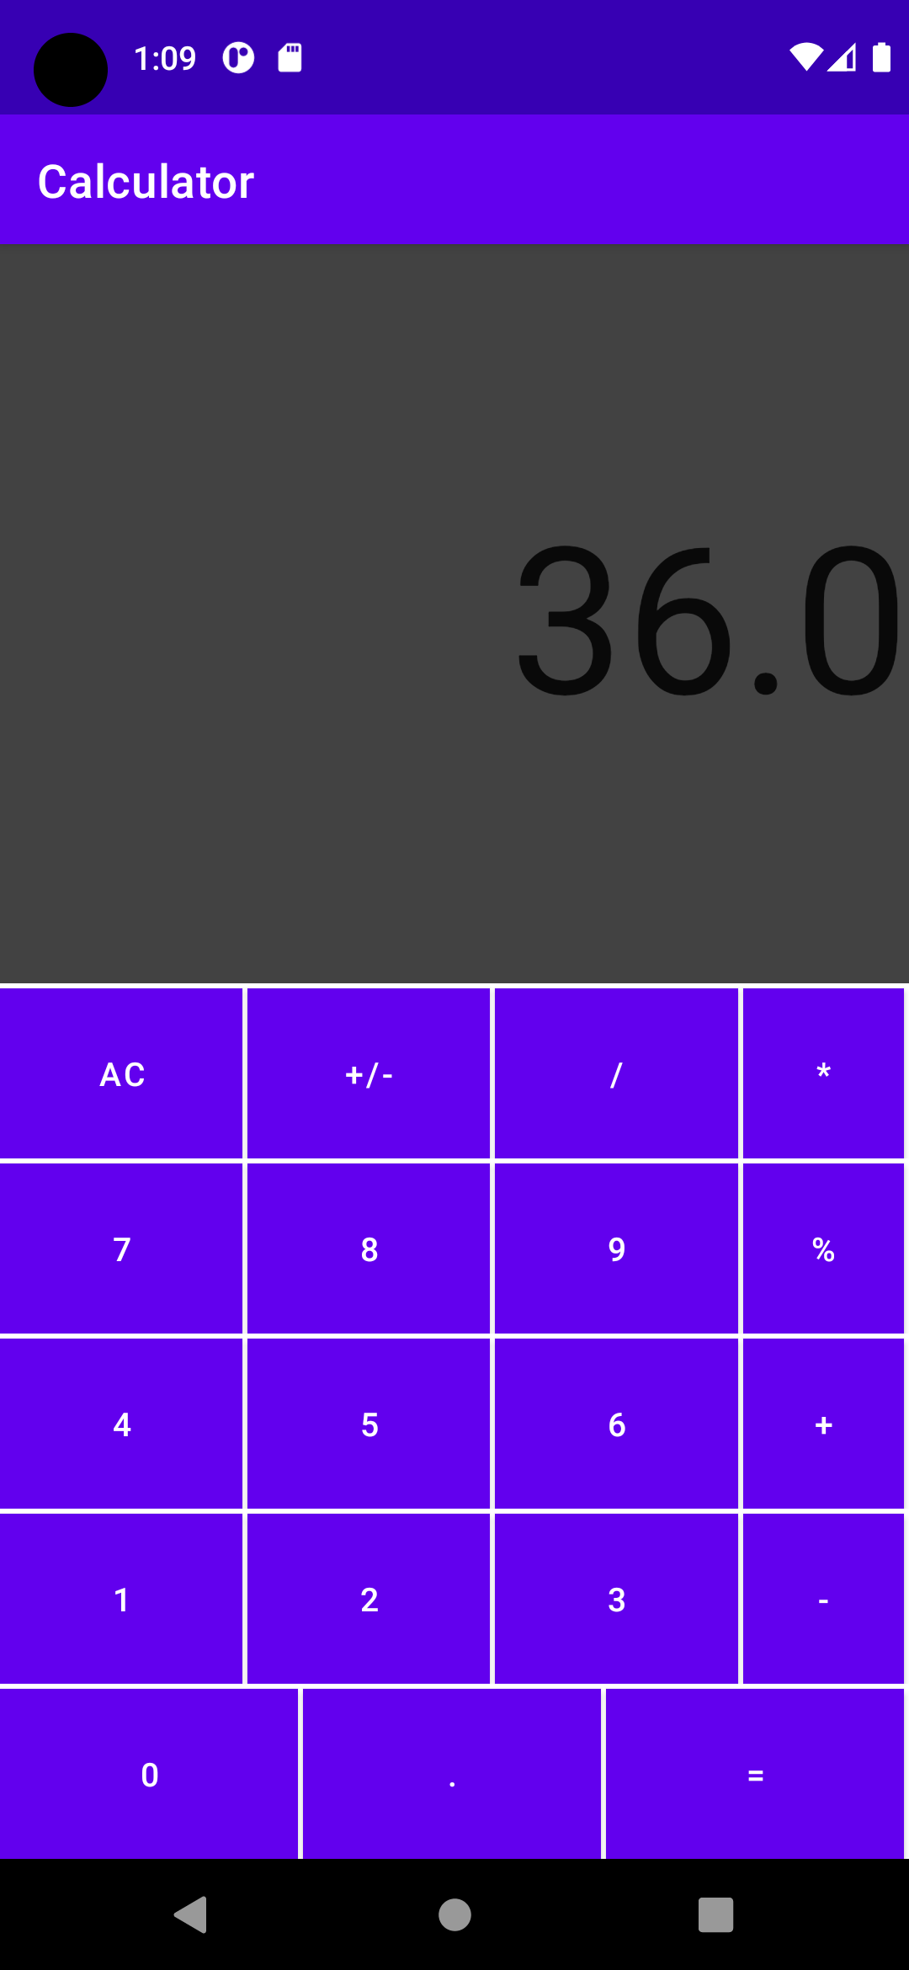

Minus Operator :-

